9. Digital Filtering Sections 1 and 2 (11/5/18)

In this chapter we move to the design of digital filters. Instead of filtering continuous data, as we did in the previous chapter, we are now looking to filter data that is sampled in time. The digital filters we design can be implemented in hardware or can be programmed into a computer.
There are two broad classes of digital filters, the finite impulse response (FIR) and the infinite impulse response (IIR). The FIR filters utilize convolution of the input signal with a finite number of points to get the output. The IIR filters calculate the output using the input data and previous output points. We will begin with the development of IIR filters.
There are also two different approaches to developing a digital filter. One approach is to develop a low pass digital filter at one specific frequency and use this as the bootstrap for the design of other types of filters at other frequencies, similar to what we did in chapter 8. However, the most common approach is to develop an analog filter and then convert it to a digital filter. This is the approach we will take. Converting an analog filter fundamentally means taking a transfer function from the Laplace or Fourier domain and moving it to the Z domain.
For the sake of clarity, in this section the Laplace domain filter is written as 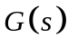 and the corresponding Z domain filter is written as 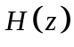. We begin by looking for a method to develop IIR filters from s domain filters. Our approach will be to take the s-domain transfer factions, use partial fraction expansion if necessary, and convert the Laplace function to Z transform functions via Table 9.1.

9.1. Infinite Impulse Response (IIR) Filters

9.1.1 The Laplace domain to the Z domain

If a signal 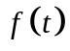is sampled periodically at a time period T, as in figure 9.1.1, it produces a discrete signal f[k].
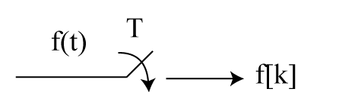
Figure 9.1.1. A continuous signal f(t) is sampled periodically to produce the signal f[k].

Mathematically we multiply f(t) it by a series of delta functions:
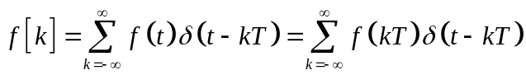. (9.1.1)
Notice that the brackets in 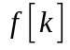 indicate that it is a discrete function. The Fourier transform of both side gives
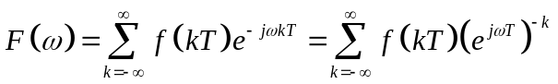 (9.1.2)
If we define
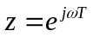, (9.1.3)
then we can rewrite Eq. 9.1.2 as
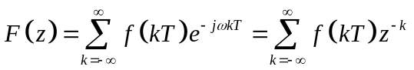. (9.1.4)
This is the definition of the Z transform.

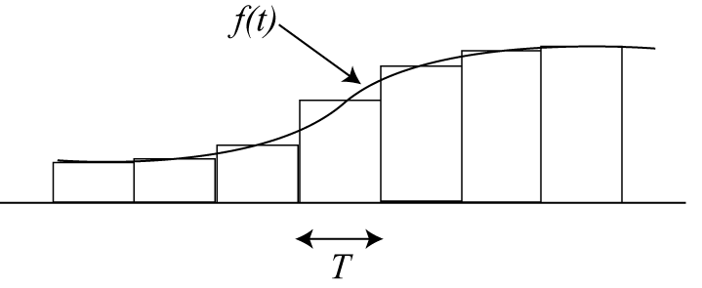
Figure 9.1.2. An analog signal approximated by a series of pulses of width T.

If we are looking for a better approximation of the analog signal f(t) as shown in Fig. 9.1.2, then we can use the pulse function 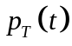 instead of the delta function .
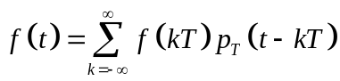. (9.1.5)
The Fourier transform of Eq. (9.1.5) is
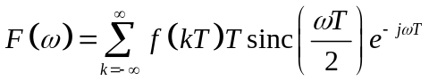. (9.1.6)
Recall the definition of the sinc function,
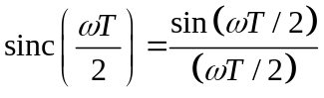. (9.1.7)
The value of T, the sampling interval, must be chosen so that it is small compared to the dynamics of the signal being sampled. This means that
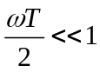. (9.1.8
Using L’Hopital’s rule, we can approximate Eq. (9.1.7) when 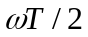 becomes very small,
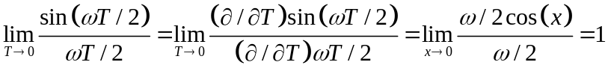 (9.1.9)
Therefore, we can rewrite Eq. (9.1.6) as,
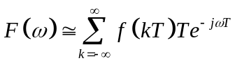. (9.1.10)
Using Eq. (9.1.3) we have a modified version of the Z transform.
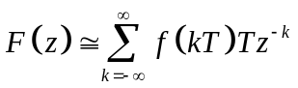. (9.1.11)
Notice that Eq. (9.1.11) has acquired a factor T, the sampling time, compared with the standard definition of the Z transform in Eq. (9.1.4).

9.1.2 Z Domain Bode Plots

We can use Bode plots to illustrate a Z domain transfer function the same way that Bode plots were used to illustrate an S domain transfer function. This will be illustrated with a simple example.
--------------------------------------------------------------------------------------------------------------
Example 9.1.1. Find the Z-domain transfer function for the following continuous function assuming the sampling rate is T = 0.01 sec
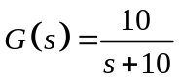. (9.1.12)
The Bode plot is shown in Fig. 9.1.3.
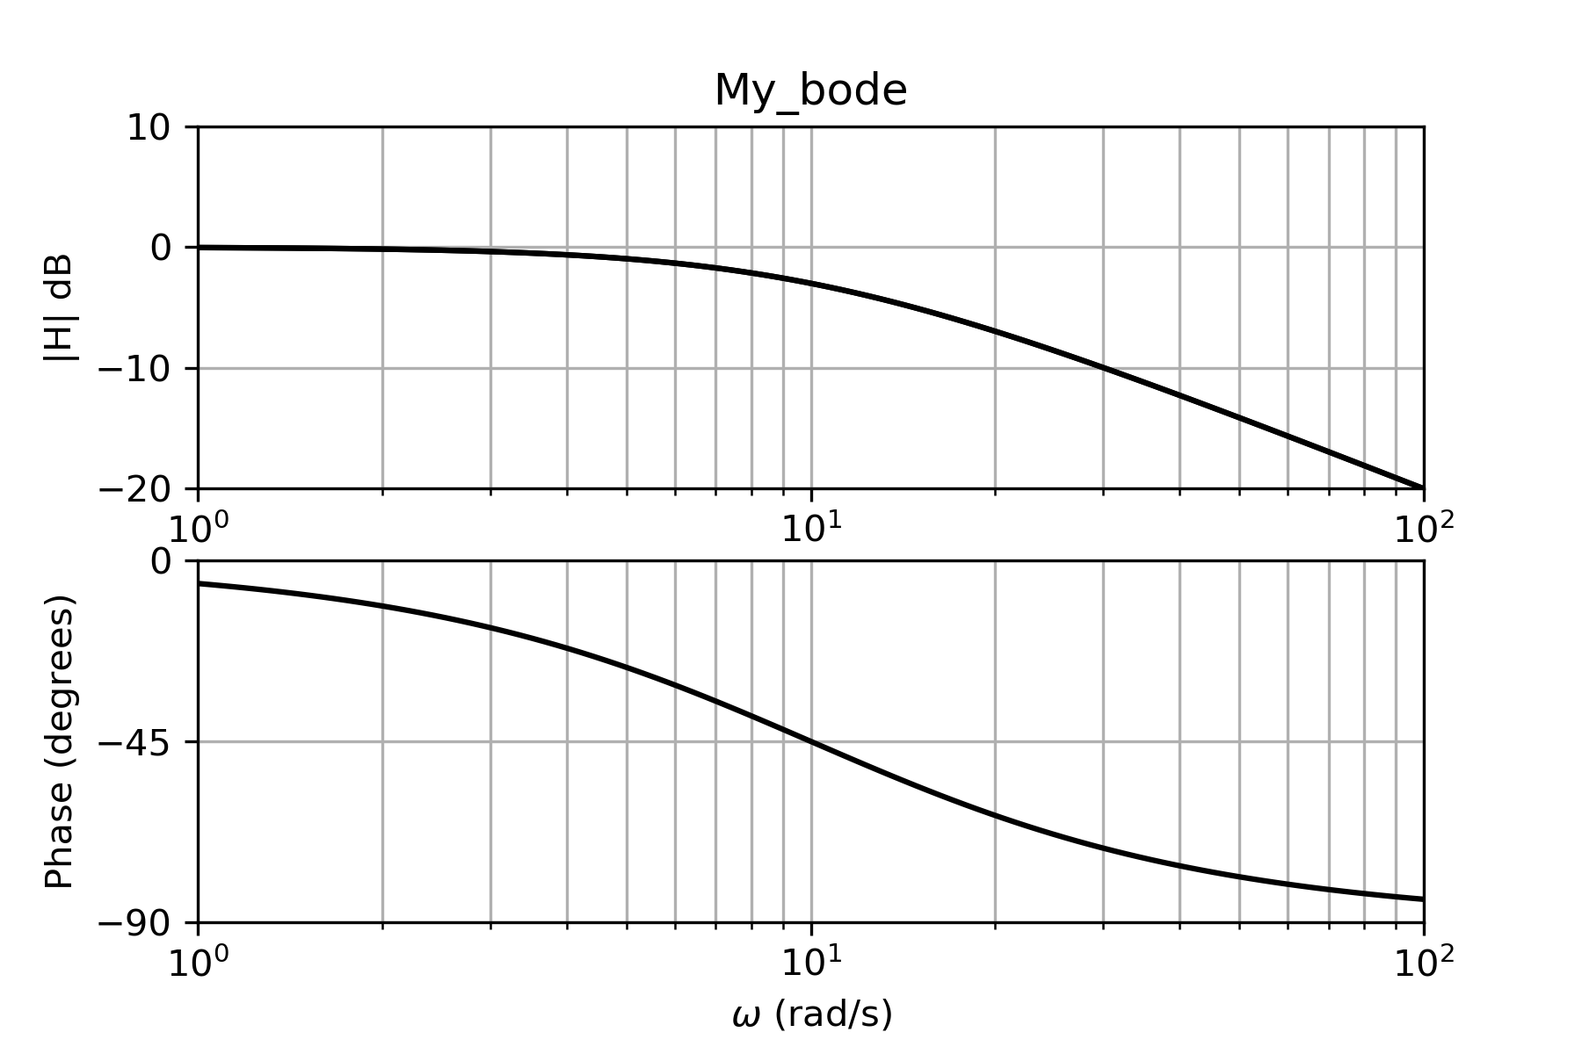
Figure 9.1.3. Bode plot of Eq. (9.1.12)

Solution
From Table 9.1.1, the corresponding time-domain function is
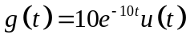.
The sampled version of this function is
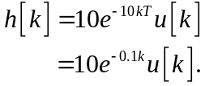
The corresponding Z transform is
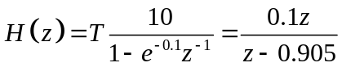.
When dealing with Laplace domain transfer functions, we usually preferred that the dc, or s = 0 value, correspond to a magnitude of 1, or 0 db, i.e. 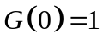. Corresponding to s=0¸
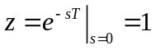. Therefore, we would like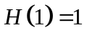.

At z = 1
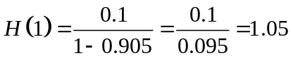.
so we use
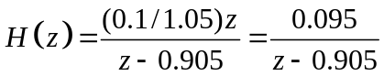 (9.1.13)

Once again, we will plot the magnitude and phase separately. Remember that because we have sampled at time T , we do not plot magnitude and phase as functions of frequency , but as functions of angle, 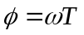. The Bode plot of Eq. (9.1.13) is given in Fig. 9.1.3.
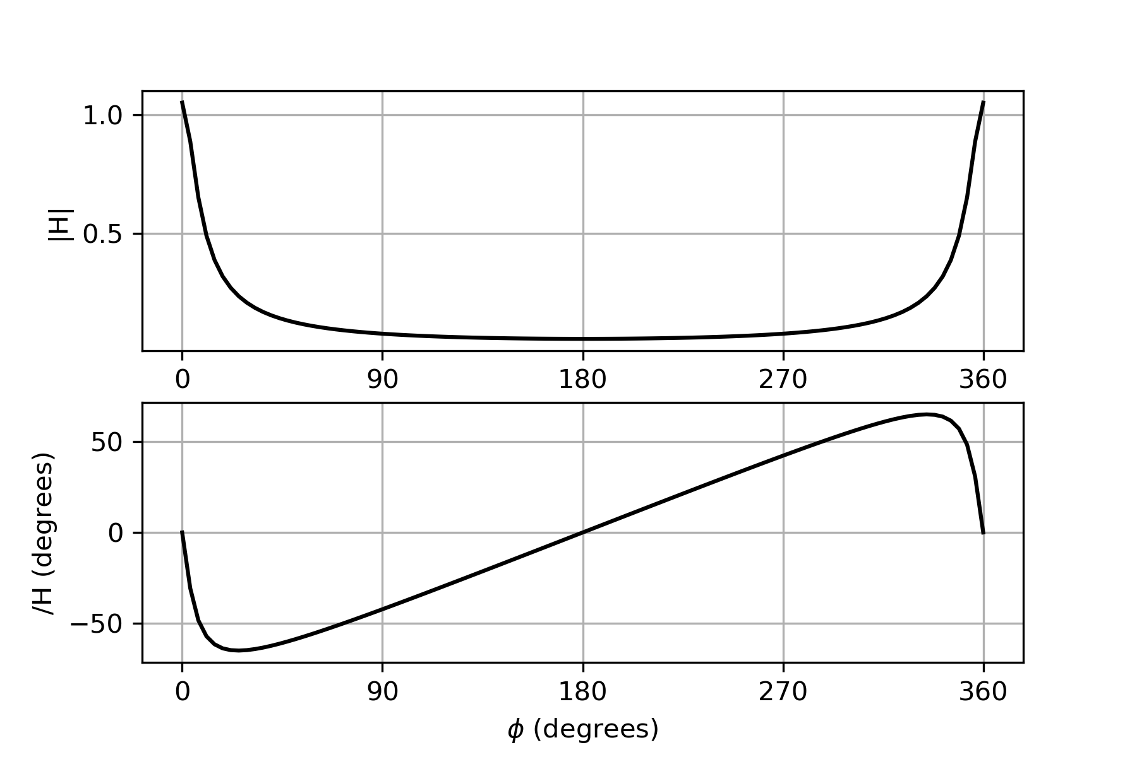
Figure 9.1.4. Bode plot of Eq. (9.1.13)

The continuous frequency at 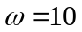 corresponds to 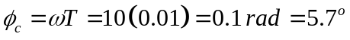. If we change to a logarithmic plot of the angle and zero in on the angle of interest, we get the Bode plot of Fig. 9.1.5 showing that at 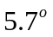 the attenuation is -3db and the phase shift is 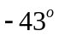, similar to the corner frequency of Eq. (9.1.12) at 10 rad/s in Fig. 9.1.3.
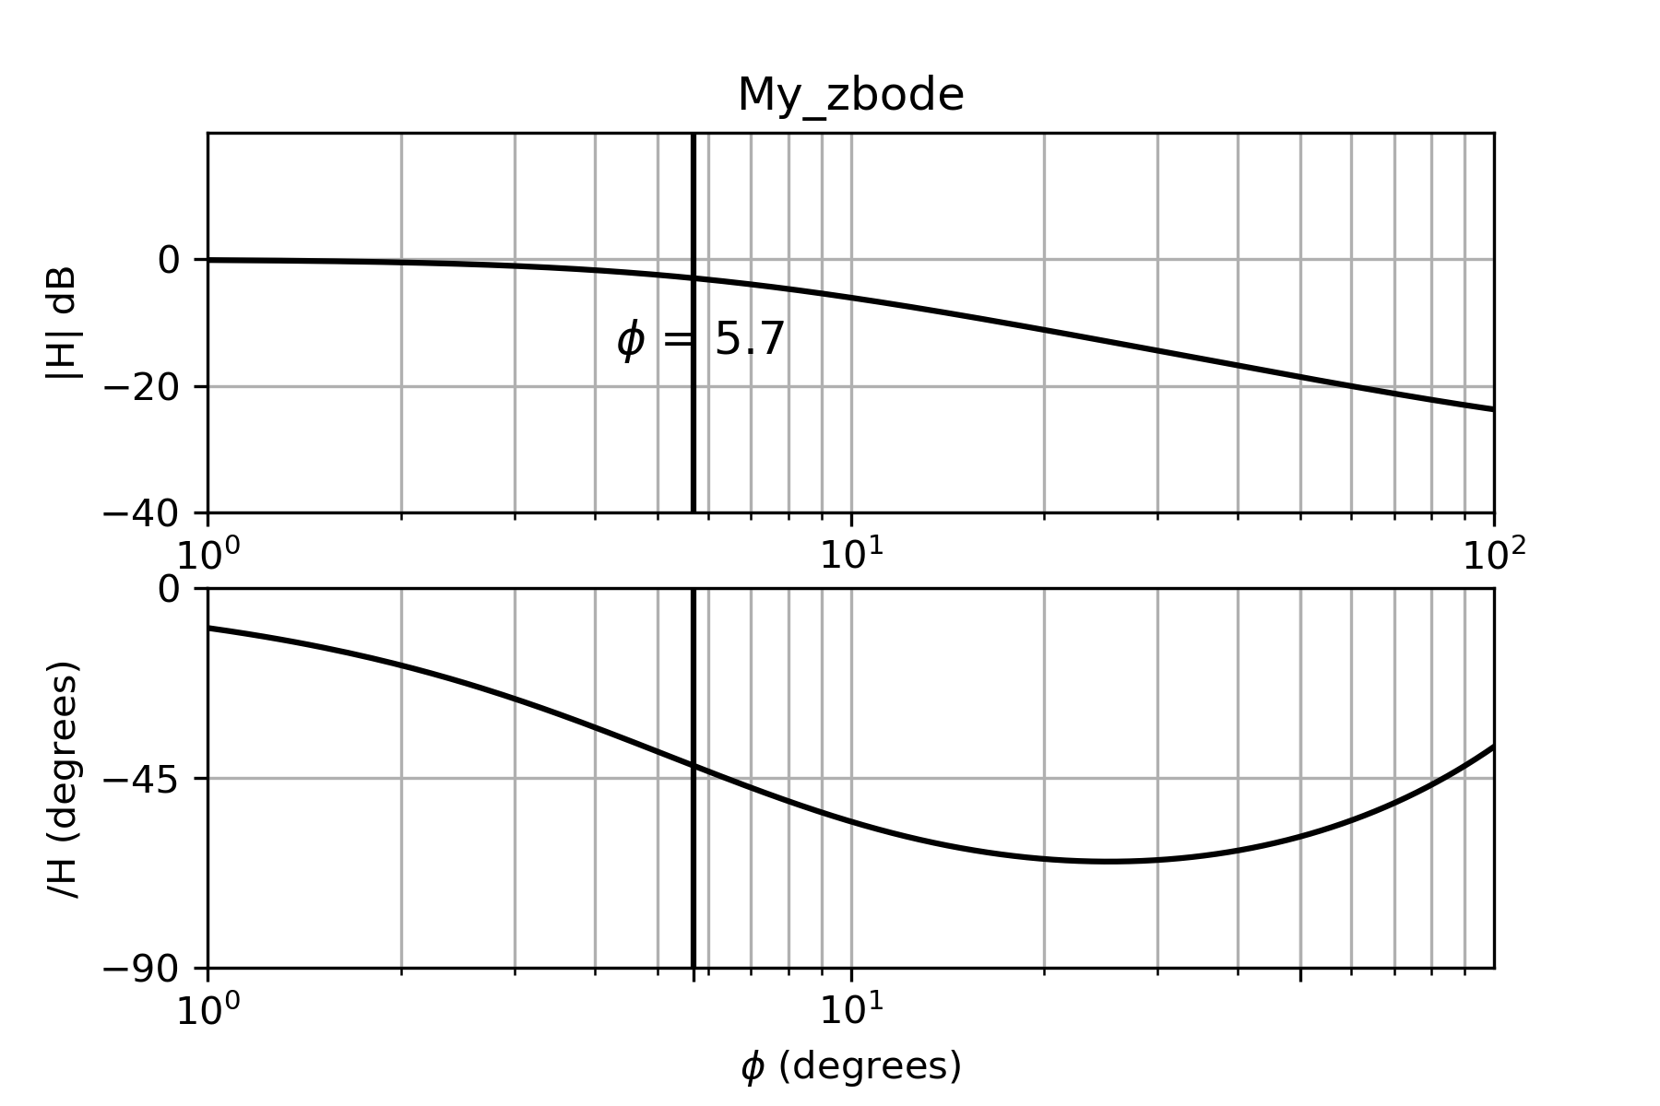
Figure 9.1.5. Bode plot of Eq. (9.1.13) showing the behavior near the corner frequency. Note that the angle corresponding to 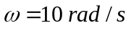 in Fig. 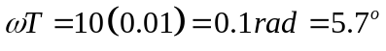.
-------------------------------------------------------------------------------------------------------

Example 9.1.2. Find the Z-domain transfer function for the following continuous function assuming the sampling rate is T = 0.01 sec.
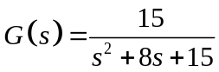. (9.1.14)
The Bode plot of Eq. (9.1.14) appears in Fig. 9.1.6.
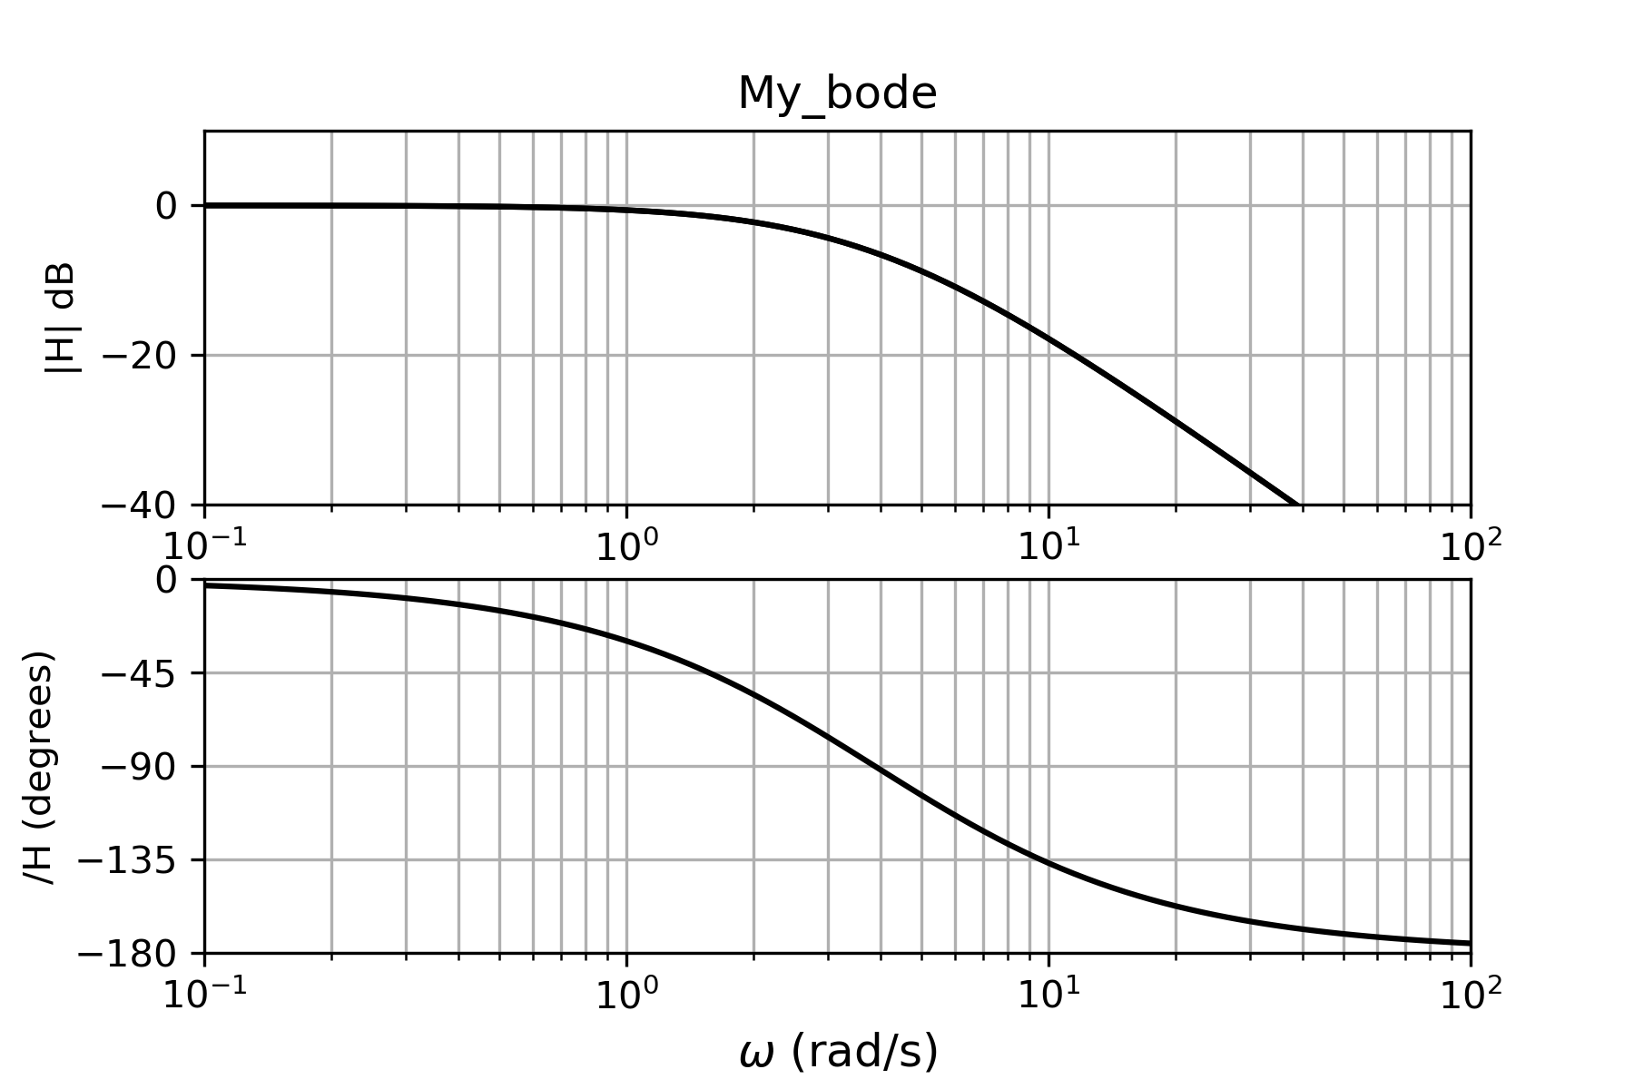
Figure 9.1.6. Bode plot of Eq. (9.1.14)
Solution

Partial fraction expansion gives us the two real poles
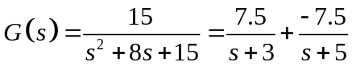
The corresponding terms in the Z domain are
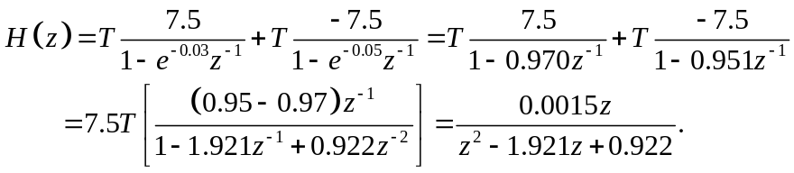
As mentioned earlier, when dealing with Laplace domain transfer functions, we usually preferred that the dc, or s = 0 value, correspond to a magnitude of 1, or 0 db, i.e. . Corresponding to s=0¸. Therefore, we would like.
At z = 1,
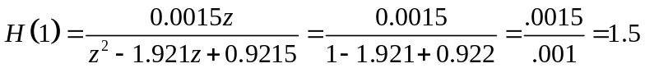.
We will add factor 2/3 to the above H(z) to get,
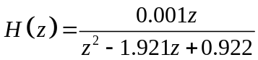. (9.1.15)
The Bode plot appears in Fig. (9.1.7). The point in Fig. (9.1.6) corresponds to the angle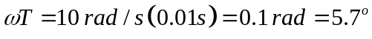. 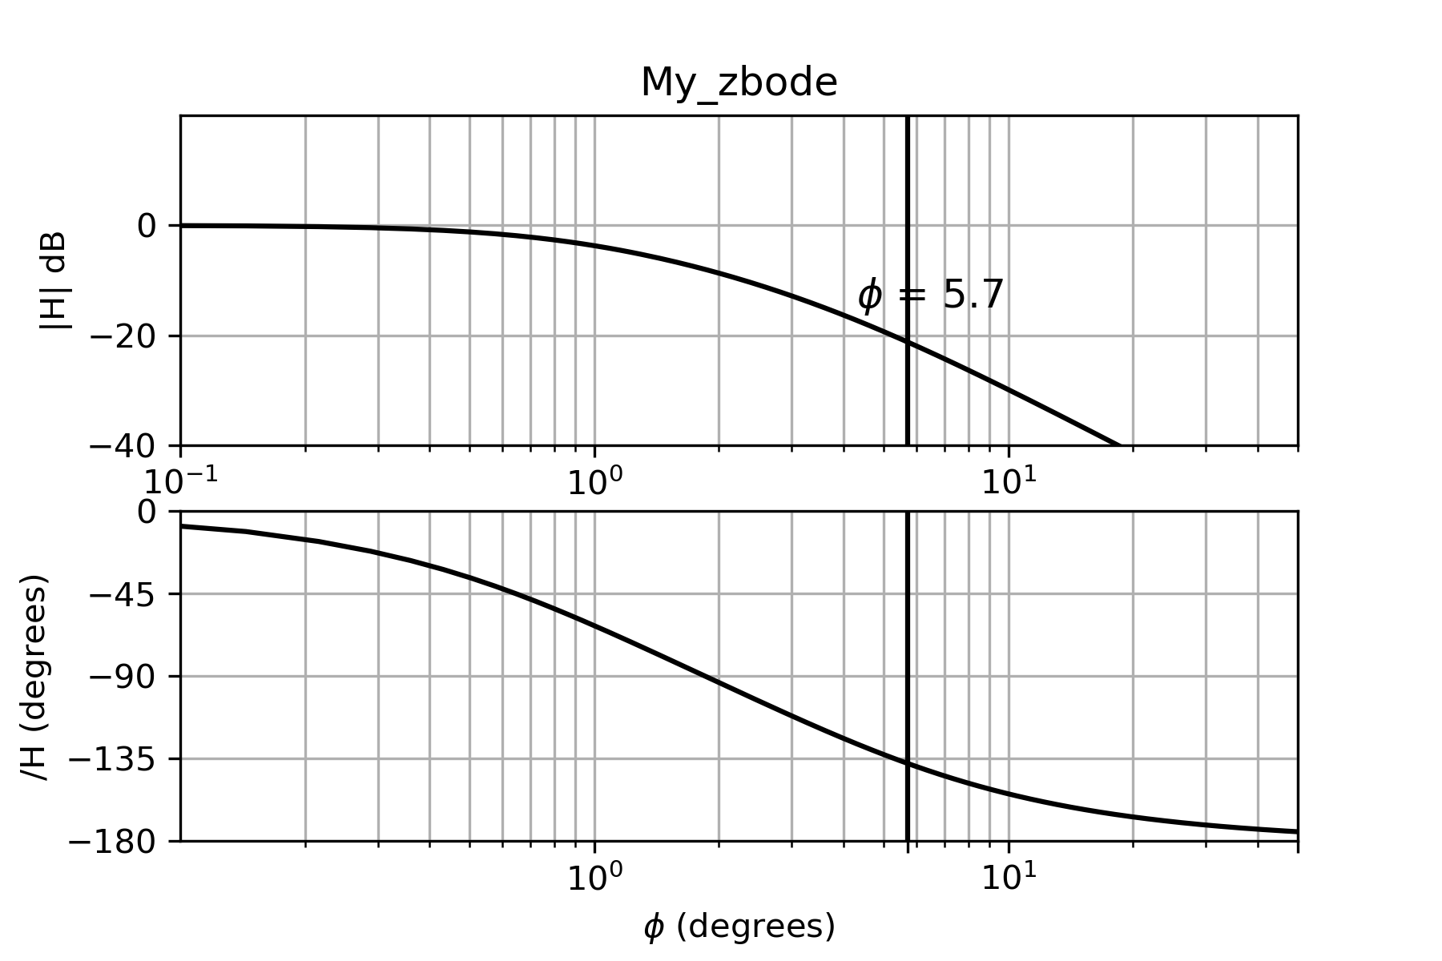

Figure 9.1.7. Bode plot of Eq. (9.1.15). The point corresponds to the angle.
---------------------------------------------------------------------------------------------------------

9.1.4 Simulating the response of a digital filter

Look back at the transfer function in Eq. (9.1.13).
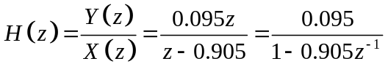
We can write this as
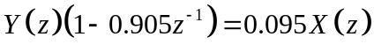,
or
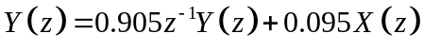.
It is a simple matter to go from theZz domain to the sampled time domain
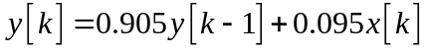. (9.1.16)
Notice how easily this can be implemented into computer code:

y(1) = 0
for k=2:NN

y(k) = 0.905*y(k-1) + 0.095*x(k)
end

Suppose we begin with an input signal of
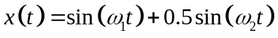 (9.1.17)
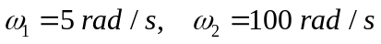, and it is sampled at 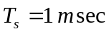, as shown in the top of Fig. 9.1.8. We will further suppose that the signal at 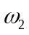 is distortion that we want to filter out. To low pass filter the frequency, we might choose a corner frequency of 10 rad/s. This removes most of, but not all, of , as shown in the bottom part of Fig. 9.1.8.
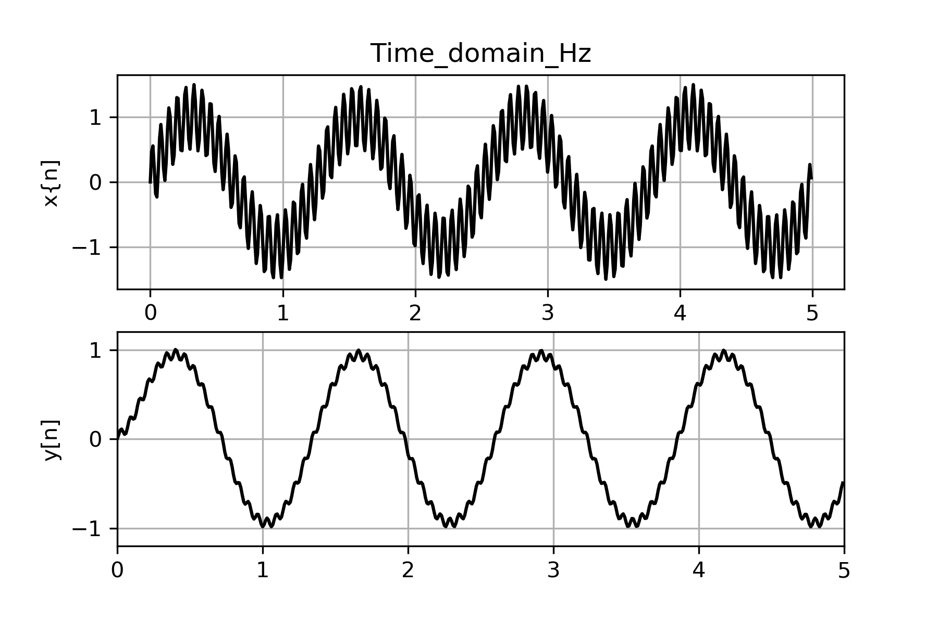
Figure 9.1.8. (top) The input signal, Eq. (9.1.17); (bottom) The output y[k] after the input is low pass filtered by a single pole filter with a corner frequency of 10 rad/s.

What hardware might be able to implement the above LPF? An example is shown in Fig. 9.1.12.
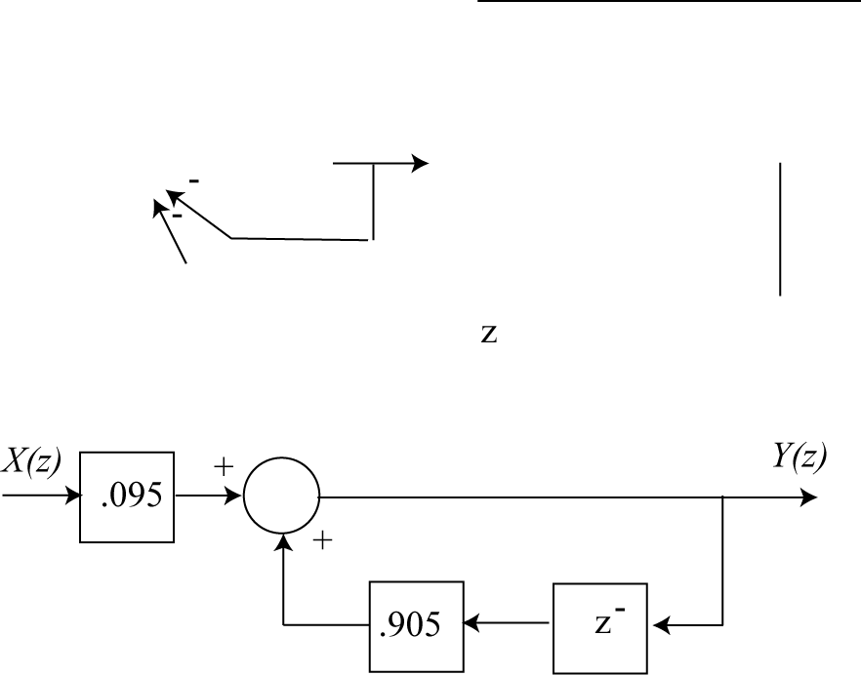
Figure 9.1.9. Diagram of a digital filter to implement the filter of Eq. (9.1.3).

9. 1.4 Converting G(s) to H(z) for complex conjugate pairs.

In order to convert a complex conjugate pair in the S domain to the corresponding terms in the Z domain, we will use Table 9.1.

Table 9.1 Some Common Laplace and Z Transform Pairs

Laplace Transforms

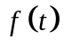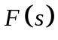

1. 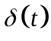 1
2. 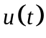

3. 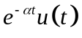 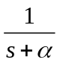
4. 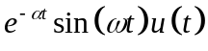 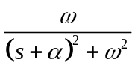
5. 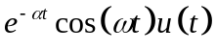 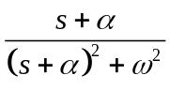

Z Transforms

1. 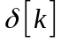
2. 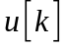 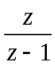
3. 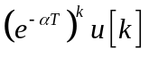 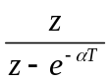
4. 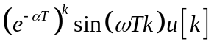 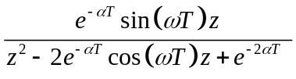
5. 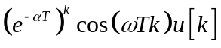 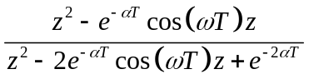
-------------------------------------------------------------------------------------------------------------
Example 9.1.3. A second order low-pass Butterworth filter with a cutoff frequency of 1 rad/s is given by
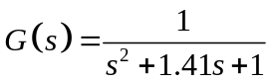. (9.1.18)
Convert this to a Z-domain transfer function assuming a sampling time of T = 0.1 seconds.
Solution

We can complete the square and write
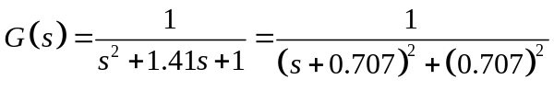,
which can be written as
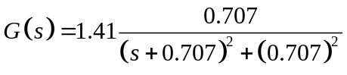.
If we look at Table 9.1, we see that the corresponding time domain function is
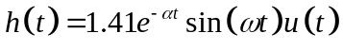
where 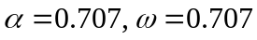. But we already knew that because we knew the poles of the Butterworth filter were at 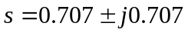.
If we now choose to sample this at T = 0.1 sec, we obtain the discrete time-domain function
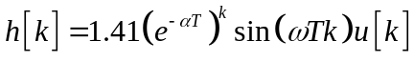,
which has the corresponding a Z-transform of
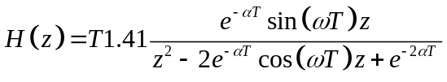
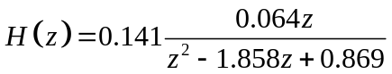.
Note that
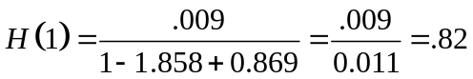.
So we will use
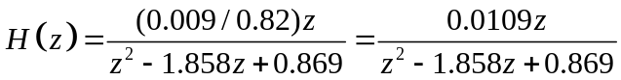. (9.1.19)
The cutoff angle is
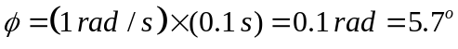

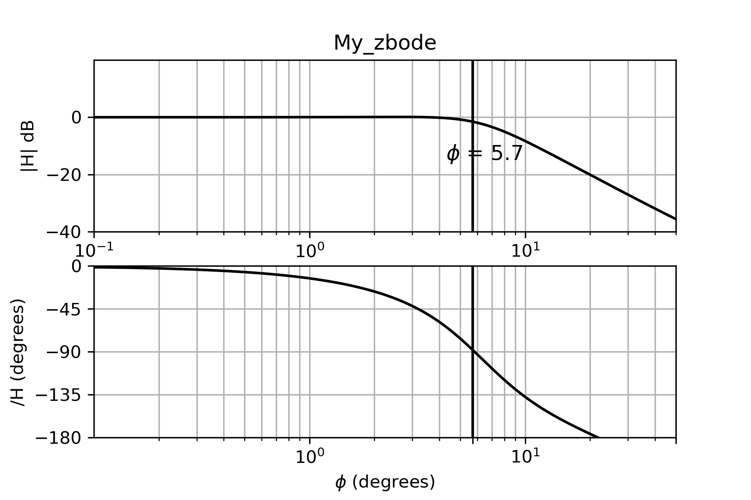
Figure 9.1.10. Bode plot of Eq. (9.1.19). Note that at the magnitude is close to -3dB and the phase is -90 degrees, as it should be.

The following code calculates the response of Eq. (9.1.19) to the input of Eq. (9.1.17)

b1 = -1.858
b2 = 0.869
a1 = .009/.82

for n in range(1,NN):
x[n] = sin(omega1*dt*n) + 0.5*sin(omega2*dt*n)
y[n] = -b1*y[n-1] - b2*y[n-2] + a1*x[n-1]

The results in Fig. 9.1.11 show that the two pole low pass filter was more effective in removing the unwanted frequency at 100 rad/s.
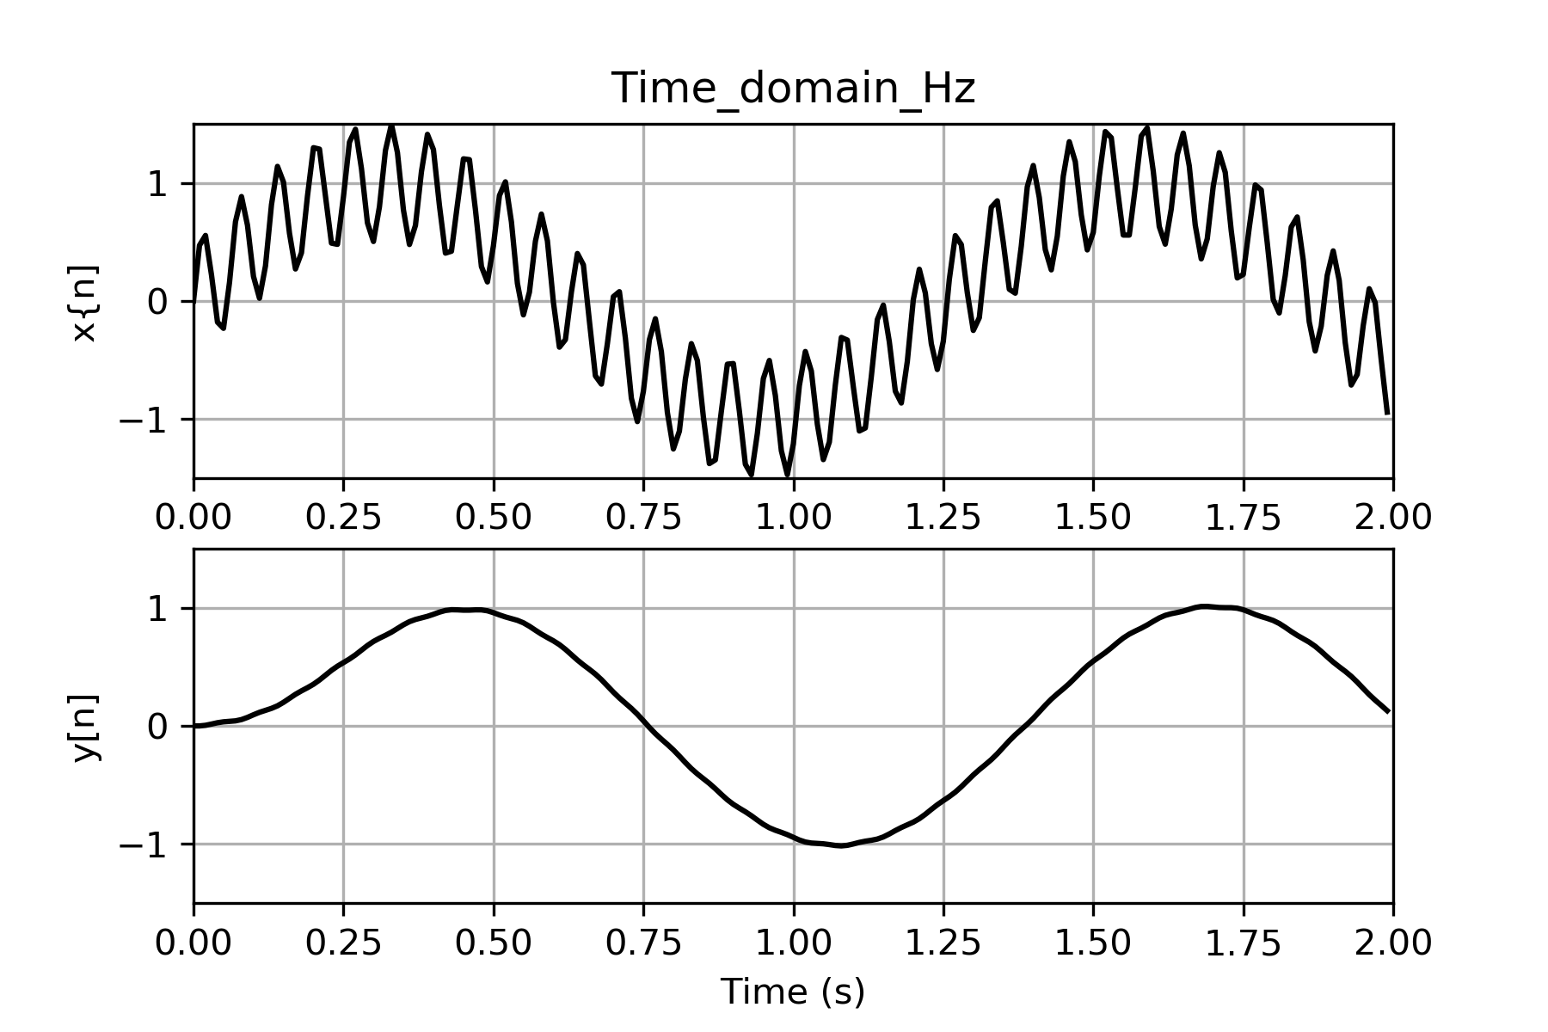
Figure 9.1.11. (top) The input signal, Eq. (9.1.17); (bottom) The output y[k] after the input is low pass filtered by a double pole filter with a corner frequency of 10 rad/s.
--------------------------------------------------------------------------------------------------------------

The following section will take a more systematic approach.

A .Completing the Square

Suppose we have a term with a complex conjugate pair. It can be rewritten as a linear combination of entries 4 and 5 of the Laplace part of Table 9.1:
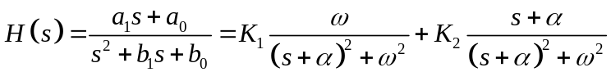 (9.1.20)
We see that each of the Laplace domain denominators have the form 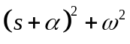, so we have to put the denominator in this form:
This will be true if
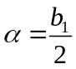 , (9.1.21 a)
and
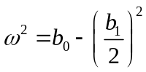, (9.1.21 b)
Similarly, the numerator of G(s) must be some linear combination of the two numerators for the Laplace terms
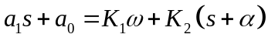.
Therefore,
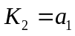, (9.1.22 a)
and
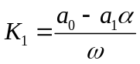. (9.1.22 b)
The corresponding H(z) will be a linear combination of entries 4 and 5 in the Z domain part of the table,
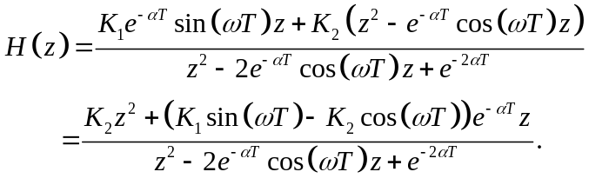
--------------------------------------------------------------------------------------------------------

Example 9.1.4. Find the corresponding Z domain transfer function for G(s) for a sampling time T:
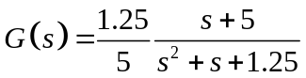. (9.1.23)
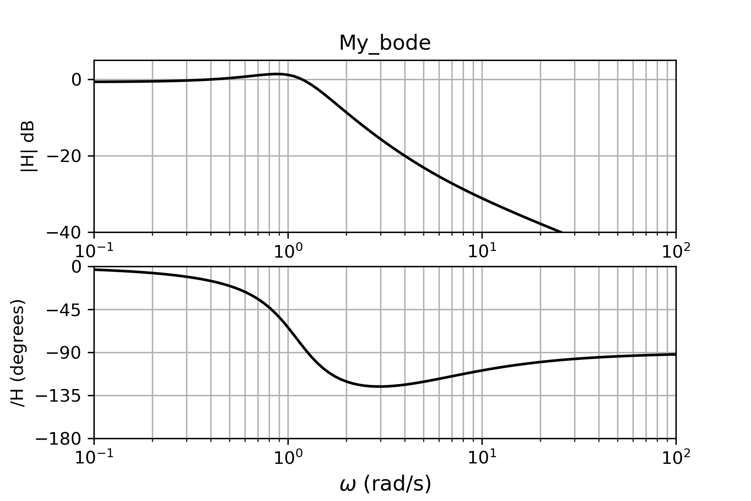
Fig. 9.1.12. Bode plot of Eq. (9.1.23).
Solution
We will ignore the term (1.25/5) in the following development and then add it at the end. From Eq. (9.1.20) we have the following constants:
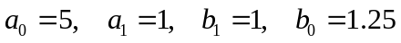.
From Eq. (9.1.21),
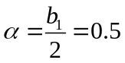 and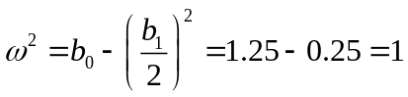 .
From Eq. (9.1.22),
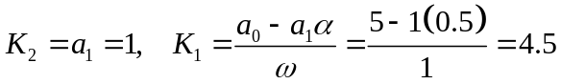,
which gives,
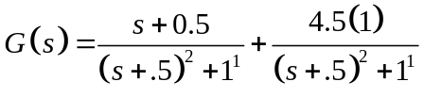.
The corresponding Z domain terms results in,
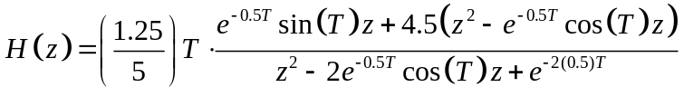. (9.1.24)
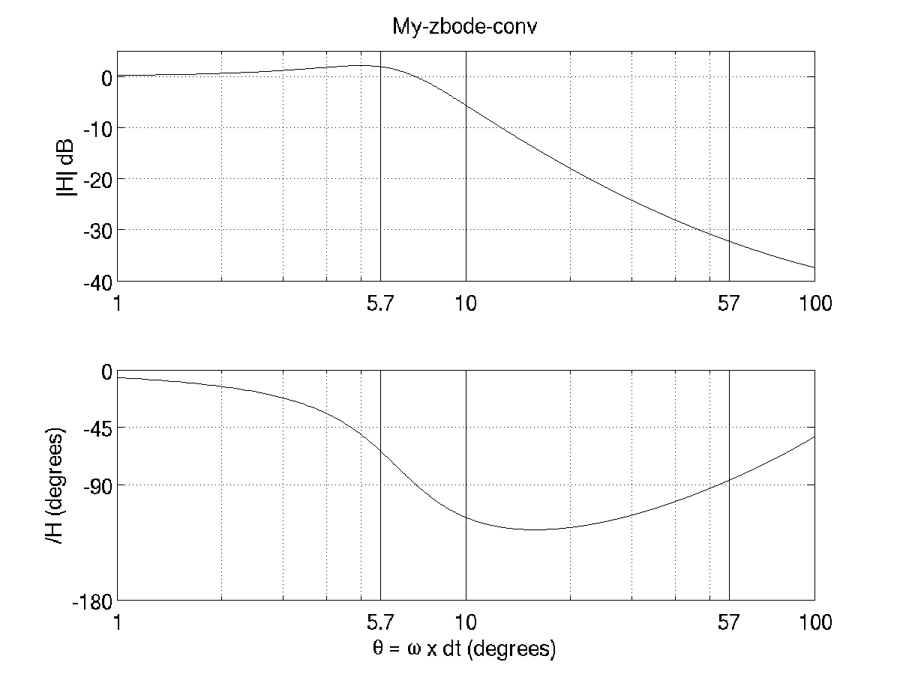
Figure 9.1.13. Bode plot of Eq. (91.1.24).
--------------------------------------------------------------------------------------------------------

B. Conjugate complex pair analysis

A simple pole in the Laplace domain is described by,
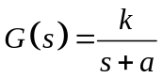. (9.1.25)
As long as we know k and a, the corresponding transfer function in the Z domain is,
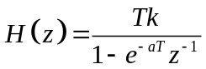.
A complex conjugate pair in the Laplace domain can be written,
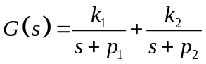, (9.1.26)
where 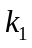 and 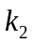 are complex conjugate pairs, as well as 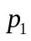 and 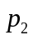. The corresponding transfer function in the Z domain is,
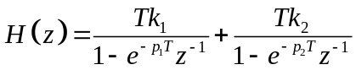 .
Both p and k can be written with their corresponding real and imaginary parts,
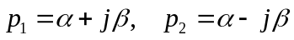. (9.1.27 a)
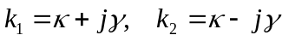 (9.1.27 b)
Therefore, H(z) can be written.
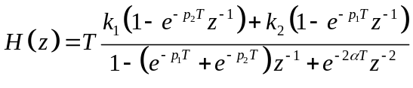.
The middle term of the denominator is,
.
The numerator can be written.
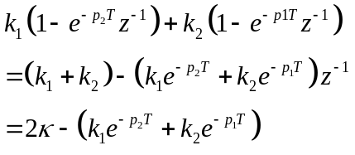
The 2nd term can be simplified to,
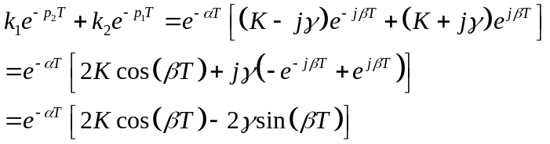
Therefore, we can write

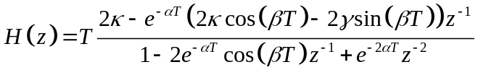 .
It will be easier if we can get it in the form,
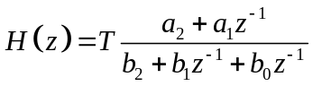. (9.1.28)
Now can get the four coefficients from the four parameters of Eq. (9.1.27)
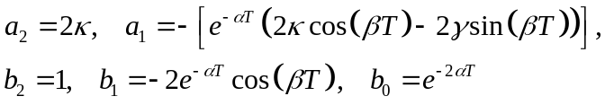 (9.1.29)
Note that these parameters comes directly from the 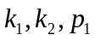 and values of Eq. (9.1.26).
-----------------------------------------------------------------------------------------------------
Example 9.1.5. Redo Example 9.1.3 using the new method.
A second order low-pass Butterworth filter with a cutoff frequency of 1 rad/s is given by
. (9.1.30)

We had found that
Solution
Converting to the parameters defined above,

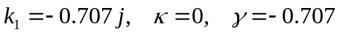

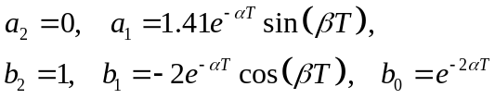

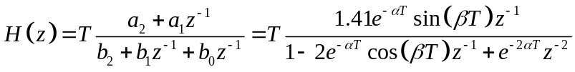
-------------------------------------------------------------------------------------------------------------
Example 9.1.6. Redo Example 9.1.4. Find the corresponding Z domain transfer function for the following for a sampling time T = 0.1 sec.:
. (9.1.31)
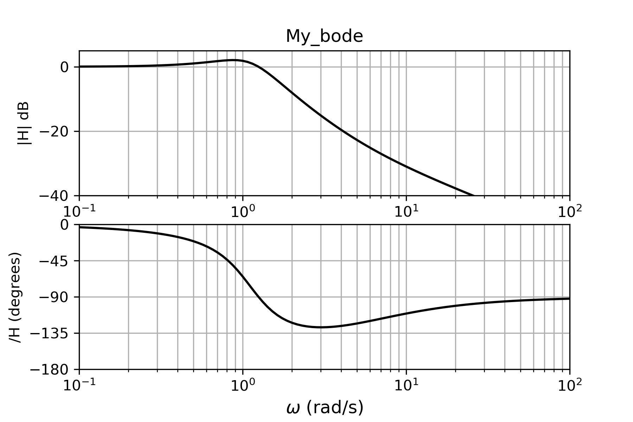
Figure 9.1.14. Bode plot of .
Solution

In my_zbode_cmplx.py:

dt = 0.1

p1,p2 = np.roots([1,1,1.25]) # Eq. (9.1.23)
k1 = (1.25/5)*(p2+5)/(p2-p1)

alpha = np.real(p1)
beta = np.imag(p1)
kappa = np.real(k1)
gamma = np.imag(k1)

a2 = 2*kappa
a1 = -exp(alpha*dt)*(2*kappa*cos(beta*dt)-2*gamma*(sin(beta*dt)))
b2 = 1
b1 = -2*exp(alpha*dt)*cos(beta*dt)
b0 = exp(2*alpha*dt)

for n in range(NN):
z = exp(1j*phi[n])
H[n] = dt*(a2*(z**2) + a1*z)/(b2*(z**2) + b1*z + b0)
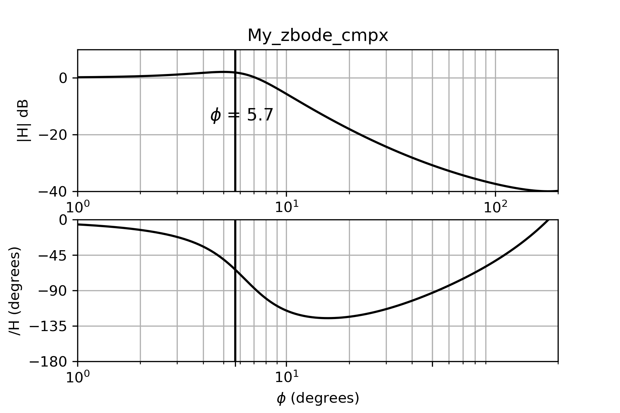
Figure 9.1.15. Bode plot of the corresponding to Eq. (9.1.31).

-------------------------------------------------------------------------------------------------------------
Example 9.1.8. Find the corresponding Z domain transfer function for the following G(s) assuming a sampling time = 0.1T:
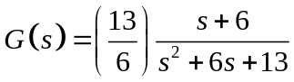 (9.1.32)
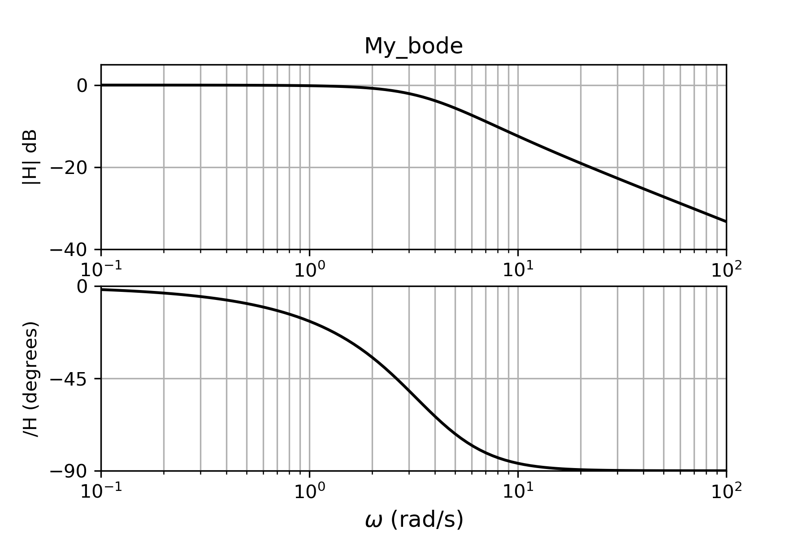
Figure 9.1.16. Bode plot of .
Solution

Using T = 0.1 sec with the same code as in the previous example,
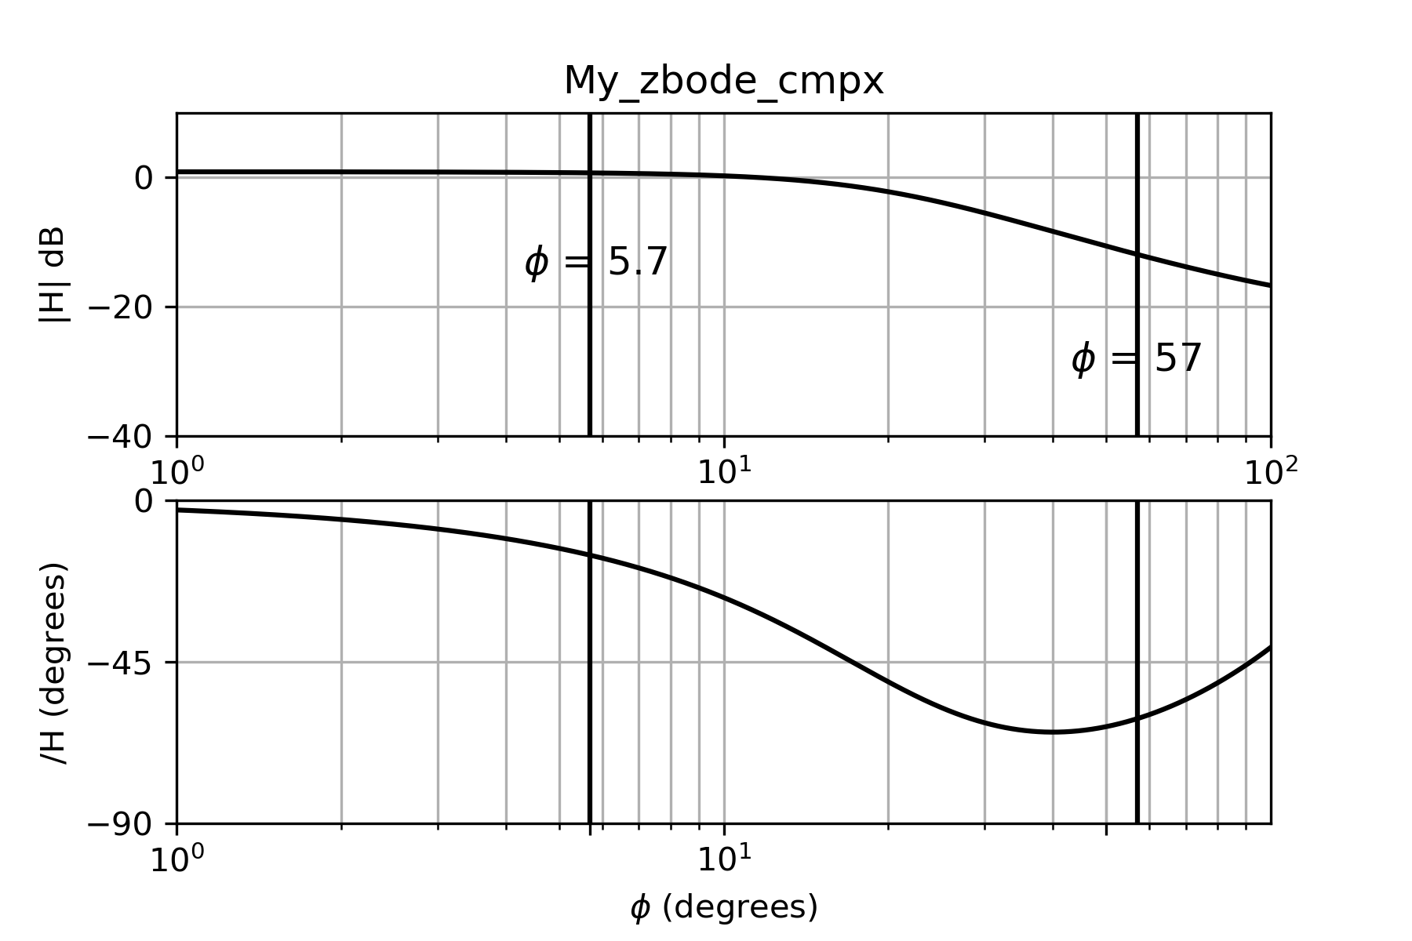
Figure 9.1.17. Bode plot of the H(z) corresponding to eq. (9.1.32)
------------------------------------------------------------------------------------------------------------
Example 9.1.9. Find the Z domain Bode plot corresponding to the transfer function, 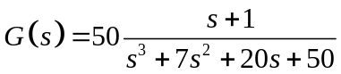 (9.1.33)
Assuming a sampling rate or T = .02 sec. 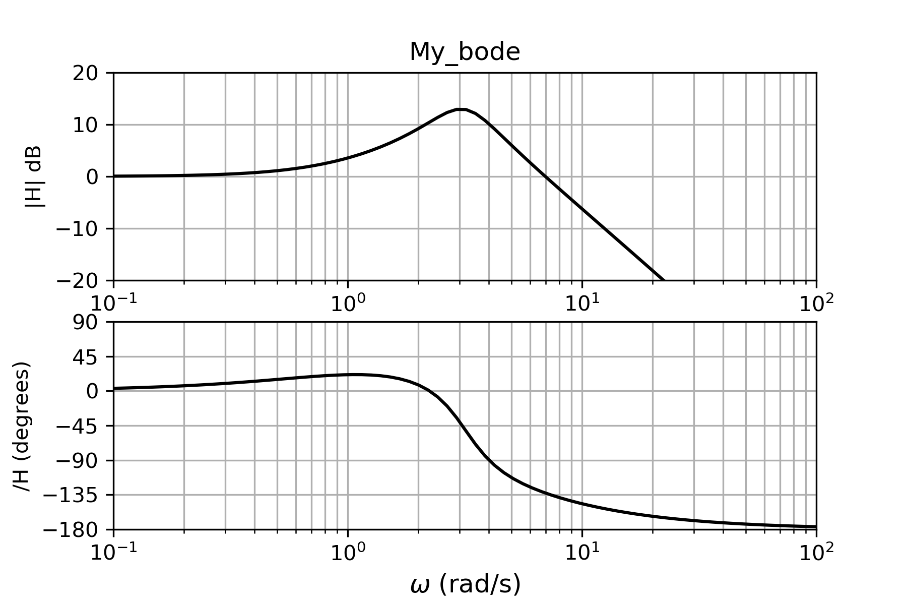
Figure 9.1.18. Bode plot of .

Solution

We start with the function,
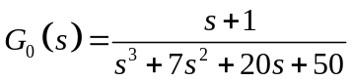.
The Bode plot of G(s) is shown in Fig. 9.1.14a. Using the MATLAB command roots([1 7 20 50 ]),we can find the roots.

The Matlab command residue can be used to find a partial fraction expansion:
a = [1 1];
b = [1 7 20 50];
[r,p,k] = residue(b,a)

There is a similar Python command:
r,p,k = scipy.signal.residue(a,b)

This returns the following values:

r = -.16 .08 – 0.06i 0.08 + 0.06i

p = -5 -1 + 3.i -1-3.i

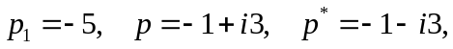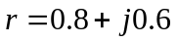
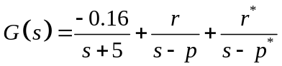 (9.1.34)
From here we design one Z domain transfer function, 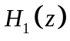, corresponding to the first term in Eq. (9.1.34), which is a single pole. Then we design a second Z domain transfer function, 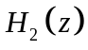corresponding to the last two terms of Eq. (9.1.34), which form a complex conjugate pair. The total transfer function corresponding to Eq. (9.1.32) will be the sum of and .
Recall from Example 9.1.1 How we found the Z-domain transfer function from a S domain function. 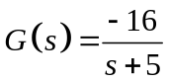,
The corresponding time-domain function was
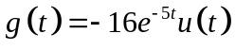,
and the sampled version of this function, assuming a sampling time of T = 0.01, is
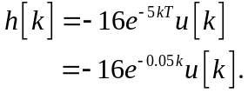
The corresponding Z transform is
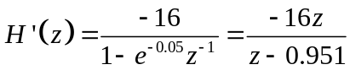,
which we change to
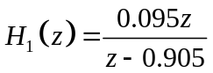,

The complex conjugate pair
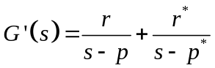
Is transposed into by the method described in the previous section.
so the partial fraction expansion is,
The Bode plot of H(z) is shown in Fig. 9.1.15b. Notice the peak in G(s) occurs at 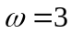. This corresponds to 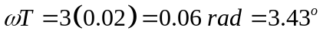
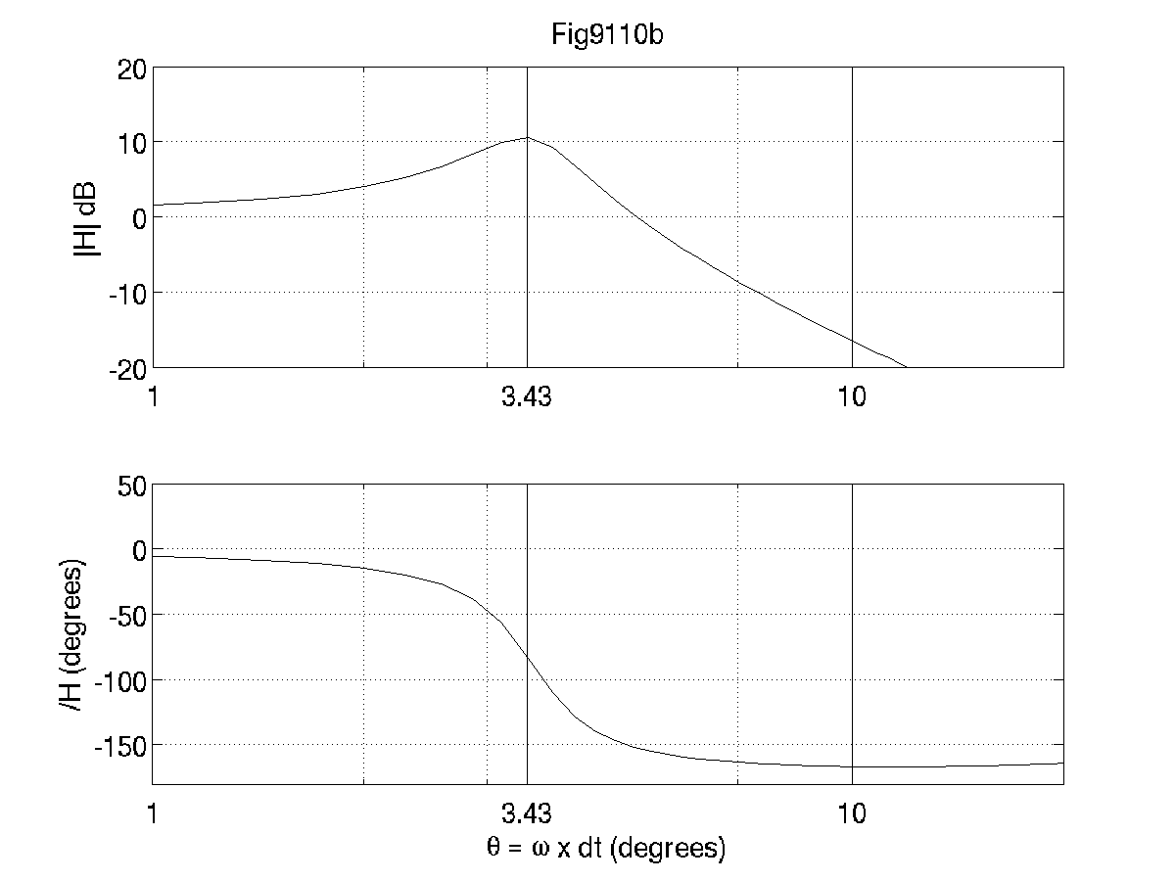
Figure 9.1.19. Bode plot of H(z) corresponding to the G(s) of Eq. (9.1.34)

-----------------------------------------------------------------------------------------------------------

9.2 Scaling

Recall from Example 9.1.1 that we found the z-domain transfer function for , (9.2.1)
assuming the sampling time is T = 0.01 sec. The corresponding time-domain function was
,
and the sampled version of this function was
The corresponding Z transform was
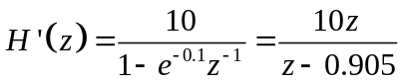,
which we changed to
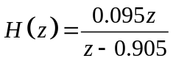,
to get unity gain at the low angles.

What would be different if the question were to take the function
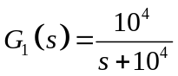 (9.2.2)
to the z-domain using the sampling time T = 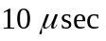? The time-domain function is
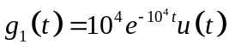,
and the sampled time domain function is
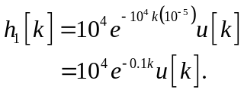
The Z transform is
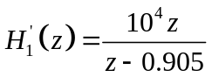,
which we will scale to
.
------------------------------------------------------------------------------------------------------------
Theorem 9.2.1. Suppose a Laplace domain function G(s) is sampled at a time T leading to a Z domain function . If the original Laplace domain function is scaled by a constant a, i.e, 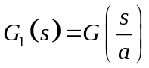, and the time constant is multiplied by the same a, i.e., 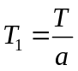, then the resulting Z-domain function will be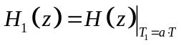.
Summary:
(9.2.3 a)
(9.2.3 b)
(9.2.3 c)
Proof

G(s) can always be written as a partial fraction expansion of single order poles:
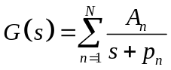
This is true even if pair of the poles are complex conjugates of each other. The corresponding Z domain function is
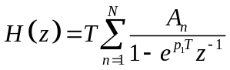.
Therefore,
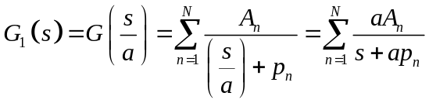,
and the corresponding Z domain function using the sampling time
.
--------------------------------------------------------------------------------------------------------------
Example 9.2.1. Given the following Laplace domain transfer function, find the corresponding Z domain transfer function if the system is sampled at T = 0.1 msec.
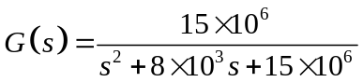. (9.2.4)
Solution

Equation (9.1.10) is the same as Eq. (9.1.4), except that it has been scaled up to kiloradians per second. Similarly, the sampling rate has been dropped down to milliseconds. Therefore, when this is in the Z domain, the math will be exactly the same as example (9.1.2)
--------------------------------------------------------------------------------------------------------------
Example 9.2.2
A second order Butterworth filter with a cut-off frequency of 10 krad/s is given by
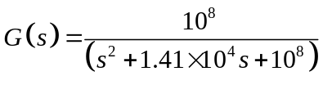. (9.2.5)
What is the corresponding Z domain transfer function if the system is sampled a T = 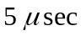?
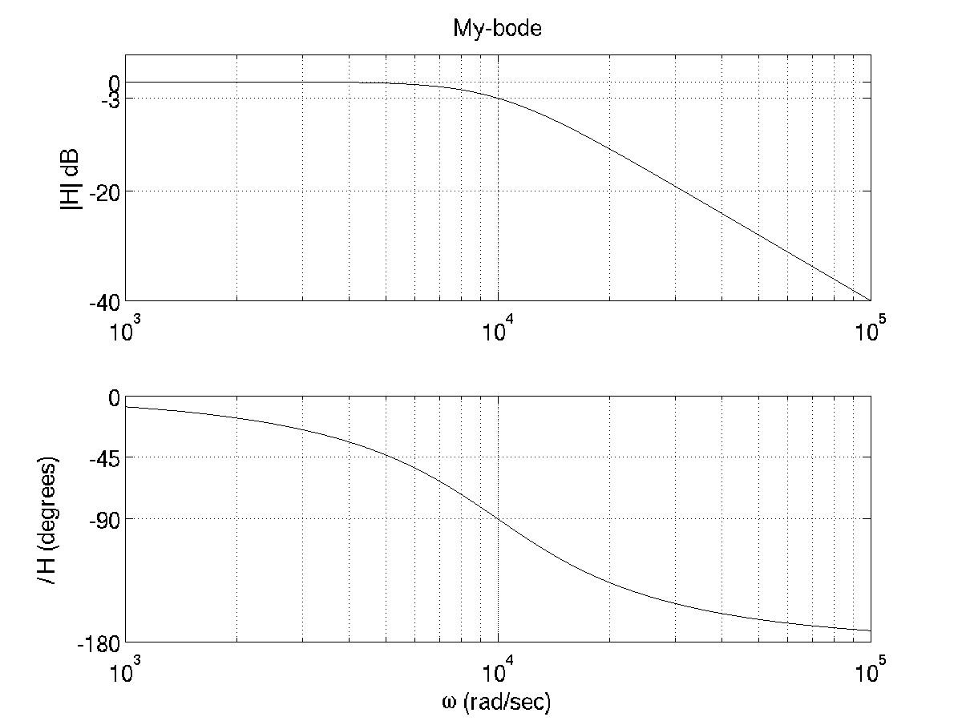
Figure 9.2.1. Bode plot of Eq. (9.2.4)
Solution

First of all, we will have an equivalent Z domain system if we scale G(s) using Eq. (9.2.3a) and 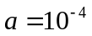,
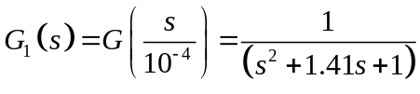, (9.2.6)
and then change the time step using Eq. (9.2.3 b),
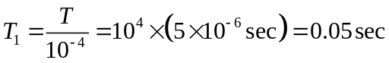.
We begin by completing the square in Eq. (9.2.6)
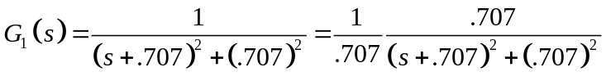.
The corresponding Z domain function is,
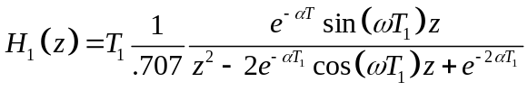 (9.2.7)
The following MATLAB commands implement this transfer function:

alpha = .707;
omega = .707

for n=1:NN
z = exp(j*phi(n));
H(n) = (del_t/.707)*exp(-alpha*del_t)*sin(omega*del_t)*z ...
/(z^2- 2*exp(-alpha*del_t)*cos(omega*del_t)*z + exp(-2*alpha*del_t));
end
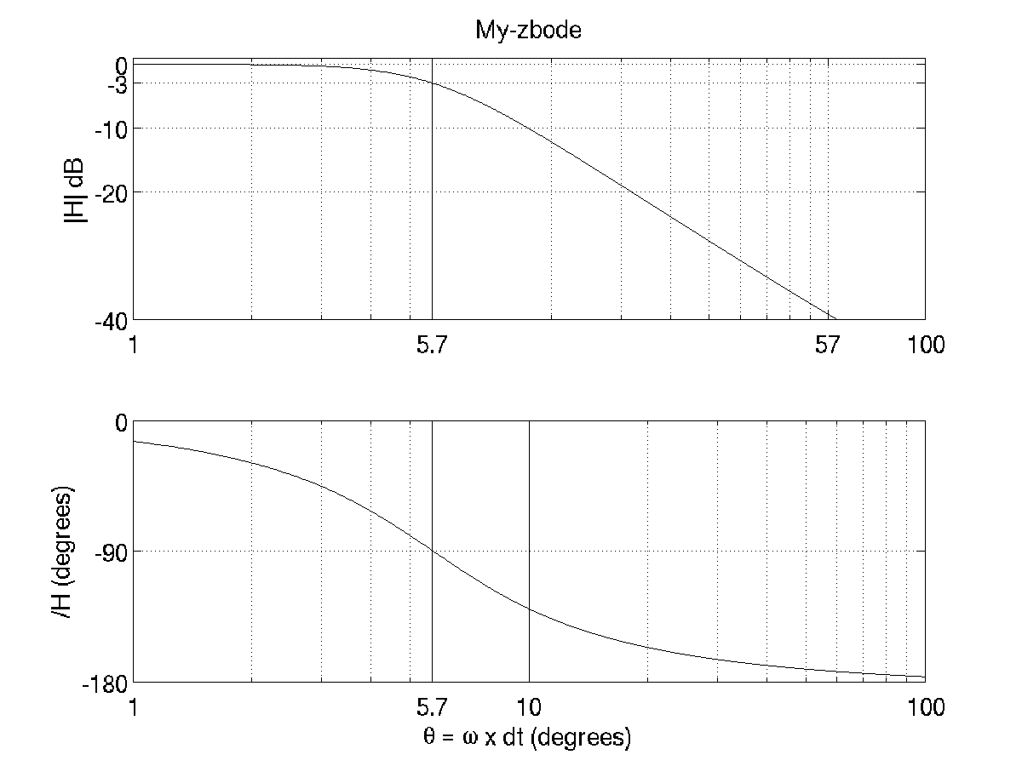
Figure 9.2.2. Bode plot of Eq. (9.2.6).

Exercises

9.1.1. Write a computer code to implement the transfer function of Eq. (9.1.5).
Simulate the response to
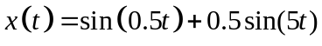

9.1.2. Design a hardware implementation of H(z) in Problem 9.1.1.

9.1.3. Convert the following transfer function to the Z domain using T = 0.01 sec.
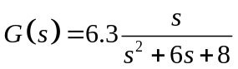.

9.1.4. Find the z domain transfer function for a 2nd order, monotonic band pass filter with a pass band between 500 and 550 rad/s. The sampling time is 0.1 msec.

9.1.5 A third order Butterworth filter with a cut-off frequency of 10 krad/sec is given by
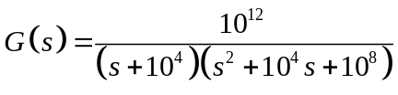.
What is the corresponding Z domain transfer function is the system is sampled a T = ?

9.2.1 Write the Z domain transfer function of a 3rd order Butterworth filter with a 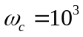 and a sampling rate of 0.1 ms.

9.2.2. Develop a Z domain transfer function to implement a 4th order bandpass Butterworth filter with a pass of of 2500 rad/s centered at 5000 rad/s. The sampling time is 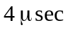.
Is a backward rectangular transform adequate, or do you need a bilateral? Provide a Z domain Bode plot. You don’t actually have to specify the Z domain transfer function, but specify the Laplace domain transform that you would use to obtain it. See Example 8.5.4.

9.2.3 A time-domain signal is given by
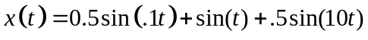
as shown below.
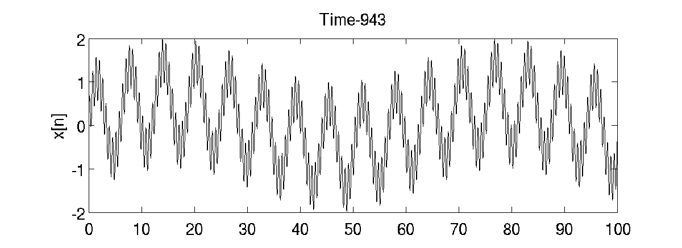
The frequencies of 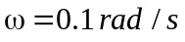 and 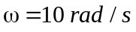 are noise. Develop a time-domain digital filter that will attenuate the noise frequencies by at least twenty-five percent and leave the frequency at 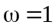 unattennuated. Use a sampling time of 0.1 sec.

% My_zbode.m

clear all

phi = (0:0.01:2*pi);
NN = length(phi);
H = zeros(1,NN);

% Find H(z)
for n=1:NN
z = exp(j*phi(n)); % determine z for this angle
H(n) = .095*z/(z - .905);
end

subplot(2,1,1)
plot((180/pi)*phi,abs(H),'k')
semilogx((180/pi)*phi,20*log10(abs(H)),'k')
%axis( [0 360 0 1 ])
axis( [ 1 100 -20 0 ])
set(gca,'XTick',[ 1 5.7 10 100 ])
grid on
set(gca,'fontsize',14)
title('My-zbode')
ylabel('|H| dB')
%xlabel('\theta = \omega x T_n ')

aaa = angle(H);
for n=1:NN
if aaa(n) > 180
aaa(n) = aaa(n) - 2*pi;
end
end

subplot(2,1,2)
plot((180/pi)*phi,(180/pi)*aaa,'k')
semilogx((180/pi)*phi,(180/pi)*aaa,'k')
%plot(phi,(180/pi)*aaa,'k')
%axis( [0 360 -90 90 ])
axis( [1 50 -90 0 ])
set(gca,'XTick',[ 1 5.7 10 100 ])
grid on
xlabel('\theta = \omega x dt (degrees)')
set(gca,'fontsize',14)
ylabel('/H (degrees)')

saveas(gcf,'plot.png')

