Algebra 1 – Unit 4 Mini Test (C)
For all of the following questions, use the system:
$$A: y=2x-7$$
$$B: x+2y=16$$
- Graph both equations on the same axes
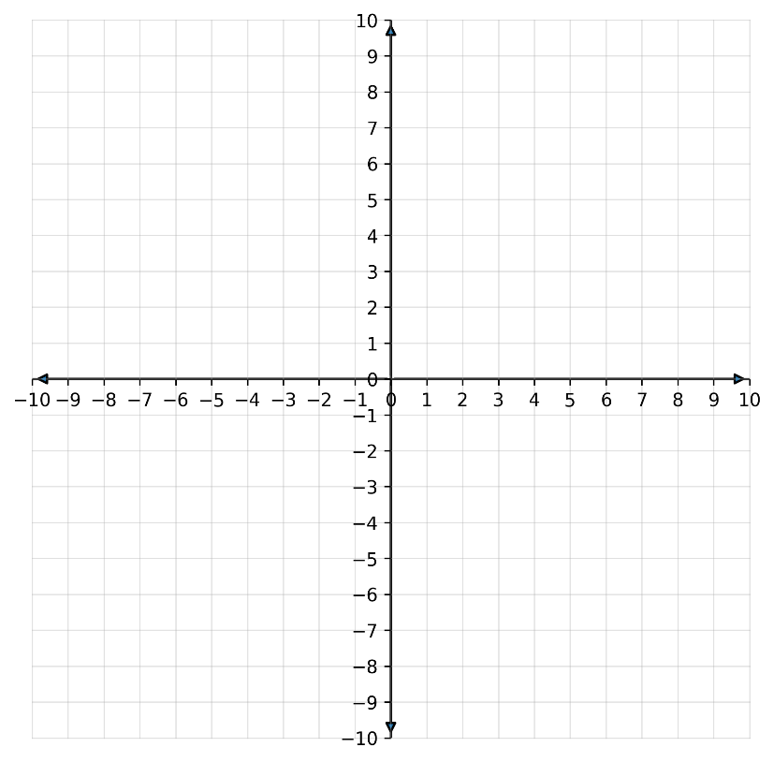

- Find the slope and y-intercept for both lines

Line A
 | slope: | ________________
 | y-intercept: | ________________
Line B
 | slope: | ________________
 | y-intercept: | ________________
- What is the solution to the system of equations?
solution: _______________

