66502 Real Estate (Kstate, Manhatan)

https://www.zillow.com/homes/66502_rb/

C:\Users\TinKoKo.Latt\AppData\Local\Programs\Python\Python36-32

Installing Pipenv

pip install pipenv

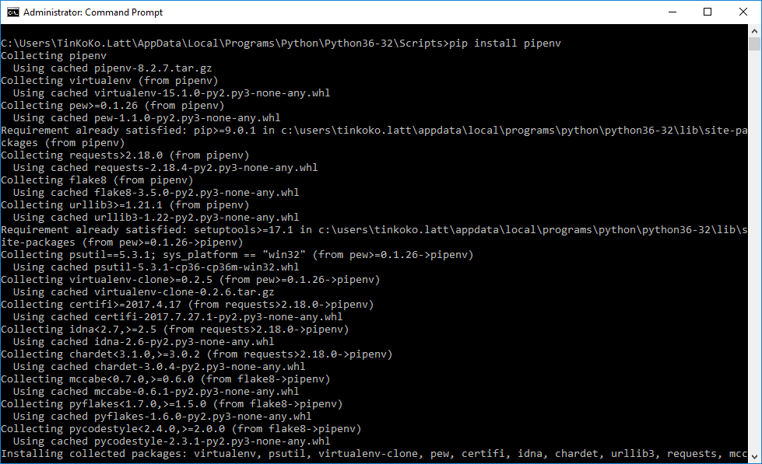

C:\Users\TinKoKo.Latt\AppData\Roaming\Python\Python36\Scripts

pipenv install requests

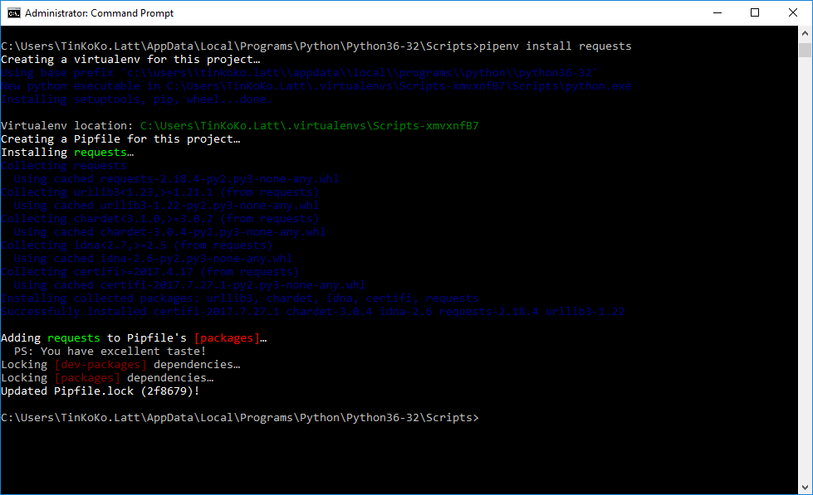

pip install lxml

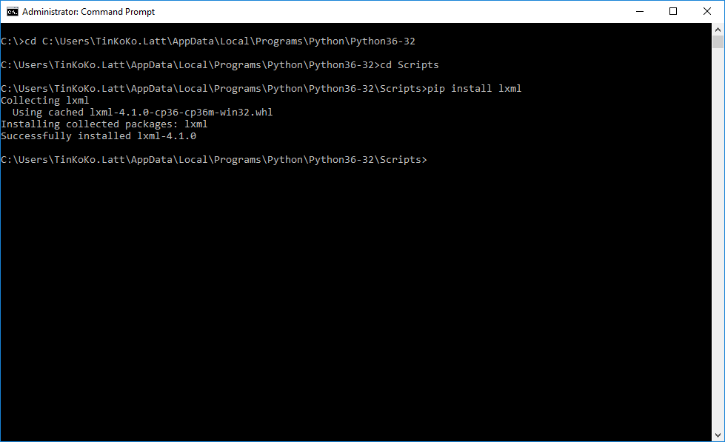

python zillow.py 66502 newest

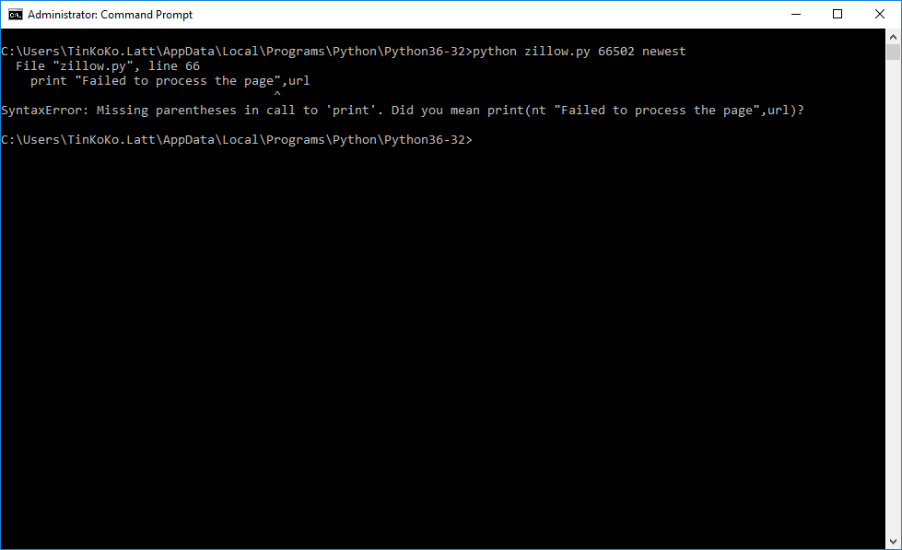

https://www.scrapehero.com/how-to-scrape-real-estate-listings-on-zillow-com-using-python-and-lxml/

https://www.digitalocean.com/community/tutorials/how-to-install-python-3-and-set-up-a-local-programming-environment-on-ubuntu-16-04

New python executable in /home/ubuntu/.local/share/virtualenvs/bin-B6Dbs8ke/bin/python

Installing setuptools, pip, wheel...done.

sudo pip install unicodecsv