AUTONOMOUS EXPENSE TRACKER
& REIMBURSEMENT SYSTEM
Technical Design Document
Architecture, Workflow & Enhancement Roadmap

Submitted by | [Name / Team]
Submitted to | [Reviewer / Organization]
Project / Track | Autonomous Agentic Systems & Financial Automation
Submission date | [DD Month YYYY]

Contents
Use this contents page as the document index. Page numbers can be refreshed in Word after opening the document if you choose to replace this list with an automatic Table of Contents.
1. Executive Summary
2. Project Overview and Objectives
3. Current-State Architecture
4. End-to-End Workflow
5. Agent Responsibilities and Decision Logic
6. Data Model and Persistence
7. Assumptions, Constraints and Risks
8. Enhancement Opportunities and Recommendations
9. Suggested Prioritisation Roadmap
10. Security, Governance and Operational Readiness
11. Acceptance Criteria and Success Metrics
12. Conclusion
Appendix A. Implementation Notes and Key Configuration

1. Executive Summary
The Autonomous Expense Tracker & Reimbursement System demonstrates an agentic workflow for receipt ingestion, structured extraction, duplicate screening, human-in-the-loop (HITL) exception handling, and controlled claim-state transitions. The documented implementation combines a Next.js 15 web interface, a FastAPI backend, a four-agent pipeline, Supabase PostgreSQL, and pgvector-based similarity search.
This document consolidates the current design and proposes an enhancement roadmap. The current system is scoped primarily to bill/receipt processing and uses sequential, rule-based agent handoffs. Recommended next steps focus on stronger cross-user duplicate detection, better explainability and review UX, policy/FAQ and natural-language status agents, more flexible orchestration where justified, provider-agnostic LLM integration, and production-grade security and observability.
Scope note Enhancements in Section 8 are proposals, not claims that these capabilities are already implemented.

2. Project Overview and Objectives

2.1 Selected Track
Autonomous Agentic Systems & Financial Automation (Multi-Agent LLM Architecture).

2.2 Problem Statement
Traditional reimbursement workflows can require manual receipt entry, repeated checks, exception chasing, and status follow-ups. The proposed system reduces this friction by extracting receipt information, screening for likely duplicates, asking users to resolve ambiguous cases, and maintaining a traceable claim lifecycle.

2.3 Objectives
- Multimodal document processing for receipt PDFs and images, including itemised and degraded documents.
- Duplicate and near-duplicate screening using semantic embeddings and cosine similarity.
- HITL exception mediation for missing fields, low-confidence extraction, blurry documents, and uncertain matches.
- Claim lifecycle tracking from Draft through Pending Approval and settlement outcomes.
- Persistent conversations, claim records, and audit-relevant state changes.

3. Current-State Architecture
The diagram below separates the client, routing/backend, agent pipeline, and persistence concerns. Decision thresholds shown are the documented implementation thresholds and should be calibrated before they are treated as production fraud controls.
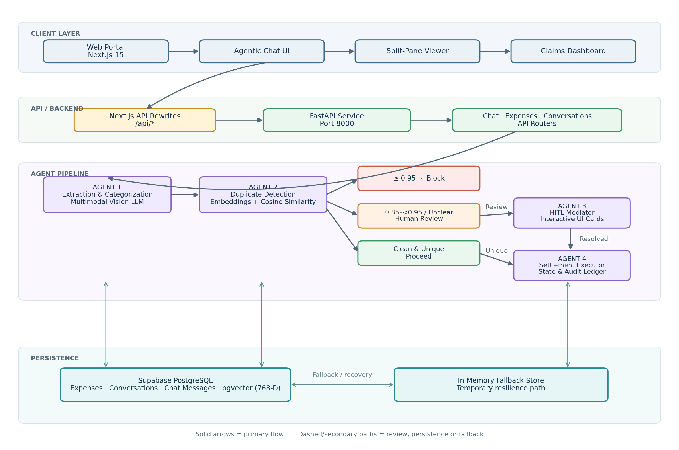

3.1 Logical Layers
Layer | Components | Responsibility
Client | Next.js 15, Tailwind CSS, Lucide, chat UI, split-pane viewer, dashboard | Receipt interaction, claim review, status visibility, and HITL cards.
Ingress / API | Next.js rewrites and FastAPI service (port 8000) | Route requests to backend APIs and coordinate application operations.
API routers | /api/chat, /api/expenses, /api/conversations | Separate chat orchestration, claim CRUD, and conversation/message operations.
Agent pipeline | Extraction, deduplication, HITL mediation, settlement executor | Extract structured data, assess matches, request clarification, and apply state transitions.
Persistence | Supabase PostgreSQL, pgvector, in-memory fallback | Store claims, embeddings, conversations, messages, and provide a fallback path.

3.2 Architecture Notes
- The chat router initiates the documented agent pipeline. Expense and conversation routers also expose direct data operations.
- The current duplicate search is scoped to the same employee and same bill date, as described in the source design.
- The database schema defines a 768-dimensional embedding field and a match_expenses function using cosine distance.
- The source describes an in-memory fallback and client-side persistence safeguards; these should be treated as resilience mechanisms, not substitutes for durable database recovery.

4. End-to-End Workflow
The sequence below illustrates the major interaction stages: receipt upload, extraction, similarity lookup, exception routing, and persistence. It is intentionally simplified to keep the execution path readable.
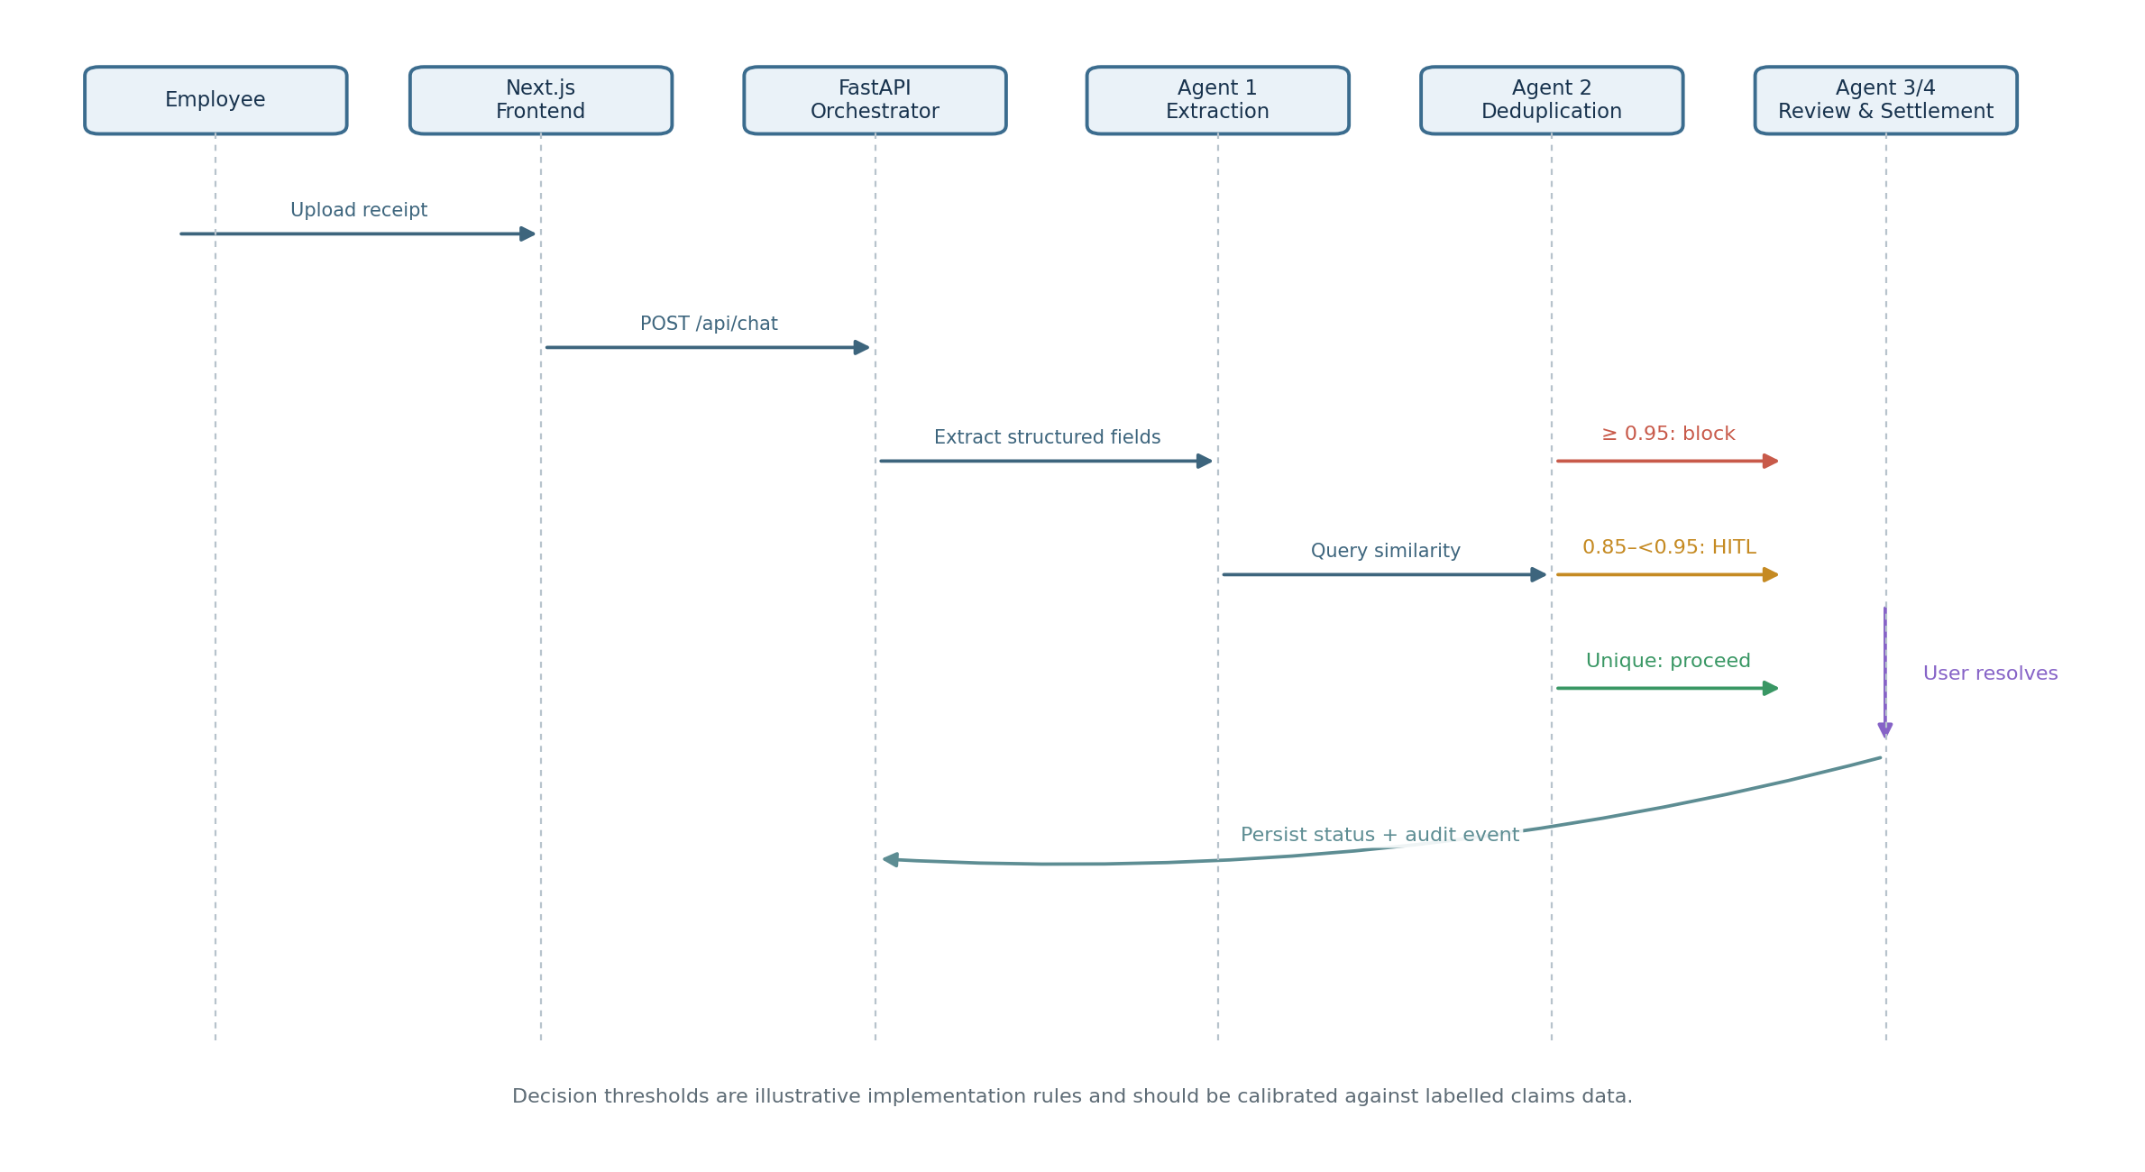

4.1 Decision Outcomes
Condition | Current documented action | Recommended control
Similarity ≥ 0.95 | Block as a likely duplicate. | Show matched claim evidence and support an authorised appeal/review path; avoid silent irreversible rejection.
0.85 ≤ similarity < 0.95 | Route to HITL review. | Present match explanations, extracted field differences, and clear actions for confirm / reject / escalate.
Blurry or incomplete data | Use HITL to resolve missing or uncertain fields. | Display field-level confidence and preserve the original uploaded document.
Clean and unique | Continue toward submission / settlement transition. | Require policy validation and an explicit approval boundary before any real ERP posting.

5. Agent Responsibilities and Decision Logic
Agent | Current responsibility | Key considerations
Agent 1 — Extraction & Categorization | Uses a multimodal vision LLM to extract fields such as vendor, date, amount, line items, and category. | Schema validation, OCR confidence, currency handling, arithmetic checks, and source-document traceability.
Agent 2 — Deduplication Engine | Creates a 768-dimensional embedding from standardised claim text and queries pgvector using cosine similarity. | Current user/date filters limit cross-user detection; embeddings should complement rather than replace deterministic matching.
Agent 3 — HITL Mediator | Presents interactive UI cards for missing metadata, blurry OCR, and uncertain matches. | Explain why intervention is required, validate user input, and record who resolved the exception.
Agent 4 — Settlement Executor | Validates state transitions and moves claims into the documented approval workflow. | Idempotency, authorisation, audit trail, retry policy, and separation of claim submission from payment execution.

6. Data Model and Persistence
The supplied design documents the following primary persistence structures:
Structure | Key fields / role | Design implications
expenses | UUID, user_id, bill_type, bill_date, vendor_name, total_amount, currency, payment_mode, remarks, specific_details JSONB, status, embedding vector(768), timestamps | Add indexed normalised fields and extraction provenance if cross-user matching is introduced.
conversations | Conversation ID, user ID, title, created_at, updated_at | Enforce ownership checks for reads and writes.
chat_messages | Conversation ID, sender, text, files/events/HITL/draft card JSONB, created_at | Define retention, redaction, and attachment metadata policies.
match_expenses() | Filters by user, bill date, similarity threshold and match count; orders by cosine distance | A global duplicate search requires deliberate changes to filters, access controls, candidate ranking, and review policy.

6.1 Persistence and Reliability Considerations
- Use PostgreSQL as the durable source of truth for claim state; treat memory stores as temporary resilience aids with explicit reconciliation.
- Add idempotency keys for claim creation and settlement requests to prevent duplicate writes during retries.
- Define backup, restore, retention, and disaster-recovery objectives for claim records and audit events.
- Store document hashes and immutable source references so corrected metadata does not overwrite the original evidence.

7. Assumptions, Constraints and Risks
Area | Current assumption / constraint | Risk or consequence
Identity and roles | The source describes a demo employee session and a switchable manager role. | Production identity, role enforcement, and tenant boundaries must not rely on client-controlled role switching.
Currency | INR is the default currency; foreign transactions are handled through remarks/conversion flags. | Currency conversion needs an explicit rate source, effective date, and audit trail.
Duplicate boundary | Duplicate screening is described as same employee and same calendar date. | Cross-user duplicate claims or shared receipt reuse may not be detected.
Fallback | The source describes Supabase → in-memory → client storage fallback behavior. | Memory/client persistence can be lost or inconsistent; reconciliation rules are required.
Document integrity | Uploaded binaries are intended to remain immutable while metadata can be corrected. | Enforce this in storage permissions and audit logging, not only in UI conventions.
Similarity thresholds | 0.95 and 0.85 are fixed decision thresholds in the current design. | Thresholds can create false positives/negatives and need validation on representative labelled data.

8. Enhancement Opportunities and Recommendations
The following are proposed extensions based on the described use case. They should be prioritised against business requirements, available data, compliance needs, and measurable error rates.

8.1 Cross-User and Multi-Signal Duplicate Detection
Current scope: the documented SQL function filters candidates by user_id and bill_date. A broader duplicate search could compare claims across employees or business units where policy and privacy rules permit it.
- Combine deterministic features: vendor/tax ID, invoice or bill number, transaction timestamp, total and tax amount, currency, payment reference, and receipt/document hash.
- Compare line-item descriptions, quantities, unit prices, tax breakdowns, merchant identity, and normalized address where available.
- Use a staged candidate-generation design: exact hashes and invoice identifiers first, structured-field blocking second, semantic/vector similarity third.
- Keep tenant, legal-entity, and access boundaries explicit; cross-user search should expose only the minimum evidence to authorised reviewers.
- Return an explainable match record: matched fields, differences, similarity score, candidate claim ID, and a review disposition.
Recommendation Do not make vector similarity the sole duplicate criterion. Use exact identifiers and structured comparisons alongside embeddings, then route uncertain cases to review.

8.2 Hybrid Search for Better Precision and Recall
If global matching produces too many false positives—or vector search misses exact duplicates—introduce hybrid retrieval. Combine exact/rule-based matching, full-text or token matching, and vector similarity. Evaluate each stage against a labelled validation set before changing thresholds.
- Candidate retrieval: invoice number / receipt hash / vendor + date + amount blocks.
- Ranking: weighted structured-field agreement plus semantic similarity.
- Calibration: measure precision, recall, false-positive rate, and false-negative rate by expense category.
- Review feedback: use confirmed duplicate and confirmed-unique decisions to tune rules and thresholds under change control.

8.3 UI and Reimbursement-Platform Enhancements
The current interface can be expanded from a demonstration of agentic processing into a more complete mock reimbursement platform, if that is within scope.
- Role-aware employee and manager views: My Claims, Team Queue, Exceptions, Policy Issues, and Settlement History.
- A claim detail page with original receipt, extracted fields, line items, policy checks, duplicate evidence, timeline, and audit history.
- Accessible HITL cards with field-level confidence, clear explanations, keyboard navigation, and explicit confirm/correct/escalate actions.
- Dashboard filters by status, date, category, employee, cost centre, and exception reason; include empty, loading, error, and retry states.
- A responsive layout, consistent status taxonomy, clear currency/date formatting, and actionable validation messages.
- A review diff that highlights what the user changed versus what the model extracted.

8.4 Intent-Based Orchestration (When Scope Expands)
The current sequential, rule-based pipeline is a reasonable fit for a narrow receipt-processing workflow. If supported intents and categories expand materially, consider an intent-aware orchestrator that routes requests to specialised capabilities. This should be driven by requirements rather than introduced solely for architectural novelty.
- Classify intent (submit claim, inspect duplicate, check status, ask policy question, correct metadata, manager review).
- Route to bounded tools or subflows with typed inputs and outputs.
- Use deterministic workflow/state-machine controls for financial state transitions even if intent selection is model-assisted.
- Apply timeouts, retry limits, maximum tool-call budgets, and safe fallback responses.
- Keep human approval gates for actions with financial or compliance consequences.

8.5 FAQ / Expense Policy Agent
A dedicated FAQ agent could answer questions about claim eligibility, spending limits, required evidence, submission deadlines, category rules, and reimbursement timelines.
- Ground responses in approved policy documents and show source references or policy section names.
- Use retrieval-augmented generation (RAG) over versioned policy content rather than relying on model memory.
- If a policy is ambiguous or unavailable, say so and route to Finance/HR instead of inventing a rule.
- Separate informational answers from claim approval decisions; the FAQ agent must not silently approve claims.

8.6 Natural-Language Claim Status Agent
A status agent can translate structured claim states into natural-language responses, for example: “Your claim is pending manager review” or “Finance requested a clearer receipt.”
- Resolve the authenticated user's claim using secure ownership checks.
- Explain the current state, last update, outstanding action, and next expected step when that information is available.
- Support follow-up questions such as “Which claims need my attention?” or “Why was this returned?”
- Do not predict payment dates unless the system has a reliable, explicitly defined source for them.

8.7 Provider-Agnostic LLM Interface and Local Deployment
The source describes an OpenAI-compatible API format as a portability goal. A provider adapter can help support hosted providers and OpenAI-compatible serving stacks, including vLLM, SGLang, NVIDIA NIM, llama.cpp, and Ollama, subject to each backend's API and model capabilities.
- Define a common client contract for chat, vision, structured output, embeddings, timeouts, retries, and error types.
- Keep model/provider configuration server-side; do not expose private provider credentials through public frontend environment variables.
- Use capability checks because not every model/server supports vision, tool calling, JSON schema enforcement, or embeddings identically.
- Make fallback routing explicit and observable; avoid silently switching to a model with materially different accuracy or privacy characteristics.
- Benchmark latency, cost, extraction accuracy, context limits, and deployment resource requirements before selecting a default.

8.8 Additional High-Value Enhancements
- Policy validation agent / rules service: Check category limits, receipt requirements, date windows, tax fields, and allowed payment types using versioned deterministic rules. Keep final approval separate.
- Line-item and arithmetic validation: Reconcile line-item totals, tax, tip, discounts, and grand total; flag discrepancies with field-level evidence.
- Confidence-aware extraction: Store per-field confidence and provenance; route low-confidence fields to HITL instead of relying on a single overall score.
- Audit and explainability layer: Record agent version, model/provider, prompt or workflow version, input/output references, decisions, overrides, timestamps, and actor identity with privacy controls.
- Security and privacy hardening: Enforce authentication, row-level security, least privilege, signed upload/download URLs, malware scanning, retention controls, and PII minimisation.
- Observability and evaluation: Add structured logs, traces, token/cost metrics, latency, error rates, queue depth, and offline evaluation datasets for extraction and deduplication.
- Asynchronous processing: For large PDFs or high volumes, use a job queue, status polling/events, bounded retries, and dead-letter handling rather than holding long requests open.
- ERP integration boundary: Wrap ERP posting behind an adapter with idempotency, reconciliation, sandbox mode, and clear separation between claim submission, approval, and payment.
- Accessibility and localisation: Support keyboard-only review, screen readers, local date/currency conventions, time zones, and multiple languages if required.
- Test strategy: Add unit, integration, contract, security, regression, and end-to-end tests; include adversarial duplicate pairs and low-quality scans.

9. Suggested Prioritisation Roadmap
Priority | Initiative | Why it matters | Suggested exit criterion
P0 — Foundation | Authentication, authorisation, durable state, idempotency, audit events | Protects claim integrity and prevents unauthorised access or duplicate writes. | Role/ownership tests pass; retries do not create duplicate claims; key actions are auditable.
P1 — Quality | Structured + semantic duplicate scoring; confidence-aware extraction; HITL evidence | Reduces false positives and improves reviewer trust. | Precision/recall measured on labelled data; review decisions are captured.
P1 — UX | Claim detail, review diff, dashboard filters, accessible exception cards | Makes the workflow understandable and operationally usable. | Employees/managers complete core tasks in usability testing.
P2 — Self-service | FAQ/policy RAG agent and natural-language status agent | Reduces routine support requests and improves transparency. | Answers cite approved policy or authoritative claim state; unsupported answers are safely declined.
P2 — Portability | LLM provider adapter and model capability registry | Enables provider changes and local deployment options. | Contract tests pass across selected providers and fallback behavior is observable.
P3 — Scale | Async jobs, queues, advanced analytics, cross-entity duplicate detection | Supports higher volume and broader organisational scope. | Load tests meet agreed latency/error targets; cross-user access is policy-approved.

9.1 Decision Gates Before Expanding Scope
- Confirm whether duplicate detection is employee-scoped, legal-entity-scoped, or organisation-wide, and who may see match evidence.
- Define the reimbursement policy source of truth and the owner responsible for policy updates.
- Agree whether ERP settlement is simulated or connected to a real financial system; define approval and payment boundaries.
- Set target precision/recall, extraction accuracy, average review time, latency, availability, and cost per claim.
- Confirm hosting, data residency, retention, and whether local inference is a business requirement.

10. Security, Governance and Operational Readiness
- Authentication and server-side authorisation must protect every claim, conversation, document, and manager action.
- Use database row-level security and least-privilege service credentials; never rely on frontend-only checks.
- Treat receipt images and extracted text as untrusted input. Defend against prompt injection embedded in documents and do not let extracted content override system instructions.
- Minimise personal and financial data sent to LLM providers; document provider retention and data-processing terms.
- Keep model-generated suggestions separate from deterministic policy decisions and authorised financial state changes.
- Log decision metadata without unnecessarily duplicating full receipt contents or sensitive personal information.
- Create an incident path for disputed duplicate flags, incorrect extraction, unauthorised access, and settlement failures.

11. Acceptance Criteria and Success Metrics
Area | Metric | How to evaluate
Extraction | Field-level exact/normalised accuracy | Evaluate vendor, date, amount, currency, invoice number, and line items on a representative labelled set.
Deduplication | Precision, recall, false-positive and false-negative rates | Use labelled same-receipt, near-duplicate, legitimate-repeat, and cross-user test pairs.
HITL | Exception rate and median resolution time | Track by failure reason and document quality.
Workflow | Successful claim completion and transition error rate | Measure end-to-end tests and production telemetry.
Reliability | Availability, retry success, recovery time, data-loss incidents | Exercise provider outages, database outages, and interrupted settlement calls.
User experience | Task completion, correction rate, user satisfaction | Run employee and manager usability tests.
Cost / latency | Cost per processed claim and p50/p95 latency | Break down extraction, embedding, orchestration, and storage costs.

Set numeric targets only after establishing a baseline and confirming the intended business risk tolerance. In particular, duplicate thresholds should be tuned against labelled data rather than assumed to be universally correct.

12. Conclusion
The current four-agent architecture is a suitable demonstration of an agentic expense-processing workflow: extraction, similarity-based duplicate screening, human exception mediation, and controlled state transitions. The most valuable next step is to strengthen correctness and governance before expanding autonomy: richer duplicate evidence, measurable thresholds, secure cross-user boundaries, auditable HITL decisions, and reliable state transitions.
Once these foundations are in place, a broader reimbursement experience can be added incrementally through policy FAQ retrieval, natural-language claim status, intent-based routing where justified, provider-agnostic LLM adapters, and operational observability.

Appendix A. Implementation Notes and Key Configuration

A.1 Documented technology stack
- Frontend: Next.js 15, Tailwind CSS, Lucide icons.
- Backend: FastAPI, documented on port 8000.
- Persistence: Supabase PostgreSQL with pgvector; embedding dimension documented as 768.
- LLM / embeddings: the source names Gemini vision and embedding models; the exact model identifiers are configuration-dependent.
- Local development: Node.js, Python virtual environment, dependency installation, backend startup, and Next.js development server.

A.2 Example environment configuration categories
The source design identifies these configuration categories; actual credentials should be stored securely and never committed to source control.
- LLM provider and model identifiers
- LLM API credentials
- Supabase project URL and public client key
- Backend URL / proxy configuration

A.3 Important implementation caveats
- Validate model identifiers and API capabilities against the provider currently selected.
- Review the SQL function and its user/date filters before enabling organisation-wide duplicate detection.
- Ensure the embedding model output dimension matches the database vector column dimension.
- Do not interpret the in-memory fallback as durable zero-data-loss storage without a defined synchronisation and recovery design.

