1. Our code are originally from <https://github.com/ai-tor> and we changed it to our own code, like changing models.
2. Install GTA V
3. copy-paste the contents of bin/Release under GTAV installation directory and replace your saved game data in Documents/Rockstar Games/GTA V/Profiles/ with the contents contents of bin/SaveGame. Additionaly, download [paths.xml](https://drive.google.com/open?id=0Bzh5djJlCOmMOTA1RVlOXzZ5dEk) and store it also in the GTAV installation directory.
4. Put all document under the same folder

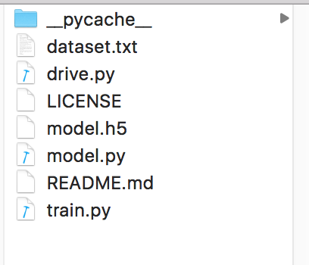

1. Use commend like

python drive.py model.h5 8000 320 160

To start server

