DETAILED PROJECT REPORT (DPR)

FLIGHT FARE PREDICTION

Objective:
To develop a predictive model for Flight Fare Prediction. The Model will Deliver the user an approximate Flight Fare from any Source Station to any Destination station.

Benefits:
1. User can get an approx idea about the flight fare without visiting any booking website signup.
2. Users can compare the price of different Airlines for any specific Route and choose the best or affordable Airline.

Data Sharing Agreement:
- Sample file name
- Length of date stamp(8 digits)
- Length of time stamp(6 digits)
- Number of Columns
- Column names
- Column data type

Architecture:
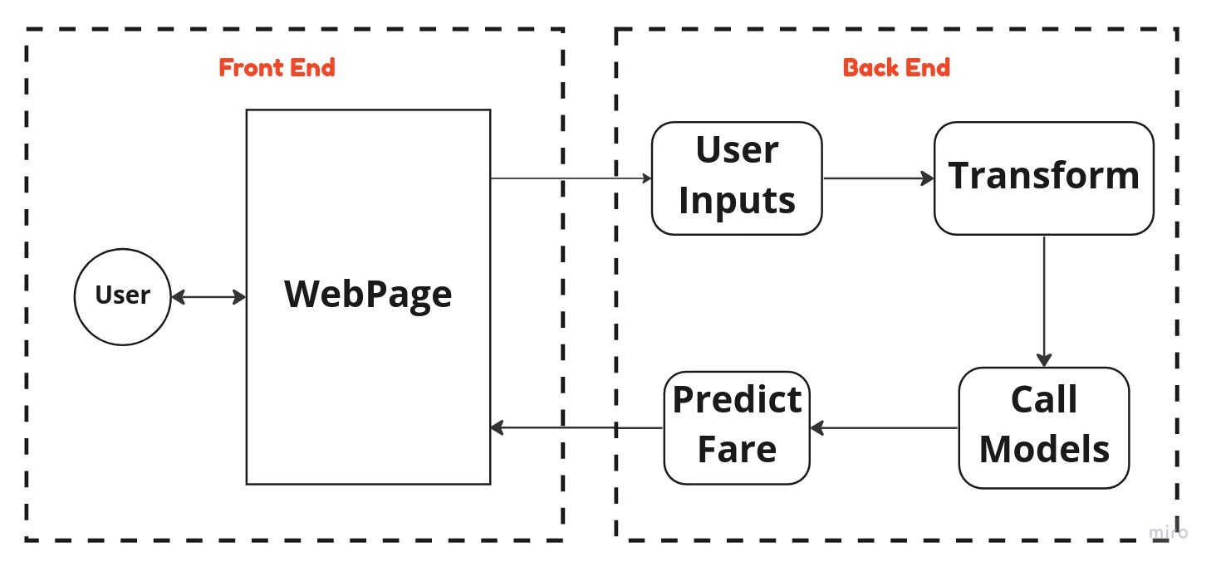

Data Insertion:
1. Insert data into database(MongoDB) and load and save the data in featurestore under Artifact Directory.

Data Validation
1. Validation of number of features or columns present in new dataset.
2. Validation of each required feature present or not.
3. Distribution of numerical features are same or not.
4. Null value precentage for each column should be less than critical value already given.

Data Transformation:
1. Extraction of day and month from date features
2. extraction and calculation of total duration in minutes.
3. Label encoding or OneHot Encoding for categorical features.

Model Training:
1. The accumulated data from db is exported in csv format for model training.
2. Data Preprocessing
- Performing EDA to get insight of data like identifying distribution , outliers ,trend among data etc.
- Check for null values in the columns. If present impute the null values.
- Encode the categorical values with numeric values.
3. After completing FE, useful features are selected. Seperate grouped data are created from the main dataframe for individual Airline.
4. Model are created mainly using 3 Algorithms -
- Decision Tree Regressor
- Random Forest Regressor
- XGBoost Regressor
5. Best model is selected on the basis of model performance and accuracy.
6. Total 9 models are made, 1 for general prediction when User provide/choose any particular Airline Name and 8 more models for 8 different Airlines which are going to be used when user asks for Fare of each available Airlines for that Route.

Prediction:
All the trained models are stored in the directory named saved_models. Using those models Flight fares are predicted and the result is displayed on the Web page.

