LOW LEVEL DOCUMENT (LLD)

FLIGHT FARE PREDICTION

Document Version Control

Date | Version | Description | Author
 | 1.0 | Initial | T. Hore

Contents
1 Introduction
1.1 What is Low-Level Design Document?
1.2 Scope
2. Architecture
3. Architecture Description
3.1. Initial Data Analysis and Model Selection
3.2. Model Retraining
3.3. Prediction
3.4. Deployment
4. Unit Test Cases ...........................................5
Abstract
1 Introduction

1.1 Why High-Level Design Document?

The goal of LLD or a low-level design document (LLDD) is to give the internal logical design of the actual program code for Flight Fare Prediction System. LLD describes the class diagrams with the methods and relations between classes and program specs. It describes the modules so that the programmer can directly code the program from the document.
1.2 Scope

Low-level design (LLD) is a component-level design process that follows a step-by-step refinement process. This process can be used for designing data structures, required software architecture, source code and ultimately, performance algorithms. Overall, the data organization may be defined during requirement analysis and then refined during data design work

2 Architecture

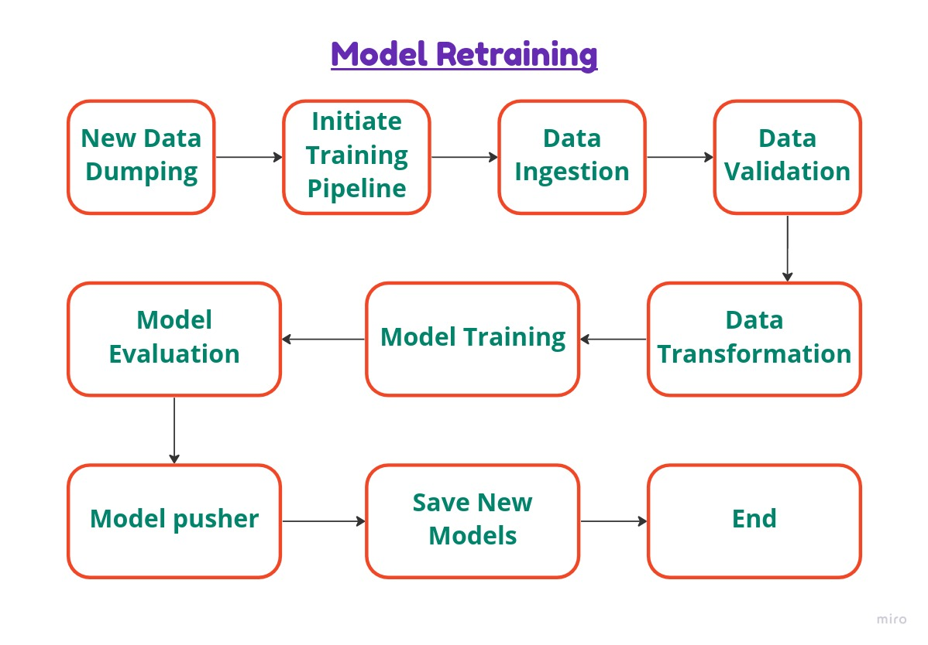
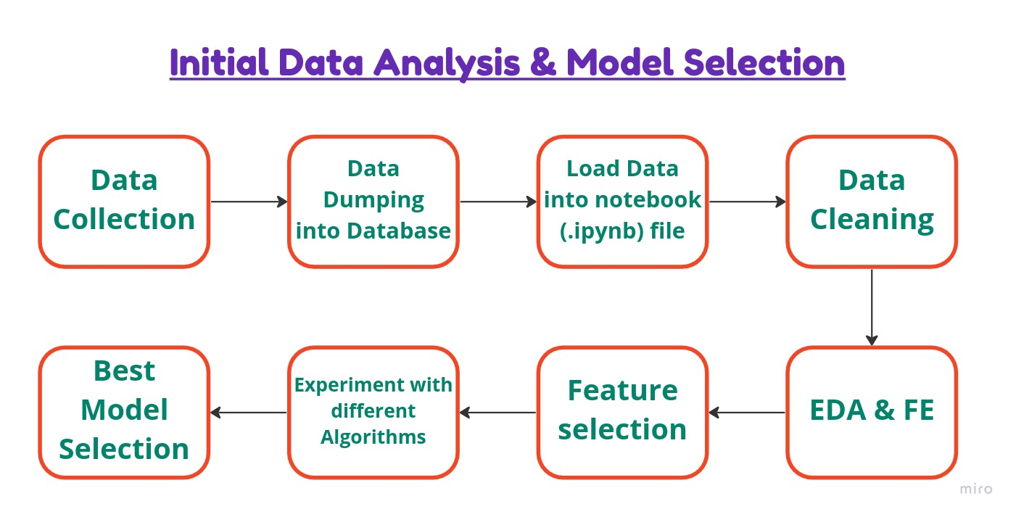
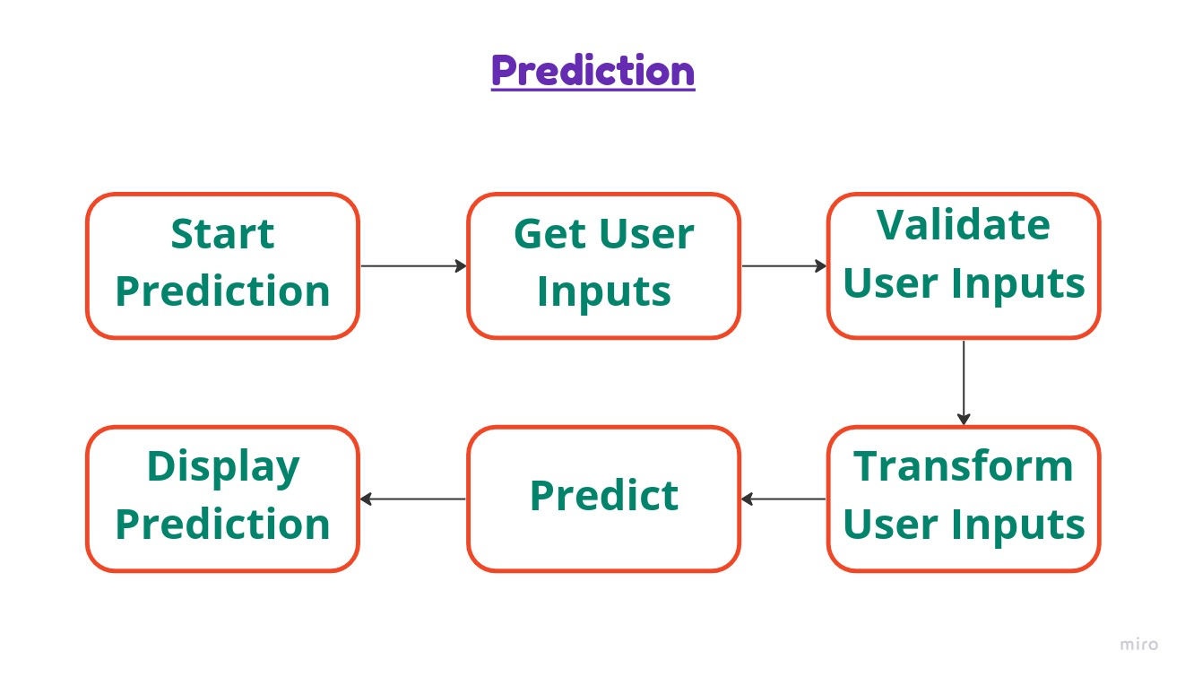

3 Architecture Description
3.1 Initial Data Analysis and Model Selection

This is the Initial phase of the project where the given dataset is dumped in the Database(MongoDB) and using that dumped data a notebook file is prepeared. At first Data is loaded from the database and after performing all the EDA and FE we got a good grip over the nature of the data. All the required transformation were also performed. Then we started experimenting with differen algorithms that are suitable for our purpose. Finally comaring the performance and accuracy of all the models we picked our best model.

In this stage we also decided to have multiple model as we want to provide the user two different options with predictions -
1. If the user asks for any specific Airline name, then we will use a general model to predict the Flight Fare for that particular Airline.
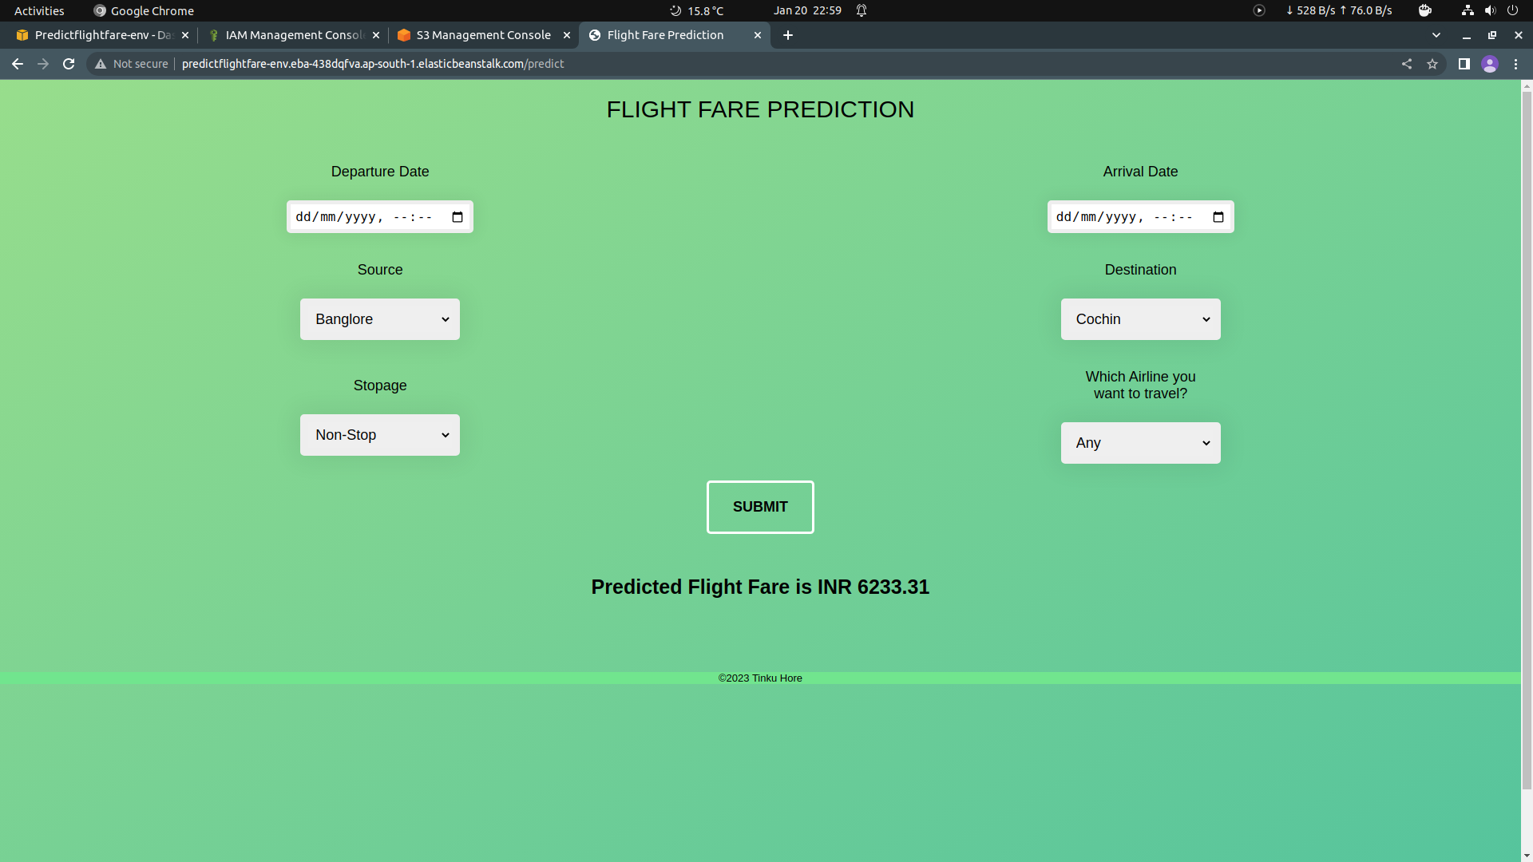

2. If the user select “Any” option available under Airline dropdown, then our programme will make a list of available airlines from that particular source station, and will show a list of fare in ascending order of those available Airlines. To achieve this we need to train seperate model for each Airline.

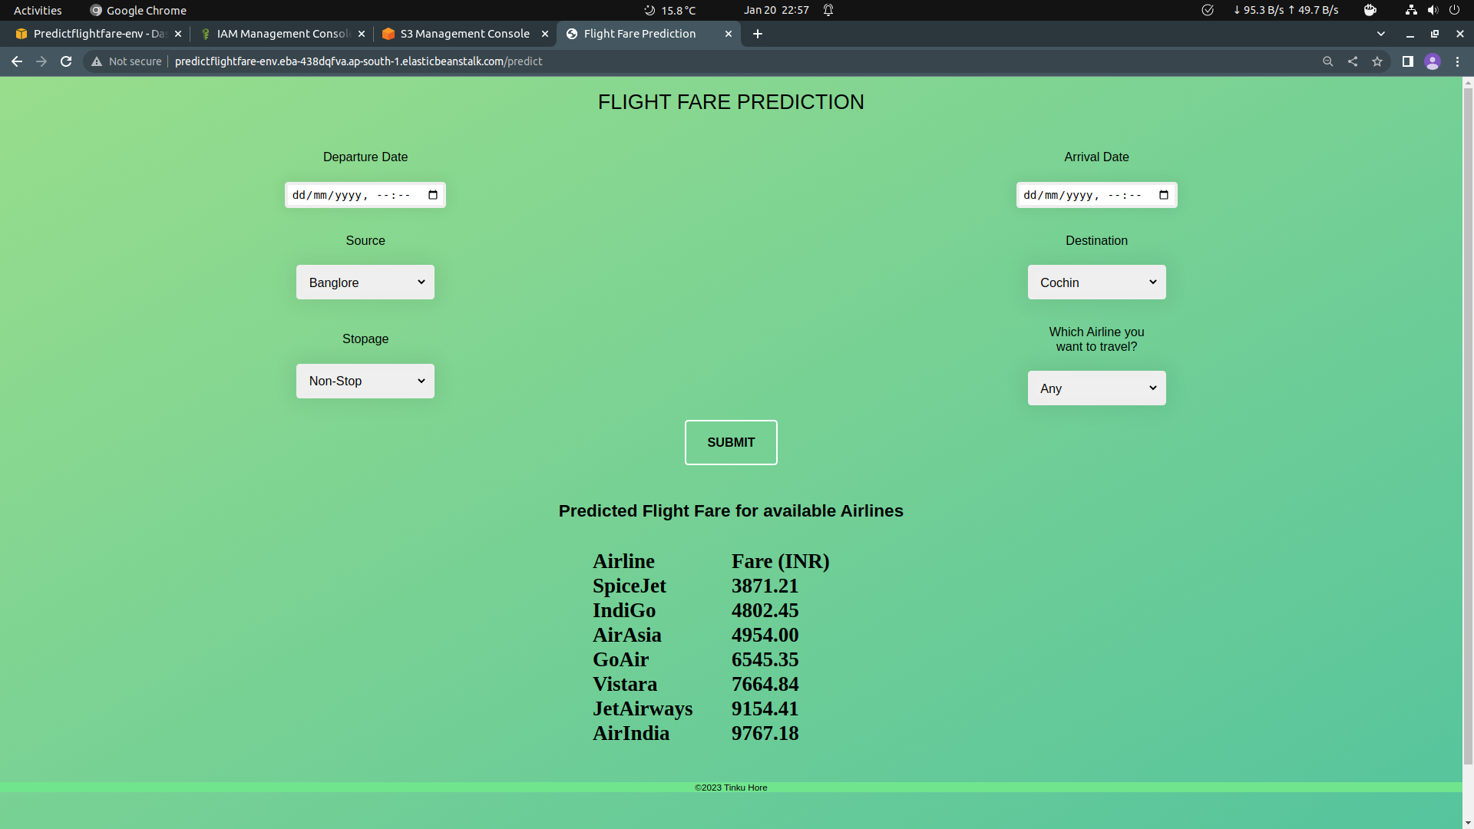

3.2 Model Retraining
All the models that our system going to use for prediction will be stored in a directory called “saved_models”. Whenever a new or updated data is available in the database, we can initiate our Model Retaraining pipeline manually. At the end of this process, new models will get stored in the same directory but in a new folder indicating a new versions of models. As soon as we commit these changes to Github, the new model will get deployed automatically.

3.3 Prediction
This is the frontend of this project. Any user can use the service with the deplyment url. Once the user provides all the required inputs in the webpage and click submit, the Predicted Fare according to user inputs will be displayed on the same page.
3.4 Deployment
The project is to be delivered using git-Actions workflow and Amazon web Services.

4 Unit Test Cases
Test Case Description | Pre-requisite | Expected Result
Verify whether the Web Application URL is accessible to the user | 1. Web Application URL  should be defined | Application URL should be  accessible to the user
Verify whether the Application loads completely for the user when the URL is accessed | 1. Application URL  is accessible  2. Application is  deployed | The Application should load completely for the user when the URL is accessed
Verify whether user is able to see input fields | 1. Application is  accessible  2. User is signed up  to the application  3. User is logged in  to the application | User should be able to see input fields on logging in
Verify whether user is able to edit all input fields | 1. Application is  accessible  2. User is signed up  to the application  3. User is logged in  to the application | User should be able to edit all input fields
Verify whether user gets Submit  button to submit the inputs | 1. Application is  accessible  2. User is signed up  to the application  3. User is logged in  to the application | User should get Submit button to submit the inputs
Verify whether user is presented with recommended results on clicking submit | 1. Application is  accessible  2. User is signed up  to the application  3. User is logged in  to the application | User should be presented with recommended results on clicking submit

