WIREFRAME DOCUMENTATION

FLIGHT FARE PREDICTION

Home Page

Landing page to get User Inputs
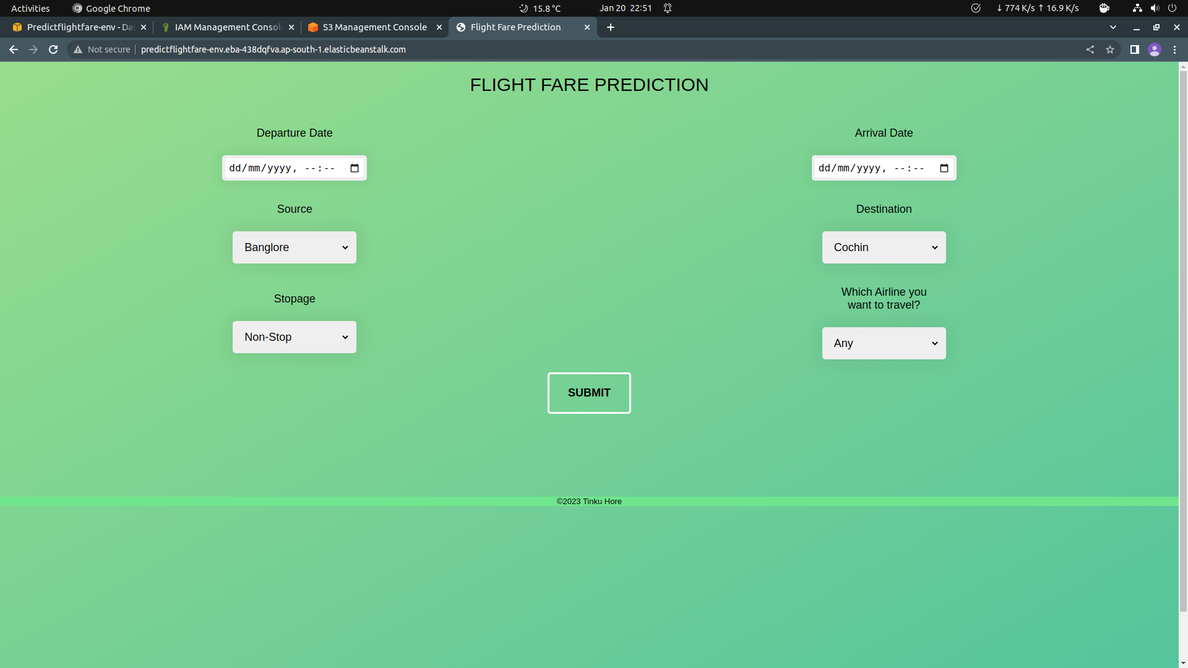

Predicted Results Displayed when User Selected a specific Airline from the dropdown.

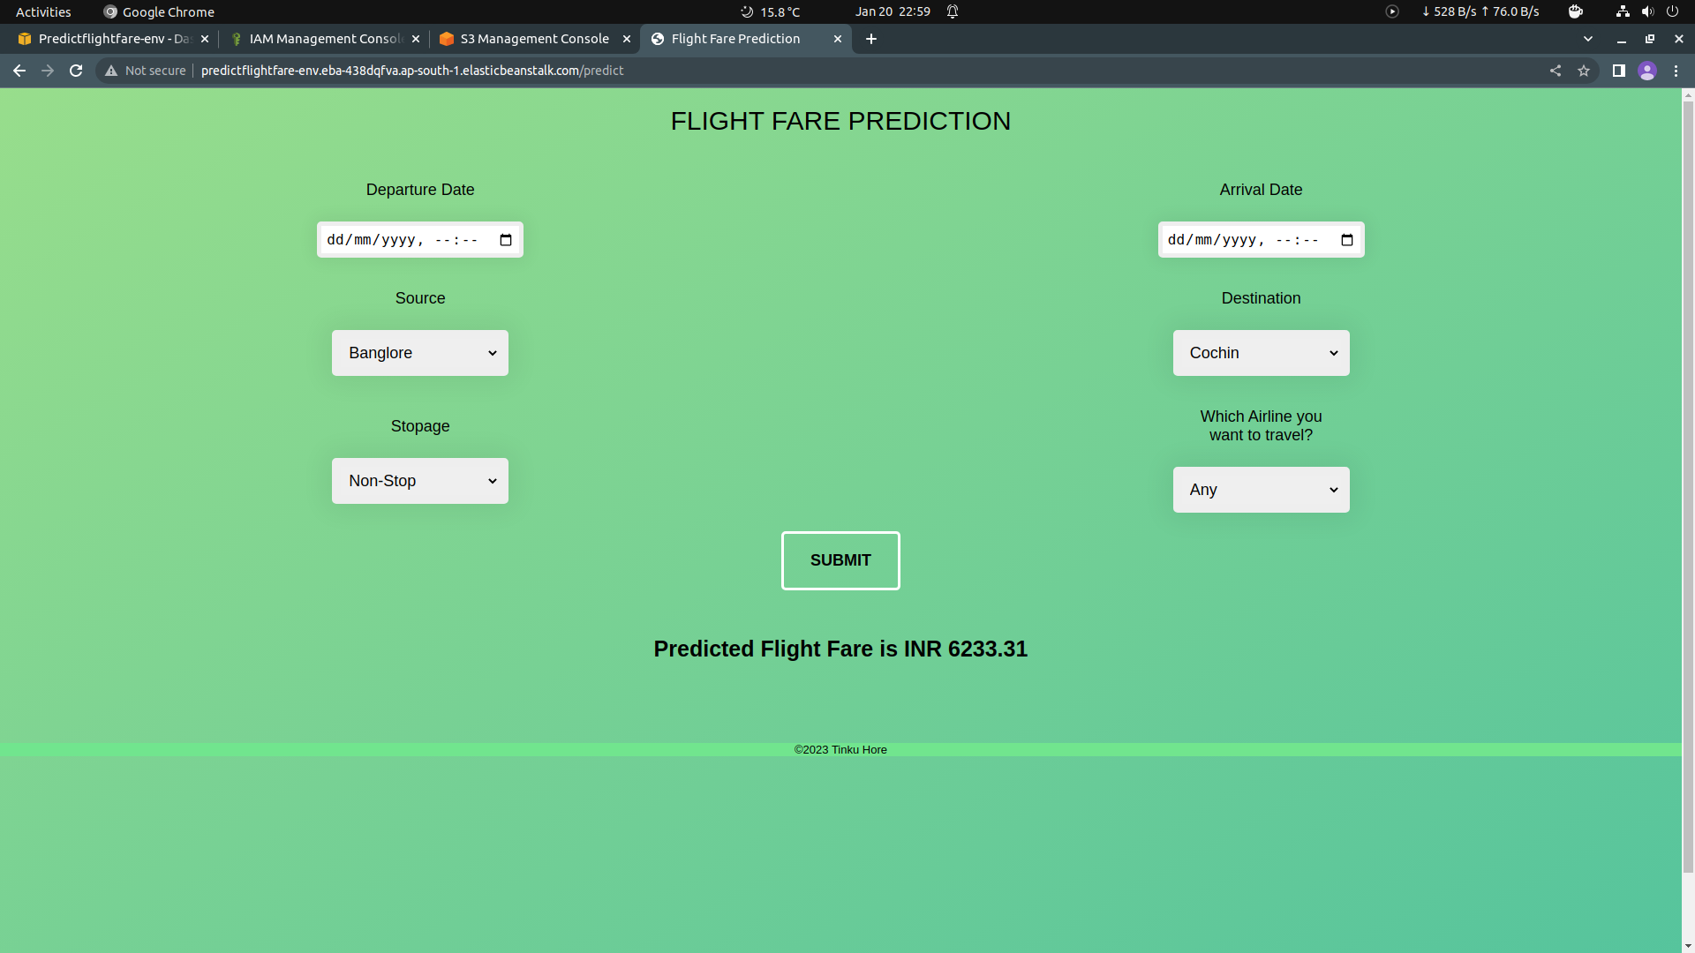

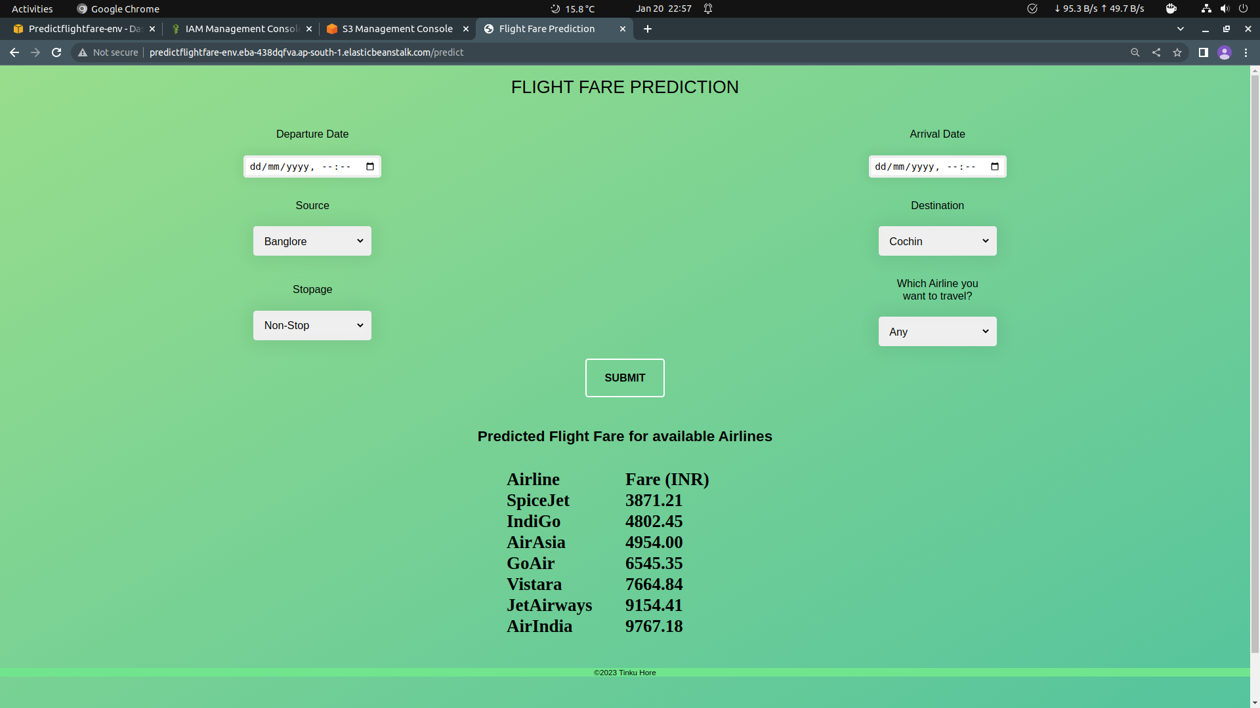
Predicted Results Displayed when User Selected Any Airline option from the dropdown.

