Tin Nguyen

Project 2 – Robot Simulator (Tom & Jerry)

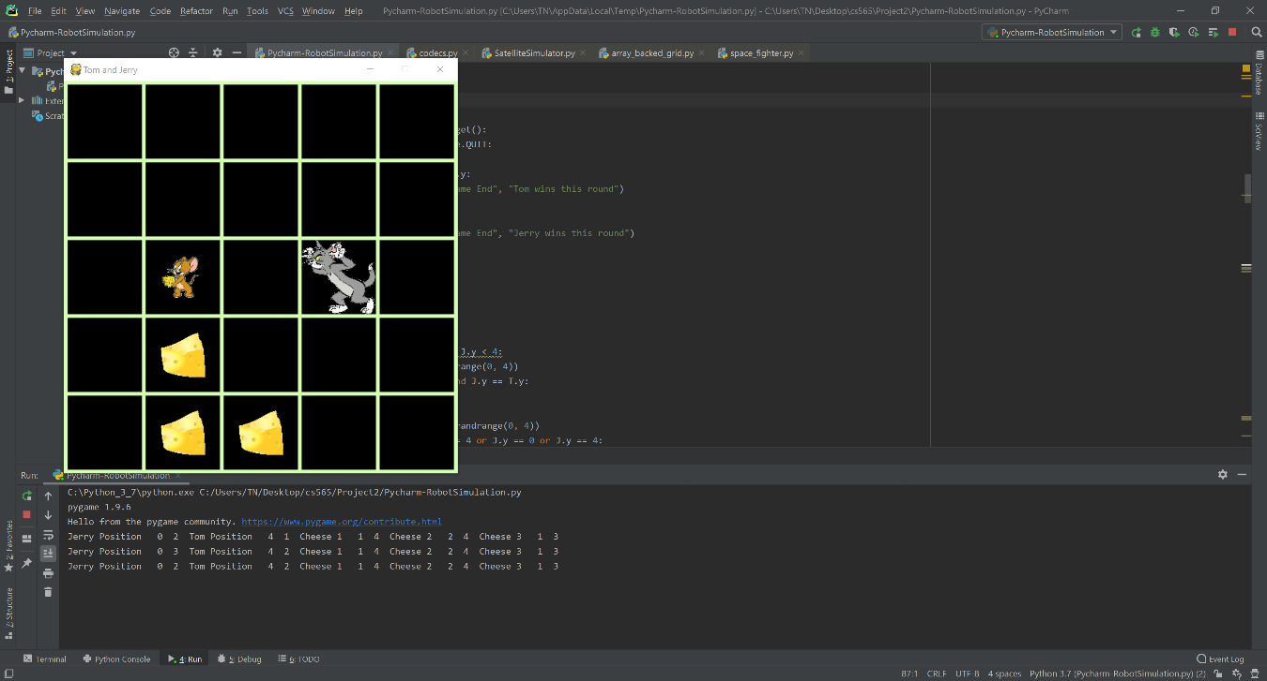

Feature in this game:

* Robot (Jerry) walks 2 step while Bomb (Tom) walks 1 step
* Collision detection: Bomb avoid Gold & Robot avoid Bomb (Also they won’t allow to walk off the screen
* Robot win by collect all the Gold (Cheese as in this simulation)
* Bomb win by walking on Robot

Win rate: 50/50

