GridBagPlus

Tinny84124  10/14/2020

A game bag system for grids’ actions by mouse’s press, click, drag and drop.

A game bag system can used in any type of game project.

Support to display types of effect by mouse’s action.

Features：

* Support to add one or more grids at one time with ease effect show.
* Support to delete one or more grids at one time with ease effect show.
* Support to replace grid’s position by drag_drop in bag container with ease effect show.
* Support to delete grid by drop out of bag container.
* 100% based on Blueprint
* All parameters used in blueprint can be customized

Number of Blueprint file: 7

Number of Enum file: 3

Number of Map file: 1

Number of Textur2D file: 7

Number of Struct file: 1

Supported Development Platforms:Xbox One, Windows 64-bit, Windows 32-bit, Steam VR, PlayStation 4, Oculus, MacOS, Linux, iOS, HTML5, Gear VR, Android.

Demo:<https://youtu.be/hnQM6jiN1kg>

Support Doc:

<https://drive.google.com/file/d/1SntPoW7z86Ocjlh8Kpn5Ej8A_GW_vx2z/view?usp=sharing>

Any additional needs, please contact me at 250394927@qq.com

HOW TO START

Step 1/3:Blueprint files check

(GameInstance,GameMode,Playercontroller)

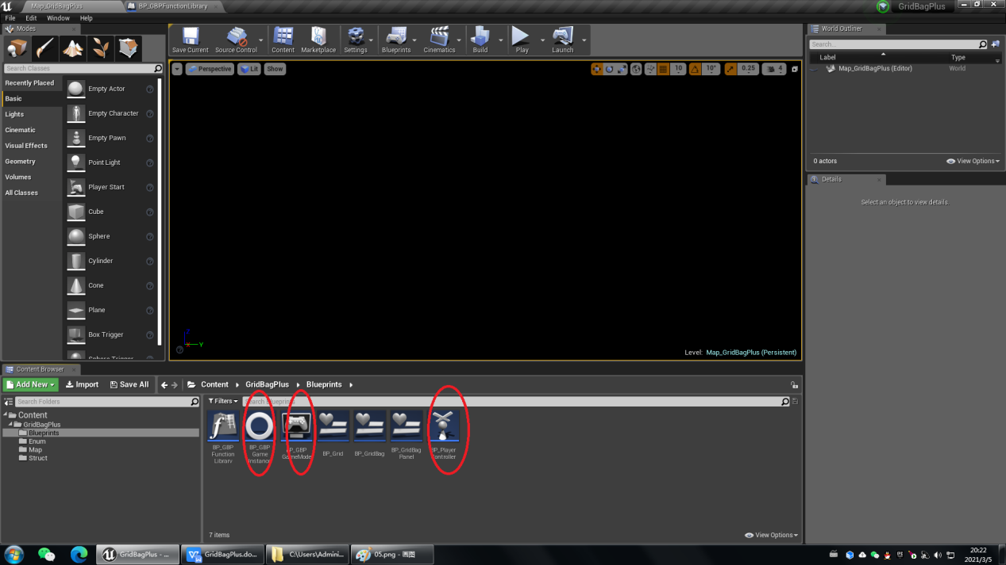

Step 2/2: Maps and Mode Set

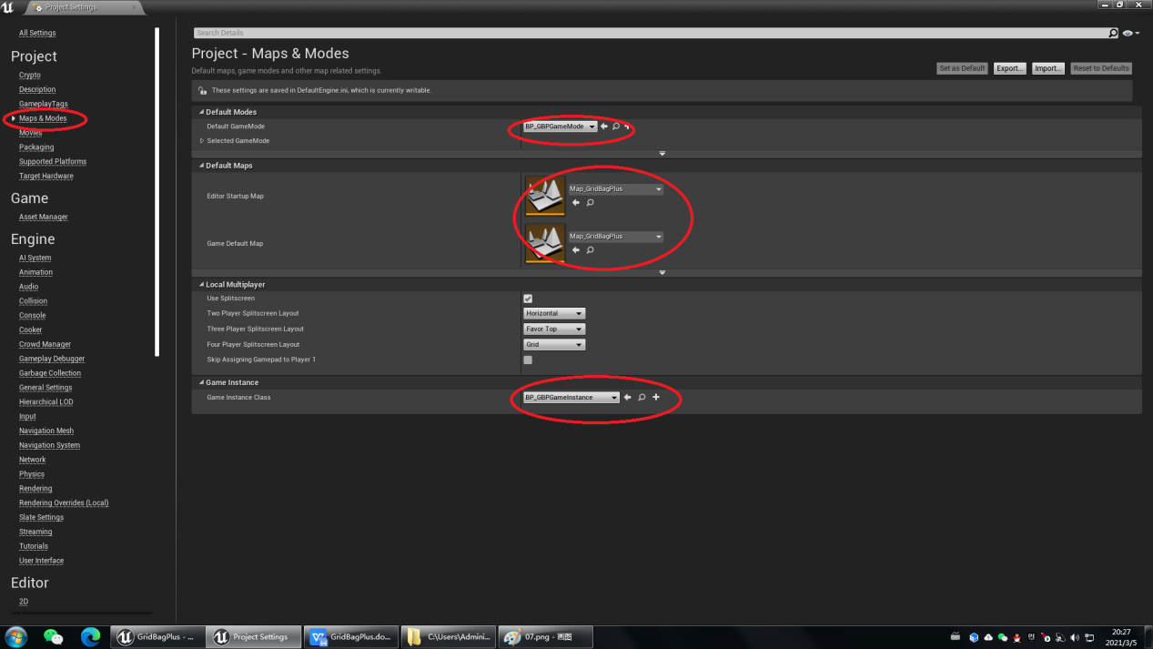

Step 2/2: PlayerController set

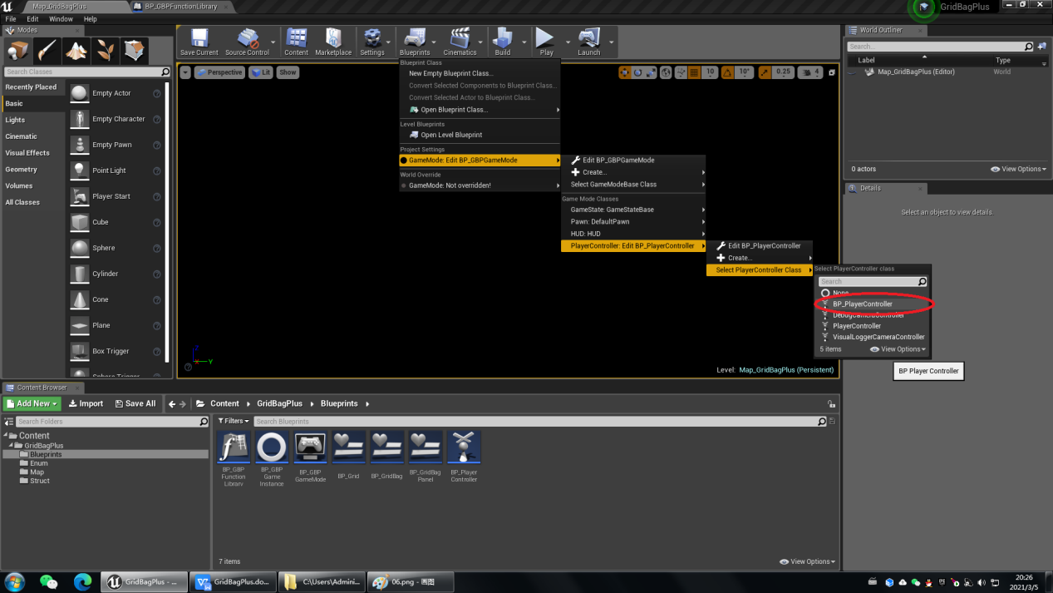

Installation is complete now.