DTMF Decoder Project Report

Contents

Introduction

DTMF stands for Dual Tone Multi Frequency. This is an in-band telecommunication signaling system using voice-frequency band over telephone lines between telephone equipment and other communications devices and switching centers. DTMF was first developed in the Bell System in the USA, and became known under the trademark Touch-Tone for use in the pushbutton telephones supplied to telephone customers, starting in 1963.[1] DTMF replaced the clockwork dial made of moving parts which was getting more and more impractical to use as the number of telephone users increased exponentially.

DTMF is used to represent up to 16 keys (most telephones only use 12 of these). Each key is represented by two differenct frequencies. The first bin (lower frequencies) consits of frequencies under 1kHz and the second bin (Upper bin) consists of frequencies above 1.2kHz. The combination of the two tones will be distinctive and different from tones of other keys and these tones cannot be mimicked by voice or random signals [2]. The DTMF Frequencies are shown in the figure below:

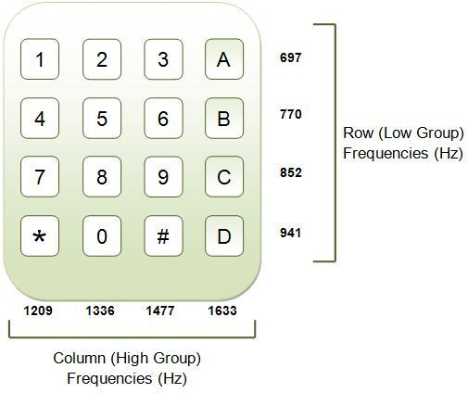Illustration 1: Picture showing the DTMF Frequencies used to represent each key.

DTMF detection is used to detect DTMF signals in the presence of speech and dialing tones pulses. Other applications of DTMF include, but not limited to, computer applications such as voice and electronic mail, call forwarding [3], controlling robots, automated locking and unlocking systems, displaying dialed numbers on a screen and sharing information consisting of numbers across various network sytems.[2]

The intent of this project is to design a DTMF Decoder and implement it in Java. I decided to choose this project because it dives into important concepts in both “sides” of my degree, that is Signal Processing and Software Design.

Research and Background
Although I did a introductory course to Signals and Systems in first semester of my second year, there was still a lot of concepts I had not grasped yet. Most of the knowledge needed to tackle this project was only going to be covered in my third year courses therefore after a long talk with my mentor who shed some much needed light on the project, I spent the whole first week researching on signal processing techniques by reading articles [4] and lectures on MIT OpenCourseWare [5]. All these helped build my understanding of signal processing and detection.
After looking at previous similar projects, most of which were implemented in Assembly and C for micro-controller projects, I noticed most of them used the Goertzel Algorithm to detect the DTMF frequencies. I decided to do more research on reasons why and it turns out it is a much faster method for computing DFTs (Direct Fourier Transform) for specific frequencies.

Goertzel's Algorithm
Created by Gerald Goertzel in 1958, the Goertzel Algortihm is a Digital Signal Processing technique that is used to efficiently compute individual terms of a Direct Fourier Transform (DFT). It returns the real and imaginary frequency components that a regular DFT or Fast Fourier Transform (FFT) would.
Like the DFT, the Goertzel algorithm analyses one selectable frequency component from a discrete signal.[6][7] Unlike direct DFT calculations, the Goertzel algorithm applies a single real-valued coefficient at each iteration, using real-valued arithmetic for real-valued input sequences. For covering a full spectrum, the Goertzel algorithm has a higher order of complexity than (FFT) algorithms; but for computing a small number of selected frequency components, it is more numerically efficient.
The Goertzel Algorithm may be used to directly obtain DFT data about the 8 DTMF frequencies and compare their magnitudes to determine which tone is being represented.

Fast Fourier Transform

Another possible path to take could be using the FFT to get the whole frequency spectrum instead of just for the 8 DTMF frequencies. This is definitely a more cumbersome computation but it will allow me to detect other frequencies in the signal and decide where certain signals should be rejected or not.

Software Implementation

Prototyping

Java Implementation

Testing

API Specifications

Possible Improvements

Conclusion

References

1) DODD, A. Z. The essential guide to telecommunications
2) (picture) http://www.engineersgarage.com/tutorials/dtmf-dual-tone-multiple-frequency
3) G. L. Smith, Dual-Tone Multifrequency Receiver Using the WE DSP16 Digital Signal
Processor, AT&T Application Note.
4)
2010 4th International Symposium on Communications, Control and Signal Processing (ISCCSP 2010) p1-5

5) Alan Oppenheim. 6.341 Discrete-Time Signal Processing, Fall 2005. (Massachusetts Institute of Technology: MIT OpenCourseWare), http://ocw.mit.edu (Accessed 26 Jan, 2016). License: Creative Commons BY-NC-SA
6) Mock, P. (March 21, 1985), "Add DTMF Generation and Decoding to DSP-μP Designs" (PDF), EDN, ISSN 0012-7515; also found in DSP Applications with the TMS320 Family, Vol. 1, Texas Instruments, 1989.
7) Chen, Chiouguey J. (June 1996), Modified Goertzel Algorithm in DTMF Detection Using the TMS320C80 DSP (PDF), Application Report, SPRA066, Texas Instruments

