**Activities**

**Part A**

**A brief overview of the programming langauges**

1. Python:

- Known for readability and simplicity.

- Versatile and widely used in web development, data analysis, artificial intelligence, and automation.

2. JavaScript:

- Primarily used for front-end web development.

- Enables interactive and dynamic user interfaces.

3. Java:

- Platform-independent language, known for its "write once, run anywhere" principle.

- Commonly used in enterprise-level applications and Android app development.

4. C++:

- An extension of C, providing object-oriented programming features.

- Widely used in game development, systems programming, and performance-critical applications.

5. C# (C Sharp):

- Developed by Microsoft, primarily used for building Windows applications and games.

- Integrates well with the .NET framework.

6. PHP:

- Server-side scripting language used for web development.

- Powers many dynamic websites and is often embedded in HTML code.

7. Ruby:

- Known for its elegant syntax and productivity.

- Often used in web development, particularly with the Ruby on Rails framework.

8. Swift:

- Developed by Apple for iOS, macOS, watchOS, and tvOS app development.

- Emphasizes safety and performance.

9. Go (Golang):

- Developed by Google, known for its efficiency and simplicity.

- Used in backend development, especially for scalable and concurrent applications.

10. Rust:

- Focuses on safety and performance, particularly in system-level programming.

- Gaining popularity for building reliable and fast systems.

I chose **java** to design a graphical user interface (GUI) that can be used during selling

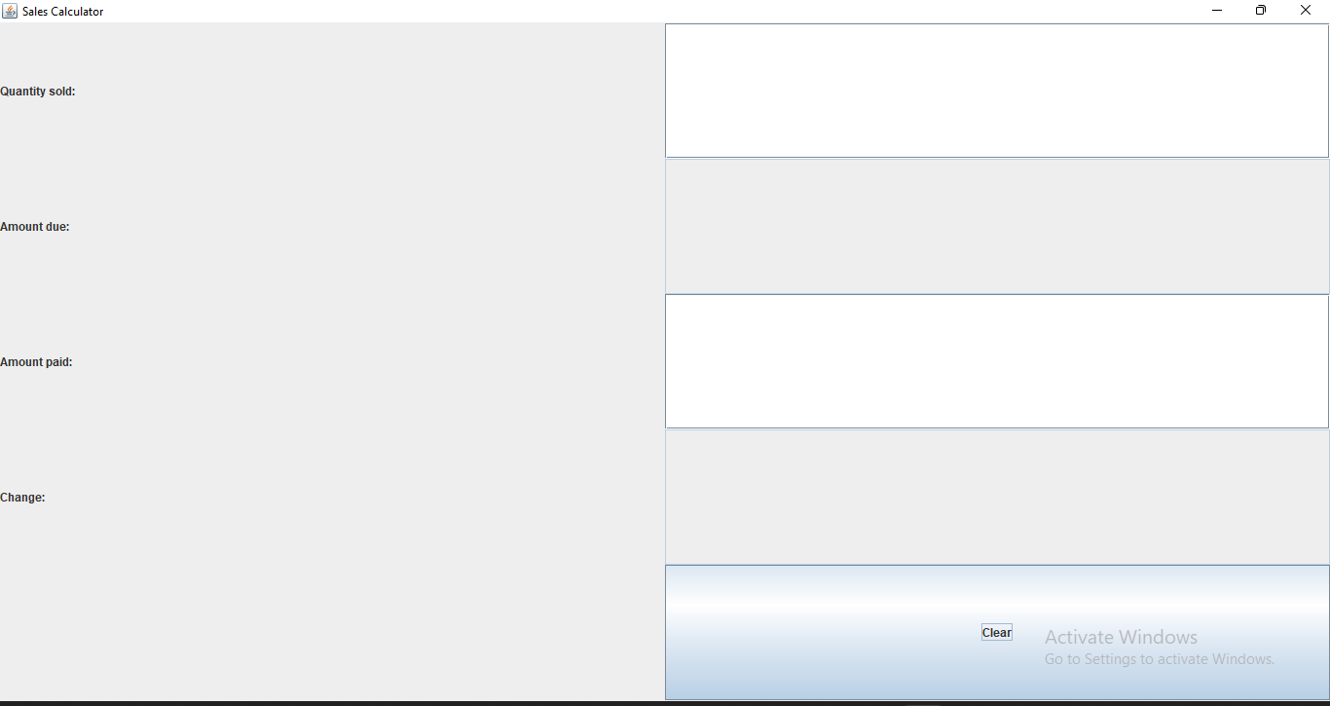

**Part B**

**This shows the user entering the quantity sold, the amount due is automatically calculated.**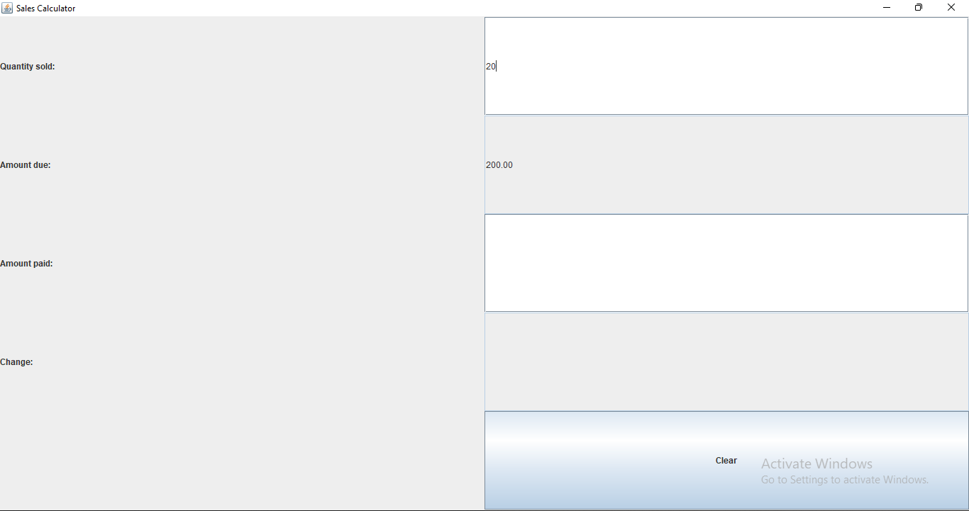

**This shows the change of the customer using amount due and the amount paid and display the Success Message where the amount paid was $450.**

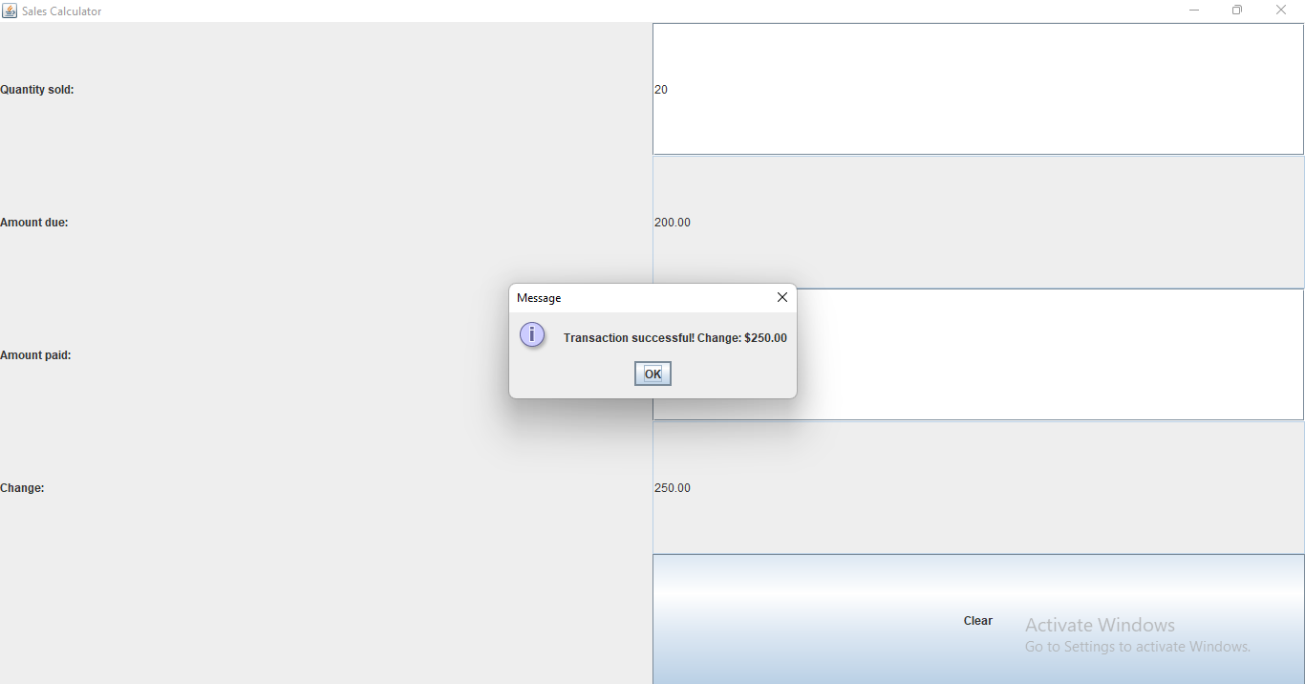

**This shows the functions of clear button where it clears all the textboxes in preparation of the next**