**GUIDELINE**

1. The project should run in Apache NetBeans IDE 19
2. Download the project in the “Final Project” folder on Google Drive
3. Download all require file and package:

* Java platform JDK 17
* jcommon-1.0.23
* jfreechart-1.0.19
* mysql-connector-java-8.0.27
* RojeruSan.parte1
* RSCalendar
* RSFoto_1.0

All the file has been included in the “Required Jar Files” in the folder on Google Drive

1. In NetBeans IDE, open the project that you have already download, then

rightclick to the libraries section and then chooes add JAR/Folder.

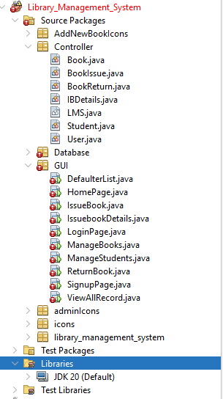

1. Choose 6 file in “Required Jar Files” and then add to the library

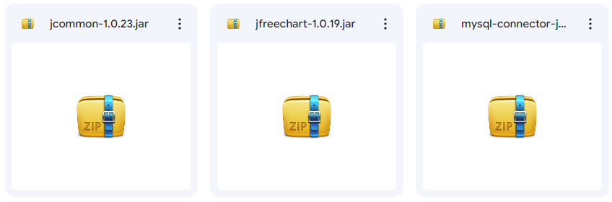

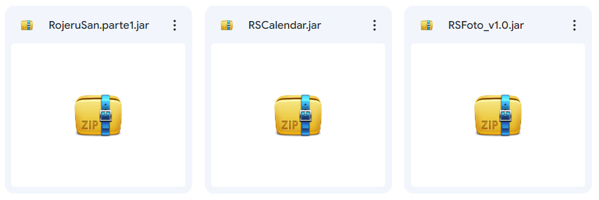

1. Download XAMPP and install then open it so it will show as below

<https://www.apachefriends.org/download.html>

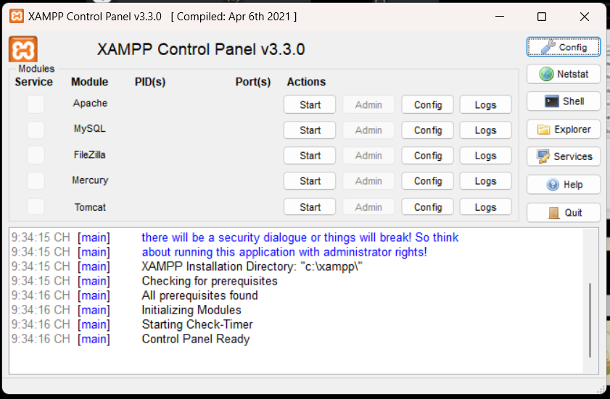

1. Press “Start” at Apache row and then press “Start” at MySQL row
2. Press “Admin” at MySQL row to show this figure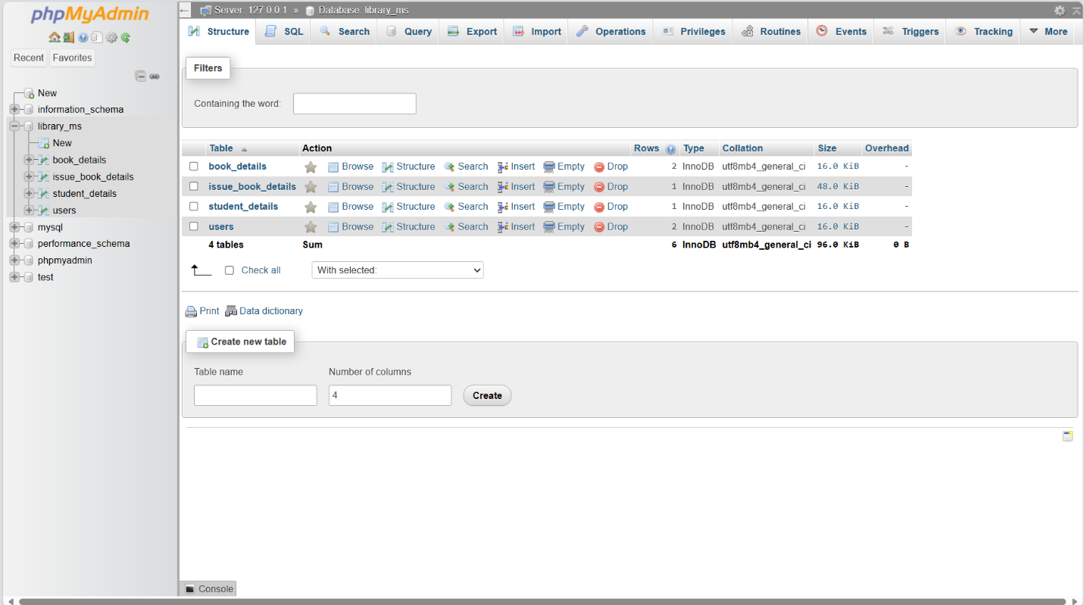
3. Choose this SQL tab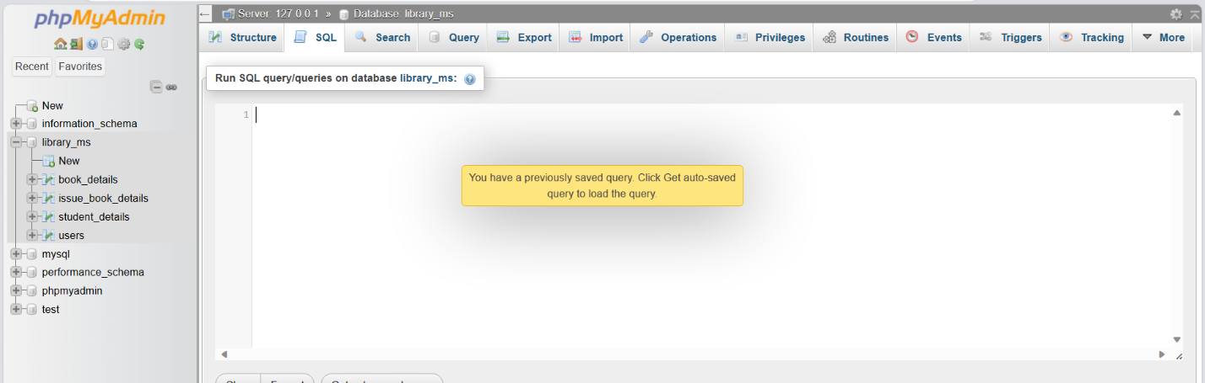
4. Paste the database code in database.txt in Required JAR Files on Google Drive to create tables

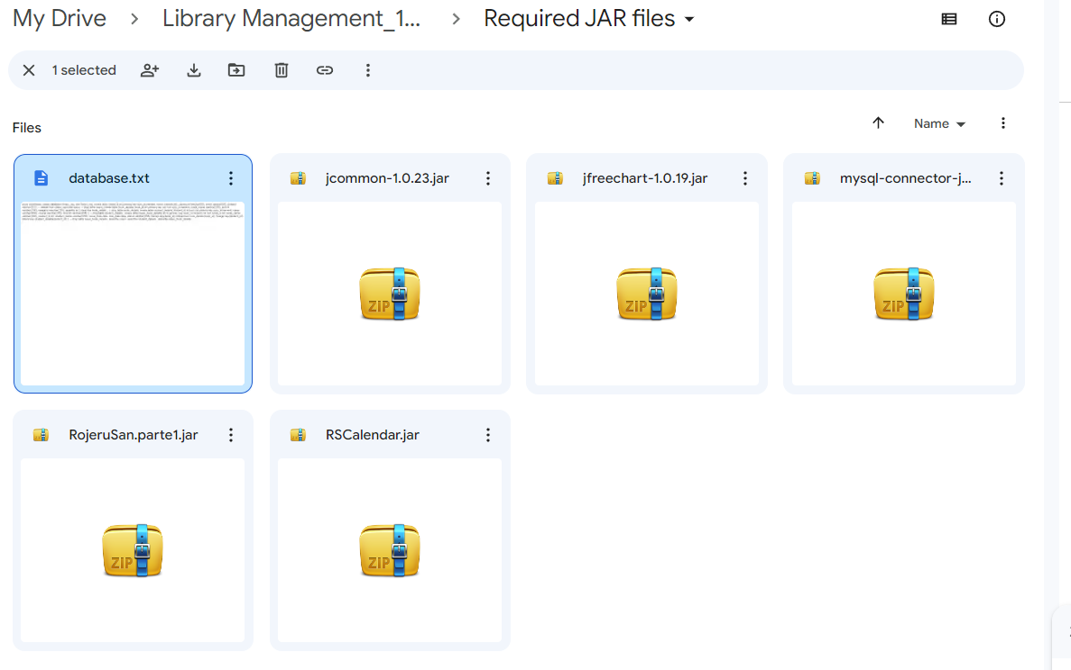

1. Press the “Go” button as shown
2. Finally, go back to NetBeans and run the project