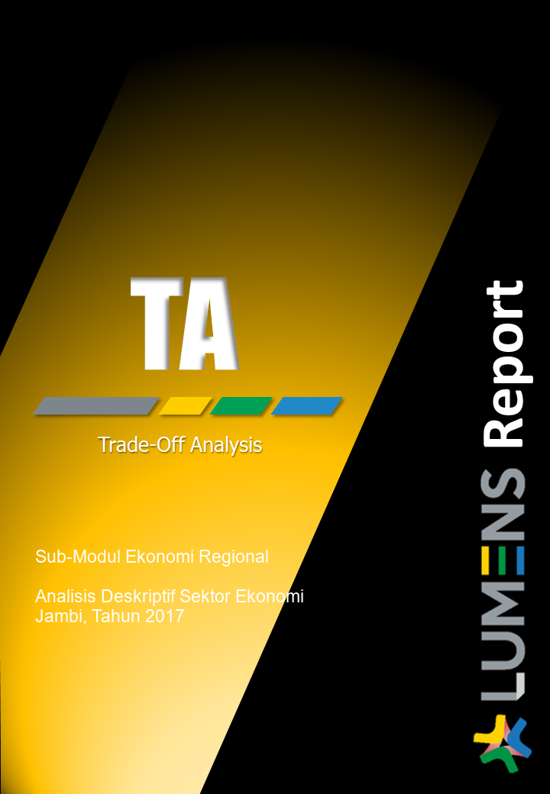
LUMENS-Trade-off Analysis (TA) Project Report
Sub-modules 2: Regional economic-Descriptive analysis (Single I-O)

------------------------------------------------------------------------------------------------------------------------------------------------
Date : 2019-07-04
Processing started : 2019-07-04 17:57:36
Processing ended : 2019-07-04 17:57:36
------------------------------------------------------------------------------------------------------------------------------------------------

1.Analysis of Sectoral Linkages

Table 1. Sectoral linkages.
SECTOR | CATEGORY | DBL | DFL | BPD | FPD
Padi | Direct land-based | 1.15 | 1.76 | 0.8 | 1.22
Tanaman Bahan Makanan lainnya | Direct land-based | 1.15 | 1.54 | 0.8 | 1.06
Karet | Direct land-based | 1.27 | 1.45 | 0.88 | 1
Kelapa Sawit | Direct land-based | 1.22 | 1.44 | 0.85 | 0.99
Kopi | Direct land-based | 1.15 | 1.24 | 0.8 | 0.86
Tanaman Pekebunan Lainnya | Direct land-based | 1.3 | 1.23 | 0.9 | 0.85
Peternakan dan hasil-hasilnya | Direct land-based | 1.62 | 1.44 | 1.13 | 1
Kayu | Direct land-based | 1.26 | 1.4 | 0.87 | 0.97
Hasil hutan lainnya | Direct land-based | 1.22 | 1.38 | 0.85 | 0.95
Perikanan | Direct land-based | 1.35 | 1.28 | 0.94 | 0.89
Pertambangan Migas | Direct land-based | 1.29 | 1.6 | 0.89 | 1.11
Pertambangan non-Migas | Direct land-based | 1.23 | 1.04 | 0.85 | 0.72
Penggalian | Direct land-based | 1.32 | 1.5 | 0.92 | 1.04
Pengilangan minyak bumi | Direct land-based | 1.72 | 1.88 | 1.19 | 1.3
Industri penggilingan padi, biji-bijian | Indirect land-based | 1.85 | 1.18 | 1.28 | 0.82
Industri Kelapa Sawit | Indirect land-based | 1.79 | 1.23 | 1.24 | 0.85
Industri Makanan dan Minuman Lainnya, kimia dan barang dari karet | Indirect land-based | 1.87 | 2.17 | 1.3 | 1.5
Industri Barang dari Kayu dan Hasil hutan lainnya, barang lain bukan logam | Indirect land-based | 1.88 | 1.3 | 1.3 | 0.9
Industri Barang dari Karet dan Plastik, besi dan baja | Indirect land-based | 1.85 | 1.23 | 1.28 | 0.85
Industri kertas dan barang dari kertas, mesin dan peralatan | Indirect land-based | 1.55 | 1.36 | 1.07 | 0.94
Industri pupuk dan bahan kimia | Indirect land-based | 1.4 | 1.06 | 0.97 | 0.73
Industri semen, dan barang galian bukan logam | Indirect land-based | 1.71 | 1.18 | 1.19 | 0.81
Industri Lainnya | Indirect land-based | 1.33 | 1.04 | 0.92 | 0.72
Listrik, Gas dan Air Bersih | Non land-based | 1.53 | 1.1 | 1.06 | 0.76
Konstruksi | Non land-based | 1.57 | 1.57 | 1.09 | 1.09
Perdagangan Besar dan Eceran | Non land-based | 1.65 | 3.14 | 1.15 | 2.18
Transportasi ,sungai, dan penyeberangan | Non land-based | 1.72 | 2.3 | 1.19 | 1.6
Penyediaan Akomodasi dan Makan Minum | Non land-based | 1.67 | 1.33 | 1.16 | 0.92
Informasi dan Komunikasi | Non land-based | 1.47 | 2.11 | 1.02 | 1.46
Jasa Keuangan dan Asuransi | Non land-based | 1.59 | 1.86 | 1.11 | 1.29
Real Estate dan Jasa Perusahaan | Non land-based | 1.73 | 1.85 | 1.2 | 1.28
Jasa Administrasi Pemerintahan | Non land-based | 1.37 | 1 | 0.95 | 0.69
Jasa Pendidikan | Non land-based | 1.43 | 1.16 | 0.99 | 0.8
Jasa Kesehatan dan Kegiatan Sosial | Non land-based | 1.39 | 1.12 | 0.96 | 0.78
Jasa lainnya, rekreasi & kebudayaan | Non land-based | 1.34 | 1.5 | 0.93 | 1.04
Kegiatan lainnya | Non land-based | 0 | 0 | 0 | 0

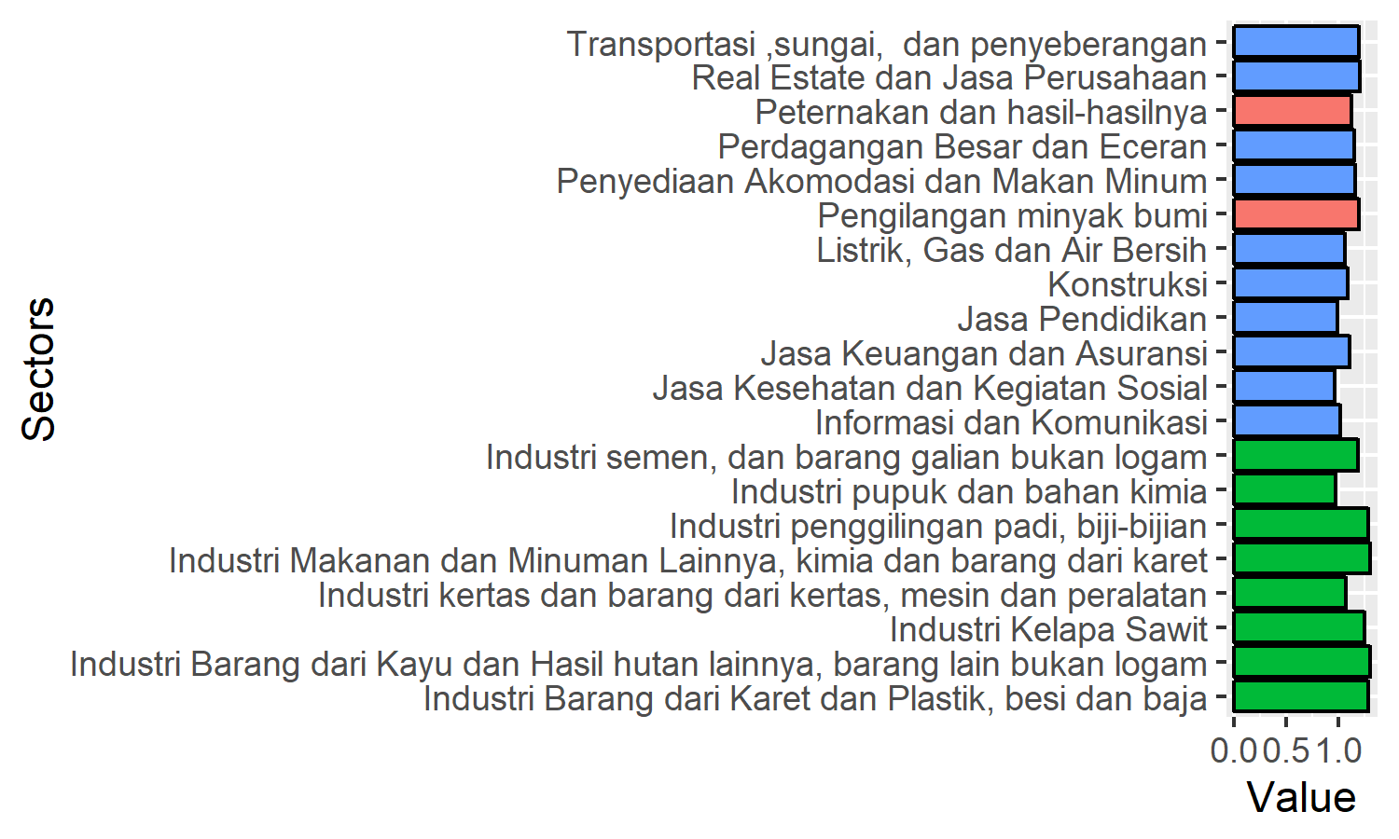
Figure 1. Ten sectors with highest Backward power of dispersion.

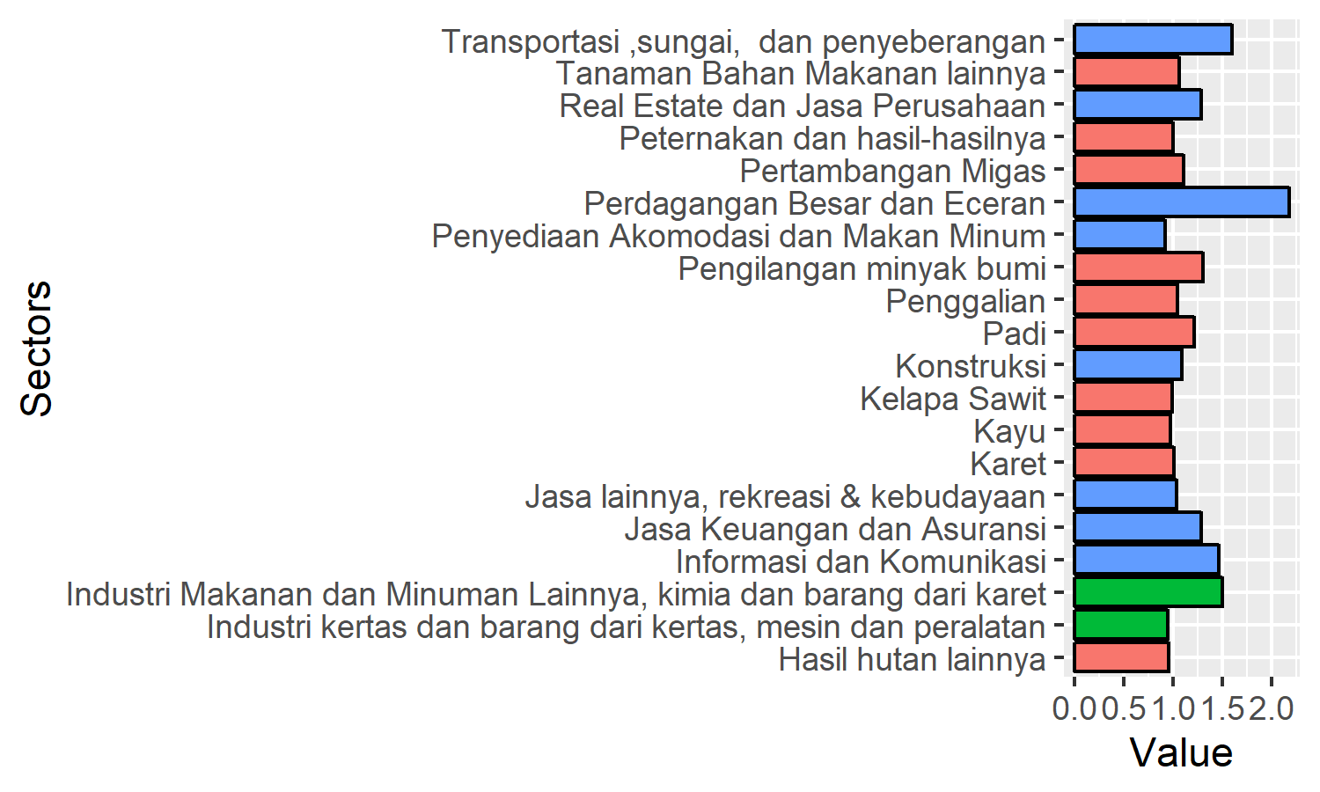
Figure 2. Ten sectors with highest Forward power of dispersion.

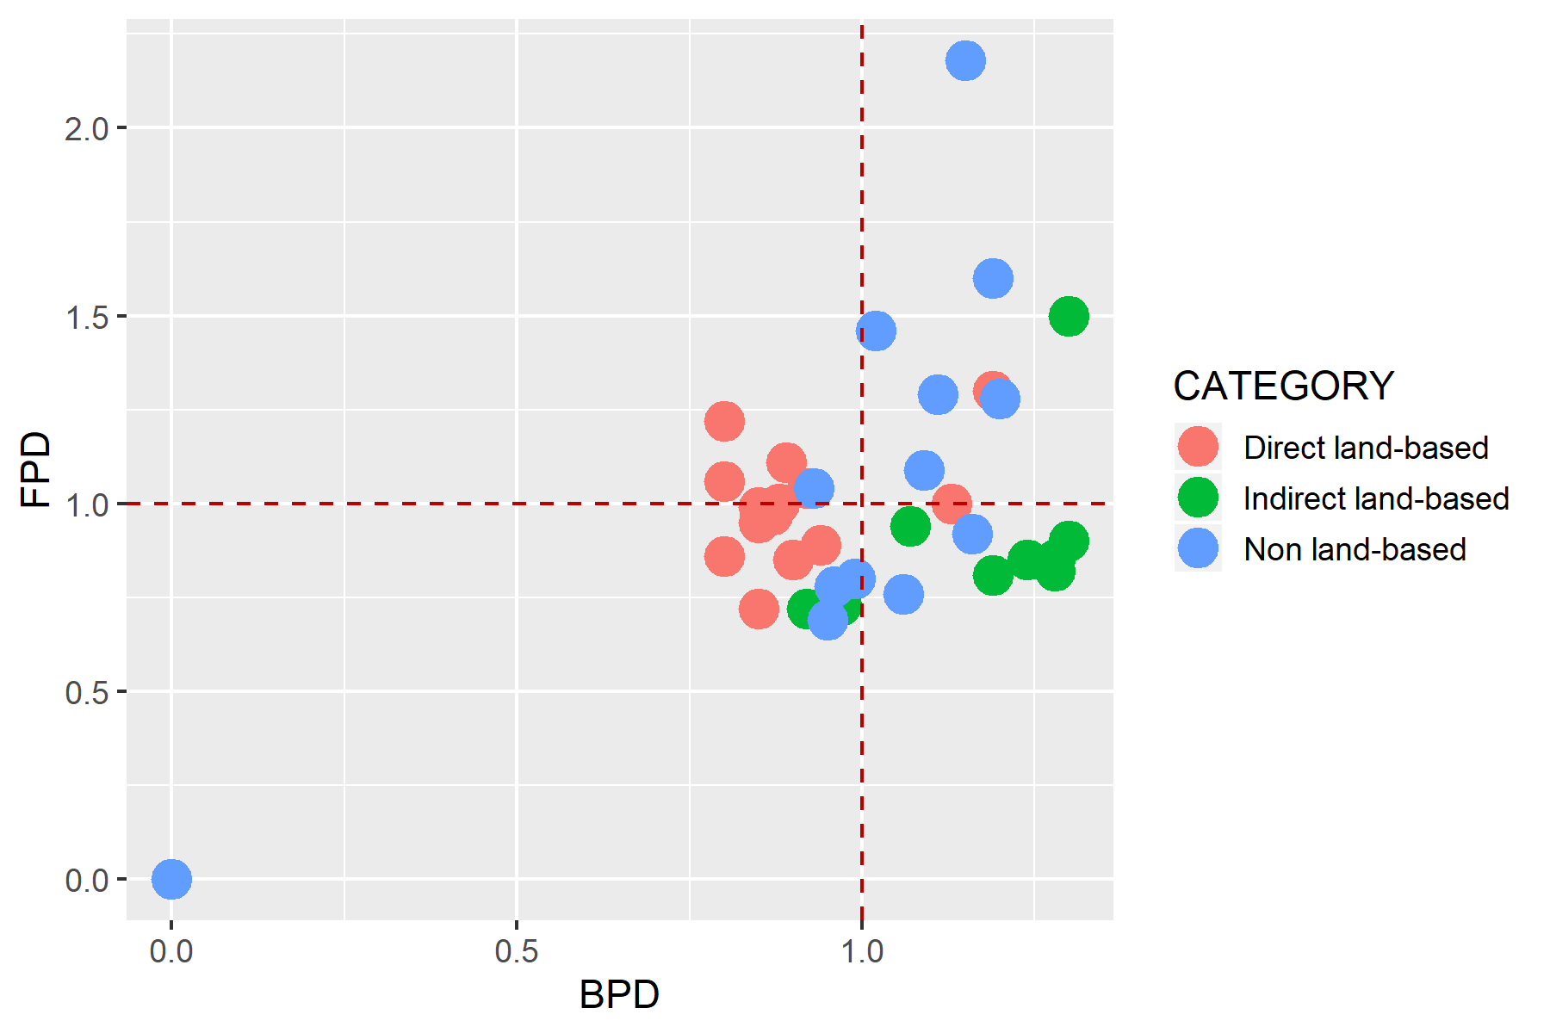
Figure 3. Sectoral typology based on linkages analysis.

Table 2. Primary sectors based on potential linkage.
SECTOR | CATEGORY | DBL | DFL
Pengilangan minyak bumi | Direct land-based | 1.19024914431007 | 1.302773857271
Industri Makanan dan Minuman Lainnya, kimia dan barang dari karet | Indirect land-based | 1.29552834534511 | 1.50402072369414
Konstruksi | Non land-based | 1.08677408291682 | 1.08785747884754
Perdagangan Besar dan Eceran | Non land-based | 1.14551951522401 | 2.17730827900902
Transportasi ,sungai, dan penyeberangan | Non land-based | 1.18931707853018 | 1.5951290000694
Informasi dan Komunikasi | Non land-based | 1.0159123540539 | 1.46179217686955
Jasa Keuangan dan Asuransi | Non land-based | 1.10515585010144 | 1.29029750070864
Real Estate dan Jasa Perusahaan | Non land-based | 1.19983035185046 | 1.28277410884823

2.Analysis of GDP

Total GDP
175560136.36178

Table 3. Sectoral GDP.
SECTOR | CATEGORY | GDP | OUTPUT | P_OUTPUT | P_GDP
Padi | Direct land-based | 4796796.6 | 6398407.2 | 0.75 | 0.03
Tanaman Bahan Makanan lainnya | Direct land-based | 11121586.2 | 15002651.3 | 0.74 | 0.06
Karet | Direct land-based | 5337946 | 8027716.9 | 0.66 | 0.03
Kelapa Sawit | Direct land-based | 1745649.9 | 2320884.2 | 0.75 | 0.01
Kopi | Direct land-based | 6171140.6 | 7290987.4 | 0.85 | 0.04
Tanaman Pekebunan Lainnya | Direct land-based | 15981872.7 | 21886184.4 | 0.73 | 0.09
Peternakan dan hasil-hasilnya | Direct land-based | 2879203 | 4913562 | 0.59 | 0.02
Kayu | Direct land-based | 2292503.7 | 2936746.4 | 0.78 | 0.01
Hasil hutan lainnya | Direct land-based | 1119166.2 | 1366582.1 | 0.82 | 0.01
Perikanan | Direct land-based | 2485390.2 | 3288715.1 | 0.76 | 0.01
Pertambangan Migas | Direct land-based | 18947340.6 | 28964473.4 | 0.65 | 0.11
Pertambangan non-Migas | Direct land-based | 8258195.8 | 11047644.7 | 0.75 | 0.05
Penggalian | Direct land-based | 2424987.3 | 3286742.6 | 0.74 | 0.01
Pengilangan minyak bumi | Direct land-based | 1778291.9 | 3462010 | 0.51 | 0.01
Industri penggilingan padi, biji-bijian | Indirect land-based | 3400774.8 | 11392356.2 | 0.3 | 0.02
Industri Kelapa Sawit | Indirect land-based | 3753111 | 8313709.1 | 0.45 | 0.02
Industri Makanan dan Minuman Lainnya, kimia dan barang dari karet | Indirect land-based | 2757959.2 | 9647090.5 | 0.29 | 0.02
Industri Barang dari Kayu dan Hasil hutan lainnya, barang lain bukan logam | Indirect land-based | 859462.9 | 2266246.7 | 0.38 | 0
Industri Barang dari Karet dan Plastik, besi dan baja | Indirect land-based | 2831492.6 | 7282437.2 | 0.39 | 0.02
Industri kertas dan barang dari kertas, mesin dan peralatan | Indirect land-based | 1094437.1 | 2179078 | 0.5 | 0.01
Industri pupuk dan bahan kimia | Indirect land-based | 127055.8 | 181929.3 | 0.7 | 0
Industri semen, dan barang galian bukan logam | Indirect land-based | 363280.9 | 792424.5 | 0.46 | 0
Industri Lainnya | Indirect land-based | 249688.7 | 521909.7 | 0.48 | 0
Listrik, Gas dan Air Bersih | Non land-based | 438480 | 625362.9 | 0.7 | 0
Konstruksi | Non land-based | 12094324.3 | 24304962.3 | 0.5 | 0.07
Perdagangan Besar dan Eceran | Non land-based | 20372636.6 | 37209870.2 | 0.55 | 0.12
Transportasi ,sungai, dan penyeberangan | Non land-based | 5914375.6 | 15074545.3 | 0.39 | 0.03
Penyediaan Akomodasi dan Makan Minum | Non land-based | 1979630.9 | 3697922.2 | 0.54 | 0.01
Informasi dan Komunikasi | Non land-based | 7096292.9 | 10589068 | 0.67 | 0.04
Jasa Keuangan dan Asuransi | Non land-based | 4576207.8 | 7665582 | 0.6 | 0.03
Real Estate dan Jasa Perusahaan | Non land-based | 4776620.8 | 9708223.1 | 0.49 | 0.03
Jasa Administrasi Pemerintahan | Non land-based | 7713187.9 | 11325333.5 | 0.68 | 0.04
Jasa Pendidikan | Non land-based | 6167114.7 | 9642230.8 | 0.64 | 0.04
Jasa Kesehatan dan Kegiatan Sosial | Non land-based | 1996647.2 | 2877512.6 | 0.69 | 0.01
Jasa lainnya, rekreasi & kebudayaan | Non land-based | 1657283.9 | 2560489.2 | 0.65 | 0.01
Kegiatan lainnya | Non land-based | 0 | 0 | - | 0

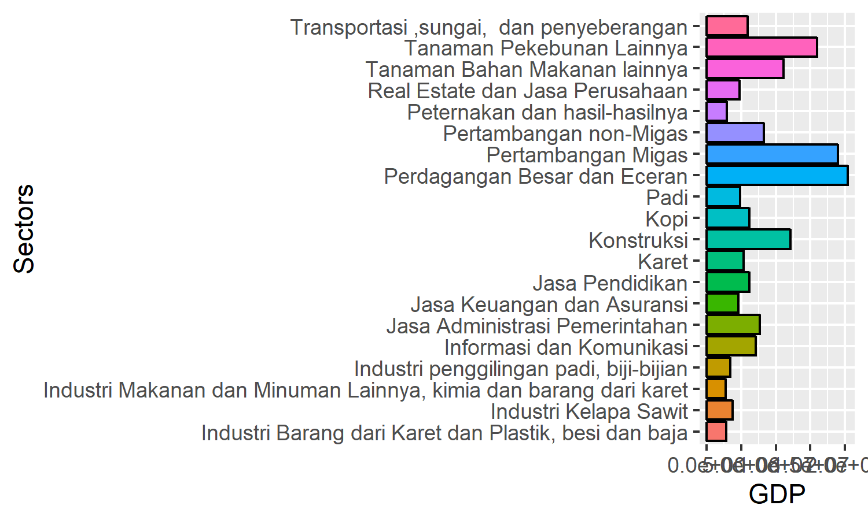
Figure 4. Twenty sectors with highest GDP.
2.Analysis of multiplier

Table 4. Sectoral multiplier.
SECTOR | CATEGORY | Out.multiplier | Inc.multiplier | Lab.multiplier
Padi | Direct land-based | 1.149 | 1.012 | 1.53427470910653e-07
Tanaman Bahan Makanan lainnya | Direct land-based | 1.151 | 0.989 | 4.11231172930015e-07
Karet | Direct land-based | 1.267 | 0.847 | 3.55386913326498e-08
Kelapa Sawit | Direct land-based | 1.223 | 0.929 | 4.39853709099139e-07
Kopi | Direct land-based | 1.152 | 0.964 | 5.48236550671381e-08
Tanaman Pekebunan Lainnya | Direct land-based | 1.296 | 0.84 | 1.23710876361904e-06
Peternakan dan hasil-hasilnya | Direct land-based | 1.625 | 0.807 | 2.03599924165557e-06
Kayu | Direct land-based | 1.262 | 0.895 | 3.28364669275595e-07
Hasil hutan lainnya | Direct land-based | 1.225 | 1.002 | 8.04711513751197e-07
Perikanan | Direct land-based | 1.352 | 0.869 | 1.23825221957902e-07
Pertambangan Migas | Direct land-based | 1.291 | 0.932 | 3.77866804706402e-07
Pertambangan non-Migas | Direct land-based | 1.226 | 0.735 | 7.28350553167216e-10
Penggalian | Direct land-based | 1.323 | 0.918 | 2.66426620716584e-07
Pengilangan minyak bumi | Direct land-based | 1.718 | 1.071 | 1.29624092624899e-06
Industri penggilingan padi, biji-bijian | Indirect land-based | 1.847 | 0.381 | 2.26701007613593e-07
Industri Kelapa Sawit | Indirect land-based | 1.794 | 0.548 | 4.21866833395121e-08
Industri Makanan dan Minuman Lainnya, kimia dan barang dari karet | Indirect land-based | 1.87 | 0.848 | 1.1819611629996e-06
Industri Barang dari Kayu dan Hasil hutan lainnya, barang lain bukan logam | Indirect land-based | 1.88 | 0.507 | 1.2061341291854e-06
Industri Barang dari Karet dan Plastik, besi dan baja | Indirect land-based | 1.853 | 0.444 | 9.08348163962623e-08
Industri kertas dan barang dari kertas, mesin dan peralatan | Indirect land-based | 1.547 | 0.693 | 2.84843521746802e-06
Industri pupuk dan bahan kimia | Indirect land-based | 1.396 | 0.71 | 4.35770892948333e-05
Industri semen, dan barang galian bukan logam | Indirect land-based | 1.71 | 0.492 | 3.49085969039262e-07
Industri Lainnya | Indirect land-based | 1.334 | 0.47 | 3.40422526251379e-08
Listrik, Gas dan Air Bersih | Non land-based | 1.532 | 0.825 | 2.47644951824288e-07
Konstruksi | Non land-based | 1.568 | 0.796 | 4.32278530721685e-07
Perdagangan Besar dan Eceran | Non land-based | 1.653 | 1.625 | 2.5536938147294e-06
Transportasi ,sungai, dan penyeberangan | Non land-based | 1.716 | 1.076 | 2.41223434973212e-06
Penyediaan Akomodasi dan Makan Minum | Non land-based | 1.672 | 0.672 | 2.97469403621736e-07
Informasi dan Komunikasi | Non land-based | 1.466 | 1.275 | 1.39135393755712e-06
Jasa Keuangan dan Asuransi | Non land-based | 1.595 | 1.056 | 9.65067217123746e-07
Real Estate dan Jasa Perusahaan | Non land-based | 1.732 | 0.932 | 1.05335773559681e-06
Jasa Administrasi Pemerintahan | Non land-based | 1.369 | 0.634 | 1.89088769128694e-09
Jasa Pendidikan | Non land-based | 1.429 | 0.727 | 3.30883685326151e-07
Jasa Kesehatan dan Kegiatan Sosial | Non land-based | 1.392 | 0.746 | 3.26706185353037e-08
Jasa lainnya, rekreasi & kebudayaan | Non land-based | 1.34 | 0.893 | 1.51369894111012e-06
Kegiatan lainnya | Non land-based | 0 | 0 | 0

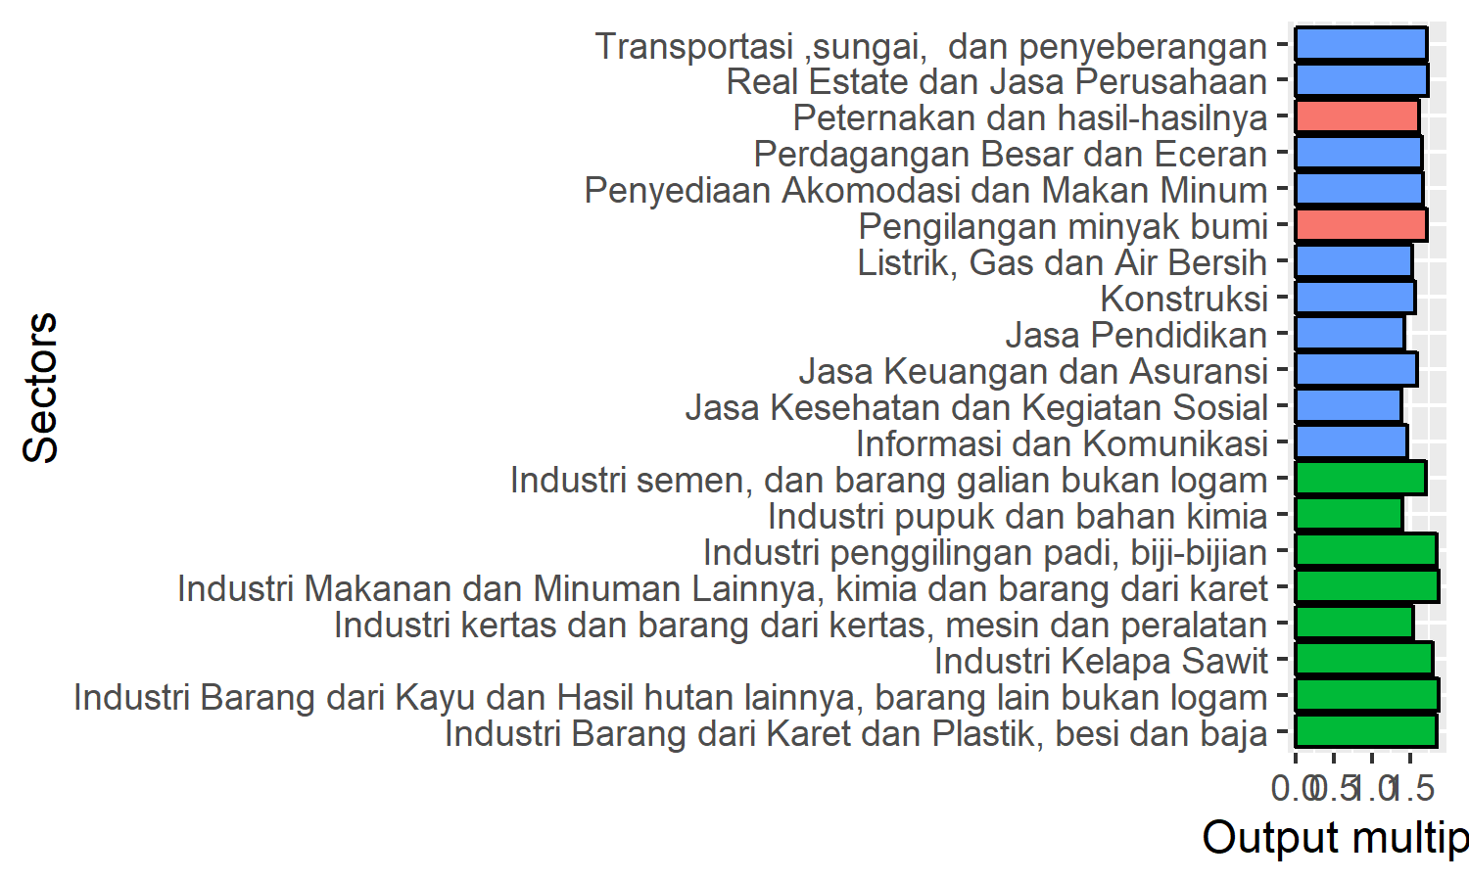
Figure 5. Twenty sectors with highest Output multiplier.

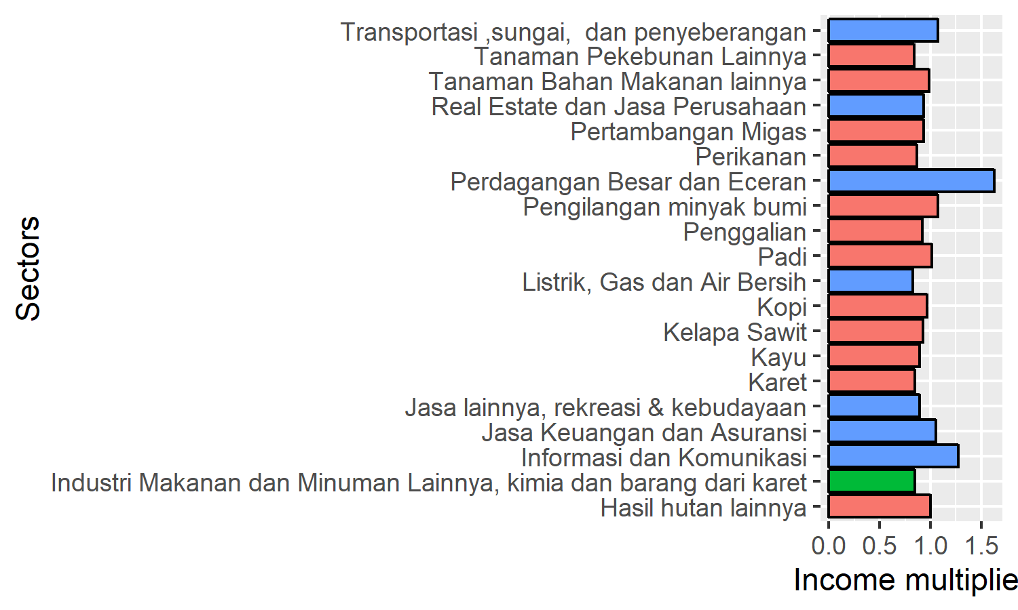
Figure 6. Twenty sectors with highest Income multiplier.

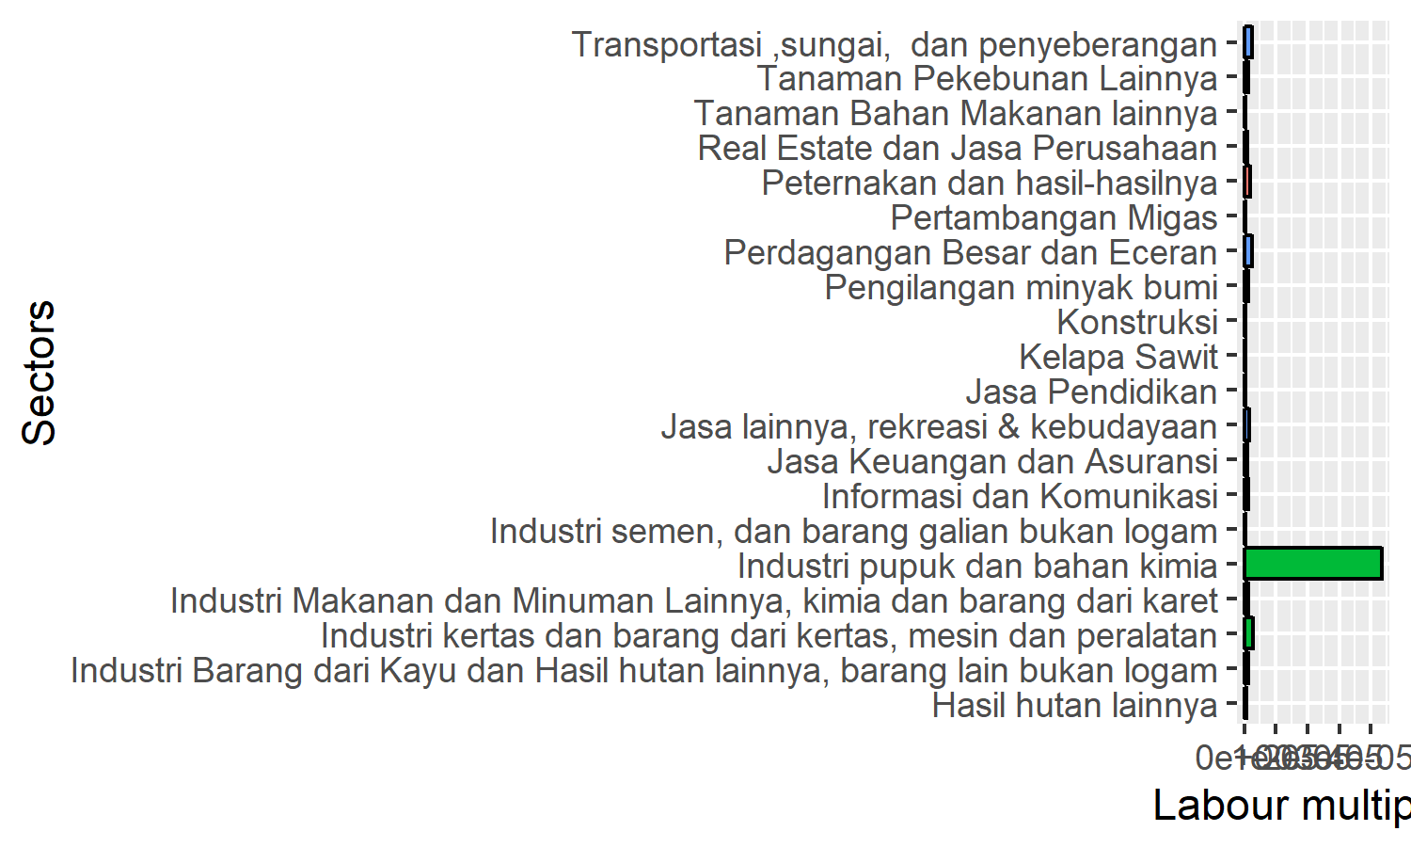
Figure 5. Twenty sectors with highest Labour multiplier.

