PENETRATION TESTING REPORT
FOOTPRINTING & NETWORK SCANNING PHASES
W2-PM-FINAL | CYBERSECURITY | NETWORKWALKS

Pentester Name | Tin Maung Soe
Program / Batch | B082 – Networkwalks
Report Date | 10 November 2026
Modules Completed | W2-PM1 – Footprinting with Multiple Kali Tools; W2-PM5 – Zenmap-Based Network Scanning
Client / Target | networkwalks.com (authorized training target); own VMware VMnet1 local network
Permission Secured | Yes – as stated in the training/sample report
Phases Covered | Phase 1: Reconnaissance & Footprinting; Phase 2: Scanning & Network Discovery

NETWORKWALKS – REMOTE CYBERSECURITY INTERNSHIP

1. Liability Disclaimer
This report documents educational reconnaissance and network-discovery activities completed as part of the Networkwalks cybersecurity internship. Testing of networkwalks.com was conducted within the scope and permission described by the training programme. The local network scan was limited to the trainee's own VMware VMnet1 virtual network.
The activities described are limited to passive or non-destructive information gathering and host discovery. No exploitation, password attacks, denial-of-service testing, data modification, or attempts to bypass security controls were performed. The observations in this report are not proof of exploitable vulnerabilities. Any further assessment must be separately authorized and conducted within an agreed scope. The author accepts responsibility for ensuring that tools are used only against systems for which appropriate permission has been obtained.

2. Introduction
The purpose of Week 2 was to practise two foundational penetration-testing activities: footprinting a permitted domain using multiple Kali Linux tools, and discovering active devices on a local network using Zenmap, the graphical interface for Nmap.
For W2-PM1, the target domain was networkwalks.com. The work collected publicly observable domain-registration, DNS, web-technology, HTTP-header, and web-application-firewall information. For W2-PM5, Windows network configuration was reviewed to identify the VMware VMnet1 subnet, then a Zenmap Ping Scan was run against that subnet to identify responsive hosts.
The report records the results visible in the supplied screenshots. Where an output does not show a value, that value is not assumed or reconstructed.

3. Tools Used
Tool | Purpose
WHOIS | Retrieves domain-registration details, registrar information, registration dates, and name servers.
WhatWeb | Identifies web-server technologies, content-management systems, frameworks, and other visible web components.
Nslookup | Queries DNS to resolve a domain name to an IP address.
cURL (-I) | Requests HTTP response headers without downloading the full page body.
Wafw00f | Checks whether a website appears to be protected by a web application firewall (WAF).
DNSRecon | Enumerates DNS records such as A, NS, MX, TXT, and SRV records.
Zenmap / Nmap | Performs network discovery; the Ping Scan profile checks which hosts respond without conducting a port scan.
Windows ipconfig | Displays local network adapter configuration, IPv4 addresses, and subnet masks.

4. Activities Performed

4.1 Footprinting & Reconnaissance (W2-PM1)

4.1.1 WHOIS – Domain Registration Information
Command executed: whois networkwalks.com
The WHOIS lookup returned registration information for networkwalks.com. The visible output identified GoDaddy.com, LLC as the registrar and showed a domain creation date of 6 November 2019 and a registry expiry date of 6 November 2027. The record listed the name servers NS6135.HOSTGATOR.COM and NS6136.HOSTGATOR.COM. Registrant information was privacy-protected through Domains By Proxy, LLC.
The lookup also displayed registrar status flags, including clientTransferProhibited, clientUpdateProhibited, clientRenewProhibited, and clientDeleteProhibited. These are registration status controls and should not be interpreted as evidence of a website vulnerability.

4.1.2 WhatWeb – Web Technology Identification
Command executed: whatweb networkwalks.com
WhatWeb identified Apache as the web server and WordPress 7.1.4 as the content-management system. The output also identified HTML5, Bootstrap 3.7.1, WP Download Manager 3.3.76, and Google Tag Manager. The domain was shown resolving to 192.232.216.135. The tool also reported HTTP behaviour including a 301 redirect to the HTTPS version and a successful 200 response for the HTTPS site.
This information provides a preliminary view of the technologies exposed by the website. Technology identification alone does not establish that any component is outdated or vulnerable.

4.1.3 Nslookup – DNS Resolution
Command executed: nslookup networkwalks.com
The query used DNS server 8.8.8.8 and returned a non-authoritative answer mapping networkwalks.com to 192.232.216.135. This confirms the IP address returned by the resolver at the time the command was run.

4.1.4 cURL – HTTP Response Headers
Command executed: curl -I https://networkwalks.com
The server returned HTTP/2 200, indicating that the HTTPS request succeeded. The visible headers included server: Apache, content-type: text/html; charset=UTF-8, cache-related headers, and WordPress-related link information. A Link header exposed the WordPress REST API endpoint at /wp-json/ and referenced a WordPress API resource. The response also included a permissions-policy header and a referrer-policy header.
HTTP headers can disclose useful information about the server and application. Their presence is an observation for configuration review, not a confirmed security weakness.

4.1.5 Wafw00f – Web Application Firewall Detection
Command executed: wafw00f networkwalks.com
Wafw00f reported that https://networkwalks.com is behind a ModSecurity (SpiderLabs) web application firewall. The screenshot shows that the detection completed after two requests. This indicates that the tool identified a WAF signature; it does not verify the effectiveness or completeness of the site's protection.

4.1.6 DNSRecon – DNS Enumeration
Command executed: dnsrecon -d networkwalks.com
DNSRecon completed general enumeration and reported DNS information including SOA, NS, A, MX, TXT, and SRV records. The visible output listed the SOA record against ns6135.hostgator.com, name servers ns6135.hostgator.com and ns6136.hostgator.com, and an A record resolving networkwalks.com to 192.232.216.135. It also listed mail.networkwalks.com as an MX host resolving to 192.232.216.135.
The TXT output included an SPF policy beginning with v=spf1 and a Google site-verification record. The SRV enumeration displayed several autodiscover entries associated with cpanelemaildiscovery.cpanel.net on port 443. DNSRecon reported that enumeration was completed and displayed '8 Records Found'.

4.2 Network Scanning with Zenmap (W2-PM5)

4.2.1 Identifying the Local Subnet
The Windows ipconfig output showed several network adapters. The VMware Network Adapter VMnet1 had IPv4 address 192.168.254.1 and subnet mask 255.255.255.0, identifying the 192.168.254.0/24 subnet used for this exercise. The same output showed VMnet8 as 192.168.142.1/24 and the Wi-Fi adapter as 10.222.86.117/24. The scan target was specifically the VMnet1 subnet, not the Wi-Fi subnet.

4.2.2 Zenmap Ping Scan
In Zenmap, the target was set to 192.168.254.0/24 and the profile was set to Ping scan. The command displayed by Zenmap was: nmap -sn 192.168.254.0/24. The scan output reported that 256 IP addresses were scanned and 2 hosts were up.
Live host | MAC address shown in screenshot | Observation
192.168.254.1 | Not displayed in the visible output | Host responded to the Ping Scan; this is the VMnet1 adapter address shown by ipconfig.
192.168.254.254 | 00:50:56:F2:94:F2 (VMware) | Host responded to the Ping Scan; Nmap identified the MAC vendor as VMware.

The scan therefore identified two responsive hosts on the selected /24 subnet. The visible output provides a MAC address for 192.168.254.254 only; no MAC address for 192.168.254.1 is reported here because it is not visible in the submitted scan output. A Ping Scan is a host discovery operation and does not, by itself, identify open ports or prove that a host is secure.

5. Risk Analysis / Impact
# | Risk / Finding | Evidence / Observation | Potential Impact | Risk Level
1 | Web technology information is identifiable | WhatWeb identified Apache, WordPress 7.1.4, Bootstrap 3.7.1 and WP Download Manager 3.3.76. | Technology details may help an attacker tailor later research if a component has a relevant weakness. | Informational
2 | HTTP response headers disclose platform details | cURL returned Apache and WordPress-related headers and exposed the /wp-json/ API link. | Unnecessary information disclosure may assist reconnaissance; no exploitable issue was demonstrated. | Low
3 | WAF identified by fingerprinting | Wafw00f detected ModSecurity (SpiderLabs). | A WAF is a protective control, but its detection does not confirm that rules are correctly configured or effective. | Informational
4 | DNS records reveal infrastructure details | DNSRecon listed mail, name-server, TXT, SPF and SRV records. | Public DNS information can reveal service providers and mail-related infrastructure useful for reconnaissance. | Informational
5 | Two hosts responded on the VMnet1 subnet | Zenmap found 192.168.254.1 and 192.168.254.254 on 192.168.254.0/24. | Unknown or unmanaged devices could increase the local network's attack surface; ownership and purpose should be confirmed. | Low / Review

Risk levels above are preliminary observations based only on the supplied evidence. No vulnerability was confirmed, and no exploitation or port/service assessment was performed in these modules.

6. Recommendations
- Maintain an inventory of the website's externally visible technologies and review vendor security advisories for the identified components. Confirm installed versions and patch status through authorized administrative access.
- Review HTTP response headers and remove or minimize unnecessary technology disclosures where practical, while preserving headers required for application functionality and security.
- Review the WordPress REST API exposure and ensure that access controls, authentication, and permissions are configured appropriately for the site's intended use.
- Review the ModSecurity configuration, enabled rule sets, logging, alert handling, and update process. Detection of a WAF should not be treated as proof that the application is fully protected.
- Review DNS records periodically, especially mail-related MX, SPF, and service records, to ensure they are accurate, necessary, and maintained.
- Confirm that both devices discovered on the VMnet1 subnet are expected. Document their purpose and ownership, and investigate any unfamiliar device.
- Keep network diagrams and asset inventories up to date. Use authorized, appropriately scoped scanning for any further service or vulnerability assessment.
- Do not attempt exploitation or intrusive testing against networkwalks.com or any other system without explicit written authorization and a clearly defined scope.

7. Conclusion
The two selected Week 2 modules provided practical experience with reconnaissance and network discovery. In W2-PM1, six Kali Linux tools were used to collect domain-registration, DNS, web technology, HTTP-header, and WAF fingerprinting information for networkwalks.com. The results identified the domain's public IP address as 192.232.216.135 and revealed several publicly observable technologies and DNS records.
In W2-PM5, Windows network configuration was used to select the VMware VMnet1 subnet 192.168.254.0/24. Zenmap's Ping Scan discovered two responsive hosts. The exercise reinforced the importance of identifying the correct network interface and subnet before scanning.
Overall, the activities strengthened practical understanding of the reconnaissance and host discovery stages of a penetration-testing workflow. The findings are preliminary and should be used to guide further authorized assessment rather than treated as confirmed vulnerabilities.

8. Evidences Collected
The following screenshots were supplied as evidence of the commands and results recorded in this report. Screenshots are included in the order of the activities. A separate Zenmap topology-export PDF was not included among the supplied evidence files.
Evidence 1 – WHOIS output (domain registration and registrar details).
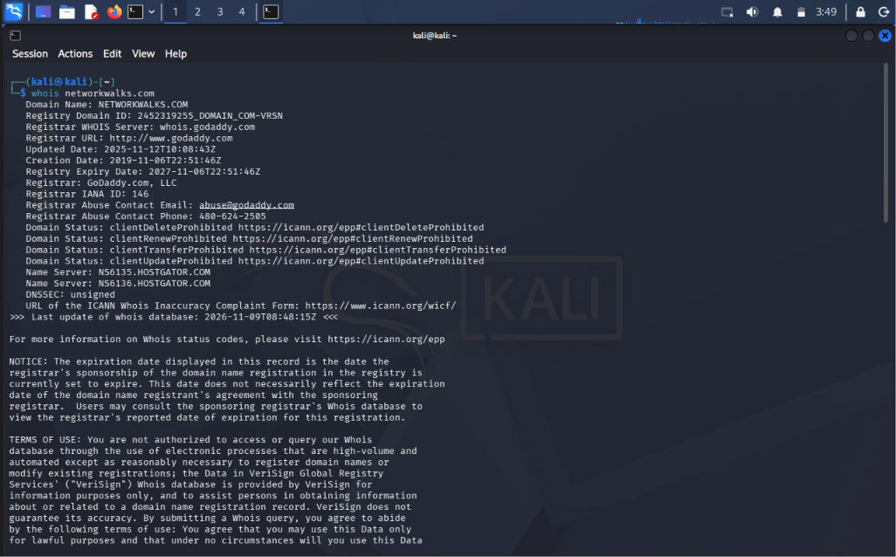
Evidence 2 – WHOIS output (continued registration and privacy-proxy details).
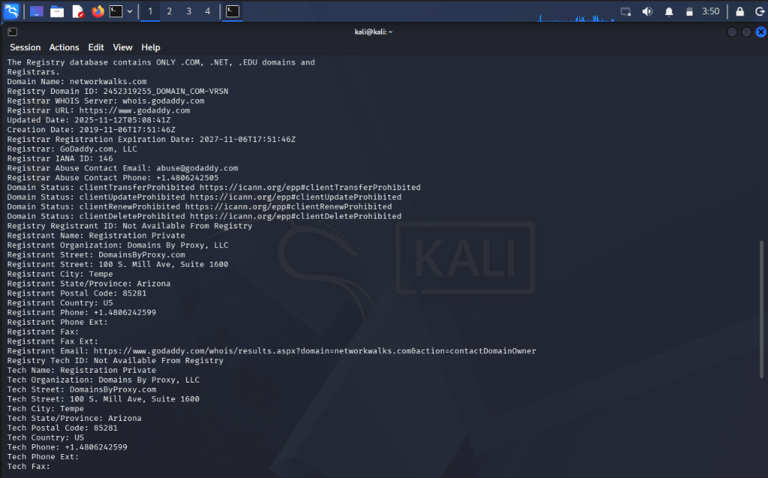
Evidence 3 – WhatWeb technology identification results.
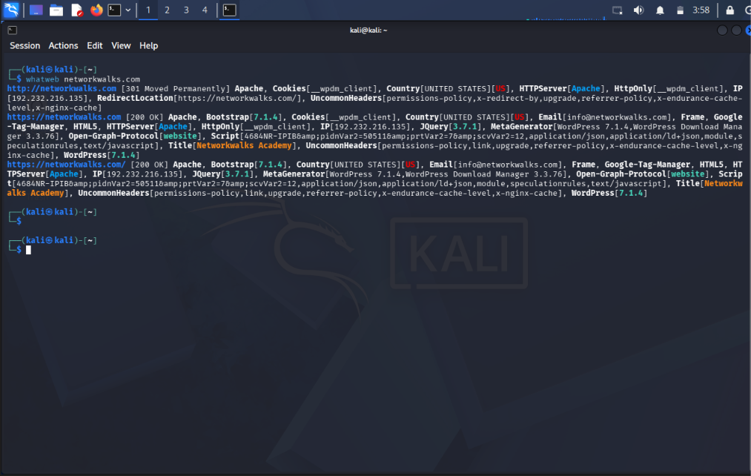
Evidence 4 – Nslookup DNS resolution result.
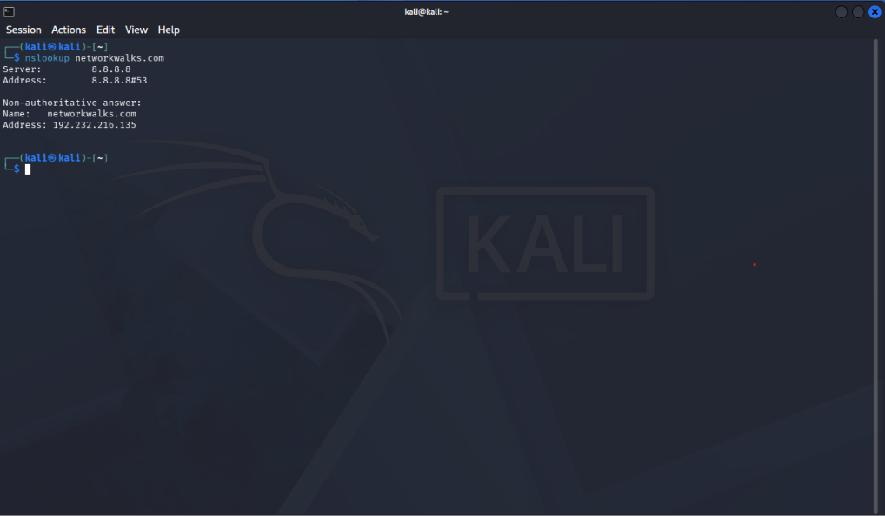
Evidence 5 – cURL HTTP response headers.
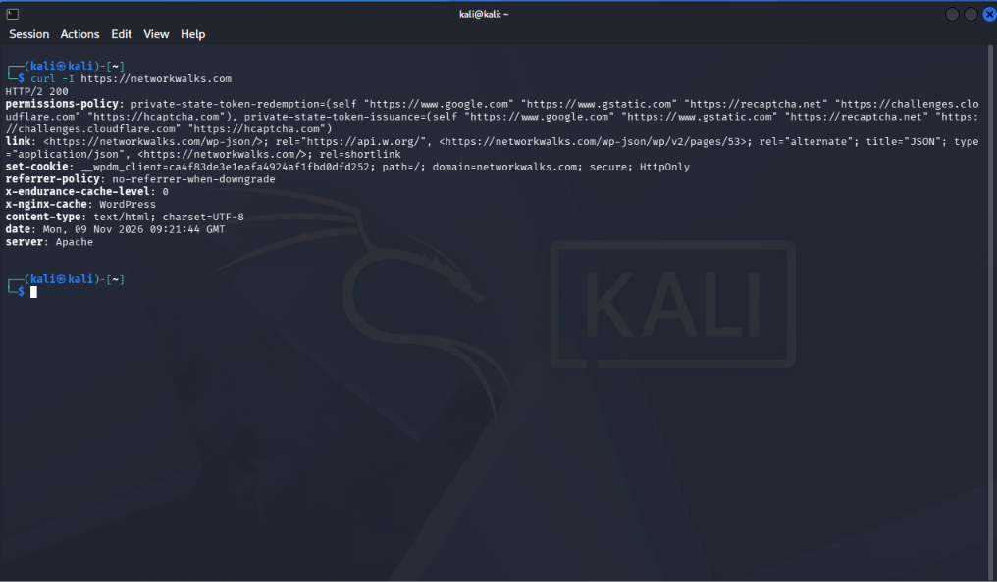
Evidence 6 – Wafw00f ModSecurity detection result.
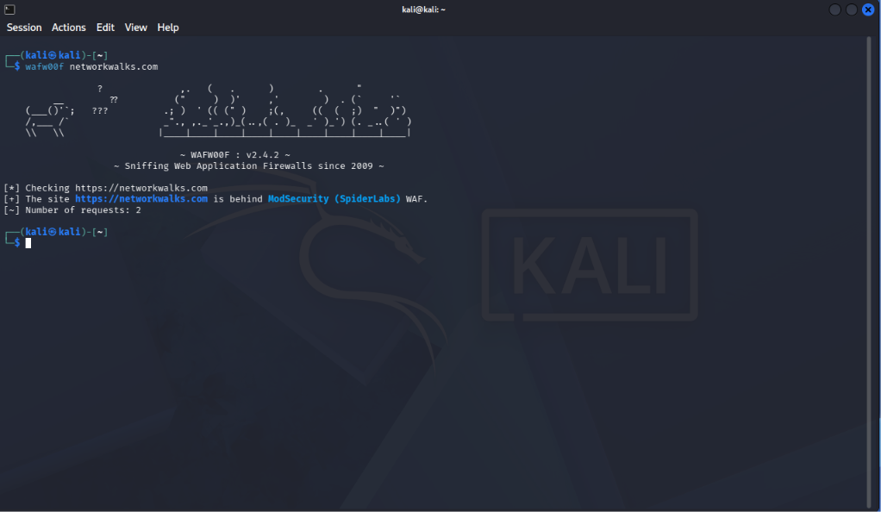
Evidence 7 – DNSRecon enumeration output.
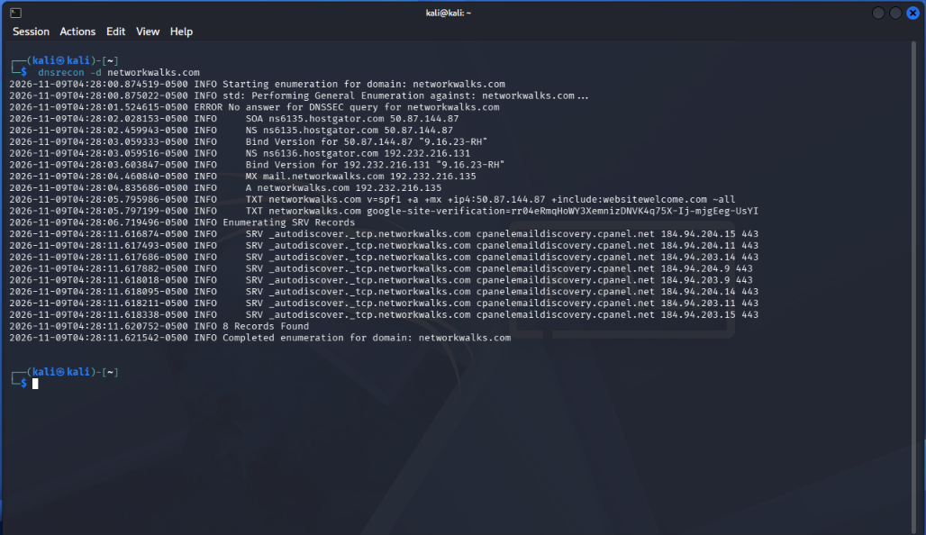
Evidence 8 – Windows ipconfig output and Zenmap setup screen.
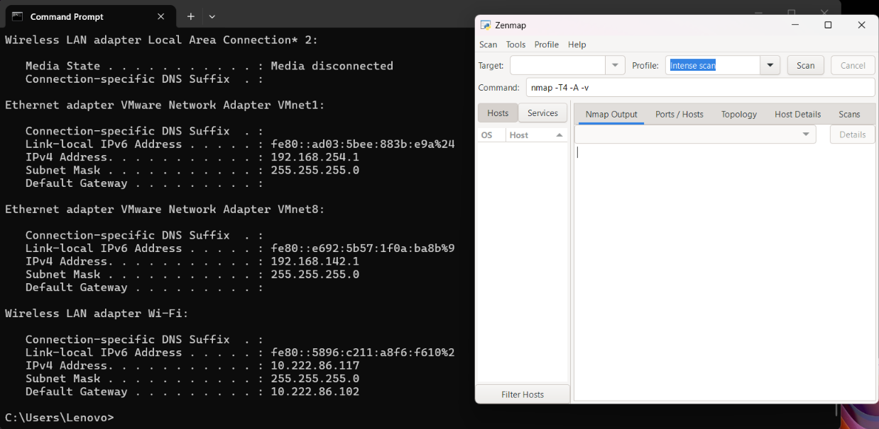
Evidence 9 – Zenmap Ping Scan target and profile selection.
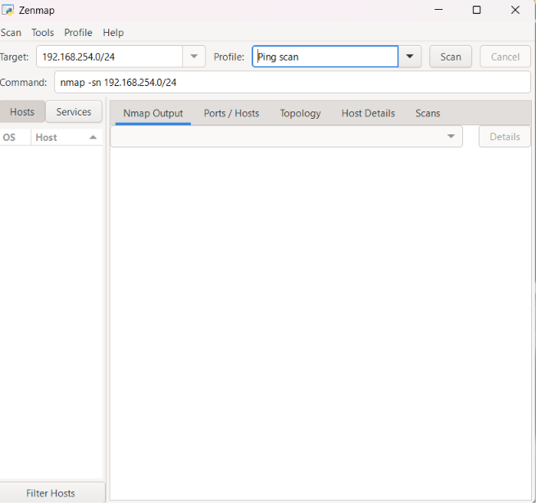
Evidence 10 – Zenmap scan results showing two live hosts.


