**实验名称 实验8. 继承与派生 优**

1. **实验内容及结果**

**设计并实现一个Teacher类和一个Student类，二者有一部分数据成员是相同的，例如num，name，sex。编写程序：**

1. **将一个Student类的对象转换为Teacher类的对象，将Student类对象的一些数据信息保留，使其成为Teacher类对象的数据的一部分。**
2. **Student类作为基类，Teacher类从Student类继承一些数据信息。**

**源代码：(1) #include<iostream>**

**#include<cstring>**

**using namespace std;**

**class Student**

**{**

**public:**

**Student(double n,const char na[],char s,float sc):num(n),sex(s),score(sc)**

**{**

**strcpy(name,na);**

**}**

**double get_num(){return num;}**

**char *get_name(){return name;}**

**char get_sex(){return sex;}**

**void display()**

**{**

**cout<<"num:"<<num<<endl;**

**cout<<"name:"<<name<<endl;**

**cout<<"sex:"<<sex<<endl;**

**cout<<"score:"<<score<<endl;**

**}**

**private:**

**double num;**

**char name[20];**

**char sex;**

**float score;**

**};**

**class Teacher**

**{**

**public:**

**Teacher(){}**

**Teacher(double n,const char na[],char s,int a):num(n),sex(s),age(a)**

**{**

**strcpy(name,na);**

**}**

**Teacher(Student &);**

**void display()**

**{**

**cout<<"num:"<<num<<endl;**

**cout<<"name:"<<name<<endl;**

**cout<<"sex:"<<sex<<endl;**

**cout<<"age:"<<age<<endl;**

**}**

**private:**

**double num;**

**char name[20];**

**char sex;**

**int age;**

**};**

**Teacher::Teacher(Student &stud)**

**{**

**num=stud.get_num();**

**strcpy(name,stud.get_name());**

**sex=stud.get_sex();**

**age=32;**

**}**

**int main()**

**{**

**Student stu1(210120,"Zhang",'m',100);**

**Teacher tea1(210124,"Zheng",'f',28),tea2;**

**tea2=Teacher(stu1);**

**cout<<"stu1:"<<endl;**

**stu1.display();**

**cout<<"tea1:"<<endl;**

**tea1.display();**

**cout<<"tea2:"<<endl;**

**tea2.display();**

**return 0;**

**}**

**(2****)#include<iostream>**

**#include<cstring>**

**using namespace std;**

**class Student**

**{**

**public:**

**void get_value()**

**{cin>>num>>name>>sex;}**

**get_value1()**

**{cin>>score;}**

**double get_num(){return num;}**

**char *get_name(){return name;}**

**char get_sex(){return sex;}**

**void display()**

**{**

**cout<<"num:"<<num<<endl;**

**cout<<"name:"<<name<<endl;**

**cout<<"sex:"<<sex<<endl;**

**}**

**void display1(){**

**cout<<"score:"<<score<<endl;**

**}**

**private:**

**double num;**

**char name[20];**

**char sex;**

**float score;**

**};**

**class Teacher:public Student**

**{**

**public:**

**void get_value2()**

**{cin>>age;}**

**void display3()**

**{**

**display();**

**cout<<"age:"<<age<<endl;**

**}**

**private:**

**int age;**

**};**

**int main()**

**{**

**Student stu1;**

**Teacher tea1;**

**cout<<"stu1:"<<endl;**

**stu1.get_value();**

**stu1.get_value1();**

**stu1.display();**

**stu1.display1();**

**cout<<"tea1:"<<endl;**

**tea1.get_value();**

**tea1.get_value2();**

**tea1.display3();**

**return 0;**

**}**

**运行结果（截图）**：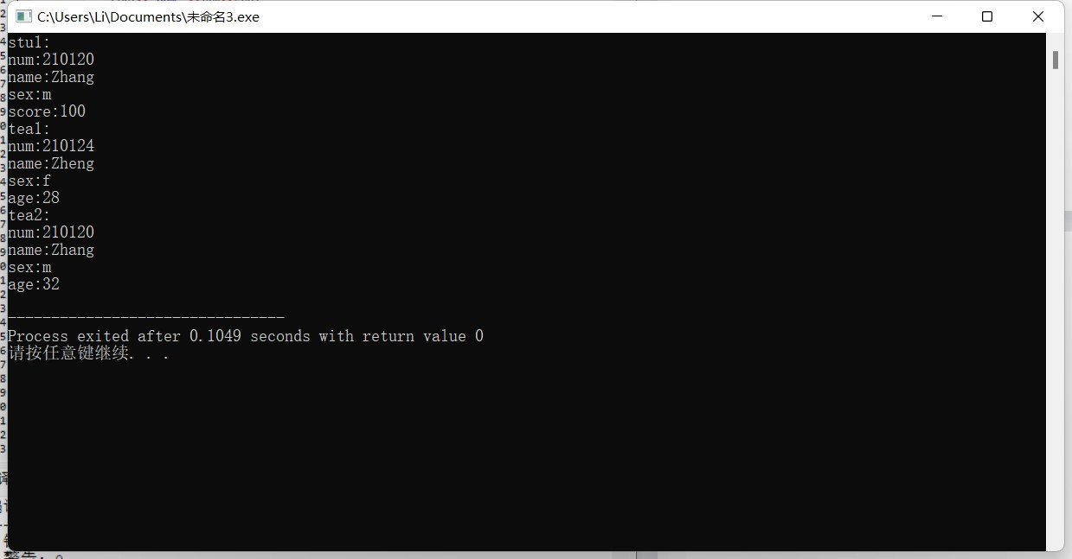

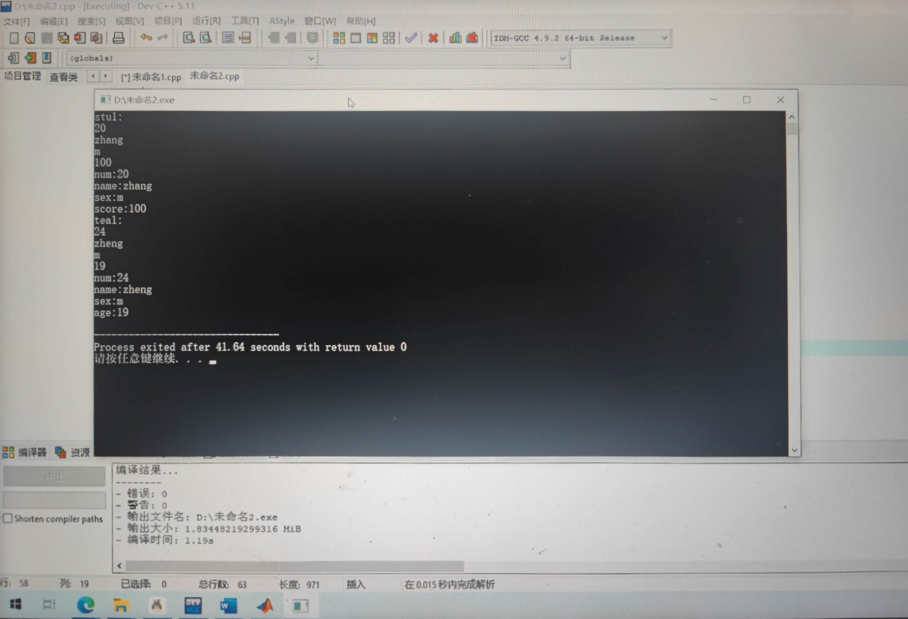

1. **实验体会**

**第一道题是对前面知识的复习，按部就班地敲完程序后发现报错，然后下面出现我看不懂的报错原因，请教过国梁后得知要在teacher类里面加入一个空的构造函数：Teacher(){}。如下列所示：**

**class Teacher**

**{**

**public:**

**Teacher(){}**

**Teacher(double n,const char na[],char s,int a):num(n),sex(s),age(a)**

**{**

**strcpy(name,na);**

**}**

**Teacher(Student &);**

**void display()**

**{**

**cout<<"num:"<<num<<endl;**

**cout<<"name:"<<name<<endl;**

**cout<<"sex:"<<sex<<endl;**

**cout<<"age:"<<age<<endl;**

**}**

**private:**

**double num;**

**char name[20];**

**char sex;**

**int age;**

**};**

**但是均不知道加入的原因是什么，所以老师能不能再讲一遍？主函数中定义了无参的tea2**

**int main()**

**{**

**Student stu1(210120,"Zhang",'m',100);**

**Teacher tea1(210124,"Zheng",'f',28),tea2;**

**tea2=Teacher(stu1);**

**cout<<"stu1:"<<endl;**

**stu1.display();**

**cout<<"tea1:"<<endl;**

**tea1.display();**

**cout<<"tea2:"<<endl;**

**tea2.display();**

**return 0;**

**}**