**实验名称 实验9. 继承与派生 优**

1. **实验内容及结果**

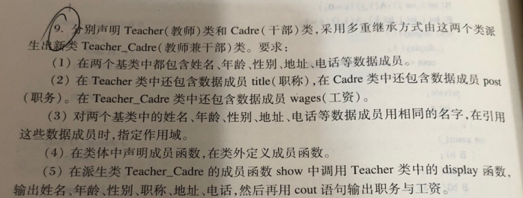

**源代码：**

#include <iostream>

#include <string>

using namespace std;

class Teacher{

public:

Teacher(string na,int ag,char se,string ti,string ad,long nu ):name(na),age(ag),sex(se),title(ti),addr(ad),num(nu){}

void display();

protected:

string name;

int age;

char sex;

string addr;

long num;

string title;

};

void Teacher::display(){

cout<<"姓名："<<name<<endl;

cout<<"年龄："<<age<<endl;

cout<<"性别："<<sex<<endl;

cout<<"职称："<<title<<endl;

cout<<"地址："<<addr<<endl;

cout<<"电话："<<num<<endl;

}

class Cadre{

public:

Cadre(string na,int ag,char se,string po,string ad,long nu):name(na),age(ag),sex(se),post(po),addr(ad),num(nu){}

void display1();

protected:

string name;

int age;

char sex;

string post;

string addr;

long num;

};

void Cadre::display1(){

cout<<"姓名："<<name<<endl;

cout<<"年龄："<<age<<endl;

cout<<"性别："<<sex<<endl;

cout<<"职务："<<post<<endl;

cout<<"地址："<<addr<<endl;

cout<<"电话："<<num<<endl; }

class Teacher_Cadre:public Teacher,public Cadre{

public:

Teacher_Cadre(string na,int ag,char se,string ti,string po,string ad,long nu,float wa):Teacher(na,ag,se,ti,ad,nu),Cadre(na,ag,se,po,ad,nu)

{wage=wa;}

void show();

private:

float wage;

};

void Teacher_Cadre::show(){

display();//teacher的display

cout<<"职务："<<post<<endl;

cout<<"工资："<<wage<<endl;

}

int main(){

Teacher_Cadre TC("Li",40,'m',"Professor","teacher","213 Shanghai Road,Beijing",17348214253,50000.5);

TC.show();

return 0;

}

**运行结果（截图）**：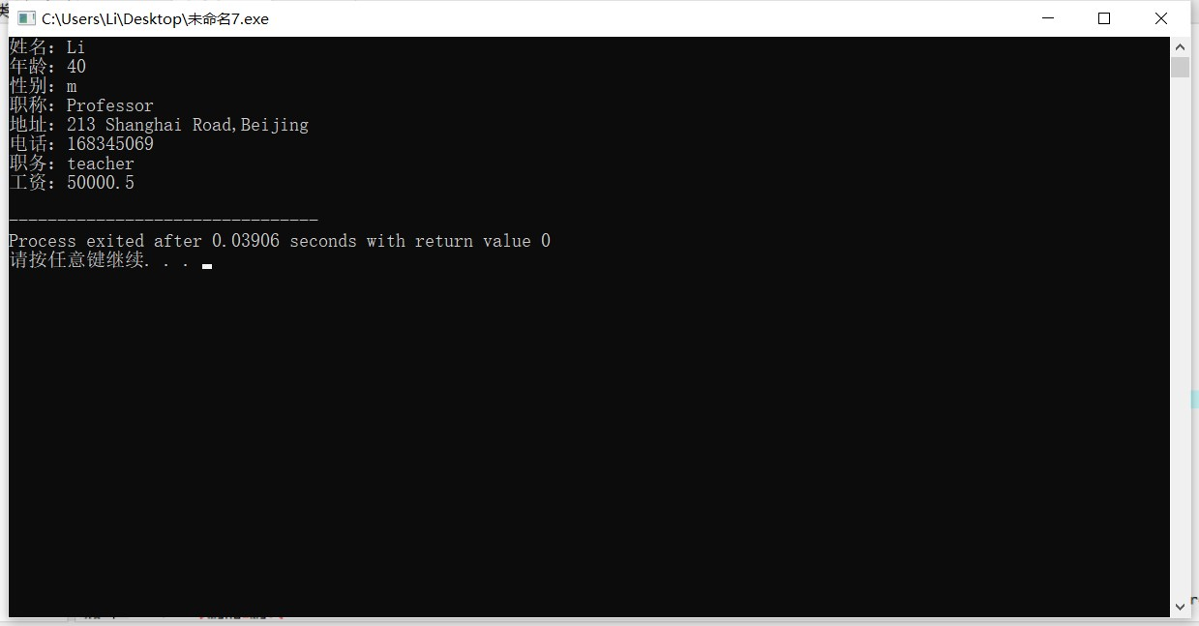

1. **实验体会**

这次的实验程序难度不大，编码的过程比较顺利（就是有点繁琐，可能有更简单的形式我没想到），总的来说不像前几次实验（主要是三四五）有点烧脑。