**PROJECT-3**

Tintu Jose

Student Id: 63849696

**Project Description:**

The project is about implementation of a real-time canny edge detection using a raspberry pi and webcam. Here we make use of OpenMP and Pthreads for multi thread programming and we have extended the code to process multiple frames in real time.

**Experimental Setup:**

**Step1:** We have to setup the C++ API if using the webcam on raspberry pi board. After that we have downloaded the source code canny_local_raspicam.c and raspicam_canny.cpp

Compile,

$ g++ raspicam_canny.cpp -o raspicam_canny -I/usr/local/include -lraspicam –lm

and test,

$ ./raspicam_canny 1.0 1.0 0.9

**Step 2:** Here we have extended the code for processing multiple images. We have used for loop in the main function to make processing any number of captured images. And the average fps calculation is noted.

**Step 3:** Now we have implemented the multi thread programming in canny_local_raspicam.c using both OpenMP and pthread and the fps calculation for both is noted.

**Step 4:** To understand the real time application, we encode the processed image into h264 video.

**Result:**

|  |  |
| --- | --- |
| **STEPS** | **Frame Rate** |
| **STEP 1** | **11.816** |
| **STEP 2** | **22.334** |
| **STEP 3 -openmp** | **12.267** |
| **STEP 3- pthread** | **11.29** |

**Fig 1: Table of all time calculations in each step**

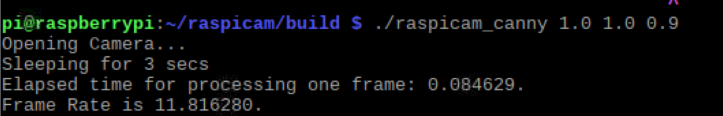

**Fig 2: Step-1**

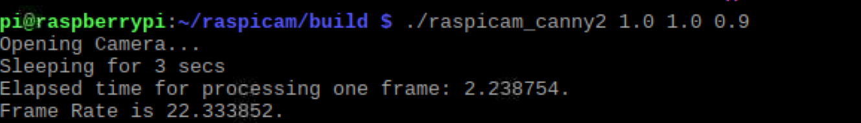

**Fig 3:Step -2**

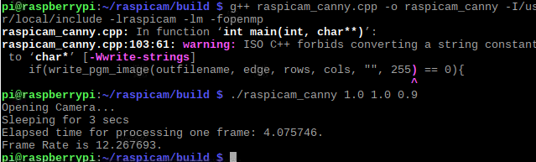

**Fig 4:Step-3 -openmp**

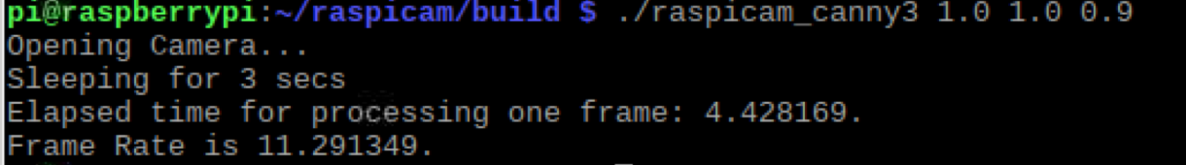

**Fig 5:Step-3 - pthread**

**Problems :**

No problem were faced during the project.

**Conclusion:**

We compiled the code using both openMP and pthread multi thread concept and the real time fps calculation of all codes are noted and we encoded the processed image into h264 video.

.