|  |  |
| --- | --- |
|  | **FPT ACADEMY INTERNATIONAL**  **FPT – APTECH COMPUTER EDUCATION** |

**Centre Name: ACE-HCMC-2-FPT.**

**Address: 590 Cach Mang Thang 8, District 3, Ho Chi Minh City, Viet Nam.**

**Wine Gourmet**

**Design Document**

|  |  |  |
| --- | --- | --- |
| **Supervisor:** | Mr. Tran Phuoc Sinh | |
| **Semester:** | 4 | |
| **Batch No:** | T1.2012.E1 | |
| **Group No:** | 6 | |
| **Order:** | **Full name** | **Roll No.** |
| 1. | Truong Trong Tin | Student1295412 |
| 2. | Tran Le Minh Y | Student1291656 |
| 3. | Ngo Tran Hung Anh | Student1291662 |
| 4. | Mai Quoc Lam Khang | Student1291650 |
| 5. | Luu Xuan Loc | Student1295177 |

**This is to certify that**

**Mr.** Truong Trong Tin

**Mr.** Tran Le Minh Y

**Mr.** Ngo Tran Hung Anh

**Mr.** Mai Quoc Lam Khang

**Mr.** Luu Xuan Loc

**have successfully designed & developed:**

eProject: Wine Gourmet

**Submitted by:**

Mr. Tran Phuoc Sinh

**Date of issue:**

**Authorized Signature:**

INDEX

Contents

REVIEW 1 II-6

II. Introduction II-7

III. Problem Definition: II-7

1. Requirement Specification II-9

2. Customer's Requirement Specifications II-9

2.1. For Guest Users: II-9

2.2. Admin: II-9

2.3. Registered User II-9

3. Non-functional Requirement Specifications II-9

• System Requirement Specifications II-10

• Server requirements: II-10

• Client requirements: II-11

• Development Software: II-11

• Technology: II-11

TASK SHEET REVIEW 1 II-12

REVIEW 2 II-13

I. Architecture & Design of the Project II-14

1) Presentation Tier: II-14

2) Business Logic Tier: II-14

3) Data Access Tier: II-14

II. Algorithms – Data Flowchart II-15

1. Symbol generates: II-15

2. Main data flowchart for users II-16

3. Login process (For admins and members) II-16

4. Logout process (For admins and members) II-17

5. Update member’s information (For admin and members) II-17

6. Delete Member (For admin only) II-17

7. Register new members (for free users only) II-17

III. User case and sequence Diagram II-19

IV. Entity – Relationship Diagrams II-20

1. Entity – Relationship Diagram II-20

TASK SHEET REVIEW 2 II-22

TASK SHEET REVIEW 3 II-39

REVIEW 1

# Introduction

First and foremost, we would like to express the deepest appreciation to our admirable instructor – Mr. Tran Phuoc Sinh. During the time of the project, he continually and convincingly conveyed a spirit of adventure in regard to research and scholarship, and an excitement in regard to teaching. Without his guidance and persistent help this dissertation would not have been possible. Therefore, once again, we truly value your dedication and guidance, Mr. Sinh.

Next, it would have been impossible to carry out and complete this project without the collaboration among our team members. Although we have gone through many obstacles during the project implementation, eventually we gained what we aimed at by our hard work, our strong commitment and of course, our brotherhood.

Finally, thanks to Aptech’s eProject team, we had a golden opportunity to apply what we have learnt into reality and gain hands-on experience which is essential for our future career.

.

1. **Problem Definition:**

Consumers often have the habit of going online to find out information about products before they decide to buy in-store or online. This buying behavior shows how vital a website is to businesses today. So our team wanted to create a website that sells wines so that users can go to the website I refer to about wines such as origin, ingredients, and bottle design, ...

**ADMIN:** ADMIN will login and have a master management access like ADMIN can update information of users, can update product, can manage orders…

**Advantages:**

Wine Gourmet is accessible to everyone who wants to buy wines, they can see the information of wines and also some article about wines.

• Users can access the website to see the information of wines

• Will show a full detail of order after user completed payment.

**Disadvantages:**

• User must register an account to make the order.

1. **Requirement Specification**

## Customer's Requirement Specifications

### For Guest Users:

* + 1. R1: Visit the Home Page and can see/search all available wines in our website.
    2. R2: Register an account with information provided to make an order.
    3. R3: Check the information of the order then click CONFIRM to finish the payment.

### Admin:

* + 1. R1: Visit the Home Page.
    2. R2: Login to Admin Account.
    3. R3: It will direct to Admin Page, there will be bunch of function that Admin can use.

### Registered User

#### R1: Visit the home page and can see/search all available wines, and buy products, comments, ...

* + 1. R2: Login in the website.
    2. R3: Select the wine.
    3. R4: Check the information on the order then click CONFIRM to finish the payment.
    4. R5: Take a screenshot or print the receipt (the receipt will include order id on it).

## Non-functional Requirement Specifications

* 1. REQ-1. Good using Interface and Experience.
  2. REQ-2. Clean code.
  3. REQ-3. Try hard to improve the performance.
  4. REQ-4. Try this website to run on all browsers.
  5. REQ-5. Try limit bugs on this website

## System Requirement Specifications

### Server requirements:

#### Hardware:

|  |  |
| --- | --- |
| Component | Requirement |
| CPU | Processor type:  Pentium IV-compatible processor or faster  Processor speed:  Recommended: 2.0 GHz or faster |
| OS | Microsoft Windows XP or higher with IIS |
| Memory (RAM) | RAM:  Minimum: 512 MB  Recommended: 2 GB or more |
| Hard Drive | Free space:  Minimum: 200 MB  Recommended: 50 GB or more  Maximum: Operating system maximum |

#### Software:

|  |  |
| --- | --- |
| Component | Requirement |
| ASP.NET Core | Version .NET Core 5.0 |
| RDBMS | XAMPP |

### Client requirements:

#### Hardware:

|  |  |
| --- | --- |
| Component | Requirement |
| CPU | Processor type:  Pentium III-compatible processor or faster  Processor speed:  Recommended: 1.0 GHz or faster |
| OS | All OS(Window ,Linux ,Android ,Mac OS …) |
| Memory (RAM) | RAM:  Minimum: 512 MB  Recommended: 1 GB or more  Maximum: Operating system maximum |
| Hard Drive | Free space:  Minimum: 10 MB |

#### Software:

|  |  |
| --- | --- |
| Component | Requirement |
| Web Browser | IE 4.0 , Firefox 3.0,Chrome or Higher….. |

### Development Software:

#### XAMPP Control Panel v3.3.0

#### Microsoft Visual Studio 2019.

* + Android Studio

### Technology:

#### ASP.Net Core 6.0

#### Java

# TASK SHEET REVIEW 1

|  |  |  |  |  |  |  |  |  |  |
| --- | --- | --- | --- | --- | --- | --- | --- | --- | --- |
| TASK SHEET GROUP 3  **REVIEW 1** | | | | | | | | | |
| **Project Ref. No.:**  **eP/Advertisement** **Portal Management** **System/01** | | **Project Title:** | **Activity Plan** **Prepared** **By:** |  | **Date of Preparation of Activity Plan:** | | | | |
| **Sr.No.** | **Task** | **Start** **Date** | |  | **Deadline** | **Team** **Mate** **Names** | **Status** |
| 1 | Product Management | Wine Gourmet | Tran Le Minh Y | 14/03/2023 | |  | 20/03/2023 | Tran Le Minh y | Done |
| 2 | Brand Management | 14/03/2023 | |  | 20/03/2023 | Mai Quoc Lam Khan | Done |
| 3 | Product in stock | 14/03/2023 | |  | 20/03/2023 | Luu Xuan Loc | Done |
| 4 | User Account | 14/03/2023 | |  | 20/03/2023 | Truong Trong Tin | Done |
| 5 | Most sold products | 14/03/2023 | |  | 20/03/203 | Ngo Tran Hung Anh | Done |

|  |  |
| --- | --- |
| **Date: 14/03/2023** | |
| Signature of Instructor:  **Mr. Tran Phuoc Sinh** | Signature of Team Leader:  **Tran Le Minh Y** |

REVIEW 2

1. **Architecture & Design of the Project**

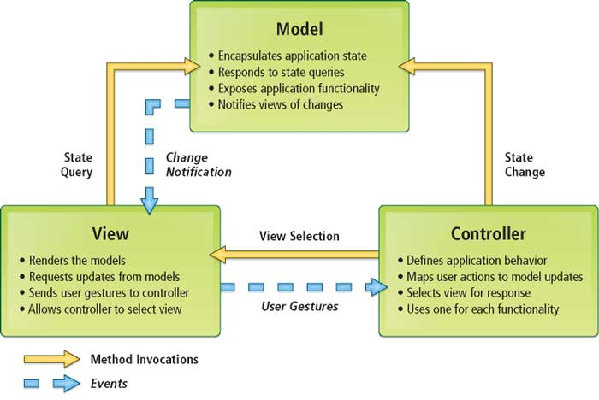

## Presentation Tier:

* + - 1. This is the tier in which the users interact with application. Presentation Tier contains Model, View, Controller used to receive a request and response to User.
      2. Technology: ASP.NET MVC5, Razor, HTML, CSS, JavaScript, Ajax, JQUERY, Twitter Bootstrap

## Business Logic Tier:

* + - 1. Is mainly working as the bridge between Data Tier and Presentation Tier. All the Data passes through the Business Tier before passing to the Presentation Tier.
      2. Technology: OOP, ASP.NET

## Data Access Tier:

* + - 1. This is basically the server which stores all the application’s data. Data tier contents Database Tables, Database Views and other means of storing Application’s data.
      2. Technology: SQL Server, Entity Framework

# Algorithms – Data Flowchart

## Symbol generates:



## Main data flowchart for users

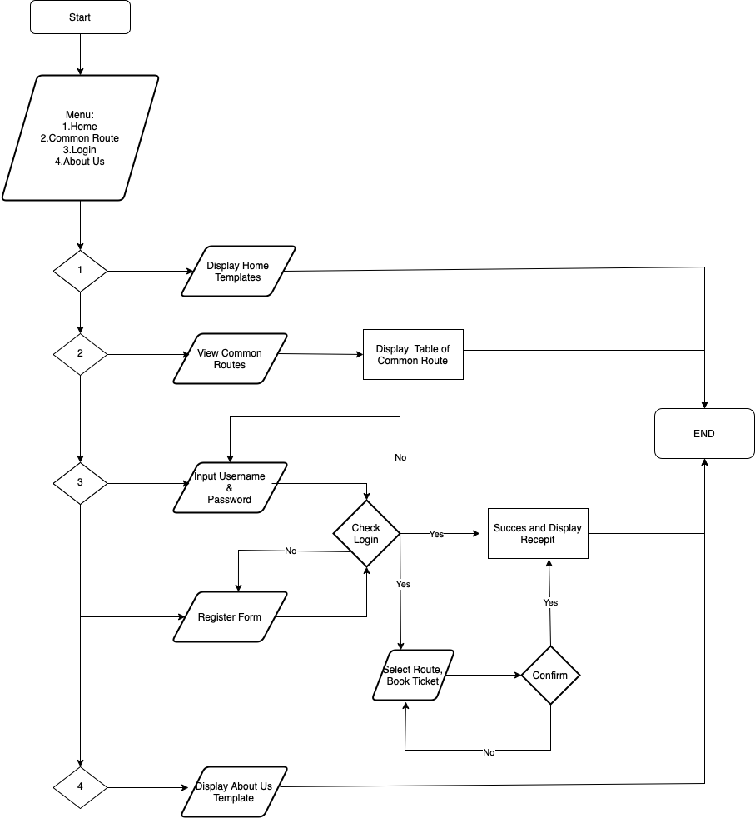

## Login process (For admins and members)

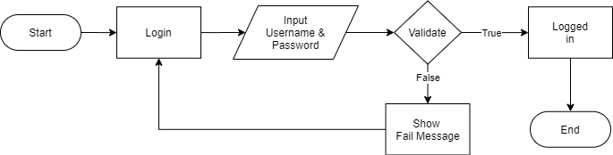

## Logout process (For admins and members)

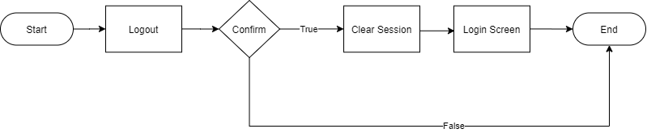

## Update member’s information (For admin and members)

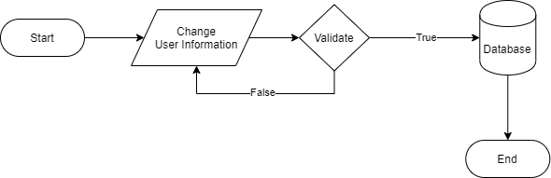

## Delete Member (For admin only)

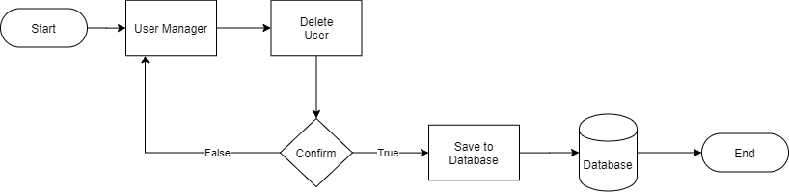

## Register new members (for free users only)

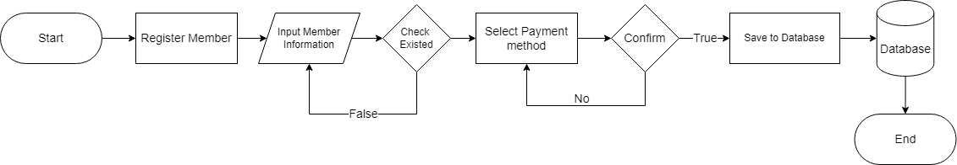

1. **User case and sequence Diagram**
   1. **User**

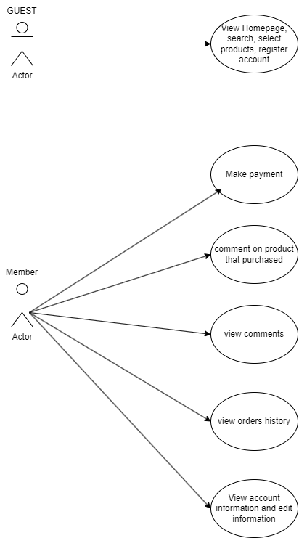

* 1. **Admin**

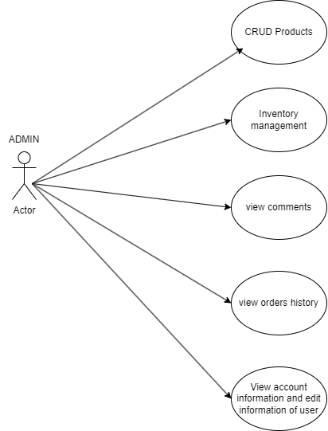

1. **Entity – Relationship Diagrams**
2. **Entity – Relationship Diagram**

|  |  |
| --- | --- |
|  |  |
|  |  |

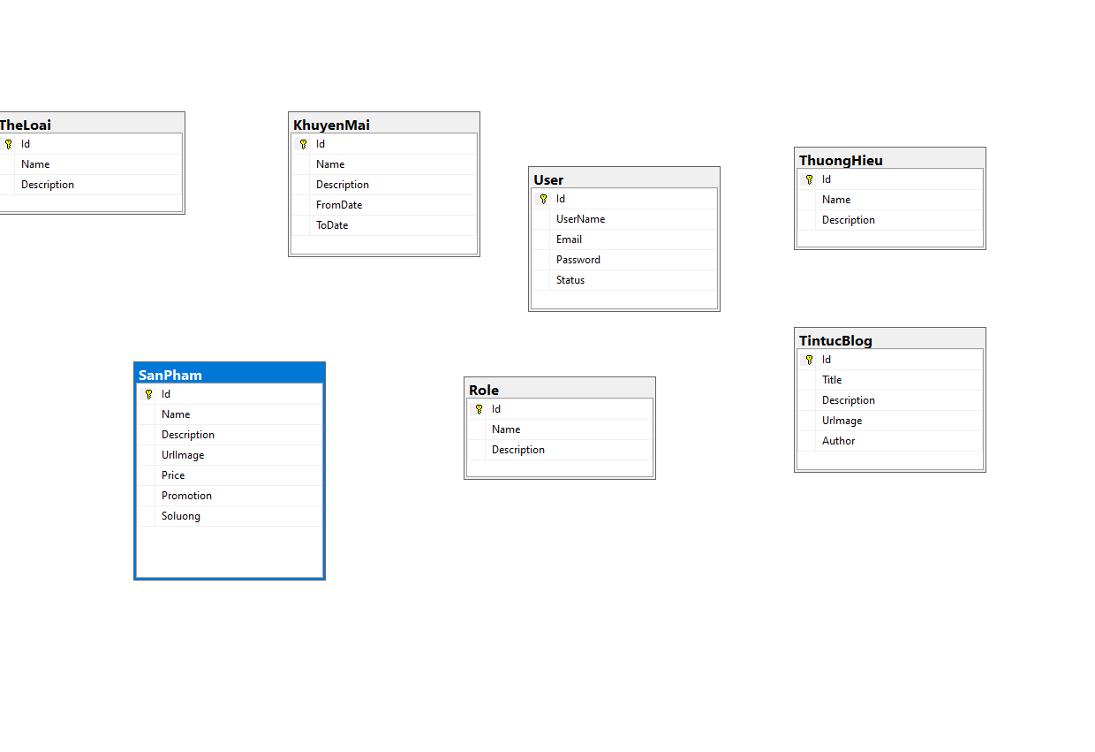

# TASK SHEET REVIEW 2

|  |  |  |  |  |  |  |  |  |  |
| --- | --- | --- | --- | --- | --- | --- | --- | --- | --- |
| TASK SHEET GROUP 3  **REVIEW 2** | | | | | | | | | |
| **Project Ref. No.:**  **eP/Advertisement** **Portal Management** **System/01** | | **Project Title:** | **Activity Plan** **Prepared** **By:** |  | **Date of Preparation of Activity Plan:** | | | | |
| **Sr.No.** | **Task** | **Actual Start** **Date** | |  | **Deadline** | **Team** **Mate** **Names** | **Status** |
| 1 | Order Management, Product Management | Wine Gourmet | Tran Le Minh Y | 21/03/2023 | |  | 26/03/2023 | Tran Le Minh y | Done |
| 2 | Customer Contact | 14/03/2023 | |  | 26/03/2023 | Mai Quoc Lam Khan | Done |
| 3 | Customer Review | 21/03/2023 | |  | 26/03/2023 | Luu Xuan Loc | Done |
| 4 | Revenue Products Sold, Order Management | 21/03/2023 | |  | 26/03/2023 | Truong Trong Tin | Done |
| 5 | Favorite Products | 21/03/2023 | |  | 26/03/203 | Ngo Tran Hung Anh | Done |

|  |  |
| --- | --- |
| **Date: 21/03/2023** | |
| Signature of Instructor:  **Mr. Tran Phuoc Sinh** | Signature of Team Leader:  **Tran Le Minh Y** |

**Review 3**

1. **GUI Design**
   1. **Client’s Side**
      1. **Homepage**

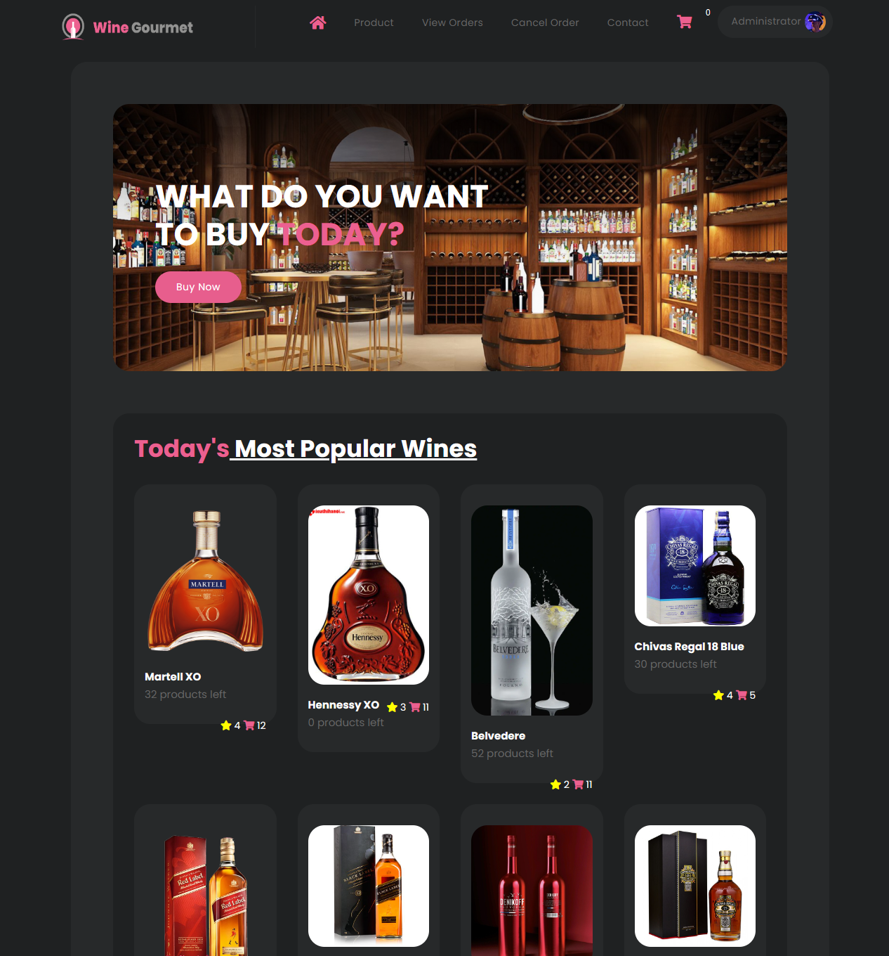

|  |  |
| --- | --- |
| Description | Homepage |
| Validation |  |
| Initial Values | N/A |
| Events | - From here, users can see products and go to different pages. |

* + 1. **Login page**

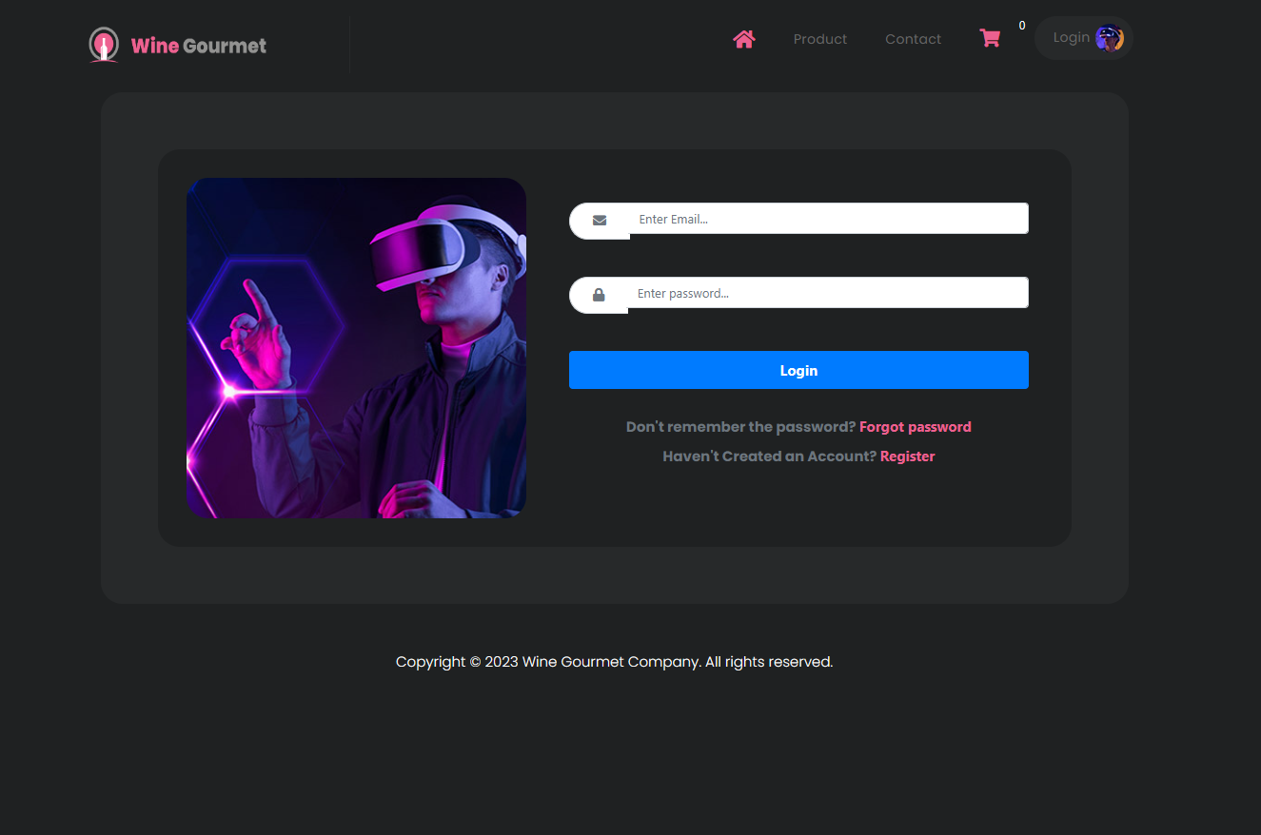

|  |  |
| --- | --- |
| Description | Login page |
| Validation | Account must use email |
| Initial Values | N/A |
| Events | - From here, users can login to their account. |

* + 1. **Search box**

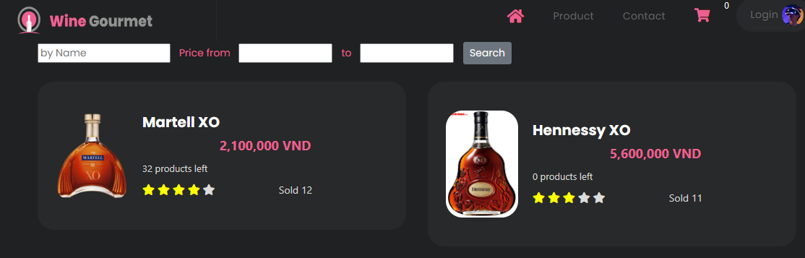

|  |  |
| --- | --- |
| Description | Search box |
| Validation | Nothing |
| Initial Values | N/A |
| Events | - From here, users can search to the products that they want to see. |

* + 1. **Cart**

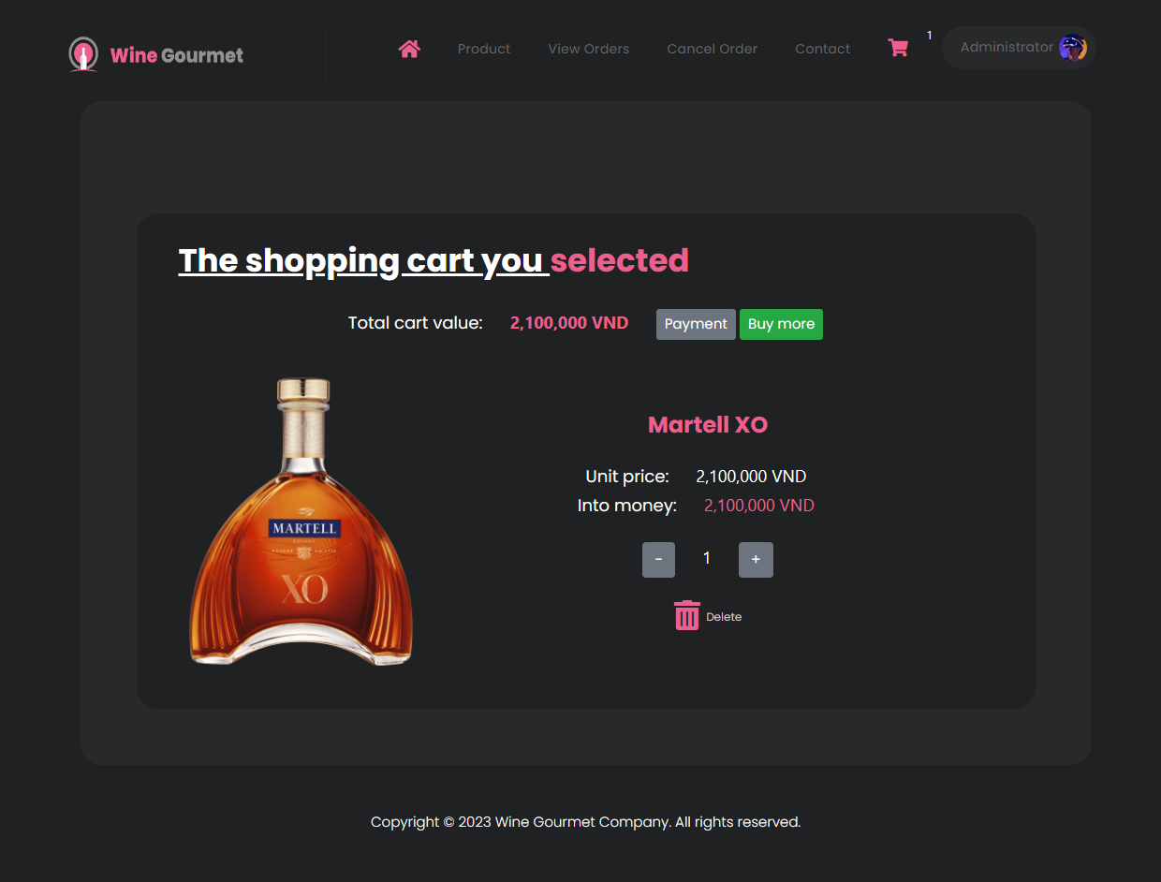

|  |  |
| --- | --- |
| Description | Cart |
| Validation | Nothing |
| Initial Values | N/A |
| Events | - From here, users view their cart. |

* + 1. **Payment**

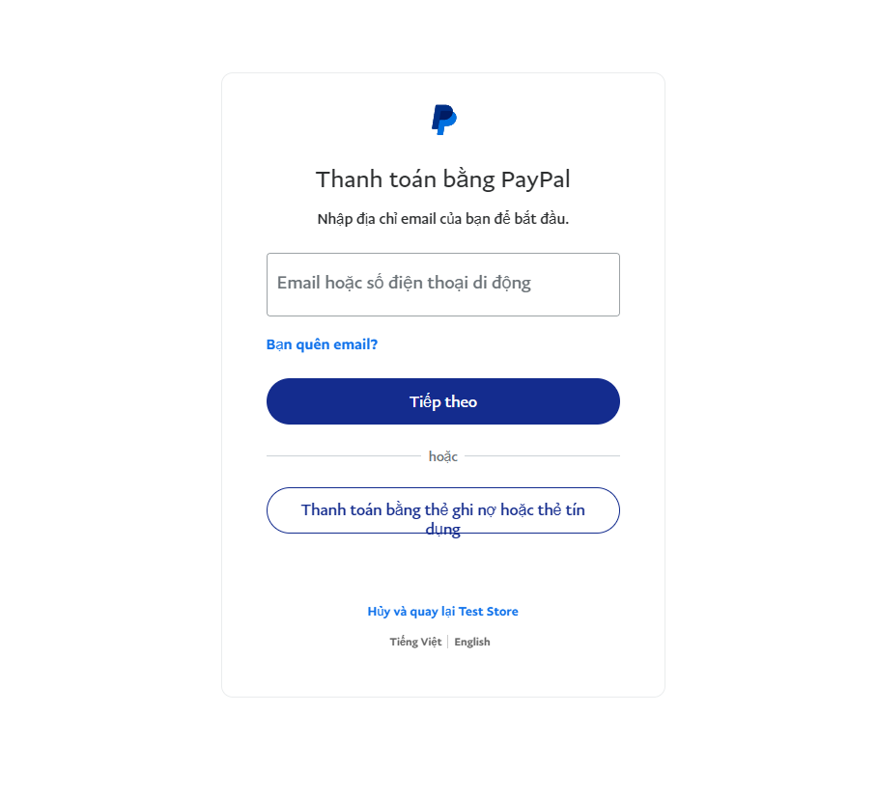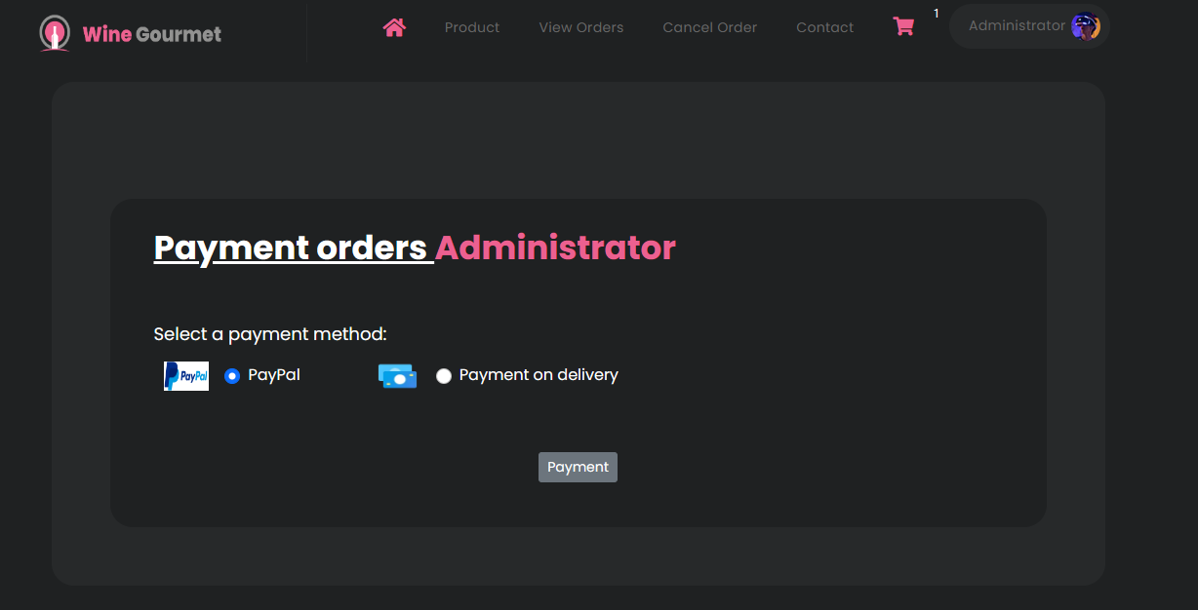

|  |  |
| --- | --- |
| Description | Payment |
| Validation | User must login to make a payment |
| Initial Values | N/A |
| Events | - From here, users can make a payment |

* + 1. **Comment**

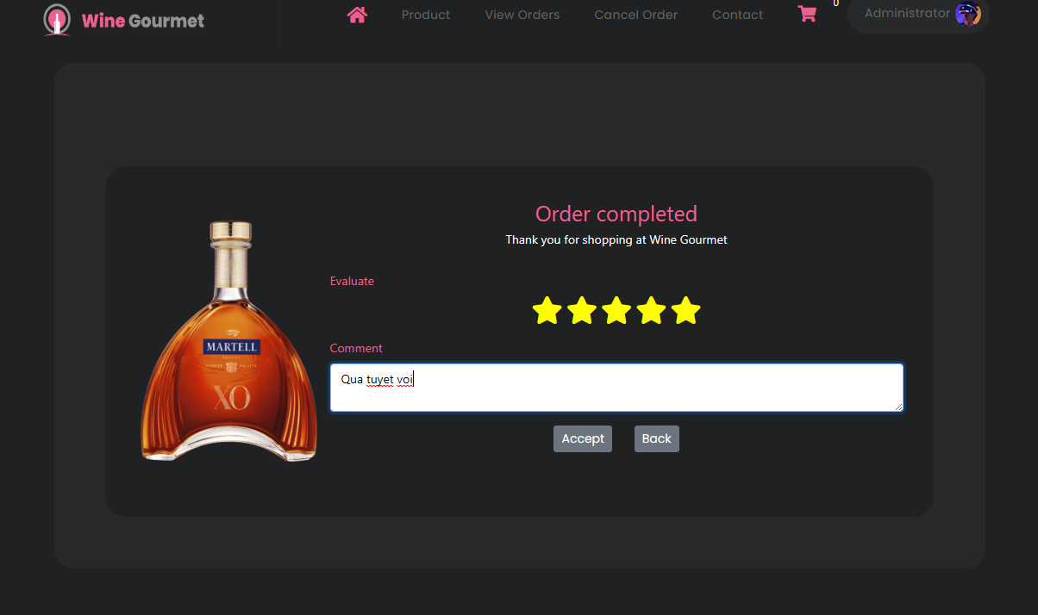

|  |  |
| --- | --- |
| Description | Comment box |
| Validation | User must buy a product then they can leave a comment |
| Initial Values | N/A |
| Events | - From here, users can leave their comments of the product after they received the product. |

* + 1. **Contact**

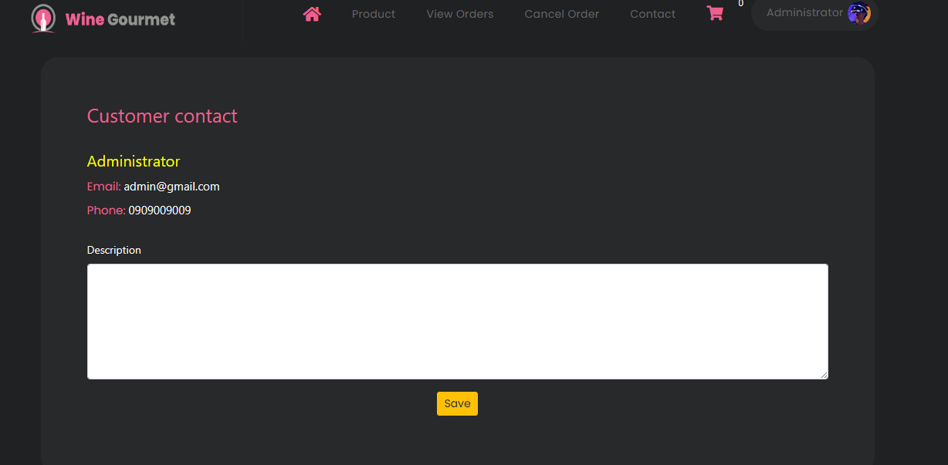

|  |  |
| --- | --- |
| Description | Contact |
| Validation | User login to contact admin |
| Initial Values | N/A |
| Events | - From here, users can contact admin |

1. **Admin’s Side**
   1. **Login**

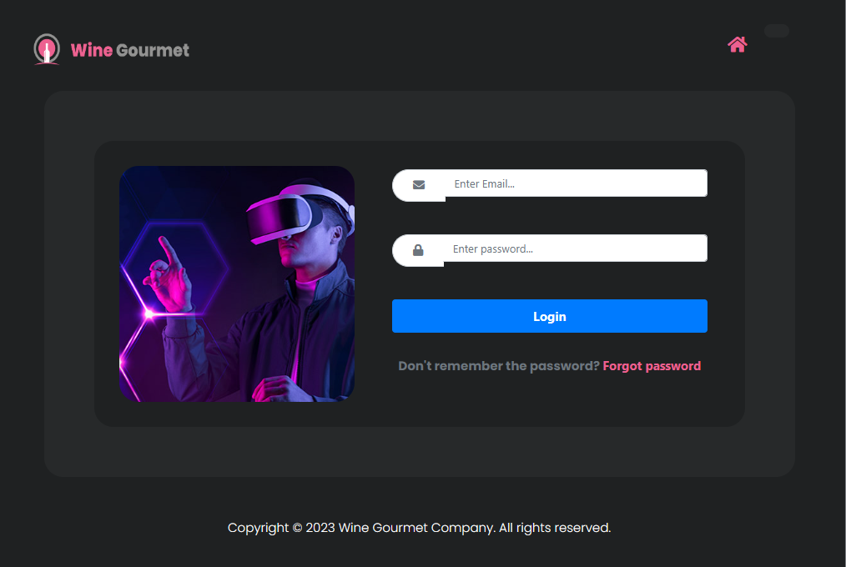

|  |  |
| --- | --- |
| Description | Login page |
| Validation | Admin must login to their account. |
| Initial Values | N/A |
| Events | - From here, admin can get into their management page. |

* 1. **Management page**

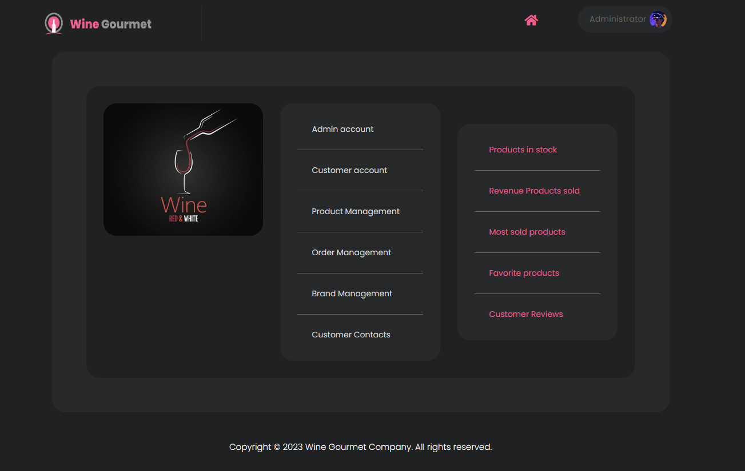

|  |  |
| --- | --- |
| Description | Management page |
| Validation | Admin must login to their account |
| Initial Values | N/A |
| Events | - From here, admin can management products, users, comments, orders,... |

* 1. **Product Management**

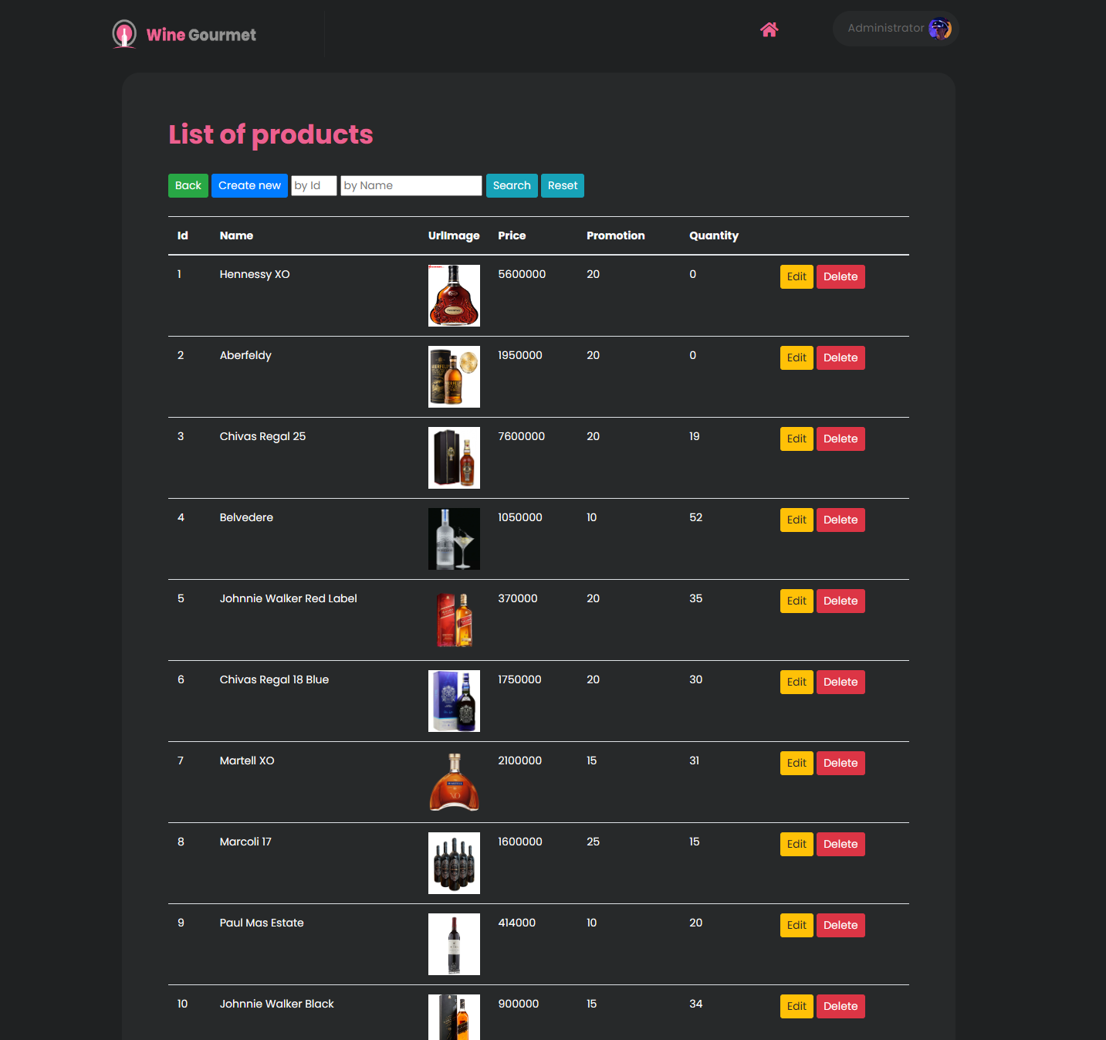

|  |  |
| --- | --- |
| Description | Product Management |
| Validation | Admin must login to their account |
| Initial Values | N/A |
| Events | - From here, admin can management products |

* 1. **Order Management**

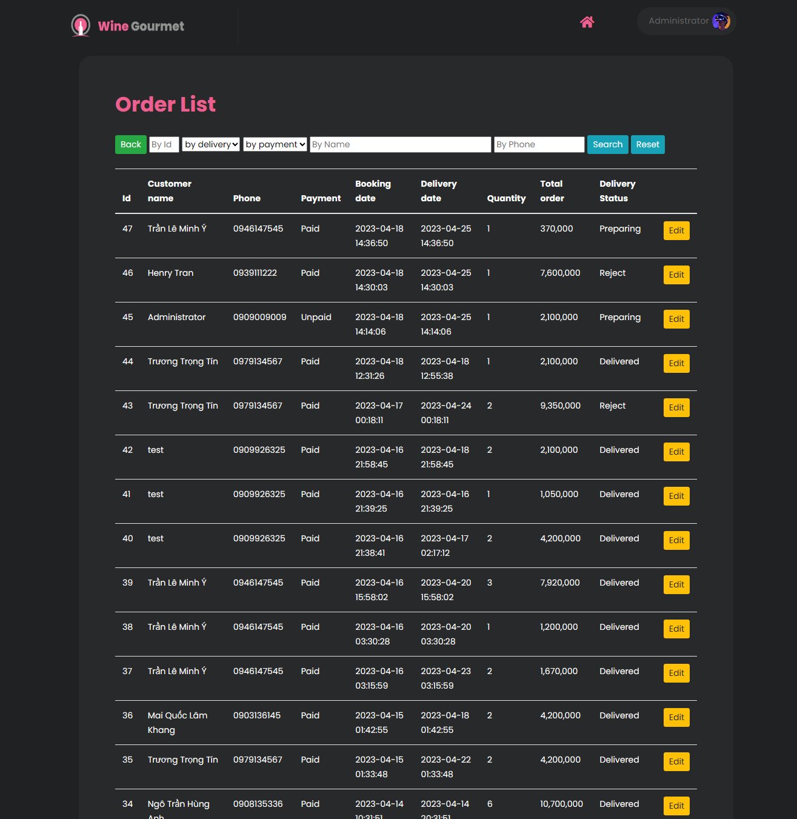

|  |  |
| --- | --- |
| Description | Order Management |
| Validation | Admin must login to their account |
| Initial Values | N/A |
| Events | - From here, admin can management orders |

* 1. **Revenue Products sold**

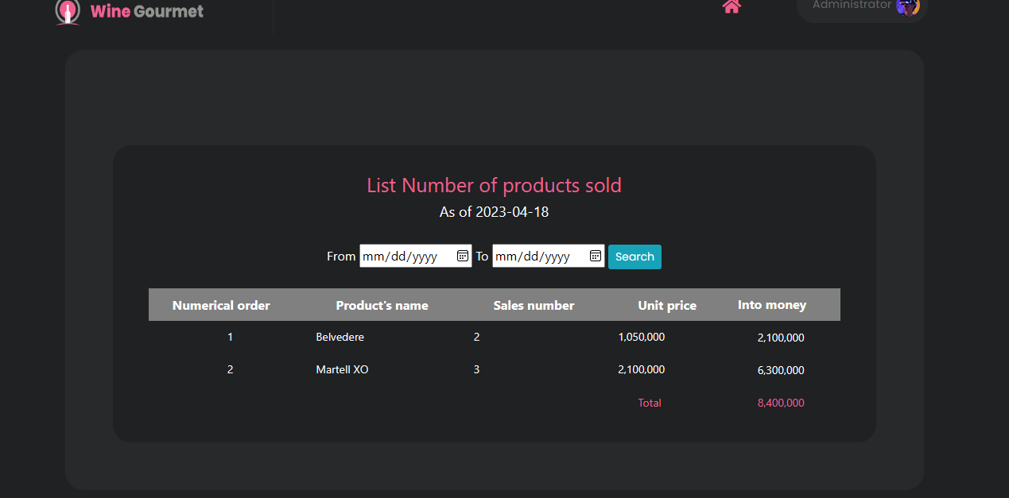

|  |  |
| --- | --- |
| Description | Revenue Management |
| Validation | Admin must login to their account |
| Initial Values | N/A |
| Events | - From here, admin can see the revenue in days, months, and years |

* 1. **Customer Review**

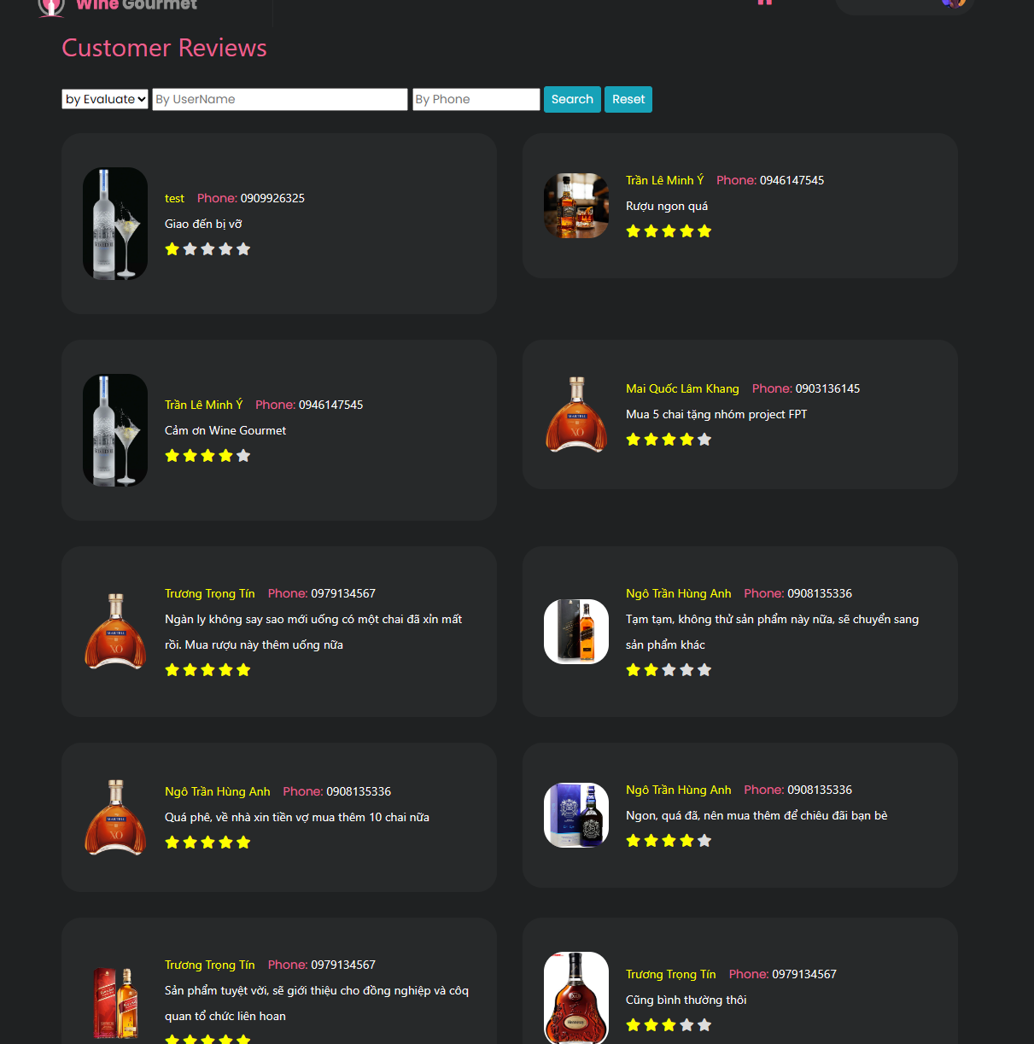

|  |  |
| --- | --- |
| Description | Customer Review |
| Validation | Admin must login to their account |
| Initial Values | N/A |
| Events | - From here, admin can see the review of customers. |

* 1. **Contact List**

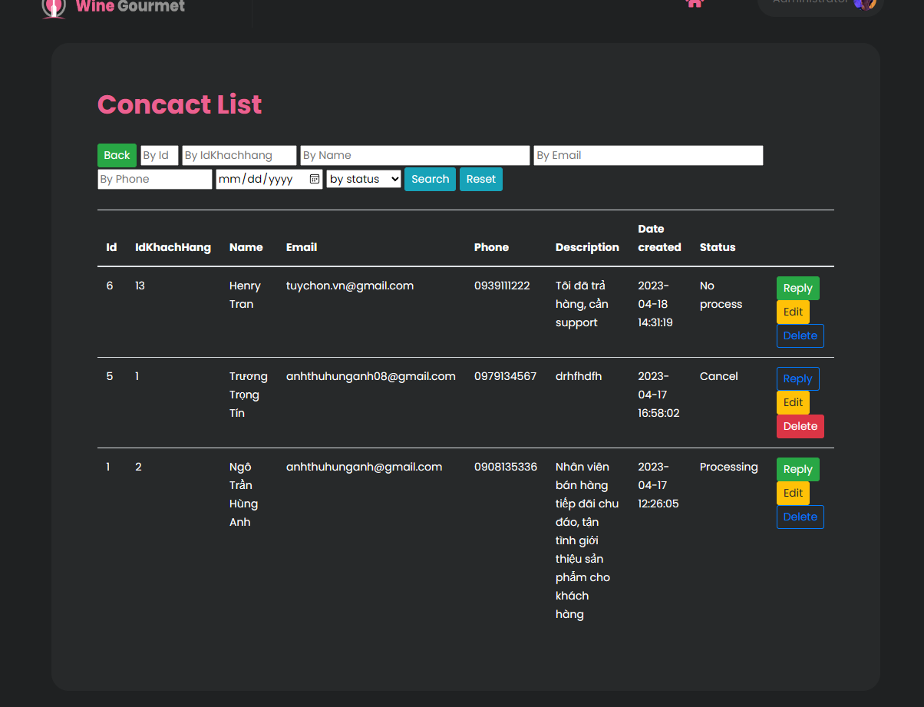

|  |  |
| --- | --- |
| Description | Contact List |
| Validation | Admin must login to their account |
| Initial Values | N/A |
| Events | - From here, admin can see the customer complaints on the products, etc. And admin can reply to customers |

# TASK SHEET REVIEW 3

|  |  |  |  |  |  |  |  |  |  |
| --- | --- | --- | --- | --- | --- | --- | --- | --- | --- |
| TASK SHEET GROUP 3  **REVIEW 2** | | | | | | | | | |
| **Project Ref. No.:**  **eP/Advertisement** **Portal Management** **System/01** | | **Project Title:** | **Activity Plan** **Prepared** **By:** |  | **Date of Preparation of Activity Plan:** | | | | |
| **Sr.No.** | **Task** | **Actual Start** **Date** | |  | **Deadline** | **Team** **Mate** **Names** | **Status** |
| 1 | UI: Product Details, Cart  Client: Account information | Wine Gourmet | Tran Le Minh Y | 21/03/2023 | |  | 14/04/2023 | Tran Le Minh y | Done |
| 2 | UI: Contact Us, Search bar  Client: Contact Us | 14/03/2023 | |  | 14/04/2023 | Mai Quoc Lam Khan | Done |
| 3 | UI: Comment and Review.  Client: Contact Us | 21/03/2023 | |  | 14/04/2023 | Luu Xuan Loc | Done |
| 4 | UI: Register, Payment Simulator (PayPal).  Client: Reset password. | 21/03/2023 | |  | 14/04/2023 | Truong Trong Tin | Done |
| 5 | Android: view cart, make payment. | 21/03/2023 | |  | 14/04/203 | Ngo Tran Hung Anh | Done |
| 6 | Android UI |  |  |  | |  |  | All | Done |