**CHAPTER 1**

**INTRODUCTION**

Describes the objectives of the project and provides information about the constraints that affect the software. The Online Dress Donation website for orphanages, used to provide new dresses to orphanages. Through online platform, textiles can handover the new stock-out, trend-out and good dresses directly to the orphanage through information provided by the orphanages, so textiles can handover the goods with their needs. This system provides a connection between administrator, Orphanages, textiles. For a given orphanage and textile, the administrator creates a login id & password, using the registration, orphanage and textile can access the system for the functionality.

The major modules included in the website are:

* ADMIN
* ORPHANAGE
* TEXTILE

## ADMIN:

This module handles all activities deal by administrator. Admin is act as an inter‐mediator .The all over control of the website is done by the admin. The admin adds orphanages and textiles for hand over the information regarding to the availability of information etc… the admin can handle the notification and view the complaints registered by orphanages and can give reply and take actions according to the complaint.

## ORPHANAGE:

The orphanage module could have activities like registration, selection of dresses and add item to the cart. Orphanage can view the available dresses through online platform and choose dresses based on their needs and proper sizes available in the site and also collect it to the cart without any cost.

## TEXTILES:

The textile can add the stock-out trend‐out details, photo and size of the dress to the website and alter or delete the added items. After each purchase will done, the textile has to update dress details available in the website. Textile also have the duty to deliver the ordered dresses to the users with an accurate manner.

**CHAPTER 2**

**SYSTEM ANALYSIS**

Requirement analysis is the first stage in the system engineering process and software development process. Requirement analysis in system engineering and software engineer, encompasses those tasks that go into determining the needs or conditions to meet for a new or altered product, taking account of the possible conflicting requirement of the various stakeholders such as users.

Requirement analysis is critical to success of the development project. Requirement must be actionable, measurable, testable related to identified business needs or opportunities, and defined to a level of detail sufficient for system design. The primary goal of the system analyst is to improve the efficiency of the existing system and for that, specification requirement is very essential. For the development of the system, a primary survey of the existing system will be conducted. Investigation is done whether the up graduation of the system into an application program could solve the problems and eradicate the inefficiency of the existing system.

* 1. DRAWBACKS OF THE EXISTING SYSTEM

The main drawback in the existing system is people can view only the limited details of the particular orphanages which are searched by the donors. In this people cannot do any donation or sponsorships. And this is the main disadvantage of orphanages which are in need of getting help from others

1.2. PROPOSED SYSTEM

The proposed system is a website for accelerating the functions of online dress donation for orphanages .The website handles all the operations of dress donation for orphanages faster and more efficient. The proposed system can inform orphanages about the good new dresses form textile through the textile manager and orphanage message interface.. The registered orphanage can add their required dress quantity and size of the needed dresses and register quality issues in by login to the website .the complaints and feedback are accessible only by admin . The orphanages can register the details required for the needs of dresses child through the website and can provide sufficient information to them .The size of the dresses of people in the orphanage for wearing suitable dresses and regarding information are collected and stored in the website by the orphanages.

This website can overcome the disadvantages of existing system. Through this system, we can reduce a lot of manual work. This enables a secured system and does not generate erroneous reports.

**CHAPTER 3**

**SYSTEM SPECIFICATION**

* 1. SOFTWARE SPECIFICATION

1. OPERATING SYSTEM : WINDOWS 10
2. FRONT END : HTML,CSS,JAVA SCRIPT.
3. BACK END : JAVA, MYSQL, APACHETOMCAT SERVER.
4. SOFTWARES USED : ECLIPSE IDE
   1. . HARDWARE SPECIFICATION

* Processor : Intel Pentium Core i3 and above
* Primary Memory : 4GB RAM and above
* Storage : 320 GB hard disk and above
* Display : VGA Color Monitor
* Key Board : Windows compatible
* Mouse : Windows compatible

**CHAPTER 4**

**SYSTEM DESIGN**

System design is the solution for the creation of a new system. The important phase is composed of several steps. It provides the understanding and procedural details necessary for implementing the system. Design goes through local and physical and logical stages of development. Logical design reviews the present physical system; details the implementation plan; and prepares input and output specification; makes edit security and control specifications; details the implementation plan; and prepares a logical design walkthrough. The physical design marks out the details of the physical system, plans the system implementation, devices a test and implementation plan, and specifies any new hardware and software.

Characteristics of well-designed system are:

* + Acceptability
  + Decision making ability
  + Economy
  + Flexibility
  + Reliability
  + Simplicity

4.1 DATA FLOW DIAGRAM

A Data flow diagram (DFD) is a diagram that describes the flow of data and the processes that changes data throughout a system. The Data Flow Diagram reviews the current physical system, prepares input and output specifications, specifies the implementations plan etc.

Four basic symbols are used to construct data flow diagrams. They are symbols that represents data source, data flows, and data transformation and data storage. The points at which data are transformed are represented by enclosed figure, usually circles, which are called nodes.

BASIC SYMBOLS

Process

Entity

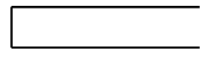

Data Store

Data Flow

Process

A process is represented using a circle. This symbol is called bubble. Bubbles are annotated with the names of corresponding functions.

* External Entity Symbol

A external entity such as a user, project manager etc is represented by a rectangle. The external entities are essentially those physical entities external to the application system, which interact with the system by inputting data to the system or by consuming the data produced by the system. In addition to the human users the external entity symbols can be used to represent external hardware and software such as application software.

* Data Flow Symbol

A directed arc or an arrow is used as a Data Flow Symbol. This represents the data flow occurring between two processors or between an external entity and a process; indirection of the Data Flow Arrow. Data flow symbols are annotated with corresponding data names.

* Data Store Symbol

A data store represents a logical file, it is represented using an open rectangle. A logical file can represent either data store symbol which represent either data structure or a physical file on the disk.

**Steps to Construct Data Flow Diagram**

Four steps are commonly used to construct a DFD

1. Process should be named for easy reference . Each name should be representative of the process.
2. The destination of flow is from top to bottom and from left to right
3. When a process is exploded in to lower level details they are numbered.

The name of data stores, sources and destinations are written in capital letters

ADMIN

USER

request

request

response

response

Fig 4.1 Level 0 DFD

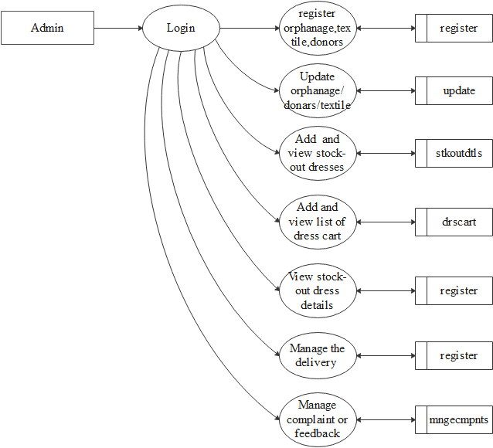

Figure.4.2 Level 1 DFD of Admin

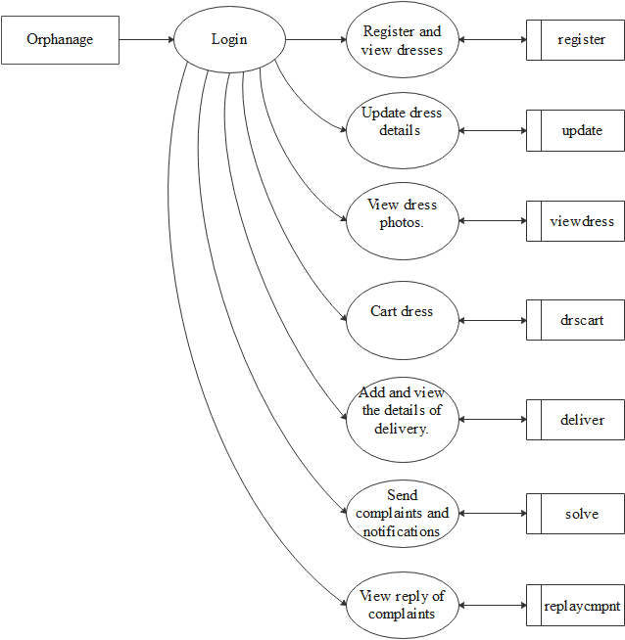

Figure.4.3 Level 1 DFD of Orphanage

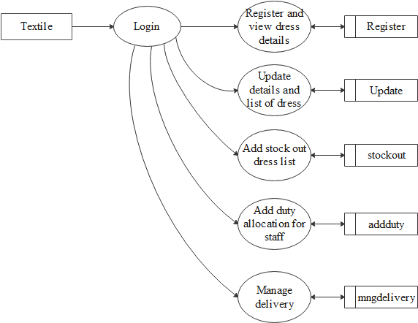

Figure.4.4 Level 1 DFD of Textiles

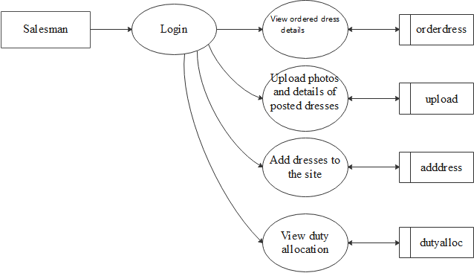

Figure.4.5 Level 1 DFD of Salesman

4.2 UML DIAGRAMS

A diagram is a graphical representation of a set of elements. The various diagrams in UML are as follows:

4.2.1 USE CASE DIAGRAM

A use case diagram at its simplest is a representation of a user's interaction with the system that shows the relationship between the user and the different use cases in which the user is involved.

Actors:-

**Admin** : Who controls the entire system

**User** : Who uses this system

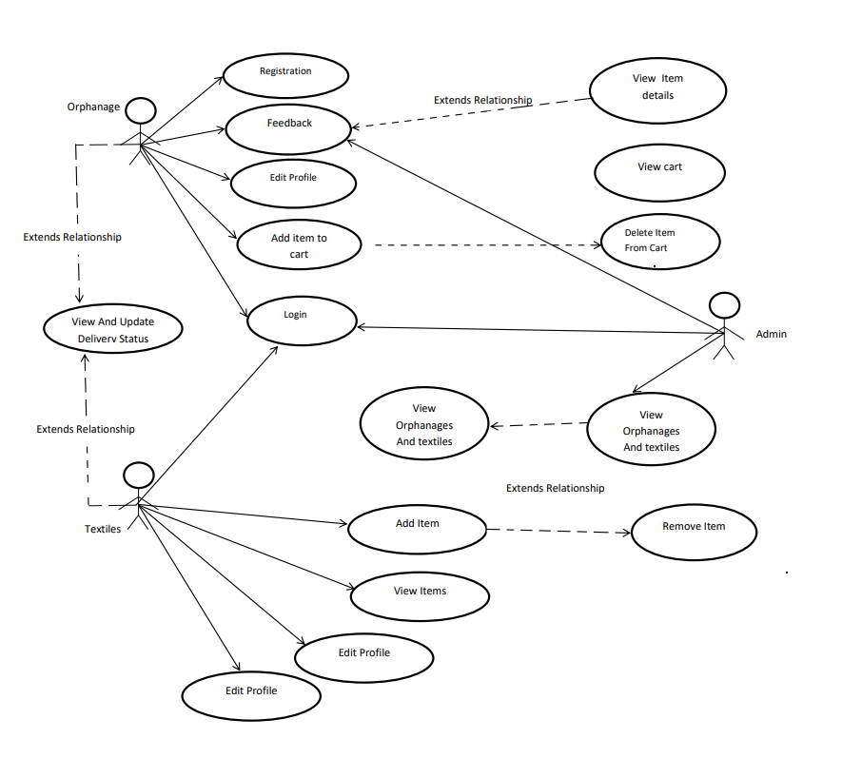

Figure.4.6 Use Case Diagram

4.2.2. ACTIVITY DIAGRAM

Activity diagram is another important diagram in UML to describe the dynamic aspects of the system. Activity diagram is basically a flowchart to represent the flow from one activity to another activity. The activity can be described as an operation of the system. The control flow is drawn from one operation to another.

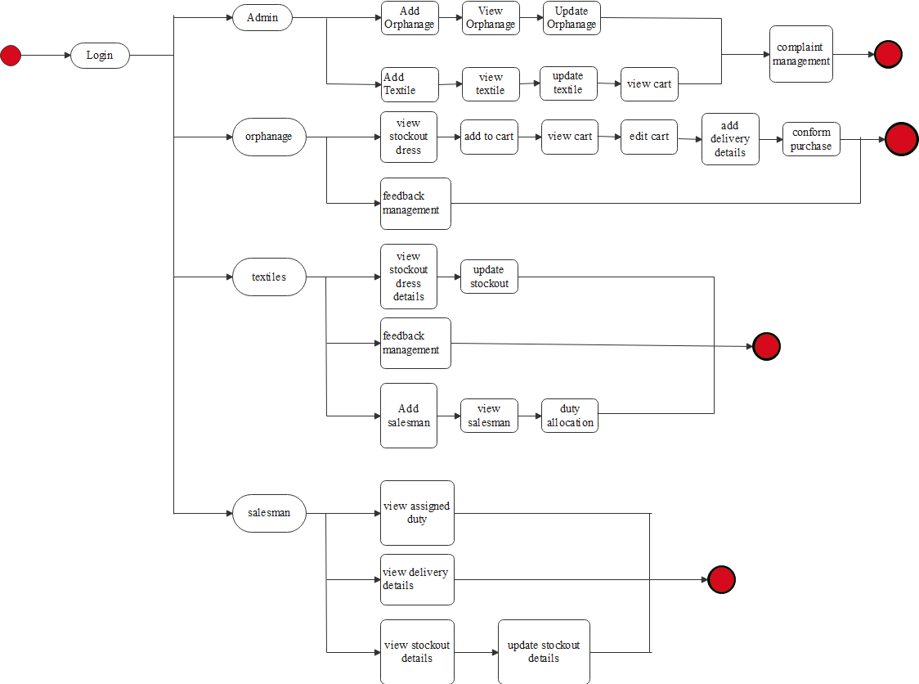

Figure.4.7 Activity Diagram

4.2.2. SEQUENCE DIAGRAM

A sequence diagram simply depicts interaction between objects in a sequential order i.e. the order in which these interactions take place. It can also use the teams event diagrams or event scenarios to refer to a sequence diagram. Sequence diagrams describe how and in what order the objects in a system function.

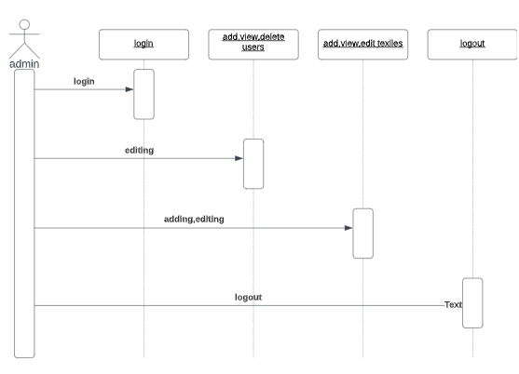

Figure.4.8 Sequence Diagram of Admin

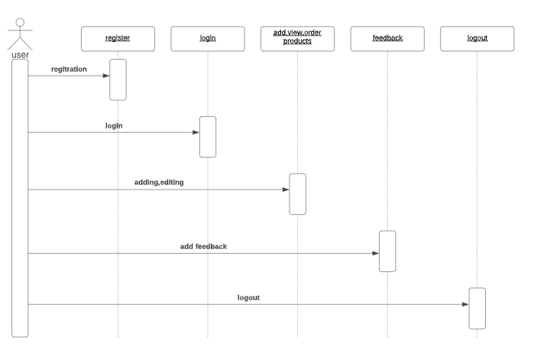

Figure.4.8 Sequence Diagram of User

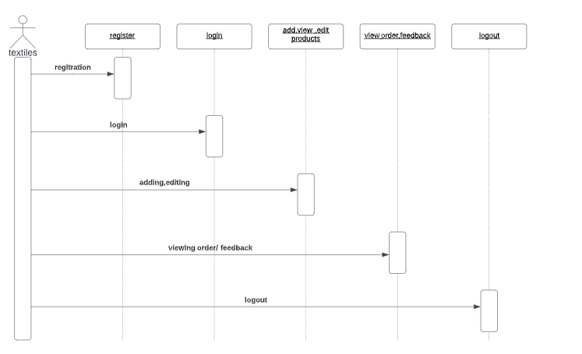

Figure.4.8 Sequence Diagram of Textiles

4.2.4. CLASS DIAGRAM

A class diagram in the Unified Modeling Language (UML) is a type of static structure diagram that describes the structure of a system by showing the system's classes, their attributes, operations (or methods), and the relationships among objects.

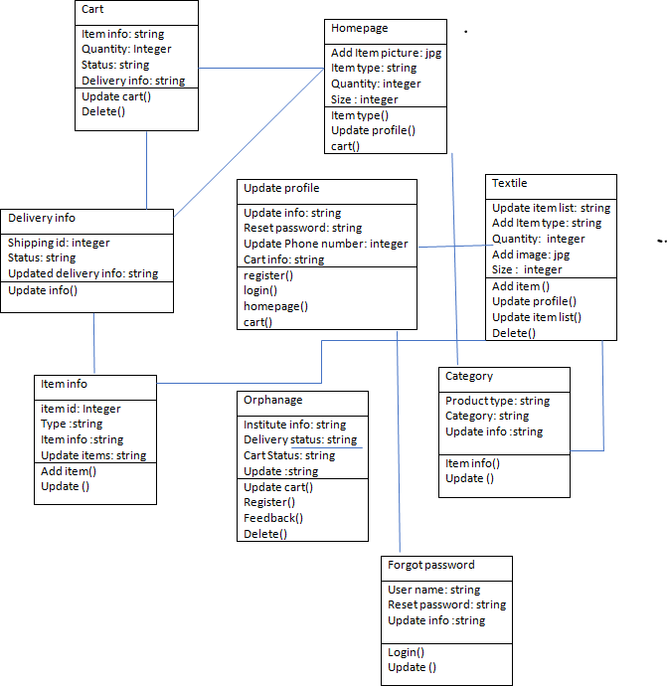

Figure.4.8 Activity Diagram

**CHAPTER 5**

**TABLE DESIGN**

A database is a collection of [information](https://searchsqlserver.techtarget.com/definition/information) that is organized so that it can be easily accessed, managed and updated. Data is organized into rows, columns and tables, and it is indexed to make it easier to find relevant information. Data gets updated, expanded and deleted as new information is added. Databases process workloads to create and update themselves, querying the data they contain and running applications against it.

**DATABASE:** Orphanage

Table.5.1 Name: **login**

Primary Key: Password

|  |  |  |  |  |
| --- | --- | --- | --- | --- |
| Sl No | FIELD | DATATYPE | CONSTRAINT | DESCRIPTION |
| 1 | username | Varchar(25) | Not Null | Username |
| 2 | password | Varchar(8) | Primary key | Password |

Table.5.2 Table Name: **reset_pwd**

Primary Key: Password

|  |  |  |  |  |
| --- | --- | --- | --- | --- |
| Sl No | FIELD | DATATYPE | CONSTRAINT | DESCRIPTION |
| 1 | username | Varchar(25) | Not Null | Username |
| 2 | oldpassword | Varchar(8) | Primary key | Password |
| 3 | newpassword | Varchar(8) | Not Null | Password |

Table.5.3 Table Name: **registration**

Primary Key:Email

|  |  |  |  |  |
| --- | --- | --- | --- | --- |
| Sl No | FIELD | DATATYPE | CONSTRAINT | DESCRIPTION |
| 1 | Sl.no | Integer | Not null | Serial no |
| 2 | Username | Varchar(30) | Not null | Name of user |
| 3 | Password | Varchar(8) | Primary key | Password |
| 4 | Orphanageverification | Varchar(8) | Not null | varification |
| 5 | Place | Varchar(15) | Not null | place |
| 6 | Address | Varchar(45) | Not null | Address |
| 7 | Phone number | Integer | Not null | Contact number |
| 8 | Email | Varchar(30) | unique | Email id |

Table.5.4 Table Name: **item details**

Primary Key: Item-id

|  |  |  |  |  |
| --- | --- | --- | --- | --- |
| Sl No | FIELD | DATATYPE | CONSTRAINT | DESCRIPTION |
| 1 | Item id | Varchar(25) | Primary key | Id for item |
| 2 | Item name | Varchar(30) | Not null | Name of item |
| 3 | Size | Integer | Not null | Size of item |
| 4 | Image | Varbinary(1024) | Not null | Image of item |
| 5 | Count | Integer | Not null | Number of items |

Table.5.5 Table Name: **order info**

Primary Key:Item id

|  |  |  |  |  |
| --- | --- | --- | --- | --- |
| Sl No | FIELD | DATATYPE | CONSTRAINT | DESCRIPTION |
| 1 | Item id | Varchar(25) | Foreign key | Item id |
| 2 | Address | Varchar(25) | Not null | Address to deliver |
| 3 | Phone number | Integer | Not null | Contact number |
| 4 | Delivery date | Date | Not null | Date for the delivery |
| 5 | status | Varchar(25) | Not null | Delivery status |

**CHAPTER 6**

**SCREENSHOTS**

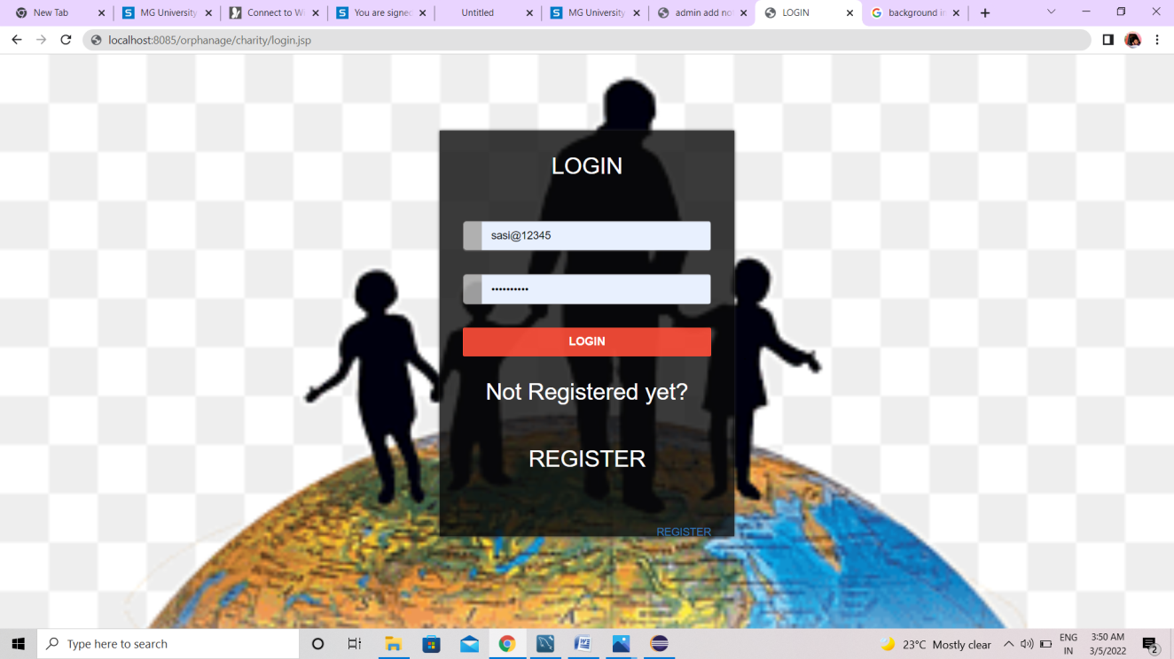

**Fig 6.1 Login Form**

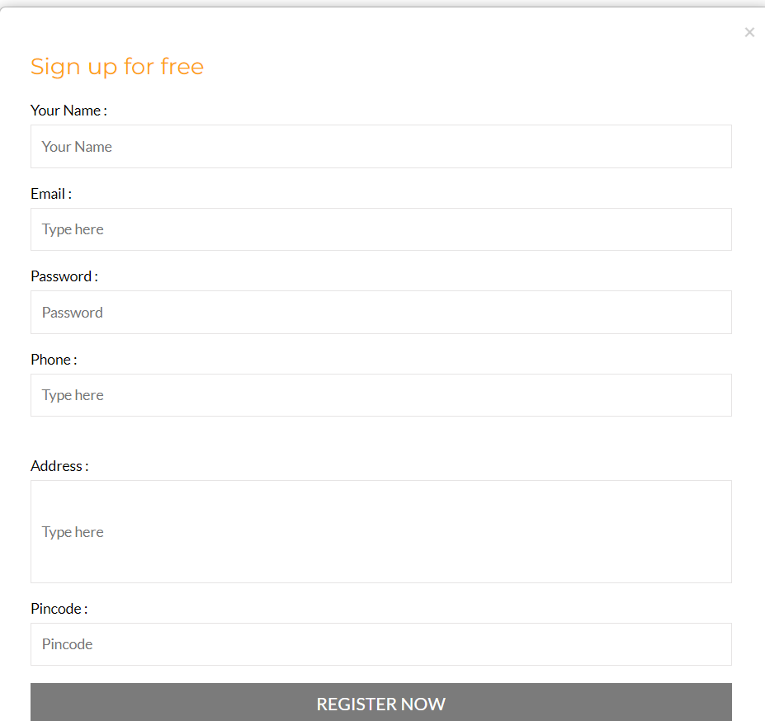

**Fig 6.2 Registeration Form**

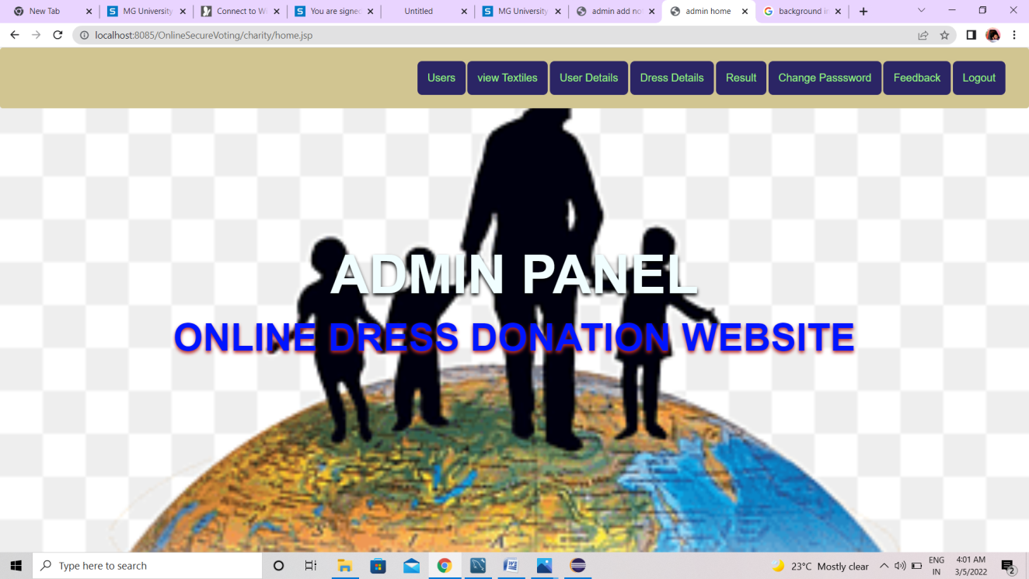

**Fig 6.3 Admin Home**

**-**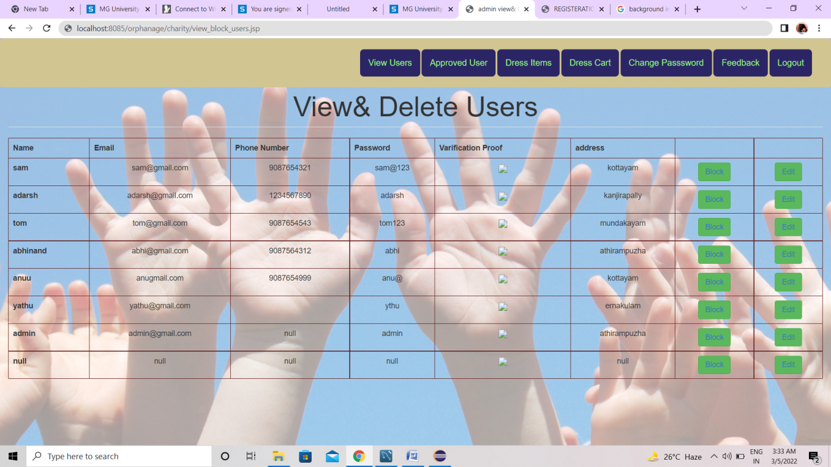

**Fig 6.4 Add & Delete Users**

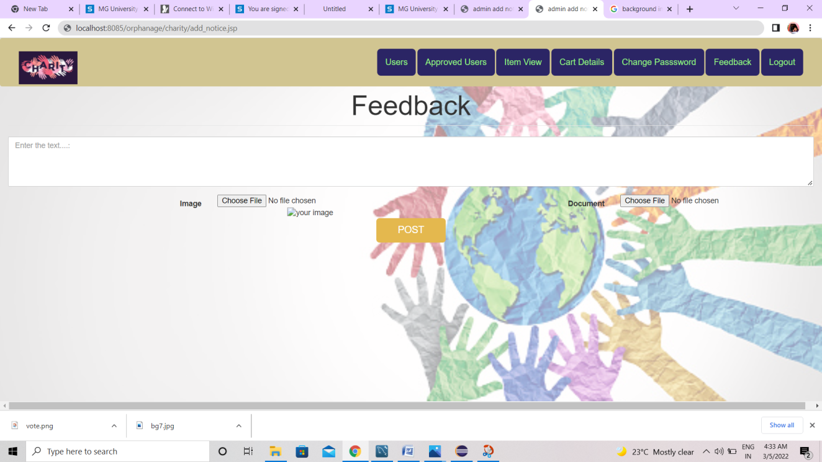

**Fig 6.5 Feedback**

**CHAPTER 7**

**CONCLUSION**

The “ONLINE DRESS DONATION WEBSITE FOR ORPHANAGES” is help the orphanage people to select the dresses for her/his wish. The system provides users with details of all type dresses and the desired description of the dress. The system also provides details which help users to order their favourite dresses. The system also gives detailed information about various materials and dress, which provide a user friendly website for both users, textile and admin. This project solves this problem by providing new dresses to the orphanages, which are needful for them. Children feel happy and it also improves their confidence in other aspects. They will not feel pity for themselves. They feel loved.

**CHAPTER 8**

**FUTURE ENHANCEMENT**

Children living in orphanages tend to lead fairly structured lives. The underprivileged children/adults are not having proper dresses to wear. They always depending on the mercy of local donors who give used dresses of their children. Some times they feel pity for themselves to wear worn out and old dresses. This project solves this problem by providing new dresses to the orphanages, which are needful for them. Children feel happy and it also improves their confidence in other aspects. They will not feel pity for themselves. They feel loved. The future advancement of this project include addition of donars, those who are interested for donating good to the orphan are included for the better performance of the project, adding food, financial support, better living to the orphans are some future scope of this project. This project is focused on orphanages so the people outside the orphanage exceeded so the next step of this project is to adding extra feature for including poor, financially backward people.

**REFERENCES**

BOOK: Murach's Java Servlets and JSP, 3rd Edition.

WEBSITE: http://www.donateinkind.in/clothes-donation