**Assignment01 –**

**Understanding of Hardware and Its Components**.

**Section 1: Multiple Choice**

1: Which Of The Following Is NOT A Component Of The CPU?

Ans :- Ram

2: What Is The Function Of RAM In A Computer?

Ans :- Ram Temporary Store Data And CPU Processes While The PC Is On Or Working. It Works Fast And Perform Smooth.

3: Which Of The Following Is A Primary Storage Device?

Ans :- 1 And 2 Both (HDD And SSD)

4: What Is The Purpose Of A GPU?

Ans:- A GPU (Graphics Processing Unit) Is Used To Render Images, Videos, And Animations.

- It Allows To Process Task Like Playing Games, Video Editing, Animation, ETC.

**Section 2: True Or False**

5: The Motherboard Is The Main Circuit Board Of A Computer Where Other Components Are Attached.

Ans:- True

6: A UPS (Uninterruptible Power Supply) Is A Hardware Device That Provides Emergency Power To A Load When The Input Power Source Fails.

Ans :- True

7: An Expansion Card Is A Circuit Board That Enhances The Functionality Of A Component.

Ans :- True

**Section 3: Short Answer**

8: Explain The Difference Between HDD And SSD.

ANS : HDD

1.Random Access Time 5-10 Ms

2.Read Latency Time High

3.Low Reliability

4.6-12 Watts

5.Relatively Large And Heavy

SDD:

1.Random Access Time 0.1 Ms

2.Read Latency Time Very Low

3.High Reliability

4.Power Consumption 2 Watts

5.Small And Light Weight

10: List And Briefly Explain Three Input Devices Commonly Used With Computers.

ANS: :- There Are 3 Commonly Input Device Used With Computer

1.Keyboard

2.Mouse

3.Microphone

1: Keyboard :-It Is The Most Commonly Used Input Device

-It Is Used Mainly For Typing Text,Numbers And Characters That Can Be Seen On The Screen

-A Keyboard Consist Of 104 Keys.

2:Mouse :- A Mouse Is A Small Pointing Device That Contains One Or More Buttons For Pointing And Selecting Items On The Computer Screen.

* + The Pointer Of The Mouse Is Called A Cursor
  + They Are Two Maouse 1.Optical Mouse 2.Scroll Mouse

3: Joystick:- It Is A Pointing Device.

* + It Moves In All Directions And Controls The Movement Of A Pointer Or Some Other Display

Symbols .

**Section 4: Practical Application**

**11: Identify And Label The Following Components On A Diagramof A Motherboard: • CPU • RAM Slots • SATA Connectors • PCI-E Slot**

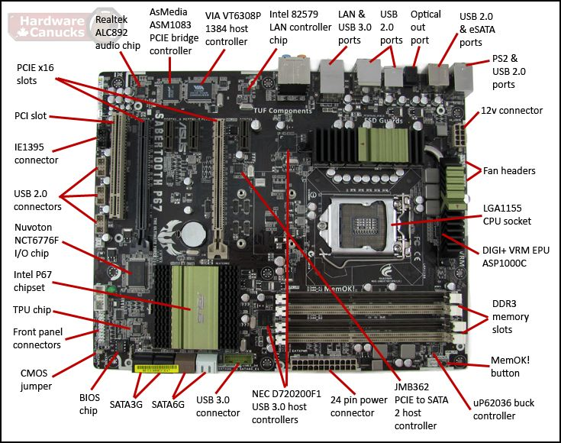

1: Cpu (Central Processing Unit):

* The Cpu Is The "Brain" Of The Computer, Responsible For Executing Instructions And Calculations.
* It’s Typically Found In A Square Or Rectangular Socket Area On The Motherboard, Often With A Heatsink And Fan Attached For Cooling.

2:Ram (Random Access Memory) Slots:

* + These Are Usually A Row Of Slots, Often In A Similar Color (E.G., Black Or Blue)
  + That Are Used To Insert Ram Sticks. Ram Is Where The Operating System And Running Programs Are Stored.

3:Sata Connectors:

* + These Are Typically Small,
  + 7-Pin Connectors That Connect To Hard Drives Or Ssds.
  + They Are Used To Transfer Data And Power To The Storage Devices.

4:Pci-E (Peripheral Component Interconnect Express) Slots:

* + Found In A Vertical Row, Often Near The Top Or Middle Of The Motherboard.

12: Demonstrate How To Install A Ram Module Into A Compute.

Ans: To Install Ram:-

1.Power Off Your Computer,

2.Open The Case,

3.Ground Yourself,

4.Locate The Ram Slots,

5.And Insert The New Ram Modules,

6.Ensuring They Click Into Place.

13: Discuss The Importance Of Proper Cooling Mechanisms In A Computer System. Include Exampples Of Cooling Methods And Their Effectiveness.

Ans: Proper Cooling In A Computer System Is Essential For Preventing Overheating, Maintaining Performance, And Extending The Lifespan Of Components. Without Adequate Cooling, High-Performance Components Like The Cpu And Gpu Can Overheat, Leading To Performance Throttling, Crashes, And Even Permanent Damage.

Importance Of Cooling :

1.Component Protection

2.Performance

3.System Stability

Longevity:-If Your Components Are Cool, You Extend Their Lifespan And Reduce The Risk Of Premature Failure.

* + There Are Three Types Of Common Colling Methods And Their Effectiveness:

1.Air Cooling

2.Liquid Cooling

3.Passive Cooling

1.Air Cooling :- Air Cooling Is Effective And Cost-Efficient,

Especially For Less Demanding Systems,

However, It Can Be Noisy And Less Effective For High-Performance Systems.

2. Liquid Cooling:- Liquid Cooling Is Generally More Efficient Than Air Cooling And Can Keep Components Cooler Under Heavier Loads.

It’s Quieter And More Efficient But Also More Expensive And Complex.

3. Passive Cooling:- Passive Cooling Is The Simplest And Least Expensive Method, But It’s Also The Least Effective.

It’s Suitable For Low-Power Components Or Systems Where Noise Is A Concern

14: Explain The Concept Of Bus Width And Its Significance In Computer Architecture.

Ans :- There Are 3 Types Of Bus :-

1. Address Bus
2. Control Bus
3. Data Bus

1.Address Bus: This Bus Identifies The Specific Location Of The Data In Memory I10 Devices

2.It Carries The Memory Address From The Cpu To Other Components

3.The Address Bus Is Typically Unidirectional

1.Control Bus: This Bus Manages The Timing And Direction Of Data Flow Coordinating

2.It Carries Control Signals From The Cpu

3.The Control Bus Is Unidirectional Flowing From The Cpu To Other Components

1.Data Bus: This Bus Carries The Actual Data Being Transferred Between The Cpu And Other Components

2.Like Memory Or Devices

3.This Bus Bidirectional Meaning Data Can Flow In Both Directions

