

**Car Breezy**

**Digital Marketplace**

|  |  |  |
| --- | --- | --- |
| **Supervisor:** | *LÊ THANH NHÂN* | |
| **Semester:** | *01* | |
| **Batch No:** | *T1.2204.M0* | |
| **Group No:** | *03* | |
| **Order:** | **Full name** | **Roll No.** |
| *1.* | *Võ Minh Tú* | *Student1379714* |
| *2.* | *Bùi Thạnh Yến Phi* | *Student1379714* |
| *3.* | *Võ Trọng Tín* | *Student1379708* |
| *4.* | *Phù Tường Vũ* | *Student1368159* |

***Month****: 07* ***Year****: 2022*



This is to certify that

|  |  |
| --- | --- |
| **Mr.** | **VÕ MINH TÚ** |
| **Mrs.** | **BÙI THẠNH YẾN PHI** |
| **Mr.** | **VÕ TRỌNG TÍN** |
| **Mr.** | **PHÙ TƯỜNG VŨ** |

Have successfully Designed & Developed

|  |  |  |
| --- | --- | --- |
|  |  |  |
| **CAR BREEZY** | | |

Submitted by:

|  |
| --- |
| **Mr. LE THANH NHAN** |

Date Of Issue:

|  |  |
| --- | --- |
|  |  |

Authorized Signature:

|  |  |
| --- | --- |
|  |  |

|  |
| --- |
| **Content** |

Content

Acknowledge

Synposis

Review1 1

Review2 (điền số trang theo thực tế)

Review3 (điền số trang theo thực tế)

Testting Document (điền số trang theo thực tế)

Final Checklist (điền số trang theo thực tế)

Tasksheet 11

|  |
| --- |
| **Acknowledge** |

As we understand that the eProject is a step-by-step learning environment that closely simulates the class-room and Lab based learning environment into actual implementation. It is a project implementation at your fingertips!! An electronic, live juncture on the machine that allows you to.

* Practice step by step i.e. laddered approach.
* Build a larger more robust application.
* Usage of certain utilities in applications designed by user.
* Single program to unified code leading to a complete application.
* Learn implementation of concepts in a phased manner.
* Enhance skills and add value.
* Work on real life projects.
* Give a real life scenario and help to create applications more complicated and useful.
* Mentoring through email support.

We would like to send a great thank to our professor and others student for the addorable supports during the time in project.

Beside serveral mistakes we had made in the project, we hope to have more oppotunities to widen our knownledge in web developing world.

We also thank you so much for your infomation and the “demo” project from India APTECH to help us get more reality experience in this project. Since we have gained more experience from this project, we will not stop learning any thing as much as we can to be more successful in the future.

Your Sincerely,

Team Group 03.

|  |
| --- |
| **Synopsis** |

The Objective of this program we aim is to give a sample project to work on real life projects. These applications help us build a larger more robust application.

The objective is not to teach us HTML/JavaScript but to provide us with a real life scenario and help us create basic applications using the tools.

Hence, we can revise the chapters before we start with the project.

This project is meant for students like us who have completed the module of HTML5. These programs should be done in the Lab sessions with assistance of the faculty if required.

The website is a tool that brings everything in the world to you such as historic monument informations, abundant natural knowledges, skills in technology or a whole digital marketplace to facilitate the process of exchange things.

It is very essential for us that will have a clear understanding of the subject. We think we should go through the project and solve the assignments as per requirements given.

And get back ***eprojects@aptech.ac.in*** as the assigned schedule.

|  |
| --- |
| **Problem Definition** |

The portal will we designed as a Single-Page-Application and responsive Website with a set of pages and menus that represent choice of activities to be performed. The pages, menus, and other visual elements must be designed in a visually appealing manner with attractive fonts, colors, and animations.

All of these should also be laid out in a responsive manner

The Web site is to be created based on the following requirements.

1. The Top of the Page should be presented with a suitable logo and a banner with depiction of cars onto it.
2. The site must contain menu with links to New, Used, Brands, Offers etc.
3. Sections should be created with proper listing of cars under NEW, USED, BRANDS etc.
4. Clicking on any car should open pop-up window with images of car and price along with tabs as Internal Specification, External, Engine, Dimensions with details mentioned in these tabs.
5. Filter with options as “Hatchbacks”, “Sedan”, “SUV”, “Convertibles” etc, should be provided.
6. Section for various Offers should be provided with listing of available offers.
7. Gallery should be provided for viewing different images.
8. Site map, Gallery, about us, Queries link, Contact us link must be added.
9. About Us and Contact Us: This menu option should display Email id, address, and contact number.

10.Color combination must be uniform throughout the project.

11.Navigation must be smooth.

Over and above this, the portal should implement the following functionalities:

* Display a continuous scrolling ticker at the bottom of the page with current date, time, and location (hint: Use geolocation features of HTML5).
* Display a visitor count at the top right corner of the page beside a logo image.
* The menu options should change color on hover and also after clicking.
* Fade in and fade out options can be used for the menus.

|  |  |  |  |  |  |  |  |  |  |  |  |  |  |  |  |
| --- | --- | --- | --- | --- | --- | --- | --- | --- | --- | --- | --- | --- | --- | --- | --- |
| |  | | --- | | **Customer Requirements Specifications** |  |  |  | | --- | --- | | **User:** | | |  | **input:** | |  | * Membership data registration * Car information * Car offer * Contact messages | |  | **Process:** | |  | * Validate membership data registration and save * Look up car information(brand, model, state, style…) * Validate offers form * Validate contact form | |  | **Output:** | |  | * Registration status * Chosen car informations * Car offer status * Contact status | |

|  |  |
| --- | --- |
| **Hardware / software requirement:** | |
|  | **Software:**  Technologies to be used: |
|  | * Frontend: HTML5, CSS, Bootstrap, Javascript, jQuery, AngularJS * Data Store: JSON files   Other Requirements:   * Operating Portal: Windows * Browsers: Edge, Chrome, Mozilla Firefox, Safari * Server: XAMPP |
|  | **Hardware:** |
|  | * Intel Core i3/i5 Processor or higher * 8 GB RAM or above * Color SVGA * 500 GB Hard Disk space * Mouse * Keyboard |

|  |
| --- |
| **Architecture and design of the project** |

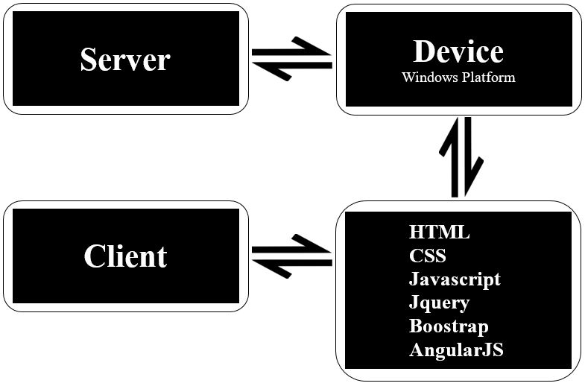

|  |
| --- |
| **SiteMap** |

1. Sơ đồ trang của project.
2. Xem Problem Statement trong đề tài của India
3. Từ Home, vẽ các menu chính thành cấp F1.
4. Bổ sung thêm cấp F2.

|  |
| --- |
| **Screen shots** |

Các layout mô tả màn hình. Sinh viên có thể vẽ layout. Nếu không thể thì code HTML cơ bản rồi chụp lại hình màn hình.

**Ví dụ cách thứ nhất:** (Khuyến cáo sử dụng)

1. **Homepage:**

|  |  |  |  |  |  |
| --- | --- | --- | --- | --- | --- |
| Logo | | | Banner size x size | | Banner size x size |
| Homepage | Categories | | Register | | About us |
| < | | Services Carousel | | > | |
| Enter text for searching:  Click for seaching | | | | | |
|  | | | | | |
| Footer | | | | | |

**Description** : Mô tả màn hình là gì? Dùng làm gì?

**From** : Được mở từ đâu? Menu nào?

**To** : Có thể tới được trang nào khác?

**Ví dụ cách thứ hai:**

1. **Homepage:**

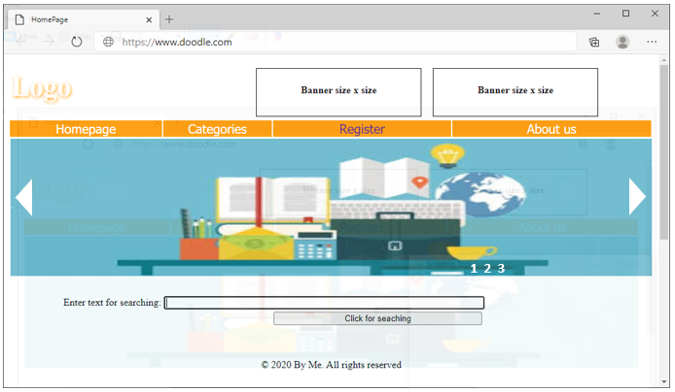

**Description** : Mô tả màn hình là gì? Dùng làm gì?

**From** : Được mở từ đâu? Menu nào?

**To** : Có thể tới được trang nào khác?

|  |
| --- |
| **Testing document** |

|  |  |  |
| --- | --- | --- |
| **Sr.No** | **Features Tested** | **Remarks** |
| 1 |  |  |
| 2 |  |  |
| 3 |  |  |
| 4 |  |  |
| 5 |  |  |
| 6 |  |  |
| 7 |  |  |
| 8 |  |  |
| 9 |  |  |
| 10 |  |  |
| 11 |  |  |
| 12 |  |  |
| 13 |  |  |
| 14 |  |  |
| 15 |  |  |

|  |
| --- |
| **Final checklist** |

|  |  |  |
| --- | --- | --- |
| **Sr.No** | **Aspected Tested** | **Suggestion/**  **Remarks** |
| 1 | Are all the users able to view the images and links? |  |
| 2 | Have all the views, modules and controllers been properly integrated and is the site function as a single page application? |  |
| 3 | Are the GUI content devoid of spelling mistakes? |  |
| 4 | Is the application user-friendly? |  |
| 5 | Is the Website launching correctly in all popular browsers? |  |
| 6 | Are all the forms validated with proper criteria? |  |
| 7 | Do all text links lead to the appropriate website? |  |
| 8 | Do all image links lead to the appropriate website? |  |
| 9 | Are all the images and links clearly visible on the page? |  |
| 10 | Does the Web page work properly in all the tested browsers? |  |
| 11 | Does the Web page take too long to be loaded fully? |  |
| 12 | Is the navigation sequences correct through all the Web pages on the site? |  |
| 13 | Is the JavaScript code working as expected in all click events? |  |
|  |  |  |
|  | (Sinh viên ghi thêm…) |  |

|  |  |  |  |  |  |  |  |
| --- | --- | --- | --- | --- | --- | --- | --- |
| **No** | **Member** | **Contents** | **Page Name** | **Activity Plan** | **Date of Preparation of Activity Plan** | | |
| **Planed Start Date** | **Actual Start Date** | **Actual Days** | **Status** |
| 1 | Võ Minh Tú | Products | Products.html | 20/07/2022 | 20/07/2022 | 5 | OK |
| 2 | Gallery | Gallery.html | 20/07/2022 | 20/07/2022 |  |  |
| 3 | Offers | Offers.html | 20/07/2022 | 20/07/2022 | 5 | OK |
|  | | | | | | | |
| 1 | Bùi Thạnh Yến Phi | Home | Home.html | 20/07/2022 | 20/07/2022 | 5 | OK |
| 2 | Footer | Footer.html | 20/07/2022 | 20/07/2022 |  |  |
| 3 | Registration | Register.html | 20/07/2022 | 20/07/2022 | 5 | OK |
|  | | | | | | | |
| 1 | Võ Trọng Tín | Contact us | Contact us.html | 20/07/2022 | 20/07/2022 | 5 | OK |
| 2 | About us | About us.html | 20/07/2022 | 20/07/2022 |  |  |
| 3 | Header | Header.html | 20/07/2022 | 20/07/2022 | 5 | OK |
|  |  |  |  |  |  |  |  |
| 1 | Phù Tường Vũ | Checkout | Checkout.html | 20/07/2022 | 20/07/2022 | 5 | OK |