**Modeling Acoustic Waves in Nonhomogeneous Mediums**

By Adam Gleichman

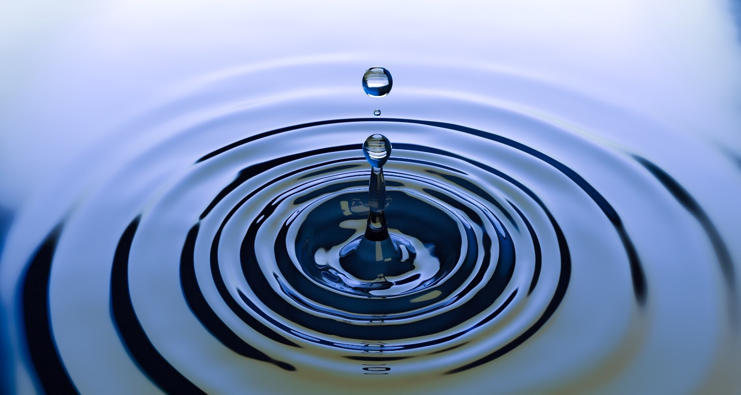

Credit: Pixabay; <https://www.pexels.com/photo/water-drop-photo-220213/>

Overview

Simulation is critical to ultrasound technology because simulation of ultrasonic waves gives us a better understanding of how ultrasonic waves interact with the environment. This allows faster research in application of ultrasonic waves for medical or geological purposes. Accurate simulations allow for a safe, cheaper, and faster way to test ideas of ultrasound application while reducing the potential of harm to others during a test in the real world. Individuals can quickly test ultrasound imagery programs with a virtual environment with simulation software potentially saving time by reducing the dependence on creating their own physical test environments.

Ultrasound applications range from imaging the human body, cancer growths, organs, sea exploration, surveys of oil underground, and finding potential sinkholes. A new field of ultrasound is searching the possibility for ultrasound therapy, a way to use ultrasound to destroy cancer cells in the body. Naturally technology like this demands the ability to know how the human body will react when the waves travel through tissue to ensure that the waves only damage the correct cells. The human body is not a simple uniform object so our goal is to create simulation software than can handle the complexity of waves traveling through multiple regions with different properties in a time effective manner.

Program Description

For this project, I would be creating a simulation function to model the travel of waves through a medium. This is basic and technically does exist but the purpose to achieve an efficient simulation model that handles wave motion in the 3D space for nonhomogeneous systems. Finite Volume Method is going to be a starting point for the project because of its efficient nature and for a nice way to setup simulation while still being robust for different functions of acoustics that we might try (shear waves, standing waves, and maybe pulses). Currently, I have a functioning 2D advection equation code (this is the first project goal) written, but it is written in Matlab.

Project Goals

-Create functioning finite volume program for the advection equation (2D) in Python

-Modify Finite Volume function to work with Godunov flux model (2D)

-Add function for attenuation equation (2D)

-Add function for Burgers’ equation

Inviscid Burgers’ equation

Viscid Burgers’ equation

-Add an input for the shock function versus a sinusoidal wave

-Repeat the previous steps for 3D

Anticipating Challenges

-Figure out which long term numerical methods for the application

Burgers’ equation, in particular, has multiple different numerical solving algorithms that seem to be widespread, but I have not seen a particular reason to use one over another for the specific application. If I can not find a good reason to pick a specific solving method, then I plan to arbitrarily pick one method and only revisit if I have extra time after the fact.