Curiosity App — Theme & Screen Designs
Comprehensive visual showcase of all shortlisted design themes and screen mockups.

Part 1: The Three Shortlisted Themes

Option 3: Nordic Clay & Sage
Dark graphite slate (#1A1D20), mineral clay (#24282C), oat milk cream (#EDE8E1), sage green & terracotta.
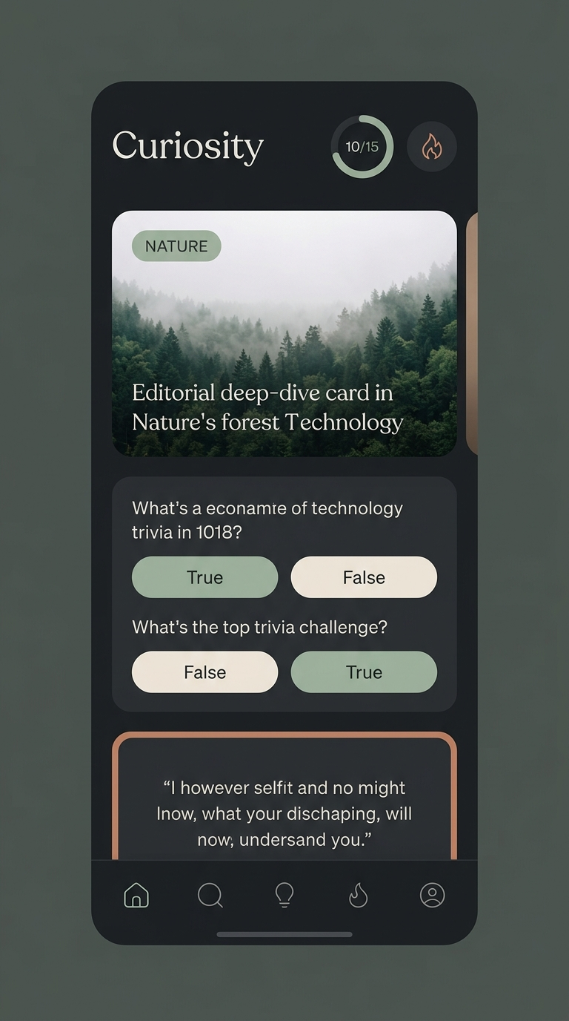

Option 1: Geist Obsidian Minimalist
Pitch-black OLED (#000000), matte cards (#111111), razor-sharp borders, electric cyan accent.
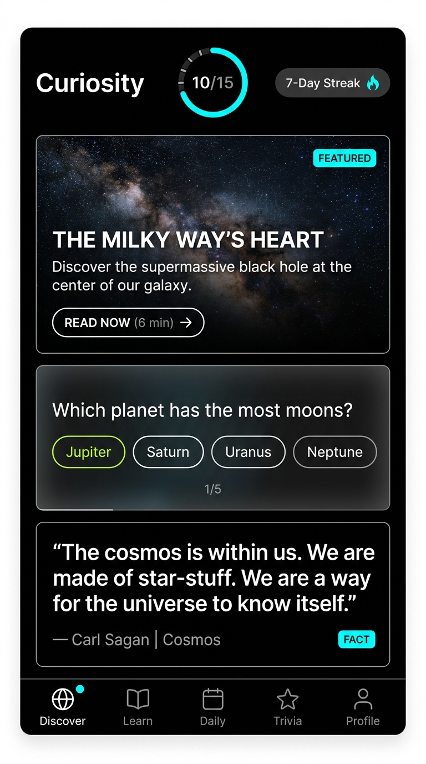

Option 2: Modern Athenaeum
Warm espresso charcoal (#141210), unbleached cream (#F5EFEB), Newsreader serif, champagne gold.
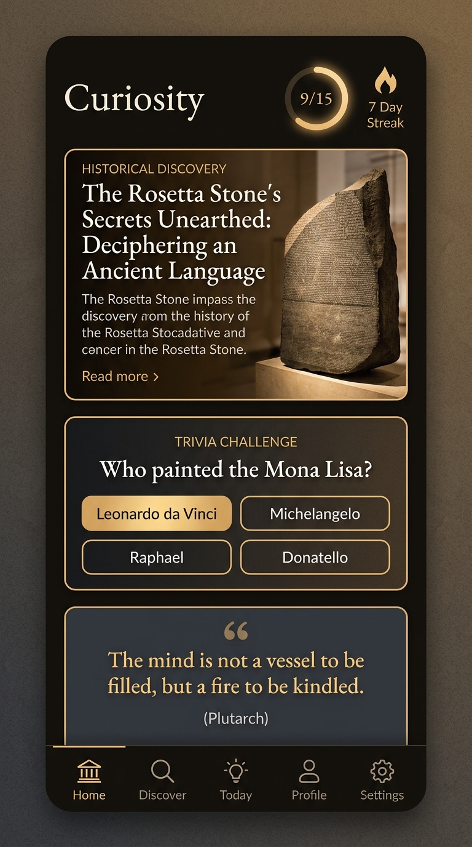

Part 2: Nordic Clay & Sage — Screen by Screen

Nordic Clay: Daily Deep Dives (Articles Feed)
15-item ambient circular progress ring (12/15), streak flame, 16:9 article card, Lora headline, bottom nav.
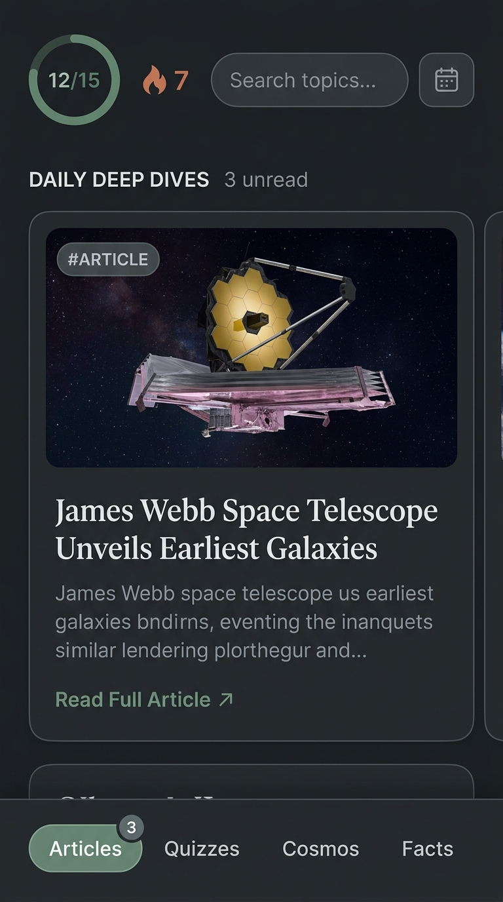

Nordic Clay: Daily Trivia Quizzes
Question card, 4 pillowy option buttons (48dp height), active checkmark feedback, sage explanation box.
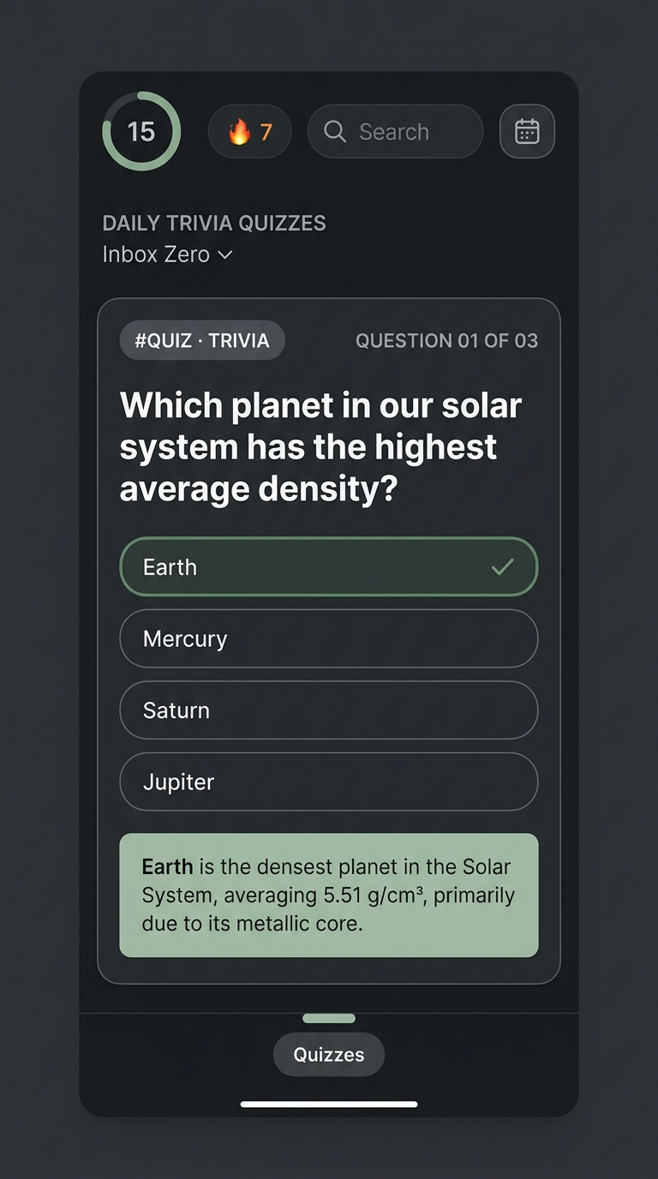

Nordic Clay: The Vault (Archive Timeline)
30-day timeline cards with thumbnail previews, date headers, and completed badges.
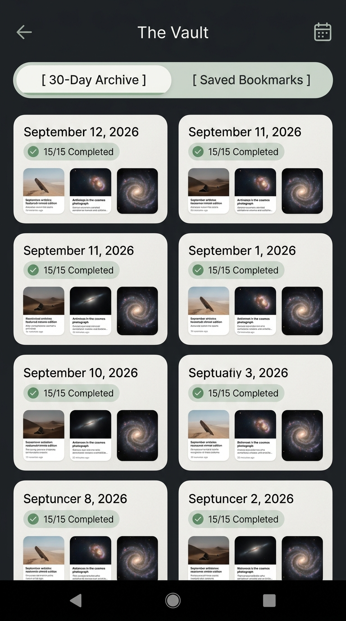

New Feature: In-App Settings & Appearance Switcher UX
Below is the proposed design for adding a dedicated Settings affordance in the Curiosity mobile app. This introduces a 48x48 dp Settings Icon in the Top Bar alongside The Vault, which pulls up an expandable pillowy Scandinavian bottom sheet modal.
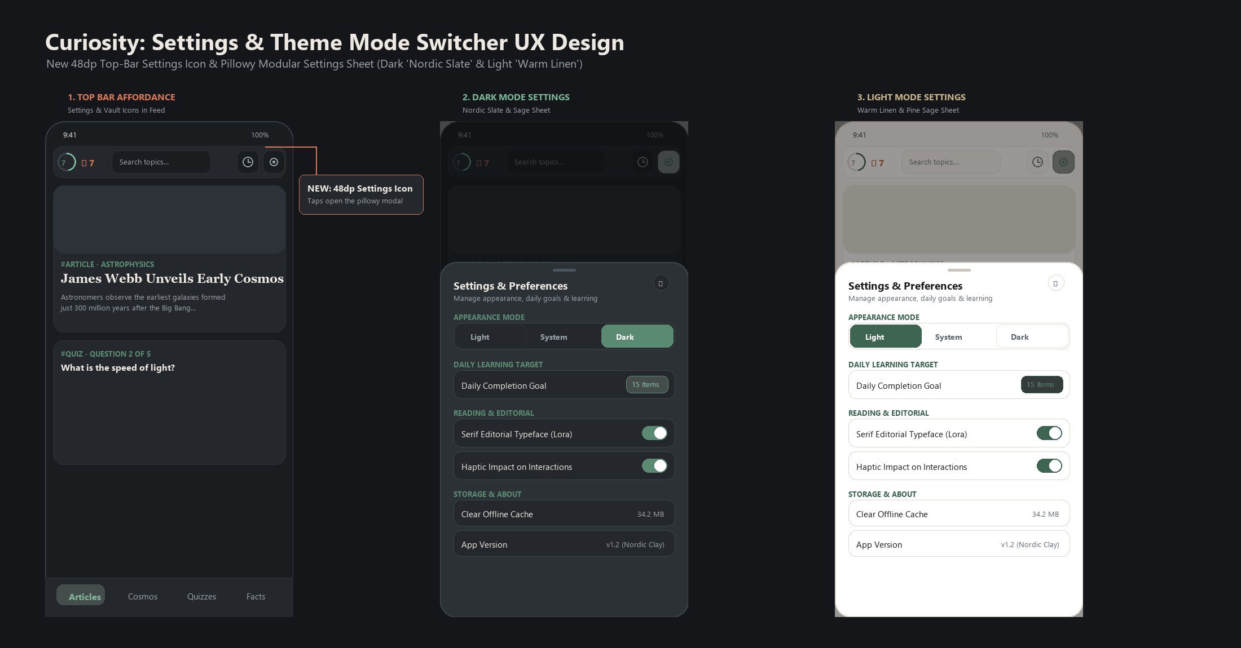
Figure: Settings Icon in Top Bar and Expandable Pillowy Settings Sheet in Dark and Light Modes.

New Feature: In-App Settings & Appearance Switcher UX
Below is the proposed design for adding a dedicated Settings affordance in the Curiosity mobile app. This introduces a 48x48 dp Settings Icon in the Top Bar alongside The Vault, which pulls up an expandable pillowy Scandinavian bottom sheet modal.
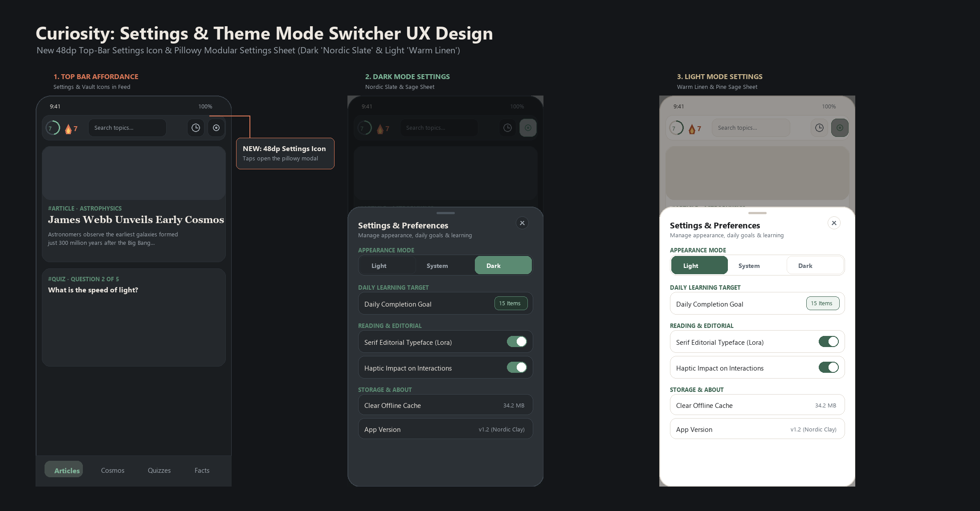
Figure: Settings Icon in Top Bar and Expandable Pillowy Settings Sheet in Dark and Light Modes.

