# 2024-Spring-HW0

All the detailed specified in Homework 0 documentation.

## Wallet Address

Please provide your MetaMask wallet address: 0x91AFb2eE1AA7FB3D0067dc5EF74Ec6b29531aB04

## Local Testing

Please provide a screenshot of the `forge test -vvv` command running in your local environment.

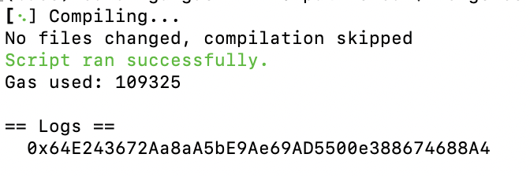

## Contract Address

Please provide the contract address that you deployed on the Sepolia network.

0x64E243672Aa8aA5bE9Ae69AD5500e388674688A4

## Sepolia Etherscan

Paste the contract address into the Sepolia Etherscan and share the screenshot.

