In countries with high per capita GDP, people live longer. Or in another way; in countries with long lifespans, per capita GDP is higher. The link between health and wealth does not tell us which is the first. But one thing is clear: although many people think, there are no two groups of countries. Dividing these countries into two groups, developing and developed countries, is highly misleading.

Labels make it easier to discuss countries. But the label should be relevant. Therefore, we recommend using the four income levels marked at the top of the chart. It is best to divide the world into four groups, preferably at the trademark level rather than at the national level, as members of each group will change next year.

This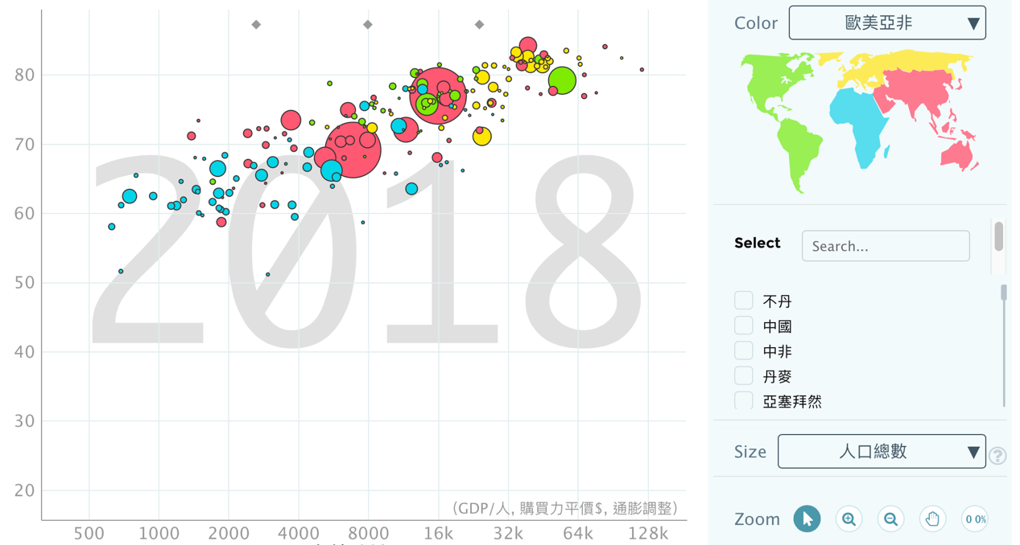 is the population we have around the world.

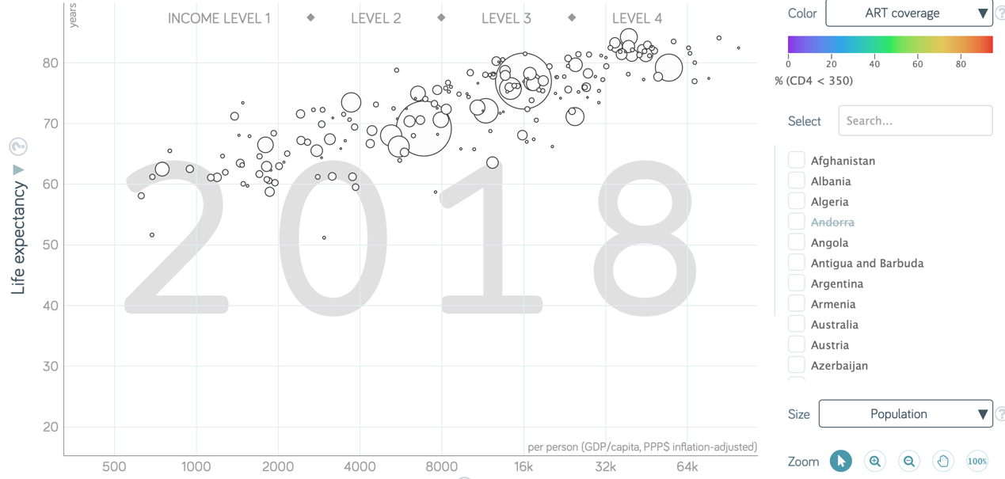This is HIV frequency that the ART coverage.

This is the Adult with HIV in 2011

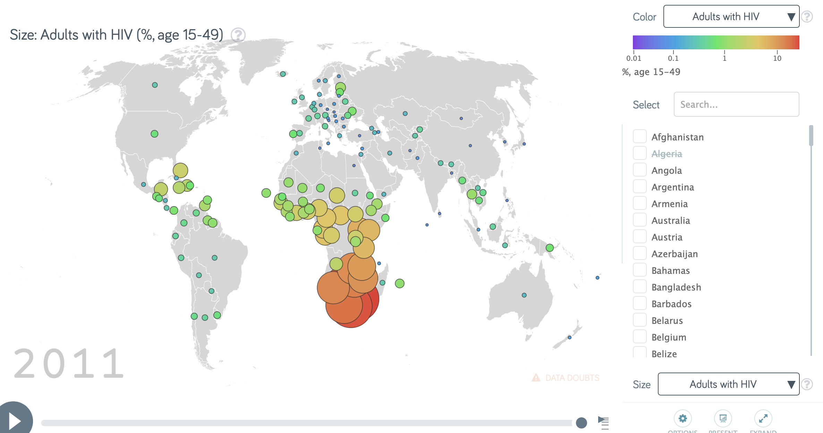

The Annual HIV deaths.

