Help student from SLST

Description



Motivation

A student from the School of Life Science and Technology come to ask for help! They sequenced two mice's genes and want to figure out the similarity of these two sequences.

Problem

You have 2 sequences of the gene. Each of them contains 4 different types of nucleotide: A, C, G, T.The similarity of different nucleotides is shown below:

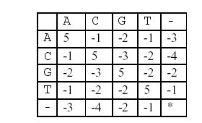(symbol '-' represent vacancy)

For two known sequences, you may have to figure out a matchup, to maximize their similarity. You may add vacancy into the sequence, but you may not modify the order of the sequence. For example, ACGT and AGG. If you match them as (A, A), (C, G), (G, G), (T, -), the similarity is 5-3+5-1=6. However, if you match them as (A, A), (C, -), (G, G), (T, G), then the similarity is 5-4+5-2=4. For these two sequences, 6 is the best similarity.

Goal

Figure out a matchup to maximize the similarity of the two sequences.

Input

Two lines.

Each line contains an integer, representing the length of the DNA, and a string, representing the gene's sequence.

The length <= 300.

Output

A number indicates the maximize similarity.

Sample Input 1

4 ACGT

3 AGG

Sample Output 1

6

Sample Input 2

7 ACAGGTT

10 AGGTCCAATT

Sample Output 2

12

Hint

Dynamic programming