Contents

Enum Definition

Table Definition

ADMIN

CONFIRMATION

COUNTRY_X_LANGUAGE

COURSE

COURSE_X_MEDIA_FILE

CURRENCY

CUSTOM_TOUR

FAQ

FAQ_CATEGORY

GUIDE

GUIDE_EVENT_TYPE

GUIDE_X_LANGUAGE

GUIDE_X_LICENSE

KEYWORD

LANGUAGE

LOCATION_CITY

LOCATION_COUNTRY

LOCATION_STATE

MESSAGE

NOTICE

PRODUCT

PRODUCT_EVENT_TYPE

PRODUCT_IMPOSSIBLE_DATE

PRODUCT_PRICE

PRODUCT_RESERVATION

PRODUCT_X_CITY

PRODUCT_X_KEYWORD

PRODUCT_X_THEME

PUBLIC_FILE

SELLER_IMPOSSIBLE_DATE

SERVICE

SERVICE_TYPE

THEME

TOUR

TOURIST

TOURIST_EMAIL

TOURIST_FACEBOOK

TOURIST_GOOGLEPLUS

TOURIST_KAKAOTALK

TOURIST_TWITTER

TOUR_PLAN

TOUR_PLAN_X_THEME

TOUR_SCHEDULE

TOUR_SCHEDULE_DAY

TOUR_SCHEDULE_NODE

TOUR_SCHEDULE_NODE_MEDIA_FILE

TOUR_SKETCH

TOUR_SKETCH_NODE

UNIT_TOUR

USER_X_INTEREST_GUIDE

USER_X_INTEREST_PRODUCT

user

# Enum Definition

# Table Definition

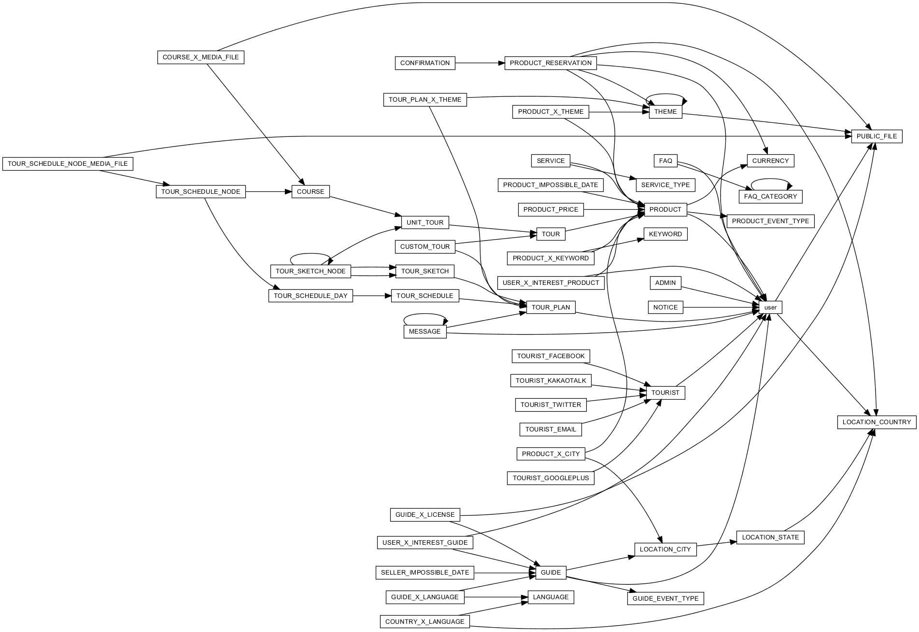

## ADMIN

user of admin type

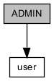

|  |  |  |  |  |  |  |
| --- | --- | --- | --- | --- | --- | --- |
| COLUMN | TYPE | NULLABLE | PKEY | DEFAULTED | REFERRED | REFER |
| ID | BIGINT |  | ● |  |  | [user] ID |
| LOGIN_ID | VARCHAR(100) |  |  |  |  |  |
| LOGIN_PASSWORD | VARCHAR(100) |  |  |  |  |  |

|  |  |  |
| --- | --- | --- |
| UNIQUE KEY | COLUMNS | DESCRIPTION |
| CONSTRAINT_3B | ID |  |
| ADMIN_LOGIN_ID_KEY | LOGIN_ID |  |

|  |  |
| --- | --- |
| COLUMN | DESCRIPTION |
| ID | table identifier |
| LOGIN_ID | login ID |
| LOGIN_PASSWORD | login password |

## CONFIRMATION

serves as evidence of tour

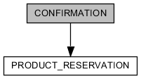

|  |  |  |  |  |  |  |
| --- | --- | --- | --- | --- | --- | --- |
| COLUMN | TYPE | NULLABLE | PKEY | DEFAULTED | REFERRED | REFER |
| ID | BIGINT |  | ● |  |  | [PRODUCT_RESERVATION] ID |
| NAME | VARCHAR(100) |  |  |  |  |  |
| ENGLISH_NAME | VARCHAR(100) |  |  |  |  |  |
| EMAIL | VARCHAR(100) |  |  |  |  |  |
| PHONE | VARCHAR(100) |  |  |  |  |  |
| TOUR_TITLE | VARCHAR(100) |  |  |  |  |  |
| TOURIST_NUM | VARCHAR(100) |  |  |  |  |  |
| TOUR_DATE | VARCHAR(100) |  |  |  |  |  |
| COST | VARCHAR(100) |  |  |  |  |  |
| PAID | VARCHAR(100) |  |  |  |  |  |
| CONTACTABLE_TIME | VARCHAR(100) |  |  |  |  |  |
| MEETING_PLACE | VARCHAR(100) |  |  |  |  |  |
| GUIDE_PHONE | VARCHAR(100) |  |  |  |  |  |
| GUIDE | VARCHAR(100) |  |  |  |  |  |
| CREATED_AT | TIMESTAMP |  |  | ● |  |  |
| UPDATED_AT | TIMESTAMP | ● |  |  |  |  |
| DELETED_AT | TIMESTAMP | ● |  |  |  |  |

|  |  |  |
| --- | --- | --- |
| UNIQUE KEY | COLUMNS | DESCRIPTION |
| CONSTRAINT_73 | ID |  |

|  |  |
| --- | --- |
| COLUMN | DESCRIPTION |
| ID | table identifier |
| NAME | name of tourist |
| ENGLISH_NAME | english name of tourist |
| EMAIL | email of tourist |
| PHONE | phone number of tourist |
| TOUR_TITLE | tour title |
| TOURIST_NUM | tourist number |
| TOUR_DATE | day when tour start |
| COST | total tour cost |
| PAID | present payment |
| CONTACTABLE_TIME | contactable time with guide |
| MEETING_PLACE | place where meet with guide |
| GUIDE_PHONE | phone number of guide |
| GUIDE | name of guide |
| CREATED_AT | timestamp when this record is created |
| UPDATED_AT | timestamp when this record is updated |
| DELETED_AT | present that this record is deleted |

## COUNTRY_X_LANGUAGE

relationship of country with language. languages are used as representative country.

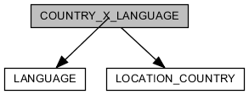

|  |  |  |  |  |  |  |
| --- | --- | --- | --- | --- | --- | --- |
| COLUMN | TYPE | NULLABLE | PKEY | DEFAULTED | REFERRED | REFER |
| ID | BIGINT |  | ● | ● |  |  |
| COUNTRY_ID | BIGINT |  |  |  |  | [LOCATION_COUNTRY] ID |
| LANGUAGE_ID | BIGINT |  |  |  |  | [LANGUAGE] ID |

|  |  |  |
| --- | --- | --- |
| UNIQUE KEY | COLUMNS | DESCRIPTION |
| CONSTRAINT_DA | ID |  |

|  |  |
| --- | --- |
| COLUMN | DESCRIPTION |
| ID | table identifier |
| COUNTRY_ID | reference country |
| LANGUAGE_ID | reference language |

## COURSE

component what constitutes product. they are sequential about time.

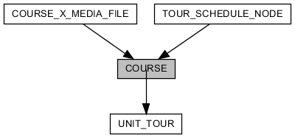

|  |  |  |  |  |  |  |
| --- | --- | --- | --- | --- | --- | --- |
| COLUMN | TYPE | NULLABLE | PKEY | DEFAULTED | REFERRED | REFER |
| ID | BIGINT |  | ● | ● | [COURSE_X_MEDIA_FILE] COURSE_ID  [TOUR_SCHEDULE_NODE] COURSE_ID |  |
| UNIT_TOUR_ID | BIGINT | ● |  |  |  | [UNIT_TOUR] ID |
| TITLE | VARCHAR(100) | ● |  |  |  |  |
| DESCRIPTION | CLOB(2147483647) | ● |  |  |  |  |
| SEQUENCE | INTEGER |  |  |  |  |  |
| CREATED_AT | TIMESTAMP |  |  | ● |  |  |
| UPDATED_AT | TIMESTAMP | ● |  |  |  |  |
| DELETED_AT | TIMESTAMP | ● |  |  |  |  |

|  |  |  |
| --- | --- | --- |
| UNIQUE KEY | COLUMNS | DESCRIPTION |
| CONSTRAINT_76 | ID |  |

|  |  |
| --- | --- |
| COLUMN | DESCRIPTION |
| ID | table identifier |
| UNIT_TOUR_ID | reference product |
| TITLE | title of course |
| DESCRIPTION | description |
| SEQUENCE | sequence number |
| CREATED_AT | timestamp when this record is created |
| UPDATED_AT | timestamp when this record is updated |
| DELETED_AT | present that this record is deleted |

## COURSE_X_MEDIA_FILE

image file what is comprised in one course.

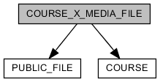

|  |  |  |  |  |  |  |
| --- | --- | --- | --- | --- | --- | --- |
| COLUMN | TYPE | NULLABLE | PKEY | DEFAULTED | REFERRED | REFER |
| ID | BIGINT |  | ● | ● |  |  |
| COURSE_ID | BIGINT |  |  |  |  | [COURSE] ID |
| PUBLIC_FILE_ID | BIGINT |  |  |  |  | [PUBLIC_FILE] ID |
| CREATED_AT | TIMESTAMP |  |  | ● |  |  |
| UPDATED_AT | TIMESTAMP | ● |  |  |  |  |

|  |  |  |
| --- | --- | --- |
| UNIQUE KEY | COLUMNS | DESCRIPTION |
| CONSTRAINT_8 | ID |  |

|  |  |
| --- | --- |
| COLUMN | DESCRIPTION |
| ID | table identifier |
| COURSE_ID | reference course |
| PUBLIC_FILE_ID | reference image file |
| CREATED_AT | timestamp when this record is created |
| UPDATED_AT | timestamp when this record is updated |

## CURRENCY

define currency

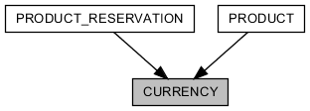

|  |  |  |  |  |  |  |
| --- | --- | --- | --- | --- | --- | --- |
| COLUMN | TYPE | NULLABLE | PKEY | DEFAULTED | REFERRED | REFER |
| ID | BIGINT |  | ● | ● | [PRODUCT] CURRENCY_ID  [PRODUCT_RESERVATION] CURRENCY_ID |  |
| NAME | VARCHAR(2048) |  |  |  |  |  |

|  |  |  |
| --- | --- | --- |
| UNIQUE KEY | COLUMNS | DESCRIPTION |
| CONSTRAINT_5 | ID |  |
| CURRENCY_NAME_KEY | NAME |  |

|  |  |
| --- | --- |
| COLUMN | DESCRIPTION |
| ID | table identifier |
| NAME | name of currency |

## CUSTOM_TOUR

selling tour-product by guide manager

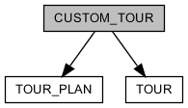

|  |  |  |  |  |  |  |
| --- | --- | --- | --- | --- | --- | --- |
| COLUMN | TYPE | NULLABLE | PKEY | DEFAULTED | REFERRED | REFER |
| ID | BIGINT |  | ● |  |  | [TOUR] ID |
| TOUR_PLAN_ID | BIGINT | ● |  |  |  | [TOUR_PLAN] ID |

|  |  |  |
| --- | --- | --- |
| UNIQUE KEY | COLUMNS | DESCRIPTION |
| CONSTRAINT_182 | ID |  |

|  |  |
| --- | --- |
| COLUMN | DESCRIPTION |
| ID | table identifier |
| TOUR_PLAN_ID | reference tour plan |

## FAQ

frequently asked questions

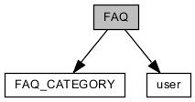

|  |  |  |  |  |  |  |
| --- | --- | --- | --- | --- | --- | --- |
| COLUMN | TYPE | NULLABLE | PKEY | DEFAULTED | REFERRED | REFER |
| ID | BIGINT |  | ● | ● |  |  |
| USER_ID | BIGINT |  |  |  |  | [user] ID |
| QUESTION | CLOB(2147483647) |  |  |  |  |  |
| ANSWER | CLOB(2147483647) |  |  |  |  |  |
| CREATED_AT | TIMESTAMP |  |  | ● |  |  |
| UPDATED_AT | TIMESTAMP | ● |  |  |  |  |
| DELETED_AT | TIMESTAMP | ● |  |  |  |  |
| CATEGORY_ID | BIGINT | ● |  |  |  | [FAQ_CATEGORY] ID |

|  |  |  |
| --- | --- | --- |
| UNIQUE KEY | COLUMNS | DESCRIPTION |
| CONSTRAINT_10 | ID |  |

|  |  |
| --- | --- |
| COLUMN | DESCRIPTION |
| ID | table identifier |
| USER_ID | reference writer |
| QUESTION | question |
| ANSWER | answer |
| CREATED_AT | timestamp when this record is created |
| UPDATED_AT | timestamp when this record is updated |
| DELETED_AT | present that this record is deleted |
| CATEGORY_ID | reference category |

## FAQ_CATEGORY

category of "faq"

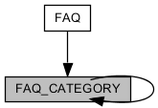

|  |  |  |  |  |  |  |
| --- | --- | --- | --- | --- | --- | --- |
| COLUMN | TYPE | NULLABLE | PKEY | DEFAULTED | REFERRED | REFER |
| ID | BIGINT |  | ● | ● | [FAQ] CATEGORY_ID  [FAQ_CATEGORY] REF_ID |  |
| NAME | VARCHAR(2048) |  |  |  |  |  |
| REF_ID | BIGINT | ● |  |  |  | [FAQ_CATEGORY] ID |
| CREATED_AT | TIMESTAMP |  |  | ● |  |  |
| UPDATED_AT | TIMESTAMP | ● |  |  |  |  |
| DELETED_AT | TIMESTAMP | ● |  |  |  |  |

|  |  |  |
| --- | --- | --- |
| UNIQUE KEY | COLUMNS | DESCRIPTION |
| CONSTRAINT_6A | ID |  |

|  |  |
| --- | --- |
| COLUMN | DESCRIPTION |
| ID | table identifier |
| NAME | name of category |
| REF_ID | refer anyone of "faq_category" |
| CREATED_AT | timestamp when this record is created |
| UPDATED_AT | timestamp when this record is updated |
| DELETED_AT | present that this record is deleted |

## GUIDE

user of guide/guide manager type

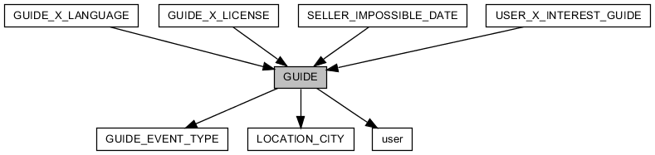

|  |  |  |  |  |  |  |
| --- | --- | --- | --- | --- | --- | --- |
| COLUMN | TYPE | NULLABLE | PKEY | DEFAULTED | REFERRED | REFER |
| ID | BIGINT |  | ● |  | [GUIDE_X_LANGUAGE] GUIDE_ID  [GUIDE_X_LICENSE] GUIDE_ID  [SELLER_IMPOSSIBLE_DATE] SELLER_ID  [USER_X_INTEREST_GUIDE] GUIDE_ID | [user] ID |
| STATUS | ENUM |  |  | ● |  |  |
| GUIDE_EVENT_TYPE_ID | BIGINT | ● |  |  |  | [GUIDE_EVENT_TYPE] ID |
| LOGIN_ID | VARCHAR(100) |  |  |  |  |  |
| LOGIN_PASSWORD | VARCHAR(100) |  |  |  |  |  |
| EMAIL_GENERATE_KEY | VARCHAR(255) |  |  |  |  |  |
| EMAIL_CERTIFIED_AT | TIMESTAMP | ● |  |  |  |  |
| SKYPE_ID | VARCHAR(40) | ● |  |  |  |  |
| RESIDENTIAL_CITY_ID | BIGINT |  |  |  |  | [LOCATION_CITY] ID |
| EXPERIENCE | INTEGER | ● |  |  |  |  |
| AGE | INTEGER | ● |  |  |  |  |
| CREATED_AT | TIMESTAMP |  |  | ● |  |  |
| UPDATED_AT | TIMESTAMP | ● |  |  |  |  |

|  |  |  |
| --- | --- | --- |
| UNIQUE KEY | COLUMNS | DESCRIPTION |
| CONSTRAINT_41 | ID |  |
| GUIDE_LOGIN_ID_KEY | LOGIN_ID |  |

|  |  |
| --- | --- |
| COLUMN | DESCRIPTION |
| ID | table identifier |
| STATUS | approved by administrator |
| GUIDE_EVENT_TYPE_ID | promotion about guide |
| LOGIN_ID | login ID |
| LOGIN_PASSWORD | login password |
| EMAIL_GENERATE_KEY | generated key for certificating email |
| EMAIL_CERTIFIED_AT | timestamp when email is certificated |
| SKYPE_ID | skype ID |
| RESIDENTIAL_CITY_ID | city of residence |
| EXPERIENCE | n years experience about guiding |
| AGE | age |
| CREATED_AT | timestamp when this record is created |
| UPDATED_AT | timestamp when this record is updated |

## GUIDE_EVENT_TYPE

define promotion type about guide

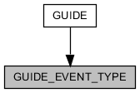

|  |  |  |  |  |  |  |
| --- | --- | --- | --- | --- | --- | --- |
| COLUMN | TYPE | NULLABLE | PKEY | DEFAULTED | REFERRED | REFER |
| ID | BIGINT |  | ● | ● | [GUIDE] GUIDE_EVENT_TYPE_ID |  |
| NAME | VARCHAR(255) |  |  |  |  |  |
| MARKER | VARCHAR(2048) | ● |  |  |  |  |
| CREATED_AT | TIMESTAMP |  |  | ● |  |  |
| UPDATED_AT | TIMESTAMP | ● |  |  |  |  |
| DELETED_AT | TIMESTAMP | ● |  |  |  |  |

|  |  |  |
| --- | --- | --- |
| UNIQUE KEY | COLUMNS | DESCRIPTION |
| CONSTRAINT_D5 | ID |  |
| GUIDE_EVENT_TYPE_NAME_KEY | NAME |  |

|  |  |
| --- | --- |
| COLUMN | DESCRIPTION |
| ID | table identifier |
| NAME | name of promotion |
| MARKER | mark as |
| CREATED_AT | timestamp when this record is created |
| UPDATED_AT | timestamp when this record is updated |
| DELETED_AT | present that this record is deleted |

## GUIDE_X_LANGUAGE

relationship of guide with language. One guide has 1 guiding-language or more.

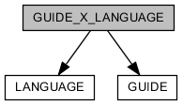

|  |  |  |  |  |  |  |
| --- | --- | --- | --- | --- | --- | --- |
| COLUMN | TYPE | NULLABLE | PKEY | DEFAULTED | REFERRED | REFER |
| ID | BIGINT |  | ● | ● |  |  |
| GUIDE_ID | BIGINT |  |  |  |  | [GUIDE] ID |
| LANGUAGE_ID | BIGINT |  |  |  |  | [LANGUAGE] ID |

|  |  |  |
| --- | --- | --- |
| UNIQUE KEY | COLUMNS | DESCRIPTION |
| CONSTRAINT_49 | ID |  |
| GUIDE_X_LANGUAGE_GUIDE_ID_LANGUAGE_ID_KEY | GUIDE_ID LANGUAGE_ID |  |

|  |  |
| --- | --- |
| COLUMN | DESCRIPTION |
| ID | table identifier |
| GUIDE_ID | reference guide |
| LANGUAGE_ID | reference language |

## GUIDE_X_LICENSE

relationship of guide with license.

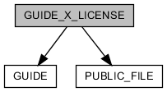

|  |  |  |  |  |  |  |
| --- | --- | --- | --- | --- | --- | --- |
| COLUMN | TYPE | NULLABLE | PKEY | DEFAULTED | REFERRED | REFER |
| ID | BIGINT |  | ● | ● |  |  |
| GUIDE_ID | BIGINT |  |  |  |  | [GUIDE] ID |
| LICENSE_PICTURE_FILE_ID | BIGINT | ● |  |  |  | [PUBLIC_FILE] ID |
| LICENSE_NAME | VARCHAR(255) |  |  |  |  |  |

|  |  |  |
| --- | --- | --- |
| UNIQUE KEY | COLUMNS | DESCRIPTION |
| CONSTRAINT_7 | ID |  |

|  |  |
| --- | --- |
| COLUMN | DESCRIPTION |
| ID | table identifier |
| GUIDE_ID | reference guide |
| LICENSE_PICTURE_FILE_ID | reference picture file about license |
| LICENSE_NAME | name of license |

## KEYWORD

define keyword for product classification

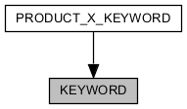

|  |  |  |  |  |  |  |
| --- | --- | --- | --- | --- | --- | --- |
| COLUMN | TYPE | NULLABLE | PKEY | DEFAULTED | REFERRED | REFER |
| ID | BIGINT |  | ● | ● | [PRODUCT_X_KEYWORD] KEYWORD_ID |  |
| NAME | VARCHAR(2048) |  |  |  |  |  |

|  |  |  |
| --- | --- | --- |
| UNIQUE KEY | COLUMNS | DESCRIPTION |
| CONSTRAINT_F | ID |  |
| KEYWORD_NAME_KEY | NAME |  |

|  |  |
| --- | --- |
| COLUMN | DESCRIPTION |
| ID | table identifier |
| NAME | name of keyword |

## LANGUAGE

define language for guiding

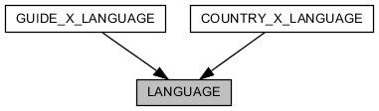

|  |  |  |  |  |  |  |
| --- | --- | --- | --- | --- | --- | --- |
| COLUMN | TYPE | NULLABLE | PKEY | DEFAULTED | REFERRED | REFER |
| ID | BIGINT |  | ● | ● | [COUNTRY_X_LANGUAGE] LANGUAGE_ID  [GUIDE_X_LANGUAGE] LANGUAGE_ID |  |
| NAME | VARCHAR(2048) |  |  |  |  |  |
| SORT_NAME | VARCHAR(100) |  |  |  |  |  |

|  |  |  |
| --- | --- | --- |
| UNIQUE KEY | COLUMNS | DESCRIPTION |
| CONSTRAINT_C | ID |  |
| LANGUAGE_SORT_NAME_KEY | SORT_NAME |  |

|  |  |
| --- | --- |
| COLUMN | DESCRIPTION |
| ID | table identifier |
| NAME | name of language |
| SORT_NAME | name of language for sorting |

## LOCATION_CITY

real city

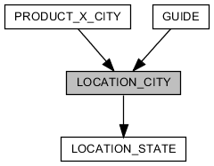

|  |  |  |  |  |  |  |
| --- | --- | --- | --- | --- | --- | --- |
| COLUMN | TYPE | NULLABLE | PKEY | DEFAULTED | REFERRED | REFER |
| ID | BIGINT |  | ● | ● | [GUIDE] RESIDENTIAL_CITY_ID  [PRODUCT_X_CITY] CITY_ID |  |
| STATE_ID | BIGINT |  |  |  |  | [LOCATION_STATE] ID |
| NAME | VARCHAR(100) |  |  |  |  |  |
| LATITUDE | DOUBLE | ● |  |  |  |  |
| LONGITUDE | DOUBLE | ● |  |  |  |  |

|  |  |  |
| --- | --- | --- |
| UNIQUE KEY | COLUMNS | DESCRIPTION |
| CONSTRAINT_50 | ID |  |
| LOCATION_CITY_STATE_ID_NAME_KEY | STATE_ID NAME |  |
| LOCATION_CITY_LATITUDE_LONGITUDE_KEY | LATITUDE LONGITUDE |  |

|  |  |
| --- | --- |
| COLUMN | DESCRIPTION |
| ID | table identifier |
| STATE_ID | reference state |
| NAME | name of city |
| LATITUDE | latitude of city |
| LONGITUDE | longitude of city |

## LOCATION_COUNTRY

real country

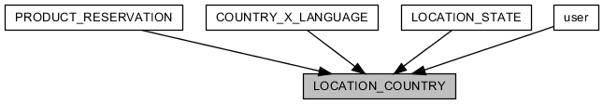

|  |  |  |  |  |  |  |
| --- | --- | --- | --- | --- | --- | --- |
| COLUMN | TYPE | NULLABLE | PKEY | DEFAULTED | REFERRED | REFER |
| ID | BIGINT |  | ● | ● | [COUNTRY_X_LANGUAGE] COUNTRY_ID  [LOCATION_STATE] COUNTRY_ID  [PRODUCT_RESERVATION] MOBILE_COUNTRY_ID  [user] MOBILE_COUNTRY_ID  [user] NATIONALITY_ID |  |
| NAME | VARCHAR(100) |  |  |  |  |  |
| SORT_NAME | VARCHAR(10) |  |  |  |  |  |
| KOREAN_NAME | VARCHAR(100) | ● |  |  |  |  |
| COUNTRY_CODE | INTEGER | ● |  |  |  |  |
| LATITUDE | DOUBLE | ● |  |  |  |  |
| LONGITUDE | DOUBLE | ● |  |  |  |  |

|  |  |  |
| --- | --- | --- |
| UNIQUE KEY | COLUMNS | DESCRIPTION |
| CONSTRAINT_D | ID |  |
| LOCATION_COUNTRY_NAME_KEY | NAME |  |
| LOCATION_COUNTRY_SORT_NAME_KEY | SORT_NAME |  |
| LOCATION_COUNTRY_LATITUDE_LONGITUDE_KEY | LATITUDE LONGITUDE |  |

|  |  |
| --- | --- |
| COLUMN | DESCRIPTION |
| ID | table identifier |
| NAME | name of country |
| SORT_NAME | name of country for sorting |
| KOREAN_NAME | korean name of country |
| COUNTRY_CODE | international dialling code |
| LATITUDE | latitude of country |
| LONGITUDE | longitude of country |

## LOCATION_STATE

real state

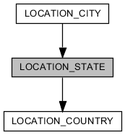

|  |  |  |  |  |  |  |
| --- | --- | --- | --- | --- | --- | --- |
| COLUMN | TYPE | NULLABLE | PKEY | DEFAULTED | REFERRED | REFER |
| ID | BIGINT |  | ● | ● | [LOCATION_CITY] STATE_ID |  |
| COUNTRY_ID | BIGINT |  |  |  |  | [LOCATION_COUNTRY] ID |
| NAME | VARCHAR(100) |  |  |  |  |  |
| LATITUDE | DOUBLE | ● |  |  |  |  |
| LONGITUDE | DOUBLE | ● |  |  |  |  |

|  |  |  |
| --- | --- | --- |
| UNIQUE KEY | COLUMNS | DESCRIPTION |
| CONSTRAINT_B | ID |  |
| LOCATION_STATE_COUNTRY_ID_NAME_KEY | COUNTRY_ID NAME |  |
| LOCATION_STATE_LATITUDE_LONGITUDE_KEY | LATITUDE LONGITUDE |  |

|  |  |
| --- | --- |
| COLUMN | DESCRIPTION |
| ID | table identifier |
| COUNTRY_ID | reference country |
| NAME | name of state |
| LATITUDE | latitude of state |
| LONGITUDE | longitude of state |

## MESSAGE

message form user to user

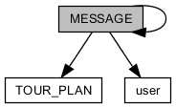

|  |  |  |  |  |  |  |
| --- | --- | --- | --- | --- | --- | --- |
| COLUMN | TYPE | NULLABLE | PKEY | DEFAULTED | REFERRED | REFER |
| ID | BIGINT |  | ● | ● | [MESSAGE] REF_ID |  |
| REF_ID | BIGINT | ● |  |  |  | [MESSAGE] ID |
| SENDER_ID | BIGINT |  |  |  |  | [user] ID |
| RECEIVER_ID | BIGINT |  |  |  |  | [user] ID |
| MESSAGE_HEADER | VARCHAR(1024) | ● |  |  |  |  |
| MESSAGE_BODY | VARCHAR(2048) |  |  |  |  |  |
| MESSAGE_FOOTER | VARCHAR(1024) | ● |  |  |  |  |
| READ | BOOLEAN |  |  | ● |  |  |
| SENDER_DELETED | BOOLEAN |  |  | ● |  |  |
| RECEIVER_DELETED | BOOLEAN |  |  | ● |  |  |
| CREATED_AT | TIMESTAMP |  |  | ● |  |  |
| UPDATED_AT | TIMESTAMP | ● |  |  |  |  |
| DELETED_AT | TIMESTAMP | ● |  |  |  |  |
| TAG | ENUM | ● |  |  |  |  |
| TOUR_PLAN_ID | BIGINT | ● |  |  |  | [TOUR_PLAN] ID |

|  |  |  |
| --- | --- | --- |
| UNIQUE KEY | COLUMNS | DESCRIPTION |
| CONSTRAINT_6 | ID |  |

|  |  |
| --- | --- |
| COLUMN | DESCRIPTION |
| ID | table identifier |
| REF_ID | represented message |
| SENDER_ID | reference sender |
| RECEIVER_ID | reference receiver |
| MESSAGE_HEADER | header content of message |
| MESSAGE_BODY | body content of message |
| MESSAGE_FOOTER | footer content of message |
| READ | read message by receiver |
| SENDER_DELETED | deleted message by sender |
| RECEIVER_DELETED | deleted message by receiver |
| CREATED_AT | timestamp when this record is created |
| UPDATED_AT | timestamp when this record is updated |
| DELETED_AT | present that this record is deleted |
| TAG | for classification |
| TOUR_PLAN_ID | reference tour-plan |

## NOTICE

notify user(tourist/guide/guide manager) by administrator

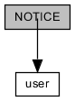

|  |  |  |  |  |  |  |
| --- | --- | --- | --- | --- | --- | --- |
| COLUMN | TYPE | NULLABLE | PKEY | DEFAULTED | REFERRED | REFER |
| ID | BIGINT |  | ● | ● |  |  |
| USER_ID | BIGINT |  |  |  |  | [user] ID |
| TITLE | CLOB(2147483647) |  |  |  |  |  |
| DESCRIPTION | CLOB(2147483647) |  |  |  |  |  |
| CREATED_AT | TIMESTAMP |  |  | ● |  |  |
| UPDATED_AT | TIMESTAMP | ● |  |  |  |  |
| DELETED_AT | TIMESTAMP | ● |  |  |  |  |

|  |  |  |
| --- | --- | --- |
| UNIQUE KEY | COLUMNS | DESCRIPTION |
| CONSTRAINT_89 | ID |  |

|  |  |
| --- | --- |
| COLUMN | DESCRIPTION |
| ID | table identifier |
| USER_ID | reference writer |
| TITLE | title |
| DESCRIPTION | description |
| CREATED_AT | timestamp when this record is created |
| UPDATED_AT | timestamp when this record is updated |
| DELETED_AT | present that this record is deleted |

## PRODUCT

selling product by guide or guide manager

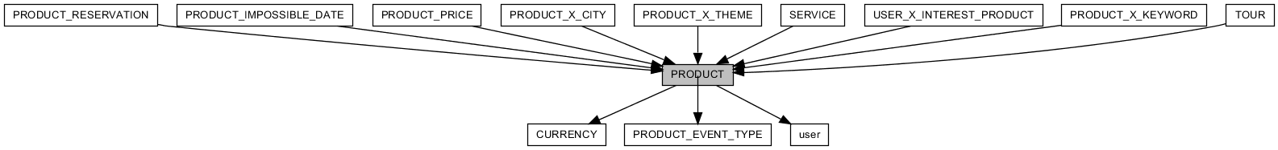

|  |  |  |  |  |  |  |
| --- | --- | --- | --- | --- | --- | --- |
| COLUMN | TYPE | NULLABLE | PKEY | DEFAULTED | REFERRED | REFER |
| ID | BIGINT |  | ● | ● | [PRODUCT_IMPOSSIBLE_DATE] PRODUCT_ID  [PRODUCT_PRICE] PRODUCT_ID  [PRODUCT_RESERVATION] PRODUCT_ID  [PRODUCT_X_CITY] PRODUCT_ID  [PRODUCT_X_KEYWORD] PRODUCT_ID  [PRODUCT_X_THEME] PRODUCT_ID  [SERVICE] ID  [TOUR] ID  [USER_X_INTEREST_PRODUCT] PRODUCT_ID |  |
| TITLE | VARCHAR(100) | ● |  |  |  |  |
| STATUS | ENUM | ● |  | ● |  |  |
| PRODUCT_EVENT_TYPE_ID | BIGINT | ● |  |  |  | [PRODUCT_EVENT_TYPE] ID |
| SELLER_ID | BIGINT | ● |  |  |  | [user] ID |
| CURRENCY_ID | BIGINT | ● |  |  |  | [CURRENCY] ID |
| IMAGE_ID | BIGINT | ● |  |  |  |  |
| SUMMARY | CLOB(2147483647) | ● |  |  |  |  |
| DESCRIPTION | CLOB(2147483647) | ● |  |  |  |  |
| INCLUSION | CLOB(2147483647) | ● |  |  |  |  |
| EXCLUSION | CLOB(2147483647) | ● |  |  |  |  |
| ETC | CLOB(2147483647) | ● |  |  |  |  |
| CREATED_AT | TIMESTAMP |  |  | ● |  |  |
| UPDATED_AT | TIMESTAMP | ● |  |  |  |  |
| DELETED_AT | TIMESTAMP | ● |  |  |  |  |
| UNLOAD | VARCHAR(1000) | ● |  |  |  |  |
| TYPE | ENUM |  |  | ● |  |  |

|  |  |  |
| --- | --- | --- |
| UNIQUE KEY | COLUMNS | DESCRIPTION |
| CONSTRAINT_18 | ID |  |

|  |  |
| --- | --- |
| COLUMN | DESCRIPTION |
| ID | table identifier |
| TITLE | title of product |
| STATUS | approved by administrator |
| PRODUCT_EVENT_TYPE_ID | promotion about product |
| SELLER_ID | reference seller |
| CURRENCY_ID | base currency |
| IMAGE_ID | representative image of product |
| SUMMARY | summary of product |
| DESCRIPTION | description |
| INCLUSION | extra options what are include in the price |
| EXCLUSION | extra options what are not include in the price |
| ETC | extra description |
| CREATED_AT | timestamp when this record is created |
| UPDATED_AT | timestamp when this record is updated |
| DELETED_AT | present that this record is deleted |
| UNLOAD | request message for stop sale product |
| TYPE | product type(tour/service) |

## PRODUCT_EVENT_TYPE

define promotion type about product

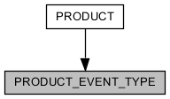

|  |  |  |  |  |  |  |
| --- | --- | --- | --- | --- | --- | --- |
| COLUMN | TYPE | NULLABLE | PKEY | DEFAULTED | REFERRED | REFER |
| ID | BIGINT |  | ● | ● | [PRODUCT] PRODUCT_EVENT_TYPE_ID |  |
| NAME | VARCHAR(255) |  |  |  |  |  |
| DISCOUNT | INTEGER |  |  | ● |  |  |
| MARKER | VARCHAR(2048) | ● |  |  |  |  |
| CREATED_AT | TIMESTAMP |  |  | ● |  |  |
| UPDATED_AT | TIMESTAMP | ● |  |  |  |  |
| DELETED_AT | TIMESTAMP | ● |  |  |  |  |

|  |  |  |
| --- | --- | --- |
| UNIQUE KEY | COLUMNS | DESCRIPTION |
| CONSTRAINT_49B | ID |  |
| PRODUCT_EVENT_TYPE_NAME_KEY | NAME |  |

|  |  |
| --- | --- |
| COLUMN | DESCRIPTION |
| ID | table identifier |
| NAME | name of promotion |
| DISCOUNT | discount rate(0 ~ 99) |
| MARKER | mark as |
| CREATED_AT | timestamp when this record is created |
| UPDATED_AT | timestamp when this record is updated |
| DELETED_AT | present that this record is deleted |

## PRODUCT_IMPOSSIBLE_DATE

impossible date to reserve a product

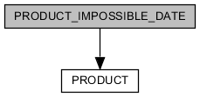

|  |  |  |  |  |  |  |
| --- | --- | --- | --- | --- | --- | --- |
| COLUMN | TYPE | NULLABLE | PKEY | DEFAULTED | REFERRED | REFER |
| PRODUCT_ID | BIGINT |  | ● |  |  | [PRODUCT] ID |
| DATE | DATE |  | ● |  |  |  |

|  |  |  |
| --- | --- | --- |
| UNIQUE KEY | COLUMNS | DESCRIPTION |
| PRODUCT_IMPOSSIBLE_DATE_PKEY | PRODUCT_ID DATE |  |

|  |  |
| --- | --- |
| COLUMN | DESCRIPTION |
| PRODUCT_ID | reference product |
| DATE | impossible date |

## PRODUCT_PRICE

price information of product. price of one product is comprised one price information or more.

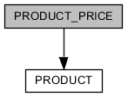

|  |  |  |  |  |  |  |
| --- | --- | --- | --- | --- | --- | --- |
| COLUMN | TYPE | NULLABLE | PKEY | DEFAULTED | REFERRED | REFER |
| ID | BIGINT |  | ● | ● |  |  |
| PRODUCT_ID | BIGINT |  |  |  |  | [PRODUCT] ID |
| MINIMUM_PEOPLE | INTEGER | ● |  |  |  |  |
| MAXIMUM_PEOPLE | INTEGER | ● |  |  |  |  |
| PRICE | DOUBLE | ● |  |  |  |  |
| CREATED_AT | TIMESTAMP |  |  | ● |  |  |
| UPDATED_AT | TIMESTAMP | ● |  |  |  |  |

|  |  |  |
| --- | --- | --- |
| UNIQUE KEY | COLUMNS | DESCRIPTION |
| CONSTRAINT_42 | ID |  |
| PRODUCT_PRICE_PRODUCT_ID_MINIMUM_PEOPLE_MAXIMUM_PEOPLE_KEY | PRODUCT_ID MINIMUM_PEOPLE MAXIMUM_PEOPLE |  |

|  |  |
| --- | --- |
| COLUMN | DESCRIPTION |
| ID | table identifier |
| PRODUCT_ID | reference product |
| MINIMUM_PEOPLE | minimum number of people is affected by this price information |
| MAXIMUM_PEOPLE | maximum number of people is affected by this price information |
| PRICE | price |
| CREATED_AT | timestamp when this record is created |
| UPDATED_AT | timestamp when this record is updated |

## PRODUCT_RESERVATION

reservation of product

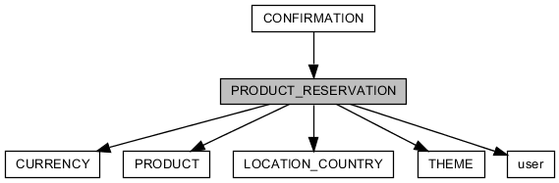

|  |  |  |  |  |  |  |
| --- | --- | --- | --- | --- | --- | --- |
| COLUMN | TYPE | NULLABLE | PKEY | DEFAULTED | REFERRED | REFER |
| ID | BIGINT |  | ● | ● | [CONFIRMATION] ID |  |
| USER_ID | BIGINT |  |  |  |  | [user] ID |
| PRODUCT_ID | BIGINT |  |  |  |  | [PRODUCT] ID |
| CURRENCY_ID | BIGINT |  |  |  |  | [CURRENCY] ID |
| BOOK_DATE | DATE |  |  |  |  |  |
| NUMBER_PEOPLE | INTEGER |  |  |  |  |  |
| AGE | ENUM | ● |  |  |  |  |
| PURPOSE_ID | BIGINT | ● |  |  |  | [THEME] ID |
| REQUEST_MESSAGE | CLOB(2147483647) | ● |  |  |  |  |
| STATUS | ENUM |  |  | ● |  |  |
| NAME | VARCHAR(100) |  |  |  |  |  |
| ENGLISH_NAME | VARCHAR(100) |  |  |  |  |  |
| MOBILE_COUNTRY_ID | BIGINT |  |  |  |  | [LOCATION_COUNTRY] ID |
| MOBILE | VARCHAR(20) |  |  |  |  |  |
| EMAIL | VARCHAR(100) |  |  |  |  |  |
| PAYOUT_STATUS | ENUM |  |  | ● |  |  |
| CREATED_AT | TIMESTAMP |  |  | ● |  |  |
| UPDATED_AT | TIMESTAMP | ● |  |  |  |  |
| DELETED_AT | TIMESTAMP | ● |  |  |  |  |
| EVENT_NAME | VARCHAR(255) | ● |  |  |  |  |
| EVENT_DISCOUNT | INTEGER |  |  | ● |  |  |
| ORIGINAL_PRICE | DOUBLE |  |  | ● |  |  |
| FINAL_PRICE | DOUBLE |  |  | ● |  |  |
| EPILOGUE_STAR_POINT | INTEGER | ● |  |  |  |  |
| EPILOGUE_COMMENT | CLOB(2147483647) | ● |  |  |  |  |
| EPILOGUE_WROTE_AT | TIMESTAMP | ● |  |  |  |  |
| EPILOGUE_REPLY | CLOB(2147483647) | ● |  |  |  |  |

|  |  |  |
| --- | --- | --- |
| UNIQUE KEY | COLUMNS | DESCRIPTION |
| CONSTRAINT_3F | ID |  |

|  |  |
| --- | --- |
| COLUMN | DESCRIPTION |
| ID | table identifier |
| USER_ID | reference people who has booked |
| PRODUCT_ID | reference product |
| CURRENCY_ID | reference currency |
| BOOK_DATE | booked date |
| NUMBER_PEOPLE | number of people |
| AGE | age of representative |
| PURPOSE_ID | purpose of tour. reference trend theme. |
| REQUEST_MESSAGE | request message about tour |
| STATUS | tour progress situation |
| NAME | name of representative |
| ENGLISH_NAME | english name of representative |
| MOBILE_COUNTRY_ID | reference activated country of cellphone |
| MOBILE | mobile number of representative |
| EMAIL | email of representative |
| PAYOUT_STATUS | is paid |
| CREATED_AT | timestamp when this record is created |
| UPDATED_AT | timestamp when this record is updated |
| DELETED_AT | present that this record is deleted |
| EVENT_NAME | promotion about product |
| EVENT_DISCOUNT | promotion about product |
| ORIGINAL_PRICE | non-discounted price by event |
| FINAL_PRICE | discounted price by event |
| EPILOGUE_STAR_POINT | score (0 ~ 5) about tour satisfaction |
| EPILOGUE_COMMENT | comment of epilogue |
| EPILOGUE_WROTE_AT | timestamp when this epilogue is wrote |
| EPILOGUE_REPLY |  |

## PRODUCT_X_CITY

relationship of product with city. tour city is one or more.

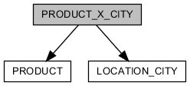

|  |  |  |  |  |  |  |
| --- | --- | --- | --- | --- | --- | --- |
| COLUMN | TYPE | NULLABLE | PKEY | DEFAULTED | REFERRED | REFER |
| ID | BIGINT |  | ● | ● |  |  |
| PRODUCT_ID | BIGINT |  |  |  |  | [PRODUCT] ID |
| CITY_ID | BIGINT |  |  |  |  | [LOCATION_CITY] ID |
| CREATED_AT | TIMESTAMP |  |  | ● |  |  |
| UPDATED_AT | TIMESTAMP | ● |  |  |  |  |
| DELETED_AT | TIMESTAMP | ● |  |  |  |  |

|  |  |  |
| --- | --- | --- |
| UNIQUE KEY | COLUMNS | DESCRIPTION |
| CONSTRAINT_24 | ID |  |
| PRODUCT_X_CITY_PRODUCT_ID_CITY_ID_KEY | PRODUCT_ID CITY_ID |  |

|  |  |
| --- | --- |
| COLUMN | DESCRIPTION |
| ID | table identifier |
| PRODUCT_ID | reference product |
| CITY_ID | reference city |
| CREATED_AT | timestamp when this record is created |
| UPDATED_AT | timestamp when this record is updated |
| DELETED_AT | present that this record is deleted |

## PRODUCT_X_KEYWORD

relationship of product with keyword.

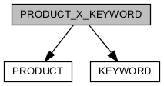

|  |  |  |  |  |  |  |
| --- | --- | --- | --- | --- | --- | --- |
| COLUMN | TYPE | NULLABLE | PKEY | DEFAULTED | REFERRED | REFER |
| ID | BIGINT |  | ● | ● |  |  |
| PRODUCT_ID | BIGINT |  |  |  |  | [PRODUCT] ID |
| KEYWORD_ID | BIGINT |  |  |  |  | [KEYWORD] ID |
| CREATED_AT | TIMESTAMP |  |  | ● |  |  |
| UPDATED_AT | TIMESTAMP | ● |  |  |  |  |
| DELETED_AT | TIMESTAMP | ● |  |  |  |  |

|  |  |  |
| --- | --- | --- |
| UNIQUE KEY | COLUMNS | DESCRIPTION |
| CONSTRAINT_65 | ID |  |

|  |  |
| --- | --- |
| COLUMN | DESCRIPTION |
| ID | table identifier |
| PRODUCT_ID | reference product |
| KEYWORD_ID | reference keyword |
| CREATED_AT | timestamp when this record is created |
| UPDATED_AT | timestamp when this record is updated |
| DELETED_AT | present that this record is deleted |

## PRODUCT_X_THEME

relationship of product with theme

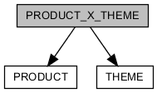

|  |  |  |  |  |  |  |
| --- | --- | --- | --- | --- | --- | --- |
| COLUMN | TYPE | NULLABLE | PKEY | DEFAULTED | REFERRED | REFER |
| ID | BIGINT |  | ● | ● |  |  |
| PRODUCT_ID | BIGINT |  |  |  |  | [PRODUCT] ID |
| THEME_ID | BIGINT |  |  |  |  | [THEME] ID |
| CREATED_AT | TIMESTAMP |  |  | ● |  |  |
| UPDATED_AT | TIMESTAMP | ● |  |  |  |  |
| DELETED_AT | TIMESTAMP | ● |  |  |  |  |

|  |  |  |
| --- | --- | --- |
| UNIQUE KEY | COLUMNS | DESCRIPTION |
| CONSTRAINT_7B | ID |  |

|  |  |
| --- | --- |
| COLUMN | DESCRIPTION |
| ID | table identifier |
| PRODUCT_ID | reference product |
| THEME_ID | reference theme |
| CREATED_AT | timestamp when this record is created |
| UPDATED_AT | timestamp when this record is updated |
| DELETED_AT | present that this record is deleted |

## PUBLIC_FILE

saved file at server

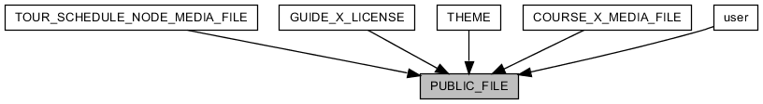

|  |  |  |  |  |  |  |
| --- | --- | --- | --- | --- | --- | --- |
| COLUMN | TYPE | NULLABLE | PKEY | DEFAULTED | REFERRED | REFER |
| ID | BIGINT |  | ● | ● | [GUIDE_X_LICENSE] LICENSE_PICTURE_FILE_ID  [COURSE_X_MEDIA_FILE] PUBLIC_FILE_ID  [THEME] BACKGROUND_IMAGE_ID  [THEME] IMAGE_ID  [TOUR_SCHEDULE_NODE_MEDIA_FILE] PUBLIC_FILE_ID  [user] PROFILE_IMAGE_ID |  |
| ORIGINAL_NAME | VARCHAR(256) |  |  |  |  |  |
| NAME | VARCHAR(256) |  |  |  |  |  |
| SIZE | BIGINT |  |  |  |  |  |
| CREATED_AT | TIMESTAMP |  |  | ● |  |  |
| UPDATED_AT | TIMESTAMP | ● |  |  |  |  |
| DELETED_AT | TIMESTAMP | ● |  |  |  |  |

|  |  |  |
| --- | --- | --- |
| UNIQUE KEY | COLUMNS | DESCRIPTION |
| CONSTRAINT_4 | ID |  |

|  |  |
| --- | --- |
| COLUMN | DESCRIPTION |
| ID | table identifier |
| ORIGINAL_NAME | file name what is file name of user end side in uploading |
| NAME | saved file name at server side after upload |
| SIZE | file size |
| CREATED_AT | timestamp when this record is created |
| UPDATED_AT | timestamp when this record is updated |
| DELETED_AT | present that this record is deleted |

## SELLER_IMPOSSIBLE_DATE

impossible date to reserve a product what is sale by seller

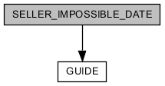

|  |  |  |  |  |  |  |
| --- | --- | --- | --- | --- | --- | --- |
| COLUMN | TYPE | NULLABLE | PKEY | DEFAULTED | REFERRED | REFER |
| SELLER_ID | BIGINT |  | ● |  |  | [GUIDE] ID |
| DATE | DATE |  | ● |  |  |  |

|  |  |  |
| --- | --- | --- |
| UNIQUE KEY | COLUMNS | DESCRIPTION |
| SELLER_IMPOSSIBLE_DATE_PKEY | SELLER_ID DATE |  |

|  |  |
| --- | --- |
| COLUMN | DESCRIPTION |
| SELLER_ID | reference seller |
| DATE | impossible date |

## SERVICE

define service for service provide by guide or guide manager

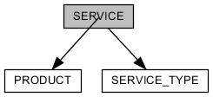

|  |  |  |  |  |  |  |
| --- | --- | --- | --- | --- | --- | --- |
| COLUMN | TYPE | NULLABLE | PKEY | DEFAULTED | REFERRED | REFER |
| ID | BIGINT |  | ● |  |  | [PRODUCT] ID |
| SERVICE_TYPE_ID | BIGINT |  |  |  |  | [SERVICE_TYPE] ID |
| TRANSPORTATION_TYPE | ENUM | ● |  |  |  |  |

|  |  |  |
| --- | --- | --- |
| UNIQUE KEY | COLUMNS | DESCRIPTION |
| CONSTRAINT_A10 | ID |  |

|  |  |
| --- | --- |
| COLUMN | DESCRIPTION |
| ID | table identifier |
| SERVICE_TYPE_ID | representative service type |
| TRANSPORTATION_TYPE | kind of transportation in the service |

## SERVICE_TYPE

define service type for service provide by guide or guide manager

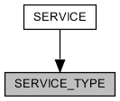

|  |  |  |  |  |  |  |
| --- | --- | --- | --- | --- | --- | --- |
| COLUMN | TYPE | NULLABLE | PKEY | DEFAULTED | REFERRED | REFER |
| ID | BIGINT |  | ● | ● | [SERVICE] SERVICE_TYPE_ID |  |
| NAME | VARCHAR(2048) |  |  |  |  |  |

|  |  |  |
| --- | --- | --- |
| UNIQUE KEY | COLUMNS | DESCRIPTION |
| CONSTRAINT_A1 | ID |  |
| SERVICE_TYPE_NAME_KEY | NAME |  |

|  |  |
| --- | --- |
| COLUMN | DESCRIPTION |
| ID | table identifier |
| NAME | name of service type |

## THEME

define theme

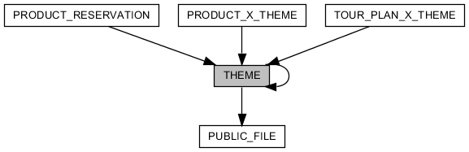

|  |  |  |  |  |  |  |
| --- | --- | --- | --- | --- | --- | --- |
| COLUMN | TYPE | NULLABLE | PKEY | DEFAULTED | REFERRED | REFER |
| ID | BIGINT |  | ● | ● | [PRODUCT_RESERVATION] PURPOSE_ID  [PRODUCT_X_THEME] THEME_ID  [THEME] REF_ID  [TOUR_PLAN_X_THEME] THEME_ID |  |
| NAME | VARCHAR(2048) |  |  |  |  |  |
| REF_ID | BIGINT | ● |  |  |  | [THEME] ID |
| TREND | BOOLEAN |  |  | ● |  |  |
| IMAGE_ID | BIGINT | ● |  |  |  | [PUBLIC_FILE] ID |
| BACKGROUND_IMAGE_ID | BIGINT | ● |  |  |  | [PUBLIC_FILE] ID |
| CREATED_AT | TIMESTAMP |  |  | ● |  |  |
| UPDATED_AT | TIMESTAMP | ● |  |  |  |  |
| DELETED_AT | TIMESTAMP | ● |  |  |  |  |

|  |  |  |
| --- | --- | --- |
| UNIQUE KEY | COLUMNS | DESCRIPTION |
| CONSTRAINT_4C | ID |  |

|  |  |
| --- | --- |
| COLUMN | DESCRIPTION |
| ID | table identifier |
| NAME | name of theme |
| REF_ID | reference anyone of "theme" |
| TREND | is representative |
| IMAGE_ID | reference icon |
| BACKGROUND_IMAGE_ID | reference picture |
| CREATED_AT | timestamp when this record is created |
| UPDATED_AT | timestamp when this record is updated |
| DELETED_AT | present that this record is deleted |

## TOUR

selling tour-product by guide or guide manager

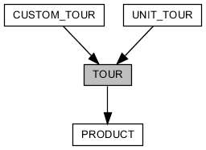

|  |  |  |  |  |  |  |
| --- | --- | --- | --- | --- | --- | --- |
| COLUMN | TYPE | NULLABLE | PKEY | DEFAULTED | REFERRED | REFER |
| ID | BIGINT |  | ● |  | [CUSTOM_TOUR] ID  [UNIT_TOUR] ID | [PRODUCT] ID |
| TYPE | ENUM |  |  |  |  |  |
| ADJUSTABLE_TIME | BOOLEAN | ● |  | ● |  |  |
| MUST_INQUIRE | BOOLEAN | ● |  | ● |  |  |
| TOUR_SCALE | ENUM | ● |  |  |  |  |
| DUE_DATE_TYPE | ENUM | ● |  |  |  |  |
| DUE_DATE | DOUBLE | ● |  |  |  |  |

|  |  |  |
| --- | --- | --- |
| UNIQUE KEY | COLUMNS | DESCRIPTION |
| CONSTRAINT_27 | ID |  |

|  |  |
| --- | --- |
| COLUMN | DESCRIPTION |
| ID | table identifier |
| TYPE | tour type(unit tour/custom tour) |
| ADJUSTABLE_TIME | is adjustable when meet with guide |
| MUST_INQUIRE | must inquire, before reserve |
| TOUR_SCALE | tour type(independent travel/associated travel) |
| DUE_DATE_TYPE | unit about period of trip |
| DUE_DATE | period of trip |

## TOURIST

user of tourist type

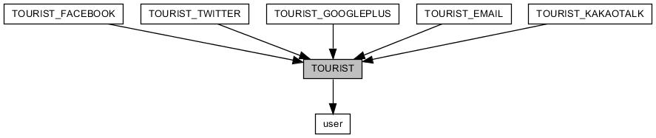

|  |  |  |  |  |  |  |
| --- | --- | --- | --- | --- | --- | --- |
| COLUMN | TYPE | NULLABLE | PKEY | DEFAULTED | REFERRED | REFER |
| ID | BIGINT |  | ● |  | [TOURIST_EMAIL] ID  [TOURIST_FACEBOOK] ID  [TOURIST_GOOGLEPLUS] ID  [TOURIST_KAKAOTALK] ID  [TOURIST_TWITTER] ID | [user] ID |
| CREATED_AT | TIMESTAMP |  |  | ● |  |  |
| UPDATED_AT | TIMESTAMP | ● |  |  |  |  |

|  |  |  |
| --- | --- | --- |
| UNIQUE KEY | COLUMNS | DESCRIPTION |
| CONSTRAINT_E | ID |  |

|  |  |
| --- | --- |
| COLUMN | DESCRIPTION |
| ID | table identifier |
| CREATED_AT | timestamp when this record is created |
| UPDATED_AT | timestamp when this record is updated |

## TOURIST_EMAIL

joined tourist through input email information

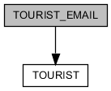

|  |  |  |  |  |  |  |
| --- | --- | --- | --- | --- | --- | --- |
| COLUMN | TYPE | NULLABLE | PKEY | DEFAULTED | REFERRED | REFER |
| ID | BIGINT |  | ● |  |  | [TOURIST] ID |
| EMAIL | VARCHAR(100) |  |  |  |  |  |
| PASSWORD | VARCHAR(100) |  |  |  |  |  |
| GENERATE_KEY | VARCHAR(255) |  |  |  |  |  |
| CERTIFIED_AT | TIMESTAMP | ● |  |  |  |  |
| CREATED_AT | TIMESTAMP |  |  | ● |  |  |
| UPDATED_AT | TIMESTAMP | ● |  |  |  |  |

|  |  |  |
| --- | --- | --- |
| UNIQUE KEY | COLUMNS | DESCRIPTION |
| CONSTRAINT_496 | ID |  |
| TOURIST_EMAIL_EMAIL_KEY | EMAIL |  |

|  |  |
| --- | --- |
| COLUMN | DESCRIPTION |
| ID | table identifier |
| EMAIL | email of tourist. login ID |
| PASSWORD | login password |
| GENERATE_KEY | generated key for certificating email |
| CERTIFIED_AT | timestamp when email is certificated |
| CREATED_AT | timestamp when this record is created |
| UPDATED_AT | timestamp when this record is updated |

## TOURIST_FACEBOOK

joined tourist through facebook

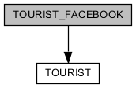

|  |  |  |  |  |  |  |
| --- | --- | --- | --- | --- | --- | --- |
| COLUMN | TYPE | NULLABLE | PKEY | DEFAULTED | REFERRED | REFER |
| ID | BIGINT |  | ● |  |  | [TOURIST] ID |
| SOCIAL_ID | VARCHAR(255) |  |  |  |  |  |
| FIRST_NAME | VARCHAR(100) | ● |  |  |  |  |
| MIDDLE_NAME | VARCHAR(100) | ● |  |  |  |  |
| LAST_NAME | VARCHAR(100) | ● |  |  |  |  |
| EMAIL | VARCHAR(255) | ● |  |  |  |  |
| GENDER | ENUM | ● |  |  |  |  |
| CREATED_AT | TIMESTAMP |  |  | ● |  |  |
| UPDATED_AT | TIMESTAMP | ● |  |  |  |  |

|  |  |  |
| --- | --- | --- |
| UNIQUE KEY | COLUMNS | DESCRIPTION |
| CONSTRAINT_1 | ID |  |
| TOURIST_FACEBOOK_SOCIAL_ID_KEY | SOCIAL_ID |  |

|  |  |
| --- | --- |
| COLUMN | DESCRIPTION |
| ID | table identifier |
| SOCIAL_ID | facebook ID. login ID |
| FIRST_NAME | first name of tourist that is received from facebook |
| MIDDLE_NAME | middle name of tourist that is received from facebook |
| LAST_NAME | last name of tourist that is received from facebook |
| EMAIL | email of tourist that is received from facebook |
| GENDER | gender of tourist that is received from facebook |
| CREATED_AT | timestamp when this record is created |
| UPDATED_AT | timestamp when this record is updated |

## TOURIST_GOOGLEPLUS

joined tourist through googleplus

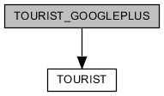

|  |  |  |  |  |  |  |
| --- | --- | --- | --- | --- | --- | --- |
| COLUMN | TYPE | NULLABLE | PKEY | DEFAULTED | REFERRED | REFER |
| ID | BIGINT |  | ● |  |  | [TOURIST] ID |
| SOCIAL_ID | VARCHAR(255) |  |  |  |  |  |
| FULL_NAME | VARCHAR(255) | ● |  |  |  |  |
| FIRST_NAME | VARCHAR(100) | ● |  |  |  |  |
| LAST_NAME | VARCHAR(100) | ● |  |  |  |  |
| EMAIL | VARCHAR(255) | ● |  |  |  |  |
| GENDER | ENUM | ● |  |  |  |  |
| CREATED_AT | TIMESTAMP |  |  | ● |  |  |
| UPDATED_AT | TIMESTAMP | ● |  |  |  |  |

|  |  |  |
| --- | --- | --- |
| UNIQUE KEY | COLUMNS | DESCRIPTION |
| CONSTRAINT_57 | ID |  |
| TOURIST_GOOGLEPLUS_SOCIAL_ID_KEY | SOCIAL_ID |  |

|  |  |
| --- | --- |
| COLUMN | DESCRIPTION |
| ID | table identifier |
| SOCIAL_ID | googleplus ID. login ID |
| FULL_NAME | full name of tourist that is received from googleplus |
| FIRST_NAME | first name of tourist that is received from googleplus |
| LAST_NAME | last name of tourist that is received from googleplus |
| EMAIL | email of tourist that is received from googleplus |
| GENDER | gender of tourist that is received from googleplus |
| CREATED_AT | timestamp when this record is created |
| UPDATED_AT | timestamp when this record is updated |

## TOURIST_KAKAOTALK

joined tourist through kakaotalk

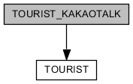

|  |  |  |  |  |  |  |
| --- | --- | --- | --- | --- | --- | --- |
| COLUMN | TYPE | NULLABLE | PKEY | DEFAULTED | REFERRED | REFER |
| ID | BIGINT |  | ● |  |  | [TOURIST] ID |
| SOCIAL_ID | VARCHAR(255) |  |  |  |  |  |
| NICKNAME | VARCHAR(255) |  |  |  |  |  |
| CREATED_AT | TIMESTAMP |  |  | ● |  |  |
| UPDATED_AT | TIMESTAMP | ● |  |  |  |  |

|  |  |  |
| --- | --- | --- |
| UNIQUE KEY | COLUMNS | DESCRIPTION |
| CONSTRAINT_9 | ID |  |
| TOURIST_KAKAOTALK_SOCIAL_ID_KEY | SOCIAL_ID |  |

|  |  |
| --- | --- |
| COLUMN | DESCRIPTION |
| ID | table identifier |
| SOCIAL_ID | kakaotalk ID. login ID |
| NICKNAME | nickname of tourist that is received from kakaotalk |
| CREATED_AT | timestamp when this record is created |
| UPDATED_AT | timestamp when this record is updated |

## TOURIST_TWITTER

joined tourist through twitter

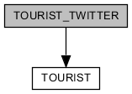

|  |  |  |  |  |  |  |
| --- | --- | --- | --- | --- | --- | --- |
| COLUMN | TYPE | NULLABLE | PKEY | DEFAULTED | REFERRED | REFER |
| ID | BIGINT |  | ● |  |  | [TOURIST] ID |
| SOCIAL_ID | VARCHAR(255) |  |  |  |  |  |
| SCREEN_NAME | VARCHAR(255) |  |  |  |  |  |
| NAME | VARCHAR(255) | ● |  |  |  |  |
| CREATED_AT | TIMESTAMP |  |  | ● |  |  |
| UPDATED_AT | TIMESTAMP | ● |  |  |  |  |

|  |  |  |
| --- | --- | --- |
| UNIQUE KEY | COLUMNS | DESCRIPTION |
| CONSTRAINT_A | ID |  |
| TOURIST_TWITTER_SOCIAL_ID_KEY | SOCIAL_ID |  |

|  |  |
| --- | --- |
| COLUMN | DESCRIPTION |
| ID | table identifier |
| SOCIAL_ID | twitter ID. login ID |
| SCREEN_NAME | screen-name of tourist that is received from twitter |
| NAME | name of tourist that is received from twitter |
| CREATED_AT | timestamp when this record is created |
| UPDATED_AT | timestamp when this record is updated |

## TOUR_PLAN

plan tour by user. also it is used component of custom tour.

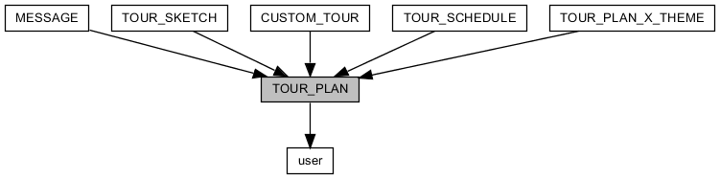

|  |  |  |  |  |  |  |
| --- | --- | --- | --- | --- | --- | --- |
| COLUMN | TYPE | NULLABLE | PKEY | DEFAULTED | REFERRED | REFER |
| ID | BIGINT |  | ● | ● | [CUSTOM_TOUR] TOUR_PLAN_ID  [MESSAGE] TOUR_PLAN_ID  [TOUR_PLAN_X_THEME] TOUR_PLAN_ID  [TOUR_SCHEDULE] TOUR_PLAN_ID  [TOUR_SKETCH] ID |  |
| USER_ID | BIGINT |  |  |  |  | [user] ID |
| TITLE | VARCHAR(200) |  |  |  |  |  |
| DESCRIPTION | CLOB(2147483647) | ● |  |  |  |  |
| START_AT | DATE | ● |  |  |  |  |
| END_AT | DATE | ● |  |  |  |  |
| CREATED_AT | TIMESTAMP |  |  | ● |  |  |
| UPDATED_AT | TIMESTAMP | ● |  |  |  |  |
| DELETED_AT | TIMESTAMP | ● |  |  |  |  |

|  |  |  |
| --- | --- | --- |
| UNIQUE KEY | COLUMNS | DESCRIPTION |
| CONSTRAINT_D6 | ID |  |

|  |  |
| --- | --- |
| COLUMN | DESCRIPTION |
| ID | table identifier |
| USER_ID | reference writer |
| TITLE | title of tour-plan |
| DESCRIPTION | description |
| START_AT | start date of tour |
| END_AT | end date of tour |
| CREATED_AT | timestamp when this record is created |
| UPDATED_AT | timestamp when this record is updated |
| DELETED_AT | present that this record is deleted |

## TOUR_PLAN_X_THEME

relationship of tour-plan with theme

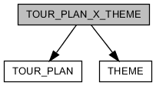

|  |  |  |  |  |  |  |
| --- | --- | --- | --- | --- | --- | --- |
| COLUMN | TYPE | NULLABLE | PKEY | DEFAULTED | REFERRED | REFER |
| ID | BIGINT |  | ● | ● |  |  |
| TOUR_PLAN_ID | BIGINT |  |  |  |  | [TOUR_PLAN] ID |
| THEME_ID | BIGINT |  |  |  |  | [THEME] ID |
| CREATED_AT | TIMESTAMP |  |  | ● |  |  |
| UPDATED_AT | TIMESTAMP | ● |  |  |  |  |

|  |  |  |
| --- | --- | --- |
| UNIQUE KEY | COLUMNS | DESCRIPTION |
| CONSTRAINT_F6 | ID |  |
| TOUR_PLAN_X_THEME_TOUR_PLAN_ID_THEME_ID_KEY | TOUR_PLAN_ID THEME_ID |  |

|  |  |
| --- | --- |
| COLUMN | DESCRIPTION |
| ID | table identifier |
| TOUR_PLAN_ID | reference tour-plan |
| THEME_ID | reference theme |
| CREATED_AT | timestamp when this record is created |
| UPDATED_AT | timestamp when this record is updated |

## TOUR_SCHEDULE

schedule sheet of tour-plan

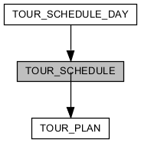

|  |  |  |  |  |  |  |
| --- | --- | --- | --- | --- | --- | --- |
| COLUMN | TYPE | NULLABLE | PKEY | DEFAULTED | REFERRED | REFER |
| ID | BIGINT |  | ● | ● | [TOUR_SCHEDULE_DAY] TOUR_SCHEDULE_ID |  |
| TOUR_PLAN_ID | BIGINT |  |  |  |  | [TOUR_PLAN] ID |
| CREATED_AT | TIMESTAMP |  |  | ● |  |  |
| UPDATED_AT | TIMESTAMP | ● |  |  |  |  |
| DELETED_AT | TIMESTAMP | ● |  |  |  |  |

|  |  |  |
| --- | --- | --- |
| UNIQUE KEY | COLUMNS | DESCRIPTION |
| CONSTRAINT_5C | ID |  |

|  |  |
| --- | --- |
| COLUMN | DESCRIPTION |
| ID | table identifier |
| TOUR_PLAN_ID | reference tour-plan |
| CREATED_AT | timestamp when this record is created |
| UPDATED_AT | timestamp when this record is updated |
| DELETED_AT | present that this record is deleted |

## TOUR_SCHEDULE_DAY

information about specific day in tour-plan. they are sequential about time.

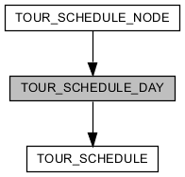

|  |  |  |  |  |  |  |
| --- | --- | --- | --- | --- | --- | --- |
| COLUMN | TYPE | NULLABLE | PKEY | DEFAULTED | REFERRED | REFER |
| ID | BIGINT |  | ● | ● | [TOUR_SCHEDULE_NODE] TOUR_SCHEDULE_DAY_ID |  |
| TOUR_SCHEDULE_ID | BIGINT |  |  |  |  | [TOUR_SCHEDULE] ID |
| SEQUENCE | INTEGER |  |  |  |  |  |
| TITLE | VARCHAR(100) | ● |  |  |  |  |
| DESCRIPTION | CLOB(2147483647) | ● |  |  |  |  |
| TRANSPORTATION_TYPE | ENUM | ● |  | ● |  |  |
| MEETING_TIME | VARCHAR(100) | ● |  |  |  |  |
| MEETING_LOCATION_NAME | VARCHAR(50) | ● |  |  |  |  |
| MEETING_LOCATION_MAP_ZOOM | INTEGER | ● |  | ● |  |  |
| MEETING_LOCATION_LATITUDE | DOUBLE | ● |  |  |  |  |
| MEETING_LOCATION_LONGITUDE | DOUBLE | ● |  |  |  |  |
| MEETING_LOCATION_DESCRIPTION | CLOB(2147483647) | ● |  |  |  |  |
| CREATED_AT | TIMESTAMP |  |  | ● |  |  |
| UPDATED_AT | TIMESTAMP | ● |  |  |  |  |
| DELETED_AT | TIMESTAMP | ● |  |  |  |  |

|  |  |  |
| --- | --- | --- |
| UNIQUE KEY | COLUMNS | DESCRIPTION |
| CONSTRAINT_94 | ID |  |

|  |  |
| --- | --- |
| COLUMN | DESCRIPTION |
| ID | table identifier |
| TOUR_SCHEDULE_ID | reference tour-schedule |
| SEQUENCE | sequence number |
| TITLE | title |
| DESCRIPTION | description |
| TRANSPORTATION_TYPE | kind of transportation in the day |
| MEETING_TIME | when meet with guide |
| MEETING_LOCATION_NAME | name of place where meet with guide |
| MEETING_LOCATION_MAP_ZOOM | zoom level of google map about place where meet with guide |
| MEETING_LOCATION_LATITUDE | latitude of place where meet with guide |
| MEETING_LOCATION_LONGITUDE | longitude of place where meet with guide |
| MEETING_LOCATION_DESCRIPTION | description about place where meet with guide |
| CREATED_AT | timestamp when this record is created |
| UPDATED_AT | timestamp when this record is updated |
| DELETED_AT | present that this record is deleted |

## TOUR_SCHEDULE_NODE

information about course in specific tour day. detailed information about course is reference "product_course" entity.

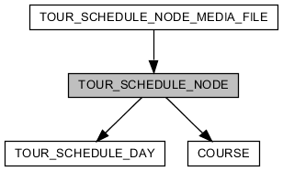

|  |  |  |  |  |  |  |
| --- | --- | --- | --- | --- | --- | --- |
| COLUMN | TYPE | NULLABLE | PKEY | DEFAULTED | REFERRED | REFER |
| ID | BIGINT |  | ● | ● | [TOUR_SCHEDULE_NODE_MEDIA_FILE] TOUR_SCHEDULE_NODE_ID |  |
| TOUR_SCHEDULE_DAY_ID | BIGINT |  |  |  |  | [TOUR_SCHEDULE_DAY] ID |
| COURSE_ID | BIGINT | ● |  |  |  | [COURSE] ID |
| START | INTEGER |  |  |  |  |  |
| SIZE | INTEGER |  |  |  |  |  |
| TITLE | VARCHAR(100) |  |  |  |  |  |
| DESCRIPTION | CLOB(2147483647) | ● |  |  |  |  |
| LATITUDE | DOUBLE | ● |  |  |  |  |
| LONGITUDE | DOUBLE | ● |  |  |  |  |
| CREATED_AT | TIMESTAMP |  |  | ● |  |  |
| UPDATED_AT | TIMESTAMP | ● |  |  |  |  |
| DELETED_AT | TIMESTAMP | ● |  |  |  |  |

|  |  |  |
| --- | --- | --- |
| UNIQUE KEY | COLUMNS | DESCRIPTION |
| CONSTRAINT_2C | ID |  |

|  |  |
| --- | --- |
| COLUMN | DESCRIPTION |
| ID | table identifier |
| TOUR_SCHEDULE_DAY_ID | reference tour-schedule-day |
| COURSE_ID | reference course |
| START | start time. unit is minute. "0" is mean twelve at night. |
| SIZE | period time about course. unit is minute. |
| TITLE | title |
| DESCRIPTION | description |
| LATITUDE | latitude of course |
| LONGITUDE | longitude of course |
| CREATED_AT | timestamp when this record is created |
| UPDATED_AT | timestamp when this record is updated |
| DELETED_AT | present that this record is deleted |

## TOUR_SCHEDULE_NODE_MEDIA_FILE

image file what is comprised in one tour-schedule-node

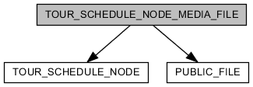

|  |  |  |  |  |  |  |
| --- | --- | --- | --- | --- | --- | --- |
| COLUMN | TYPE | NULLABLE | PKEY | DEFAULTED | REFERRED | REFER |
| ID | BIGINT |  | ● | ● |  |  |
| TOUR_SCHEDULE_NODE_ID | BIGINT |  |  |  |  | [TOUR_SCHEDULE_NODE] ID |
| PUBLIC_FILE_ID | BIGINT |  |  |  |  | [PUBLIC_FILE] ID |
| CREATED_AT | TIMESTAMP |  |  | ● |  |  |
| UPDATED_AT | TIMESTAMP | ● |  |  |  |  |

|  |  |  |
| --- | --- | --- |
| UNIQUE KEY | COLUMNS | DESCRIPTION |
| CONSTRAINT_DA6 | ID |  |

|  |  |
| --- | --- |
| COLUMN | DESCRIPTION |
| ID | table identifier |
| TOUR_SCHEDULE_NODE_ID | reference tour-schedule-node |
| PUBLIC_FILE_ID | reference image file |
| CREATED_AT | timestamp when this record is created |
| UPDATED_AT | timestamp when this record is updated |

## TOUR_SKETCH

collection tour-information

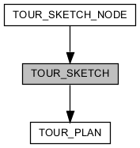

|  |  |  |  |  |  |  |
| --- | --- | --- | --- | --- | --- | --- |
| COLUMN | TYPE | NULLABLE | PKEY | DEFAULTED | REFERRED | REFER |
| ID | BIGINT |  | ● |  | [TOUR_SKETCH_NODE] TOUR_SKETCH_ID | [TOUR_PLAN] ID |
| CREATED_AT | TIMESTAMP |  |  | ● |  |  |
| UPDATED_AT | TIMESTAMP | ● |  |  |  |  |

|  |  |  |
| --- | --- | --- |
| UNIQUE KEY | COLUMNS | DESCRIPTION |
| CONSTRAINT_F1 | ID |  |

|  |  |
| --- | --- |
| COLUMN | DESCRIPTION |
| ID | table identifier |
| CREATED_AT | timestamp when this record is created |
| UPDATED_AT | timestamp when this record is updated |

## TOUR_SKETCH_NODE

tour-information

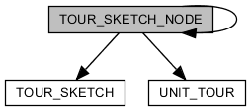

|  |  |  |  |  |  |  |
| --- | --- | --- | --- | --- | --- | --- |
| COLUMN | TYPE | NULLABLE | PKEY | DEFAULTED | REFERRED | REFER |
| ID | BIGINT |  | ● | ● | [TOUR_SKETCH_NODE] REF_ID |  |
| TOUR_SKETCH_ID | BIGINT |  |  |  |  | [TOUR_SKETCH] ID |
| SEQUENCE | DOUBLE |  |  |  |  |  |
| NAME | VARCHAR(200) |  |  |  |  |  |
| REF_ID | BIGINT | ● |  |  |  | [TOUR_SKETCH_NODE] ID |
| TYPE | ENUM |  |  |  |  |  |
| UNIT_TOUR_ID | BIGINT | ● |  |  |  | [UNIT_TOUR] ID |
| CREATED_AT | TIMESTAMP |  |  | ● |  |  |
| UPDATED_AT | TIMESTAMP | ● |  |  |  |  |

|  |  |  |
| --- | --- | --- |
| UNIQUE KEY | COLUMNS | DESCRIPTION |
| CONSTRAINT_3A | ID |  |

|  |  |
| --- | --- |
| COLUMN | DESCRIPTION |
| ID | table identifier |
| TOUR_SKETCH_ID | reference tour-sketch |
| SEQUENCE | sequence number |
| NAME | name of information |
| REF_ID | reference tour-sketch-node |
| TYPE | tour-sketch-node is two types: folder(no information. for classification), item(belong folder-node) |
| UNIT_TOUR_ID |  |
| CREATED_AT | timestamp when this record is created |
| UPDATED_AT | timestamp when this record is updated |

## UNIT_TOUR

selling tour-product by guide

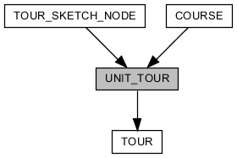

|  |  |  |  |  |  |  |
| --- | --- | --- | --- | --- | --- | --- |
| COLUMN | TYPE | NULLABLE | PKEY | DEFAULTED | REFERRED | REFER |
| ID | BIGINT |  | ● |  | [COURSE] UNIT_TOUR_ID  [TOUR_SKETCH_NODE] UNIT_TOUR_ID | [TOUR] ID |
| TRANSPORTATION_TYPE | ENUM | ● |  |  |  |  |
| MEETING_TIME | VARCHAR(100) | ● |  |  |  |  |
| MEETING_LOCATION_NAME | VARCHAR(50) | ● |  |  |  |  |
| MEETING_LOCATION_MAP_ZOOM | INTEGER | ● |  | ● |  |  |
| MEETING_LOCATION_LATITUDE | DOUBLE | ● |  |  |  |  |
| MEETING_LOCATION_LONGITUDE | DOUBLE | ● |  |  |  |  |
| MEETING_LOCATION_DESCRIPTION | CLOB(2147483647) | ● |  |  |  |  |

|  |  |  |
| --- | --- | --- |
| UNIQUE KEY | COLUMNS | DESCRIPTION |
| CONSTRAINT_8B | ID |  |

|  |  |
| --- | --- |
| COLUMN | DESCRIPTION |
| ID | table identifier |
| TRANSPORTATION_TYPE | kind of transportation in the trip |
| MEETING_TIME | when meet with guide |
| MEETING_LOCATION_NAME | name of place where meet with guide |
| MEETING_LOCATION_MAP_ZOOM | zoom level of google map about place where meet with guide |
| MEETING_LOCATION_LATITUDE | latitude of place where meet with guide |
| MEETING_LOCATION_LONGITUDE | longitude of place where meet with guide |
| MEETING_LOCATION_DESCRIPTION | description about place where meet with guide |

## USER_X_INTEREST_GUIDE

relationship of user with guide.

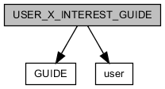

|  |  |  |  |  |  |  |
| --- | --- | --- | --- | --- | --- | --- |
| COLUMN | TYPE | NULLABLE | PKEY | DEFAULTED | REFERRED | REFER |
| ID | BIGINT |  | ● | ● |  |  |
| USER_ID | BIGINT |  |  |  |  | [user] ID |
| GUIDE_ID | BIGINT |  |  |  |  | [GUIDE] ID |
| CREATED_AT | TIMESTAMP |  |  | ● |  |  |
| UPDATED_AT | TIMESTAMP | ● |  |  |  |  |

|  |  |  |
| --- | --- | --- |
| UNIQUE KEY | COLUMNS | DESCRIPTION |
| CONSTRAINT_2 | ID |  |
| USER_X_INTEREST_GUIDE_USER_ID_GUIDE_ID_KEY | USER_ID GUIDE_ID |  |

|  |  |
| --- | --- |
| COLUMN | DESCRIPTION |
| ID | table identifier |
| USER_ID | reference user |
| GUIDE_ID | reference guide |
| CREATED_AT | timestamp when this record is created |
| UPDATED_AT | timestamp when this record is updated |

## USER_X_INTEREST_PRODUCT

relationship of user with product.

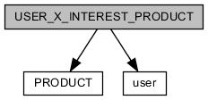

|  |  |  |  |  |  |  |
| --- | --- | --- | --- | --- | --- | --- |
| COLUMN | TYPE | NULLABLE | PKEY | DEFAULTED | REFERRED | REFER |
| ID | BIGINT |  | ● | ● |  |  |
| USER_ID | BIGINT |  |  |  |  | [user] ID |
| PRODUCT_ID | BIGINT |  |  |  |  | [PRODUCT] ID |
| CREATED_AT | TIMESTAMP |  |  | ● |  |  |
| UPDATED_AT | TIMESTAMP | ● |  |  |  |  |

|  |  |  |
| --- | --- | --- |
| UNIQUE KEY | COLUMNS | DESCRIPTION |
| CONSTRAINT_DB | ID |  |
| USER_X_INTEREST_PRODUCT_USER_ID_PRODUCT_ID_KEY | USER_ID PRODUCT_ID |  |

|  |  |
| --- | --- |
| COLUMN | DESCRIPTION |
| ID | table identifier |
| USER_ID | reference user |
| PRODUCT_ID | reference product |
| CREATED_AT | timestamp when this record is created |
| UPDATED_AT | timestamp when this record is updated |

## user

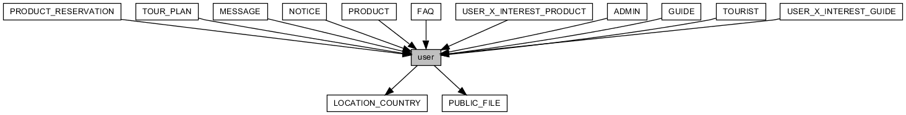

|  |  |  |  |  |  |  |
| --- | --- | --- | --- | --- | --- | --- |
| COLUMN | TYPE | NULLABLE | PKEY | DEFAULTED | REFERRED | REFER |
| ID | BIGINT |  | ● | ● | [ADMIN] ID  [FAQ] USER_ID  [GUIDE] ID  [MESSAGE] RECEIVER_ID  [MESSAGE] SENDER_ID  [NOTICE] USER_ID  [PRODUCT_RESERVATION] USER_ID  [PRODUCT] SELLER_ID  [TOURIST] ID  [TOUR_PLAN] USER_ID  [USER_X_INTEREST_GUIDE] USER_ID  [USER_X_INTEREST_PRODUCT] USER_ID |  |
| TYPE | ENUM |  |  |  |  |  |
| EMAIL | VARCHAR(100) | ● |  |  |  |  |
| FIRST_NAME | VARCHAR(100) | ● |  |  |  |  |
| MIDDLE_NAME | VARCHAR(100) | ● |  |  |  |  |
| LAST_NAME | VARCHAR(100) | ● |  |  |  |  |
| PROFILE_IMAGE_ID | BIGINT | ● |  |  |  | [PUBLIC_FILE] ID |
| PROFILE_DESCRIPTION | CLOB(2147483647) | ● |  |  |  |  |
| GENDER | ENUM | ● |  |  |  |  |
| MOBILE_COUNTRY_ID | BIGINT | ● |  |  |  | [LOCATION_COUNTRY] ID |
| MOBILE | VARCHAR(20) | ● |  |  |  |  |
| NATIONALITY_ID | BIGINT | ● |  |  |  | [LOCATION_COUNTRY] ID |
| ACCOUNT_STATUS | ENUM |  |  | ● |  |  |
| CREATED_AT | TIMESTAMP |  |  | ● |  |  |
| UPDATED_AT | TIMESTAMP | ● |  |  |  |  |
| DELETED_AT | TIMESTAMP | ● |  |  |  |  |
| AGREE_RECEIVE | BOOLEAN |  |  | ● |  |  |
| LOCALE | VARCHAR(16) | ● |  |  |  |  |

|  |  |  |
| --- | --- | --- |
| UNIQUE KEY | COLUMNS | DESCRIPTION |
| CONSTRAINT_3 | ID |  |

|  |  |
| --- | --- |
| COLUMN | DESCRIPTION |
| ID | table identifier |
| TYPE |  |
| EMAIL |  |
| FIRST_NAME |  |
| MIDDLE_NAME |  |
| LAST_NAME |  |
| PROFILE_IMAGE_ID |  |
| PROFILE_DESCRIPTION |  |
| GENDER |  |
| MOBILE_COUNTRY_ID |  |
| MOBILE |  |
| NATIONALITY_ID |  |
| ACCOUNT_STATUS |  |
| CREATED_AT | timestamp when this record is created |
| UPDATED_AT | timestamp when this record is updated |
| DELETED_AT | present that this record is deleted |
| AGREE_RECEIVE |  |
| LOCALE |  |