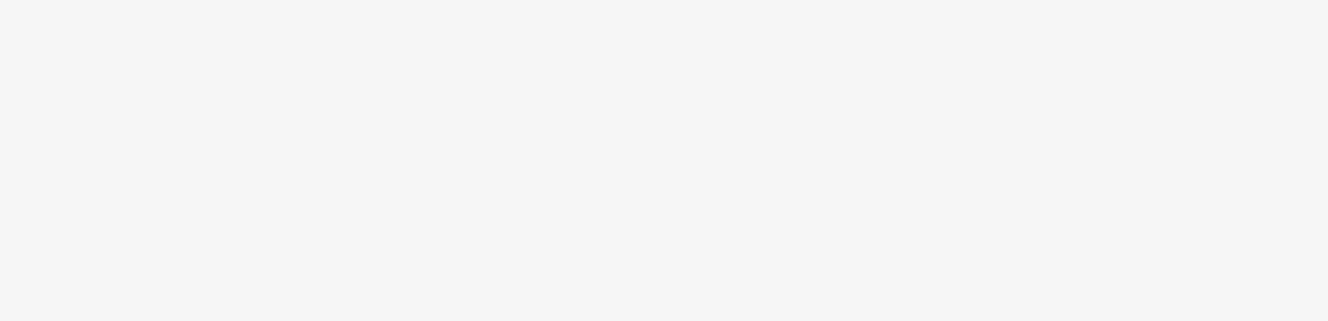

**Tio Marello**

High-School Senior

C:\Users\abdou\Desktop\Resumes for Customer\Customer Project\Resume 2\icon2.pngC:\Users\abdou\Desktop\Resumes for Customer\Customer Project\Resume 2\icon1.pngC:\Users\abdou\Desktop\Resumes for Customer\Customer Project\Resume 2\icon6.pngC:\Users\abdou\Desktop\Resumes for Customer\Customer Project\Resume 2\icon5.pngC:\Users\abdou\Desktop\Resumes for Customer\Customer Project\Resume 2\icon4.pngC:\Users\abdou\Desktop\Resumes for Customer\Customer Project\Resume 2\icon3.png

**E.L Meyers Jr/Sr High School**

Diploma: June 2021

GPA: 3.8

Rank: 2nd in class

EXPERIENCE

CAREER OBJECTIVE

Windows / MacOS

Fast Typist (90 WPM)

**Intern Programmer and 3D Modeler**

*Vizvibe, Wilkes-Barre, PA / June 2020 - Present*

* Collaborated with a senior programmer to develop new software features.
* Tracked own time, developing time management skills and task compartmentalization.
* Broke down complex software problems into solvable, programmable problems.
* Developed hard computer skills such as typing and use of file systems.

**Geisinger Hospital Volunteer**

*Geisinger South Wilkes-Barre, PA / June 2019 – August 2019*

* Distributed amenities to in-patients throughout the hospital, ensuring a friendly and amiable hospital stay.
* Talked to in-patients, developing client relation skills.
* Worked with hospital staff to make sure supplies were packed as well as areas clean.

Communication

Collaboration

Self-Motivation

Problem Solving

**Email:**

[tiomarello@gmail.com](mailto:youremail@gmail.com)

**Phone:**

(570) 301-6797

**Address:**

29 Amherst Ave, Wilkes-Barre, PA, 18702

**Website:**

Tiomarello.github.io

Self-motivated high school senior looking to transform experience gained from various extracurriculars into a tangible career in service; experience from clubs such as speech and debate and Future Business Leaders of America prime me for customer relations and communication while also honing my critical and on-my-feet thinking.

CONTACT

SOFT SKILLS

HARD SKILLS

EDUCATION