Predicting Airline Flight Delays Using Apache Spark
A Comparative Study of Machine Learning Classifiers on the 2025 BTS On-Time Performance Data
Module: M33877 Big Data and Machine Learning Applications
Assessment: Coursework Item 2, Part 2: Big Data Applications Project (technical report)
Student: Soh Chee Yong Student ID: UP2653853
Lecturer: Ms Aarushi Vadhavkar
Word count (main text, sections 1 to 8): 2,310 words, excluding tables, figure captions, code extracts, references and appendices
Source code: BDMLA_Flight_Delay_Spark.ipynb (Google Colab, PySpark 4.0.4), submitted in the accompanying .zip file

Contents
Abstract
1. Introduction
1.1 Background
1.2 Problem statement
1.3 Objectives
2. Related Work
3. Dataset Selection, Exploration and Preparation
3.1 Source and rationale
3.2 Exploration
3.3 Cleaning
3.4 Reducing target leakage
4. Big Data Framework and Architecture
4.1 Scale-out
5. Methodology and Implementation
5.1 Feature engineering
5.2 Splitting, imbalance and evaluation
5.3 Models and tuning
6. Results
7. Discussion
7.1 Limitations
7.2 What I learnt
8. Conclusions and Future Work
References
Appendix A. Notebook structure and reproduction
Appendix B. Feature dictionary
Appendix C. Excluded (leakage) columns

Abstract
Flight delays are costly for airlines and passengers, and much of that cost comes from not knowing in advance which flights will run late. In this project I used Apache Spark to process all twelve monthly 2025 files of the U.S. Bureau of Transportation Statistics on-time dataset (7,001,619 flights) and to predict whether a flight will arrive at least 15 minutes late using schedule information only. Columns recorded during or after the flight were excluded, and Logistic Regression, Random Forest and Gradient-Boosted Trees were trained and tuned with Spark MLlib. On a random test split, Gradient-Boosted Trees gave the best F1 (0.479) and ROC-AUC (0.735). On a stricter test using later months, all models dropped and Random Forest had the highest F1, which shows that the preferred model depends on how it is evaluated.

1. Introduction

1.1 Background
Flight delays cost the U.S. economy an estimated $32.9 billion in 2007 (Ball et al., 2010); this historical figure gives context rather than a current cost. The Bureau of Transportation Statistics (BTS) counts a flight as delayed when it arrives 15 or more minutes late, and publishes a record for every domestic flight of the larger U.S. carriers. I selected this dataset because it contains several million flight records, giving me the opportunity to apply Spark to a substantial data-processing task rather than a sample that would fit comfortably in pandas.

1.2 Problem statement
The question is: using only information known before the aircraft leaves the gate, can we predict whether a flight will arrive 15 or more minutes late? (DELAYED = 1 if ARR_DELAY ≥ 15). Many public notebooks on this data report high accuracy only because they use departure delay or other post-flight columns (Kaufman et al., 2012). A schedule-only model could instead be run the evening before to help plan crews and spare aircraft.

1.3 Objectives
- Build a scalable Spark pipeline that ingests, unions and cleans all twelve monthly files for 2025.
- Engineer features from schedule information only, excluding columns recorded during or after the flight.
- Train, tune and compare three Spark MLlib classifiers: Logistic Regression, Random Forest and Gradient-Boosted Trees.
- Evaluate them with metrics that are suitable for an imbalanced target, together with training time.
- Show how the approach would scale out to more processors, a cluster or GPUs.

2. Related Work
Sternberg et al. (2017) found that most delay studies use classification, with tree models and congestion features recurring; Rebollo and Balakrishnan (2014) and Gui et al. (2020) found random forests strong, and Belcastro et al. (2016) joined flight and weather data in a scalable MapReduce pipeline. Both random forests (Breiman, 2001) and gradient boosting (Friedman, 2001) are available in Spark MLlib (Meng et al., 2016). This project adds aircraft-rotation features and a temporal evaluation on the latest full year.

3. Dataset Selection, Exploration and Preparation

3.1 Source and rationale
The data is the BTS Reporting Carrier On-Time Performance table (Bureau of Transportation Statistics, 2026): one row per domestic flight, with carrier, tail number, airports, scheduled and actual times, cancellation and diversion flags, and delay minutes by cause. I downloaded the twelve 2025 monthly CSVs (about 3 GB) to Google Drive. Screenshot 1 shows the files being checked, read and unioned in Spark.
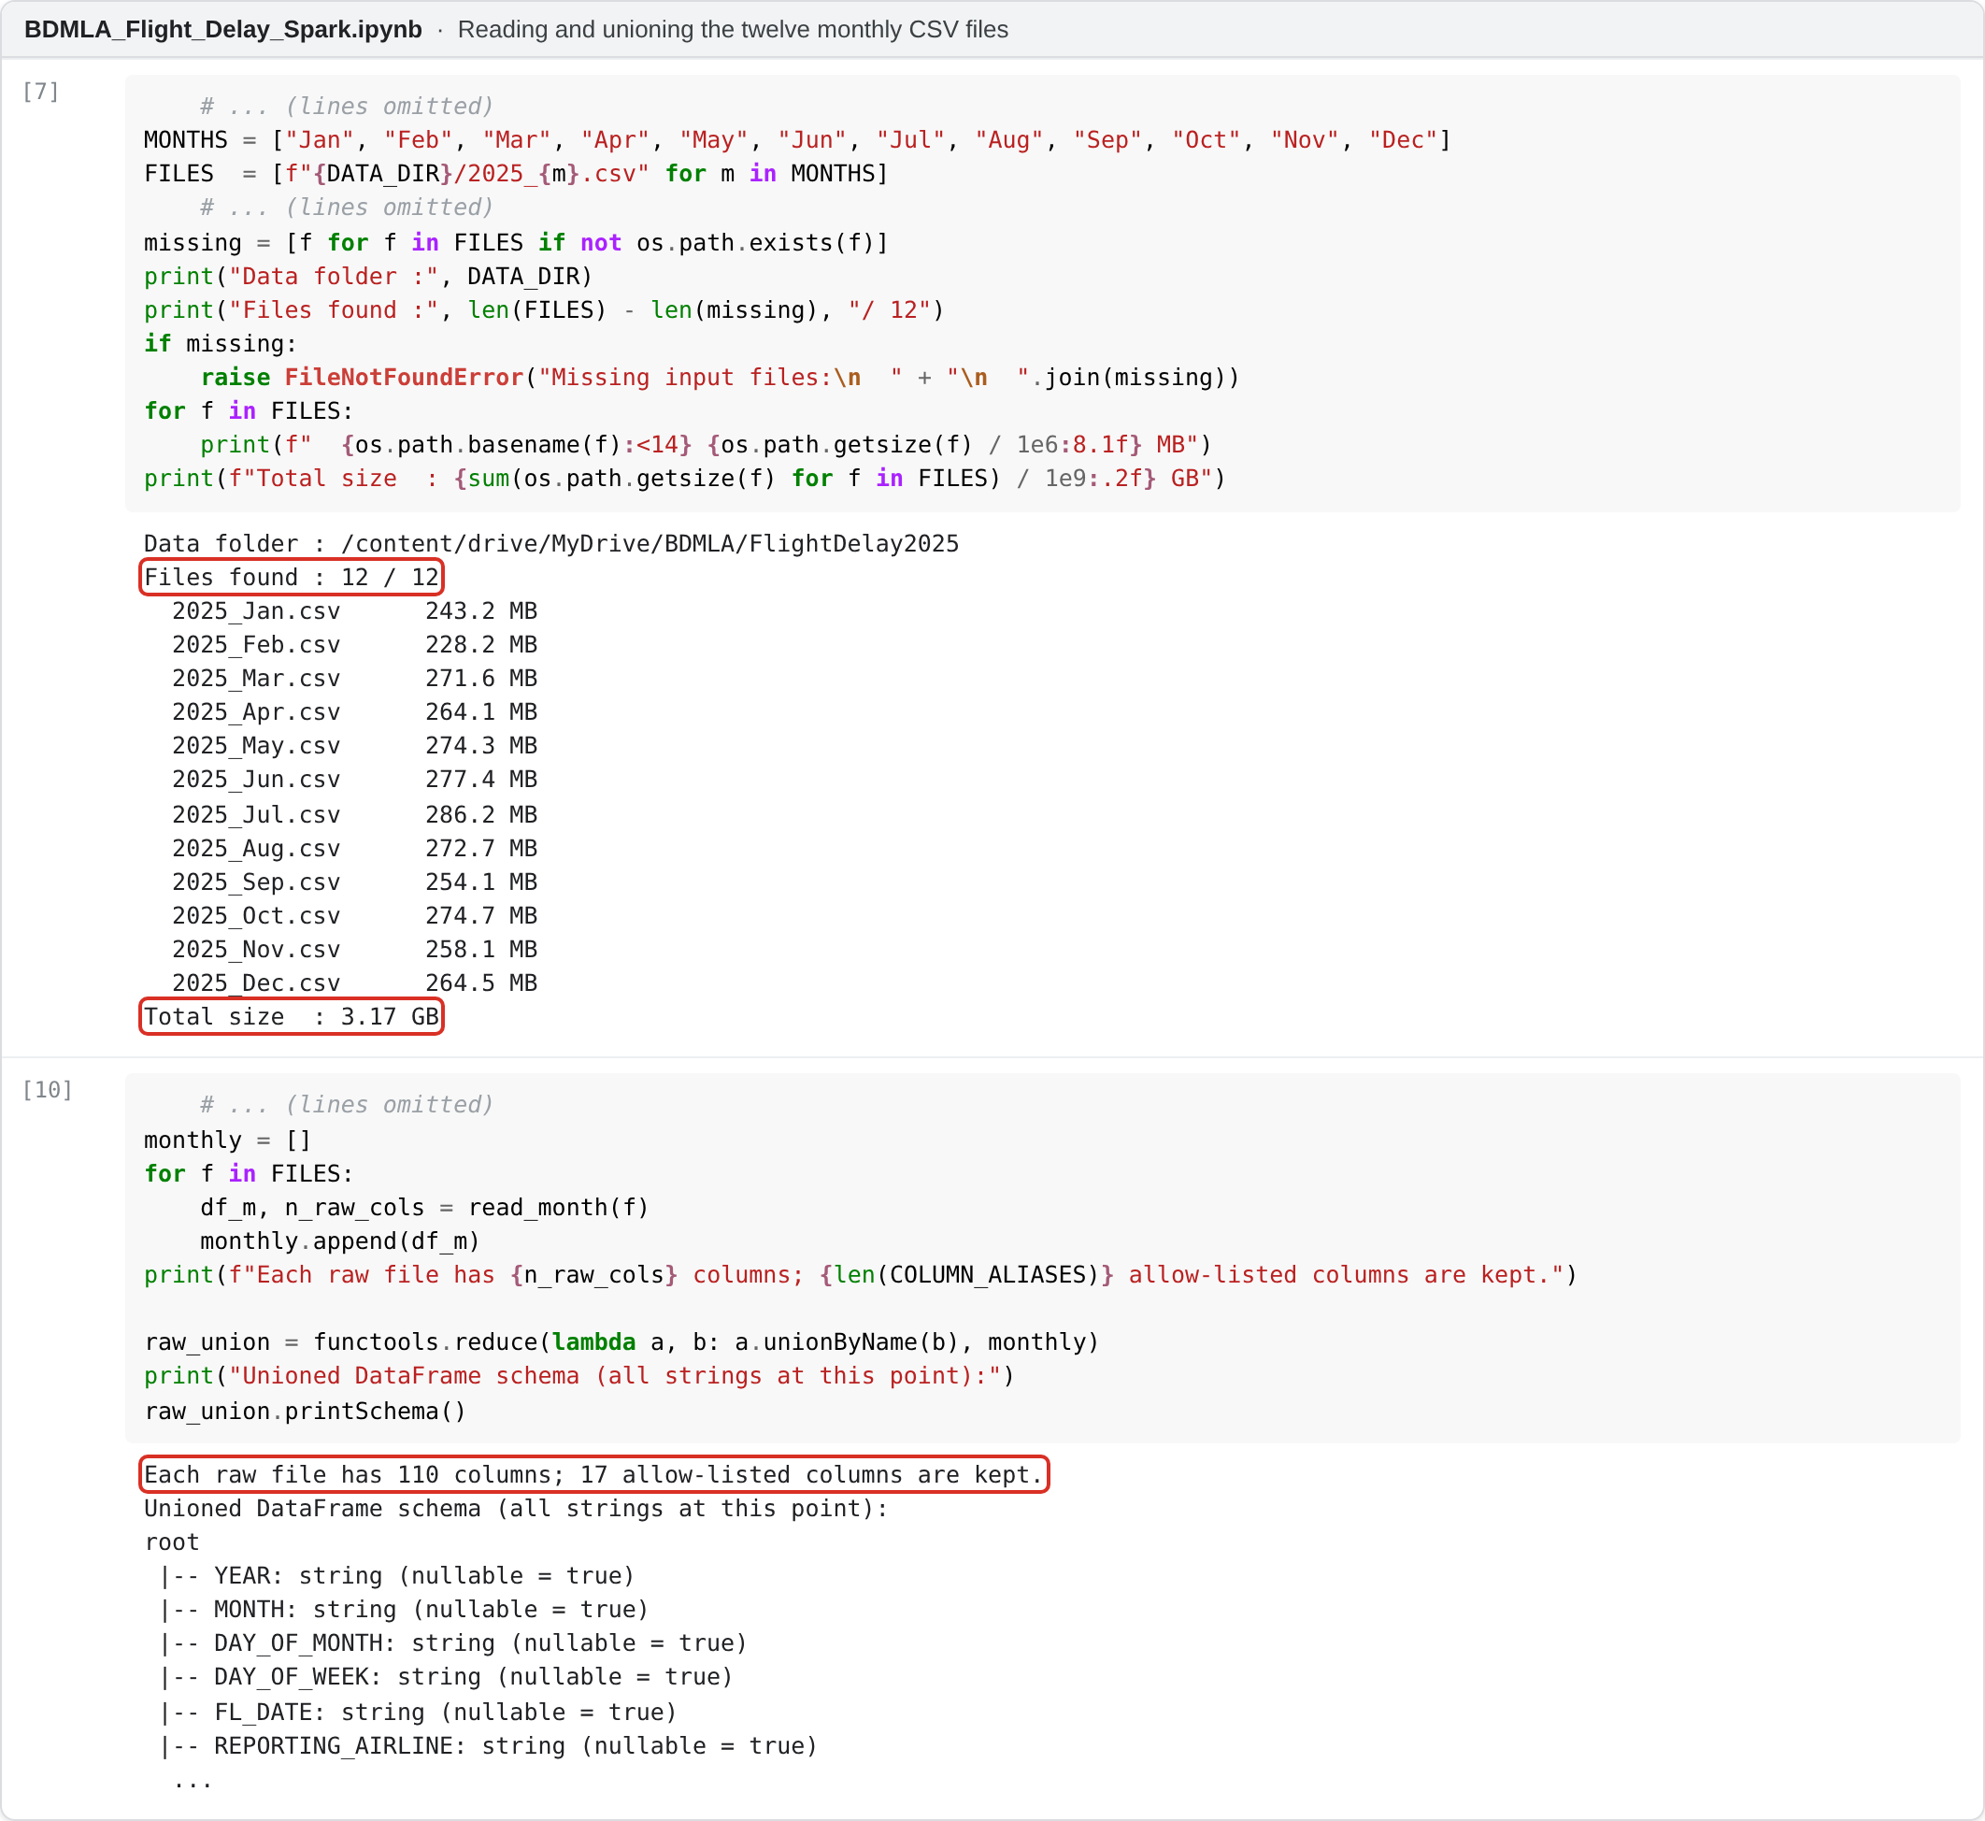
Screenshot 1. Reading the twelve monthly files and unioning them with an allow-list of 17 columns (notebook output).
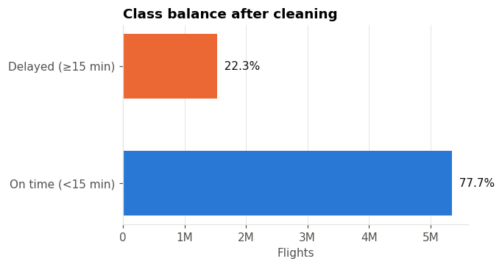
Figure 1. Class balance after cleaning (DELAYED = 1 when ARR_DELAY ≥ 15 minutes).

3.2 Exploration
After cleaning, 22.31% of flights are delayed (Figure 1), so the data is imbalanced: always predicting "on time" would score 77.70% accuracy. Delays peak in July (about 29%) and December and are lowest in September (about 17%); Sundays are worst, and airlines range from about 17% to 28% (Figure 2). The clearest pattern is by hour: about 9% of 5am departures arrive late, against about 33% at 7pm, consistent with delays carrying over to later legs. Figure 3 supports this: an aircraft's first leg is late about 15% of the time and its seventh about 34%, and turnarounds under 40 minutes have a 38% delay rate, against about 21% for 60 to 179 minutes. Holiday proximity (Figure 4) peaks at about 26% three days from a holiday but is noisy, which matters later.
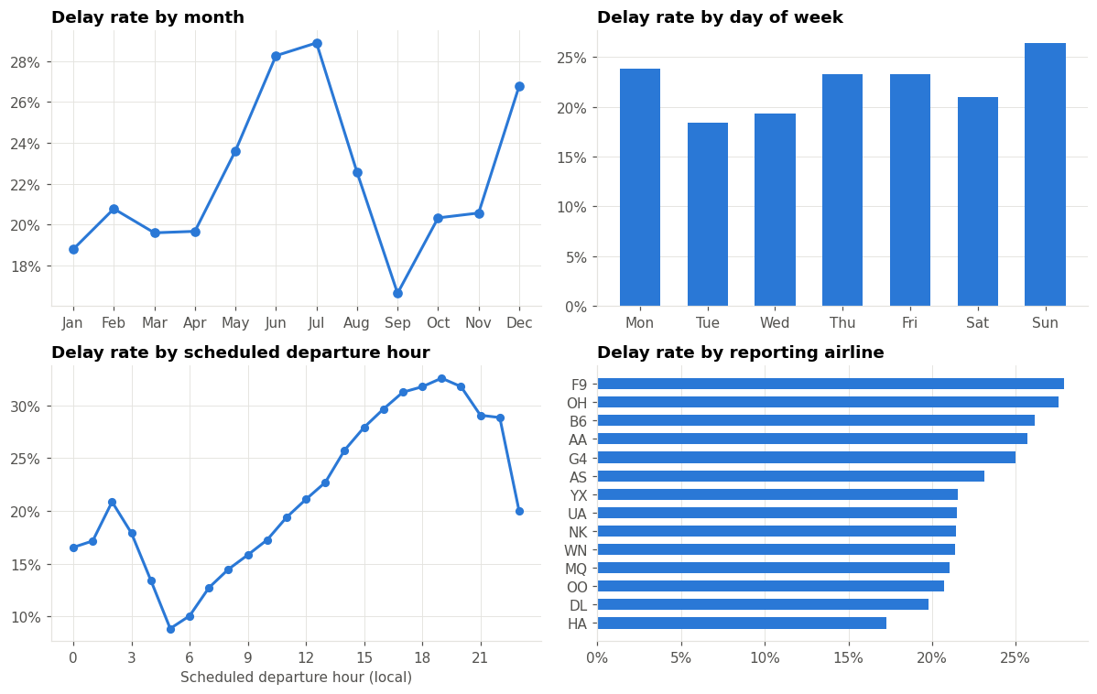
Figure 2. Delay rate by month, day of week, scheduled departure hour and reporting airline.
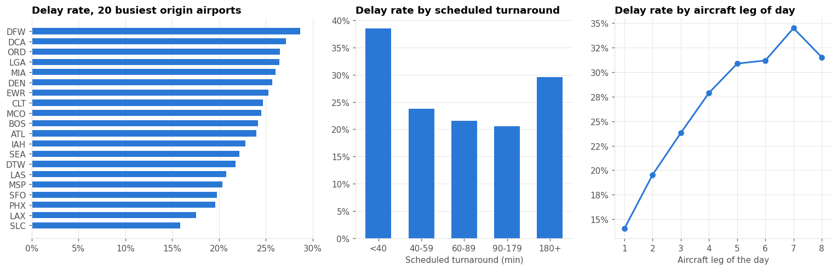
Figure 3. Delay rate at the 20 busiest origin airports, by scheduled turnaround, and by aircraft leg of the day.
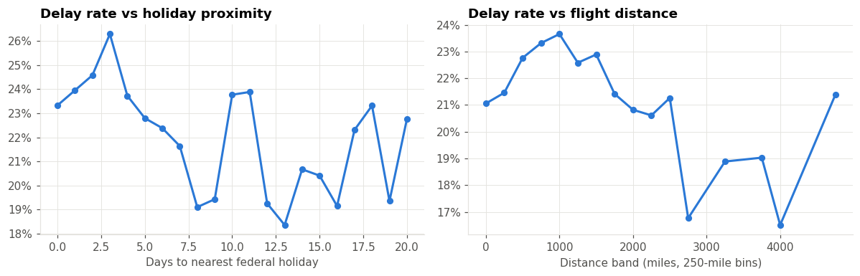
Figure 4. Delay rate by distance to the nearest federal holiday and by flight distance; both patterns are noisy.

3.3 Cleaning
Cancelled and diverted flights were removed because they have no arrival-delay label, then null ARR_DELAY rows, duplicates and impossible schedule values (Table 1). Missing tail numbers were kept, with a neutral rotation value and a HAS_PREV_LEG flag. The data-quality profile in Screenshot 2 shows why: the 122,135 missing delays match the cancelled and diverted flights almost exactly.
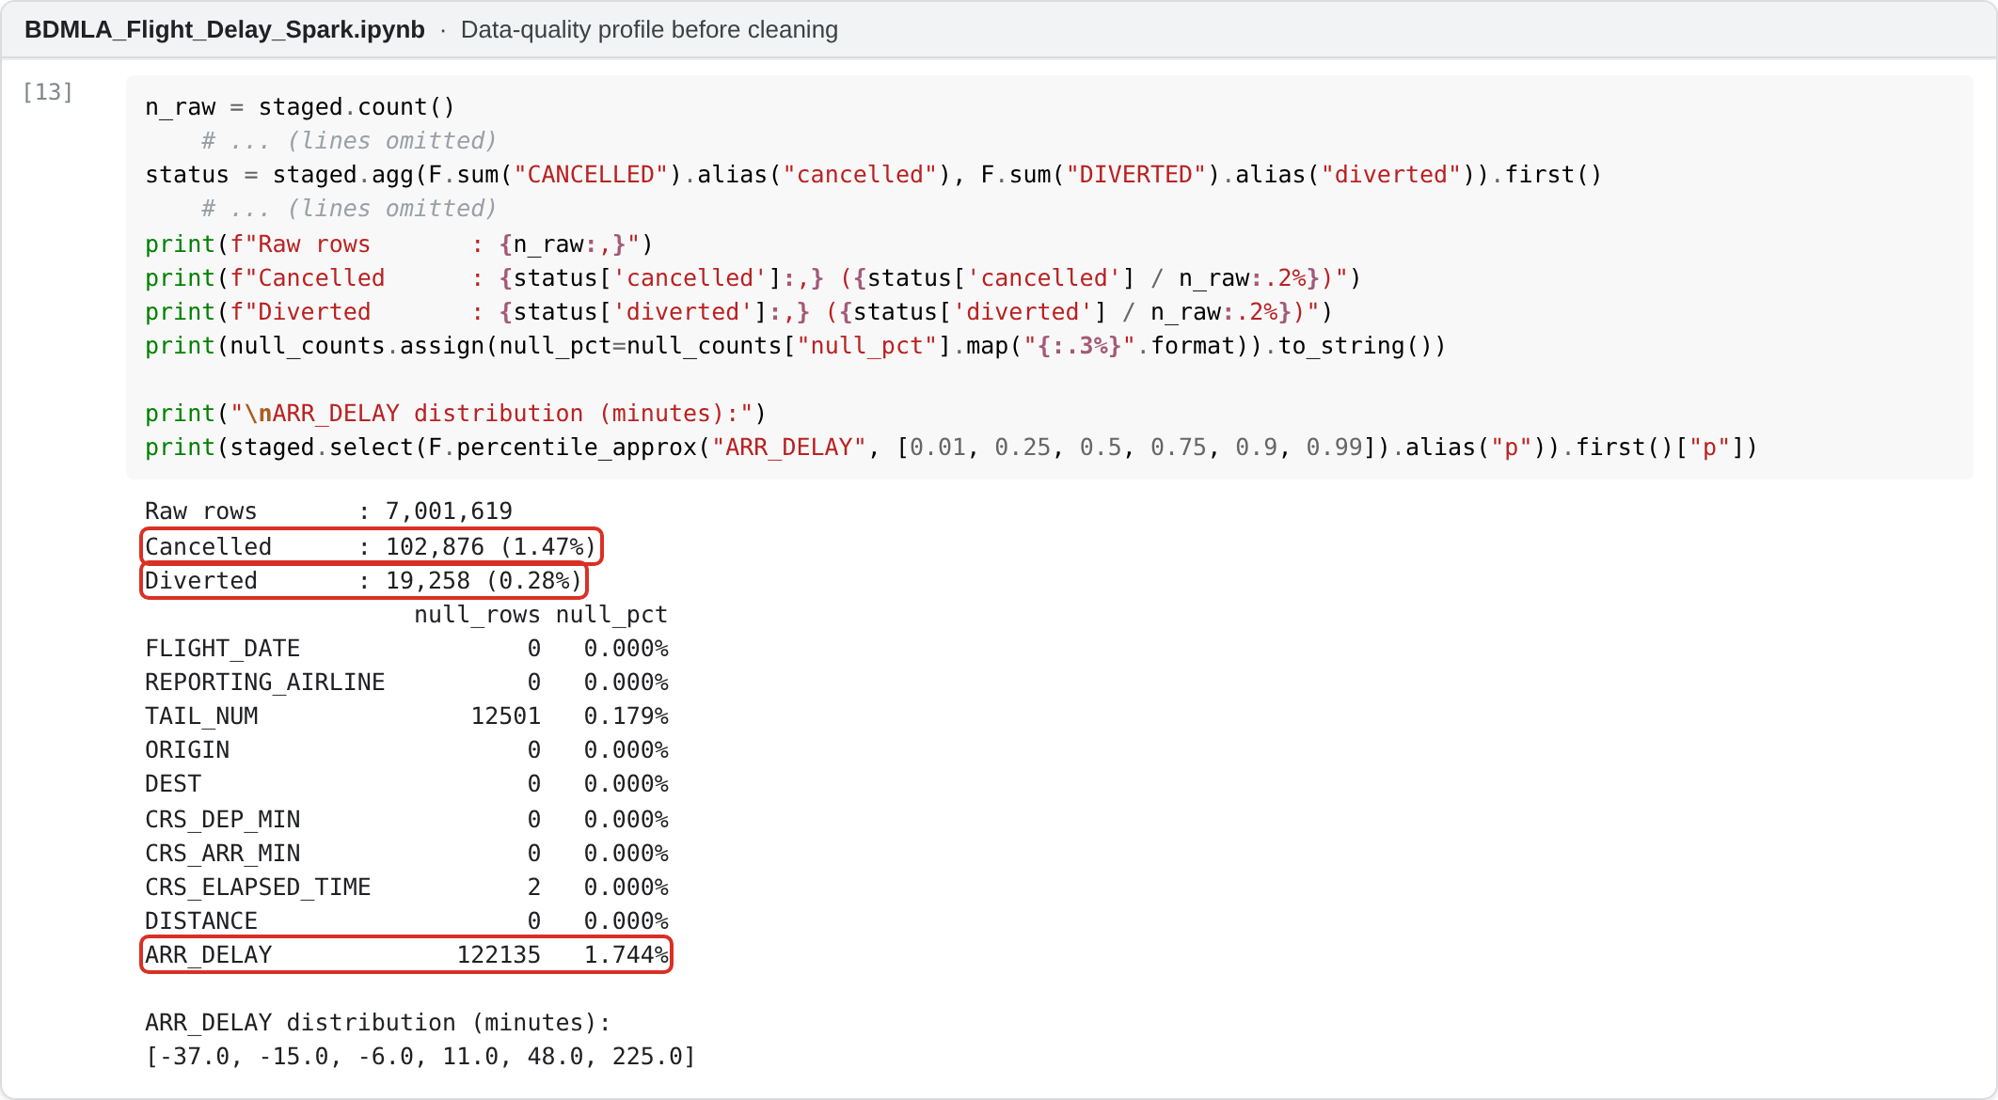
Screenshot 2. Data-quality profile before cleaning (notebook output).
Step | Rows remaining | Rows removed
Raw flights (12 files) | 7,001,619 | -
Remove cancelled | 6,898,743 | 102,876
Remove diverted | 6,879,485 | 19,258
Remove null ARR_DELAY | 6,879,484 | 1
Remove duplicates | 6,879,484 | 0
Remove invalid schedule values | 6,879,483 | 1
Table 1. Cleaning funnel (from tables/cleaning_funnel.csv).

3.4 Reducing target leakage
Leakage was the main risk, so I tried to control it at three levels. First, an allow-list loads only 17 of the 110 raw columns, so post-flight fields never enter the DataFrame; I also excluded DEP_TIME, DEP_DELAY, TAXI_OUT and DEP_DEL15, which are unknown before departure, and ARR_DELAY is dropped once the label is built. Second, an assertion checks the features against the forbidden columns (Appendix C). Third, schedule counts such as flights per hour are computed before cancellations are removed; otherwise a stormy day would look quiet and the feature would encode the outcome. This removes direct post-flight predictors, but does not make the features completely leakage-free (Section 7.1).

4. Big Data Framework and Architecture
Figure 5 shows the pipeline. Everything runs in Google Colab with PySpark 4.0.4, using the DataFrame/Spark SQL API for data processing and Spark MLlib for modelling.
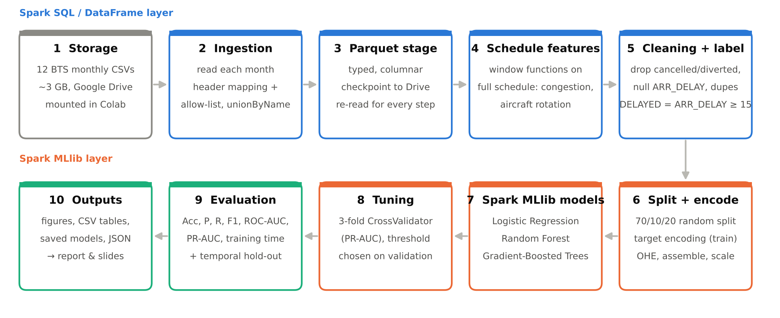
Figure 5. End-to-end architecture of the Spark pipeline.
Spark turns a job into stages of parallel tasks, one per data partition (Zaharia et al., 2016), and its Catalyst optimiser pushes the column allow-list down to the file scan (Armbrust et al., 2015). In Colab the driver and executor share one two-core VM in local mode (Figure 6; its configuration is in Screenshot 3); the same code runs on a cluster by changing the master URL.
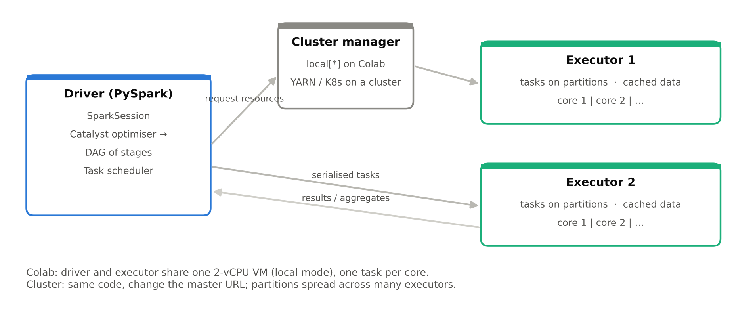
Figure 6. Spark execution model: in Colab the driver and executor share one VM; on a cluster, tasks are spread across executors.
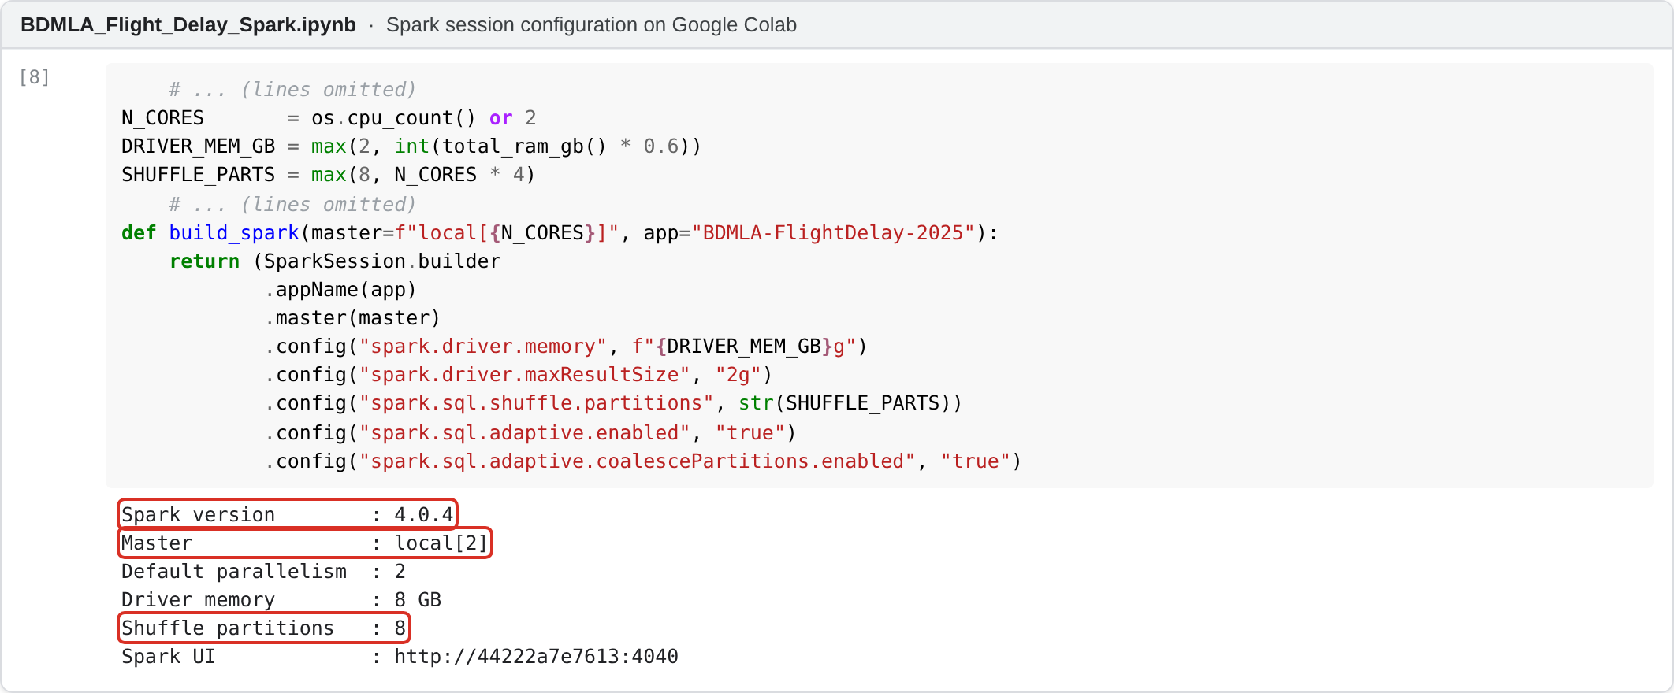
Screenshot 3. Spark session configuration on Colab: local mode, two cores, tuned shuffle partitions (notebook output).
These optimisations made a full year practical on free Colab:
- CSV to Parquet once: the same aggregation took 79.8 s on CSV and 3.2 s on Parquet (25.1x faster), and the Drive copy acts as a checkpoint (Screenshot 4).
- Fewer shuffle partitions plus Adaptive Query Execution, broadcast joins for the encoding tables and caching of model-ready data.
- Single-pass evaluation: confusion matrices and F1 for 37 thresholds are each one Spark aggregation.
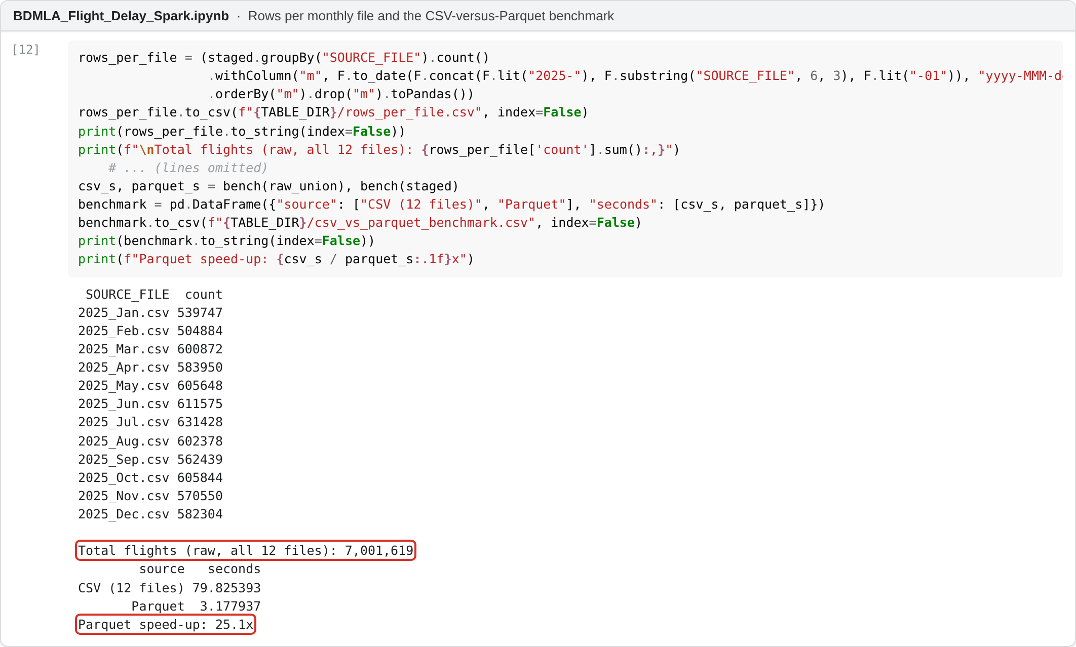
Screenshot 4. Rows per monthly file and the CSV-versus-Parquet benchmark (notebook output).

4.1 Scale-out
As an exploratory local benchmark, the notebook times the same workload once with 1 and 2 cores. A full aggregation went from 4.8 s to 2.0 s (2.41x), but the 1-core run went first, so warmer caches probably explain part of this; repeated runs with median timings would be needed for a firm claim. A Logistic Regression fit on a cached 20% sample barely changed (1.03x), as each iteration is a short, overhead-dominated job. On Dataproc or Databricks the notebook would run unchanged with more executors, and RAPIDS and XGBoost's Spark integration offer GPU acceleration (Chen & Guestrin, 2016). Figure 7 plots both speed-ups against the ideal.
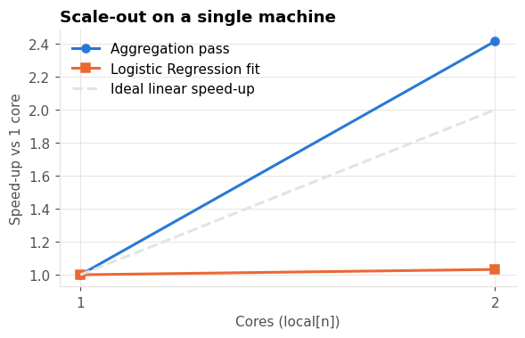
Figure 7. Exploratory speed-up from one to two local cores (single run).

5. Methodology and Implementation

5.1 Feature engineering
I ended up with 39 features in four groups (the full list is in Appendix B):
- Calendar and time: month, day, weekday, weekend flag, scheduled departure and arrival hour (with sine/cosine encodings) and days to the nearest federal holiday.
- Flight: scheduled elapsed time, distance and airline (one-hot, about 15 carriers).
- Congestion (from the schedule): scheduled departures and arrivals at the airport in the same hour, and daily airport and carrier volume.
- Aircraft rotation: the leg of the day for that tail number and the scheduled turnaround time since its previous leg, computed with a window function:
w_tail = Window.partitionBy("TAIL_NUM", "FLIGHT_DATE").orderBy("CRS_DEP_MIN")
df = (df.withColumn("TAIL_LEG_OF_DAY", F.row_number().over(w_tail))
.withColumn("SCHED_TURNAROUND_MIN",
F.col("CRS_DEP_MIN") - F.lag("CRS_ARR_MIN").over(w_tail)))

The turnaround subtracts two scheduled times at the same airport, so both are in that airport's local time. Legs are ordered by local departure time within each day, which could misorder rare large time-zone cases; there is no check that the previous destination matches the current origin, and a leg whose previous arrival crosses midnight is treated as having no previous leg.
ORIGIN, DEST, ROUTE (thousands of pairs), origin-by-hour and carrier-by-origin have too many categories for one-hot encoding under Spark's maxBins limit, so each became a smoothed target encoding (Micci-Barreca, 2001), TE = (n·mean + m·prior)/(n + m) with m = 100, fitted on the training split only. Screenshot 5 shows the encoders and the leakage assertion passing.
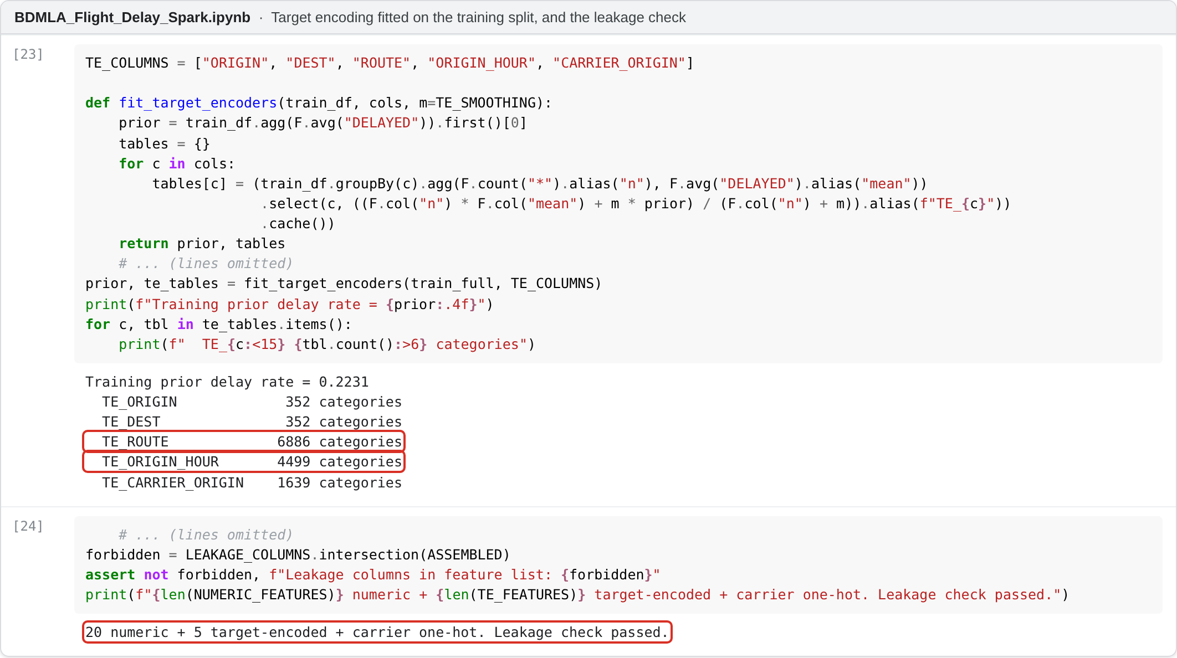
Screenshot 5. Smoothed target encoding fitted on the training split, and the leakage check (notebook output).

5.2 Splitting, imbalance and evaluation
The data was split randomly 70/10/20 into train, validation and test. Because of Colab limits, models were fitted on a 30% sample of the training split (1,445,229 rows); validation and test (1,376,914 rows) were scored in full. For the imbalance (He & Garcia, 2009) I used class weights w = N/(2·N_class) and tuned the decision threshold on validation to maximise F1. Figure 8 shows the validation F1 at each threshold: the peaks sit near 0.5 because the class weights already rebalance the models.
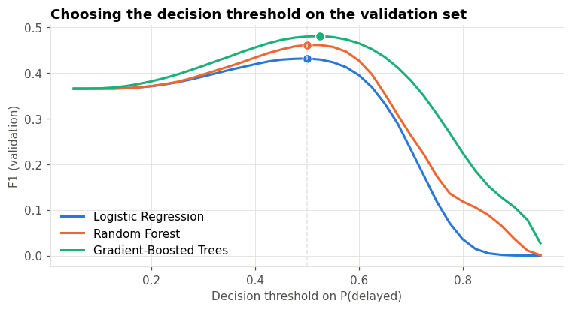
Figure 8. Validation F1 against the decision threshold; dots mark the chosen thresholds.
Accuracy alone is misleading here, so a majority-class baseline is reported alongside precision (the cost of false alarms), recall (delays caught), F1, ROC-AUC and PR-AUC, which is more informative when positives are rare (Saito & Rehmsmeier, 2015), plus training time.

5.3 Models and tuning
All three models share one standardised feature vector. Logistic Regression is the interpretable linear baseline, Random Forest averages decorrelated trees, and Gradient-Boosted Trees add trees sequentially, each correcting the last. Each was tuned with CrossValidator (3-fold, PR-AUC) on a training sample (Table 2, Screenshot 6) and refitted on the full training sample. The target encoders were fitted on the whole training split before cross-validation, so the held-out folds were not fully independent of the encoding; CV scores may be slightly optimistic, although the test set was not affected.
Model | Grid searched (3-fold CV) | Selected | CV PR-AUC
Logistic Regression | regParam {0.0001, 0.001, 0.01} × elasticNet {0, 0.5} | regParam=0.0001, elasticNetParam=0.0 | 0.369
Random Forest | maxDepth {8, 12} × numTrees {60, 120} | maxDepth=12, numTrees=120 | 0.444
Gradient-Boosted Trees | maxDepth {4, 6} × stepSize {0.05, 0.1}, 60 iterations | maxDepth=6, stepSize=0.1 | 0.469
Table 2. Hyperparameter grids (searched on a 5% training sample), selected values and mean cross-validated PR-AUC.
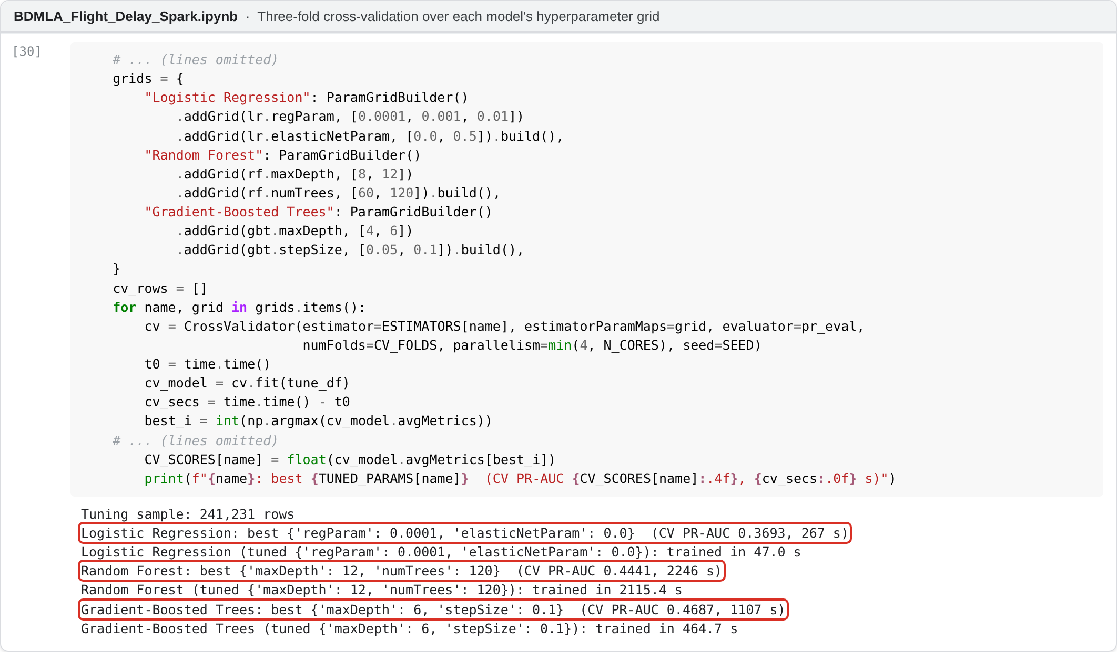
Screenshot 6. Three-fold cross-validation output: the selected settings and mean CV PR-AUC per model (notebook output).

6. Results
Table 3 shows the test-set results of the tuned models at the validation-tuned threshold.
Model | Accuracy | Precision | Recall | F1 | ROC-AUC | PR-AUC | Train (s)
Majority baseline | 77.70% | 0.000 | 0.000 | 0.000 | 0.500 | - | -
Logistic Regression | 0.624 | 0.325 | 0.638 | 0.431 | 0.676 | 0.368 | 47
Random Forest | 0.669 | 0.362 | 0.630 | 0.460 | 0.715 | 0.457 | 2115
Gradient-Boosted Trees | 0.710 | 0.400 | 0.598 | 0.479 | 0.735 | 0.482 | 465
Table 3. Test-set performance (delayed = positive class). Thresholds: LR 0.500, RF 0.500, GBT 0.525.
On the random test split, Gradient-Boosted Trees achieved the highest F1 and ROC-AUC; Logistic Regression was fastest and Random Forest slowest to train. Both tree models achieved higher ROC-AUC than Logistic Regression (0.676), which suggests that feature interactions help to predict delays. GBT beat Random Forest on every threshold-free metric in under a quarter of the training time. In practical terms, GBT identifies about 60% of delayed flights (recall 0.598), but with a precision of 0.400 roughly six in ten of its alerts are false alarms, and it misses about 40% of delays.
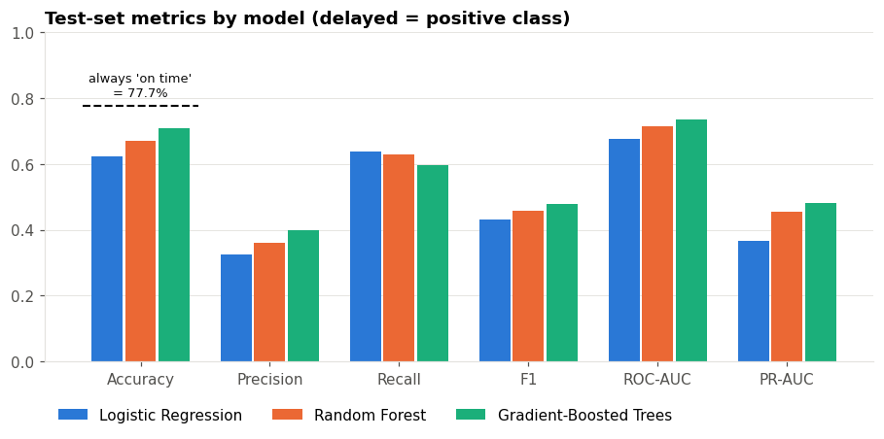
Figure 9. Test-set metrics for the three models; the dashed line is the majority-class accuracy.
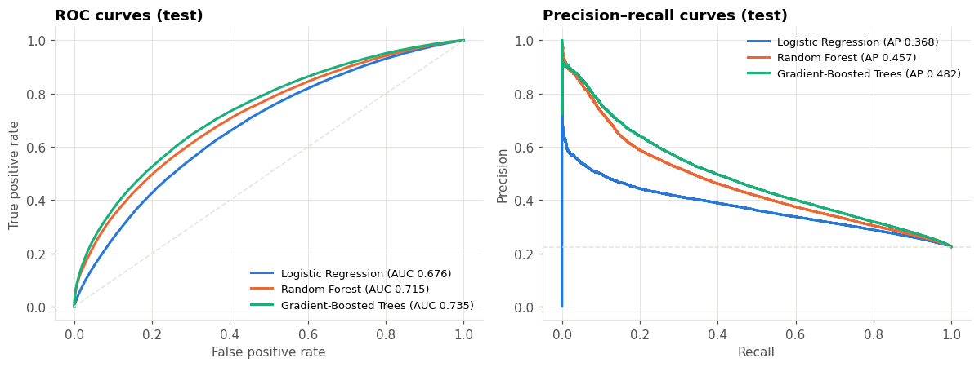
Figure 10. ROC and precision-recall curves on the test set.
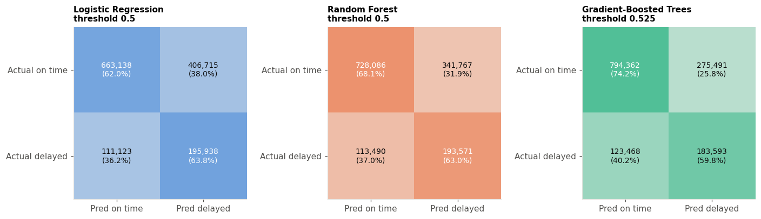
Figure 11. Confusion matrices at each model's validation-tuned threshold.
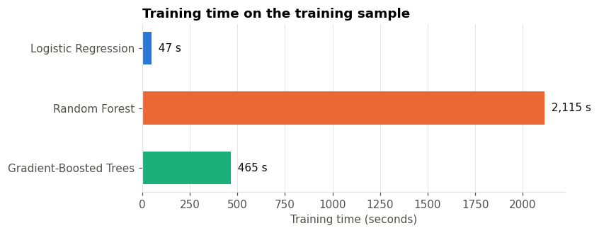
Figure 12. Training time on the training sample.
Figure 10 adds two details. The ROC curves never cross, so the ranking of the models holds at every threshold. The precision-recall curves show that for the riskiest 5 to 10% of flights the tree models are right 80 to 90% of the time, against about 55% for Logistic Regression, so a short high-risk list from GBT would be quite reliable. Figure 11 shows the cost of the chosen threshold: GBT flags about a third of all flights and raises about 1.5 false alarms for every delay it catches.
Table 4 shows what tuning added compared with each model's default settings. Only Random Forest improved, and it doubled its training time to do so, while tuned Random Forest still stayed behind default GBT. On this data the choice of algorithm mattered more than tuning.
Model | Default ROC-AUC | Tuned ROC-AUC | Default F1 | Tuned F1 | Train time (default → tuned)
Logistic Regression | 0.676 | 0.676 | 0.431 | 0.431 | 49 s → 47 s
Random Forest | 0.705 | 0.715 | 0.450 | 0.460 | 1077 s → 2115 s
Gradient-Boosted Trees | 0.735 | 0.735 | 0.479 | 0.479 | 443 s → 465 s
Table 4. Default versus tuned configurations on the test set (Section 13 of the notebook).
Figure 13 shows the most important features; in GBT the top three were DAY_OF_MONTH, DAYS_TO_HOLIDAY and SCHED_TURNAROUND_MIN. Because impurity importance can favour continuous features, I also ran a permutation test (Figure 14). It partly agrees: the origin-airport-by-hour delay rate (TE_ORIGIN_HOUR) and the scheduled turnaround matter most. Importance does not establish causation.
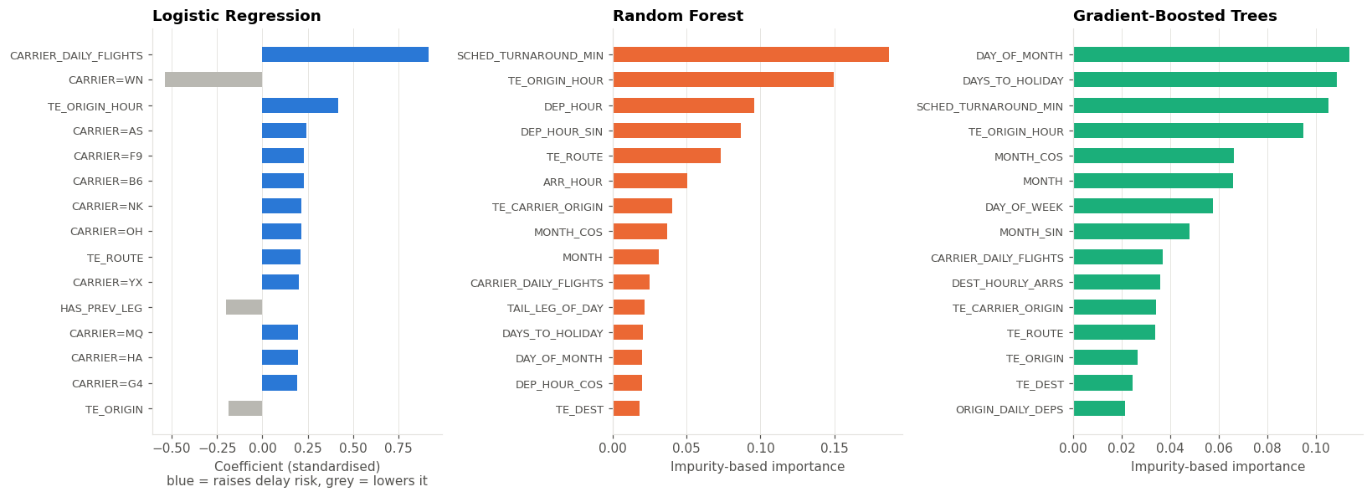
Figure 13. Top features: Logistic Regression coefficients (left), Random Forest and GBT importances.
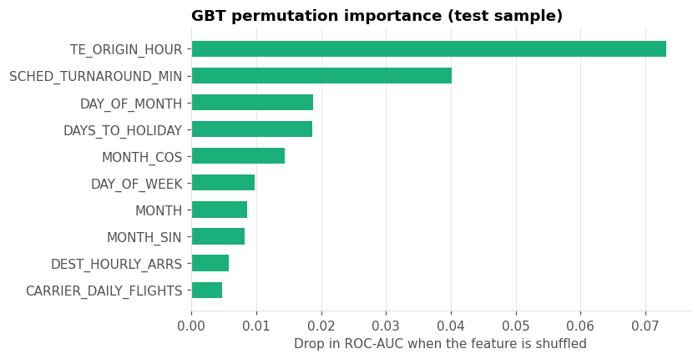
Figure 14. GBT permutation importance: drop in test ROC-AUC when each feature is shuffled.
Finally, Table 5 compares the random split with a stricter temporal split, where everything (including the target encoders) is refitted on January to September and tested on October to December. The decision thresholds were reused from the random-split validation set, which includes some October to December flights, so this test is not completely independent; selecting thresholds on September only would be cleaner.
Model | ROC-AUC random | ROC-AUC temporal | F1 random | F1 temporal
Logistic Regression | 0.676 | 0.603 | 0.431 | 0.130
Random Forest | 0.715 | 0.672 | 0.460 | 0.402
Gradient-Boosted Trees | 0.735 | 0.679 | 0.479 | 0.377
Table 5. Random versus temporal (train Jan to Sep, test Oct to Dec) evaluation.
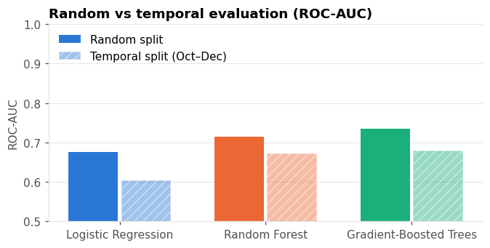
Figure 15. ROC-AUC on the random test split versus the temporal test (October to December).

7. Discussion
First, the baseline matters: doing nothing gives 77.70% accuracy, so F1, recall and PR-AUC are more informative. Second, the threshold is a business decision: spare-crew planning tolerates false alarms, while passenger alerts need precision.
I consider the temporal test (Table 5, Figure 15) more relevant to practical use because it evaluates the models on later months excluded from training. ROC-AUC fell to 0.679 for GBT and 0.672 for Random Forest, and Random Forest had the higher temporal F1 (0.402 against 0.377), so the preferred model depends on the metric and the setting. Logistic Regression collapsed (recall 0.079); seasonal change and the way its linear month terms extrapolate to unseen months are possible explanations, but an ablation test would be needed to confirm the cause. The high impurity importance of day-of-month and holiday distance suggests the trees partly learned specific bad days under the random split, which does not carry over.
Schedule-only prediction is possible but limited, because most delay causes (weather, air traffic control, knock-on delays) are invisible in the schedule.

7.1 Limitations
- No weather data. Weather is a known cause of delay, and earlier work found that adding it improves accuracy (Belcastro et al., 2016).
- Tail numbers record the aircraft that actually flew; same-day aircraft swaps may leak a little information into the rotation features.
- Rotation features rely on local scheduled times without a destination-origin check (Section 5.1).
- Temporal thresholds were chosen on a validation set that overlaps October to December.
- Target encoding and cross-validation: the encoders were fitted on the training split before cross-validation, so CV scores may be optimistic, and training rows use in-sample encodings. Out-of-fold encoding inside the CV pipeline would address both.
- Compute limits: a training sample, small tuning grids and 2 cores.
- One year of data, so year-to-year changes (new routes, fleet changes) are not tested.

7.2 What I learnt
The main things I learnt were about evaluation rather than algorithms. Accuracy was misleading on its own, since predicting "on time" for every flight beats every model on it. Leakage was harder to avoid than I expected: subtle issues, such as counting flights after removing cancellations or fitting encoders before cross-validation, only became clear on closer inspection. The temporal test changed my view of which model is best, and a stopped three-hour run and a Spark version difference in feature metadata taught me to checkpoint results and check outputs that look wrong.

8. Conclusions and Future Work
This project built a Spark pipeline over 7,001,619 flights from 2025 that excludes post-flight information. On the random split, Gradient-Boosted Trees performed best on F1 (0.479) and ROC-AUC; on later, unseen months Random Forest had the higher F1, so the choice of model depends on how it will be used. Parquet, broadcast joins and in-Spark evaluation made a full year workable on free Colab.
Before adding complexity, I would validate the existing method: use out-of-fold target encoding inside the CV pipeline, select temporal thresholds on an earlier month, audit the rotation features, and compare runs with and without class weights and threshold tuning. Only then would I add weather forecasts available at the prediction time and repeat the timing runs on a Dataproc cluster.

References
Armbrust, M., Xin, R. S., Lian, C., Huai, Y., Liu, D., Bradley, J. K., Meng, X., Kaftan, T., Franklin, M. J., Ghodsi, A., & Zaharia, M. (2015). Spark SQL: Relational data processing in Spark. In Proceedings of the 2015 ACM SIGMOD International Conference on Management of Data (pp. 1383–1394). https://doi.org/10.1145/2723372.2742797
Ball, M., Barnhart, C., Dresner, M., Hansen, M., Neels, K., Odoni, A., Peterson, E., Sherry, L., Trani, A., & Zou, B. (2010). Total delay impact study: A comprehensive assessment of the costs and impacts of flight delay in the United States. NEXTOR.
Belcastro, L., Marozzo, F., Talia, D., & Trunfio, P. (2016). Using scalable data mining for predicting flight delays. ACM Transactions on Intelligent Systems and Technology, 8(1), Article 5. https://doi.org/10.1145/2888402
Breiman, L. (2001). Random forests. Machine Learning, 45(1), 5–32. https://doi.org/10.1023/A:1010933404324
Bureau of Transportation Statistics. (2026). Reporting carrier on-time performance (1987–present) [Data set]. U.S. Department of Transportation. https://www.transtats.bts.gov/DL_SelectFields.aspx?gnoyr_VQ=FGJ
Chen, T., & Guestrin, C. (2016). XGBoost: A scalable tree boosting system. In Proceedings of the 22nd ACM SIGKDD International Conference on Knowledge Discovery and Data Mining (pp. 785–794). https://doi.org/10.1145/2939672.2939785
Friedman, J. H. (2001). Greedy function approximation: A gradient boosting machine. The Annals of Statistics, 29(5), 1189–1232. https://doi.org/10.1214/aos/1013203451
Gui, G., Liu, F., Sun, J., Yang, J., Zhou, Z., & Zhao, D. (2020). Flight delay prediction based on aviation big data and machine learning. IEEE Transactions on Vehicular Technology, 69(1), 140–150. https://doi.org/10.1109/TVT.2019.2954094
He, H., & Garcia, E. A. (2009). Learning from imbalanced data. IEEE Transactions on Knowledge and Data Engineering, 21(9), 1263–1284. https://doi.org/10.1109/TKDE.2008.239
Kaufman, S., Rosset, S., Perlich, C., & Stitelman, O. (2012). Leakage in data mining: Formulation, detection, and avoidance. ACM Transactions on Knowledge Discovery from Data, 6(4), Article 15. https://doi.org/10.1145/2382577.2382579
Meng, X., Bradley, J., Yavuz, B., Sparks, E., Venkataraman, S., Liu, D., Freeman, J., Tsai, D. B., Amde, M., Owen, S., Xin, D., Xin, R., Franklin, M. J., Zadeh, R., Zaharia, M., & Talwalkar, A. (2016). MLlib: Machine learning in Apache Spark. Journal of Machine Learning Research, 17(34), 1–7.
Micci-Barreca, D. (2001). A preprocessing scheme for high-cardinality categorical attributes in classification and prediction problems. ACM SIGKDD Explorations Newsletter, 3(1), 27–32. https://doi.org/10.1145/507533.507538
Rebollo, J. J., & Balakrishnan, H. (2014). Characterization and prediction of air traffic delays. Transportation Research Part C: Emerging Technologies, 44, 231–241. https://doi.org/10.1016/j.trc.2014.04.007
Saito, T., & Rehmsmeier, M. (2015). The precision-recall plot is more informative than the ROC plot when evaluating binary classifiers on imbalanced datasets. PLoS ONE, 10(3), e0118432. https://doi.org/10.1371/journal.pone.0118432
Sternberg, A., Soares, J., Carvalho, D., & Ogasawara, E. (2017). A review on flight delay prediction (arXiv:1703.06118). arXiv. https://doi.org/10.48550/arXiv.1703.06118
Zaharia, M., Xin, R. S., Wendell, P., Das, T., Armbrust, M., Dave, A., Meng, X., Rosen, J., Venkataraman, S., Franklin, M. J., Ghodsi, A., Gonzalez, J., Shenker, S., & Stoica, I. (2016). Apache Spark: A unified engine for big data processing. Communications of the ACM, 59(11), 56–65. https://doi.org/10.1145/2934664

Appendix A. Notebook structure and reproduction
The full source code is the Colab notebook BDMLA_Flight_Delay_Spark.ipynb in the submitted .zip file. To reproduce: place the twelve CSV files in MyDrive/BDMLA/FlightDelay2025/, open the notebook in Colab and choose Runtime → Run all. All figures, tables, saved models and the values used in this report are written to MyDrive/BDMLA/FlightDelay2025_outputs/.
Section | What it does
1–3 | Environment (Java, PySpark), Drive mount, configuration, SparkSession tuning
4 | Read 12 CSVs, header normalisation, column allow-list, unionByName, CSV → Parquet checkpoint, CSV vs Parquet benchmark
5–7 | Data-quality profile, schedule features on full schedule (window functions), cleaning funnel, label creation
8 | Exploratory analysis (Figures 1–4 and supporting tables)
9–11 | 70/10/20 split, smoothed target encoding (train only), feature pipeline, class weights
12–13 | Evaluation helpers, majority baseline, Logistic Regression, Random Forest, GBT, 3-fold CrossValidator
14–15 | Model comparison charts, ROC/PR curves, confusion matrices, threshold tuning, feature and permutation importance
16–18 | Temporal hold-out (Jan–Sep → Oct–Dec), export of results and models, 1-core vs N-core scaling experiment
Table A1. Notebook sections.

Appendix B. Feature dictionary
Feature | Type | Definition (from the published schedule)
MONTH, DAY_OF_MONTH, DAY_OF_WEEK, IS_WEEKEND | numeric | Calendar fields of the scheduled flight date
MONTH_SIN/COS, DEP_HOUR_SIN/COS | numeric | Cyclical encodings of month and scheduled departure time
DEP_HOUR, ARR_HOUR | numeric | Scheduled departure / arrival hour (local)
CRS_ELAPSED_TIME, DISTANCE | numeric | Scheduled block time (min) and great-circle distance (miles)
DAYS_TO_HOLIDAY | numeric | Days to the nearest U.S. federal holiday
ORIGIN_HOURLY_DEPS, DEST_HOURLY_ARRS | numeric | Scheduled departures (arrivals) at the airport in the same hour, incl. later-cancelled flights
ORIGIN_DAILY_DEPS, CARRIER_DAILY_FLIGHTS | numeric | Scheduled daily volume at the origin and for the carrier
TAIL_LEG_OF_DAY, SCHED_TURNAROUND_MIN, HAS_PREV_LEG | numeric | Aircraft rotation: leg number of the day, scheduled minutes since the previous leg's scheduled arrival (capped at 720)
TE_ORIGIN, TE_DEST, TE_ROUTE, TE_ORIGIN_HOUR, TE_CARRIER_ORIGIN | numeric | Smoothed training-set delay rate of the category (m = 100)
CARRIER=… | one-hot | Reporting airline
Table B1. Features used by all three models.

Appendix C. Excluded (leakage) columns
Never loaded into the feature set: ARR_DELAY (label source only), ARR_DELAY_NEW, ARR_DEL15, ARR_TIME, ACTUAL_ELAPSED_TIME, AIR_TIME, WHEELS_ON, WHEELS_OFF, TAXI_IN, TAXI_OUT, DEP_TIME, DEP_DELAY, DEP_DELAY_NEW, DEP_DEL15, CARRIER_DELAY, WEATHER_DELAY, NAS_DELAY, SECURITY_DELAY, LATE_AIRCRAFT_DELAY, CANCELLATION_CODE.

