Team name: 3 guys and a girl

Idea:

App.name: The Hungry Spectator- search events and link restaurants, weather and maps

SeatGeek, Zamato, GoogleMaps, OpenWeather

Description:

Go a page, search for concert/event in area. Googles maps to locate where the event is at. Zamato locate restaurants, OpenWeather find weather for day of event.

Sketch of project----

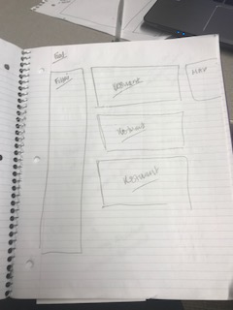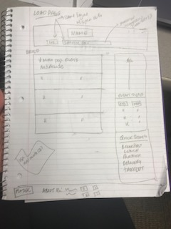

Rough breakdown of tasks:

Project Lead: Denise Erazmus

* UI – Denise and Kalpesh- IDs, Classes etc using bootstrap
* Backend- API call, trigger events, handle responses ( will get specific once UI is created)
* Documentation- API, coding standard and design documentation