Session 07(AIML) -Assignment Questions

NAME: sakshi ganesh tipale.
Domain: Artifical Intelligence And Machine Learning.
Collage and Branch: Zeal Polytechnic Pune(AIML).

Q1: Creating Tuples)
Write a program to create tuples using different methods:
a) A tuple with 5 numbers using parentheses.
b) A mixed tuple containing integer, string, float, and boolean.
c) An empty tuple using two different ways.
d) A single-element tuple with the value 99.
Print all tuples and their types. Add comments explaining the rules for single-
element tuples.
ANS:
# a) Tuple with 5 numbers using parentheses
numbers = (10, 20, 30, 40, 50)

# b) Mixed tuple containing different data types
mixed = (101, "Python", 3.14, True)

# c) Empty tuple using two different ways
empty1 = ()
empty2 = tuple()

# d) Single-element tuple
single = (99,) # Comma is mandatory

# Printing tuples and their types
print("Numbers Tuple:", numbers)
print("Type:", type(numbers))

print("\nMixed Tuple:", mixed)
print("Type:", type(mixed))

print("\nEmpty Tuple 1:", empty1)
print("Type:", type(empty1))

print("\nEmpty Tuple 2:", empty2)
print("Type:", type(empty2))

print("\nSingle Element Tuple:", single)
print("Type:", type(single))

# Note:
# (99) is treated as an integer.
# (99,) is treated as a tuple because of the comma.
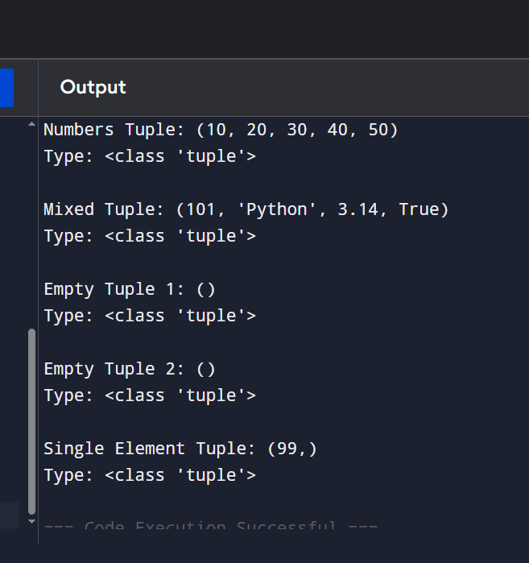

Q2: (Tuple Packing)
Create a tuple without using parentheses (tuple packing) to store: your name, age, and city.
Print the tuple and its type.
Then unpack the tuple into three separate variables and print them individually.
ANS:
# Tuple Packing (without parentheses)
person = "Sakshi", 20, "Nagpur"

print("Tuple:", person)
print("Type:", type(person))

# Tuple Unpacking
name, age, city = person

print("\nName:", name)
print("Age:", age)
print("City:", city)

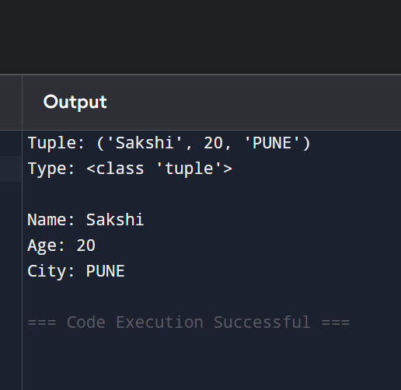

Q3: Indexing and Negative Indexing)
Create the tuple: colors = ('red', 'green', 'blue', 'yellow', 'purple', 'orange') Print:
First element
Third element
Last element (using negative index)
Second last element (using negative index)
Take an index number as input from the user and print the element at that index.
ANS:
colors = ('red', 'green', 'blue', 'yellow', 'purple', 'orange')

# Accessing elements
print("First element:", colors[0])
print("Third element:", colors[2])
print("Last element:", colors[-1])
print("Second last element:", colors[-2])

# User input
index = int(input("Enter an index number: "))

if -len(colors) <= index < len(colors):
print("Element at index", index, "is", colors[index])
else:
print("Invalid Index")

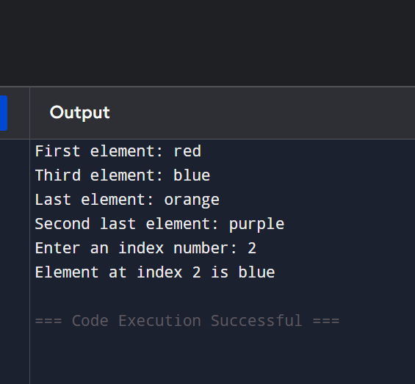

Q4: Slicing Tuples)
Given the tuple: numbers = (0, 1, 2, 3, 4, 5, 6, 7, 8, 9, 10)
Using slicing, print:
a) Elements from index 2 to 7
b) First 5 elements
c) Last 4 elements
d) Every second element
e) The entire tuple in reverse order
Add comments explaining the slicing syntax.
ANS:
# Tuple
numbers = (0, 1, 2, 3, 4, 5, 6, 7, 8, 9, 10)

# Slicing Syntax:
# tuple[start : stop : step]
# start -> starting index (included)
# stop -> ending index (excluded)
# step -> increment/decrement value

# a) Elements from index 2 to 7
print("Elements from index 2 to 7:", numbers[2:8])

# b) First 5 elements
print("First 5 elements:", numbers[:5])

# c) Last 4 elements
print("Last 4 elements:", numbers[-4:])

# d) Every second element
print("Every second element:", numbers[::2])

# e) Entire tuple in reverse order
print("Tuple in reverse order:", numbers[::-1])

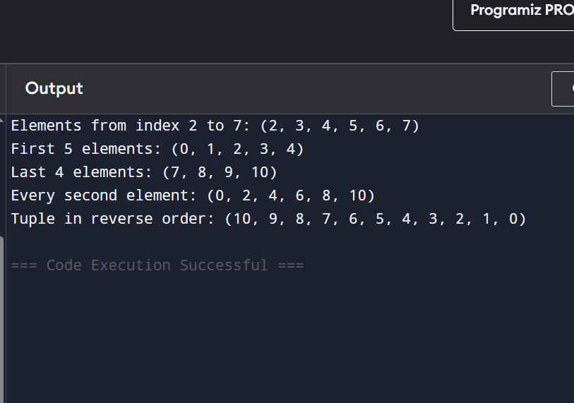

Q5: Nested Tuples)
Create a nested tuple to represent a 3x3 matrix:
matrix ((1, 2, 3), (4, 5, 6), (7, 8, 9))
Print:
The first row
The element at second row, third column
The element at third row, first column.
ANS:
# Creating a nested tuple (3x3 matrix)
matrix = (
(1, 2, 3),
(4, 5, 6),
(7, 8, 9)
)

# Printing required elements
print("First row:", matrix[0])

print("Element at second row, third column:",
matrix[1][2])

print("Element at third row, first column:",
matrix[2][0])

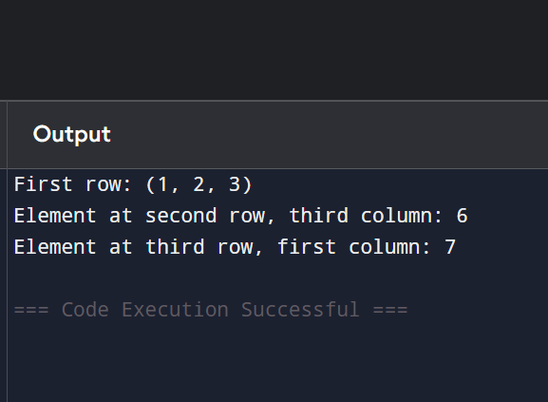

Q6: Iterating and Unpacking)
Create a tuple: student = ('Rahul', 20, 'Computer Science', 'A')
a) Iterate through the tuple using a for loop and print each item.
b) Unpack the tuple into four variables (name, age, branch, grade) and print them with descriptive messages.
ANS:

# Creating a tuple
student = ('Rahul', 20, 'Computer Science', 'A')

# a) Iterating through the tuple
print("Tuple Elements:")
for item in student:
print(item)

# b) Unpacking the tuple
name, age, branch, grade = student

print("\nStudent Details:")
print("Name:", name)
print("Age:", age)
print("Branch:", branch)
print("Grade:", grade)
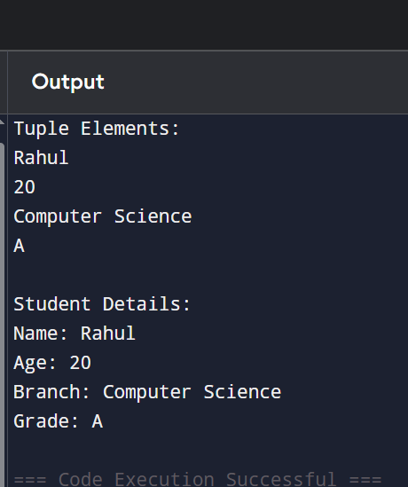

Q7: (count() Method)
Create the tuple: grades = ('A', 'B', 'A', 'C', 'A', 'B', 'D', 'A', 'B')
Count and print how many times 'A' appears.
Count and print how many times 'B' appears.
Take a grade as input from the user and print how many times it appears.
ANS:
# Creating a tuple
grades = ('A', 'B', 'A', 'C', 'A', 'B', 'D', 'A', 'B')

# Counting occurrences
print("Number of A grades:", grades.count('A'))
print("Number of B grades:", grades.count('B'))

# User input
grade = input("Enter a grade: ")

print("Occurrences of", grade, ":", grades.count(grade))

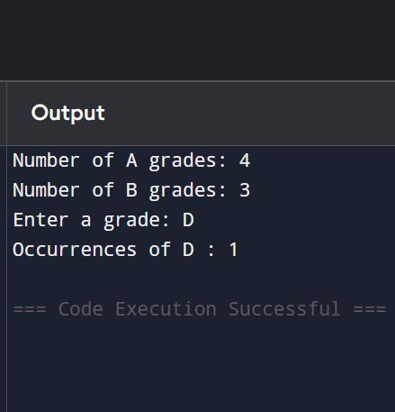

Q8: . (index() Method)
Create the tuple: fruits = ('apple', 'banana', 'cherry', 'banana', 'mango', 'apple')
Find and print the first index of 'banana'.
Find and print the first index of 'banana' starting the search from index 2.
Use try-except to safely find the index of 'kiwi' and print "Not found" if it doesn't exist.
ANS:
# Creating a tuple
fruits = ('apple', 'banana', 'cherry', 'banana', 'mango', 'apple')

# First index of banana
print("First index of banana:", fruits.index('banana'))

# First index of banana starting from index 2
print("Banana found from index 2:", fruits.index('banana', 2))

# Using try-except for kiwi
try:
print("Index of kiwi:", fruits.index('kiwi'))
except ValueError:
print("Not found")

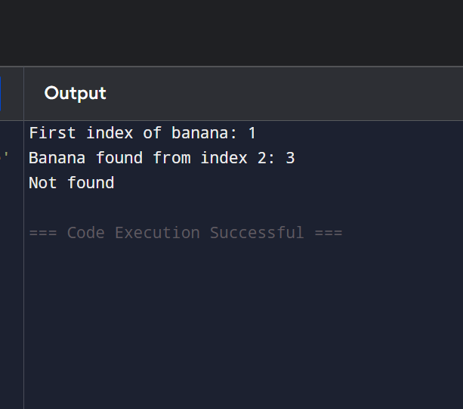
Q9: Immutability of Tuples)
Create a tuple: coordinates = (10, 20)
Demonstrate that tuples are immutable by trying to:
Change the first element
Add a new element using append()
Explain what errors occur (in comments). Then show the correct way to modify data by converting the tuple to a list, making changes, and converting back to a tuple.
ANS:
# Creating a tuple
coordinates = (10, 20)

print("Original Tuple:", coordinates)

# Tuples are immutable

# coordinates[0] = 100
# Error:
# TypeError: 'tuple' object does not support item assignment

# coordinates.append(30)
# Error:
# AttributeError: 'tuple' object has no attribute 'append'

# Correct way:
# Convert tuple to list
temp = list(coordinates)

# Make changes
temp[0] = 100
temp.append(30)

# Convert back to tuple
coordinates = tuple(temp)

print("Modified Tuple:", coordinates

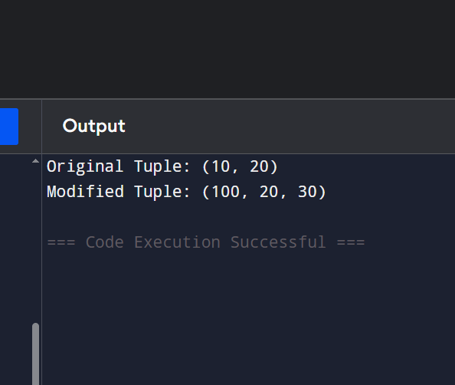

Q10: Mini Project - Combined Concepts) Create a Student Record Program using tuples:
Take input for name, roll number, 3 subject marks.
Store all information in a tuple (use packing).
Print the complete record.
Unpack the tuple and print each value with proper labels.
Use count() to check how many times a particular mark appears (if any).
Create a nested tuple to store multiple student records (at least 2 students)
and access specific values.
Add meaningful comments and use proper formatting
ANS:
# Taking input from user
name = input("Enter Student Name: ")
roll_no = int(input("Enter Roll Number: "))

mark1 = int(input("Enter Marks of Subject 1: "))
mark2 = int(input("Enter Marks of Subject 2: "))
mark3 = int(input("Enter Marks of Subject 3: "))

# Tuple Packing
student = (name, roll_no, mark1, mark2, mark3)

# Display complete record
print("\nStudent Record:")
print(student)

# Tuple Unpacking
name, roll_no, mark1, mark2, mark3 = student

print("\nStudent Details")
print("Name :", name)
print("Roll Number:", roll_no)
print("Mark 1 :", mark1)
print("Mark 2 :", mark2)
print("Mark 3 :", mark3)

# Using count()
search_mark = int(input("\nEnter a mark to count: "))
print("Occurrences:", student.count(search_mark))

# Nested Tuple containing multiple student records
student1 = ("Rahul", 101, 80, 75, 90)
student2 = ("Priya", 102, 85, 88, 92)

records = (student1, student2)

print("\nAll Student Records:")
print(records)

# Accessing specific values
print("\nFirst Student Name:", records[0][0])
print("Second Student Roll Number:", records[1][1])
print("Second Student Third Subject Marks:", records[1][4])

