Session 05 (AIML) -Assignment Questions

NAME: sakshi ganesh tipale.
Domain: Artifical Intelligence And Machine Learning.
Collage and Branch: Zeal Polytechnic Pune(AIML).

Q1: (String Indexing)
Write a program that takes a string input from the user. Print:
The first character
The last character (using negative index)
The 3rd character from the start
The 2nd character from the end
Add comments explaining positive and negative indexing.
ANS:
# Positive indexing starts from 0 (left to right)
# Negative indexing starts from -1 (right to left)

text = input("Enter a string: ")

print("First character:", text[0])
print("Last character:", text[-1])
print("3rd character from start:", text[2])
print("2nd character from end:", text[-2])
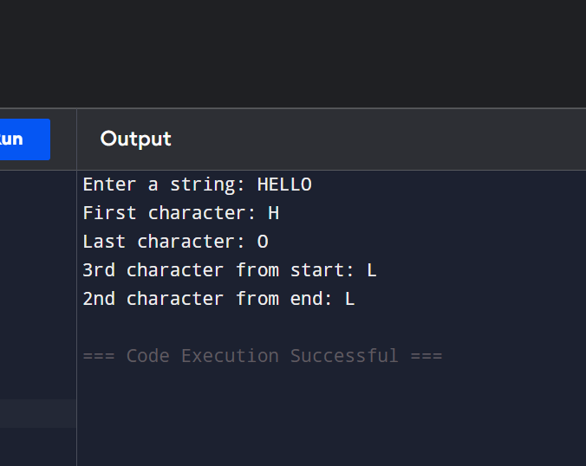

Q2: (String Slicing)
Take a string input from the user.
Using slicing, print:
a) The first 5 characters
b) The last 4 characters
c) The string in reverse order
d) Every 2nd character of the string
Include comments explaining the slicing syntax [start:end:step].
ANS: # Slicing syntax: string[start:end:step]

text = input("Enter a string: ")

print("First 5 characters:", text[:5])
print("Last 4 characters:", text[-4:])
print("Reverse string:", text[::-1])
print("Every 2nd character:", text[::2])
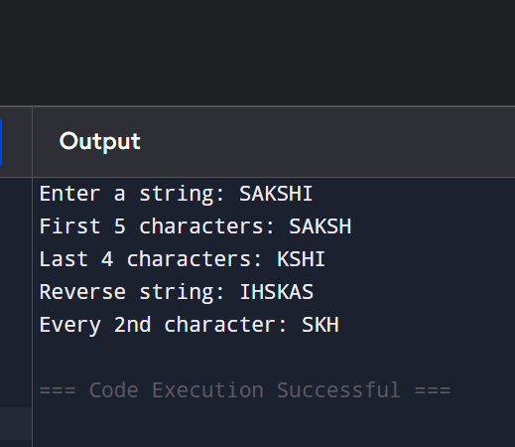

Q3: String Membership)
Write a program that:
Takes a main string and a substring as input from the user.
Checks whether the substring is present in the main string using in and not in.
Prints appropriate messages (e.g., "Substring found!" or "Substring not found!").
Note that it is case-sensitive.
ANS:
main_string = input("Enter main string: ")
substring = input("Enter substring: ")

if substring in main_string:
print("Substring found!")
else:
print("Substring not found!")

if substring not in main_string:
print("Substring is not present.")
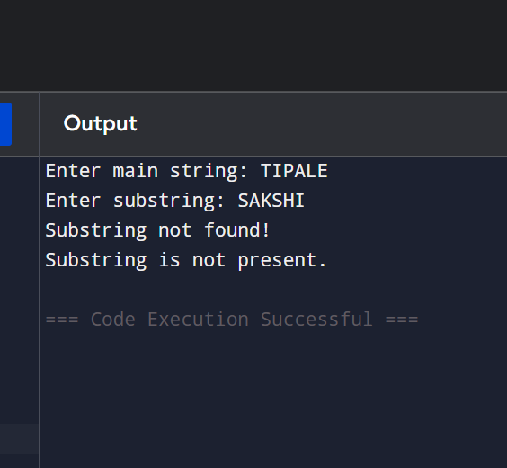

Q4: len() Function)
Write a program that:
Takes a string as input.
Prints the length of the string using len().
Prints the last character using len() (without using negative index).
Prints the middle character if the length is odd.
Add comments on common mistakes with len().
ANS:
# len() gives total number of characters
# Common mistake: Last index is len(string)-1

text = input("Enter a string: ")

length = len(text)

print("Length of string:", length)
print("Last character:", text[length - 1])

if length % 2 != 0:
middle = length // 2
print("Middle character:", text[middle])
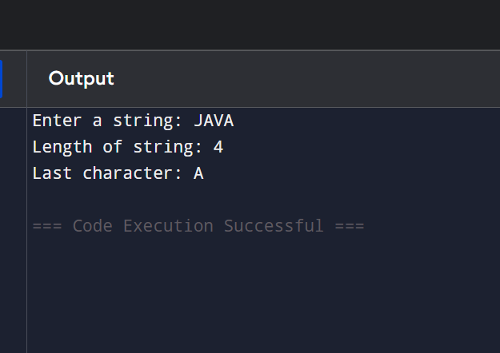

Q5: range() Basic Forms)
Write a program using for loop and range() to:
a) Print numbers from 0 to 10.
b) Print numbers from 5 to 15.
c) Print odd numbers from 1 to 21.
Explain the three forms of range() in comments.
ANS:
# range(stop)
# range(start, stop)
# range(start, stop, step)

print("Numbers from 0 to 10:")
for i in range(11):
print(i)

print("\nNumbers from 5 to 15:")
for i in range(5, 16):
print(i)

print("\nOdd numbers from 1 to 21:")
for i in range(1, 22, 2):
print(i)
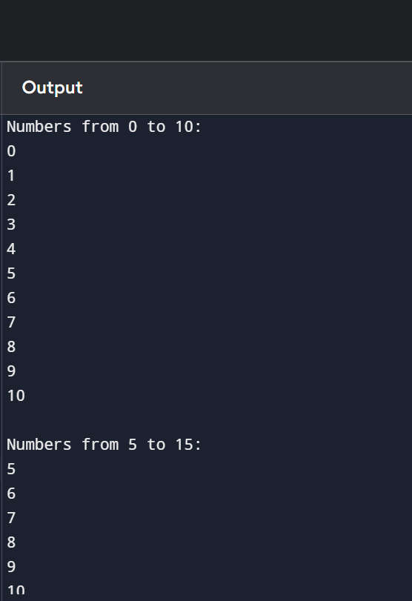

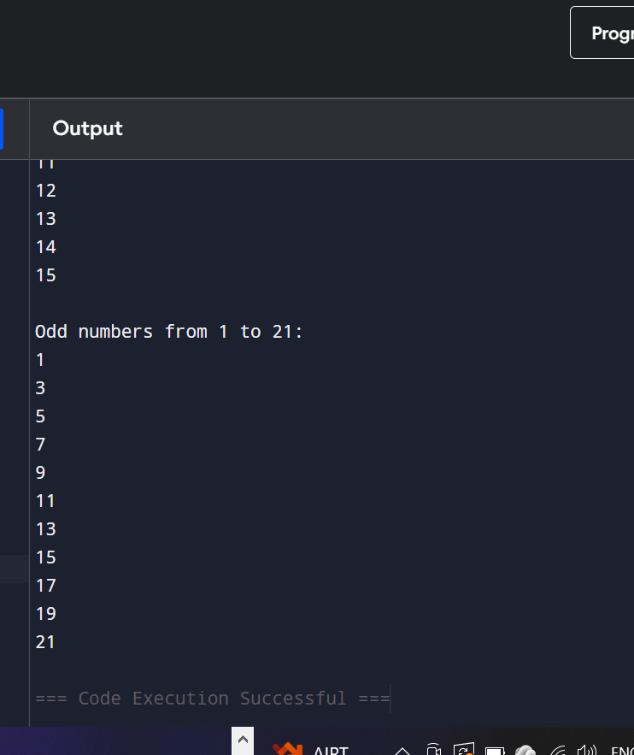

Q6: range() with Negative Step)
Use range() to print:
Numbers from 20 down to 10 (decreasing).
Numbers from 15 down to 1 in steps of 2.
Print each sequence on a new line with proper messages.
ANS:
# Numbers from 20 down to 10

print("Numbers from 20 to 10:")
for i in range(20, 9, -1):
print(i, end=" ")

print("\n")

# Numbers from 15 down to 1 in steps of 2

print("Numbers from 15 to 1 in steps of 2:")
for i in range(15, 0, -2):
print(i, end=" ")
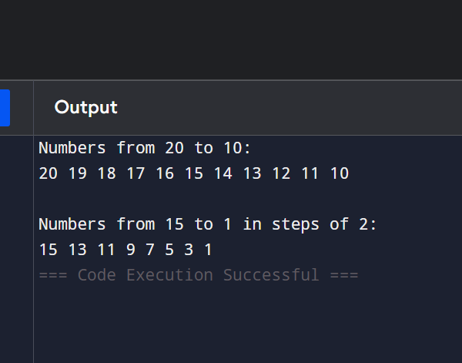

Q7: Combined: Strings + range())
Write a program that takes a string from the user.
Using a for loop and range() with len(), print:
Each character of the string one by one (with its index).
The string in reverse order using negative step in range().
ANS:
text = input("Enter a string: ")

print("Characters with index:")

for i in range(len(text)):
print(i, ":", text[i])

print("\nString in reverse order:")

for i in range(len(text)-1, -1, -1):
print(text[i], end="")
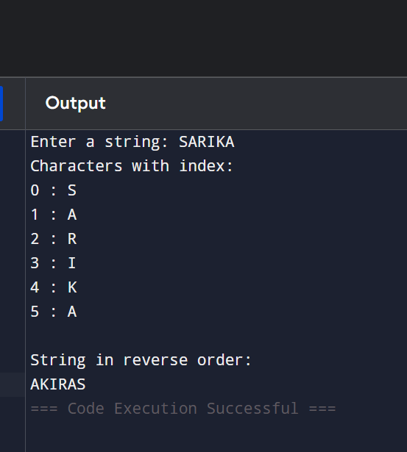

Q8: Membership with range())
Write a program that:
Takes a number as input from the user.
Checks if the number is present in range(1, 51) and in range(10, 100, 5).
Session 05 (AMI)-Assignment Questions
Prints clear messages for each check.
ANS:
num = int(input("Enter a number: "))

if num in range(1, 51):
print("Number is present in range(1, 51)")
else:
print("Number is NOT present in range(1, 51)")

if num in range(10, 100, 5):
print("Number is present in range(10, 100, 5)")
else:
print("Number is NOT present in range(10, 100, 5)")
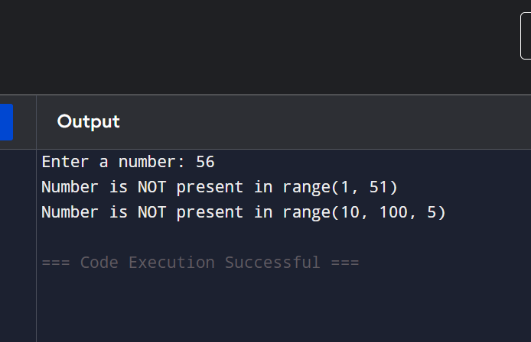

Q9: Slicing + range())
Write a program that prints the following using range() and string slicing concepts where applicable:
First 10 even numbers (2 to 20).
Numbers from 1 to 30 in steps of 3.
A string "PythonProgramming" sliced to show "Python", "Programming", and the reverse.
ANS:
# First 10 even numbers
print("First 10 even numbers:")
for i in range(2, 21, 2):
print(i, end=" ")

print("\n")
# Numbers from 1 to 30 in steps of 3

print("Numbers from 1 to 30 in steps of 3:")
for i in range(1, 31, 3):
print(i, end=" ")

print("\n")
# String slicing

text = "PythonProgramming"

print("Python :", text[:6])
print("Programming :", text[6:])
print("Reverse :", text[::-1])
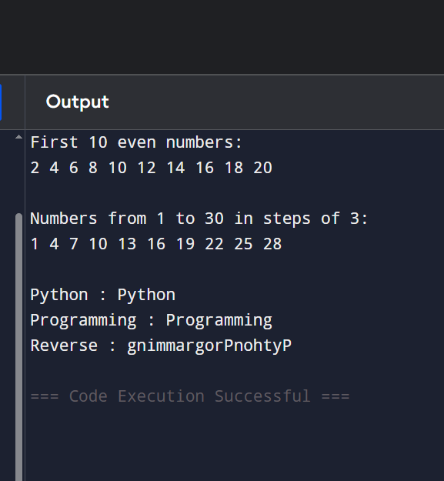
Q10: Mini Project - Combined)
Create a String Analyzer program:
Take a string input from the user.
Using functions or directly:
1. Print length of the string.
2. Print first half and second half using slicing.
3. Check if the word "python" (case insensitive you may convert) is present.
4. Use range() to print all characters with their positive and negative indices.
Add proper comments and use meaningful variable names.
ANS:
# String Analyzer Program

text = input("Enter a string: ")

# Length of string
print("Length:", len(text))

# First half and second half
mid = len(text) // 2

print("First Half:", text[:mid])
print("Second Half:", text[mid:])

# Check for "python" (case-insensitive)
if "python" in text.lower():
print("The word 'python' is present.")
else:
print("The word 'python' is not present.")

# Characters with positive and negative indices
print("\nCharacter Positions:")

for i in range(len(text)):
negative_index = i - len(text)
print("Positive Index:", i,
"Negative Index:", negative_index,
"Character:", text[i])
