Session 06 (AIML) -Assignment Questions

NAME: sakshi ganesh tipale.
Domain: Artifical Intelligence And Machine Learning.
Collage and Branch: Zeal Polytechnic Pune(AIML).

Q1: Creating Lists)
Write a program to create the following lists using different methods:
a) A list of 5 integers directly.
b) An empty list using both [] and list().
c) A list containing mixed data types (int, string, float, boolean).
d) A list of 7 zeros using repetition (*).
Print all lists with clear labels and add comments explaining each creation method.
ANS:
# a) List of 5 integers directly
numbers = [10, 20, 30, 40, 50]

# b) Empty lists using [] and list()
empty_list1 = []
empty_list2 = list()

# c) List with mixed data types
mixed_list = [100, "Python", 45.5, True]

# d) List of 7 zeros using repetition (*)
zeros_list = [0] * 7

# Printing all lists
print("List of Integers:", numbers)
print("Empty List using []:", empty_list1)
print("Empty List using list():", empty_list2)
print("Mixed Data Type List:", mixed_list)
print("List of 7 Zeros:", zeros_list)
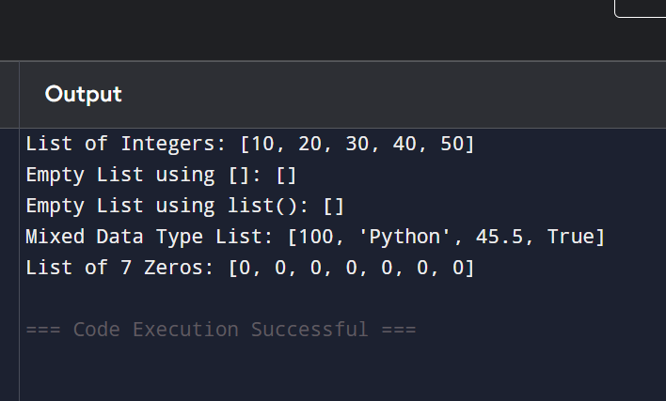

Q2: Indexing and Negative Indexing)
Create a list: fruits = ["apple", "banana", "mango", "orange", "grape"]
Write code to print:
First item
Third item
Last item (using negative index)
Second last item (using negative index)
Take a number as input from the user and print the item at that index (handle basic cases only).
ANS:
fruits = ["apple", "banana", "mango", "orange", "grape"]

print("First item:", fruits[0])
print("Third item:", fruits[2])
print("Last item:", fruits[-1])
print("Second last item:", fruits[-2])

index = int(input("Enter index number: "))
print("Item at index", index, "is", fruits[index])
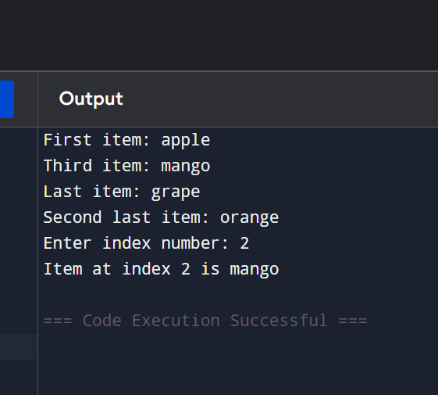

Q3: (Slicing Lists)
Given the list: numbers = [10, 20, 30, 40, 50, 60, 70, 80, 90, 100] Using slicing, print:
a) First 4 elements
b) Last 3 elements
c) Elements from index 2 to 7
d) Every second element
e) The entire list in reverse order
ANS:
numbers = [10, 20, 30, 40, 50, 60, 70, 80, 90, 100]

# First 4 elements
print("First 4 elements:", numbers[:4])

# Last 3 elements
print("Last 3 elements:", numbers[-3:])

# Elements from index 2 to 7
print("Index 2 to 7:", numbers[2:8])

# Every second element
print("Every second element:", numbers[::2])

# Reverse list
print("Reverse list:", numbers[::-1])

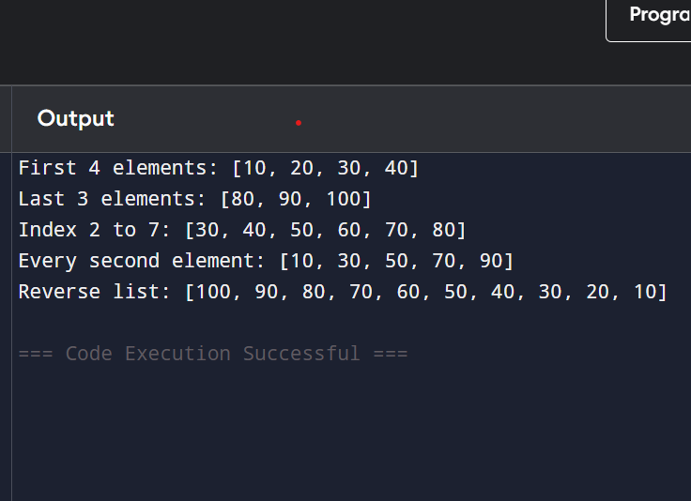

Q4:(Modifying Lists)
Create a list: colors = ["red", "blue", "green", "yellow"]
Perform the following:
Change "blue" to "purple" using indexing.
Change the last item to "black".
Print the list after each change.
ANS:
colors = ["red", "blue", "green", "yellow"]

# Change blue to purple
colors[1] = "purple"
print("After changing blue to purple:", colors)

# Change last item to black
colors[-1] = "black"
print("After changing last item to black:", colors)
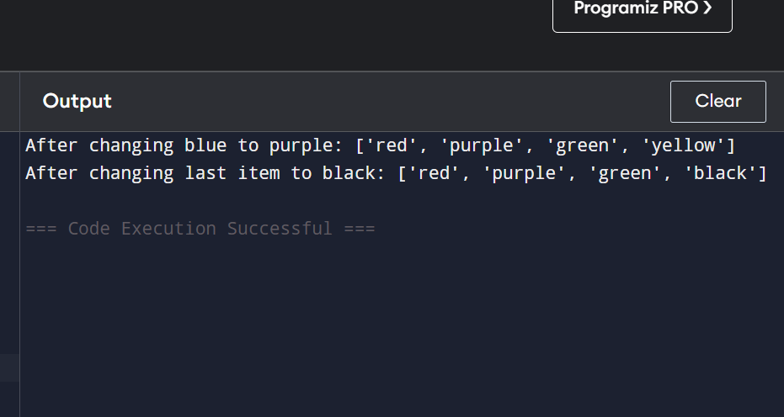

Q5: append() and insert())
Write a program that starts with an empty list.
Use append() to add 5 different city names one by one.
Use insert() to add one more city at position 2.
Print the final list.
Take user input for at least 2 cities.
ANS: cities = []

# Taking user input
city1 = input("Enter city 1: ")
city2 = input("Enter city 2: ")

cities.append(city1)
cities.append(city2)

# Adding more cities
cities.append("Mumbai")
cities.append("Pune")
cities.append("Nashik")

# Insert city at position 2
cities.insert(2, "Nagpur")

print("Final City List:", cities)
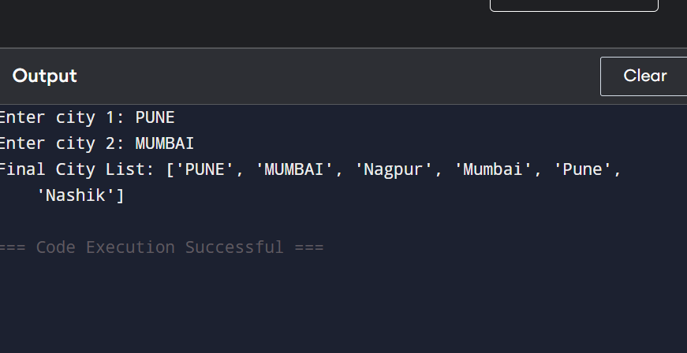

Q6: remove(), pop(), and clear())
Create a list: items = [10, 20, 30, 20, 40, 50]
Perform and print after each operation:
a) Remove the first occurrence of 20 using remove().
b) Remove the item at index 3 using pop() and print the removed value.
c) Remove the last item using pop().
d) Clear the entire list using clear()..
Add comments explaining the difference between remove() and pop().
ANS:
items = [10, 20, 30, 20, 40, 50]

# a) Remove first occurrence of 20
items.remove(20)
print("After remove(20):", items)

# b) Remove item at index 3
removed_item = items.pop(3)
print("Removed item:", removed_item)
print("After pop(3):", items)

# c) Remove last item
last_item = items.pop()
print("Removed last item:", last_item)
print("After pop():", items)

# d) Clear list
items.clear()
print("After clear():", items)

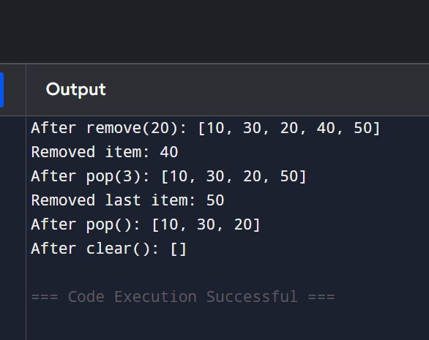

Q7: index() and count())
Create a list: scores = [85, 92, 78, 92, 65, 92, 88]
Find and print the index of the first occurrence of 92.
Count and print how many times 92 appears.
Take a number as input from the user and check if it exists in the list. If yes, print its index and count.
ANS: # Create the list
scores = [85, 92, 78, 92, 65, 92, 88]

# Find index of first occurrence of 92
print("First index of 92:", scores.index(92))

# Count occurrences of 92
print("Count of 92:", scores.count(92))

# Take input from user
num = int(input("Enter a number to search: "))

if num in scores:
print(num, "exists in the list.")
print("First Index:", scores.index(num))
print("Count:", scores.count(num))
else:
print(num, "does not exist in the list.")
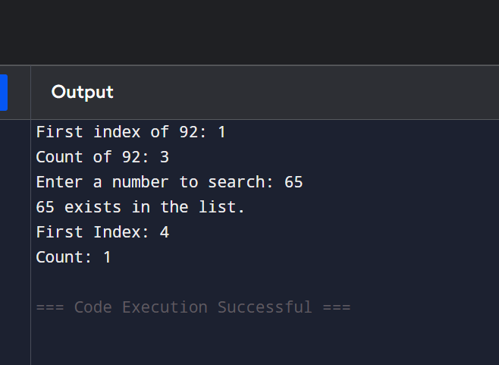

Q8: sort() and reverse())
Create a list: marks = [45, 78, 65, 90, 34, 82, 71]
Session 06 (AML) Assignment Questions
Sort the list in ascending order and print it.
Sort the list in descending order and print it.
Reverse the original list (without sorting) and print it.
Add comments on the difference between sort() and reverse().
ANS: # Create the list
marks = [45, 78, 65, 90, 34, 82, 71]

# Sort in ascending order
ascending_marks = marks.copy()
ascending_marks.sort()
print("Ascending Order:", ascending_marks)

# Sort in descending order
descending_marks = marks.copy()
descending_marks.sort(reverse=True)
print("Descending Order:", descending_marks)

# Reverse original list without sorting
reversed_marks = marks.copy()
reversed_marks.reverse()
print("Reversed Original List:", reversed_marks)

# Difference:
# sort() arranges elements in order.
# reverse() only changes the current order of elements.

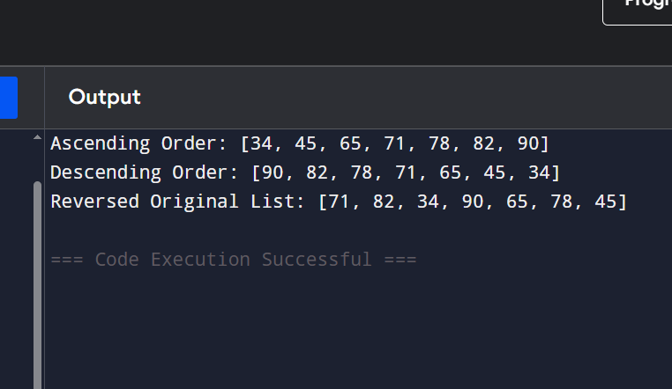

Q9: extend() vs append())
Create two lists: list1 = [1, 2, 3] list2 = [4, 5, 6]
Demonstrate:
a) Using extend() to add list2 to list1.
b) Using append() to add list2 to a copy of list1.
Print both results and explain the difference in comments.
ANS:
# Create two lists
list1 = [1, 2, 3]
list2 = [4, 5, 6]

# Using extend()
extend_list = list1.copy()
extend_list.extend(list2)

# Using append()
append_list = list1.copy()
append_list.append(list2)

print("Using extend():", extend_list)
print("Using append():", append_list)

# Difference:
# extend() adds each element of list2 individually.
# append() adds list2 as a single nested list element.
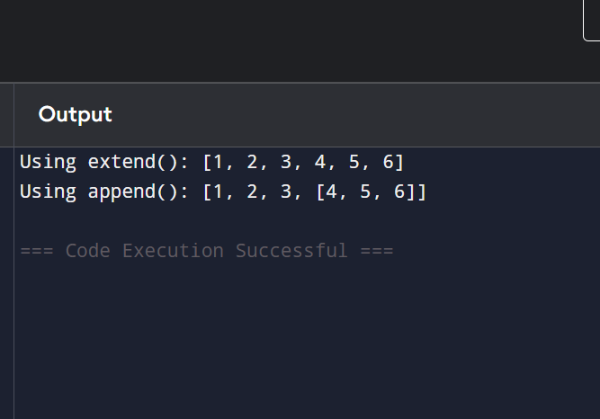

Q10: . (Mini Project - Combined Concepts)
Create a Student Marks Manager program using lists:
Take 5 subject marks as input from the user and store them in a list.
Print the list.
Add one more subject mark using append().
Print the highest and lowest marks (using built-in functions).
Sort the marks in descending order.
Calculate and print the average marks.
Use len() to show total number of subjects.
Use proper comments, meaningful variable names, and control structures where needed.
ANS:
# Student Marks Manager

marks = []

# Take 5 subject marks from user
for i in range(5):
mark = int(input(f"Enter mark for subject {i+1}: "))
marks.append(mark)

# Print marks list
print("Marks List:", marks)

# Add one more subject mark
extra_mark = int(input("Enter mark for one more subject: "))
marks.append(extra_mark)

print("Updated Marks List:", marks)

# Highest and Lowest marks
print("Highest Mark:", max(marks))
print("Lowest Mark:", min(marks))

# Sort in descending order
marks.sort(reverse=True)
print("Marks in Descending Order:", marks)

# Calculate average
average = sum(marks) / len(marks)
print("Average Marks:", average)

# Total subjects
print("Total Number of Subjects:", len(marks))
