Session 02 (AIML) -Assignment Questions

Name: sakshi ganesh tipale.
Domain: Artifical Intelligence And Machine Learning.
Collage and Branch: Zeal Polytechnic Pune(AIML).

Q1: (if Statement)
Write a program that asks the user to enter their age.
If the age is 18 or more, print the message: "You are eligible to vote."
(Do not print anything if the condition is False).
Add comments.

ANS:
# Program to check voting eligibility

# Take age input from user

age = int(input("Enter your age: "))

# Check if age is 18 or more
if age >= 18:
print("You are eligible to vote.")

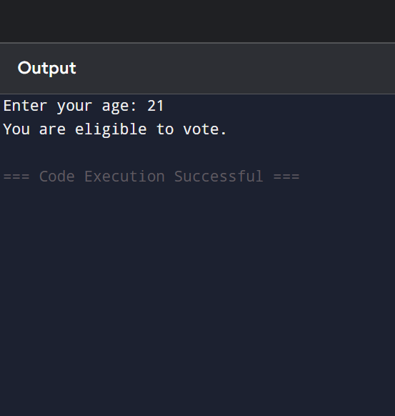

Q2: . (if-else Statement)
Write a program that takes a number as input from the user and checks whether it is even or odd.Print "Even Number" or "Odd Number" accordingly.
ANS: # Program to check whether a number is even or odd

# Take number input from user
num = int(input("Enter a number: "))

# Check even or odd
if num % 2 == 0:
print("Even Number")
else:
print("Odd Number")
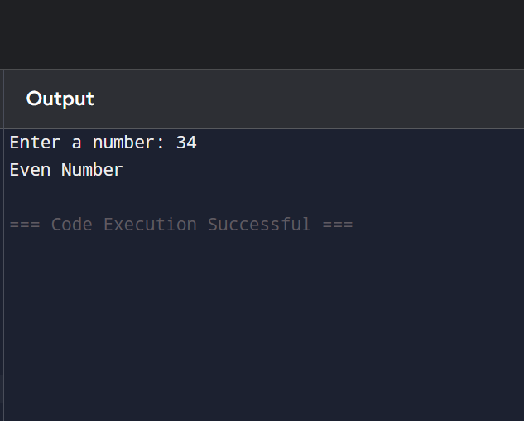

Q3: (if-elif-else Statement)
Write a program to assign grades based on marks entered by the user:
Marks ≥ 90 "Grade A- Excellent"
Marks ≥ 75"Grade B Good"
Marks ≥ 60 "Grade C Average"
Marks ≥ 40 "Grade D - Pass"
Marks < 40 "Fail"Use if-elif-else and print the appropriate grade message
ANS: # Program to assign grades based on marks
# Take marks input from user
marks = int(input("Enter marks: "))
# Check grade
if marks >= 90:
print("Grade A - Excellent")
elif marks >= 75:
print("Grade B - Good")
elif marks >= 60:
print("Grade C - Average")
elif marks >= 40:
print("Grade D - Pass")
else:
print("Fail")
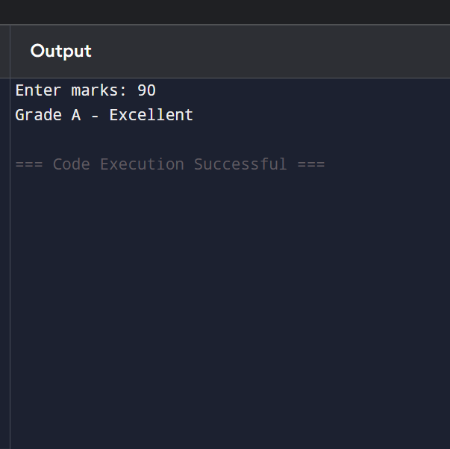

Q4: (For Loop with range)
Write a program using for loop and range() to:
a) Print all numbers from 1 to 30.
b) Print all odd numbers from 1 to 50.
c) Print the sum of numbers from 1 to 15.
Add comments explaining the use of range()
ANS:
A): # range(1, 31) generates numbers from 1 to 30
for i in range(1, 31):
print(i)
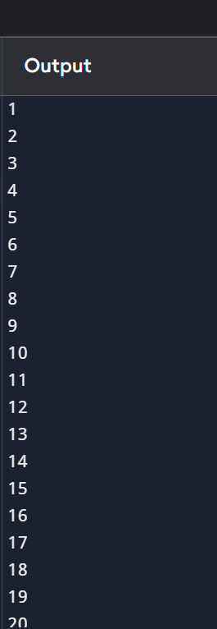

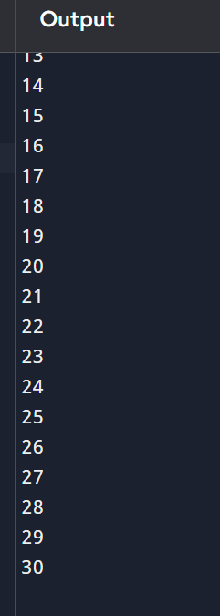

B): # range(start, stop, step)
# step = 2 prints only odd numbers

for i in range(1, 51, 2):
print(i)
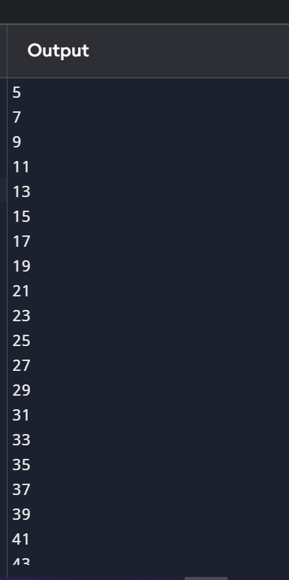

C):
# Program to find sum of numbers from 1 to 15
sum = 0

# range(1, 16) generates numbers from 1 to 15
for i in range(1, 16):
sum += i
print("Sum =", sum)
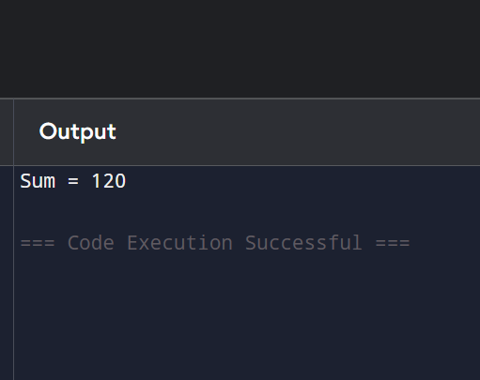

Q5: While Loop)
Write a program using while loop to print the following: Numbers from 1 to 20. Also print the cube of each number (i.e., 13, 23, 33, ...).
Stop when the number exceeds 20

ANS:
# Program to print numbers from 1 to 20 and their cubes

num = 1

while num <= 20:
print("Number =", num, " Cube =", num ** 3)
num += 1
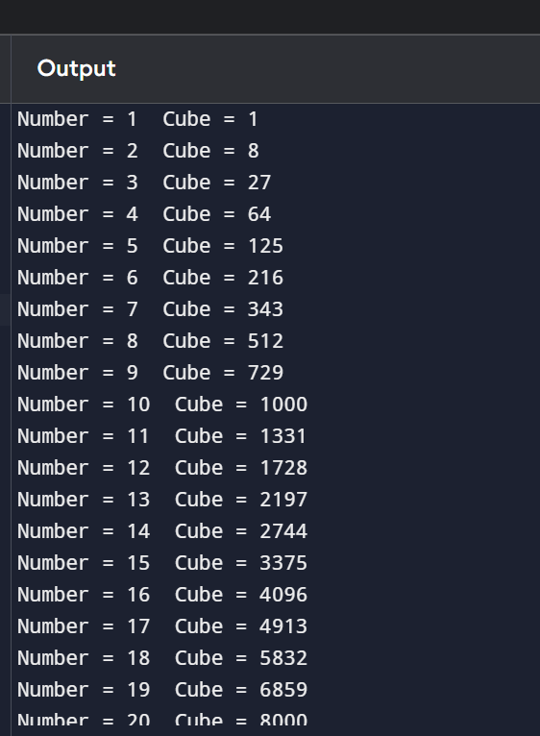

Q6: While Loop - User Controlled)

Write a program that repeatedly asks the user to enter a positive number.

Keep adding the entered numbers to a running total.

Stop when the user enters a negative number or zero.

Finally, print the total sum.
ANS: # Sum of positive numbers

total = 0
while True:
num = int(input("Enter a positive number: "))

if num <= 0:
break
total += num
print("Total Sum =", total)
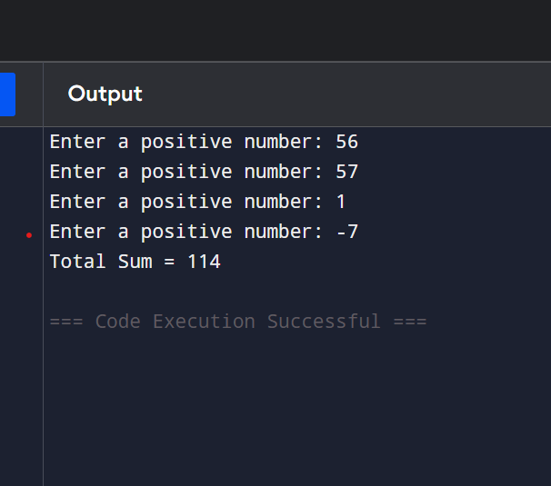

Q7: Nested if Statement)
Write a program that takes two inputs:
temperature (integer)
is_raining (enter "yes" or "no")
Then give advice using nested if:
If temperature > 30 and not raining "Hot day, wear light clothes."
If temperature > 30 and raining "Hot and rainy, carry umbrella."

If temperature < 15 and raining umbrella." "Cold and rainy, wear jacket and take
Else give a suitable message.
ANS: # Weather advice
temperature = int(input("Enter temperature: "))
is_raining = input("Is it raining? (yes/no): ")
if temperature > 30:
if is_raining == "yes":
print("Hot and rainy, carry umbrella.")
else:
print("Hot day, wear light clothes.")
elif temperature < 15:
if is_raining == "yes":
print("Cold and rainy, wear jacket and take umbrella.")
else:
print("Cold day, wear warm clothes.")

else:
print("Weather is pleasant.")
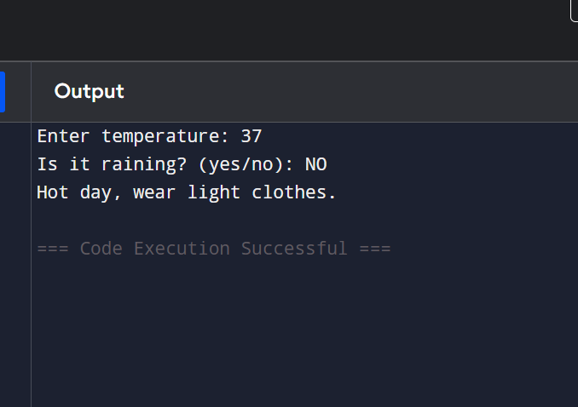

Q8: (For Loop + if-elif-else)
Write a program using for loop that goes from 1 to 40 and:
Prints "Fizz" if number is divisible by 3
Prints "Buzz" if number is divisible by 5
Prints "FizzBuzz" if divisible by both 3 and 5 Otherwise prints the number
ANS: # FizzBuzz from 1 to 40
for num in range(1, 41):
if num % 3 == 0 and num % 5 == 0:
print("FizzBuzz")
elif num % 3 == 0:
print("Fizz")
elif num % 5 == 0:
print("Buzz")
else:
print(num)
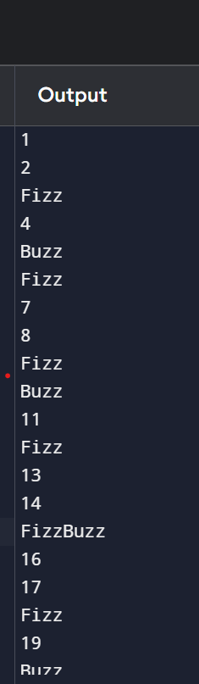
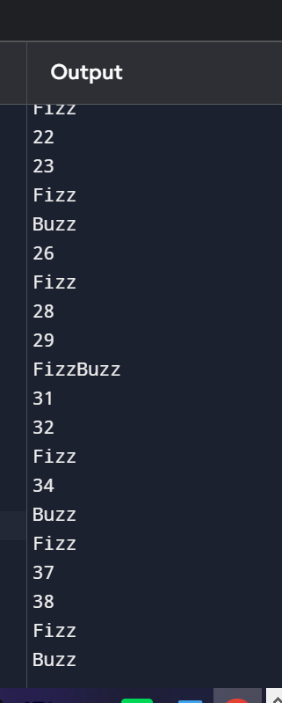

Q9: Menu Driven Program)
Create a simple calculator using while loop and if-elif-else:
Display this menu repeatedly:
1. Add two numbers
2. Subtract two numbers
3. Multiply two numbers
4. Divide two numbers
5. Exit
Ask user for choice.
Take two numbers as input.
Perform the operation.
Continue until user chooses 5 (Exit).
Handle division by zero case.
ANS: # Menu Driven Calculator using while loop
while True:
print("\n----- Calculator Menu -----")
print("1. Add two numbers")
print("2. Subtract two numbers")
print("3. Multiply two numbers")
print("4. Divide two numbers")
print("5. Exit")

choice = int(input("Enter your choice: "))

if choice == 5:
print("Exiting Calculator...")
break

elif choice >= 1 and choice <= 4:

num1 = float(input("Enter first number: "))
num2 = float(input("Enter second number: "))

if choice == 1:
print("Result =", num1 + num2)

elif choice == 2:
print("Result =", num1 - num2)

elif choice == 3:
print("Result =", num1 * num2)

elif choice == 4:
if num2 == 0:
print("Error: Division by zero is not allowed.")
else:
print("Result =", num1 / num2)

else:
print("Invalid choice! Please enter a number from 1 to 5.")
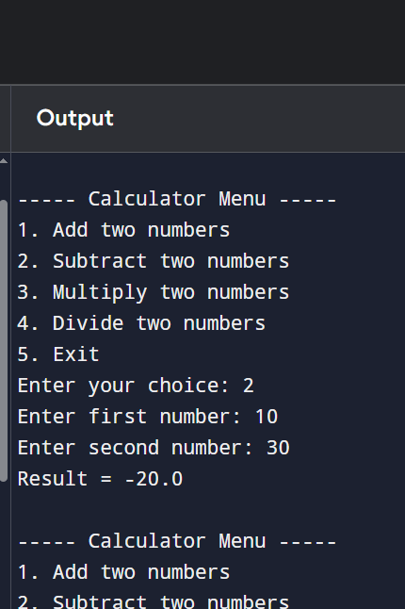
Q10: Debugging)
The following code contains several errors. Correct the program and add meaningful comments explaining each fix:
num input("Enter a number: ")

if num 100

print("Large number")

elif num 50

print("Medium number")

else

print("Small number")

count=1

while count < 10

print (count)

count + 1
ANS: # Corrected Program

num = int(input("Enter a number: "))

if num >= 100:
print("Large number")
elif num >= 50:
print("Medium number")
else:
print("Small number")

count = 1

while count < 10:
print(count)
count += 1
