Session 08(AIML) -Assignment Questions

NAME: sakshi ganesh tipale.
Domain: Artifical Intelligence And Machine Learning.
Collage and Branch: Zeal Polytechnic Pune(AIML).

Q1: (Creating Sets)
Write a program to create the following sets:
a) A set with 5 integers.
b) A set with mixed data types (integer, string, float).
c) An empty set using the correct method.
d) A set from the string "hello" using the set() constructor.
Print each set and its type. Add comments explaining why sets automatically remove duplicates.
ANS:
# a) Creating a set with 5 integers
integer_set = {10, 20, 30, 40, 50}

print("Integer Set:", integer_set)
print("Type:", type(integer_set))

# b) Creating a set with mixed data types
mixed_set = {10, "Python", 5.5}

print("Mixed Set:", mixed_set)
print("Type:", type(mixed_set))

# c) Creating an empty set using set()
empty_set = set()

print("Empty Set:", empty_set)
print("Type:", type(empty_set))

# d) Creating a set from string "hello"
hello_set = set("hello")

print("String Set:", hello_set)
print("Type:", type(hello_set))
# Sets automatically remove duplicates because
# a set stores only unique values.
# If the same value is added multiple times,
# it keeps only one copy.
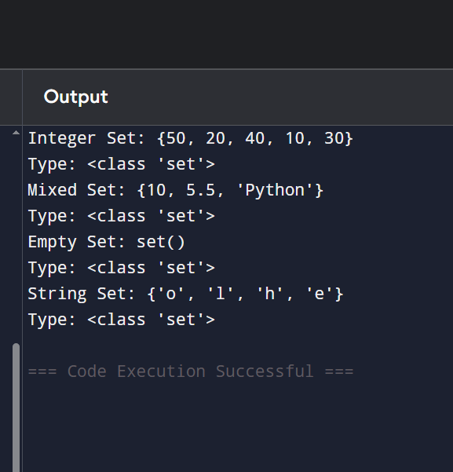
Q2: (Characteristics of Sets)
Create a set: numbers = {10, 20, 30, 20, 40, 10, 50)
Print the set and observe the output.
Demonstrate that sets are unordered by printing the set multiple times.
Try to access the first element using indexing (numbers[0]) and explain the error in comments.
ANS:
# Creating a set with duplicate values
numbers = {10, 20, 30, 20, 40, 10, 50}

# Printing the set
print("Set:", numbers)

# Demonstrating that sets are unordered
# The order may change when printed multiple times
print("Second print:", numbers)
print("Third print:", numbers)

# Trying to access first element using indexing
# print(numbers[0])
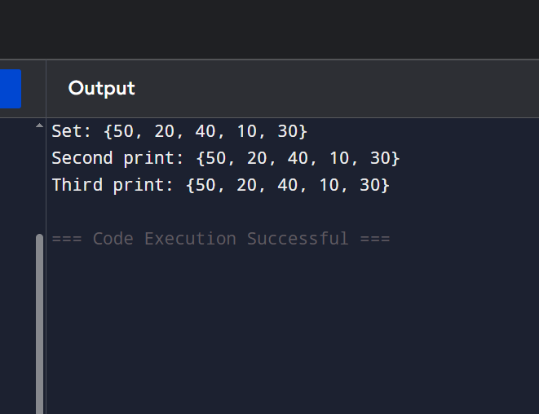
Q3: Membership Testing)
Write a program that:
Takes a set of 5 colors as input from the user.
Asks the user to enter a color name.
Checks whether the color is present in the set using in and not in.
Prints appropriate messages.
ANS:

# Creating an empty set
colors = set()

# Taking 5 colors as input from user
print("Enter 5 colors:")

for i in range(5):
color = input("Enter color: ")
colors.add(color)

print("Colors set:", colors)

# Asking user to enter a color to search
search_color = input("Enter color to check: ")

# Checking membership using in and not in
if search_color in colors:
print("Color is present in the set.")

elif search_color not in colors:
print("Color is not present in the set.")
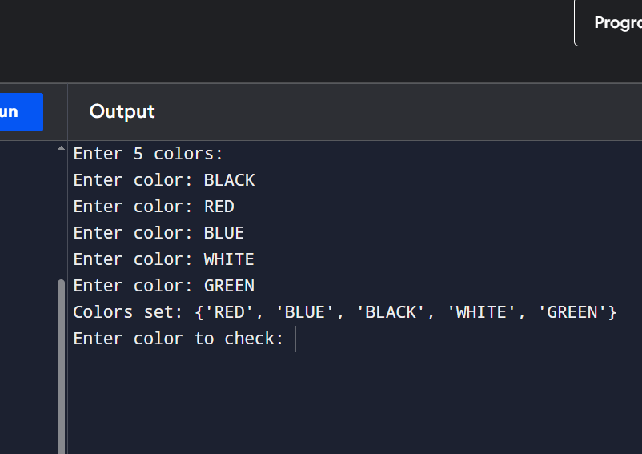

Q4: add(), remove(), discard())
Create a set: fruits = {'apple', 'banana', 'mango'} Perform the following operations and printthe set after each step:
a) Add 'orange' using add().
b) Add 'banana' again (observe the result).
c) Remove 'mango' using remove().
d) Try to remove 'grape' using discard() (no error should occur).
ANS:
# Creating the set
fruits = {'apple', 'banana', 'mango'}

print("Original Set:", fruits)

# a) Add 'orange'
fruits.add('orange')
print("After adding orange:", fruits)

# b) Add 'banana' again
# No duplicate will be added
fruits.add('banana')
print("After adding banana again:", fruits)

# c) Remove 'mango'
fruits.remove('mango')
print("After removing mango:", fruits)

# d) Remove 'grape' using discard()
# No error occurs if item is not present
fruits.discard('grape')
print("After discarding grape:", fruits)
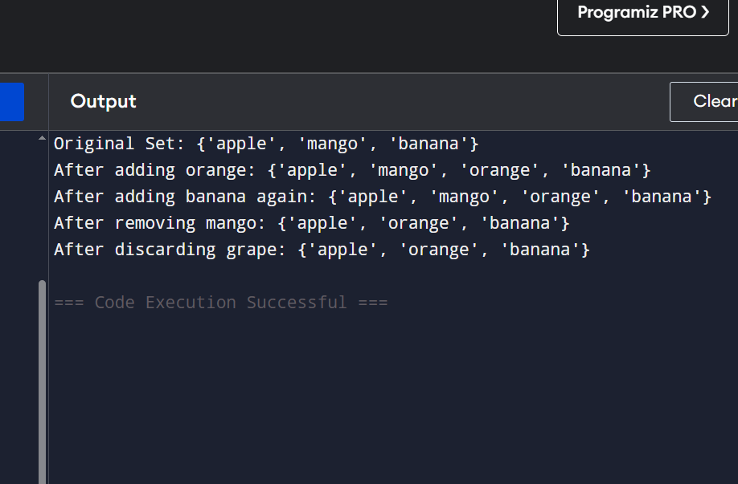
Q5: pop() and clear())
Create a set: s = (100, 200, 300, 400, 500)
Use pop() to remove and print one element.
Print the set after popping.
Clear the entire set using clear().
Print the final empty set.
Add comments explaining the difference between remove(), discard(), and pop().
ANS:
# Creating a set
s = {100, 200, 300, 400, 500}

print("Original Set:", s)

# Remove one element using pop()
removed_element = s.pop()

print("Removed Element:", removed_element)

# Print set after pop()
print("Set after pop():", s)

# Clear all elements
s.clear()

# Print empty set
print("Set after clear():", s)

# Difference between remove(), discard(), and pop():
# remove(x) -> Removes x. Gives KeyError if x is not present.
# discard(x) -> Removes x. No error if x is not present.
# pop() -> Removes and returns a random element from the set.
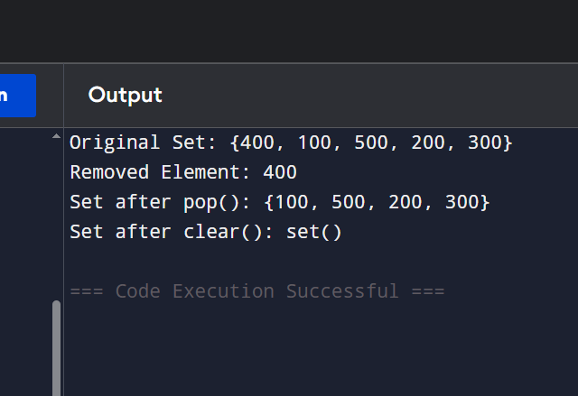

Q6: update() and copy()) Create two sets:
set1 = (1, 2, 3) set2 (3, 4, 5, 6)
Make a copy of set1.
Update set1 with elements from set2 using update().
Print both the original copy and the updated set.
ANS:
# Creating two sets
set1 = {1, 2, 3}
set2 = {3, 4, 5, 6}

# Making a copy of set1
copy_set = set1.copy()

# Updating set1 with elements from set2
set1.update(set2)

# Printing results
print("Original Copy:", copy_set)
print("Updated Set1:", set1)
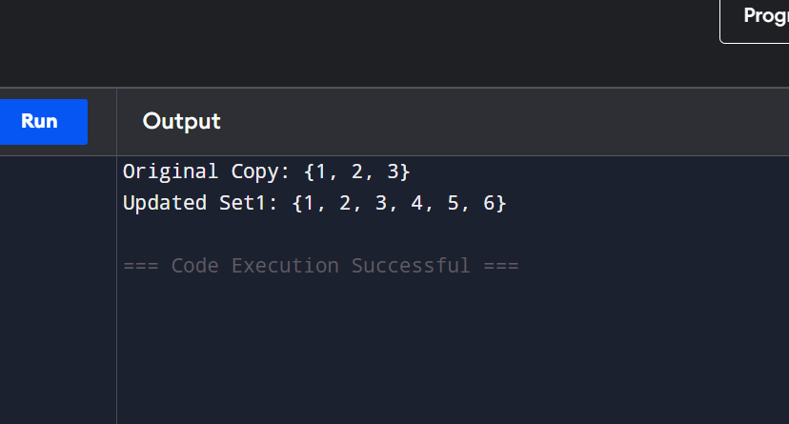

Q7: Union and Intersection)
Create two sets:
A = {1, 2, 3, 4, 5} B = {4, 5, 6, 7, 8)
Print the union of A and B (using both union() and operator).
Print the intersection of A and B (using both.intersection() and & operator).
Add comments explaining what each operation does.
ANS:
# Creating two sets
A = {1, 2, 3, 4, 5}
B = {4, 5, 6, 7, 8}

# Union Operation
# Combines all unique elements from both sets
print("Union using union():", A.union(B))

# Union using | operator
print("Union using | :", A | B)

# Intersection Operation
# Returns only the common elements present in both sets
print("Intersection using intersection():", A.intersection(B))

# Intersection using & operator
print("Intersection using & :", A & B)
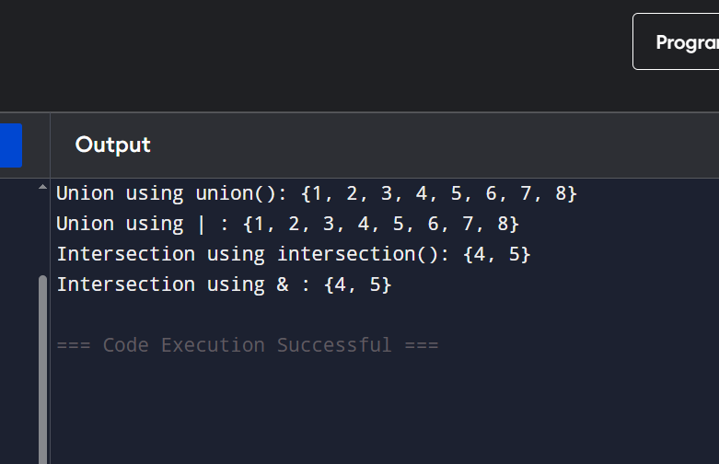

Q8: Combined Methods)
Write a program that:
Takes 6 numbers as input from the user and stores them in a set (duplicates should be removed automatically)
Adds two more numbers using add().
Removes one number safely using discard().
Prints the final set and its length using len().
ANS: numbers = set()

# Taking 6 numbers as input
print("Enter 6 numbers:")
for i in range(6):
num = int(input("Enter number: "))
numbers.add(num)

# Adding two more numbers
numbers.add(70)
numbers.add(80)

# Removing one number safely
numbers.discard(20)

# Printing final set and length
print("Final Set:", numbers)
print("Length of Set:", len(numbers))
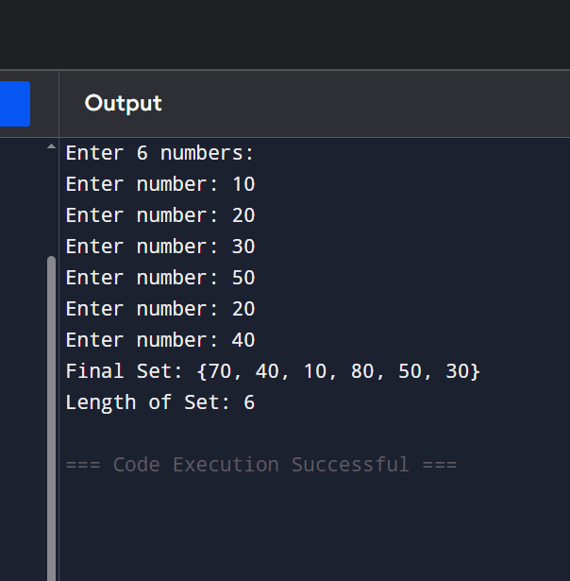

Q9: Practical Application)
Write a program to remove duplicate marks from a list of student scores using a set:
scores = [85, 92, 78, 92, 85, 88, 95, 78]
Convert the list to a set.
Print the unique scores.
Convert the set back to a sorted list and print it.
Print the total number of unique scores.
ANS:

# List of student scores
scores = [85, 92, 78, 92, 85, 88, 95, 78]

# Convert list to set to remove duplicates
unique_scores = set(scores)

# Print unique scores
print("Unique Scores:", unique_scores)

# Convert set back to a sorted list
sorted_scores = sorted(unique_scores)

# Print sorted list
print("Sorted Scores:", sorted_scores)

# Print total number of unique scores
print("Total Unique Scores:", len(unique_scores))
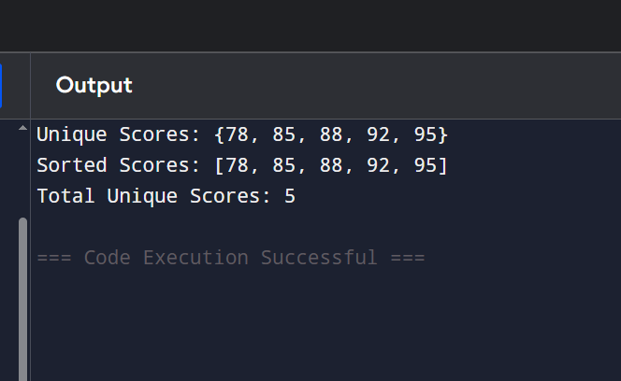

Q10: Mini Project - Combined Concepts)
Create a Unique Item Collector program using sets:
Repeatedly ask the user to enter items (e.g., favorite fruits, colors, or numbers).
Store all entered items in a set (duplicates should be ignored).
Provide a menu with options:
1. Add item
2. Remove item (use discard)
3. Show all unique items
4. Check if an item exists
5. Clear all items
6. Exit
Use a while loop for the menu and appropriate set methods. Add meaningful comments.
ANS:

# Mini Project - Unique Item Collector

# Create an empty set to store unique items
items = set()

while True:
# Display menu
print("\n===== Unique Item Collector =====")
print("1. Add Item")
print("2. Remove Item")
print("3. Show All Unique Items")
print("4. Check if an Item Exists")
print("5. Clear All Items")
print("6. Exit")

choice = input("Enter your choice (1-6): ")

# Add item
if choice == "1":
item = input("Enter item to add: ")
items.add(item)
print("Item added successfully!")

# Remove item using discard()
elif choice == "2":
item = input("Enter item to remove: ")
items.discard(item)
print("Item removed (if it existed).")

# Show all unique items
elif choice == "3":
print("Unique Items:", items)

# Check if item exists
elif choice == "4":
item = input("Enter item to check: ")

if item in items:
print("Item exists in the set.")
else:
print("Item does not exist in the set.")

# Clear all items
elif choice == "5":
items.clear()
print("All items cleared.")

# Exit program
elif choice == "6":
print("Exiting program...")
break

# Invalid choice
else:
print("Invalid choice! Please enter a number between 1 and 6.")
