Session 04 (AIML) -Assignment Questions

NAME: sakshi ganesh tipale.
Domain: Artifical Intelligence And Machine Learning.
Collage and Branch: Zeal Polytechnic Pune(AIML).

Q1: Lambda Function)
write a lambda function named square that takes a number x and returns its square.
Call the lambda function with input from the user and print the result.
Also write the same logic using a normal def function and compare both in comments.
ANS: # Lambda Function
square = lambda x: x * x
num = int(input("Enter a number: "))
print("Square using lambda:", square(num))

# Same logic using normal function
def square_def(x):
return x * x
print("Square using def:", square_def(num))

# Comparison:
# Lambda function -> Short, used for simple operations.
# def function -> Better for complex logic and readability.
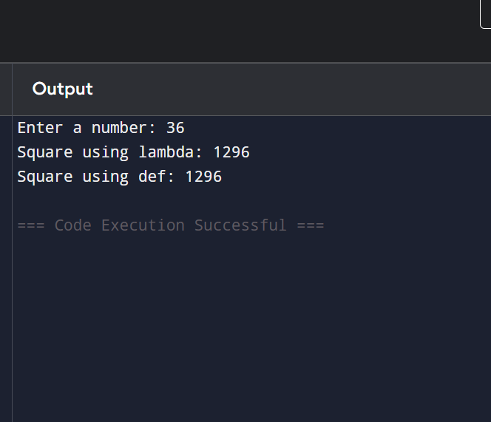

Q2: Lambda with Multiple Arguments)
Create a lambda function add_three(a, b, c) that returns the sum of three numbers.
Take three numbers as input from the user and print their sum using this lambda function.
ANS:
# Lambda function to add three numbers

add_three = lambda a, b, c: a + b + c

a = int(input("Enter first number: "))
b = int(input("Enter second number: "))
c = int(input("Enter third number: "))

print("Sum =", add_three(a, b, c)).
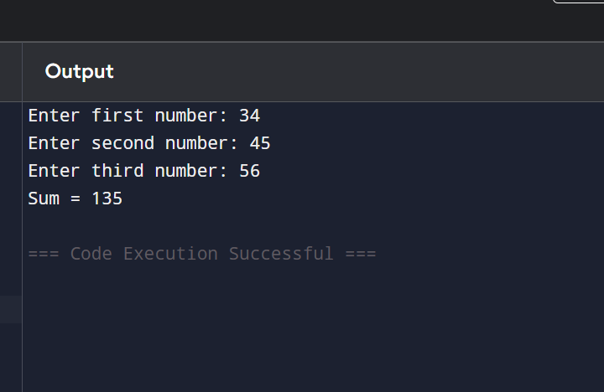

Q3: . (For Loop Revision)Write a program using a for loop and range() to:
a) Print all numbers from 1 to 25.
b) Print the sum of all numbers from 1 to 20.
c) Print the table of 5 (5 x 1 to 5 x 10).
Add comments explaining when to use for loop.
ANS: # For loop is used when the number of iterations is known.

# a) Print numbers from 1 to 25
print("Numbers from 1 to 25:")
for i in range(1, 26):
print(i)

# b) Sum of numbers from 1 to 20
total = 0
for i in range(1, 21):
total += i

print("Sum of numbers from 1 to 20 =", total)

# c) Table of 5
print("Table of 5:")
for i in range(1, 11):
print("5 x", i, "=", 5 * i)
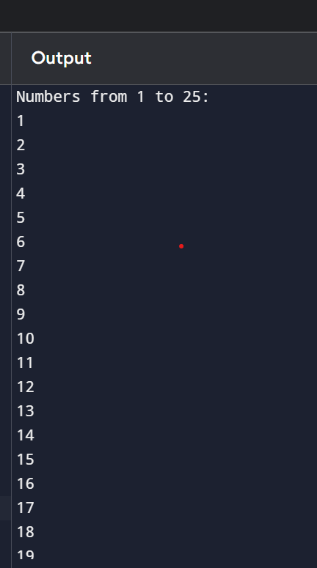
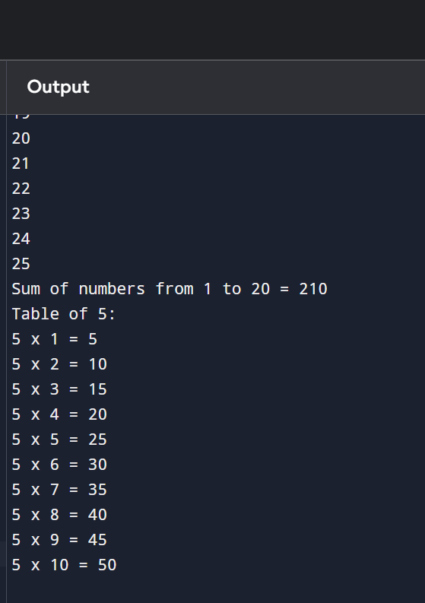

Q4: While Loop Revision)Write a program using a while loop that:
Repeatedly asks the user to enter a positive number.
Keeps adding the numbers to a running total.
Stops when the user enters 0 or a negative number.
Finally prints the total sum.
ANS: # Keep taking positive numbers and add them.
# Stop when user enters 0 or a negative number.
total = 0
while True:
num = int(input("Enter a positive number (0 or negative to stop): "))

if num <= 0:
break

total += num

print("Total Sum =", total)
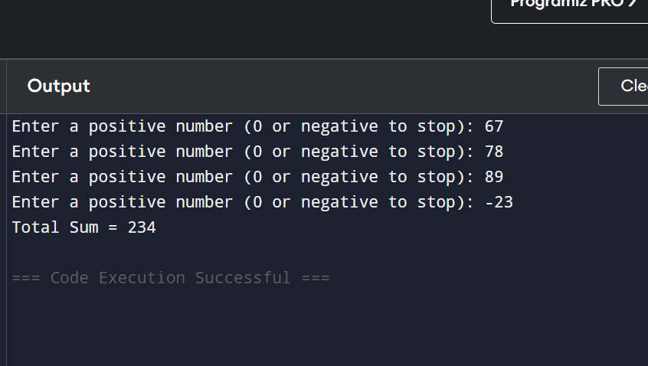

Q5: Math Module)
Write a program that imports the math module and does the following:
Takes a number as input.
Prints its square root using math.sqrt().
Prints its factorial using math.factorial() (for positive integers only).
Prints the ceiling and floor value using math.ceil() and math.floor().
Add comments about the usefulness of the math module
ANS: # Importing math module
import math
# The math module provides useful mathematical functions
# such as square root, factorial, ceiling, and floor.

num = float(input("Enter a number: "))
# Square Root
print("Square Root =", math.sqrt(num))
# Ceiling and Floor Values
print("Ceiling Value =", math.ceil(num))
print("Floor Value =", math.floor(num))
# Factorial (only for positive integers)
if num >= 0 and num.is_integer():
print("Factorial =", math.factorial(int(num)))
else:
print("Factorial is only defined for positive integers.").
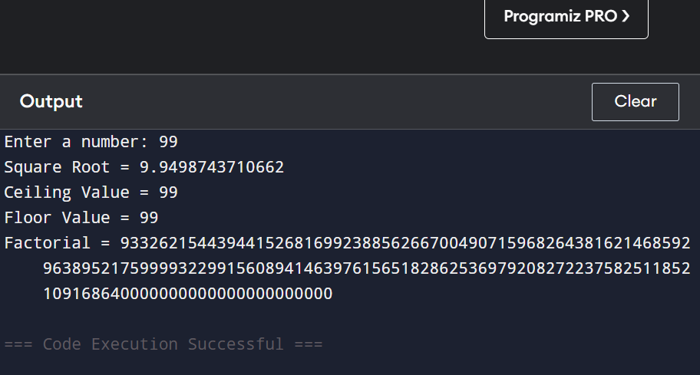

Q6: Random Module)
Write a program using the random module that:
Generates and prints 5 random integers between 1 and 100.
Generates and prints one random number between 50 and 150.
Prints a random floating point number between 0 and 1.
Use different functions from the random module.
ANS: # Importing random module
import random
# Generates random values useful in games,
# simulations, testing, and guessing programs.

print("5 Random Integers between 1 and 100:")

for i in range(5):
print(random.randint(1, 100))

# Random integer between 50 and 150
print("\nRandom Integer between 50 and 150:")
print(random.randint(50, 150))

# Random floating-point number between 0 and 1
print("\nRandom Float between 0 and 1:")
print(random.random()).
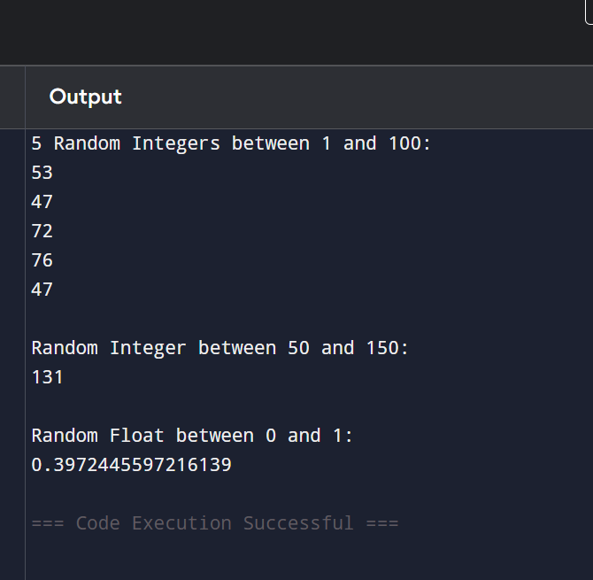

Q7: Import Methods)
Demonstrate different ways of importing modules:
1. Import the entire math module using import math and use math.pow(2, 4).
2. Import only sqrt from math using from math import sqrt.
3. Import math with an alias as m and use m.factorial(5).
Print the results with clear messages.
ANS:
# 1. Import entire math module
import math
print("Using import math:")
print("2 raised to 4 =", math.pow(2, 4))
# 2. Import only sqrt from math
from math import sqrt
print("\nUsing from math import sqrt:")
print("Square root of 25 =", sqrt(25))

# 3. Import math with alias
import math as m
print("\nUsing import math as m:")
print("Factorial of 5 =", m.factorial(5))
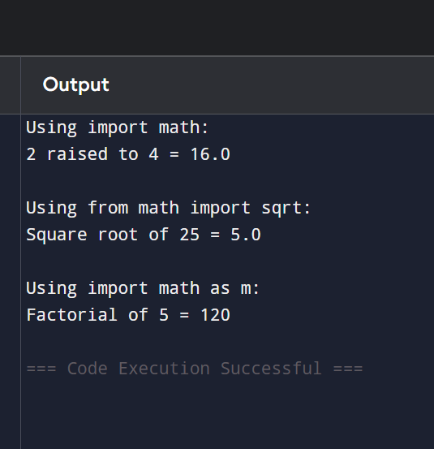
Q8: (Custom Module)
Create a custom module file named mymodule.py that contains:
2/3
A function greet(name) that prints "Hello [name], Welcome to Python Class!"
A function calculate_power(base, exp) that returns base raised to exponent.
Then write a main program that imports this module and uses both functions.
ANS:
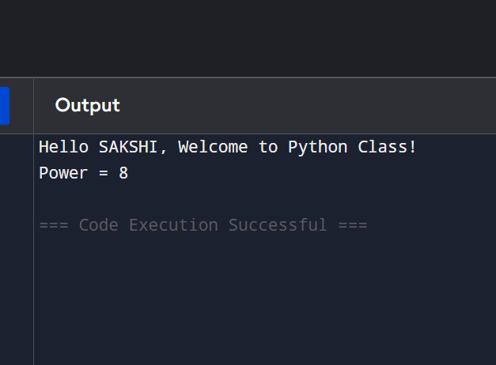

Q9: name "main")
Write a program that:
- Creates a small function and demonstrates the use of if_name__ == "_main_": so that some code runs only when the file is executed directly.
ANS: # Function definition
def greet():
print("Hello! Welcome to Python.")

# This code runs only when the file is executed directly
if __name__ == "__main__":
print("Program is running directly.")
greet()
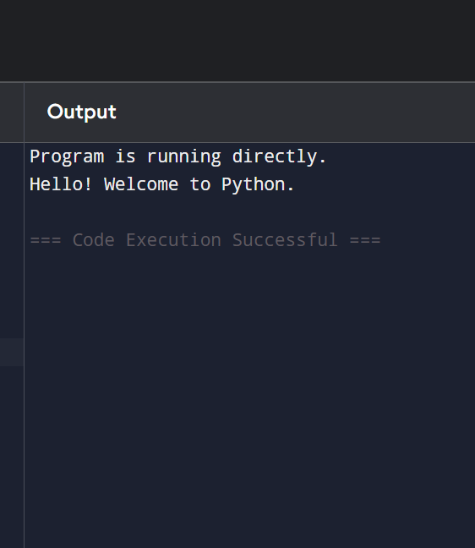

Q10: (Mini Project - Combined Concepts)
Create a Simple Math Utility Program using functions, lambda, loops and modules:
Write the following:
1. A lambda function to calculate square of a number.
2. A normal function using math module to calculate power.
3. Use a while loop to repeatedly ask the user for a number and choice (Square /Power / Random Number).
4. Use random module to generate a random number when chosen.
Continue until the user chooses to exit.
Use proper functions and comments.
ANS: # Simple Math Utility Program

import math
import random

# Lambda function to calculate square
square = lambda x: x * x

# Normal function using math module to calculate power
def calculate_power(base, exp):
return math.pow(base, exp)

# Function to generate random number
def generate_random():
return random.randint(1, 100)

# Main Program
while True:

print("\n===== Simple Math Utility =====")
print("1. Square of a Number")
print("2. Power of a Number")
print("3. Generate Random Number")
print("4. Exit")

choice = int(input("Enter your choice: "))

if choice == 1:
num = int(input("Enter a number: "))
print("Square =", square(num))

elif choice == 2:
base = int(input("Enter base: "))
exp = int(input("Enter exponent: "))
print("Power =", calculate_power(base, exp))

elif choice == 3:
print("Random Number =", generate_random())

elif choice == 4:
print("Thank You! Program Ended.")
break

else:
print("Invalid Choice! Please try again.")
