Session 03 (AIML) - Assignment Questions

NAME: sakshi ganesh tipale.
DOMAIN: Artificial Intelligence And Machine Learning.
COLLAGE &BRANCH: Zeal Polytechnic.pune(AIML).

Q1: Basic Function)
Write a function named welcome() that prints the message:
"Welcome to Python Programming!"
Call the function to execute it.
Add a comment explaining why functions are useful.
ANS: # Functions help us organize code and avoid repetition.
def welcome():
print("Welcome to Python Programming!")
# Calling the function
welcome()
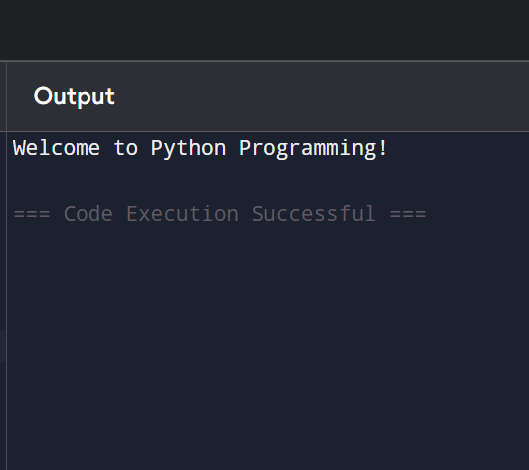
Q2: (Function with Parameter)
Create a function named greet(name) that takes one parameter name and prints:
"Hello, [name]! Welcome back."
Call the function with your own name.
Also call it with a different name to show reusability.
ANS: def greet(name):
print("Hello,", name + "! Welcome back.")

# Calling the function with different names
greet("Sakshi")
greet("Ayush")
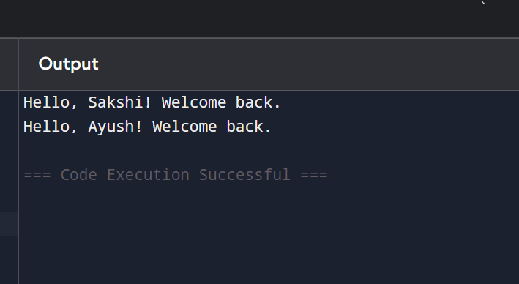

Q3: Default Parameter)
Write a function show_message(message="Hello") that prints the message.
Call the function without passing any argument.
Call the function again by passing a different message.
Explain the benefit of default parameters in a comment.
ANS: # Default parameters provide a value when no argument is passed.
def show_message(message="Hello"):
print(message)
# Calling without argument
show_message()
# Calling with a different message
show_message("Good Morning!")
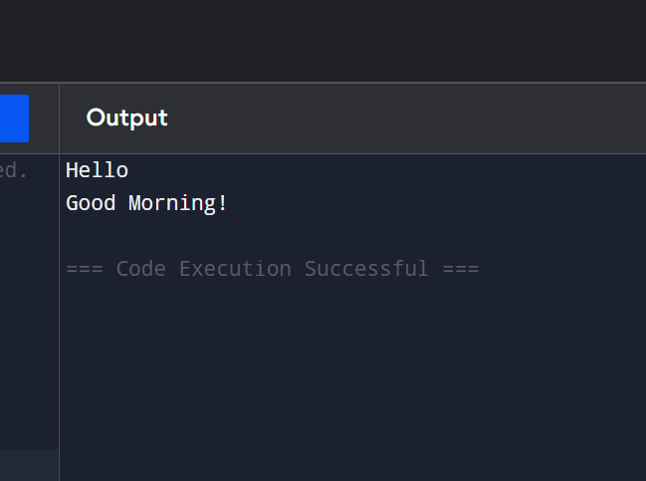

Q4: Function with Multiple Parameters & Return)
Create a function calculate_sum(a, b) that takes two numbers and returns their sum.
Call the function with two numbers and store the result in a variable.
Print the result.Also demonstrate the difference between print() inside the function and using return.
ANS: def calculate_sum(a, b):
return a + b

# Calling the function and storing the result
result = calculate_sum(10, 20)

# Printing the returned result
print("Sum =", result)

# Difference between print() and return

def sum_print(a, b):
print("Sum =", a + b)
sum_print(10, 20)
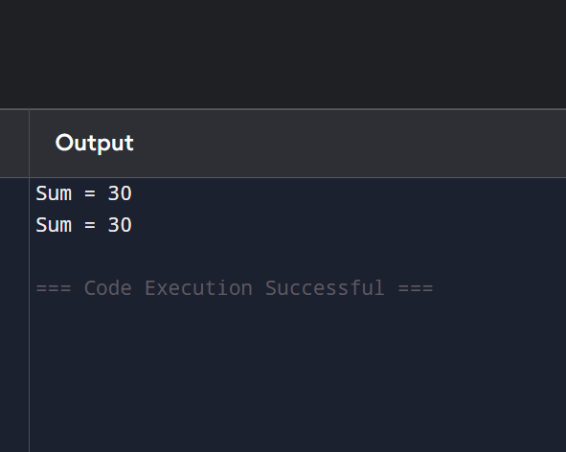

Q5: Positional vs Keyword Arguments)
Write a function student_info(name, age) that prints the name and age. Call this function twice:1. Using positional arguments.
2. Using keyword arguments.
Add comments explaining the difference.
ANS: def student_info(name, age):
print("Name:", name)
print("Age:", age)

# Using positional arguments
# Values are assigned based on their position.
student_info("Sakshi", 20)

print()
# Using keyword arguments
# Values are assigned using parameter names, so order does not matter.
student_info(age=20, name="Sakshi")
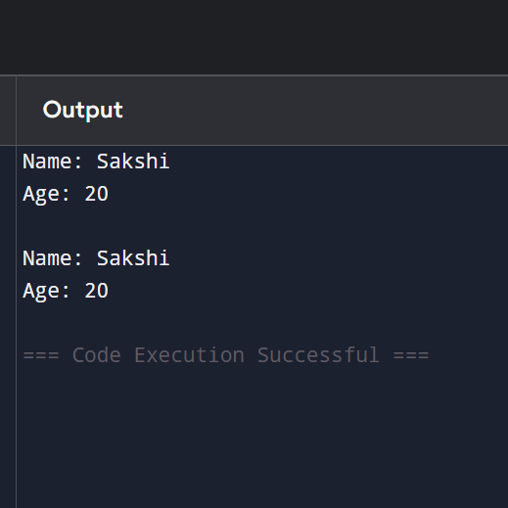

Q6: Function with Return Value)
Write a function square(num) that returns the square of the given number.
Write another function cube(num) that returns the cube of the number.

In the main program, take a number as input from the user and print its square and cube using these functions.
ANS: def square(num):
return num * num

def cube(num):
return num * num * num

# Take input from the user
number = int(input("Enter a number: "))

# Call functions and print results
print("Square =", square(number))
print("Cube =", cube(number))
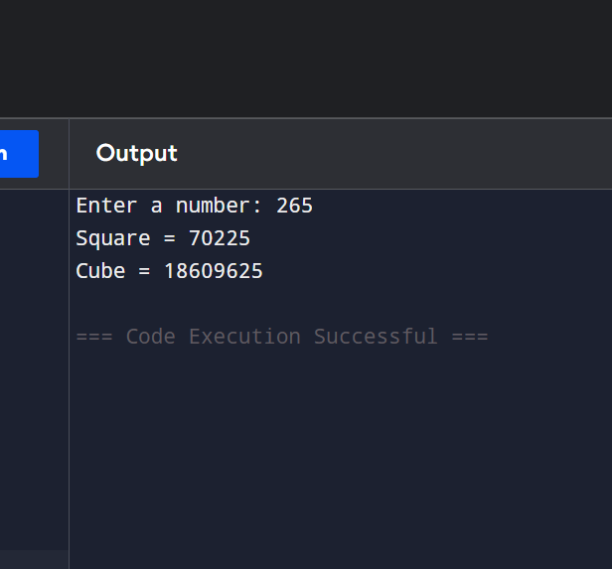

Q7: Recursion - Basic)
Write a recursive function countdown(n) that prints numbers from n down to 1.
Call countdown(10).
Make sure to include the base case (stopping condition).
ANS: def countdown(n):
# Base case (stopping condition)
if n == 0:
return

print(n)
countdown(n - 1)

# Call the function
countdown(10)
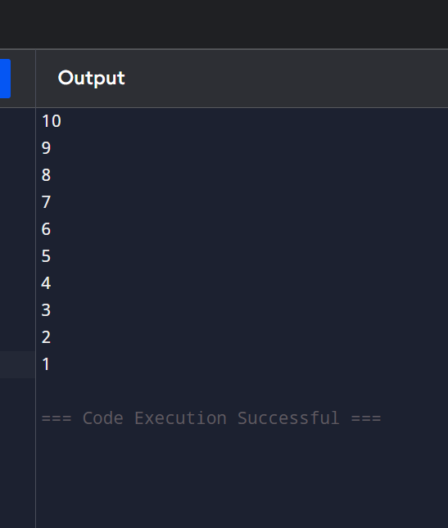

Q8: Recursion - Factorial)
Write a recursive function factorial(n) that calculates and returns the factorial of a number.
Example: factorial(5) should return 120.
Test it with input from the user and print the result.
Add a comment explaining the base case.
ANS: def factorial(n):
# Base case:
# Factorial of 0 or 1 is 1, so recursion stops here.
if n == 0 or n == 1:
return 1

return n * factorial(n - 1)

# Take input from the user
num = int(input("Enter a number: "))

# Print factorial
print("Factorial =", factorial(num))
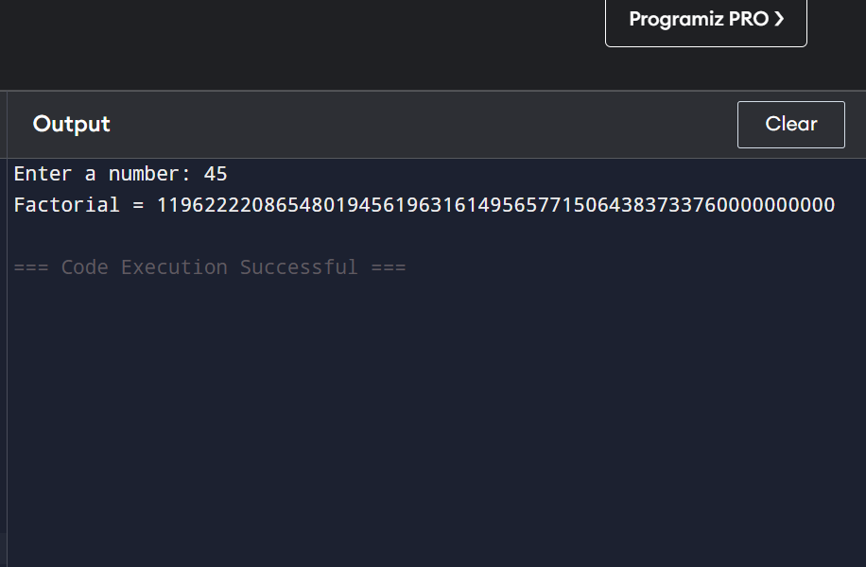
Q9: (Scope Local vs Global) Write a program to demonstrate scope:
Create a global variable total = 0
Write a function add_value(x) that adds x to total (use the global keyword).
Call the function multiple times and print the value of total after each call.
Also try to print a local variable outside its function to show it doesn't work
ANS:
# Global variable
total = 0
def add_value(x):
global total
total += x
# Local variable
local_var = x

print("Total =", total)

# Calling the function multiple times
add_value(10)
add_value(20)
add_value(30)

# Trying to access local variable outside the function
# This will cause an error because local_var is local to add_value()

# print(local_var)
print("Final Total =", total)
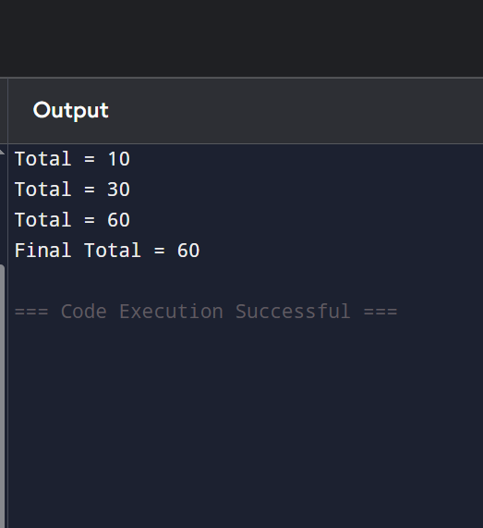

Q10: Mini Project - All Concepts)
Create a Simple Number Analyzer program using functions:
Write the following functions:
1. get_number() takes input from user and returns the number.
2. is_even(num) returns True if number is even, else False.
returns base raised to exponent (use default
3. power(base, exp=2)
argument).
4. show_result(num) prints whether the number is even/odd and its square.
Use a while loop to repeatedly ask the user for numbers until they enter 0.
Use recursion only if needed for one small part.
ANS:
# Function to get a number from the user
def get_number():
return int(input("Enter a number (0 to exit): ")

# Function to check if a number is even
def is_even(num):
return num % 2 == 0

# Function to calculate power
# Default exponent is 2 (square)
def power(base, exp=2):
return base ** exp

# Function to display results
def show_result(num):
if is_even(num):
print(num, "is Even")
else:
print(num, "is Odd")

print("Square =", power(num))
print()

# Main program using while loop
while True:
number = get_number()

if number == 0:
print("Program Ended.")
break

show_result(number)
