Session 13(AIML) -Assignment Questions

NAME: sakshi ganesh tipale.
GITHUB LINL: https://github.com/tipalesakshi396-gif/my-first
Domain: Artifical Intelligence And Machine Learning.
Collage and Branch: Zeal Polytechnic Pune(AIML).

Q1:
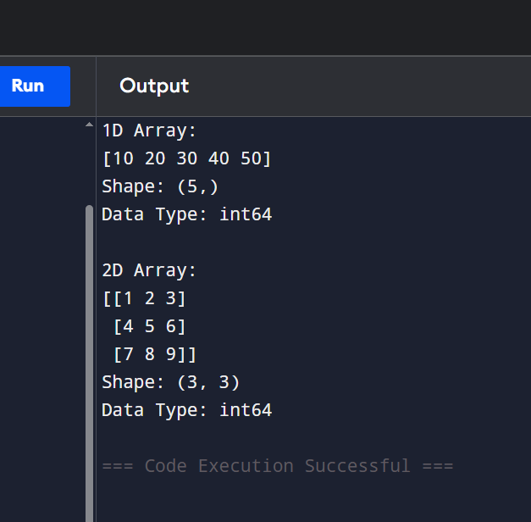
Q2:
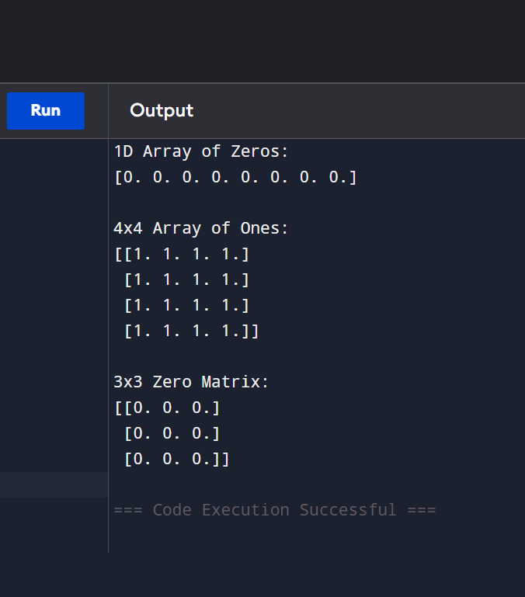

Q3:
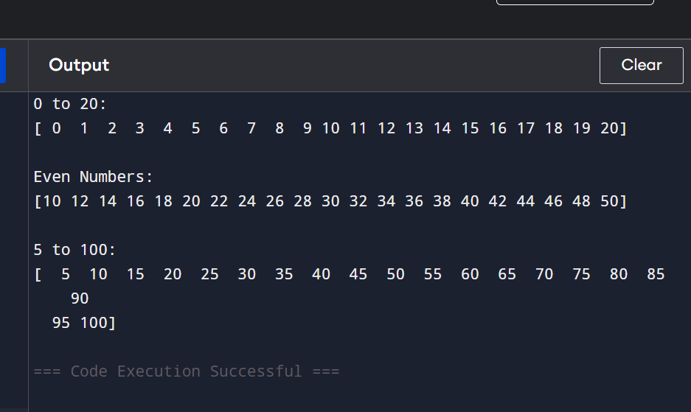
Q4:
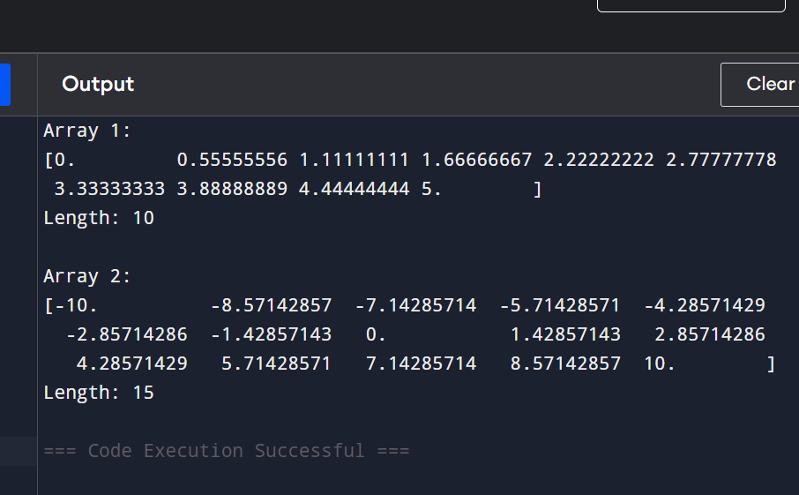

Q5:
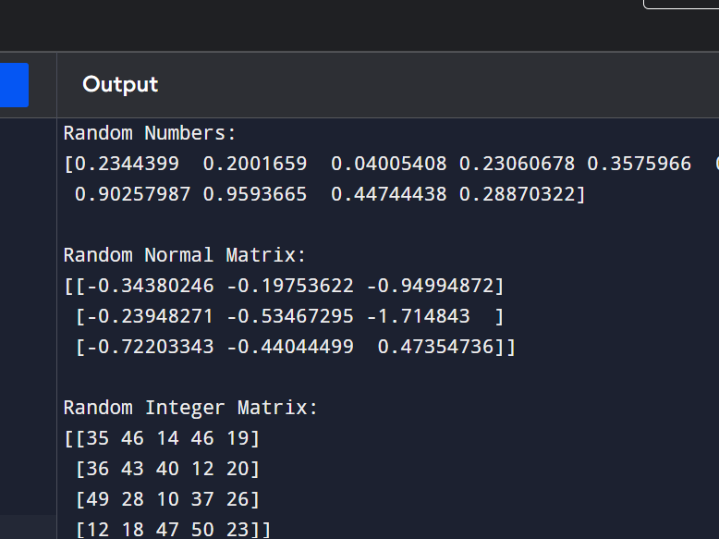

Q6:
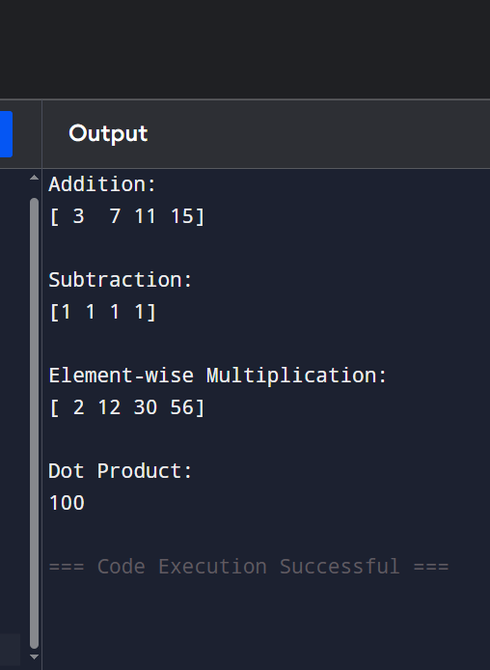

Q7:
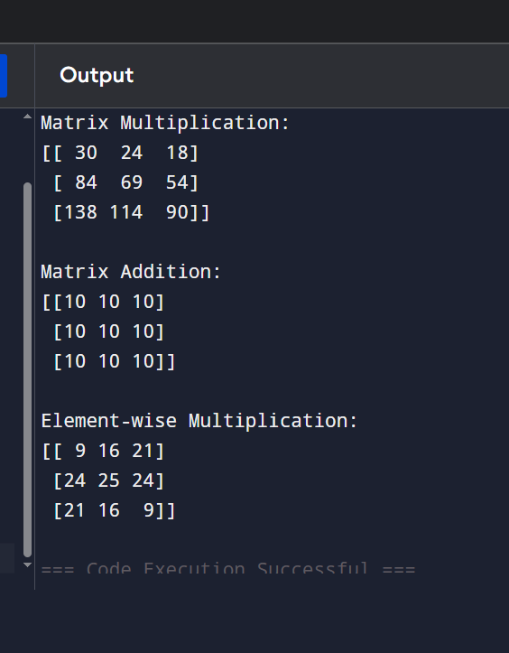
Q8:
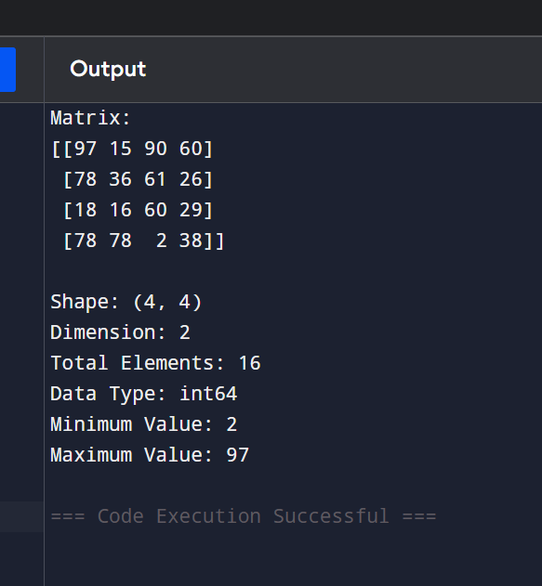

Q9:
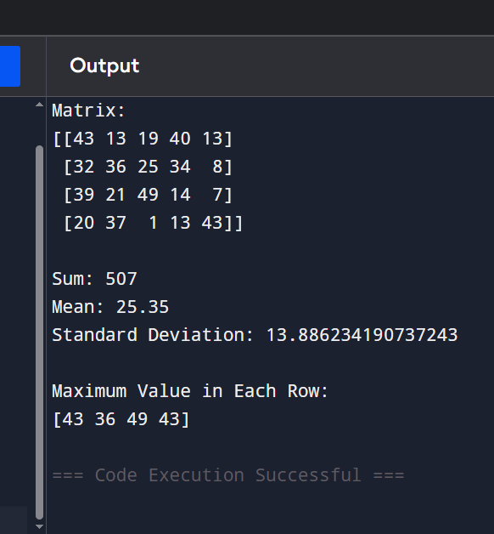
Q10:
