SETR: A Reproducible English–Thai Scholarly Translation Stress-Test Benchmark for Epistemically Consequential Errors
Original Paper | Prepared for Language Resources and Evaluation
Author information and target-journal metadata to be inserted before submission.

Abstract
Machine translation increasingly mediates access to scholarly evidence, but fluent output can contain localized changes that alter the interpretation of research claims. This study introduces Scholarly Epistemic Translation Risk (SETR), a reproducible English–Thai diagnostic benchmark and evaluation framework for stress-testing automated safeguards against epistemically consequential translation corruptions. From a frozen corpus of 120 Scopus-indexed 2025 research articles, 80 abstracts were stratified across arts and humanities, social sciences, health and life sciences, and STEM. A balanced benchmark of 400 instances comprised 80 clean translations and 320 controlled corruptions spanning polarity, epistemic force, methodological design, and evidence omission. Documents were split at the document level into 40 development and 40 held-out test documents. Five detector configurations were evaluated: deterministic safeguards (D1), cross-lingual semantic displacement (D2), backtranslation consistency (D3), OpenThai-SystemOne risk scoring (D4), and a stacked ensemble (D5). D1 achieved AUROC = 0.671 and AUPRC = 0.892; D5 achieved AUROC = 0.668 and AUPRC = 0.891. Removing D1 reduced ensemble AUPRC by 0.084, showing that transparent preservation and mismatch features carried most incremental value. Methodological-design corruptions were most detectable (D5 AUROC = 0.894), whereas polarity corruptions were near chance (0.508). Selective retention increased accuracy from 0.670 at full coverage to 0.770 at 50% coverage, although calibration remained weak. SETR contributes a frozen challenge-set resource, a leakage-controlled multi-signal evaluation protocol, and phenomenon-specific evidence about safeguard strengths and blind spots. The benchmark evaluates controlled-error sensitivity, not natural-error prevalence or human-certified translation quality.
Keywords: machine translation; English–Thai; translation quality estimation; challenge set; controlled perturbation; scholarly communication; reproducibility

1. Introduction
Scholarly communication increasingly depends on computational translation. Abstracts, metadata, evidence summaries, and research-assessment materials are routinely moved across languages before being indexed, synthesized, evaluated, or used as input to downstream artificial-intelligence systems. This development expands access to research but also creates a methodological problem: translation is not merely a linguistic preprocessing step. If a translation changes whether an effect is present, how strongly a conclusion is warranted, what study design was used, or which evidence was reported, the translated text can alter the epistemic content available to subsequent readers and algorithms.
Contemporary machine translation (MT) systems have substantially improved fluency and broad semantic adequacy, including for multilingual and lower-resource settings (Costa-jussà et al., 2022; Gao et al., 2022). Nevertheless, aggregate quality gains do not guarantee robustness to localized errors. Prior research has shown that negation, numbers, terminology, omissions, and other critical phenomena can remain difficult even when overall translations appear plausible (Tang et al., 2021; Karpinska et al., 2022; Amrhein et al., 2022). In scholarly prose, such errors are unusually consequential because they can change claims about evidence, methods, or uncertainty without necessarily creating obvious grammatical anomalies.
Machine-translation evaluation has therefore moved beyond lexical overlap toward learned metrics, reference-free quality estimation, error-span detection, uncertainty estimation, and challenge-set evaluation. COMET demonstrated the value of cross-lingual pretrained representations for MT evaluation (Rei et al., 2020), while xCOMET combined sentence-level scoring with localized error detection and explicit stress tests (Guerreiro et al., 2024). MQM-based expert evaluation has emphasized that translation quality is multidimensional and that evaluation procedures themselves can change conclusions about system quality (Freitag et al., 2021a, 2021b). Reference-free and backtranslation-based approaches further show that useful signals can be extracted without requiring a human reference translation (Fomicheva et al., 2020; Moon et al., 2020; Song et al., 2021; Agrawal et al., 2022).
However, three gaps remain important for scholarly translation. First, most MT metrics optimize agreement with broad quality judgments rather than directly testing whether they detect meaning-changing scholarly corruptions. Second, individual metrics have heterogeneous sensitivities: semantic metrics can overlook discrete factual or structural changes, while deterministic checks may detect critical numbers or lexical markers but miss semantically diffuse errors (Glushkova et al., 2023; Karpinska et al., 2022). Third, multilingual evaluation itself can be distorted by translation errors, making translation a measurement layer rather than a neutral conduit (Thellmann et al., 2026). These issues motivate a complementary-signal strategy focused on epistemic risk rather than a single scalar notion of translation quality.
This study operationalizes Scholarly Epistemic Translation Risk (SETR) as the risk that a translated scholarly abstract contains a controlled change capable of altering the interpretation of research evidence. SETR is positioned within Translation-Mediated Epistemic Integrity (TMEI), a broader framework treating translation as a methodological layer in evidence processing. Instead of assuming any automated metric to be human-equivalent ground truth, the study asks a narrower and reproducible question: how sensitive are complementary computational safeguards to controlled, epistemically consequential perturbations in English–Thai scholarly translations?

2. Related Work and Theoretical Positioning

2.1 From aggregate MT quality to critical-error sensitivity
Traditional MT evaluation relied heavily on reference-based lexical overlap. Neural metrics such as COMET subsequently improved correlations with human judgments by exploiting multilingual contextual representations (Rei et al., 2020). Yet high overall correlation does not ensure sensitivity to individual critical phenomena. DEMETR was explicitly designed to diagnose metric sensitivity to controlled perturbations and showed that learned metrics vary substantially by phenomenon (Karpinska et al., 2022). ACES similarly assembled accuracy-oriented challenge sets and recommended combining metrics with different strengths, giving greater weight to source information, and modelling language-specific information beyond generic multilingual embeddings (Amrhein et al., 2022).
xCOMET extended this direction by integrating sentence-level evaluation with fine-grained error detection and stress-testing localized critical errors and hallucinations (Guerreiro et al., 2024). These developments support an evaluation paradigm in which diagnostic sensitivity to consequential errors is treated as distinct from global quality correlation. SETR adopts that diagnostic perspective but narrows it to scholarly evidence, where polarity, epistemic force, study design, and omission can directly affect interpretation.

2.2 Reference-free, semantic, and backtranslation signals
Quality estimation seeks to assess translation reliability without a gold reference. Fomicheva et al. (2020) showed that unsupervised quality-estimation signals can approach supervised alternatives by exploiting information available from the MT process. SentSim directly compared source and translated sentences in a multilingual semantic space, demonstrating that cross-lingual semantic similarity can provide a cost-effective reference-free signal (Song et al., 2021). Multilingual sentence embeddings created through knowledge distillation further support cross-language comparison in a shared representational space (Reimers & Gurevych, 2020).
Backtranslation provides a complementary view. Rather than directly evaluating source–target similarity, the target is translated back into the source language and compared with the original. Semantic versions of round-trip evaluation have shown improved associations with human judgments relative to lexical round-trip measures (Moon et al., 2020). At WMT 2022, backtranslation alone was weaker than supervised quality-estimation systems, but it improved performance when combined with other scorers (Agrawal et al., 2022). This is directly relevant to SETR: backtranslation is treated not as a sufficient quality metric, but as one signal family whose value must be tested alongside deterministic, cross-lingual, and Thai-native signals.

2.3 Linguistically and epistemically consequential error types
Not all translation errors carry the same epistemic consequence. Negation is a canonical example because its mistranslation can reverse propositional meaning. Tang et al. (2021) found that although neural MT improved substantially, negation remained vulnerable to under-translation and direction-specific variation. Domain-specific MT studies similarly identify terminology, omission, and mistranslation as consequential categories, especially in technical contexts where readers may rely on lexical precision.
For scholarly abstracts, the present study focuses on four controlled corruption families. Polarity corruption changes whether a reported relationship or finding holds. Epistemic-force corruption strengthens or weakens the warranted certainty of a claim. Methodological-design corruption changes the described study design or inferential basis. Evidence omission removes information needed to interpret the result. These families are not claimed to exhaust naturally occurring translation errors; instead, they instantiate distinct pathways through which translation can alter the epistemic content of scholarly evidence.

2.4 Multilingual and Thai-specific considerations
Evaluation in multilingual settings remains uneven because language resources, model alignment, and calibration differ substantially across languages (Xu et al., 2024). Thai is particularly relevant because it combines an active research ecosystem with lower-resource characteristics compared with English. Thai–English MT research has shown continued gains from multilingual pretraining and data augmentation, but performance remains sensitive to architecture and resource availability (Hlaing et al., 2022; San et al., 2024).
To add a Thai-native decision signal, the present study used OpenThai-SystemOne v0.3, a 0.8-billion-parameter Thai–English decision model that returns categorical, scalar, and yes/no judgments with confidence in a single forward pass (iApp Technology, 2026). Its role was deliberately limited: OpenThai was one detector component, not a gold-standard translator, not a human surrogate, and not the conceptual focus of the study.

2.5 Uncertainty, calibration, and selective use
Translation safeguards are useful only if their outputs can support decisions under uncertainty. Uncertainty-aware MT evaluation has shown that point estimates alone can be misleading and that uncertainty information can help identify potentially critical mistakes (Glushkova et al., 2021). In other predictive domains, selective prediction formalizes the trade-off between coverage and error by allowing a system to defer uncertain cases rather than force a decision. SETR therefore evaluates not only discrimination but also calibration and risk–coverage behavior. The intended use is triage: low-risk cases may proceed through automated workflows, while high-risk or uncertain cases can be flagged for additional verification.

2.6 Conceptual framework and research questions
Figure 1 positions SETR as an operational component of TMEI. The framework separates benchmark construction from detector evidence and from downstream decision policy. The central methodological assumption is complementarity: different safeguards may be sensitive to different epistemic failure modes, so performance must be evaluated both globally and by corruption family.
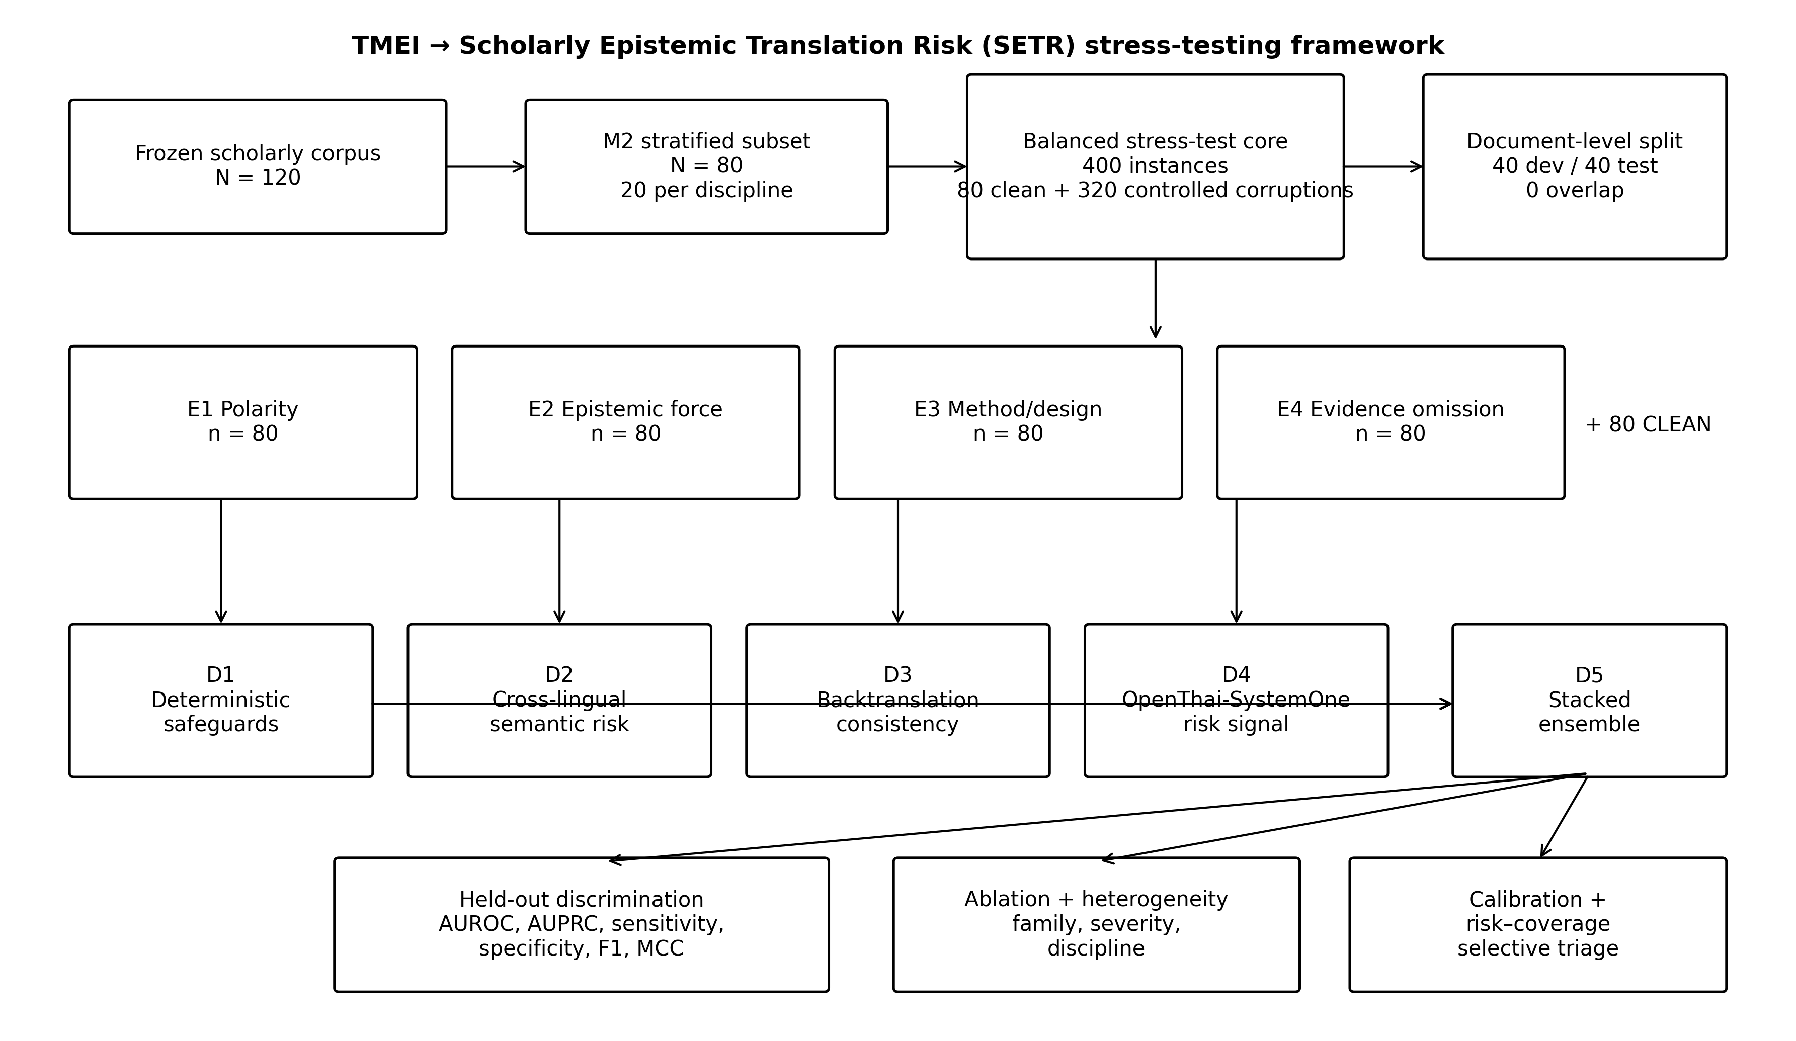
Figure 1. SETR research framework and frozen experimental workflow.
RQ1. How accurately can automated safeguards detect controlled epistemically consequential corruptions in English–Thai scholarly translations?
RQ2. Which safeguard signal families contribute most to detecting such corruptions?
RQ3. How effectively does a multi-signal ensemble discriminate translation risk and support selective use?
RQ4. Which controlled corruption families are most difficult to detect?
RQ5. Does detection performance vary by corruption severity or scholarly discipline?

2.7 Contributions of this study
This study makes four contributions to language-resource and MT-evaluation research. First, it provides a frozen, balanced English–Thai scholarly translation challenge set in which four epistemically consequential corruption families are instantiated at the document level. Second, it operationalizes a multi-signal diagnostic architecture that combines transparent deterministic checks, cross-lingual semantic displacement, backtranslation consistency, and a Thai-native risk signal without treating any component as ground truth. Third, it uses document-level leakage control, development-only threshold selection, held-out testing, ablation, calibration, risk–coverage analysis, and 10,000 document-cluster bootstrap resamples in a reproducible frozen protocol. Fourth, it reports phenomenon-specific blind spots rather than relying on a single aggregate score, showing particularly strong sensitivity to methodological-design corruption and near-chance sensitivity to polarity corruption. Together, these contributions position SETR as an evaluation resource for stress-testing safeguards, not as a universal translation-quality metric.

3. Materials and Methods

3.1 Study design and claim boundary
This was a fully computational, controlled stress-testing study. Ground truth was known by construction: clean instances were labelled 0 and controlled perturbations were labelled 1. No human translation-quality labels were used, and no model output was interpreted as human-equivalent ground truth. The design therefore evaluates controlled-error sensitivity, internal consistency, and risk ordering rather than real-world translation-error prevalence or human-certified translation quality.
The experiment was frozen before final analysis. The final freeze report confirmed 400 aligned benchmark instances from 80 documents, 400 complete OpenThai outputs, 400 deterministic-signal rows, 400 semantic-signal rows, 400 complete backtranslations, 400 backtranslation-signal rows, 40 development documents, 40 test documents, zero document overlap, and freeze_pass = true.

3.2 Corpus and sampling
The source corpus comprised 120 English-language research articles published in 2025 and indexed in Scopus. The corpus was stratified equally across four broad disciplinary panels: arts and humanities (AH), social sciences (SS), health and life sciences (HL), and science, technology, engineering, and mathematics (STEM), with 30 articles per panel. The primary Stage 2 translation pipeline translated English titles and abstracts into Thai using the frozen NLLB-200-distilled-600M model and generated English backtranslations with OPUS-MT Thai–English. No manual post-editing was performed.
For M2, 80 documents were selected using a frozen deterministic seed, 20 per disciplinary panel. This subset was used to construct the controlled SETR benchmark.

3.3 Controlled perturbation benchmark
The balanced core benchmark contained 400 instances: 80 clean Thai translations and four controlled corruption instances per document. The four corruption families were E1 polarity, E2 epistemic force, E3 methodological design, and E4 evidence omission, yielding 80 instances per family. Each document therefore contributed exactly five core instances, preventing family imbalance at the document level.
Perturbations were applied deterministically and logged. Polarity corruption inverted or negated a result-bearing proposition; epistemic-force corruption altered the warranted strength of a claim; methodological-design corruption inserted or substituted a study-design description; and evidence omission removed or truncated result-bearing information. Severity labels (subtle, moderate, severe) were deterministically assigned within each family. A separate trigger-based numerical challenge set was generated when numeric tokens were present, but it was not included in the balanced core inferential analysis because numeric triggers were unavailable for all documents.

3.4 Detector architecture
Five detector configurations were evaluated. D1, deterministic safeguards, encoded explicit preservation and mismatch features including numbers, acronyms, negation, hedging, certainty markers, methodological concepts, and source–target length ratios. D2, cross-lingual semantic risk, was defined as one minus cosine similarity between the English source and Thai candidate in a multilingual sentence-embedding space. D3, backtranslation consistency, translated each Thai candidate back to English with the frozen OPUS-MT Thai–English model and extracted semantic displacement, token-Jaccard loss, numeric mismatch, and negation mismatch. D4 used the risk probability returned by OpenThai-SystemOne v0.3. D5 was a stacked logistic ensemble combining D1–D4.
The multilingual semantic model was sentence-transformers/paraphrase-multilingual-MiniLM-L12-v2, frozen at revision e8f8c211226b894fcb81acc59f3b34ba3efd5f42. The backtranslation model was Helsinki-NLP/opus-mt-th-en. OpenThai-SystemOne v0.3 was used as a Thai-native decision signal; its output was not used to generate benchmark labels.

3.5 Leakage control and data splitting
Documents, not rows, were the unit of splitting. A deterministic SHA-256 ordering based on seed 2026101203 assigned 40 documents (200 instances) to development and 40 documents (200 instances) to the held-out test set. Consequently, clean and corrupted versions of the same abstract could not appear in different partitions.
For learned D1 and D3 classifiers, GroupKFold cross-validation on development documents generated out-of-fold predictions. The D5 meta-learner was trained on out-of-fold base signals and then fitted on the complete development data. Classification thresholds were selected exclusively on development data using Youden's J statistic and then frozen for held-out evaluation.

3.6 Outcomes and statistical analysis
Primary performance measures were AUROC, AUPRC, sensitivity, specificity, F1, Matthews correlation coefficient (MCC), and Brier score. Because each document generated five correlated instances, 95% confidence intervals were estimated by cluster bootstrap at the document level with 10,000 resamples (seed 2026101206). The test set contained 160 perturbed and 40 clean instances; therefore, the positive prevalence and non-informative AUPRC baseline were 0.80.
RQ2 was addressed by comparing individual detectors and by ablation of each D1–D4 signal family from the ensemble. RQ4 used family-specific performance against clean instances. RQ5 evaluated severity descriptively and with Spearman rank correlation and Kruskal–Wallis testing, while discipline-specific performance was treated as descriptive because each panel contained only 8–11 test documents. Calibration was summarized in five equal-frequency bins and by Brier score. Selective-use behavior was assessed by retaining progressively larger proportions of the most confident D5 decisions and computing selective error and accuracy; the area under the empirical risk–coverage curve (AURC) was also recorded.

3.7 Reproducibility and computational environment
All model identifiers, seeds, split logic, feature definitions, thresholds, and freeze gates were stored in machine-readable registries. Intermediate detector files were aligned by instance identifier, and the final freeze step generated an SHA-256 manifest. The analysis pipeline ran locally on a CPU-only Windows environment. This design supports exact reruns without manual intervention.

4. Results

4.1 Benchmark and held-out design
The frozen benchmark contained 400 instances from 80 documents. The development and test partitions each contained 40 clean instances and 40 instances from each of the four corruption families, for 200 instances per partition (Table 1). The held-out test prevalence of controlled corruption was therefore 0.80.
All final integrity checks passed: 400 benchmark rows, 400 complete OpenThai decisions, 400 deterministic-signal rows, 400 semantic rows, 400 complete candidate backtranslations, 400 backtranslation-signal rows, and exact identifier alignment. Forty documents were assigned to development and 40 to testing with no overlap.
Table 1. Frozen benchmark composition by split and corruption family.
split | family | instances | documents | positive | negative
development | CLEAN | 40 | 40 | 0 | 40
development | E1_POLARITY | 40 | 40 | 40 | 0
development | E2_EPISTEMIC_FORCE | 40 | 40 | 40 | 0
development | E3_METHOD_DESIGN | 40 | 40 | 40 | 0
development | E4_EVIDENCE_OMISSION | 40 | 40 | 40 | 0
test | CLEAN | 40 | 40 | 0 | 40
test | E1_POLARITY | 40 | 40 | 40 | 0
test | E2_EPISTEMIC_FORCE | 40 | 40 | 40 | 0
test | E3_METHOD_DESIGN | 40 | 40 | 40 | 0
test | E4_EVIDENCE_OMISSION | 40 | 40 | 40 | 0

4.2 Overall detection performance (RQ1)
D1 and D5 provided the strongest held-out discrimination (Table 2; Figures 2–3). D1 achieved AUROC = 0.671 (95% CI [0.634, 0.714]) and AUPRC = 0.892 (95% CI [0.879, 0.912]). D5 achieved AUROC = 0.668 (95% CI [0.633, 0.711]) and AUPRC = 0.891 (95% CI [0.879, 0.910]). Because the perturbation prevalence was 0.80, the AUPRC values should be interpreted against a baseline of 0.80; D5 improved AUPRC by approximately 0.091 above that baseline.
At the development-selected threshold of 0.444, D5 sensitivity was 0.713, specificity 0.500, F1 0.776, MCC 0.181, and Brier score 0.231. D1 produced lower sensitivity (0.650) but higher specificity (0.625), MCC (0.224), and slightly lower Brier score (0.226). Thus, the ensemble did not dominate the deterministic detector across all metrics; its principal gain was higher sensitivity and F1.
Table 2. Held-out detector performance. Confidence intervals use document-cluster bootstrap (B = 10,000).
detector | AUROC_95CI | AUPRC_95CI | sensitivity | specificity | F1 | MCC | Brier
D1 | 0.671 [0.634, 0.714] | 0.892 [0.879, 0.912] | 0.650 | 0.625 | 0.746 | 0.224 | 0.226
D2 | 0.527 [0.510, 0.549] | 0.803 [0.791, 0.820] | 0.600 | 0.450 | 0.691 | 0.041 | 0.439
D3 | 0.507 [0.468, 0.549] | 0.813 [0.801, 0.836] | 0.688 | 0.350 | 0.743 | 0.032 | 0.253
D4 | 0.483 [0.453, 0.509] | 0.810 [0.794, 0.826] | 0.169 | 0.850 | 0.280 | 0.020 | 0.397
D5 | 0.668 [0.633, 0.711] | 0.891 [0.879, 0.910] | 0.713 | 0.500 | 0.776 | 0.181 | 0.231

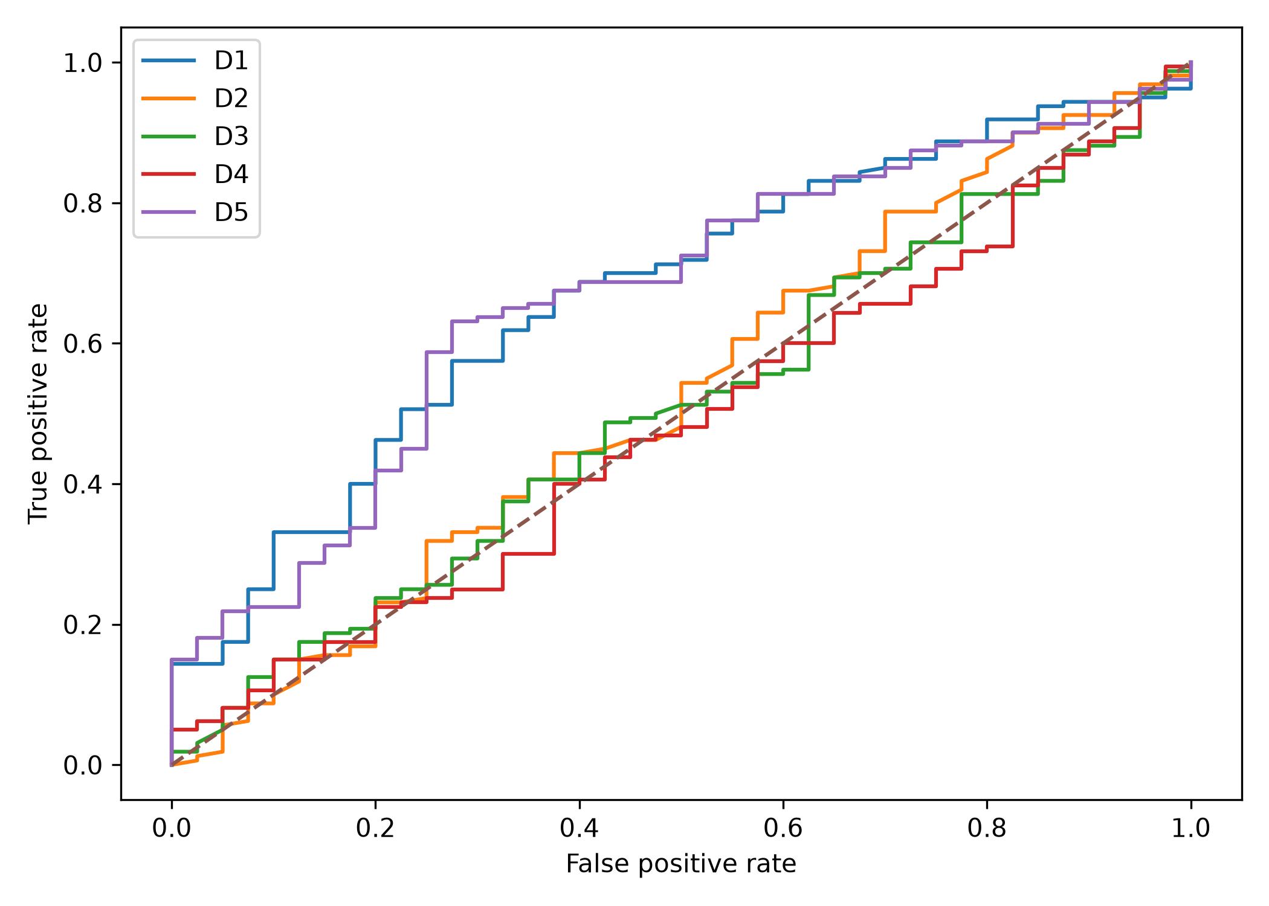
Figure 2. Receiver-operating-characteristic curves for D1–D5 on the held-out test set.
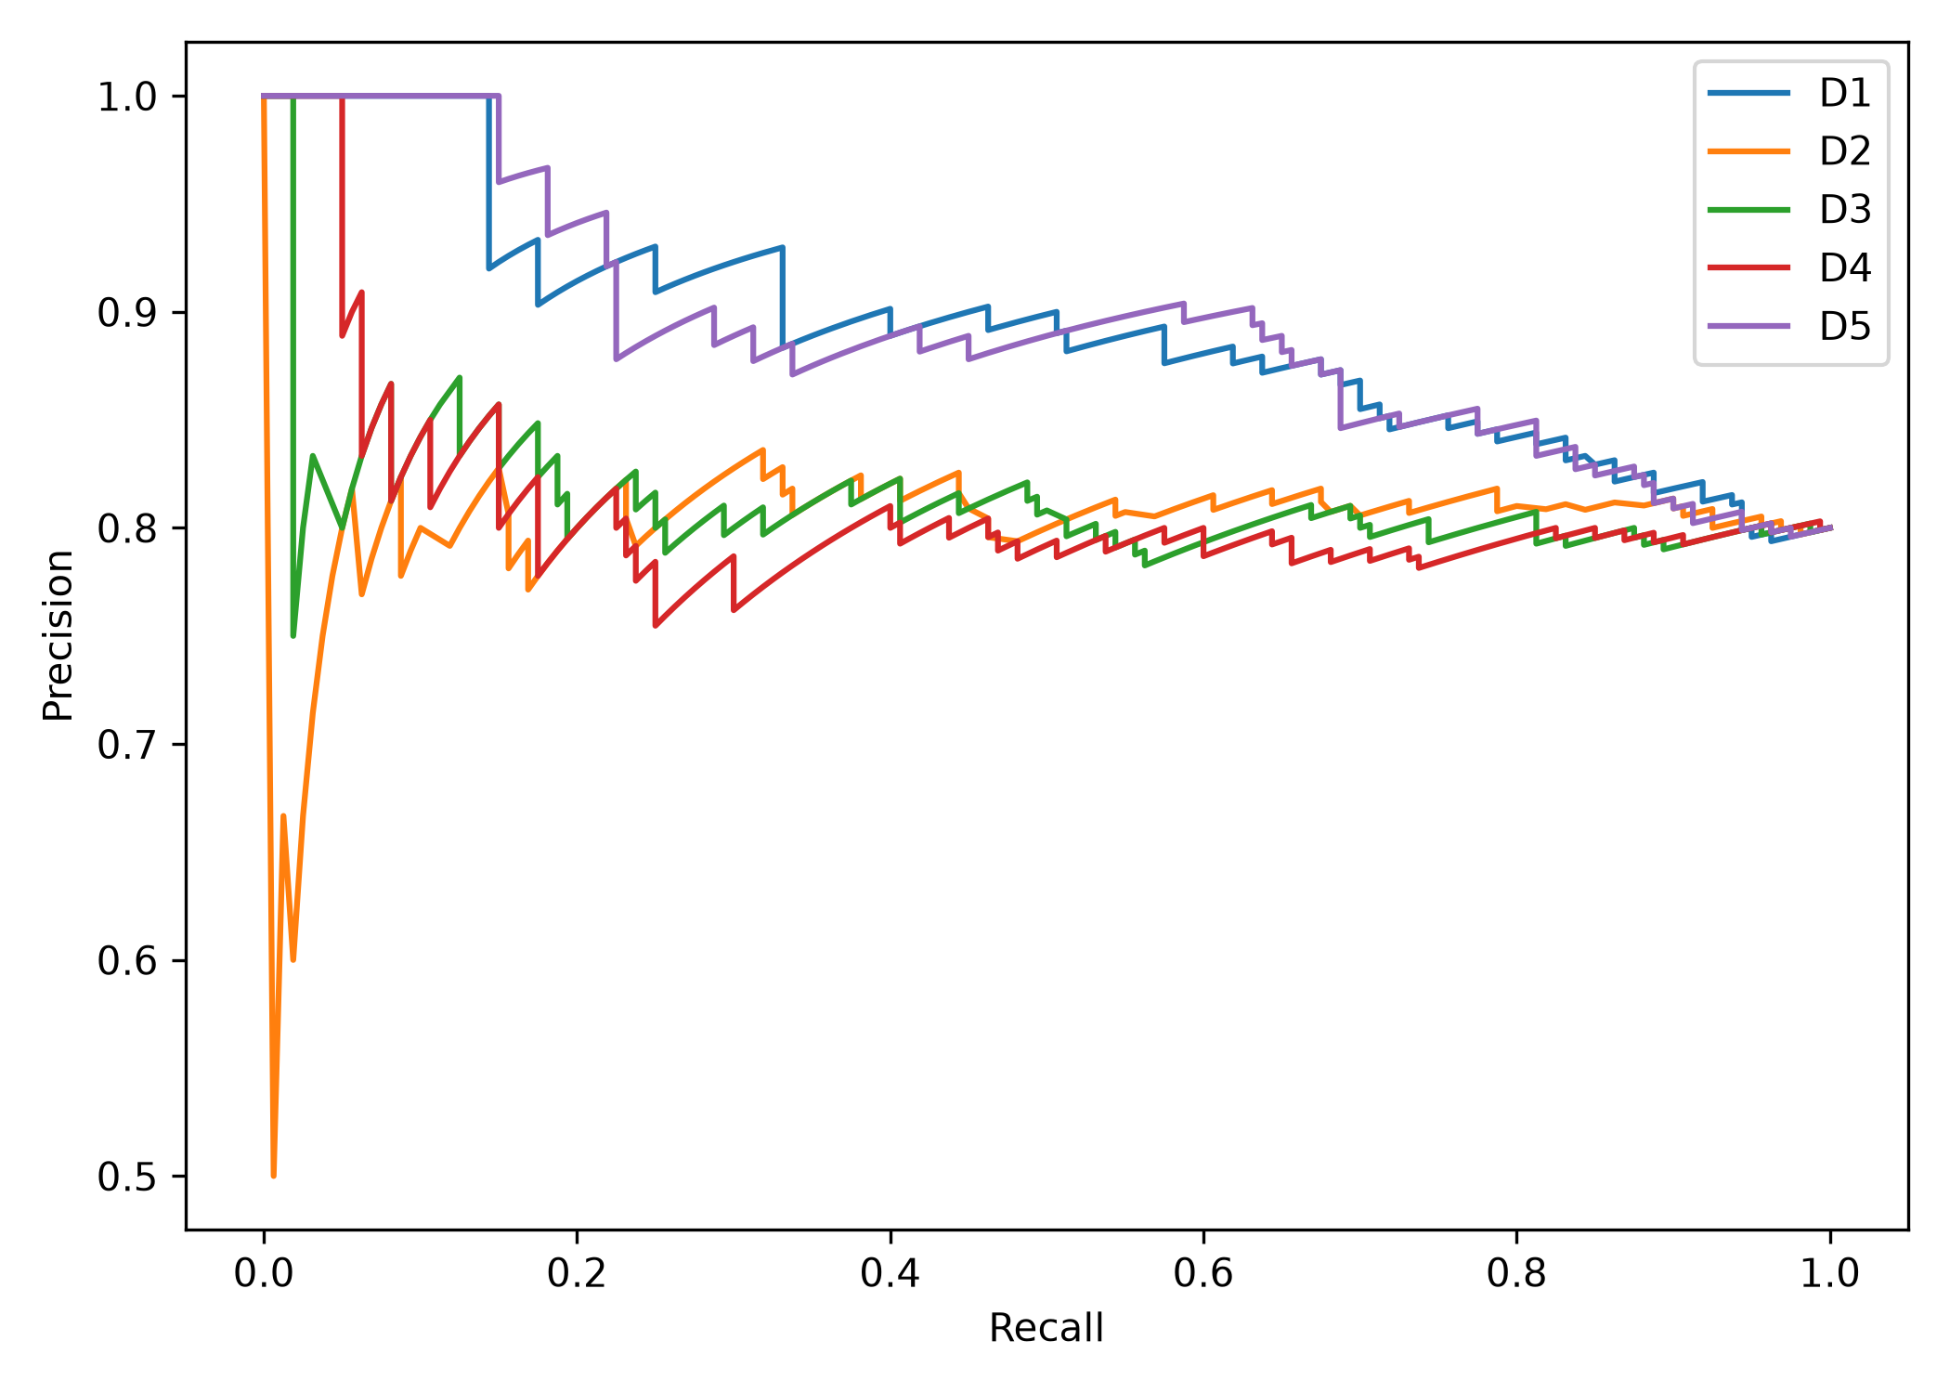
Figure 3. Precision–recall curves for D1–D5 on the held-out test set.

4.3 Signal contribution and ablation (RQ2)
The ablation analysis identified D1 as the dominant contributor to ensemble performance (Table 6; Figure 6). Removing D1 reduced held-out AUROC from 0.668 to 0.525 and AUPRC from 0.891 to 0.807, corresponding to ΔAUROC = -0.143 and ΔAUPRC = -0.084. By contrast, removing D2 slightly increased AUROC to 0.676 and AUPRC to 0.895; removing D3 produced AUROC = 0.669 and AUPRC = 0.892; and removing D4 left AUROC unchanged at 0.668 with AUPRC = 0.891.
These results indicate that complementary signals were not equally informative in this benchmark. Deterministic preservation/mismatch features carried most of the discriminative contribution, while the semantic, backtranslation, and Thai-native signals added little incremental discrimination after D1 was present.
Table 6. Ensemble ablation analysis on the held-out test set.
configuration | removed | AUROC | AUPRC | delta_AUROC_vs_full | delta_AUPRC_vs_full
Full D1+D2+D3+D4 | none | 0.668 | 0.891 | 0.000 | 0.000
D2_score+ D3_score+ D4_score | D1 | 0.525 | 0.807 | -0.143 | -0.084
D1_score+ D3_score+ D4_score | D2 | 0.676 | 0.895 | 0.008 | 0.004
D1_score+ D2_score+ D4_score | D3 | 0.669 | 0.892 | 0.001 | 0.001
D1_score+ D2_score+ D3_score | D4 | 0.668 | 0.891 | 0.000 | -0.000

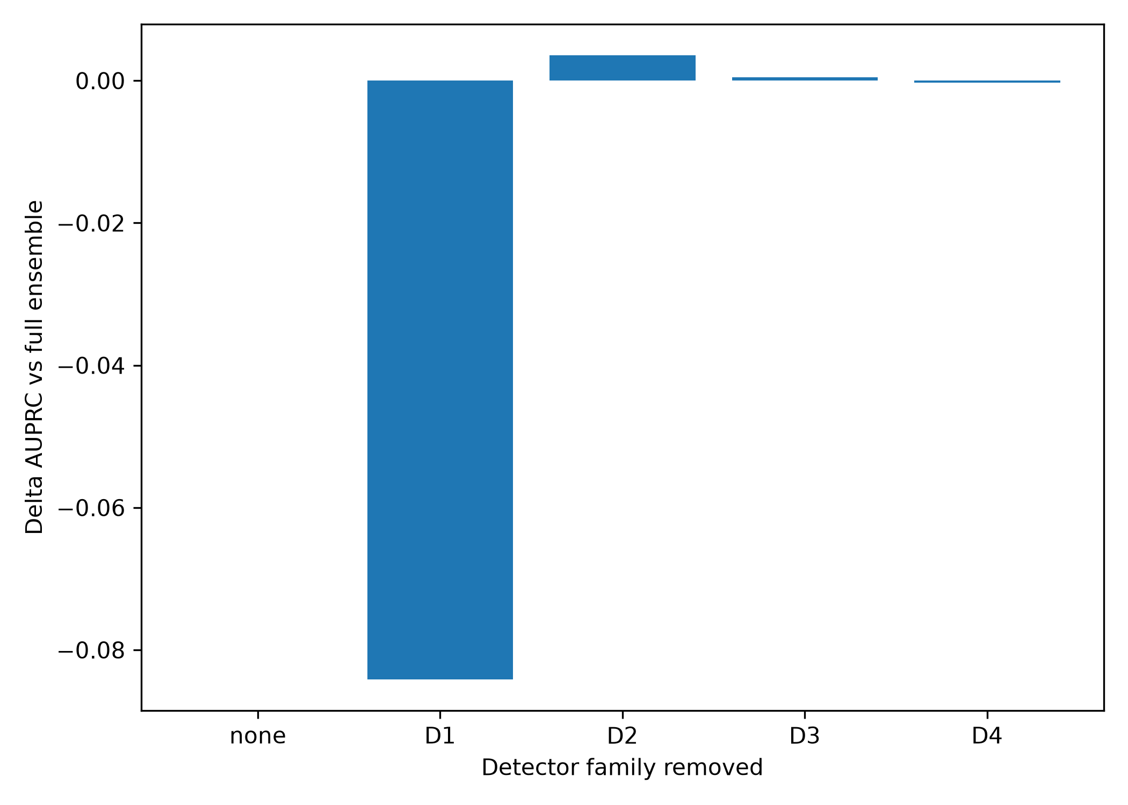
Figure 6. Change in AUPRC relative to the full D1–D4 ensemble after removing each signal family.

4.4 Ensemble discrimination, calibration, and selective use (RQ3)
Calibration analysis showed monotonic risk ordering but systematic underestimation of the observed event rate (Table 7a; Figure 7). Across predicted-risk quintiles, mean predicted risks increased from 0.324 to 0.731, whereas observed corruption rates increased from 0.650 to 0.900. The D5 Brier score was 0.231. Accordingly, the D5 score should be interpreted primarily as a ranking or triage signal rather than a calibrated probability of real-world translation error.
Selective retention produced a clearer operational benefit (Table 7b; Figure 8). At 100% coverage, accuracy was 0.670 and error rate 0.330. Retaining the 50% most confident decisions increased selective accuracy to 0.770 and reduced error to 0.230. Intermediate coverage levels showed a gradual trade-off: accuracy was 0.750 at 60% coverage, 0.743 at 70%, 0.731 at 80%, and 0.706 at 90%. The empirical risk–coverage AURC was 0.135. These results support selective triage, but they do not establish that deferred cases would necessarily be corrected by subsequent human review.
Table 7a. D5 calibration by equal-frequency risk bins.
bin | n | mean_predicted_risk | observed_event_rate
(0.267, 0.362] | 40 | 0.324 | 0.650
(0.362, 0.478] | 40 | 0.425 | 0.725
(0.478, 0.562] | 40 | 0.519 | 0.850
(0.562, 0.676] | 40 | 0.617 | 0.875
(0.676, 0.821] | 40 | 0.731 | 0.900

Table 7b. Selective risk–coverage performance for D5.
coverage | retained_n | selective_error_rate | selective_accuracy | mean_confidence
0.500 | 100.0 | 0.230 | 0.770 | 0.213
0.600 | 120.0 | 0.250 | 0.750 | 0.195
0.700 | 140.0 | 0.257 | 0.743 | 0.180
0.800 | 160.0 | 0.269 | 0.731 | 0.165
0.900 | 180.0 | 0.294 | 0.706 | 0.151
1.000 | 200.0 | 0.330 | 0.670 | 0.138

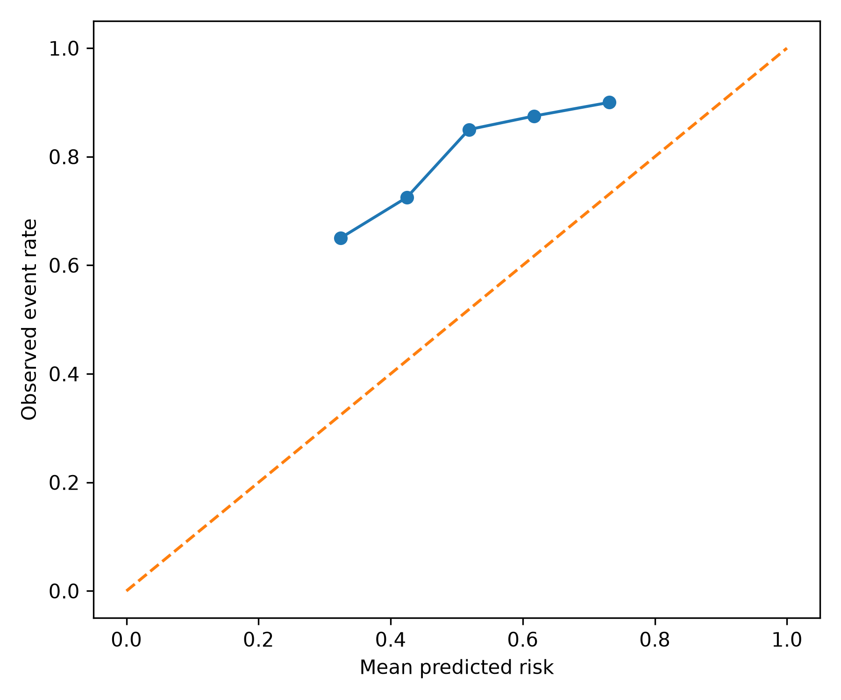
Figure 7. Calibration plot for D5 on the held-out test set.
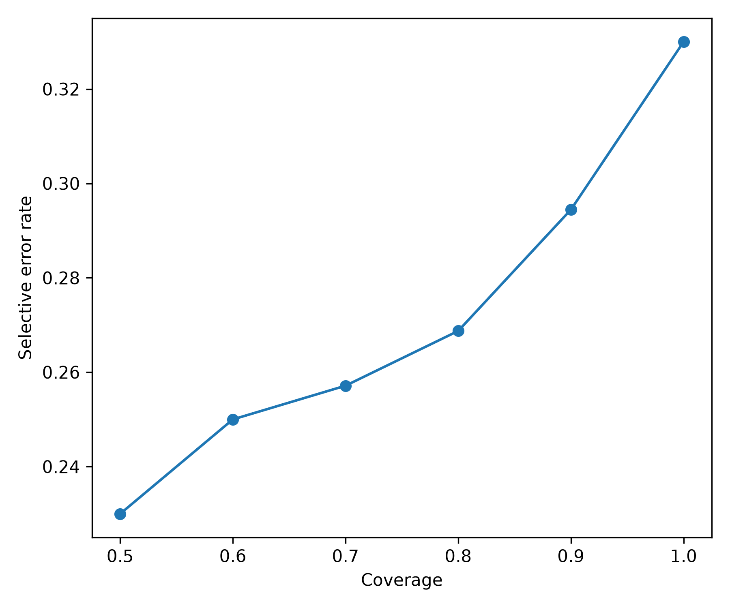
Figure 8. Selective error as a function of retained coverage for D5.

4.5 Error-family heterogeneity (RQ4)
Detection difficulty varied sharply by corruption family (Table 3; Figure 4). Methodological-design corruption was the most detectable family: D5 achieved AUROC = 0.894, AUPRC = 0.900, sensitivity = 0.975, and F1 = 0.788. D1 performed similarly strongly for this family (AUROC = 0.906, AUPRC = 0.911). Epistemic-force corruption showed moderate detectability with D5 AUROC = 0.659 and AUPRC = 0.640. Evidence omission was also moderately detectable (D5 AUROC = 0.611; AUPRC = 0.613).
Polarity corruption was the hardest family. D5 AUROC was 0.508 and AUPRC 0.544, effectively near chance discrimination in this balanced family-versus-clean comparison. None of the individual detectors resolved this difficulty: D1 AUROC = 0.513, D2 = 0.512, D3 = 0.522, and D4 = 0.465. The result identifies polarity reversal as a critical blind spot of the current safeguard stack.
Table 3. Detector performance by controlled error family versus clean instances.
family | detector | AUROC | AUPRC | sensitivity | specificity | F1 | MCC
E1_POLARITY | D1 | 0.513 | 0.534 | 0.350 | 0.625 | 0.406 | -0.026
E1_POLARITY | D2 | 0.512 | 0.511 | 0.550 | 0.450 | 0.524 | 0.000
E1_POLARITY | D3 | 0.522 | 0.517 | 0.675 | 0.350 | 0.581 | 0.026
E1_POLARITY | D4 | 0.465 | 0.516 | 0.175 | 0.850 | 0.264 | 0.034
E1_POLARITY | D5 | 0.507 | 0.544 | 0.450 | 0.500 | 0.462 | -0.050
E2_EPISTEMIC_FORCE | D1 | 0.661 | 0.640 | 0.700 | 0.625 | 0.675 | 0.326
E2_EPISTEMIC_FORCE | D2 | 0.501 | 0.504 | 0.575 | 0.450 | 0.541 | 0.025
E2_EPISTEMIC_FORCE | D3 | 0.495 | 0.534 | 0.700 | 0.350 | 0.596 | 0.053
E2_EPISTEMIC_FORCE | D4 | 0.494 | 0.514 | 0.125 | 0.850 | 0.196 | -0.036
E2_EPISTEMIC_FORCE | D5 | 0.659 | 0.640 | 0.750 | 0.500 | 0.667 | 0.258
E3_METHOD_DESIGN | D1 | 0.906 | 0.911 | 0.975 | 0.625 | 0.830 | 0.641
E3_METHOD_DESIGN | D2 | 0.547 | 0.521 | 0.650 | 0.450 | 0.591 | 0.102
E3_METHOD_DESIGN | D3 | 0.469 | 0.518 | 0.625 | 0.350 | 0.549 | -0.026
E3_METHOD_DESIGN | D4 | 0.444 | 0.492 | 0.150 | 0.850 | 0.231 | 0.000
E3_METHOD_DESIGN | D5 | 0.894 | 0.900 | 0.975 | 0.500 | 0.788 | 0.540
E4_EVIDENCE_OMISSION | D1 | 0.605 | 0.595 | 0.575 | 0.625 | 0.590 | 0.200
E4_EVIDENCE_OMISSION | D2 | 0.547 | 0.538 | 0.625 | 0.450 | 0.575 | 0.076
E4_EVIDENCE_OMISSION | D3 | 0.541 | 0.560 | 0.750 | 0.350 | 0.625 | 0.109
E4_EVIDENCE_OMISSION | D4 | 0.529 | 0.596 | 0.225 | 0.850 | 0.327 | 0.096
E4_EVIDENCE_OMISSION | D5 | 0.611 | 0.613 | 0.675 | 0.500 | 0.621 | 0.178

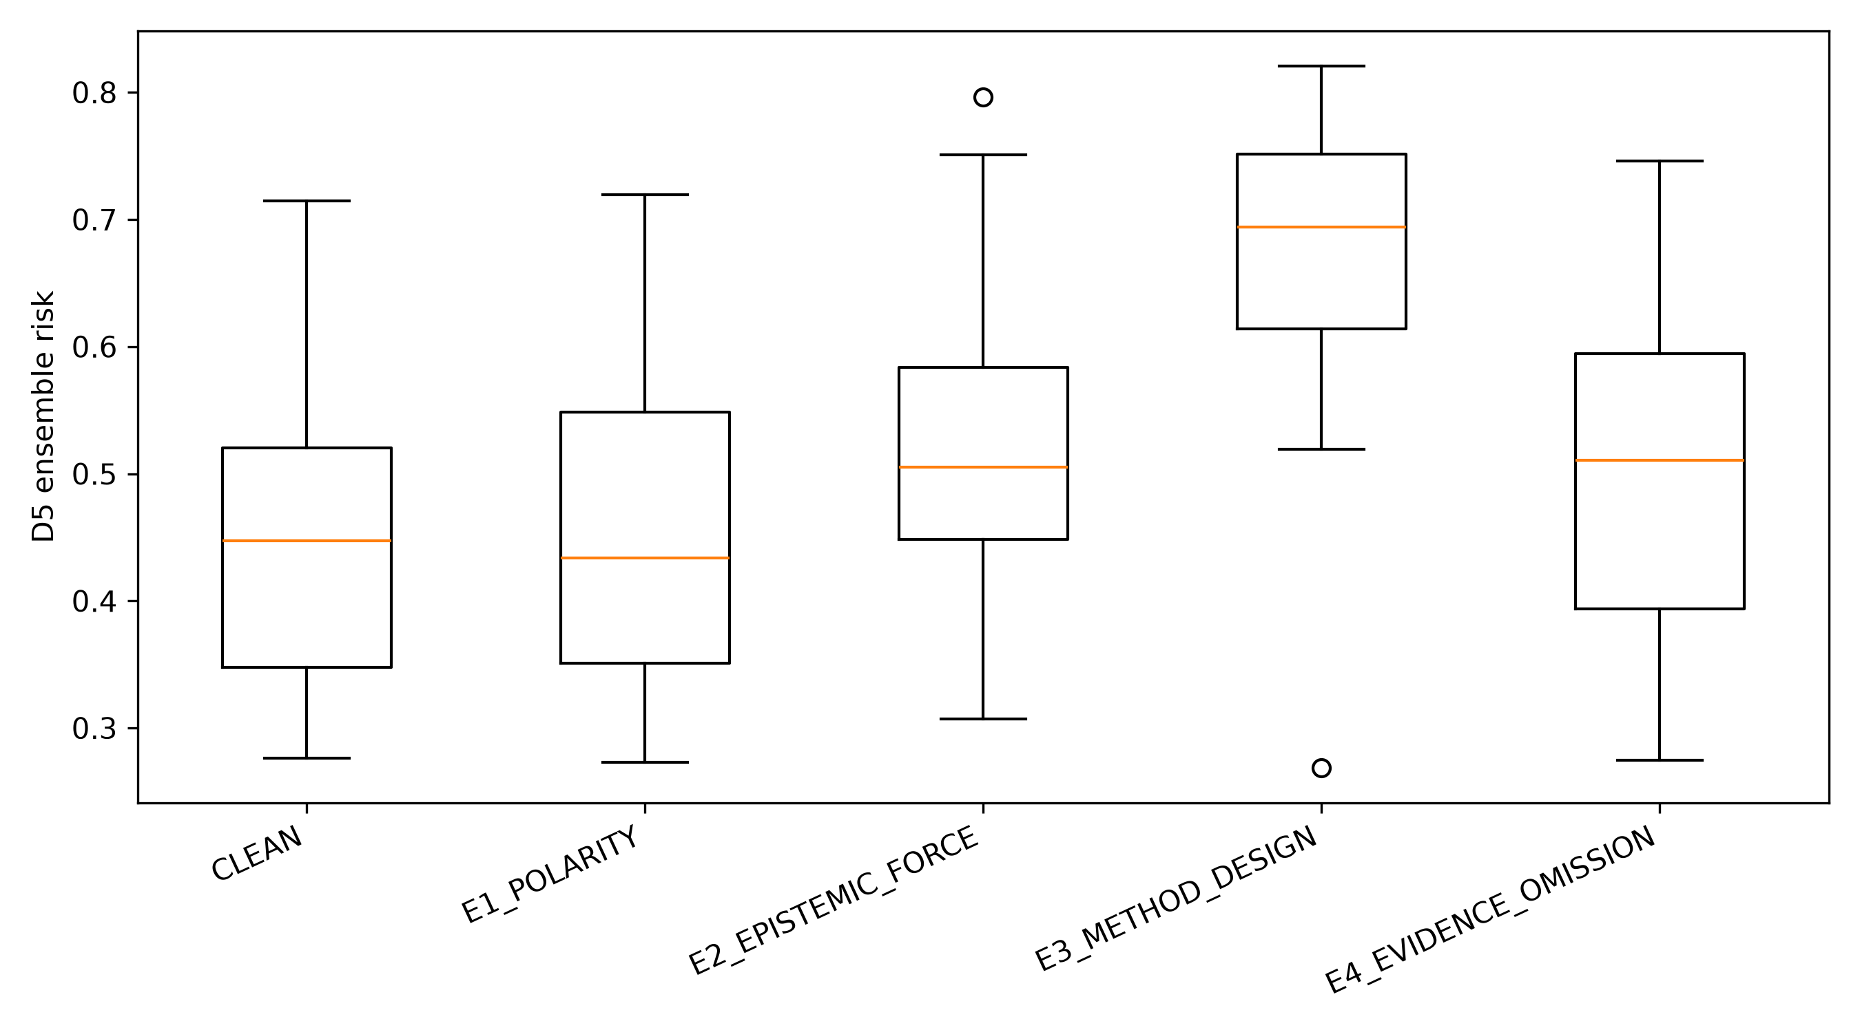
Figure 4. D5 ensemble risk distributions by clean and controlled error family.

4.6 Severity and disciplinary variation (RQ5)
Risk scores increased descriptively with perturbation severity but the trend did not meet conventional statistical significance (Table 4; Figure 5). Mean D5 risk was 0.510 for subtle, 0.540 for moderate, and 0.568 for severe corruptions; corresponding detection rates were 0.660, 0.667, and 0.820. The Spearman association between ordinal severity and risk was ρ = 0.154 (p = 0.052), while the Kruskal–Wallis comparison was H = 3.782 (p = 0.151). These results are consistent with a weak monotonic tendency but do not justify a claim of statistically established severity calibration.
Discipline-specific results were heterogeneous but descriptive because of small subgroup sizes (Table 5). D5 AUROC ranged from 0.622 in health and life sciences to 0.719 in STEM; arts and humanities achieved 0.684 and social sciences 0.663. AUPRC ranged from 0.868 to 0.911. Specificity was lowest in health and life sciences (0.273) and highest in STEM (0.636), whereas sensitivity showed the opposite tendency in several panels. These differences suggest domain sensitivity but require larger independent samples for confirmatory inference.
Table 4. D5 risk and detection by perturbation severity.
severity | n | documents | mean_D5_risk | median_D5_risk | detection_rate_D5 | spearman_severity_rho_all | spearman_p_all | Kruskal_H_all | Kruskal_p_all
moderate | 60 | 31 | 0.540 | 0.556 | 0.667 | 0.154 | 0.052 | 3.782 | 0.151
severe | 50 | 29 | 0.568 | 0.564 | 0.820 | 0.154 | 0.052 | 3.782 | 0.151
subtle | 50 | 30 | 0.510 | 0.508 | 0.660 | 0.154 | 0.052 | 3.782 | 0.151

Table 5. D5 held-out performance by disciplinary panel.
panel | n | documents | AUROC | AUPRC | sensitivity | specificity | F1 | MCC | Brier
AH | 40 | 8 | 0.684 | 0.905 | 0.719 | 0.500 | 0.780 | 0.187 | 0.250
HL | 55 | 11 | 0.622 | 0.868 | 0.841 | 0.273 | 0.831 | 0.118 | 0.223
SS | 50 | 10 | 0.662 | 0.897 | 0.625 | 0.600 | 0.725 | 0.182 | 0.235
STEM | 55 | 11 | 0.719 | 0.911 | 0.659 | 0.636 | 0.753 | 0.241 | 0.222

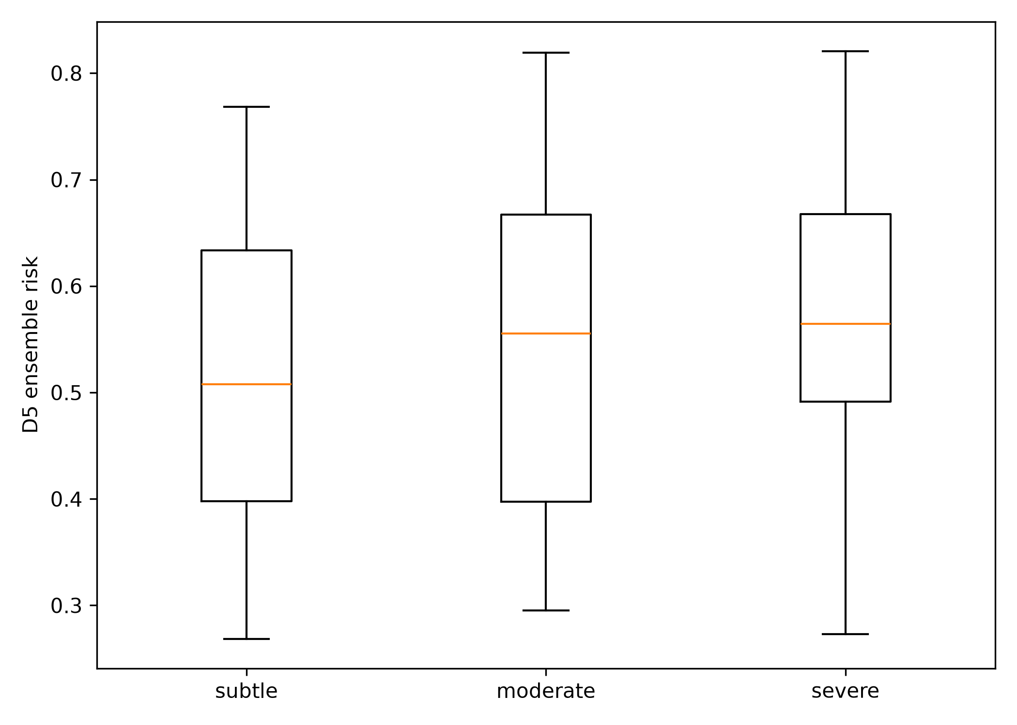
Figure 5. D5 ensemble risk distributions across controlled severity levels.

5. Discussion

5.1 Summary of principal findings
Five findings are central. First, the strongest overall detectors were D1 and D5, but the ensemble did not outperform deterministic safeguards consistently across discrimination, MCC, or Brier score. Second, ablation demonstrated that D1 accounted for most of the ensemble's incremental value. Third, detector sensitivity was highly phenomenon-specific: methodological-design corruption was readily detected, while polarity corruption remained near chance. Fourth, risk scores ordered cases sufficiently well to support selective retention, with accuracy increasing from 0.670 at full coverage to 0.770 at 50% coverage. Fifth, severity and disciplinary patterns were suggestive rather than conclusive.

5.2 Interpretation: epistemic risk is heterogeneous, not scalar
The most important interpretation is that scholarly translation risk is structurally heterogeneous. A single scalar semantic-similarity score did not capture the phenomena that mattered most in this benchmark. D2's AUROC of 0.527 is consistent with prior concerns that cross-lingual semantic encoders can preserve broad meaning while under-penalizing specific translationese or localized factual changes (Zhao et al., 2020). Likewise, backtranslation has documented value as a complementary signal rather than a sufficient standalone quality estimator (Moon et al., 2020; Agrawal et al., 2022), which is consistent with D3's near-chance aggregate AUROC here.
D1's importance is theoretically informative. The features most useful for the benchmark were explicit preservation and mismatch checks tied to the epistemic structure of research claims: negation, certainty markers, methodological concepts, numbers, and related surface signals. This aligns with challenge-set evidence that learned metrics can miss critical local phenomena and that combining transparent lexical or structural cues with neural metrics can improve robustness (Karpinska et al., 2022; Glushkova et al., 2023). The result does not imply that deterministic rules are generally superior to neural metrics; rather, it shows that when the target errors are structured and epistemically meaningful, deliberately engineered safeguards can be disproportionately useful.
The polarity result is equally consequential. Negation and direction changes can reverse the proposition while leaving lexical and semantic neighborhoods largely intact. Tang et al. (2021) showed that negation remains a non-trivial MT phenomenon despite strong aggregate system quality. In the present study, no detector substantially separated polarity corruptions from clean instances. This failure is more informative than an artificially high aggregate score: it identifies a specific risk class that should be targeted in future safeguard design.

5.3 Theoretical implications for Translation-Mediated Epistemic Integrity
SETR extends MT evaluation by shifting the unit of concern from general translation quality to preservation of epistemically consequential relations. Within TMEI, translation is a measurement layer: changes to polarity, evidential force, design, or reported evidence can propagate into literature synthesis, research assessment, evidence retrieval, or AI-assisted review. This perspective is compatible with recent findings that translation errors in multilingual benchmarks can measurably alter downstream evaluation outcomes (Thellmann et al., 2026).
The empirical results further suggest that epistemic integrity is best represented as a vector of partially independent risks rather than a single latent quality variable. Methodological-design corruption was highly visible to D1/D5, whereas polarity was almost invisible. Consequently, a safeguard architecture should be evaluated by phenomenon coverage and blind spots, not only by one global AUROC or correlation coefficient.

5.4 Practical implications: safeguards should triage, not certify
The operational implication is a layered safeguard workflow. Deterministic checks are inexpensive and, in this benchmark, carried the largest marginal contribution. Semantic and backtranslation signals can still supply complementary evidence, especially when future benchmarks include less rule-like errors. Thai-native scoring may be useful as an additional independent view, but the weak standalone D4 performance observed here argues against treating a small decision model as a quality oracle.
The risk–coverage results support selective use. A system could automatically pass only high-confidence cases, route intermediate cases through additional computational checks, and defer high-risk or ambiguous cases for expert review. This is more defensible than binary auto-certification. However, the observed calibration gap is important: D5 scores systematically underestimated the empirical perturbation rate. Any deployment requiring probabilistic interpretation would therefore need external calibration on naturally occurring errors and the target application domain.

5.5 Limitations
Several limitations constrain interpretation. First, the benchmark contains controlled perturbations, not a representative sample of naturally occurring English–Thai translation errors. Performance therefore estimates sensitivity to constructed stress-test phenomena, not real-world error prevalence. Second, the source corpus contained 80 M2 documents and only 40 held-out test documents, limiting subgroup inference. Third, the analysis was restricted to scholarly abstracts and to one language pair. Full texts may introduce discourse-level dependencies, tables, equations, and terminology patterns not represented here.
Fourth, four core corruption families were evaluated. Numerical corruption was retained as an auxiliary trigger-based challenge rather than part of the balanced core, and other important phenomena—entity substitution, causal inversion, comparator changes, unit errors, citation attribution, and discourse-level scope—remain untested. Fifth, the primary Thai translations came from one frozen MT system, so the benchmark does not characterize error distributions across commercial or LLM-based translators.
Sixth, no human expert labels were used by design. This strengthens reproducibility of the controlled benchmark but means the study cannot claim alignment with human judgments of translation quality or harm. OpenThai-SystemOne was one computational signal, not human ground truth. Seventh, the 4:1 positive-to-clean ratio makes AUPRC numerically high even for weak detectors; interpretation must therefore consider the 0.80 prevalence baseline. Finally, the ensemble was not externally validated, and its probability estimates were not well calibrated.

5.6 Recommendations for future research
Future work should validate SETR on naturally occurring translation errors annotated by bilingual domain experts and should explicitly compare controlled-error sensitivity with real-world error detection. External validation should include multiple translation systems and additional language pairs, particularly typologically diverse and low-resource languages. Full-text scholarly documents should be studied to capture discourse scope, tables, units, and citation context.
Methodologically, future safeguards should target the polarity blind spot directly through contradiction-aware or natural-language-inference features, explicit negation scope modelling, and counterfactual consistency tests. The strong D1 contribution also motivates systematic expansion of transparent epistemic checks for effect direction, uncertainty, study design, population, comparator, outcome, and quantitative claims. Finally, selective-deferral policies should be prospectively evaluated with human reviewers to measure whether flagged cases actually reduce downstream interpretive error and whether the added verification burden is acceptable.

6. Conclusion
This study introduced SETR, a reproducible stress-testing framework for evaluating automated safeguards against controlled, epistemically consequential corruptions in English–Thai scholarly translation. Across 400 frozen benchmark instances, deterministic safeguards and the stacked ensemble provided moderate overall discrimination, but ablation showed that deterministic features contributed most of the ensemble's value. Detection was highly phenomenon-specific: methodological-design corruption was detected reliably, whereas polarity corruption remained a major blind spot. The ensemble's risk ordering supported selective triage, but its probability calibration was inadequate for interpreting scores as real-world error probabilities. These findings support a layered conception of translation safeguards: transparent deterministic checks, semantic and backtranslation evidence, language-specific signals, and selective deferral can be combined to identify risk, but they should not be treated as substitutes for expert judgment. SETR therefore contributes a methodological bridge between machine-translation evaluation and the integrity of scholarly evidence, while preserving a strict boundary between controlled-error sensitivity and claims about natural translation quality or safety.

Declarations

Ethics statement
The study used bibliographic records and scholarly abstracts and involved no human participants, intervention, or collection of private personal data. The M2 benchmark labels were generated by controlled computational perturbation.

Availability of data and materials
The public reproducibility materials supporting this study are archived in Zenodo at [ZENODO DOI]. The versioned deposit contains frozen aggregate statistical tables, publication figures, model/version and random-seed registries, data documentation, freeze reports, and provenance manifests. Verbatim scholarly source abstracts and full derived translations are not redistributed publicly where redistribution rights are not established; the repository provides schemas and reconstruction instructions for legally obtained local copies. The GitHub release corresponding to the archived version is available at [GITHUB RELEASE URL].

Code availability
The compatibility-patched analysis scripts used to reproduce D1–D5 scoring, held-out statistical evaluation, ablation, calibration, risk–coverage analysis, figure generation, and the final freeze gate are included in the Zenodo/GitHub research compendium at [ZENODO DOI]. Code is released under the MIT License; repository-authored documentation, aggregate result tables, and figures are released under CC BY 4.0, while third-party source texts and model weights remain subject to their original terms.

AI and computational tools disclosure
Machine-translation and decision models were used as research instruments according to the frozen protocol. No model output was treated as human-equivalent ground truth. Any generative-AI assistance used in manuscript preparation should be disclosed according to the target journal's policy.

Conflict of interest
The authors declare no conflict of interest relevant to this study. [Verify before submission.]

Funding
[Insert verified funding statement and grant number before submission.]

References
Agrawal, S., Mehandru, N., Salehi, N., & Carpuat, M. (2022). Quality estimation via backtranslation at the WMT 2022 quality estimation task. In Proceedings of the Seventh Conference on Machine Translation (WMT) (pp. 593–596). Association for Computational Linguistics. https://doi.org/10.18653/v1/2022.wmt-1.54
Amrhein, C., Moghe, N., & Guillou, L. (2022). ACES: Translation accuracy challenge sets for evaluating machine translation metrics. In Proceedings of the Seventh Conference on Machine Translation (WMT) (pp. 479–513). Association for Computational Linguistics. https://doi.org/10.18653/v1/2022.wmt-1.44
Costa-jussà, M. R., Cross, J., Çelebi, O., Elbayad, M., Heafield, K., Heffernan, K., Kalbassi, E., Lam, J., Licht, D., Maillard, J., Sun, A., Wang, S., Wenzek, G., Youngblood, A., Akula, B., Gonzalez, G., Hansanti, P., Hoffman, J., Jarrett, S., … Wang, J. (2022). No language left behind: Scaling human-centered machine translation. arXiv. https://doi.org/10.48550/arXiv.2207.04672
Fomicheva, M., Sun, S., Yankovskaya, L., Blain, F., Guzmán, F., Fishel, M., Aletras, N., Chaudhary, V., & Specia, L. (2020). Unsupervised quality estimation for neural machine translation. Transactions of the Association for Computational Linguistics, 8, 539–555. https://doi.org/10.1162/tacl_a_00330
Freitag, M., Foster, G., Grangier, D., Ratnakar, V., Tan, Q., & Macherey, W. (2021a). Experts, errors, and context: A large-scale study of human evaluation for machine translation. Transactions of the Association for Computational Linguistics, 9, 1460–1474. https://doi.org/10.1162/tacl_a_00437
Freitag, M., Rei, R., Mathur, N., Lo, C.-K., Stewart, C., Foster, G., Lavie, A., & Bojar, O. (2021b). Results of the WMT21 metrics shared task: Evaluating metrics with expert-based human evaluations on TED and news domain. In Proceedings of the Sixth Conference on Machine Translation (pp. 733–774). Association for Computational Linguistics.
Gao, C., Chaudhary, V., Chen, P.-J., Wenzek, G., Ju, D., Krishnan, S., Ranzato, M., Guzmán, F., & Fan, A. (2022). The FLORES-101 evaluation benchmark for low-resource and multilingual machine translation. Transactions of the Association for Computational Linguistics, 10, 522–538. https://doi.org/10.1162/tacl_a_00474
Glushkova, T., Zerva, C., Rei, R., & Martins, A. F. T. (2021). Uncertainty-aware machine translation evaluation. In Findings of the Association for Computational Linguistics: EMNLP 2021. Association for Computational Linguistics. https://doi.org/10.18653/v1/2021.findings-emnlp.330
Glushkova, T., Zerva, C., & Martins, A. F. T. (2023). BLEU meets COMET: Combining lexical and neural metrics towards robust machine translation evaluation. arXiv. https://doi.org/10.48550/arXiv.2305.19144
Guerreiro, N. M., Rei, R., van Stigt, D., Coheur, L., Colombo, P., & Martins, A. F. T. (2024). xCOMET: Transparent machine translation evaluation through fine-grained error detection. Transactions of the Association for Computational Linguistics, 12, 979–995. https://doi.org/10.1162/tacl_a_00683
Hlaing, Z. Z., Thu, Y. K., Supnithi, T., & Netisopakul, P. (2022). Improving neural machine translation with POS-tag features for low-resource language pairs. Heliyon, 8, e10375. https://doi.org/10.1016/j.heliyon.2022.e10375
iApp Technology. (2026). OpenThai-SystemOne (Version 0.3) [Machine-learning model documentation]. OpenThai. https://openthai.ai/en/openthai-systemone
Karpinska, M., Raj, N., Thai, K., Song, Y., Gupta, A., & Iyyer, M. (2022). DEMETR: Diagnosing evaluation metrics for translation. In Proceedings of the 2022 Conference on Empirical Methods in Natural Language Processing (pp. 9540–9561). Association for Computational Linguistics. https://doi.org/10.18653/v1/2022.emnlp-main.649
Koo, R., Lee, M., Raheja, V., Park, J. I., Kim, Z. M., & Kang, D. (2023). Benchmarking cognitive biases in large language models as evaluators. arXiv. https://doi.org/10.48550/arXiv.2309.17012
Moon, J., Cho, H. C., & Park, E. L. (2020). Revisiting round-trip translation for quality estimation. arXiv. https://doi.org/10.48550/arXiv.2004.13937
Rei, R., Stewart, C., Farinha, A. C., & Lavie, A. (2020). COMET: A neural framework for MT evaluation. In Proceedings of the 2020 Conference on Empirical Methods in Natural Language Processing (EMNLP) (pp. 2685–2702). Association for Computational Linguistics. https://doi.org/10.18653/v1/2020.emnlp-main.213
Reimers, N., & Gurevych, I. (2020). Making monolingual sentence embeddings multilingual using knowledge distillation. In Proceedings of the 2020 Conference on Empirical Methods in Natural Language Processing (EMNLP) (pp. 4512–4525). Association for Computational Linguistics. https://doi.org/10.18653/v1/2020.emnlp-main.365
San, M. E., Usanavasin, S., Thu, Y. K., & Okumura, M. (2024). A study for enhancing low-resource Thai-Myanmar-English neural machine translation. ACM Transactions on Asian and Low-Resource Language Information Processing, 23, 1–24. https://doi.org/10.1145/3645111
Shi, B.-X. (2026). Statistical analysis of human and AI machine translation accuracy, style, and context in academic English. Journal of Psycholinguistic Research, 55. https://doi.org/10.1007/s10936-026-10274-5
Song, Y., Zhao, J., & Specia, L. (2021). SentSim: Crosslingual semantic evaluation of machine translation. In Proceedings of the 2021 Conference of the North American Chapter of the Association for Computational Linguistics: Human Language Technologies (pp. 3143–3156). Association for Computational Linguistics. https://doi.org/10.18653/v1/2021.naacl-main.252
Sun, K., & Wang, R. (2024). Textual similarity as a key metric in machine translation quality estimation. arXiv. https://doi.org/10.48550/arXiv.2406.07440
Tang, G., Rönchen, P., Sennrich, R., & Nivre, J. (2021). Revisiting negation in neural machine translation. Transactions of the Association for Computational Linguistics, 9, 740–755. https://doi.org/10.1162/tacl_a_00395
Thellmann, K., Stadler, B., Färber, M., & Lehmann, J. (2026). Quantifying the impact of translation errors on multilingual LLM evaluation. In Proceedings of the 64th Annual Meeting of the Association for Computational Linguistics (Long Papers) (pp. 41311–41334). Association for Computational Linguistics. https://doi.org/10.18653/v1/2026.acl-long.1916
Tiedemann, J., & Thottingal, S. (2020). OPUS-MT—Building open translation services for the world. In Proceedings of the 22nd Annual Conference of the European Association for Machine Translation (pp. 479–480). European Association for Machine Translation.
Xu, Y.-M., Hu, L., Zhao, J., Qiu, Z., Xu, K.-X., Ye, Y.-Q., & Gu, H. (2024). A survey on multilingual large language models: Corpora, alignment, and bias. Frontiers of Computer Science, 19. https://doi.org/10.1007/s11704-024-40579-4
Yan, Y., Song, J., Fu, B., Ye, N., & Shi, X. (2024). Automatic reference-free fine-grained machine translation error detection via named entity recognition and back-translation. In Lecture Notes in Computer Science (pp. 306–317). Springer. https://doi.org/10.1007/978-981-97-5672-8_26
Zhao, W., Glavaš, G., Peyrard, M., West, R., & Eger, S. (2020). On the limitations of cross-lingual encoders as exposed by reference-free machine translation evaluation. In Proceedings of the 58th Annual Meeting of the Association for Computational Linguistics (pp. 1656–1671). Association for Computational Linguistics. https://doi.org/10.18653/v1/2020.acl-main.151

