VirtualExams
Manual: architecture, components and tools

A web-based framework for practice exams and, later, supervised exams, written for COMP 352 (Data Structures and Algorithms).
Repository: github.com/tiperiu/VirtualExams
November 2026 · describes the code as of commit e3f391b (29-question demo exam, 10 question types)

Contents
1 Overview — what VirtualExams does, the two modes, the main terms
2 Architecture — the whole picture, the repository, how the code is organised, why no server is needed
3 The exam app — what students see: start page, questions, review, results, submission file
4 Question types — how a type is built, and each of the ten types in turn
5 The problem bank — folders, file naming, problem and solution files, images
6 The problem editor — creating, editing and checking problems
7 Building an exam — the spec file, build_exam.py, pack_exam.py, publishing
8 Grading — how answers are graded, partial credit, offline grading with grade.mjs
9 Extending the framework — adding a new question type
10 Limitations and next steps — security, the server, authentication
A Command reference — every command in one place

1 Overview
VirtualExams runs exams in a web browser. A student enters their student ID, answers the questions one page at a time, reviews their answers and submits. The answers are saved as one JSON file. The framework was built for the data-structures and algorithms material of COMP 352, so most question types are interactive exercises — tracing a sort, building a heap, filling a hash table, rebalancing an AVL tree — rather than plain multiple choice.
Three ideas run through the whole design:
- Problems are independent of exams. Every problem is its own small JSON file in a problem bank, with its answer key in a separate file. An exam is just a list of bank problems with points.
- Question types are templates. A type (for example "hash table") knows how to draw any problem of that kind and how to grade it. A problem only supplies the data: the keys, the table size, the probing method.
- The answer is computed, not typed in. For the algorithmic types the grader runs the algorithm on the problem data, so a problem cannot have a wrong answer key, and the feedback can list every step.

1.1 The two modes
Mode | What the student gets | Use
practice (default) | After submitting: the score, which answers were right, the correct answers and a step-by-step explanation. | Practice sets published to students; the solutions travel with the exam.
exam | No feedback; the submission file is saved and graded afterwards. | Real exams. Needs the server (chapter 10) to be secure.

1.2 Terms used in this manual
Term | Meaning
problem | One exercise: a JSON file with a type and the data of the exercise (e.g. bank/problems/hash-table/hash-linear-m11.json).
solution | The answer key of a problem, in a separate file with the same name under solutions/. For most types it only holds the scoring mode and an explanation.
question type | The code that draws and grades one kind of problem: js/types/<type>/view.js and grader.js.
problem bank | A folder with problems/, solutions/ and assets/, one subfolder per type. bank/ is the course bank.
spec | A JSON file describing one exam: which bank folders, which problems with how many points, title, date, duration, mode.
exam folder | The output of the build: a self-contained folder (exams/<id>/) that students open.
bundle | exam.bundle.js: all the JSON of an exam packed into one script file, so the exam opens from disk.
submission | The JSON file a student downloads when submitting: their ID, times and one answer per question.

2 Architecture

2.1 The whole picture
Figure 1 shows how the parts fit together. Everything on the top half happens on your computer; the bottom half is what students do.
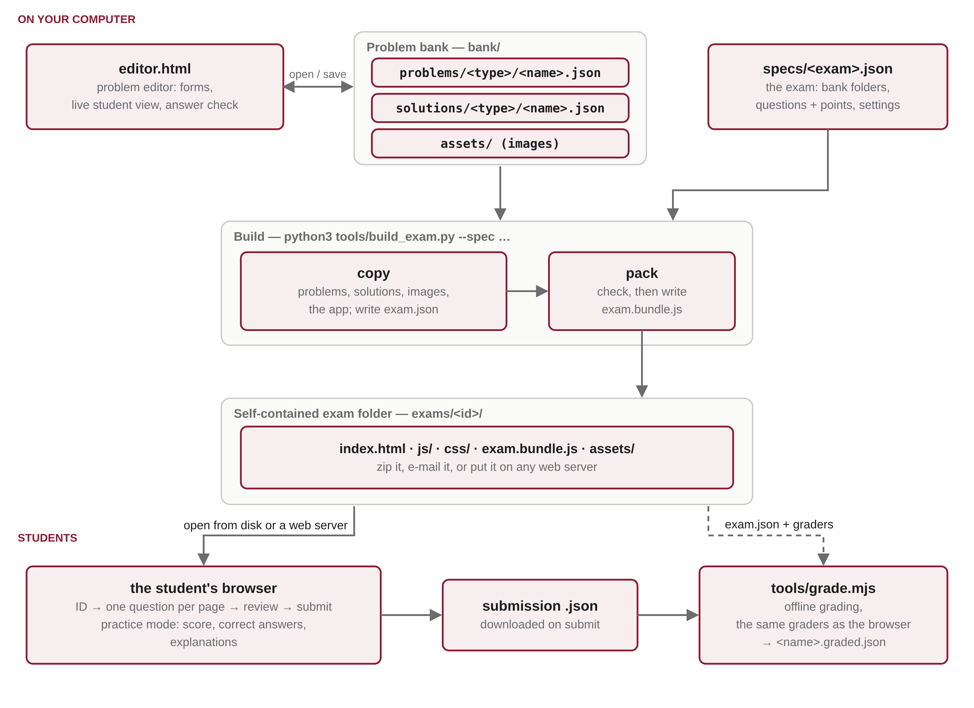
Figure 1. Architecture: from writing problems to grading submissions.
- Write problems with the editor (editor.html). It reads and writes the problem bank directly: one problem file and one solution file per problem.
- Describe an exam in a spec file (specs/<exam>.json): the bank folders, the questions and their points, and the exam settings.
- Build with python3 tools/build_exam.py --spec specs/<exam>.json. It copies the chosen problems, solutions and images and the exam app into a new folder, and packs the data into exam.bundle.js.
- Publish the exam folder: zip it, e-mail it, or put it on any web server. Students open its index.html in a browser.
- Students answer and submit. In practice mode they see their results at once. Each submission is also downloaded as a JSON file.
- Grade submissions offline with node tools/grade.mjs if needed. It uses exactly the same grading code as the browser.

2.2 The repository
VirtualExams/
index.html the exam app (template copied into every exam)
editor.html the problem editor
css/ exam.css, editor.css
js/
util.js small DOM helpers, dates, storage
app.js the exam app: start page, questions, review, results
exam-loader.js loads exam.bundle.js
grading/grade-exam.js grades a whole submission (browser and Node)
types/ one folder per question type: view.js + grader.js
array-fill.js shared "fill an array" component
common.js shared prompt rendering
editor/ the editor: app.js, bank.js, form.js, types/ (one form per type)
bank/ the problem bank: problems/, solutions/, assets/
specs/ exam descriptions (demo-comp352.json)
exams/ built exams (demo-comp352/)
tools/
build_exam.py builds an exam folder from a spec
pack_exam.py writes exam.bundle.js (run by build_exam.py)
grade.mjs offline grader (Node.js)
README.md

2.3 How the code is organised
The app is plain JavaScript with no build step and no libraries: every file is a classic <script> that adds itself to one global object, VE. This is deliberate, because classic scripts load from disk (file://) where JavaScript modules do not.
- Each question type registers a view, VE.views[type] = { render, isAnswered }, and a grader, VE.graders[type] = { grade }.
- The exam app (app.js) never needs to know the types: for each question it looks up VE.views[q.type] to draw it and VE.graders[q.type] to grade it.
- Graders are pure functions — no page, no network — so tools/grade.mjs loads the same files into Node and grades exactly as the browser does.
- The editor (editor.html) loads the same type files, so its preview is the real student view and its "Check my answer" button runs the real grader.

2.4 Why it works without a server
A built exam opens by double-clicking index.html, with no server. The one obstacle is a browser security rule: a page opened from disk (file://) may not read other files on the disk with JavaScript, so it cannot read exam.json or the problem files. It may still load <script> files. The pack step therefore rewrites all the exam data as one script, exam.bundle.js, which the page loads like any other script (Figure 2).
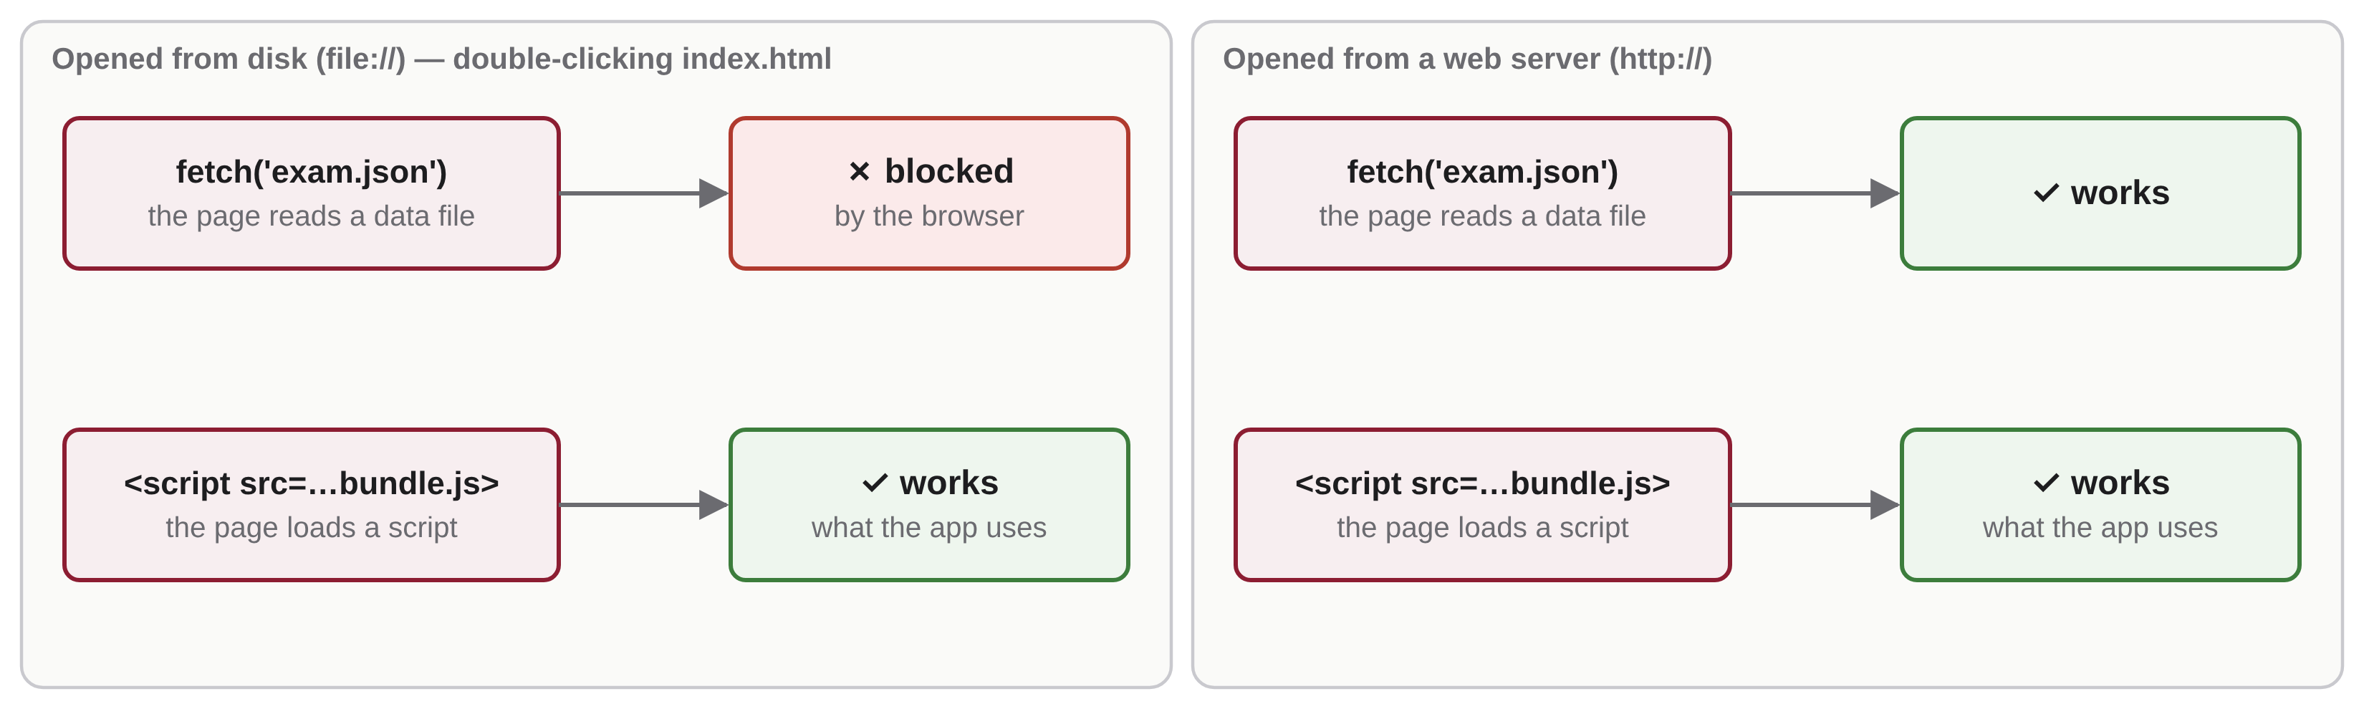
Figure 2. What the browser allows from disk and from a web server.
The same exam folder works unchanged on a web server: there the page could read the JSON files directly, but it simply loads exam.bundle.js as well. A server only delivers files; all the exam logic runs in the student's browser.

3 The exam app
This chapter shows what students see. The screenshots are from the demo exam, exams/demo-comp352/.

3.1 Start page
The start page shows the course, the exam details (type, date, time, duration, number of questions and points) and the instructions from the spec. The student types their student ID, which is checked against the spec's studentIdPattern (8 digits for Concordia), and presses Start.
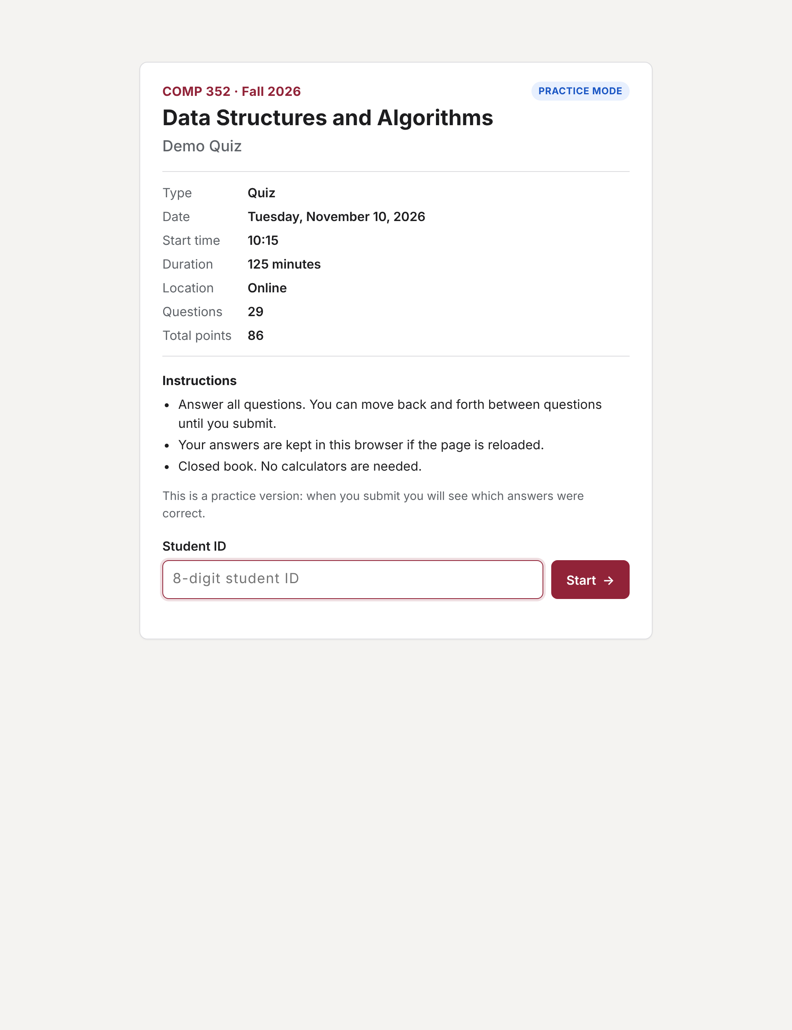
Figure 3. The start page.

3.2 Answering
Questions are shown one per page. The numbered pills at the top jump to any question and show which ones are answered; Previous / Next move in order. If the spec sets a duration, a countdown runs in the header (it turns red in the last five minutes; nothing is enforced yet). Every change is saved in the browser's local storage at once, so a reload or a closed tab does not lose answers.
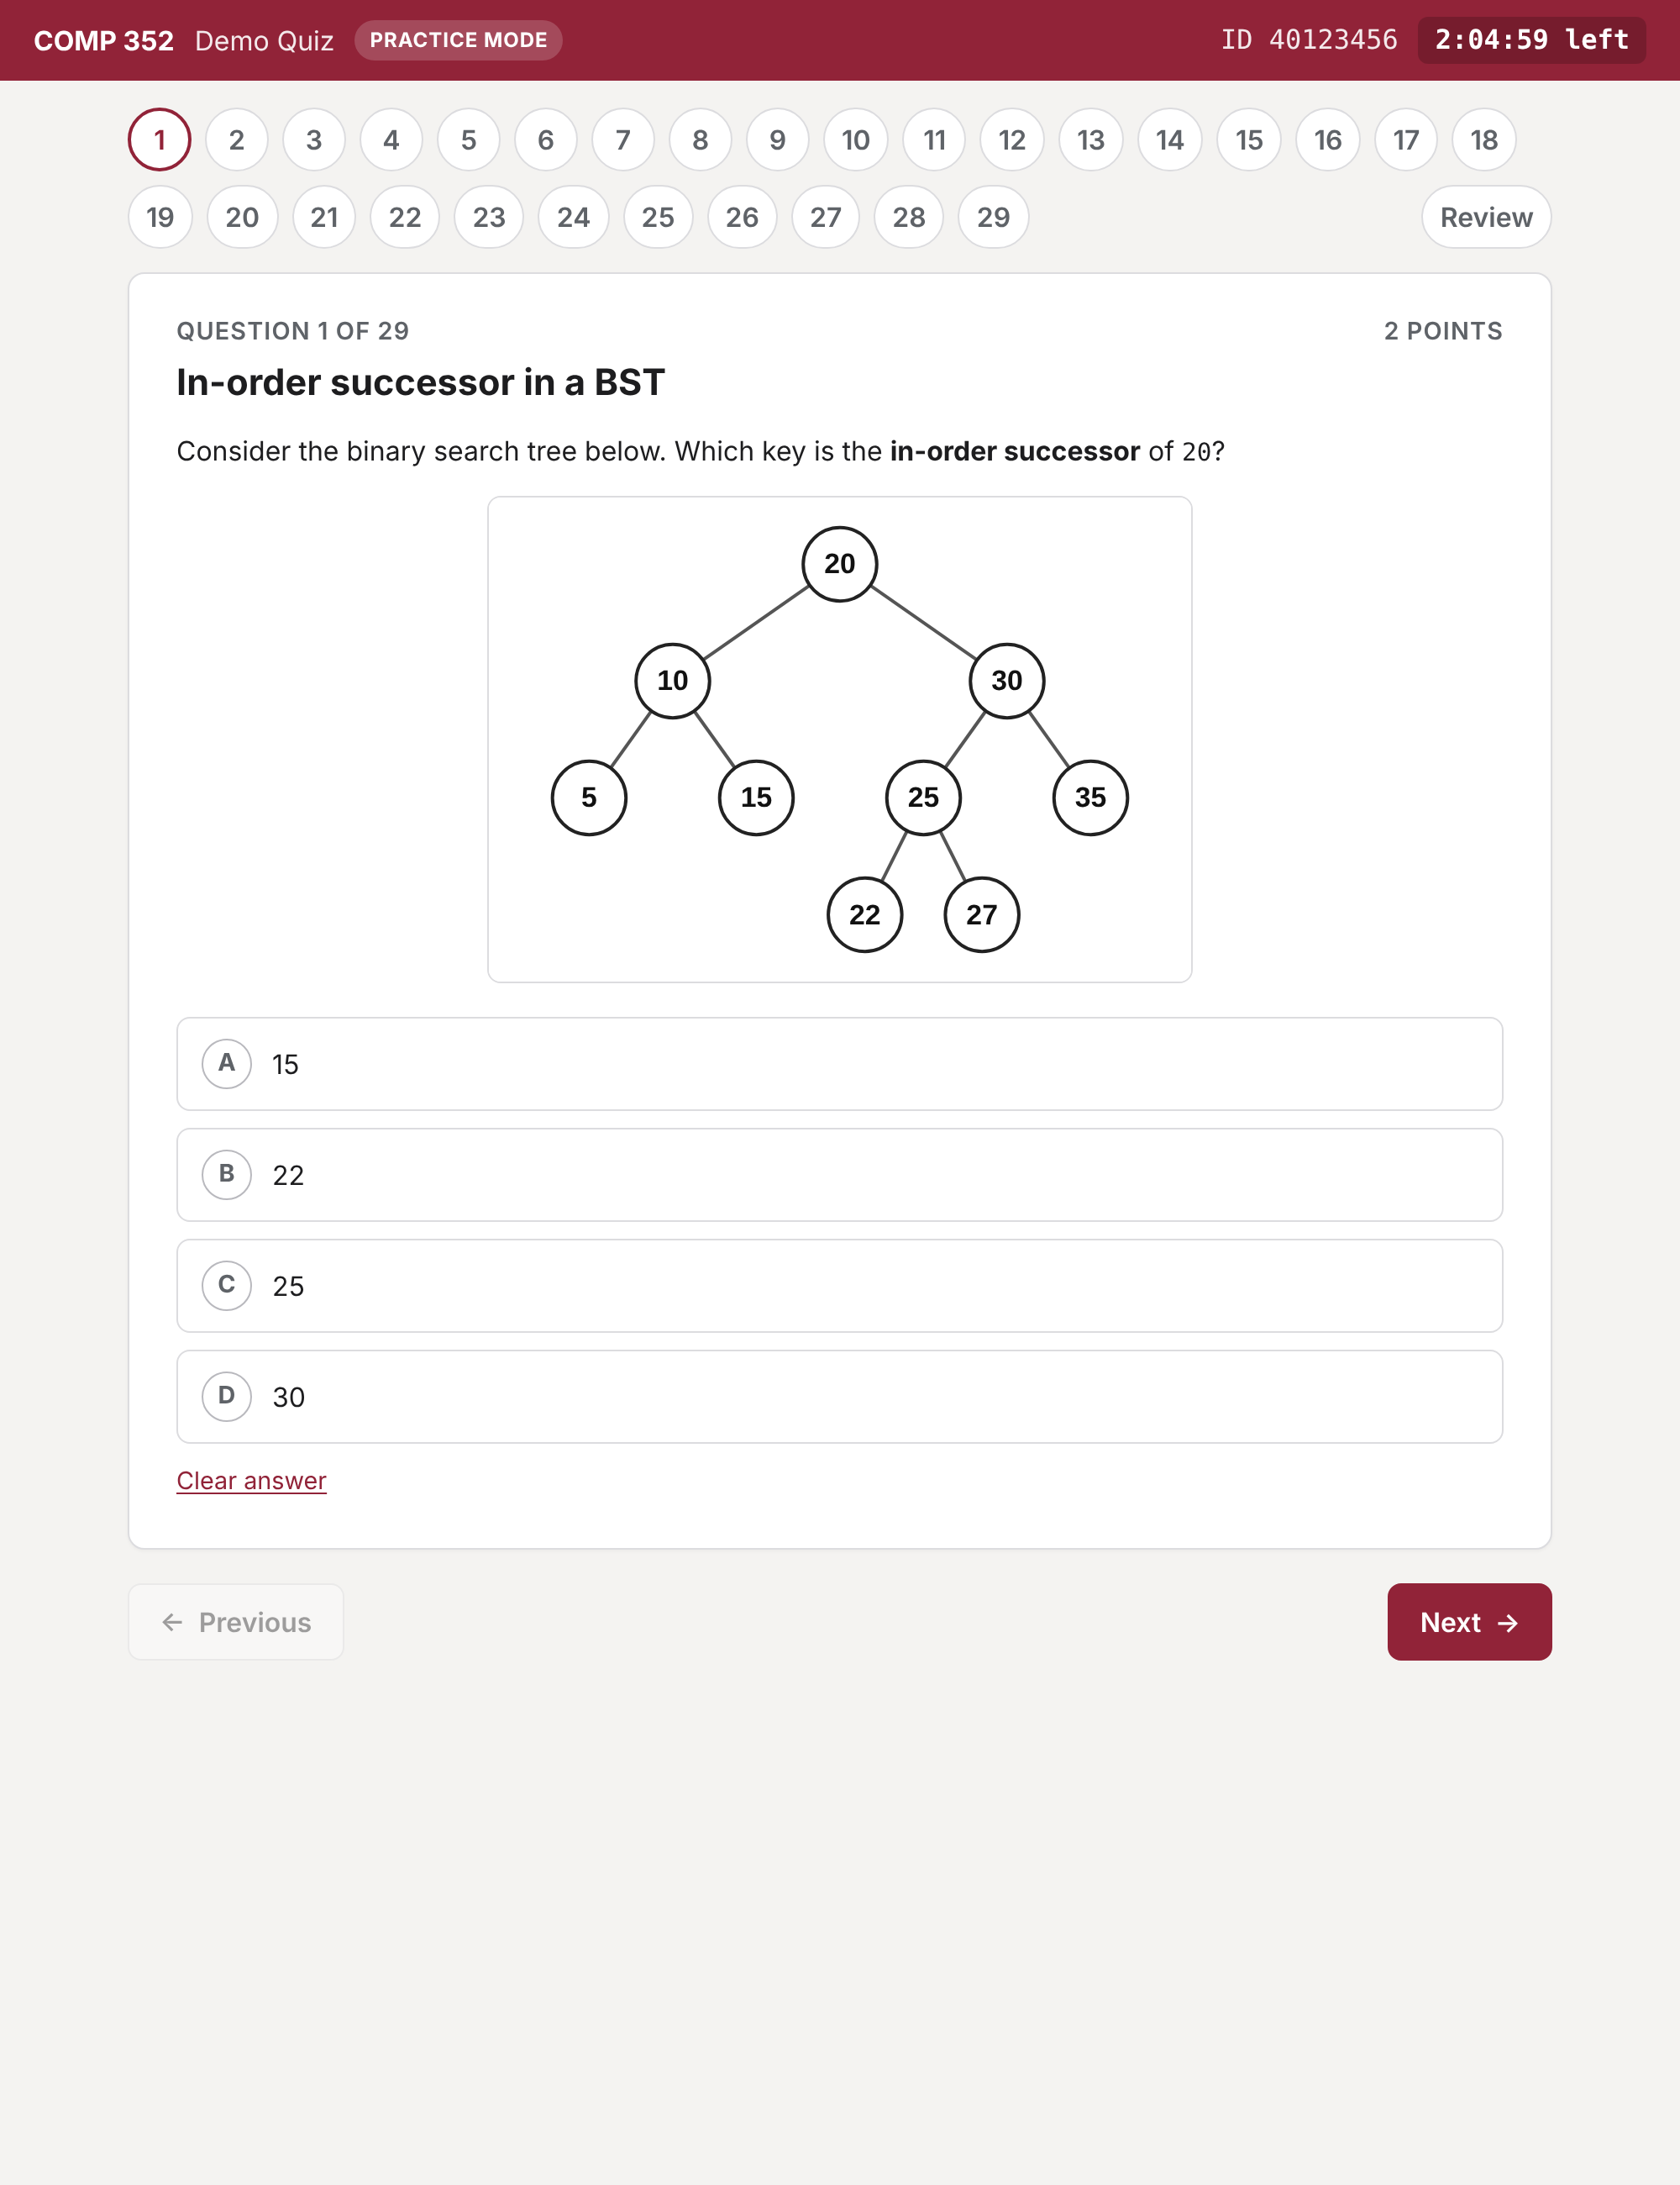
Figure 4. A question page, with the question pills and the countdown.

3.3 Review and submit
Review lists every question with its status (answered or not) and a link back to it. Submit asks for confirmation, then downloads the submission file and, in practice mode, shows the results.
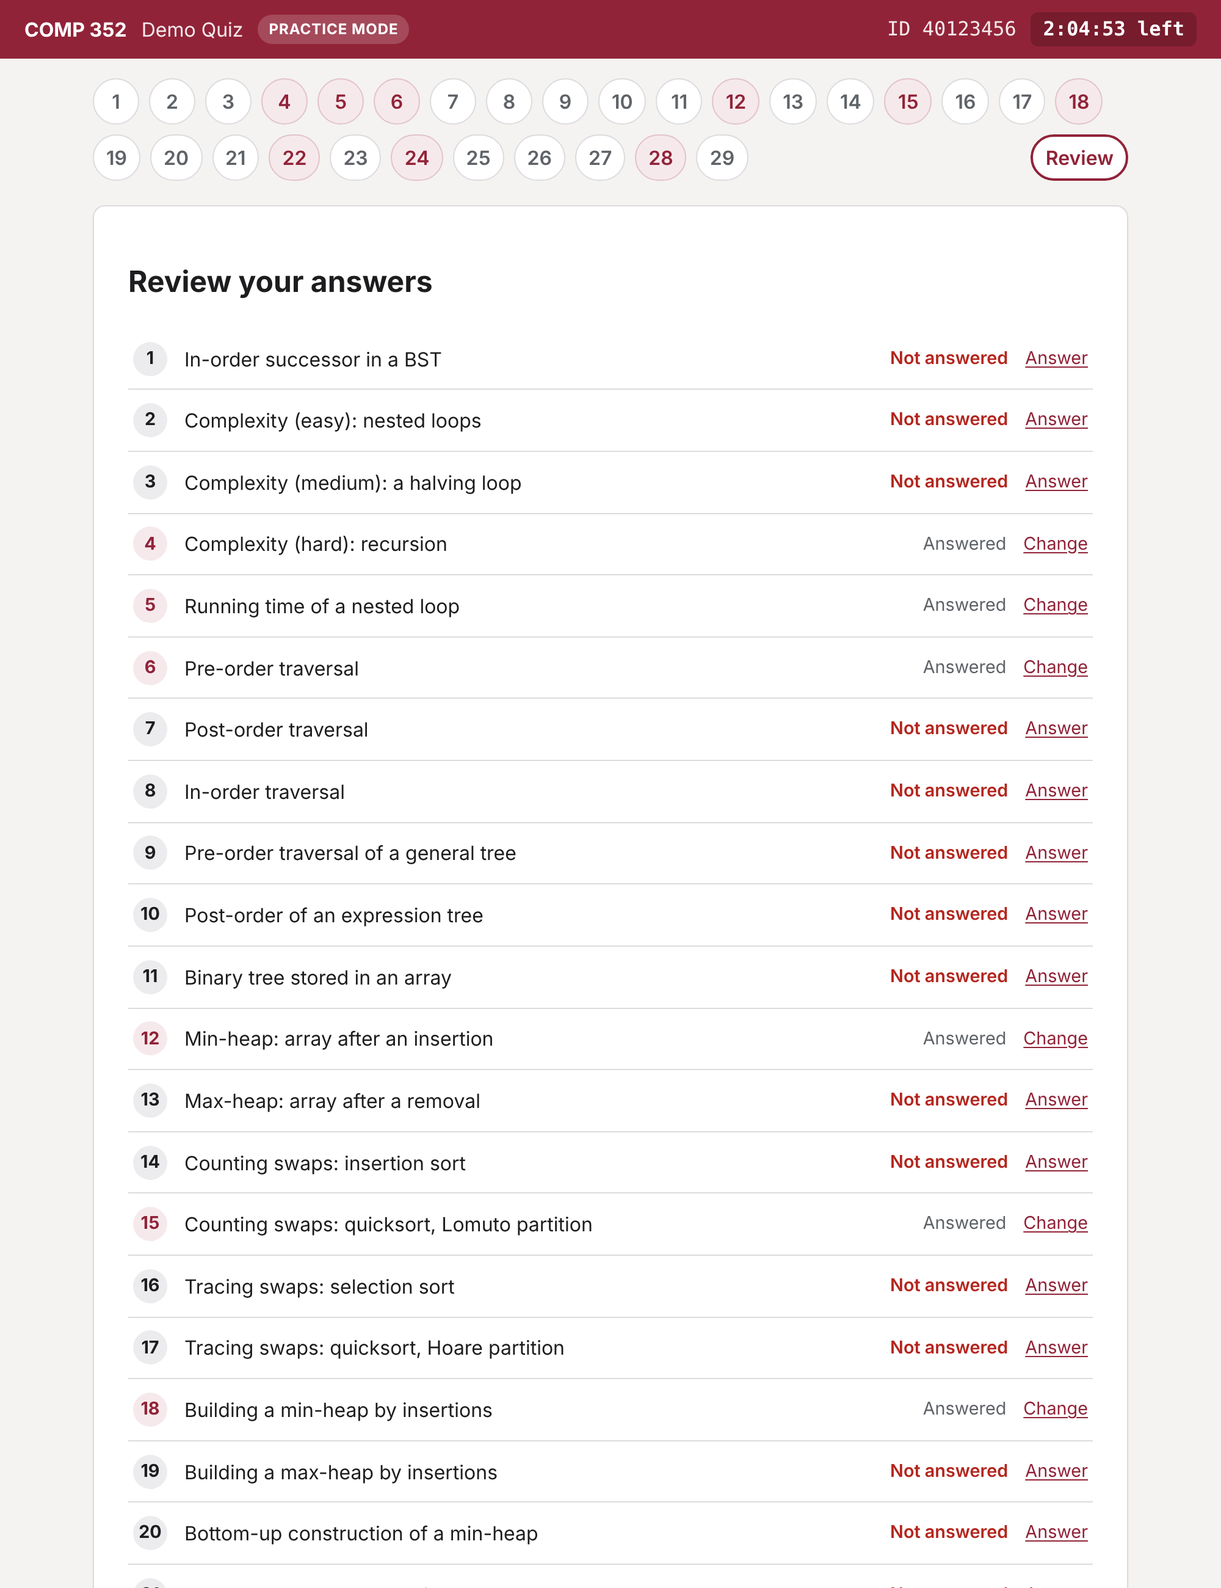
Figure 5. The review page.

3.4 Results (practice mode)
The results page shows the score and, for every question, the status (correct, partially correct, incorrect, not answered), the points, the student's answer, the correct answer and the explanation. For the algorithmic types the explanation is generated step by step from the problem.
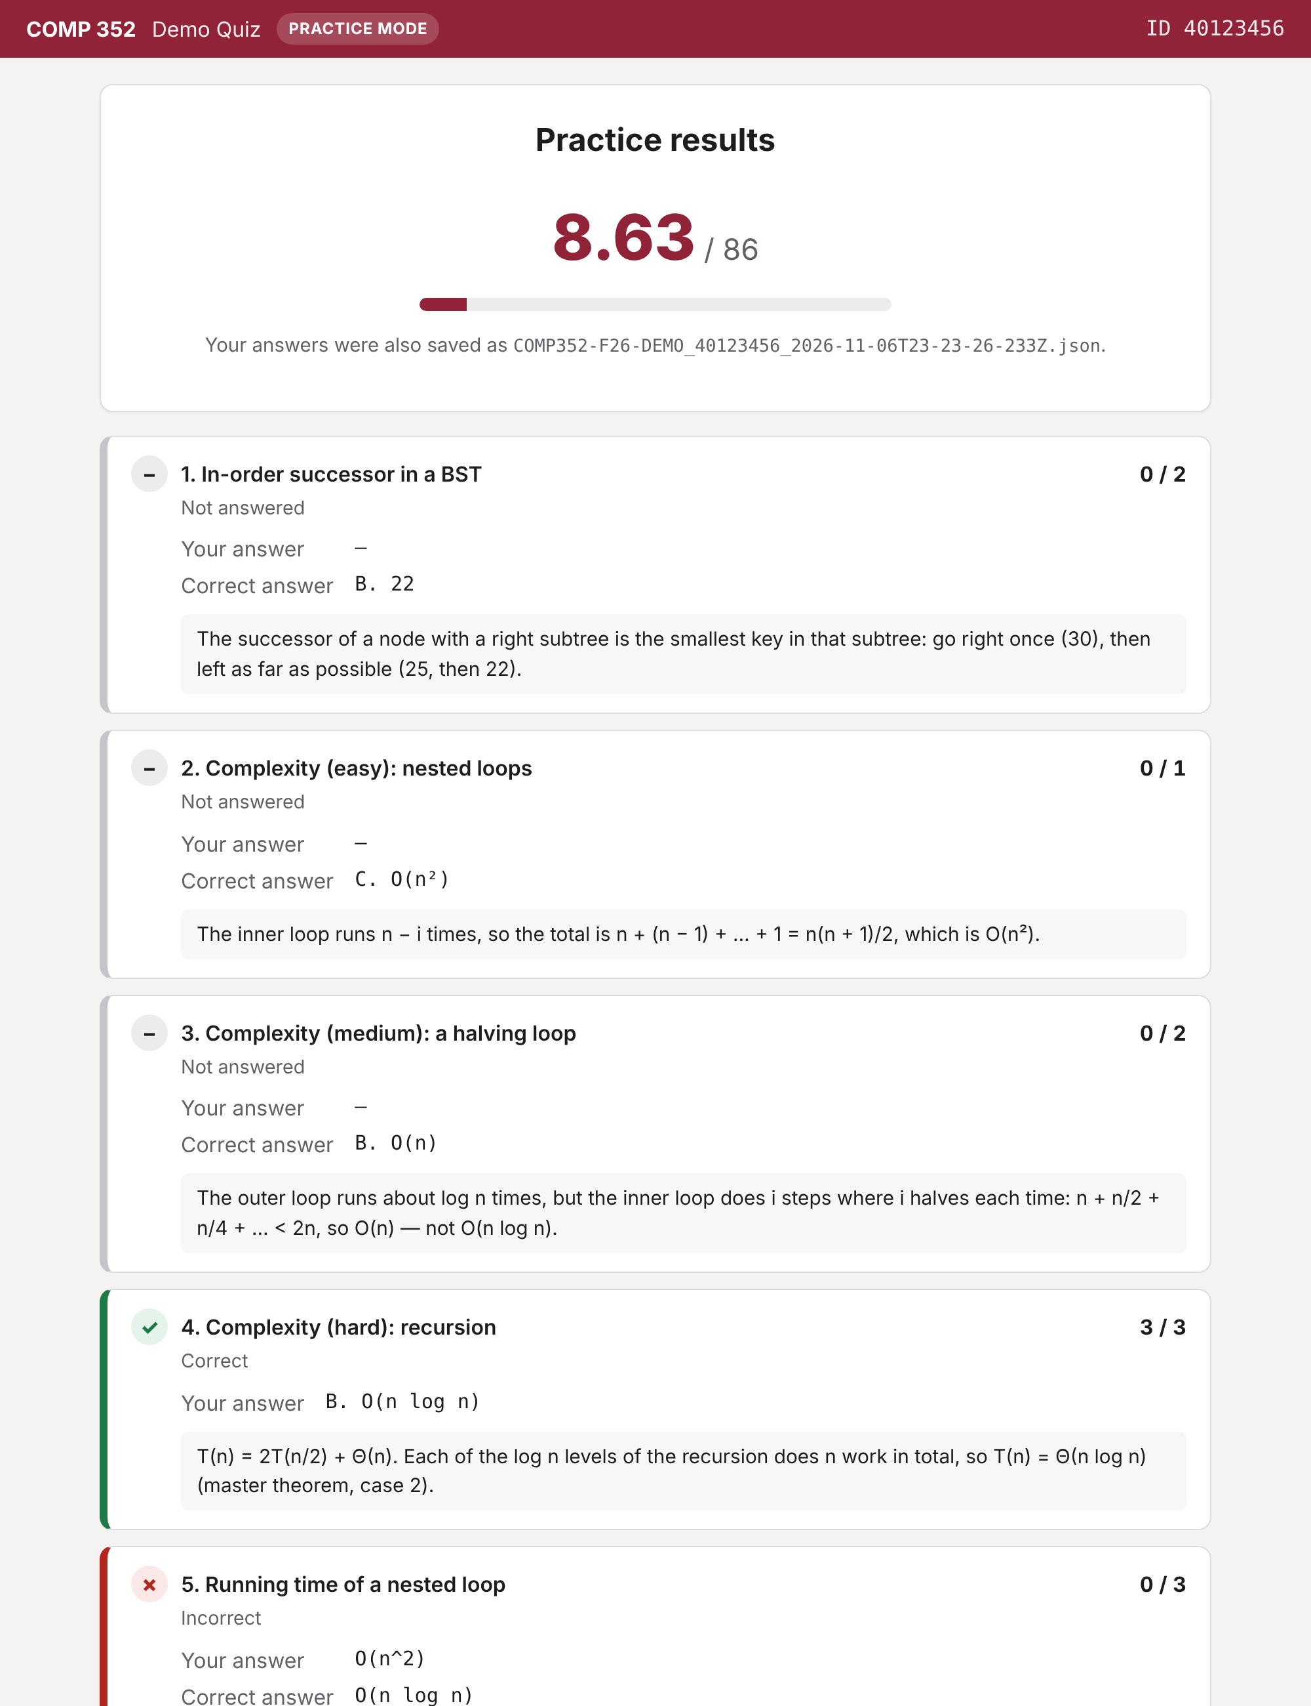
Figure 6. The practice results page.
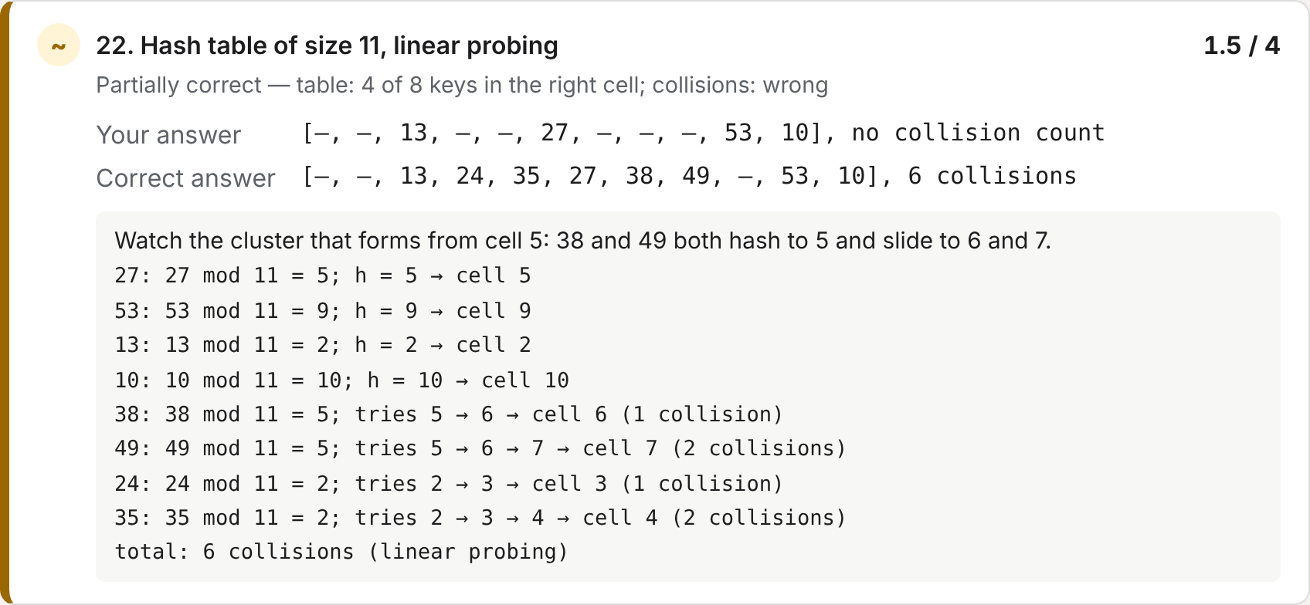
Figure 7. Feedback for a partly correct hash-table answer: every key's probe sequence is listed.

3.5 The submission file
One file per student and exam, named <examId>_<studentId>_<timestamp>.json:
{
"format": "virtualexams.submission/v1",
"examId": "COMP352-F26-DEMO", "course": "COMP 352", "mode": "practice",
"student": { "id": "40123456" },
"startedAt": "...", "submittedAt": "...",
"answers": [
{ "questionId": "q1", "type": "mcq",
"problem": "problems/mcq/bst-successor.json",
"response": { "selected": ["b"] } }
]
}

3.6 How the page starts
Figure 8 shows what happens when index.html opens. The loader finds the exam folder from <body data-exam="…"> (a built exam says ".", its own folder), adds exam.bundle.js as a script, and hands the data to the app. Two address options help when testing: ?exam=<folder> opens another exam folder and ?mode=exam or ?mode=practice overrides the mode.
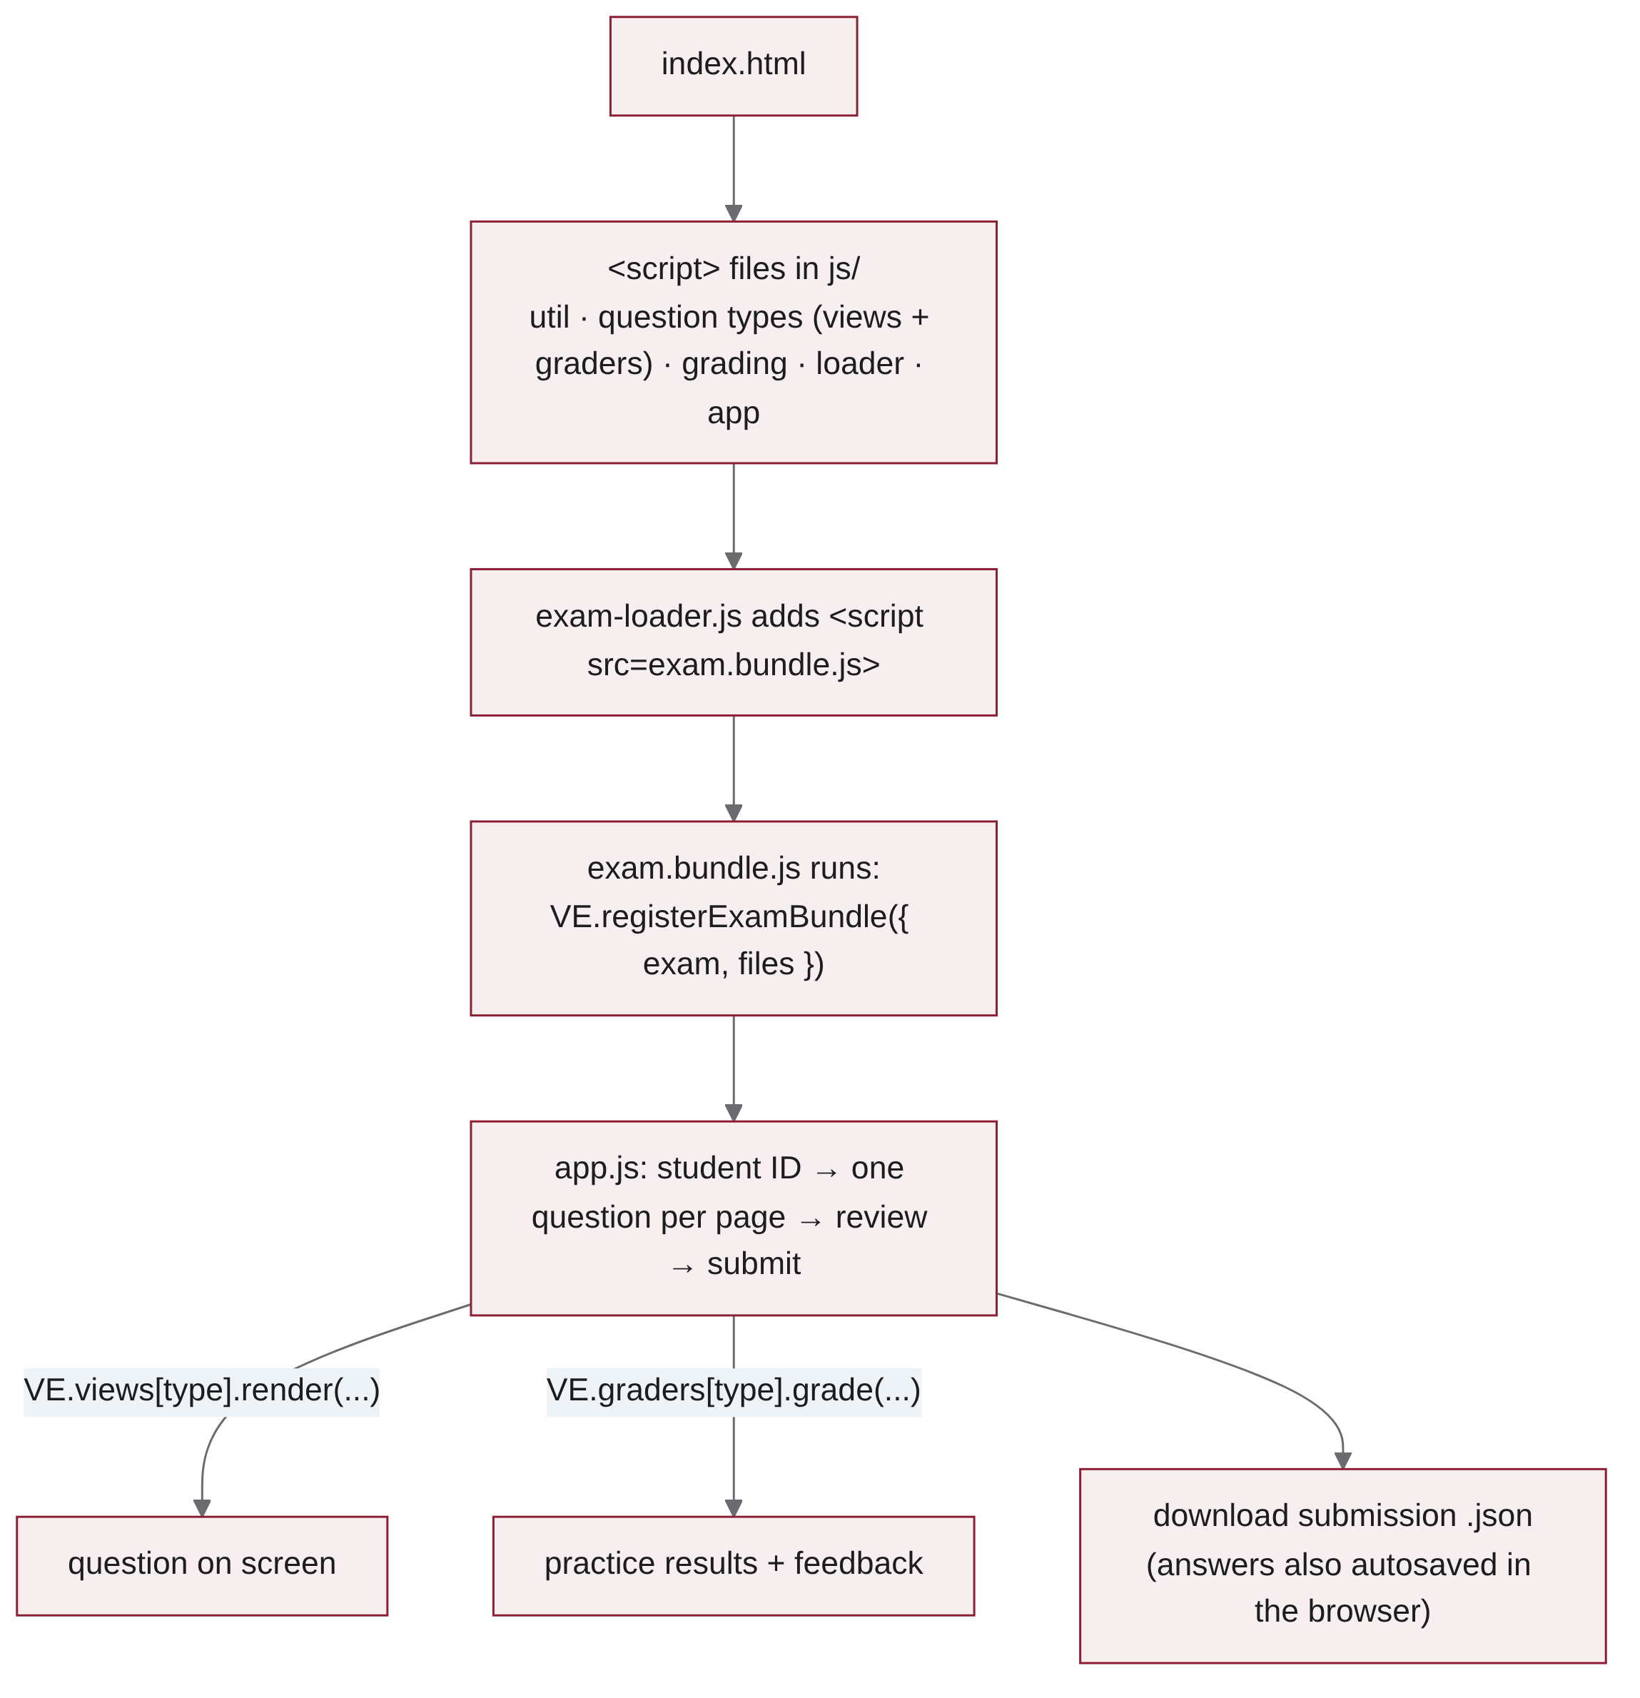
Figure 8. Start-up of the exam page.

4 Question types

4.1 How a question type is built
A question type is a folder js/types/<type>/ with two files, plus an editor form (Figure 9):
- view.js — render({ container, problem, response, onChange }) draws the problem and calls onChange(response) whenever the student changes the answer. isAnswered(response) tells the app whether to show the question as answered.
- grader.js — grade({ problem, solution, response, points }) returns { status, score, detail, yourAnswer, correctAnswer, explanation }.
- Algorithmic types also have a model file (for example hash.js, bst.js) with the simulation, shared by the view, the grader and the editor.
- js/editor/types/<type>.js — the editor form for the type.
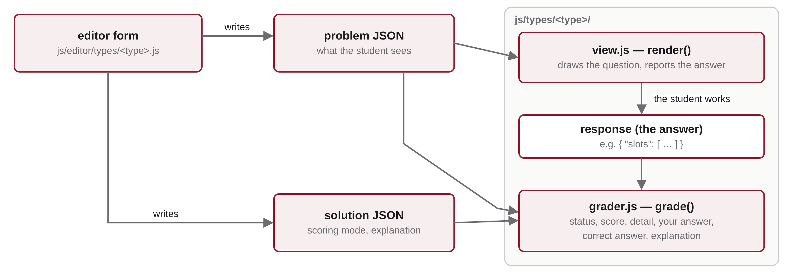
Figure 9. The parts of a question type and the data that flows between them.

4.2 The ten types at a glance
Type | The student… | Partial credit
mcq | picks one option (or several) | no: all or nothing
text | types a short answer | no; without accepted answers it is graded by hand
tree-traversal | lists the nodes of a drawn tree in pre-, in-, post- or level-order | "positional"
tree-array | stores a tree, or a heap after an insertion/removal, in an array | "positional"
sort-count | counts the swaps or comparisons of a sort | no
sort-trace | shows every swap of a sort, one row per swap | "prefix"
heap-build | builds a min/max heap by insertions or bottom-up | "positional"
hash-table | inserts keys with probing and counts the collisions | yes (default)
radix-sort | shows the array after each pass of LSD radix sort | yes (default)
bst-update | builds a search tree / AVL tree after insertions or deletions | yes (default)

In the problem files below, fields in italics are optional. Every solution file may have an explanation (HTML) shown in practice mode, and every problem may have a title, a prompt (HTML; most types generate one if it is missing) and an image.

4.3 Multiple choice — mcq
Options with ids; one correct option, or several with "multiple": true (check boxes). Prompts are HTML, so code can be shown in <pre><code> blocks, as in the complexity questions of the demo.
Problem field | Meaning
options | list of { "id": "a", "text": "O(n)" }
multiple | true for check boxes
image | { "src": "assets/q1-bst.svg", "alt": "…", "width": "420px" }

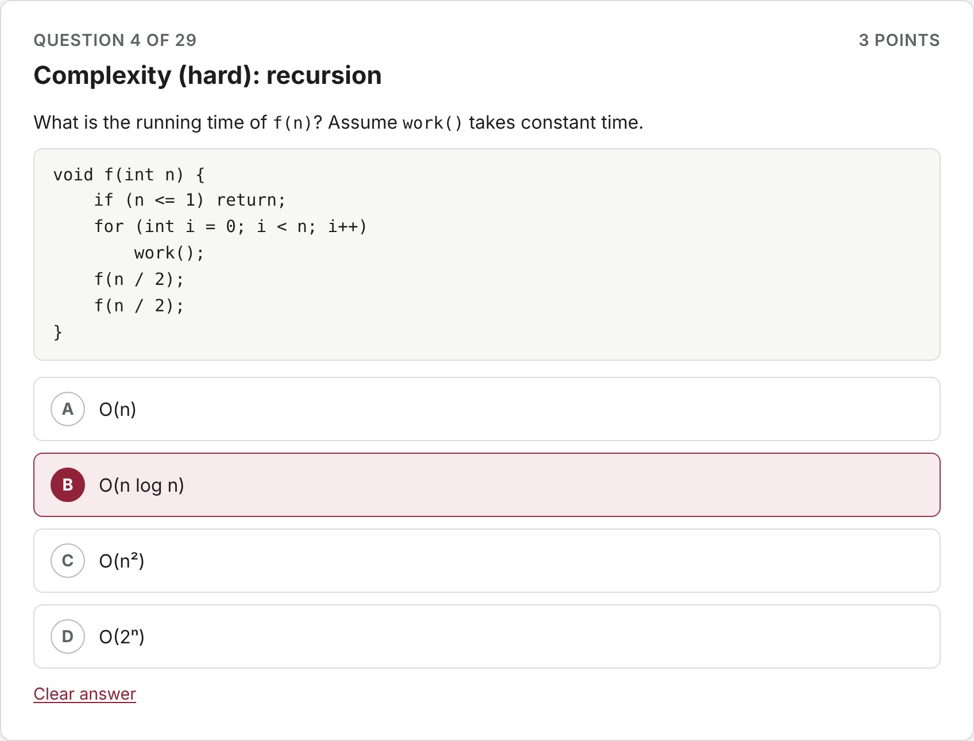
Figure 10. A multiple-choice question with code in the prompt.
Solution: { "correct": ["b"] }. Grading: correct only if the selected set equals the correct set; no partial credit.

4.4 Short text answer — text
A one-line or multi-line answer, for example a Big-O expression.
Problem field | Meaning
multiline | a text area instead of one line
placeholder, maxLength | input hints and limit

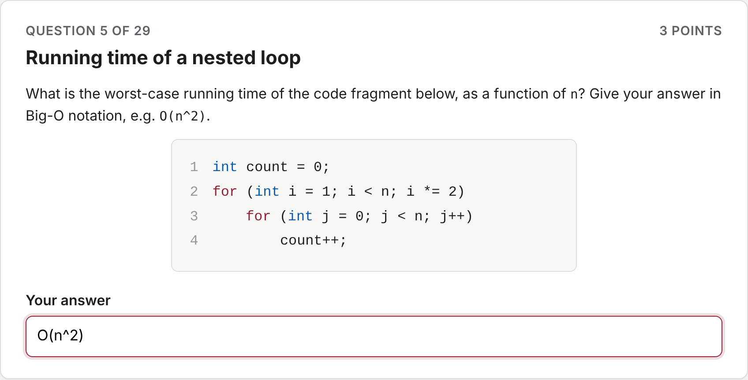
Figure 11. A short text answer, as typed by a student (this one is wrong: the loop runs in O(n log n)).
Solution: "accepted" (exact answers) and/or "patterns" (regular expressions), with "caseSensitive" (default false) and "ignoreWhitespace" (default true). With neither, the answer is left for grading by hand ("pending").

4.5 Tree traversal — tree-traversal
A tree is drawn; the student clicks or drags its nodes into an answer tray in the requested order. Works for binary and general trees (in-order needs a binary tree).
Problem field | Meaning
traversal | preorder, inorder, postorder or levelorder
tree | nested { "id": "A", "label": "A", "children": [ … ] }; null for a missing left child
binary | false for a general tree

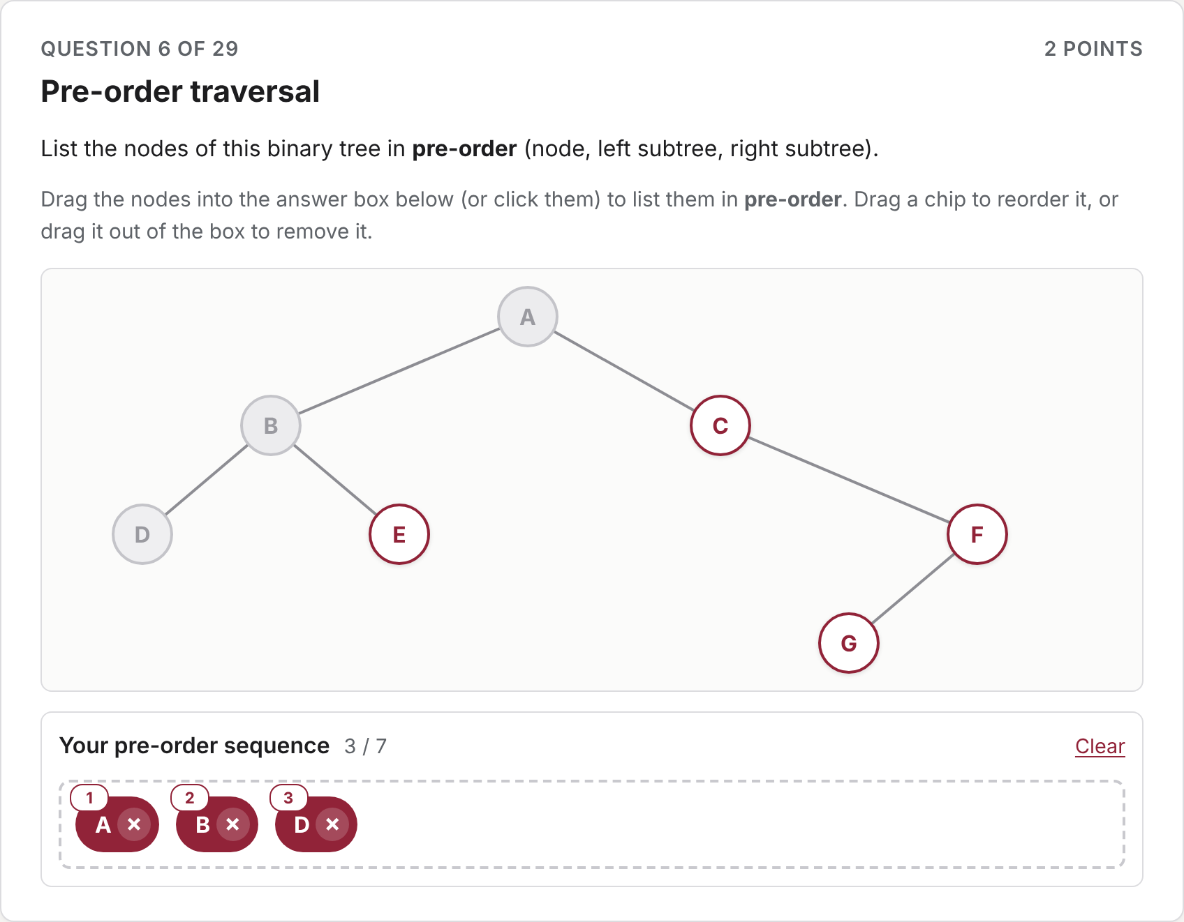
Figure 12. A pre-order traversal in progress.
Solution: optional "sequence" (computed from the tree if missing). Grading: "exact" (default) or "positional" (fraction of positions right).

4.6 Tree stored in an array — tree-array
The student drags the nodes into indexed array cells; cells left empty count as X. Three tasks: store a binary tree (children of index i at 2i+1 and 2i+2), or show a heap's array after inserting keys or removing the root.
Problem field | Meaning
task | layout, heap-insert or heap-remove
tree | the tree (for heaps: the heap before the operation)
heap | min or max
insert / removeCount | keys to insert, or how many removals
slots | number of cells shown (the student decides where the array ends)

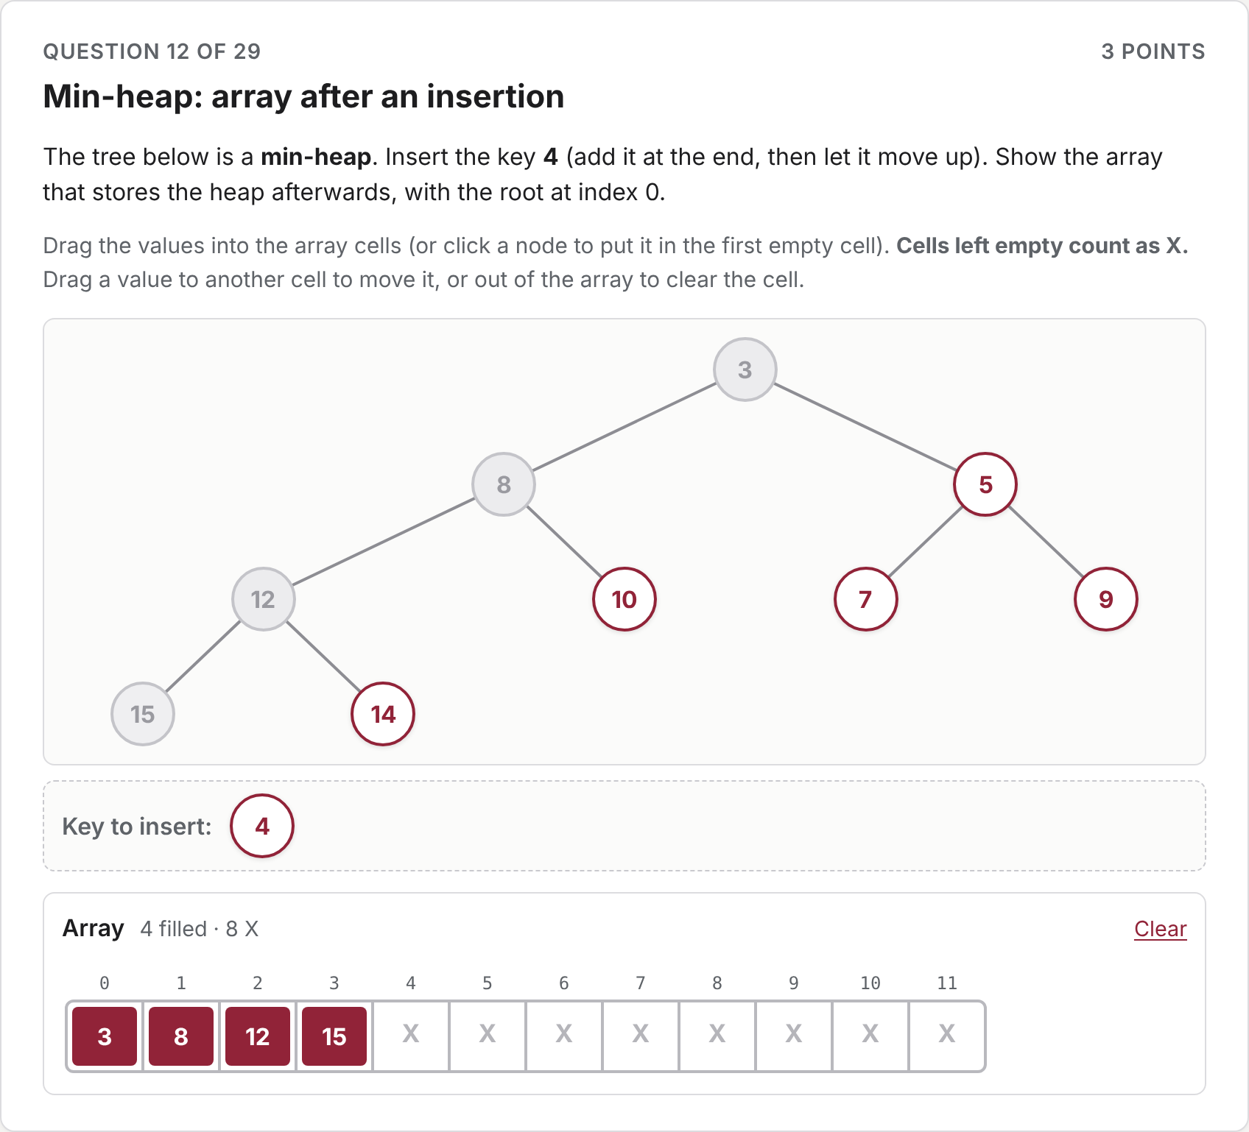
Figure 13. A min-heap insertion: the key to insert is offered as an extra node.
Solution: optional "slots" (computed by simulating the heap if missing). Grading: "exact" (default) or "positional".

4.7 Counting swaps or comparisons — sort-count
The data, the algorithm and its pseudocode are shown; the student types one number (digits only).
Problem field | Meaning
data | the array
algorithm | selection, insertion, quicksort-hoare or quicksort-lomuto
order | increasing (default) or decreasing
count | swaps or comparisons
showPseudocode, pseudocode | hide or replace the generated pseudocode

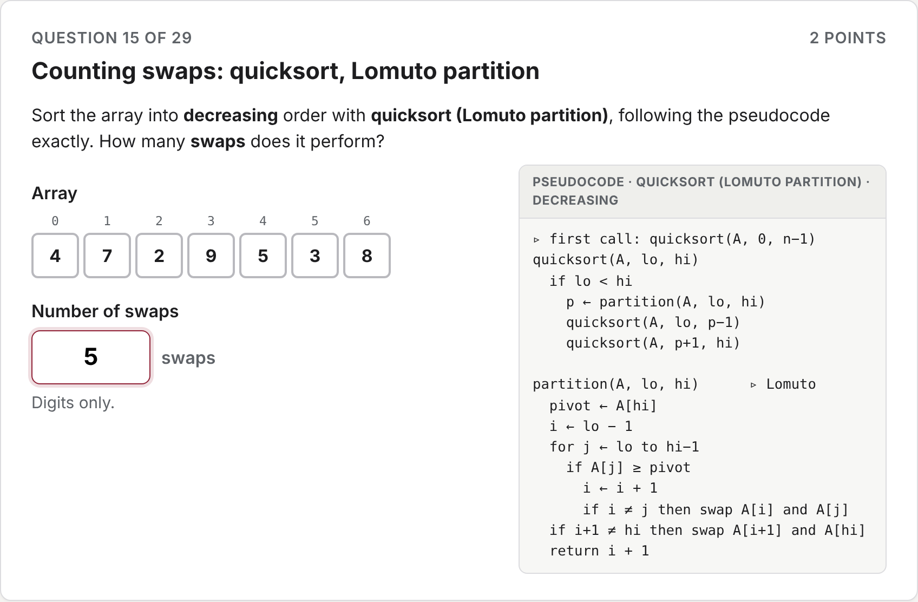
Figure 14. Counting the swaps of quicksort with the Lomuto partition.
Grading: the count is computed by running exactly the pseudocode shown (self-swaps are skipped, as the pseudocode says); exact match.

4.8 Tracing the swaps — sort-trace
Each row starts as a copy of the row above; the student makes one swap per row (click or drag two cells) and adds rows as needed.
Problem field | Meaning
data, algorithm, order | as for sort-count
rows | rows shown at the start (default 1)

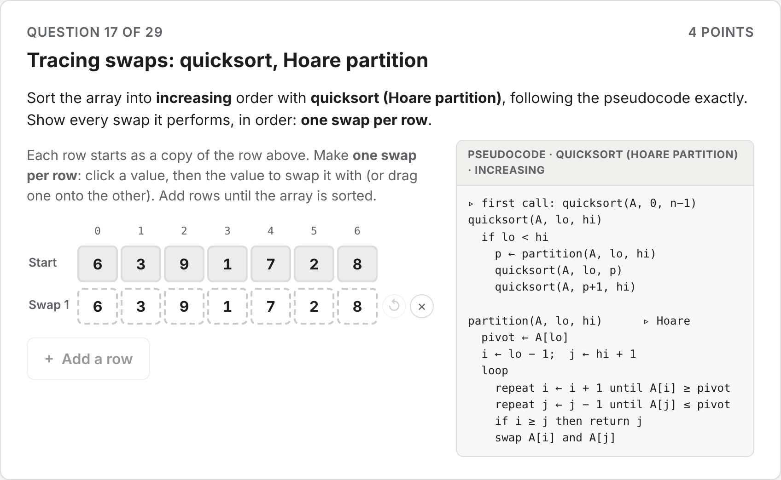
Figure 15. Tracing quicksort with the Hoare partition, one swap per row.
Grading: "exact" (default) or "prefix": credit for the swaps that are right before the first mistake.

4.9 Building a heap — heap-build
Build a min- or max-heap from the given keys, either by inserting them one at a time or with the bottom-up construction; the student only sees the method chosen. The array is drawn as a tree as the student fills it.
Problem field | Meaning
data | the keys (insertion order, or the initial array for bottom-up)
method | insert or bottom-up
heap | min or max
slots | number of cells shown

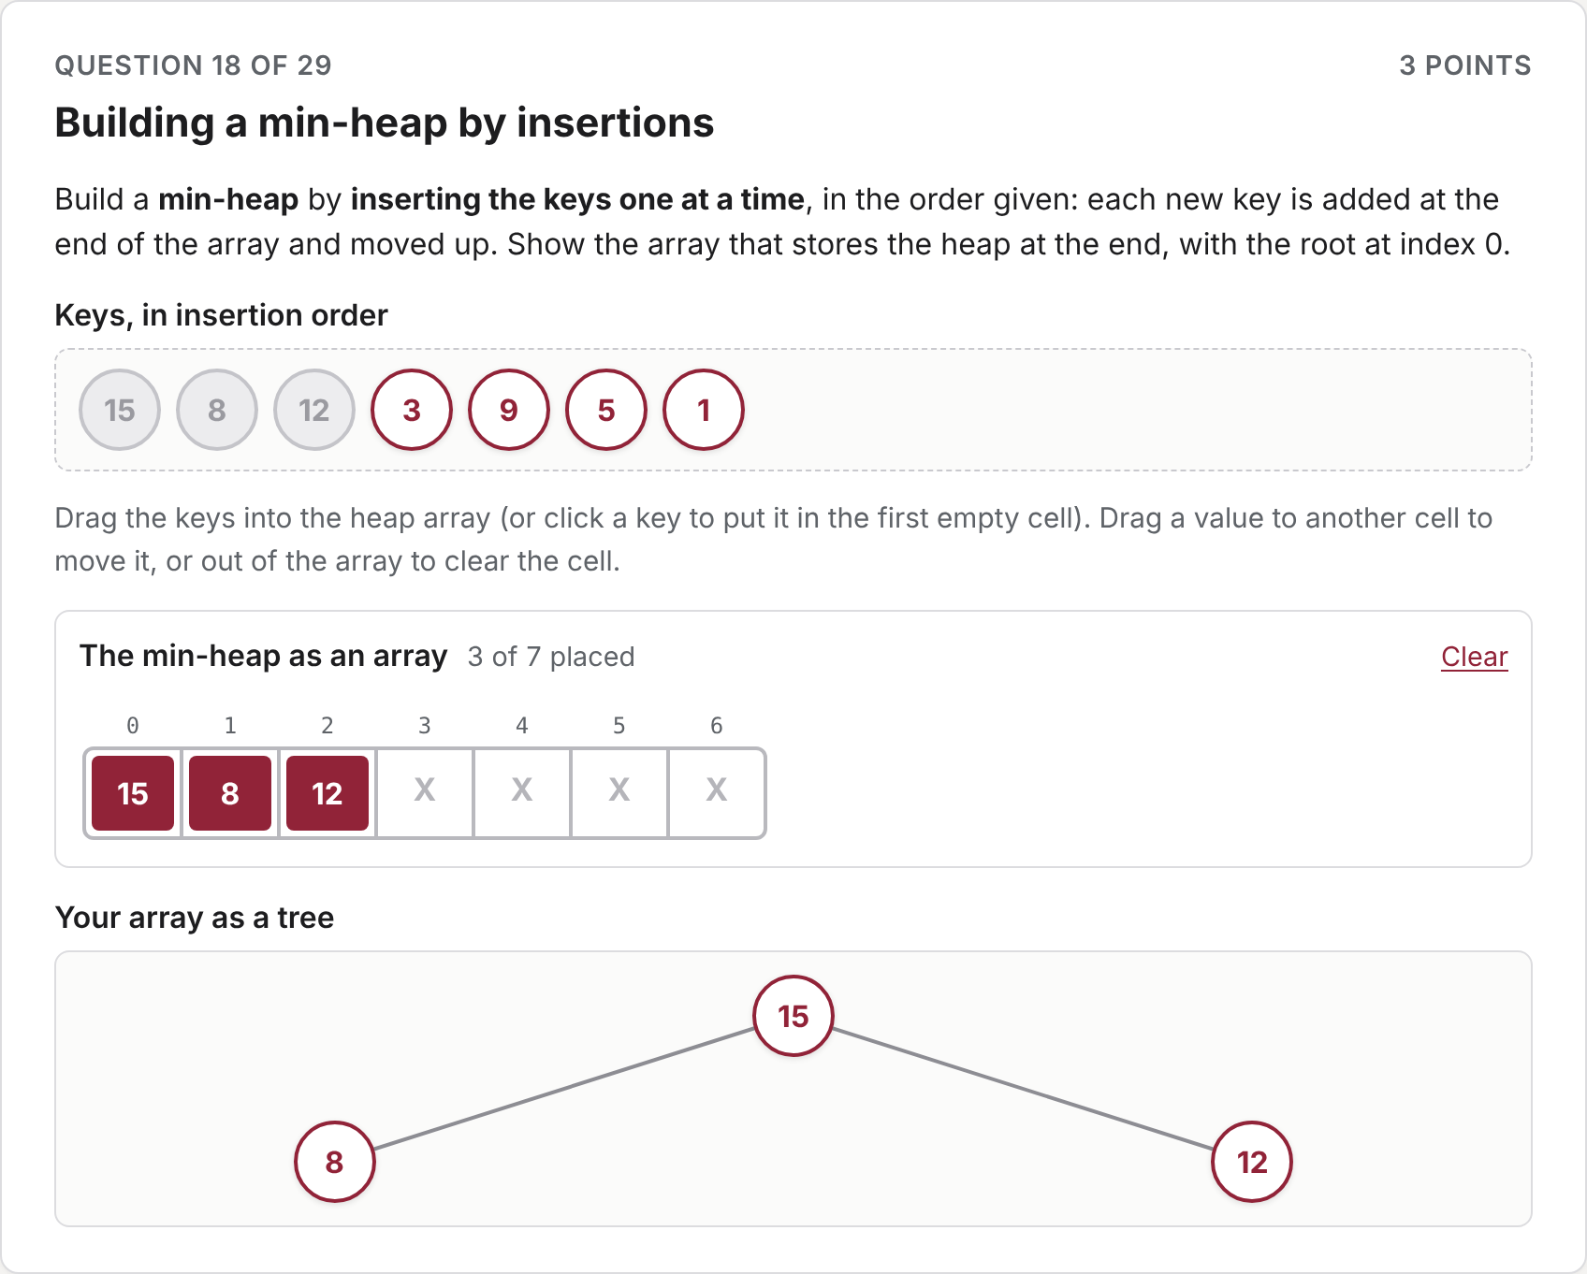
Figure 16. Building a min-heap by insertions, with the live tree view.
Grading: "exact" (default) or "positional". The feedback lists every sift-up / sift-down step.

4.10 Hash tables — hash-table
Insert the keys, in order, into a table of size m with h(k) = k mod m, and give the total number of collisions. An information box explains the hash function with an example of the mod operation, the probing rule and what counts as a collision. Under every key the student sees its h(k) in small print (and h′(k) for double hashing), so the question is about probing, not arithmetic.
Problem field | Meaning
keys | distinct non-negative whole numbers, in insertion order
size | the table size m
probing | linear (default), quadratic or double
q | double hashing: h′(k) = q − (k mod q); default the largest prime below m

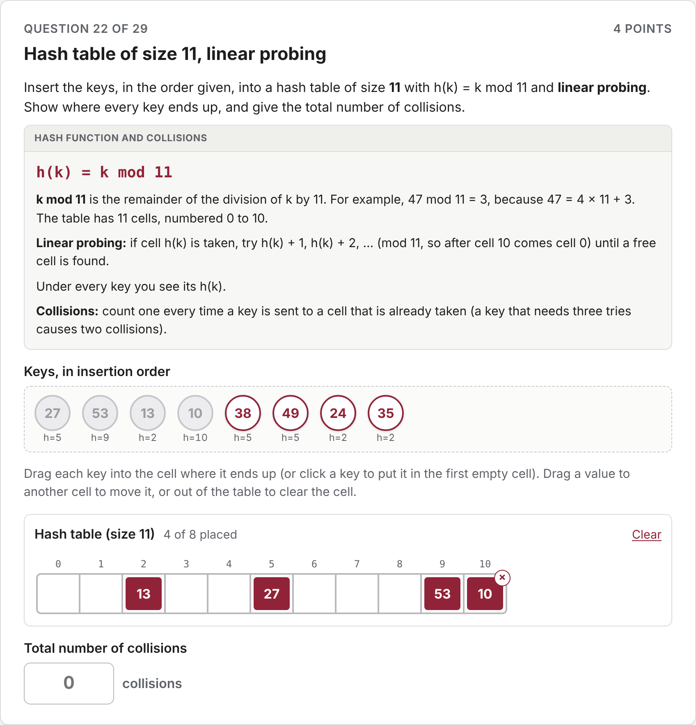
Figure 17. Linear probing in a table of size 11; each key shows its h(k).
Grading: "partial" (default): 75 % of the points in proportion to the keys in the right cell, 25 % for the collision count ("countWeight" changes the split); or "exact". A collision is one probe that finds the cell taken.

4.11 Radix sort — radix-sort
LSD radix sort: the student shows the array after each of the first passes. Each row offers the numbers in the order of the row above, with the digit of that pass highlighted; shorter numbers get faded leading zeros. In binary every number shows its decimal value and its bits.
Problem field | Meaning
data | non-negative whole numbers
base | decimal (default) or binary
passes | number of passes shown (default 4)

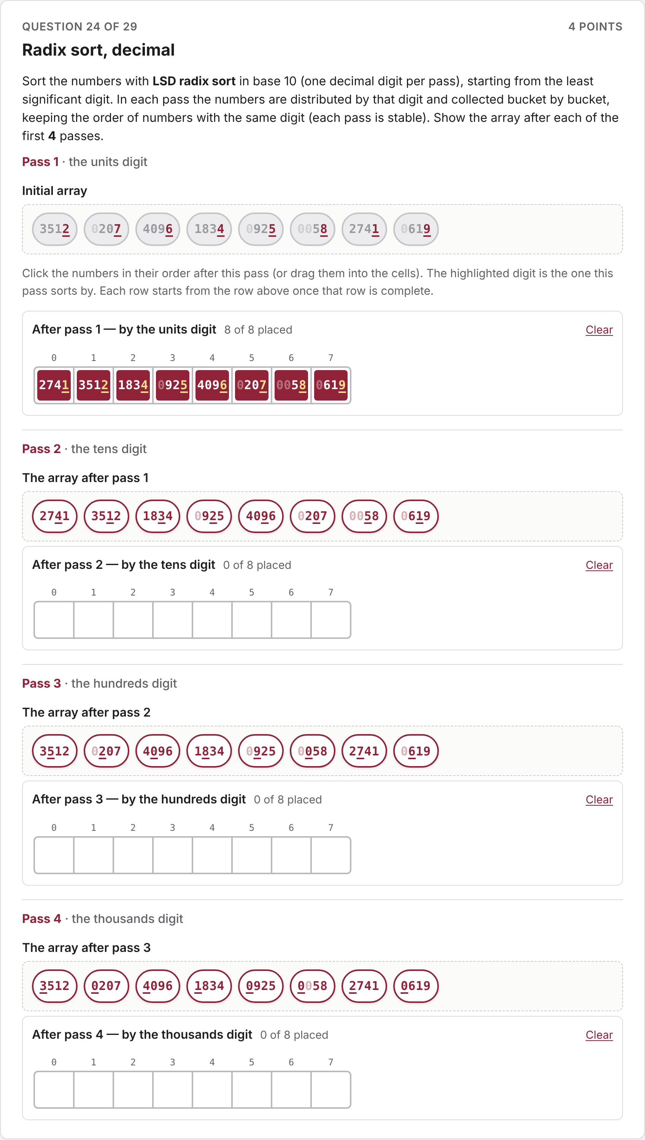
Figure 18. Decimal radix sort after the first pass.
Grading: "passes" (default): fraction of passes right, each pass checked against the correct pass applied to the student's own previous row, so one mistake is not counted again; "positional" or "exact". The feedback lists the buckets of every pass.

4.12 Search tree and AVL updates — bst-update
The tree after one or more insertions or deletions in a binary search tree or an AVL tree. The starting tree is built by inserting keys in order, so it is always valid. The student sees the starting tree and builds the new one by dragging, starting from a copy: a key from the pool onto an external node (the small squares) to insert it; a node onto an external node to move it, onto another node to swap the two, or out of the tree to remove it. By default a dragged node takes its whole subtree along, which makes rotations quick; a switch moves only the node.
As in the textbook, keys are stored only in the internal nodes of a proper binary tree and the external nodes are drawn as empty squares ("externalNodes": false draws only the keys).
Problem field | Meaning
treeType | bst (default) or avl
keys | the starting tree, as keys in insertion order
operations | e.g. [{"insert": 35}], [{"delete": 30}, {"insert": 12}]
replaceWith | a deleted key with two internal children is replaced by its successor (default) or predecessor
externalNodes | true (default) or false

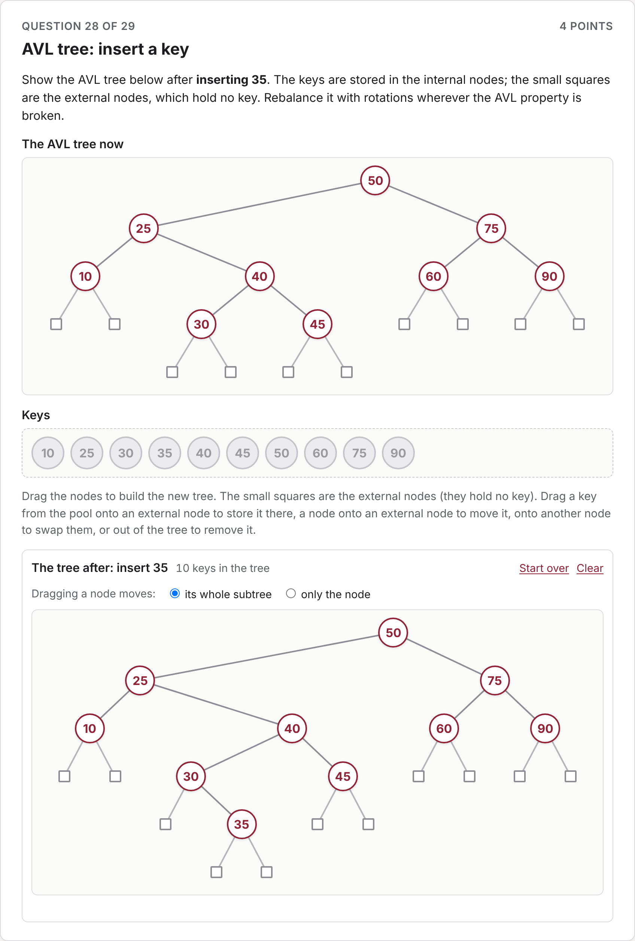
Figure 19. An AVL insertion: 35 has been placed; the rotation comes next.
Grading: "positional" (default): fraction of keys in the right position; or "exact". The detail says when the student's tree is not a search tree or not balanced, and the explanation lists the search path, every deletion step and every rotation (single or double, and which node moves up).
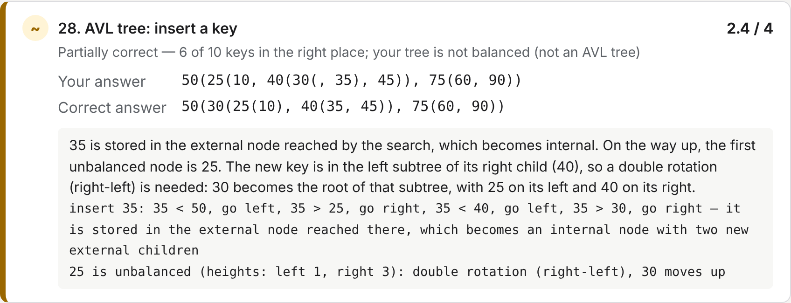
Figure 20. Feedback for an AVL insertion where the student forgot to rotate.

5 The problem bank
A bank is any folder with this layout; bank/ is the course bank, and you can keep one per course:
bank/
problems/<type>/<name>.json what the student sees
solutions/<type>/<name>.json the answer key: same type folder, same file name
assets/ images used by the problems
The solution is a separate file so that it never has to reach students in exam mode; it is found by the naming convention. Problems refer to images as "assets/<file>", either in the image field or as <img src="assets/…"> in a prompt; the same path works in the bank, in the editor and in every exam built from it.

5.1 Example: a problem and its solution
bank/problems/hash-table/hash-linear-m11.json:
{
"type": "hash-table",
"title": "Hash table of size 11, linear probing",
"keys": [27, 53, 13, 10, 38, 49, 24, 35],
"size": 11,
"probing": "linear"
}
bank/solutions/hash-table/hash-linear-m11.json:
{
"scoring": "partial",
"explanation": "Watch the cluster that forms from cell 5: 38 and 49 both hash to 5 and slide to 6 and 7."
}
There is no answer in the solution: the table and the 6 collisions are computed. Making a variant of this question means copying the file and changing the keys or the size.

5.2 The demo bank
Type folder | Problems
mcq/ | bst-successor, complexity-easy, complexity-medium, complexity-hard
text/ | loop-complexity-text
tree-traversal/ | preorder-binary, inorder-binary, postorder-bst, preorder-general, postorder-expression
tree-array/ | tree-to-array, heap-insert, heap-remove
sort-count/, sort-trace/ | sort-count-insertion, sort-count-lomuto; sort-trace-selection, sort-trace-hoare
heap-build/ | heap-insert-min, heap-insert-max, heap-bottom-up-min, heap-bottom-up-max
hash-table/ | hash-linear-m11, hash-double-m13
radix-sort/ | radix-decimal, radix-binary
bst-update/ | bst-insert, bst-delete-two-children, avl-insert-double-rotation, avl-delete-rotation

6 The problem editor
Open editor.html in Chrome or Edge (it works straight from disk). Press Open bank folder… and choose bank/; the browser asks once for permission to read and write that folder, and Reopen returns to it after a reload.
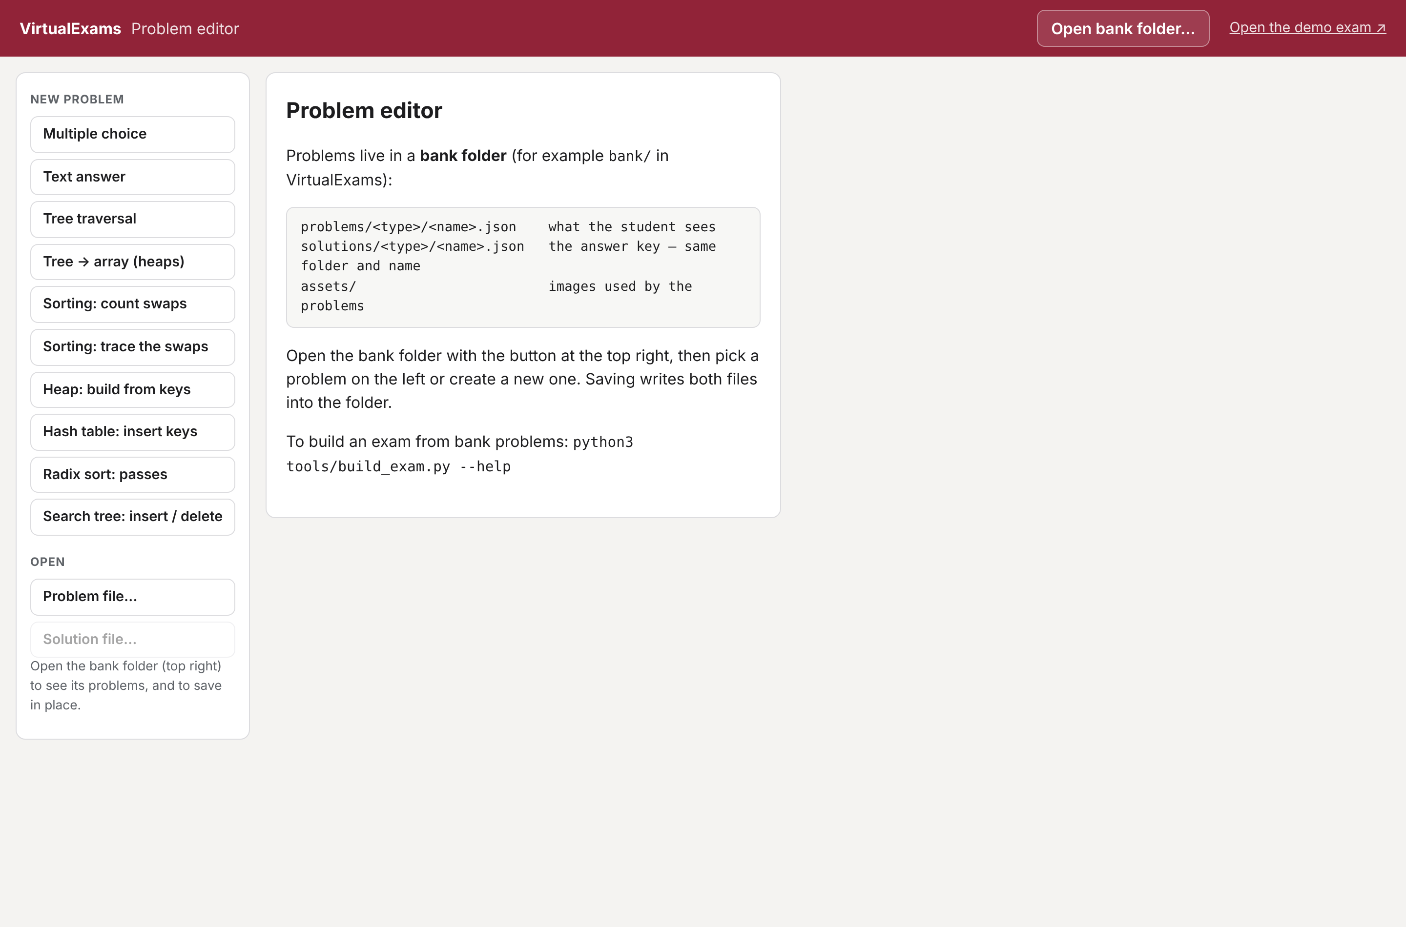
Figure 21. The editor before a bank is opened: new-problem buttons on the left.

6.1 Editing a problem
- Left: a New problem button per type, and the bank's problems grouped by type with a filter box. Click a problem to open it.
- Middle: the form for that type — title, prompt, image, the problem data, the scoring mode and the explanation. The name field sets the file name; changing it saves a copy under the new name.
- Right, Student view: the problem exactly as students see it, updated as you type. Answer it and press Check my answer to run the real grader; the answer key line shows the computed answer.
- Save (or Ctrl/Cmd+S) writes problems/<type>/<name>.json and solutions/<type>/<name>.json. Unsaved changes are marked, and the editor asks before discarding them.
- Add image… copies an image into the bank's assets/ folder and uses it in the problem.
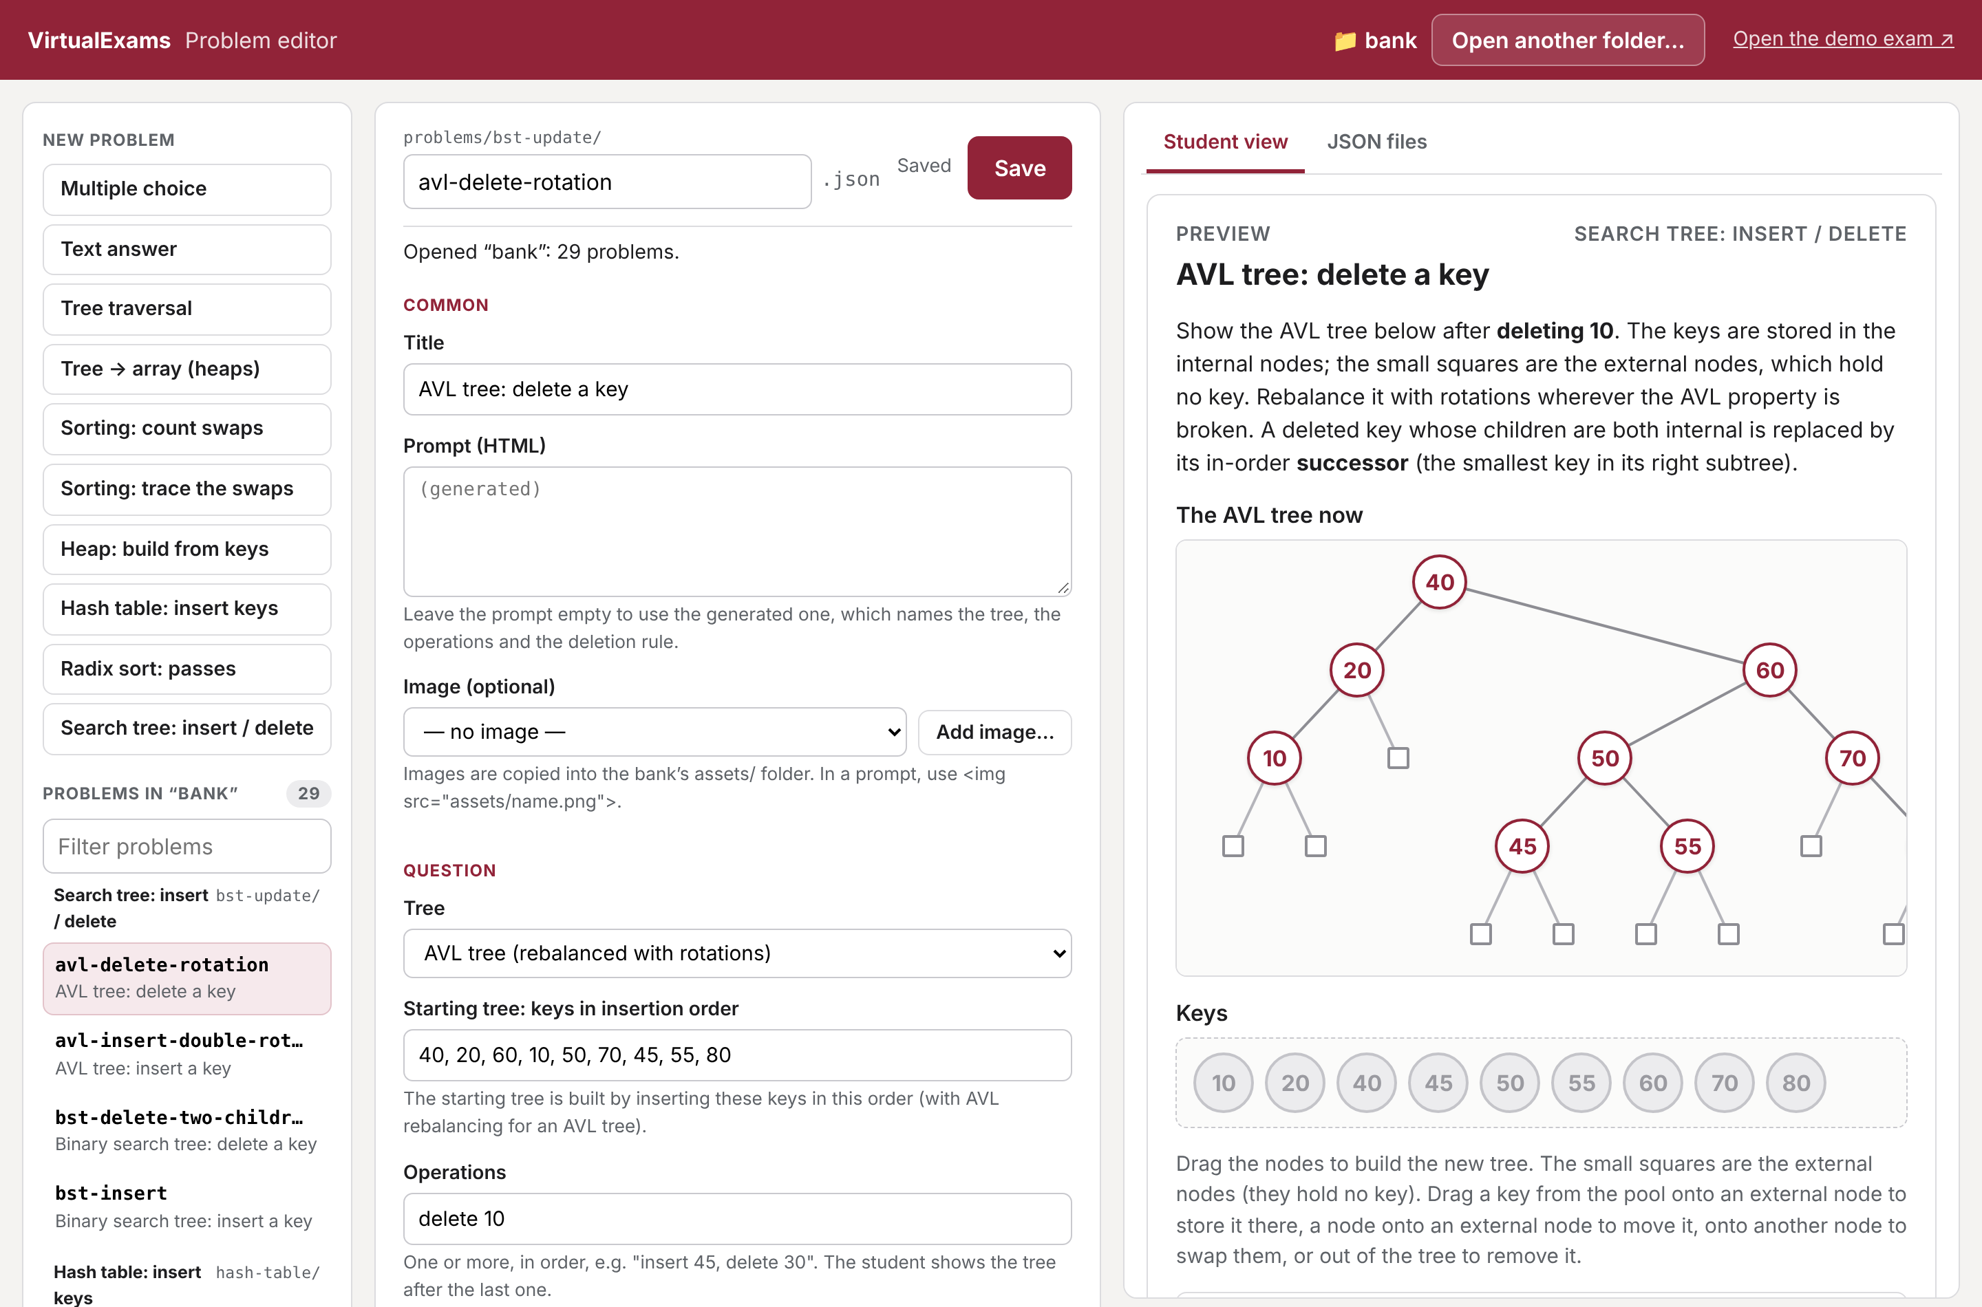
Figure 22. Editing the AVL-deletion problem, with the live student view.

6.2 The JSON tab
The JSON files tab shows both files exactly as they will be saved. They can be edited there for fields the forms do not cover; Apply JSON puts the change back into the form.
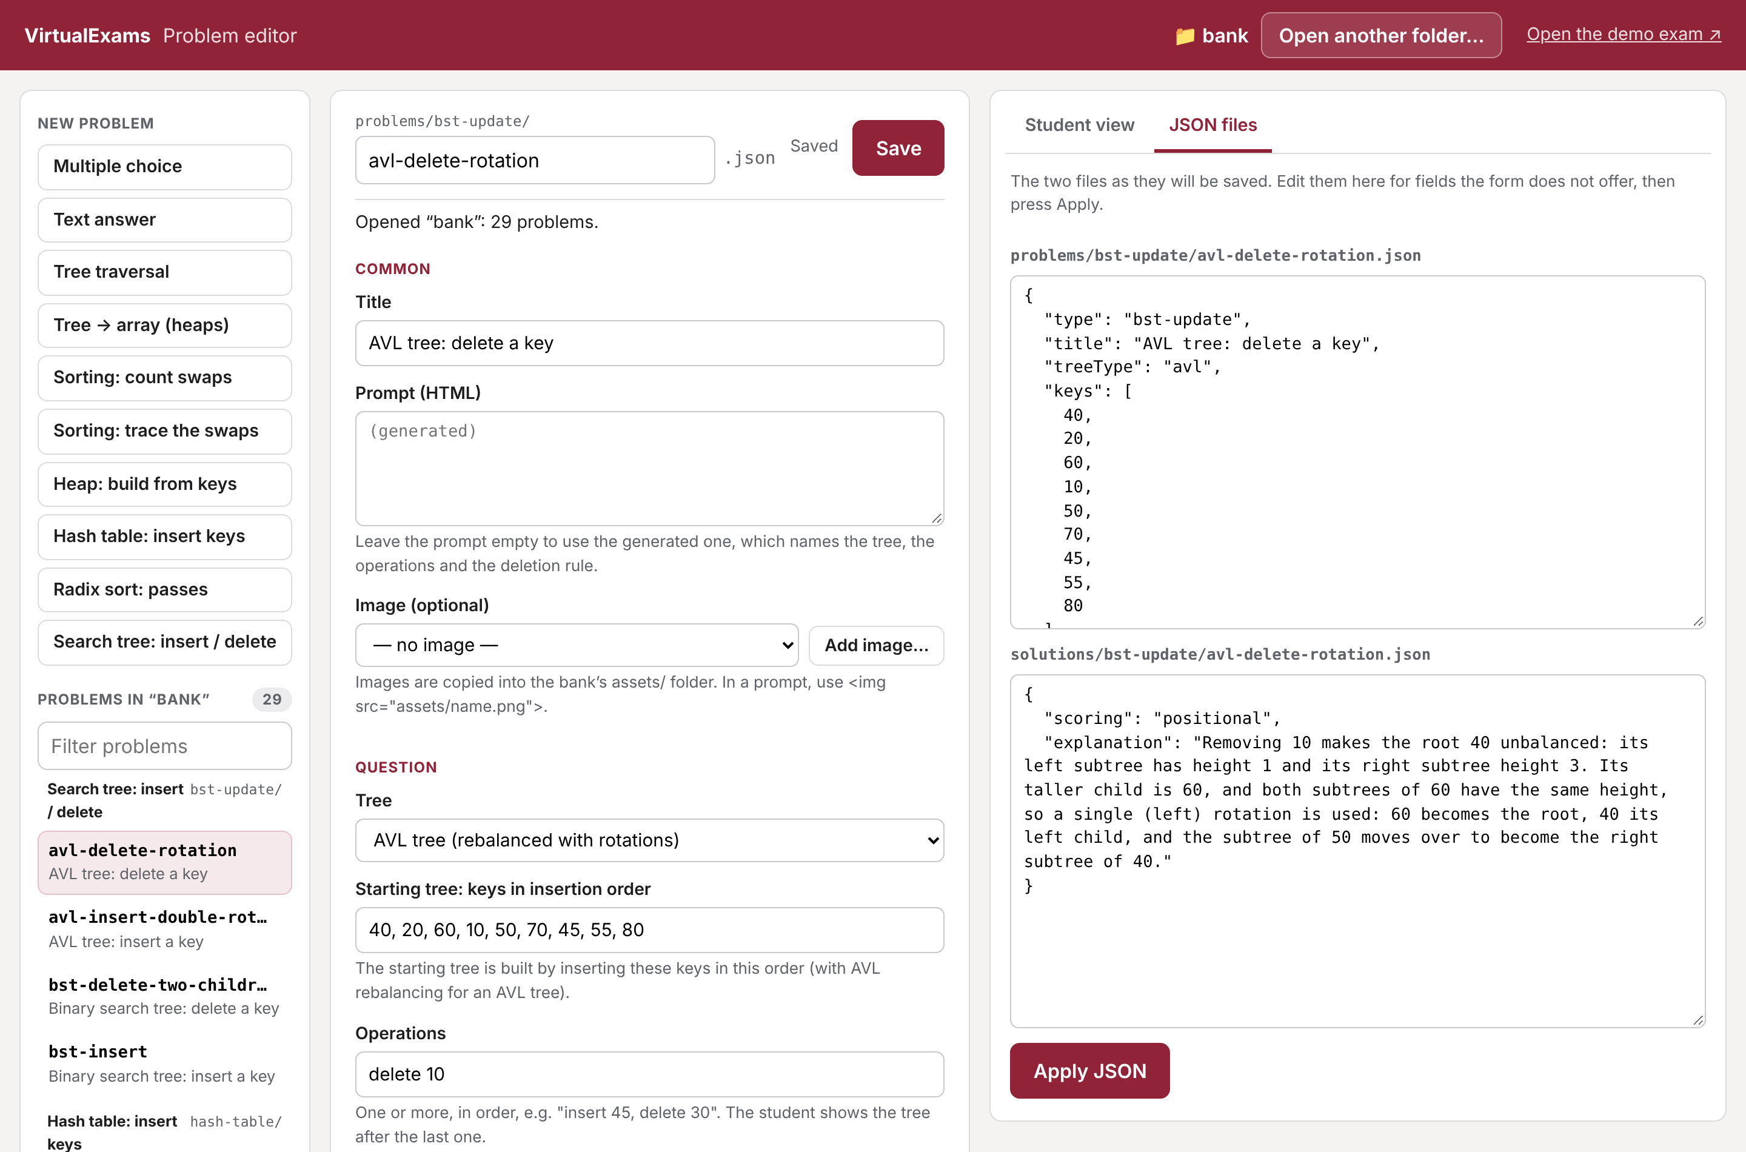
Figure 23. The JSON files tab.
Note Folder access needs Chrome or Edge. In other browsers the editor can open single files and downloads <name>.json and <name>.solution.json instead of saving; build_exam.py also accepts a <name>.solution.json next to its problem.
Trees for the tree-traversal and tree-array types are typed as text: A(B(D, E), C(, F)) — children in parentheses, and an empty place before the comma for a missing left child.

7 Building an exam
One command turns a spec and a bank into a publishable exam folder:
python3 tools/build_exam.py --spec specs/demo-comp352.json --force

7.1 The spec file
{
"folders": {
"problems": "../bank/problems",
"solutions": "../bank/solutions",
"assets": "../bank/assets"
},
"out": "../exams/demo-comp352",
"examId": "COMP352-F26-DEMO",
"course": { "code": "COMP 352", "term": "Fall 2026",
"title": "Data Structures and Algorithms" },
"title": "Demo Quiz", "examType": "Quiz", "mode": "practice",
"date": "2026-11-10", "startTime": "10:15",
"durationMinutes": 125, "location": "Online",
"studentIdPattern": "^\\d{8}$",
"instructions": ["Answer all questions. …", "…"],
"questions": [
{ "problem": "mcq/bst-successor.json", "points": 2 },
{ "problem": "hash-table/hash-linear-m11", "points": 4 },
{ "problem": "bst-update", "points": 4 }
]
}
Field | Meaning
folders | the bank folders, relative to the spec file. solutions and assets default to the folders next to problems; assets may be a list.
questions | each problem is relative to the problems folder (".json" optional). A type folder ("bst-update") or a wildcard ("sort-*/*.json") takes several problems with the same points. The solution is the file with the same path in the solutions folder.
out | where the exam is built, relative to the spec (default exams/<examId>).
mode | practice (default) or exam.
durationMinutes | shows a countdown (not enforced yet).
studentIdPattern | regular expression the student ID must match; studentIdHint / studentIdError set the messages.
other fields | examId, course, title, examType, date, startTime, location, instructions are shown on the start page.

7.2 What build_exam.py does
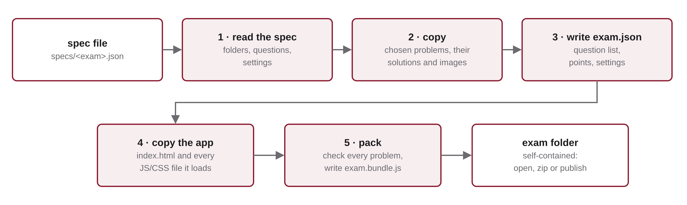
Figure 24. The steps of build_exam.py.
- Reads the spec: the bank folders, the questions and the settings.
- Copies each chosen problem, its solution and the images it uses into the exam folder. A missing problem or image stops the build; a missing solution is reported and the question shows as "graded later".
- Writes exam.json: the settings and the question list, each question pointing to its copied files.
- Copies the exam app: index.html and exactly the JS and CSS files it loads, and points the page at its own folder.
- Packs (pack_exam.py): checks every problem (an invalid tree, keys that do not fit the table, an impossible deletion…) and writes all the JSON into exam.bundle.js.
exams/demo-comp352/
index.html css/ js/ the exam app
exam.bundle.js all the exam data, as one script
assets/ the images used
exam.json problems/ solutions/ readable copies (already inside the bundle)

7.3 The two scripts
Script | Input → output | When you run it
build_exam.py | spec + bank → a complete exam folder | always: it is the build
pack_exam.py | an exam folder's JSON files → exam.bundle.js | never directly; build runs it. Only after hand-editing JSON inside a built exam: python3 tools/pack_exam.py exams/<folder>

7.4 Options
Option | Effect
--spec FILE | build from a spec file
--force | replace an existing exam folder (it refuses folders that are not exams)
--mode practice|exam | override the spec's mode
--no-solutions | leave the solution files out of the exam
--problems-dir, --solutions-dir, --assets-dir | use other bank folders than the spec's
--copy-all-assets | copy whole asset folders, not only the files the problems use
-o/--out, --id, --title, --course-code, --course-title, --term, --exam-type, --date, --start-time, --duration, --location, --points | exam settings from the command line

A quick practice set needs no spec at all — name the problems, folders or wildcards on the command line:
python3 tools/build_exam.py --problems-dir bank/problems heap-build "bst-update/avl-*" \
--out exams/trees-practice --title "Heaps and trees" --course-code "COMP 352" --points 2

7.5 Publishing
The exam folder depends on nothing else in the repository. Students can open its index.html straight from disk (send them the zipped folder), or you can put the folder on any web server — a course web page, GitHub Pages, a lab machine. Nothing needs to be rebuilt for one or the other.
Important A practice exam contains its solutions — that is how it gives feedback — so a student who opens exam.bundle.js can read them. That is fine for practice. A real exam should be built with --no-solutions and served by the future exam server.

8 Grading
Grading works the same way in the browser (practice results) and offline (Figure 25). js/grading/grade-exam.js goes through the exam's questions, finds the student's answer for each, calls the grader of that question's type with the question's points, and adds up the scores.
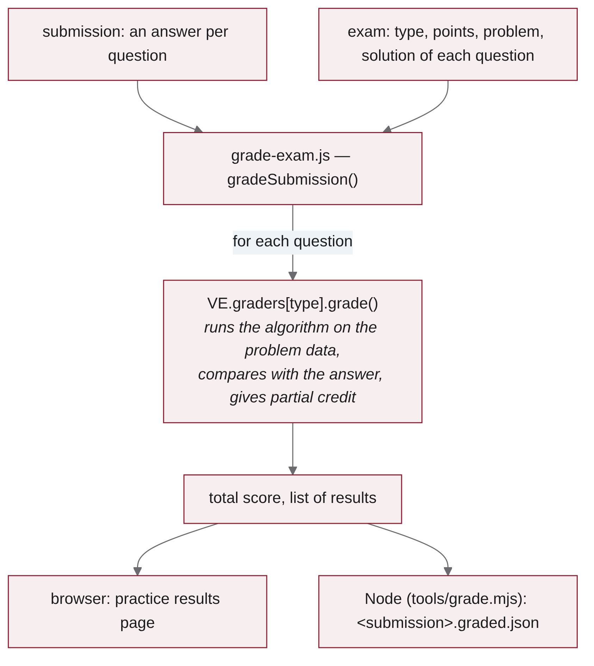
Figure 25. Grading a submission.

8.1 What a grader returns
Field | Meaning
status | correct, partial, incorrect, unanswered or pending (graded by hand)
score | points earned, rounded to 2 decimals
detail | a short reason, e.g. "6 of 10 keys in the right place; your tree is not balanced"
yourAnswer, correctAnswer | readable forms of both answers
explanation | the solution's explanation plus, for the algorithmic types, the generated steps

8.2 Partial credit
Each type decides how partial credit works; "scoring" in the solution file selects the rule, and "exact" (all or nothing) is always available.
Type | Default | Partial rule
mcq | exact | none
text | exact match | none; "pending" without accepted answers
tree-traversal, tree-array | exact | "positional": fraction of positions right
sort-count | exact | none
sort-trace | exact | "prefix": swaps right before the first mistake
heap-build | exact | "positional": fraction of cells right
hash-table | partial | 75 % for keys in the right cell + 25 % for the collision count ("countWeight")
radix-sort | passes | fraction of passes right, each checked against the student's own previous row; or "positional"
bst-update | positional | fraction of keys in the right position

8.3 Offline grading
With Node.js installed, grade any number of submission files against a built exam:
node tools/grade.mjs exams/demo-comp352/exam.json ~/Downloads/COMP352-F26-DEMO_*.json
It writes <submission>.graded.json next to each submission and prints one line per student with the total and the score of every question. Submissions for another exam (a different examId) are skipped with a message.

9 Extending the framework

9.1 Adding a question type
- Create js/types/<type>/view.js (registers VE.views['<type>']) and grader.js (registers VE.graders['<type>']). Put any simulation in a separate model file so that the view, the grader and the editor share it. VE.arrayFill (array cells) and VE.treeEdit (tree building) are reusable components.
- Create the editor form js/editor/types/<type>.js (registers VE.editors['<type>'] with a label, a blank problem and a form).
- Add the <script> tags to both index.html and editor.html.
- Add the model and grader files to GRADER_SCRIPTS in tools/grade.mjs, and the type name to KNOWN_TYPES in tools/pack_exam.py (with a validation function if problems can be invalid).
- Add problems to bank/problems/<type>/ and bank/solutions/<type>/, put them in a spec and build.
Note build_exam.py needs no change: it copies whatever index.html loads.

9.2 Adding problems
Most new problems need no code at all: copy a problem file and change its data, or use the editor. All four tree problems of the demo, for example, are the same type with different treeType, keys and operations.

10 Limitations and next steps
- Security. This version runs entirely on the student's machine. A practice exam contains its solutions, and a submission is a file the student downloads. That is right for practice and not enough for a graded exam.
- Time limit. The countdown is shown but not enforced.
- The exam server (planned). For supervised exams in the lab, a small server would authenticate students (for example against LDAP), serve exams built with --no-solutions, and receive and store submissions, with the class list kept as a CSV next to the submissions. Grading on the server can reuse grade-exam.js and the type graders unchanged, as grade.mjs already does.
- Variants. Shuffled options and per-student variants of a problem (different keys, same type) are natural extensions, since problems are generated from data.

Appendix A Command reference
Task | Command
Edit problems | open editor.html in Chrome or Edge → Open bank folder… → bank/
Build an exam from a spec | python3 tools/build_exam.py --spec specs/demo-comp352.json --force
Build a real exam without solutions | python3 tools/build_exam.py --spec specs/<exam>.json --mode exam --no-solutions --force
Quick practice set | python3 tools/build_exam.py --problems-dir bank/problems hash-table radix-sort --out exams/hashing --points 3
Re-pack a hand-edited exam | python3 tools/pack_exam.py exams/<folder>
All build options | python3 tools/build_exam.py --help
Try an exam | open exams/<folder>/index.html; add ?mode=exam to test exam mode
Grade submissions offline | node tools/grade.mjs exams/<folder>/exam.json submissions/*.json

