- Quel est la catégorie de film la plus loué, quel est son chiffre d’affaire.

SELECT category.name, film_category.category_id, COUNT(rental.inventory_id) AS count_rental, SUM(amount) AS total_sales
FROM payment
INNER JOIN rental ON payment.rental_id = rental.rental_id
INNER JOIN inventory ON rental.inventory_id = inventory.inventory_id
INNER JOIN film_category ON inventory.film_id = film_category.film_id
INNER JOIN category ON film_category.category_id = category.category_id
GROUP BY film_category.category_id, category.name
ORDER BY count_rental DESC;
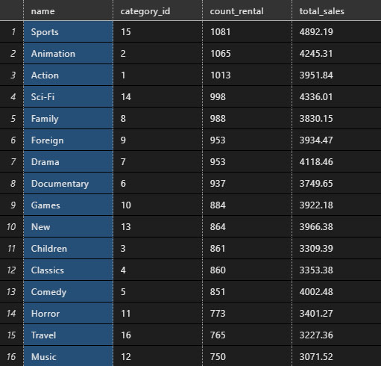
- Combien d’utilisateurs “distincte” ont loué des films d’actions.
SELECT COUNT(DISTINCT customer_id) AS number_of_customers, category.name AS category_name FROM rental
INNER JOIN inventory ON rental.inventory_id = inventory. inventory_id
INNER JOIN film_category ON inventory.film_id = film_category.film_id
INNER JOIN category ON film_category.category_id = category.category_id
GROUP BY film_category.category_id, category.name
HAVING film_category.category_id = 1
ORDER BY number_of_customers DESC;


- Déterminer la moyenne de revenu par catégorie ordonnée dans l’ordre décroissant.

SELECT category.name AS category_name, AVG(amount) AS average_price
FROM payment
INNER JOIN rental ON payment.rental_id = rental.rental_id
INNER JOIN inventory ON rental.inventory_id = inventory.inventory_id
INNER JOIN film_category ON inventory.film_id = film_category.film_id
INNER JOIN category ON film_category.category_id = category.category_id
GROUP BY film_category.category_id, category.name
ORDER BY average_price DESC;

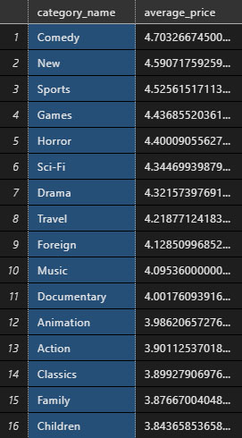

- Quels sont les films qui sont retournés en retard.

SELECT film.title, extract(day from return_date - rental_date) AS number_day, rental.rental_date, rental.return_date
FROM rental
INNER JOIN inventory on rental.inventory_id = inventory.inventory_id
INNER JOIN film on inventory.film_id = film.film_id
WHERE extract(day from return_date - rental_date) > film.rental_duration
ORDER BY number_day DESC;

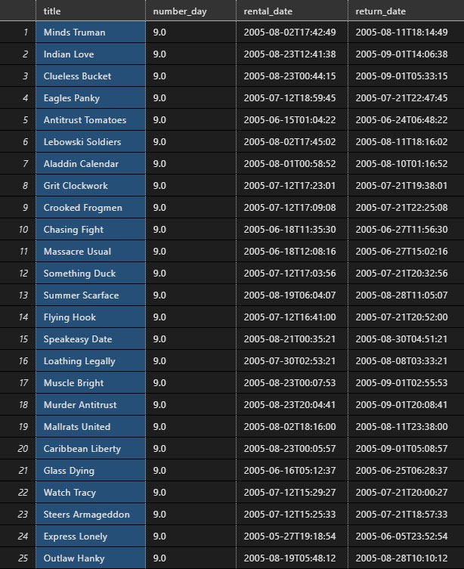

- Déterminer le nombre de client par pays

SELECT country.country, COUNT(customer.customer_id) AS number_of_customer
FROM country
INNER JOIN city ON country.country_id = city.country_id
INNER JOIN address ON city.city_id = address.city_id
INNER JOIN customer ON address.address_id = customer.address_id
GROUP BY country.country_id
ORDER BY number_of_customer DESC;
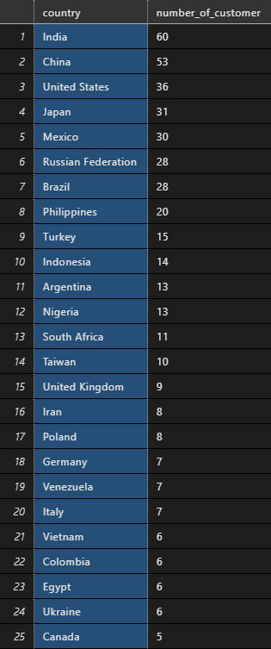
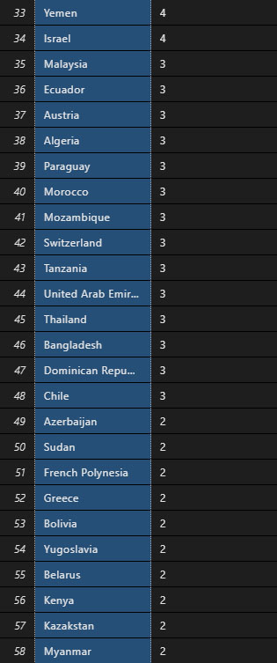

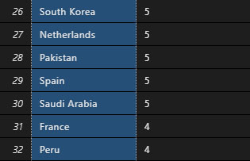


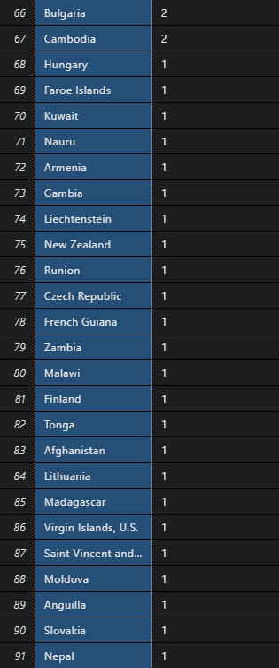


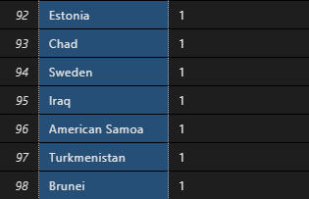

- Trouver les 5 clients qui génèrent le plus de profits pour la société.

- Quel est le tarif de location moyen pour chaque genre ? (du plus élevé au plus bas)

- Peut-on savoir combien d'utilisateurs distincts ont loué chaque genre?

- Combien de films loués ont été retournés tard, tôt et à temps ?

