

Watcher Raspberry Pi setup and operation

Contents:

- Assembly and wiring.
- Device setup and configuration
- Operation

1. Assembly and Wiring:
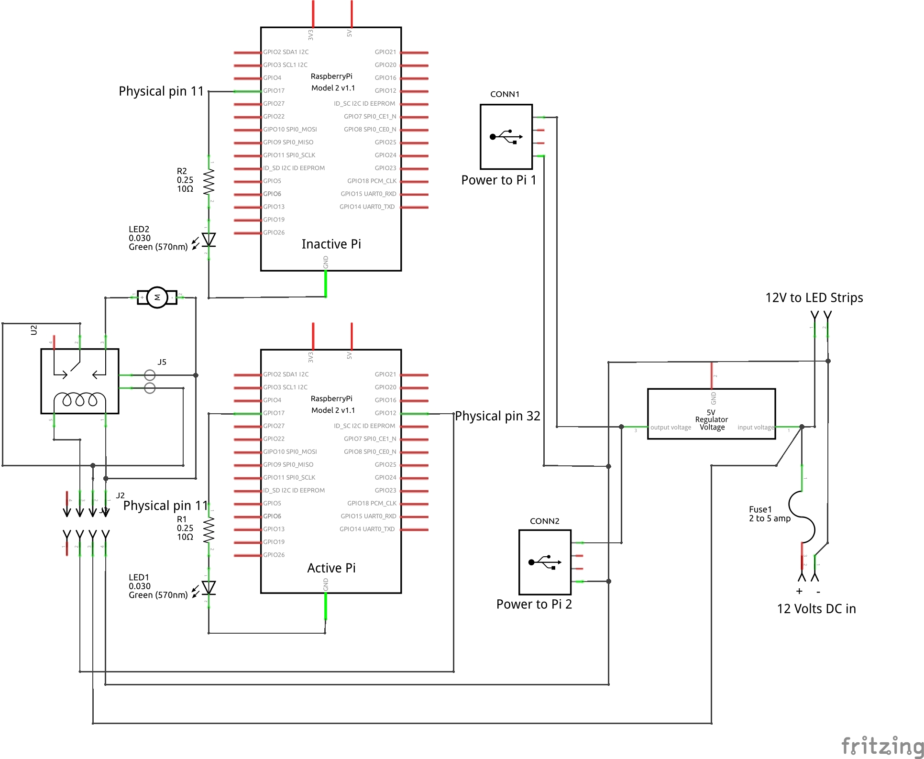
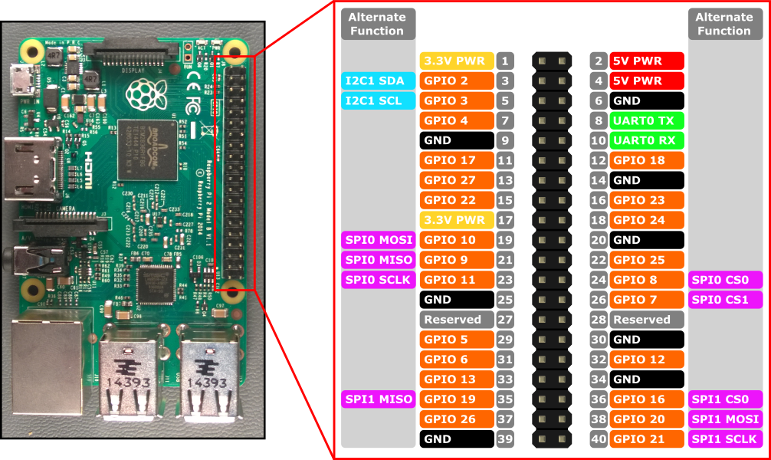

2. Device setup and configuration:
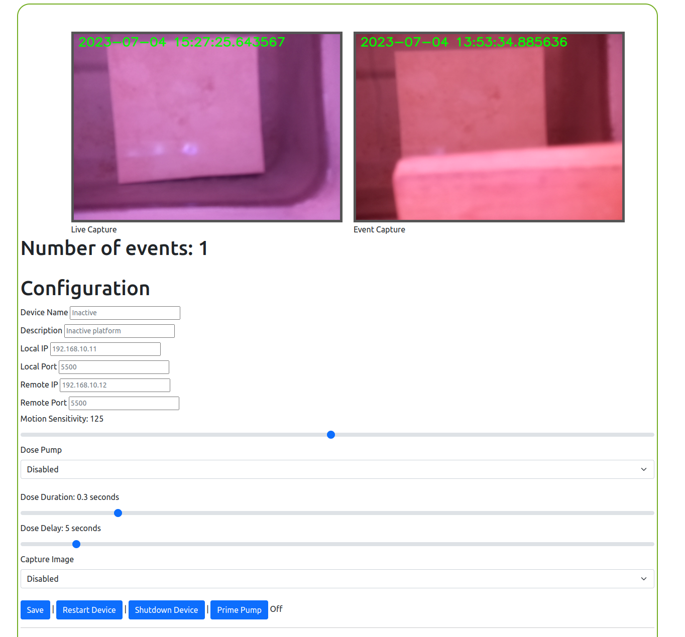
Once you have the Assay assembled and ready with you’re cameras set in your desired locations plug Ethernet cables into each Pi and connect them to your router’s Ethernet ports. You may use a network switch at the Assay location and just use one cable to router if you prefer.

Then plug the USB power cables from the units into the USB ports on the power supply.

Setup the dosing pump as desired.

The LED strips: The ribbon cable from power supply has a brown wire, this is your + voltage and gets connected to the white wires on the LED strips.

Now you can plug the power supply in to the provided wall adapter and let the units boot up.

2. Device setup and configuration: (Continued)
How do I find my device on the network?
There are many ways to do this.
Log in to your router and list the connected devices, look for a host name something like this “raspberrypi.local”.

I like to use an IP Scanner, an Angry IP scanner but don’t let the name fool you.
Angry IP Scanner can be downloaded from the link below or you might find it in Windows App Store.

https://en.softonic.com/download/angry-ip-scanner/windows/post-download

Record the IP address of both the Raspberry Pi’s
Once you have found your devices IP Address, enter the fallowing URL in a browser
http://device_ip:5500

Counterintuitive Alert!!! On the motion sensitivity the lower the number the more sensitive it will be and vice versa.

Dose Pump: Enable or disable the dosing pump. For the Active platform you will want this enabled.

Dose Duration: Sets the duration the pump will run for each trigger.

Dose Delay: Sets the delay before another motion event can trigger the pump.

Capture Image: Enable or disable capturing an image for every motion event. WARNING. When enabled this can use up all the devices free space in a hurry. This should only be used for trouble shooting or dialing in the motion sensitivity.

Device name and description are optional. The device name will show as the page title in your browser.

The IP configurations are not necessary and may be removed in future versions.

3. Operation:

Operation is quite simple.

To reboot the device just click the Restart Device button and then confirm. Once the device is rebooted the browser will be directed back to the main page.

Same to shut down the device. Click the Shutdown Device button and then confirm.

If you are on the Active platform you can use the Prime Pump button to prime the dosing pump.
Click the button again to stop the pump.

ATTENTION: It is always good practice to shut these devices down through the interface properly.
Data loss and corruption may occur if they are just unplugged all the time.

