**IDIOT Token — Whitepaper**

Ticker: IDIOT | Network: Base

Contract: 0xC29EF04CFFe38012dcfc1E96a2B368443f298dE1

Oblivious to hype, allergic to promises.

# 1. Vision

IDIOT Token is a no-nonsense meme token: a loud community, transparent rules, and zero hand-holding. Its vision is to embrace absurdity while keeping blockchain principles honest — no taxes, no admin keys, and no false promises.

# 2. Core Principles

* Meme-first, not money-first
* Zero utility claims; no expectation of profit
* No owner gimmicks or stealth functions
* Transparent contract and supply
* Community-led culture: ROMO & FOMO

# 3. Token Details

|  |  |
| --- | --- |
| Network | Base |
| Ticker | IDIOT |
| Decimals | 18 |
| Total Supply | 1,000,000,000 |
| Taxes | 0% |
| Ownership | Renounced |
| Mint/Burn | Disabled |

# 4. Tokenomics

Transparent allocation with zero hidden fees. The chart below is a formatting-corrected placeholder. Update the allocations in the table to reflect final percentages; the current slices are equal purely to fix layout and readability issues while awaiting your final numbers.

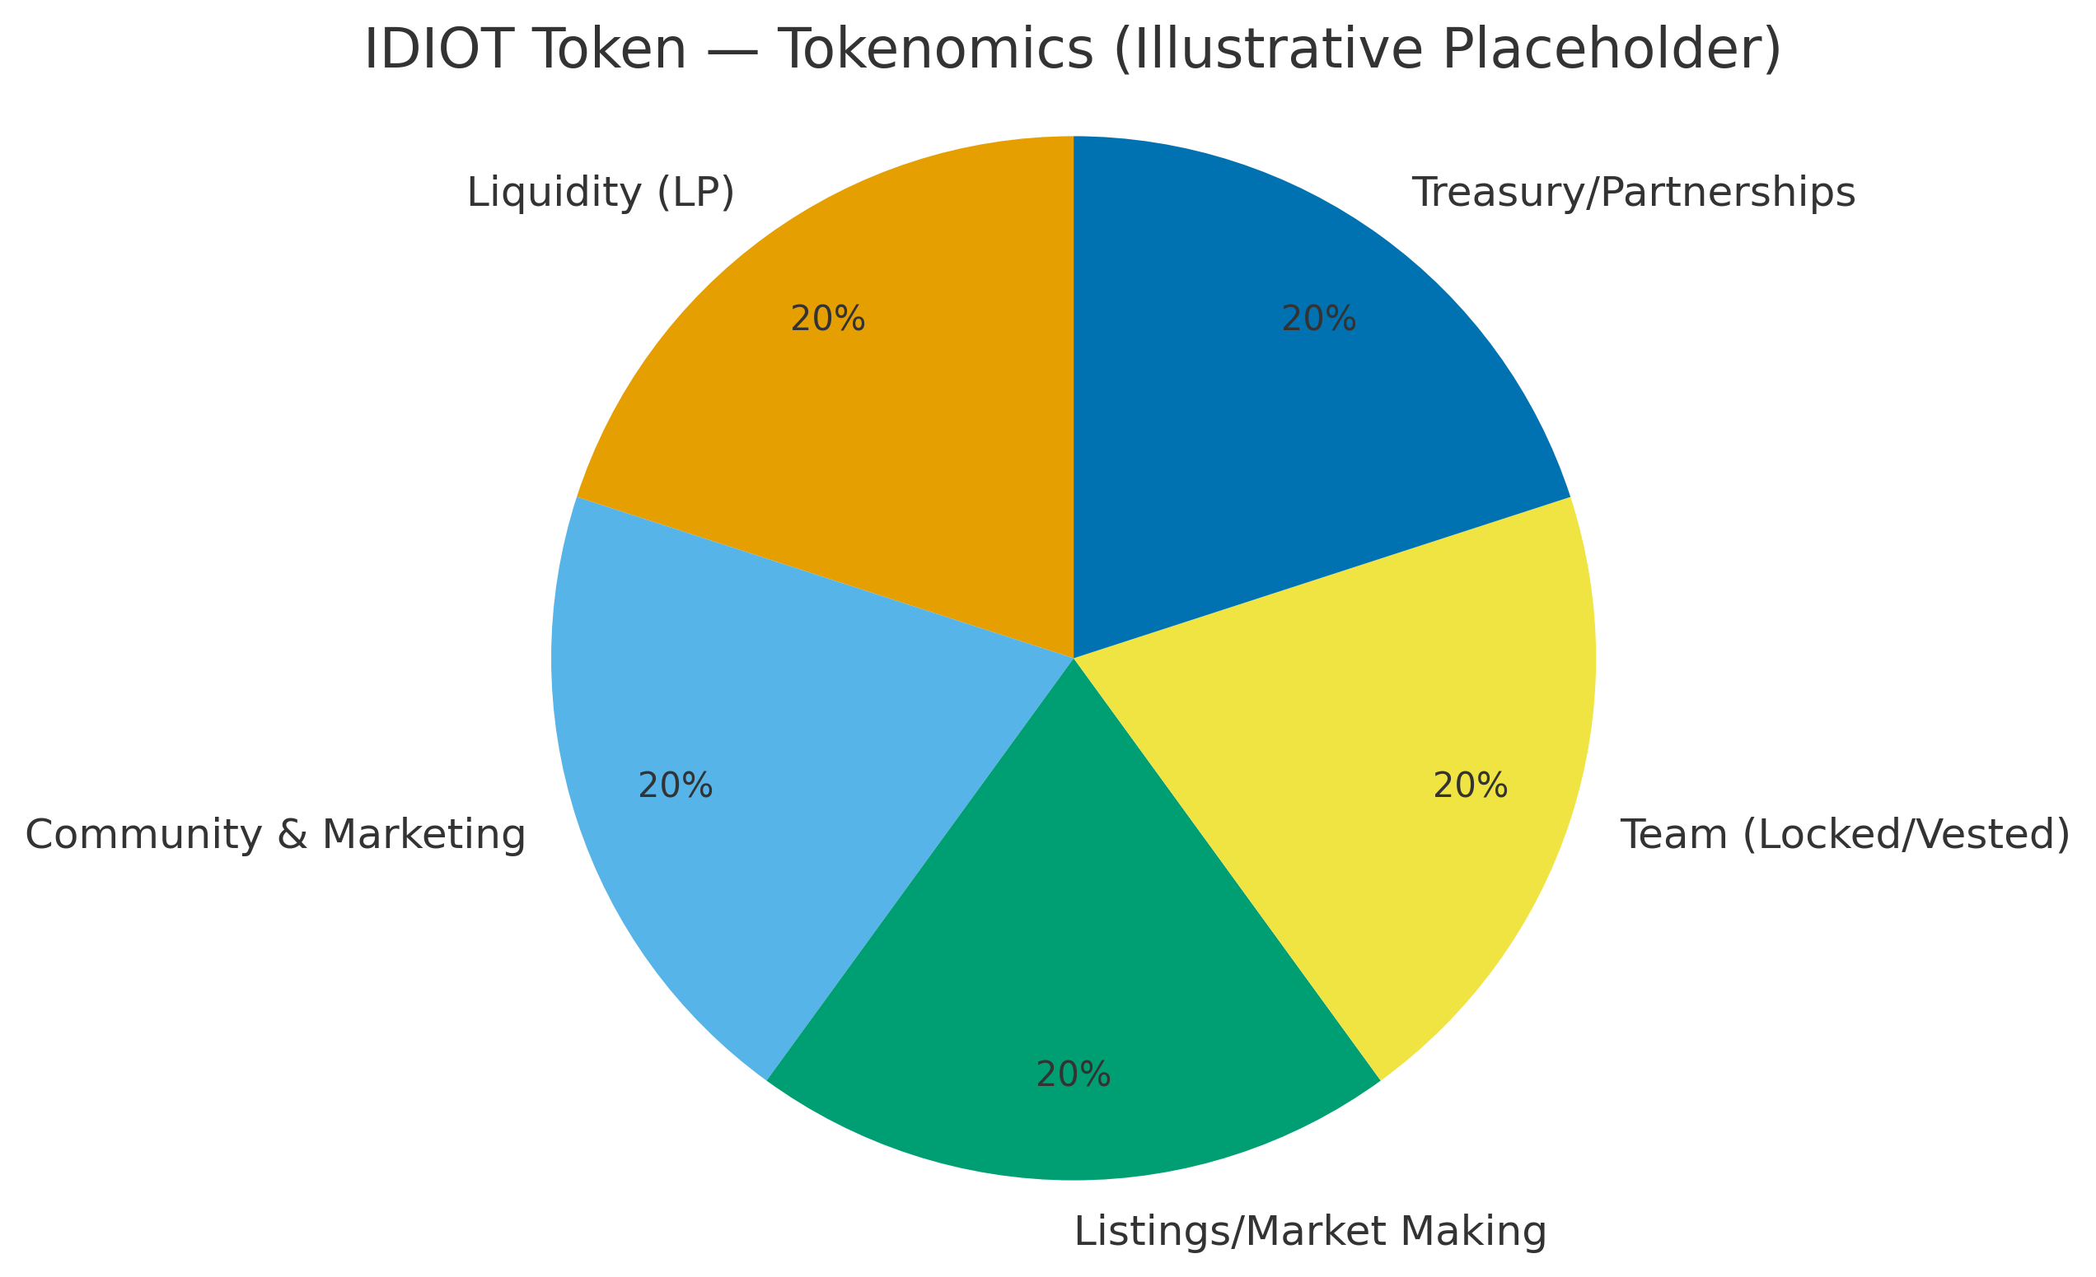

Figure 1 — Tokenomics distribution (illustrative placeholder — replace with final allocations).

|  |  |  |
| --- | --- | --- |
| Category | Percent (%) | Notes |
| Liquidity (LP) | TBD |  |
| Community & Marketing | TBD |  |
| Listings/Market Making | TBD |  |
| Team (Locked/Vested) | TBD |  |
| Treasury/Partnerships | TBD |  |

Note: Team allocation to follow a 12‑month cliff with 24‑month linear vesting thereafter. Liquidity to be locked; details provided on the official site and BaseScan once finalized.

# 5. Roadmap

Phase 1 — Launch & Liquidity: Deploy on Base. Establish Uniswap LP. Verify contract. Kick off memes.

Phase 2 — Community Growth: Expand Discord, X, and contests. Meme raids and collabs.

Phase 3 — Listings: Get on trackers, DEX tools, and aggregators. Build visibility.

Phase 4 — Meme Domination: IRL stunts, partnerships, and full clown‑world recognition.

# 6. Culture

ROMO — Regret Of Missing Out. FOMO — Fear Of Missing Out. We buy the peak, sell the dip — intentionally backwards. The purpose is to enjoy the absurdity together, not to promise financial gain.

# 7. Security & Transparency

* Contract verified on BaseScan: 0xC29EF04CFFe38012dcfc1E96a2B368443f298dE1
* No admin keys or owner functions — ownership renounced
* 0% tax — no reflections, no hidden fees
* Liquidity locked & transparent
* Team allocation locked & vested (12‑month cliff, 24‑month linear)

# 8. Official Links

• Website: https://stupidiots.com

• Discord: https://discord.gg/zpfnkHHE

• X (Twitter): https://x.com/Stup_IDIOT_s

• Facebook: https://www.facebook.com/profile.php?id=61580473892697

Disclaimer: IDIOT Token is a meme token with no intrinsic value or expectation of profit. This document is provided for entertainment only and is not financial advice. DYOR.