1.Ans:

If I have network address from 192.168.1.1 to 192.168.1.255, then we can say that:
The network identifier would be 192.168.1.0
- An address like 192.168.0.0 becomes unusable for any other purpose after it's
established as a network number. If an administrator assigns 192.168.0.0 to any device
on the network as a static IP address, the network stops functioning until that device is
taken offline.As a network number, this address is used in routing tables and by routers
to share network information with each other.
The broadcast address would be 192.168.1.255
- A broadcast is a multipoint connection in a computer network. A data packet is
transmitted from one point to all users of a messaging network in this way. This occurs
with the use of the broadcast address.
So, valid ip addresses would be 192.168.1.1 to 192.168.1.254.

2.Ans:

my ip :192.168.0.103
my mac:00:26:82:A0:FD:E4 (wlp3s0b1)

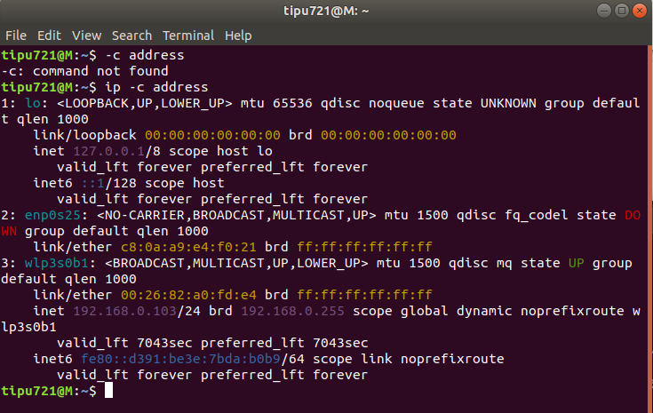

3.Ans:

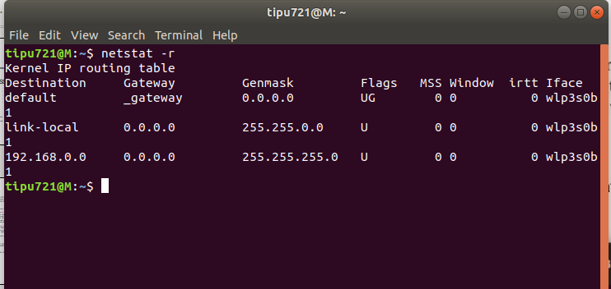
4.Ans:

a) Creating Virtual Interface :

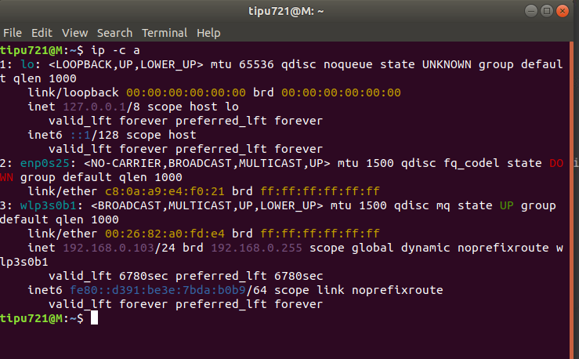
b) Inserting Interface in the Routing Table:

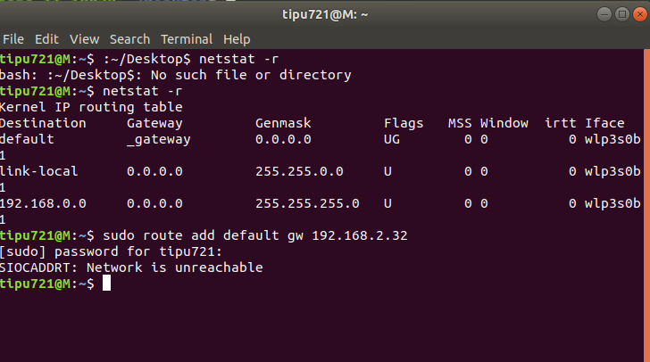
c) Deleting Interface from Routing table:

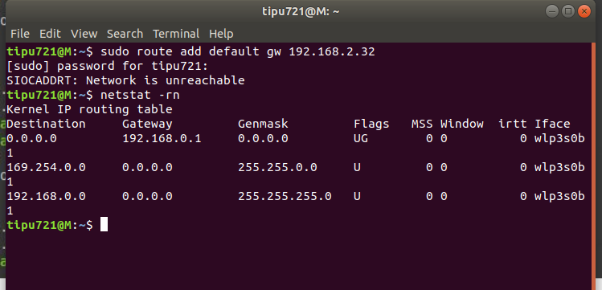

d)Deleting Virtual Interface:

