Linux Networking Commands

ping:

ping is the primary TCP/IP command used to troubleshoot connectivity, reachability, and name resolution.Used without parameters, this command displays Help content. You can also use this command to test both the computer name and the IP address of the computer.
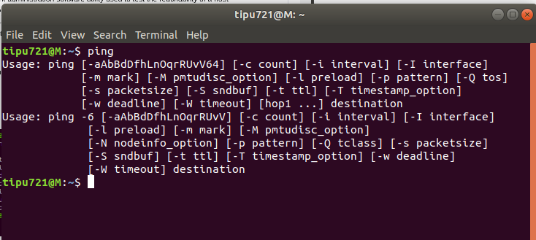

Dig:
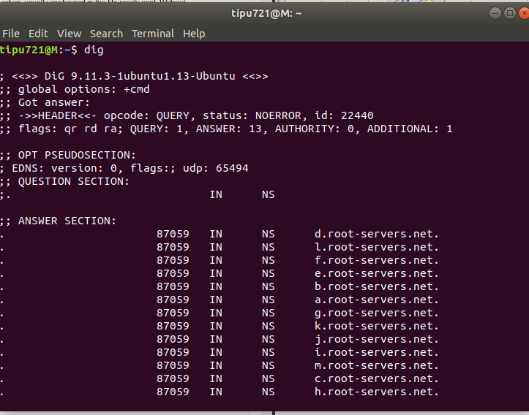
dig is a network administration command-line tool for querying the Domain Name System (DNS).dig is useful for network troubleshooting and for educational purposes. Dig supports Internationalized domain name (IDN) queries.dig is a component of the domain name server software suite BIND.

IP Address:
Type "ipconfig" and press "Enter." Look for "Default Gateway" under your network adapter for your router's IP address. Look for "IPv4 Address" under the same adapter section to find your computer's IP address.
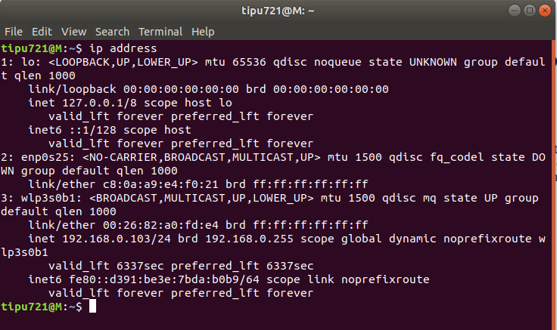
Tracepath:

The tracepath command in Linux allows to trace the path to the destination path determining MTU along this path using UDP port or any other ports that will not require any superuser permissions.Tracepath, tracepath6 are the path traces to host a network detecting MTU along with its path.

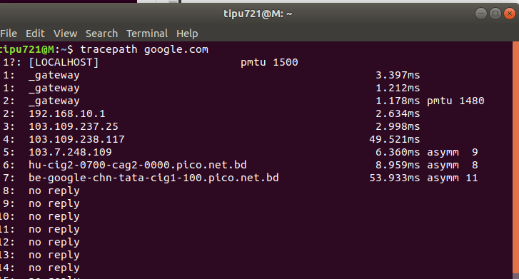

Host name:

hostname command in Linux is used to obtain the DNS(Domain Name System) name and set the system’s hostname or NIS(Network Information System) domain name. A hostname is a name which is given to a computer and it attached to the network. Its main purpose is to uniquely identify over a network.
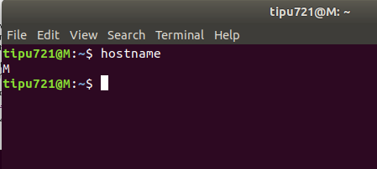

twconfig:
The configuration file stores system-specific information, including the location of Tripwire data files, and the settings used to send email notification. The configuration file settings are generated during the installation process, but can be changed by the system administrator at any time. The configuration file is signed with the site key, and the site passphrase is required to edit the file.
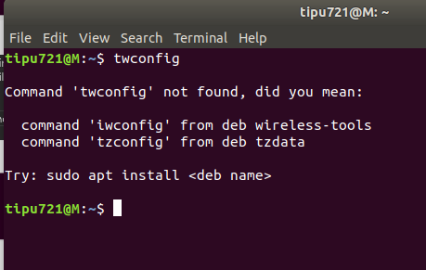

W:
w command in Linux is used to show who is logged on and what they are doing. This command shows the information about the users currently on the machine and their processes. The header shows, in this order, the current time, how long the system has been running, how many users are currently logged on, and the system load averages for the past 1, 5, and 15 minutes. The following entries are displayed for each user: login name, the tty name, the remote host, login time, idle time, JCPU, PCPU, and the command line of their current process. The JCPU time is the time used by all processes attached to the tty. It does not include past background jobs but does include currently running background jobs. The PCPU time is the time used by the current process, named in the “what” field.
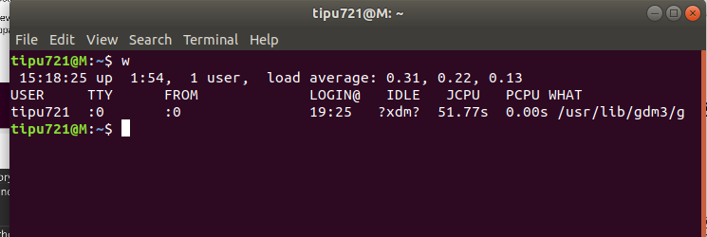

Wget:
GNU Wget is a command-line utility for downloading files from the web. With Wget, you can download files using HTTP, HTTPS, and FTP protocols. Wget provides a number of options allowing you to download multiple files, resume downloads, limit the bandwidth, recursive downloads, download in the background, mirror a website, and much more.
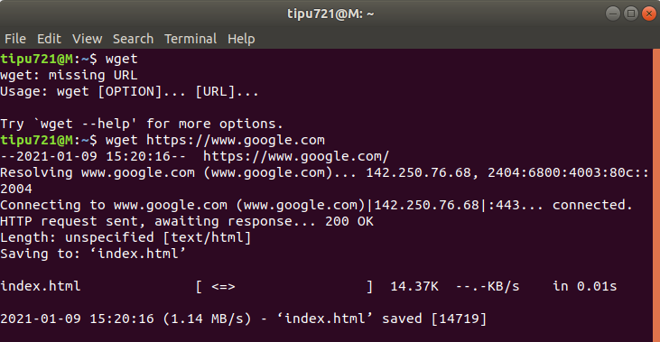
Whois:
whois searches for an object in a WHOIS database.WHOIS is a query and response protocol that is widely used for querying databases that store the registered users of an Internet resource, such as a domain name or an IP address block, but is also used for a wider range of other information.
