Installation Guide
(Status 18.08.2013 / Version 0.9.0)

Table of Contents
Introduction/Overview 3
Module description 3
Getting Started 4
Requirements 4
Installation 4
Configure the module 4
Configure the account 6
Minimal configurations 8
Structure and functionality 10
Demo 10
Additional features / Tips 11
Troubleshooting and bugs 12

Introduction/Overview
Title of module: oxTiramizoo
Category: Order fulfillment & logistics
Author: tiramizoo GmbH
Link: http://tiramizoo.com/
Contact e-mail: support@tiramizoo.com

Module description
Tiramizoo is a direct delivery service. oxTiramizoo module provides easilly integration with Tiramizoo API.

Getting Started

Requirements
Active account at Tiramizoo (http://tiramizoo.com/).

Installation
- Copy all files from copy_this folder to the OXID eSales installation path. This step does not overwrite any files.
- Run SQL statements from sql/install.sql file into your database
- If the template does not support blocks, please compare changed files according to metadata file
- Go to eShop Admin -> Extensions -> Modules, select the "OXID Tiramizoo.com" extension and press the "Activate" button in the "Overview" tab.
- After these steps, the "Tirazmizoo" menu item appears in the eShop Admin navigation

Configure the module
At Tiramizoo -> Settings
The configuration form has to be filled in with proper data:
Tiramizoo URL: The URL of the tiramizoo service endpoint (production versionhttps://api.tiramizoo.com/v1, testing version https://sandbox.tiramizoo.com/api/v1)
Shop URL: URL used to build the webhook url for order creation. The tiramizoo service will send a request to the url each time an order status change occurs.
Packing strategy: The shop admin is able to specify what packages are used by the shop. He can do that in 3 ways:
All products have individual dimensions: That means each product will be packed separately (number of products equals number of packages).
Specific dimensions of packages: That means that the admin is able to specify all package sizes they use in shop to pack products. Then the packing algorithm starts to pack all products in as smallest number of packages as possible and assumes the resulting package size as the package to deliver. Go to the tiramizoo website configuration to specify these dimensions (Production version, testing version).
All products should fit to one package: That means every product will go to one package (no matter how many products customer bought there will be only 1 package for courier)
Default dimensions and weight: Tiramizoo delivery works only if every article in basket has specified dimensions and weight. The module allows to specify global dimensions and weight. These values are applied for each product without specified dimensions and weight.
Tiramizoo payment methods assigned Payment methods which are available for tiramizoo service. *Warning: Cash on delivery is currently not supported by Tiramizoo.
Enable only articles with stock: Admin is able to turn on/off stock monitoring. That means if any of products in customer's basket are not available in the shop's stock, the tiramizoo delivery option will not show up.
Retail Locations The user api tokens available in the user dashboard after registration on the tiramizoo.com site. The API token is required to authenticate api requests. Plugin offers to connect for more than one tiramizoo account. Shop can deliver orders from more than one retail location. The decision which api token is going to be used is made by postal codes comparisons.
Synchronize all configuration: Configuration options from all retail locations (tiramizoo accounts) are synchronized daily. This process is performed in the first http request to the shop after midnight. It is possible to synchronize configuration directly by pressing the "Synchronize" button

At the Administer Products -> Categories -> Category selection -> Tiramizoo tab
Product's main category and all its parents categories need to have Tiramizoo service enabled to let containing products be delivered by Tiramizoo service. Also dimensions form enables to specify default product dimensions which will apply to all products which have the category selected as a main category and will not have dimensions specified explicitly.
Please consider, that inheritance of category properties that are not assigned as Main category, wouldn't be apply to products they have.
Products ready for delivery with tiramizoo should be available in stock (if "Enable only articles in stock" is selected), should have dimensions and weight specified and dimensions and weight can not cross specific level.
Validation of products will take place when delivery and payment methods appear. That means, even if flag "available for tiramizoo" is set, tiramizoo service could not appear as one of delivery option in 3th step of checkout process because of validation
At the Administer Products -> Products -> Article selection -> Tiramizoo tab
You can enable or disable Tiramizoo delivery for selected product. This page contains preview of the effective dimensions

Configure the account
The main configuration of tiramizoo delivery is available on the tiramizoo website.
Packages presets: (Profile -> Default packages sizes) Retail location admin is able to specify package sizes that they use to pack products.
Pickup contact:
Go to Profile -> Account and click on "New Contact" link
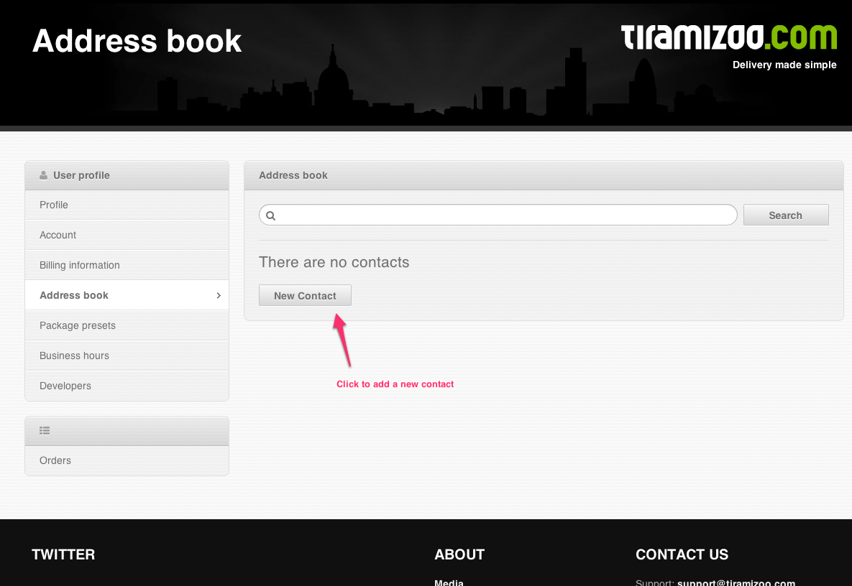

Fill the required form fields and press the "Create contact" button
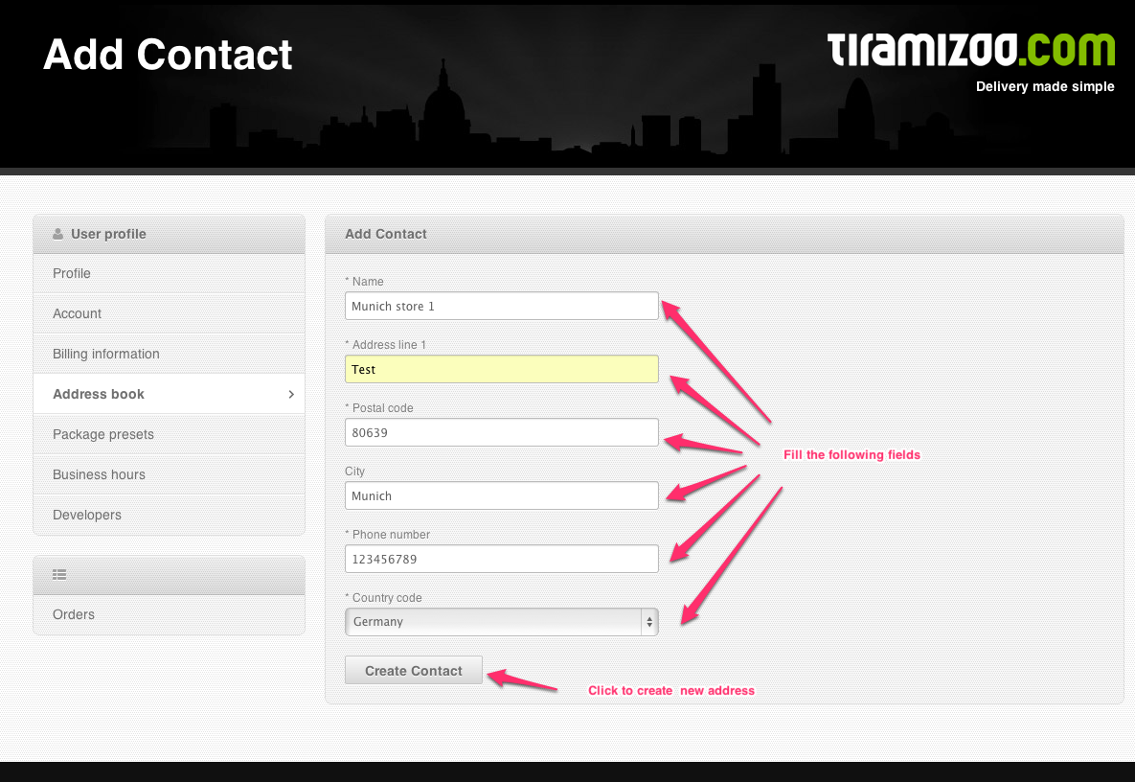
Click on radio button to set selected contact as "Pickup contact"
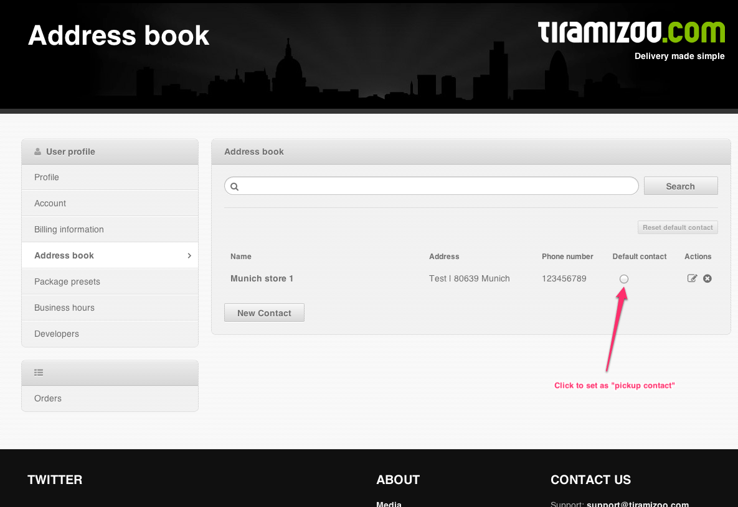

Enable Immediate delivery type: (Profile -> Account -> Immediate time window enabled) Select Yes to enable Immediate delivery type or no to disable.
Enable Evening delivery type: (Profile -> Account -> Time window preset) Select time window to enable Evening delivery type or left blank to disable.
Retail location name: (Profile -> Account -> Name) Name of retail location presented on Oxid tiramizoo settings.
Business hours: (Profile -> Account -> Business hours) Specify when courier can pick up delivery. Selected days and hours could be extended by special days e.g. 24/12/2013 8:00-14:00 (in this example business hours are reduced).

Minimal configurations
The tiramizoo delivery option is only available if the following rules are met:
Tiramizoo account configuration:
- Pickup contact is selected and has valid postal code
- Immediate delivery type or Evening delivery type is enabled
- Package presets are specified if shop use "Specific dimensions of packages" as packing strategy
Oxid plugin configuration:
- Tiramizoo API url is filled correctly with sandbox or production API url
- Shop url is not empty
- One or more available payment method are checked
- The API Token is added
Article in basket configuration
- Article has specified dimensions and weight directly or inherited by global / category settings.
- Article is enabled with Tiramizoo Delivery
- Article's main category and its parent categories are enabled with Tiramizoo Delivery
- Article stock quantity is greater than 0 if "Enable only articles with stock: is selected
Oxid eShop configuration
- Tiramizoo Delivery Set is active
- Tiramizoo Cost rule is active and assigned to Tiramizoo Delivery Set
- Warning: We highly recommend to set customer's phone number as a required field. It enables courier to contact customer when necessary*

Structure and functionality
This module provides integration with Tiramizoo API. Add 2 delivery sets in payment step (only if Tiramizoo delivery is availalbe to customer postal code and basket items is valid) in checkout proccess. After saving order send order data to Tiramizoo API.
The checkout has 5 steps. Step 1 - Cart, Step 2 - Address, Step 3 - Payment, Step 4 - Ordering, Step 5 - Confirmation
- All items added by the user need to have the tiramizoo service enabled, either directly or by their parent category.
- User adds items to the basket.
- User goes to the checkout (Step 1)
- User specifies the delivery address (Step 2)
- User selects tiramizoo as delivery option (Step 3)
- User selects the delivery time window (when he wants the courier to deliver)
- User selects payment method (Step 3)
- User verifies and confirms (or corrects if needed) the order by going to step 5
- Between Step 4 and Step 5 the plugin sends a request to tiramizoo.com to create the order
- User sees the thank you page and receives an email with the tracking url

Demo
- The Demo shop is available here: http://oxid-demo.tiramizoo.com
- Admin panel access: http://oxid-demo.tiramizoo.com/admin
- Admin username: oxid-demo@tiramizoo.com password: secret
- Test client username: test@tiramizoo.com password: secret
- Demo shop settings and data are reverted to default every 4h

Additional features / Tips
- WebHook notifications
The plugin is able to receive push notification sent by tiramizoo each time the order status has changed. The order state is then changed on shop level as well. Go to Order tab to check the current order status. Webhook url needs to be accessible for POST request.
- Disable tiramizoo service for individual product
Available on product page
- Mark individual product to not be packed with others - standalone
Available on product page
- Disable tiramizoo service for individual category
Available on category page
- Mark each product within category as individual product to not be packed with others - standalone
Available on category page
- Change cost calculation method of delivery
Default price paid by customer for every delivery is set as Tiramizoo Standard Cost rule and it could be changed. If needed that price is depended on conditions like (article dimensions, basket total price, article amount in basket) it could be solved by adding new cost rules. But if needed more complexity cost calculation depends on other factors (from tiramizoo configuration and time windows delivery type) it should be done by changing the method calculateDeliveryPrice in class oxTiramizoo_DeliveryPrice

Troubleshooting and bugs
- Check "Minimal configurations" section of this document
- Use the newest version of plugin from master branch and Your eShop version is 4.7.x/5.0.x.
- In case of any issues or suggestions please let us know through github issues

