**Insert BLOB Into Database**

**Configuring File System Adapter Service**:

Create the "File System Adapter Service" of type "File System Adapter" under Deployment in Administration menu.

Use the File System adapter to collect (import) files from a file system into a business process and extract (export) files from a business process to a file system. You can configure the File System adapter to start a business process after files are collected from the file system or include the File System adapter in a business process flow. In addition, you can schedule the File System adapter to run at specific time intervals.

You can create multiple File System adapter configurations, one for each of several collection folders. Alternatively, you can use a single File System adapter configuration to point to different directories by specifying the directories for file collection and extraction explicitly in a business process.

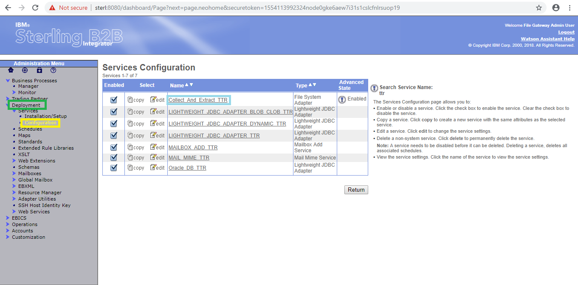

By using "edit" button we can edit the existed service and by using "copy" button we can copy the service.

Ensure that the adapter is enabled.

The following will illustrate the "File System Adapter Service" .

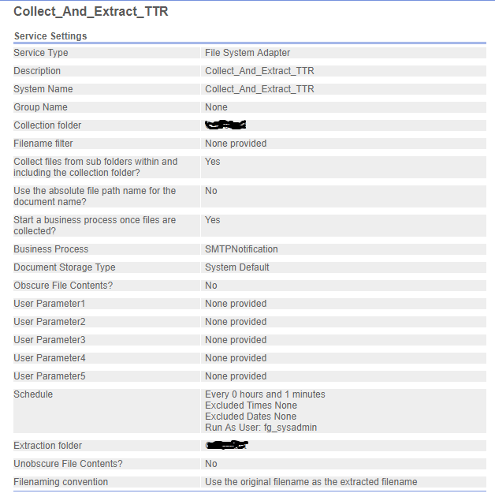

**Configuring Lightweight JDBC Adapter :**

The Lightweight Java Database Connectivity (JDBC) adapter enables you to retrieve data from a JDBC-compliant database or update a JDBC-compliant database as part of a business process within Sterling B2B Integrator. This adapter is useful if you want to retrieve or manipulate data and need the flexibility of specifying various SQL queries.

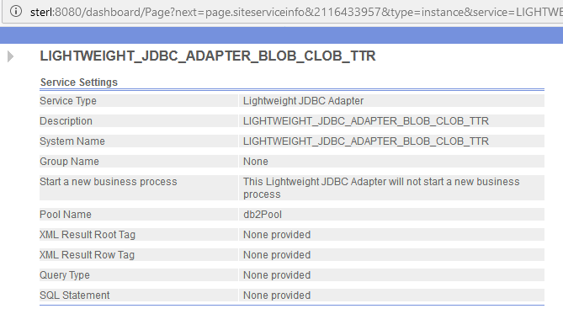

Create the Business Process under the Business Process in Administration menu

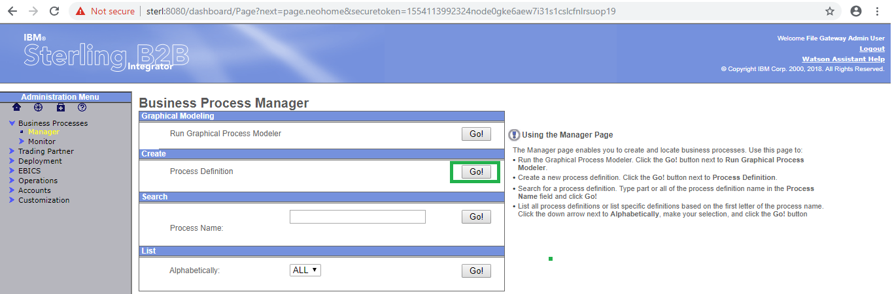

Click on "Go" button as shown above.

Select the Business Process Text Editor and click on next.

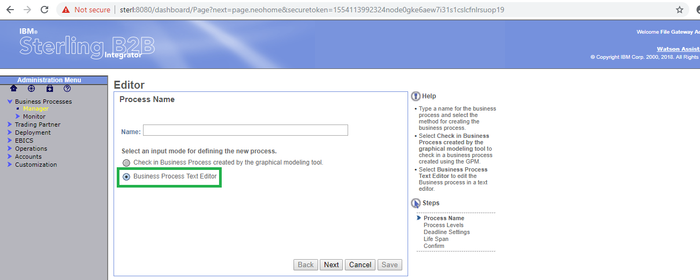

Copy the xml code in the Business Text Editor as below and click on next.

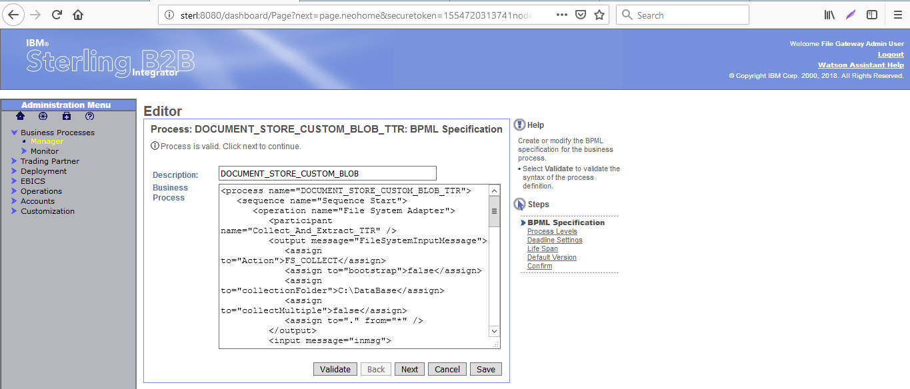

Click on "Validate" button for validating the process.

Business Process shown as below.

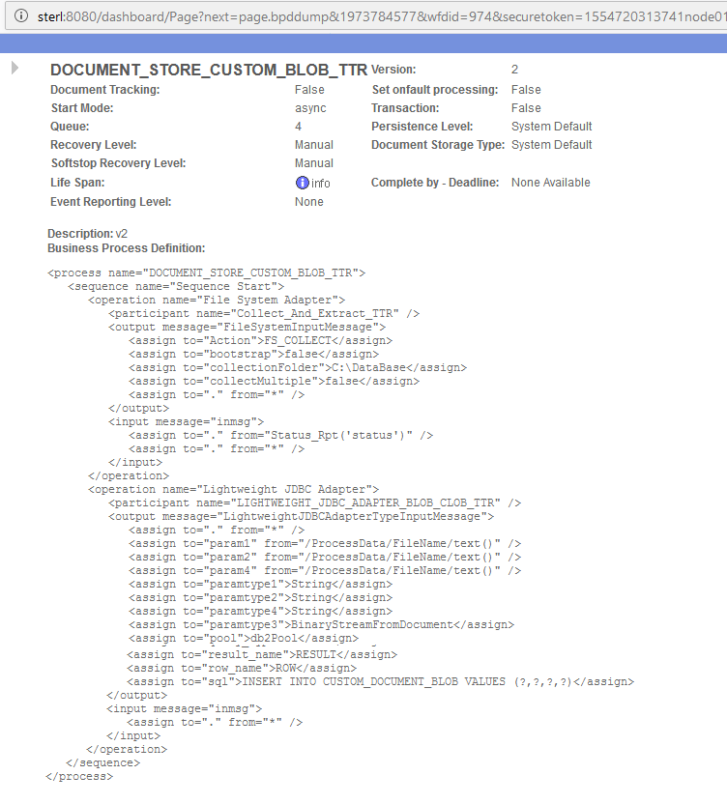

Use the File System adapter to collect (import) files from a file system into a business process and extract (export) files from a business process to a file system. You can configure the File System adapter to start a business process after files are collected from the file system or include the File System adapter in a business process flow. In addition, you can schedule the File System adapter to run at specific time intervals.

You can create multiple File System adapter configurations, one for each of several collection folders. Alternatively, you can use a single File System adapter configuration to point to different directories by specifying the directories for file collection and extraction explicitly in a business process.

The below operation will collect the files from the given "collectionFolder" i.e. "C:\DataBase" using the Action FS_COLLECT.

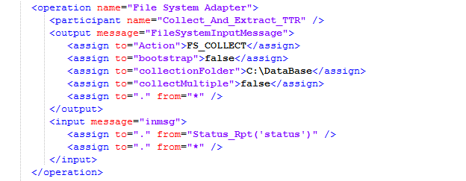

The Lightweight Java Database Connectivity (JDBC) adapter enables you to retrieve data from a JDBC-compliant database or update a JDBC-compliant database as part of a business process within Sterling B2B Integrator. This adapter is useful if you want to retrieve or manipulate data and need the flexibility of specifying various SQL queries..

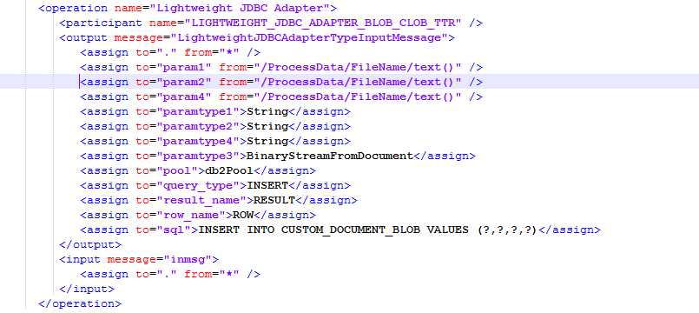

Run the process by click on the "execution manager" .

Modify the process by click on "source manager" as shown as below.

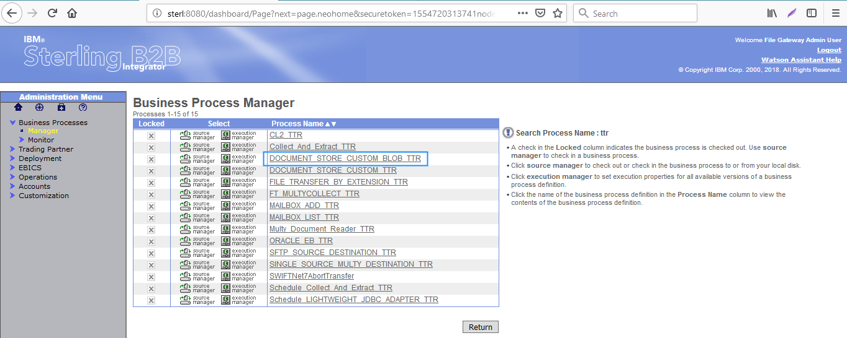

In the below shows the different version of process. first one is latest version of process and which is the last modified version.

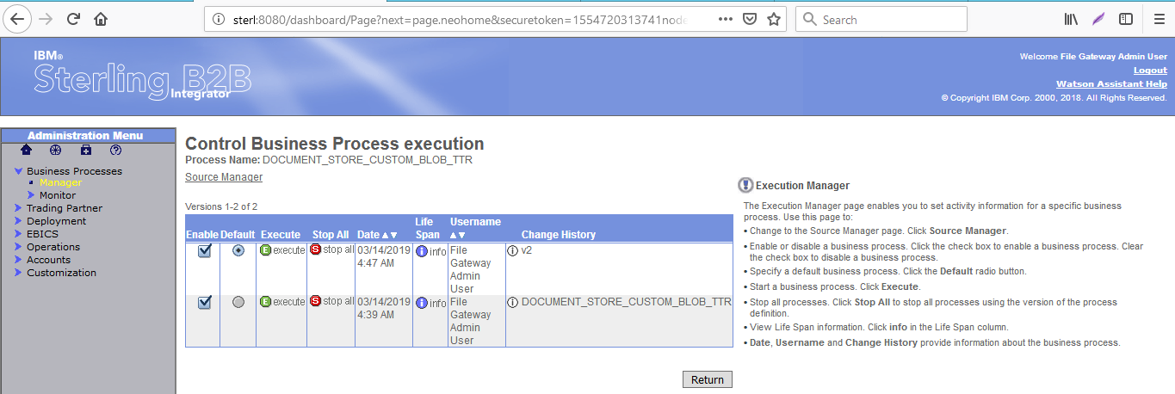

After click on the "execute" the following window will open

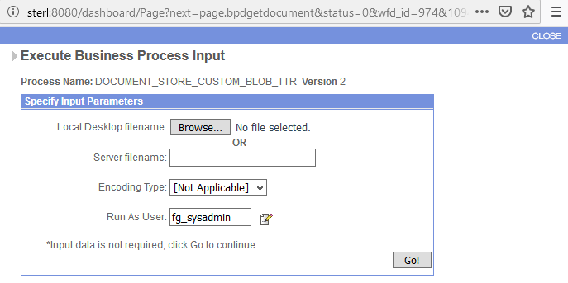

Click on the "Go" the following window will open

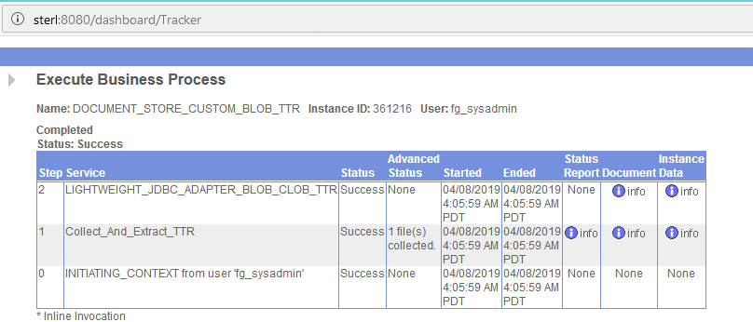

The source code of the process is as below.

