**1) How To Encrypt Document And Store in Data Base**

**File System Adapter Services**:

First we have to collect file from the folder using "File System Adapter" service for encrypt and store file in data

base. you can see service implementation xml below .

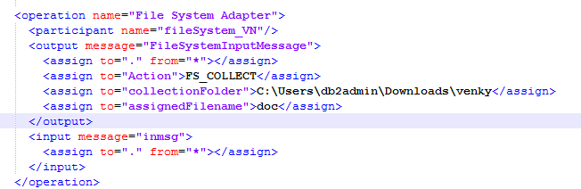

Action: we have two actions ' FS_COLLECT ' for collect the files. And ' FS_EXTRACT ' for extract files to folder.

collectionFolder: for this attribute we assign folder path where we collect files for encryption.

**EBICS Encryption Service:**

This service used for encrypt the document and give the encrypted document. After encryption service give the

'SymmetricKeyId' this key id used for decryption of document.

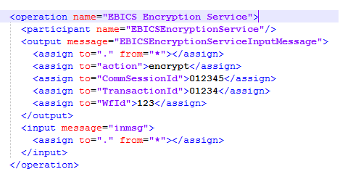

**Lightweight JDBC Adapter:**

This service is used for database operations. you can see below xml for implementation of service. we are getting four

parameters by using Xpath. And fifth parameter is 'BinaryStreamFromDocument' for this input document get from

PrimaryDocument.

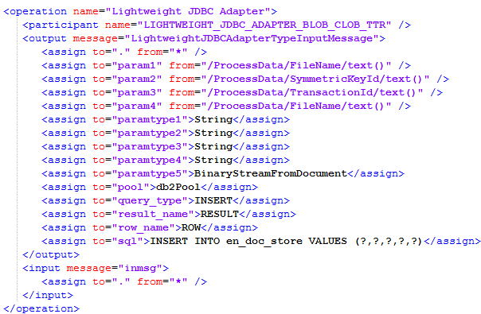

by sequence of execution of above service we can achieve the task. below shown process perform document encryption and store in database. for execution of process click on 'execution manager'

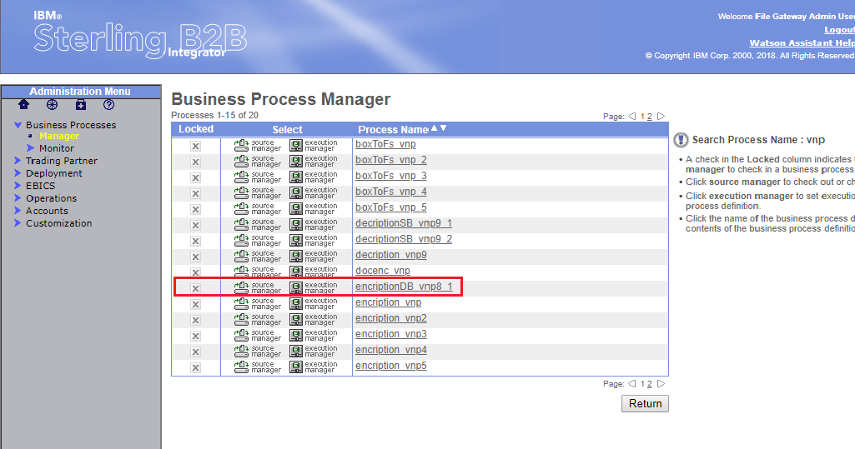

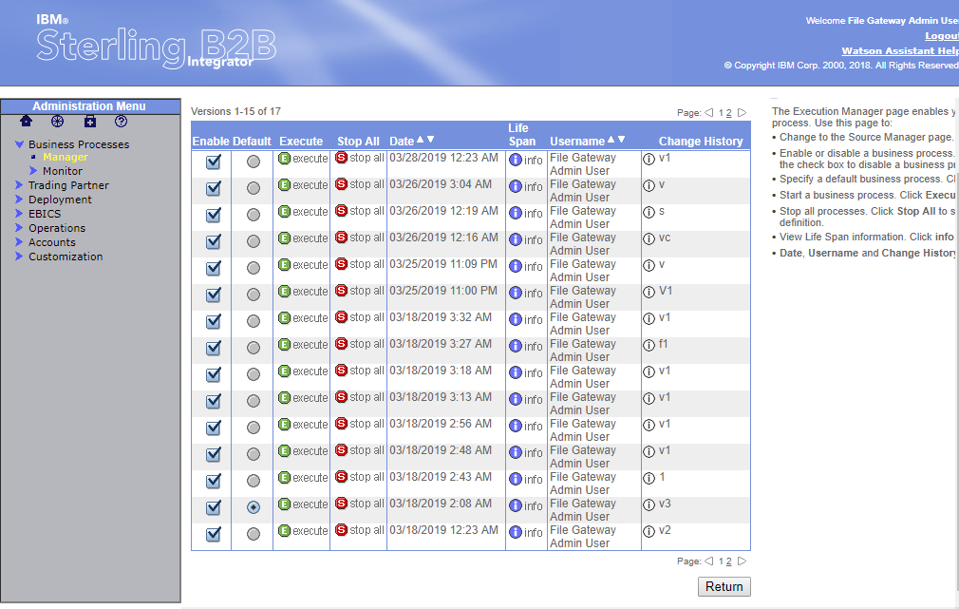

above image we can see different version of process. first one is latest version of process. by seeing date also we can

find latest version. by click on execute we can run the process. After click on execute we will see popup like below and

by click on go process will execute

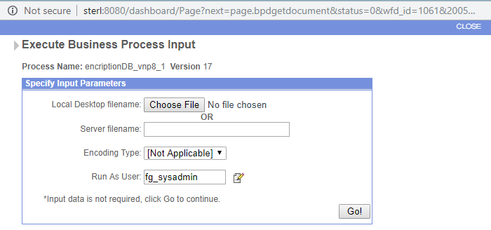

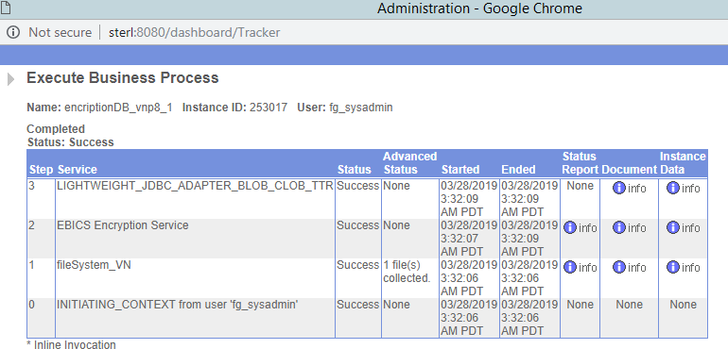

**2)How To Get Documents From DB And Decrypt Store In Folder**

**Lightweight JDBC Adapter:**

The Lightweight Java Database Connectivity (JDBC) adapter enables you to retrieve data from a JDBC-compliant database or update a JDBC-compliant database as part of a business process within Sterling B2B Integrator. This adapter is useful if you want to retrieve or manipulate data and need the flexibility of specifying various SQL queries.

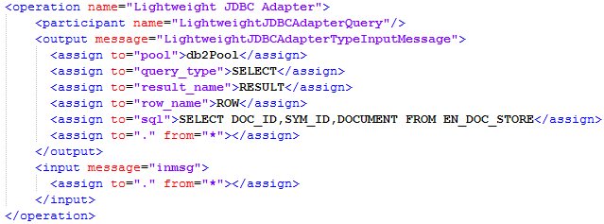

above service get the document records from database table and add result into primary document. Retrieved Documents are added to process data xml.

for extracting of retrieved documents we need loop for that rule is created.

C:\Users\Administrator\Documents\B2B\img\decserv9.png

PrimaryDocument contains Lightweight JDBC Adapter Service query result. we use primary document to be extracting

retrieved documents from database. for that primary document query result conevrted into DOM and added to processdata.

by using 'DocToDOM' function converting document into dom and added to the processdata xml.

C:\Users\Administrator\Documents\B2B\img\decserv3.png

**For Each Document service:**

The For Each Document service incrementally processes a set of documents. Each time the service runs, it makes the next document in the document set the primary document. This enables business processes to contain loops that operate on each document in turn.

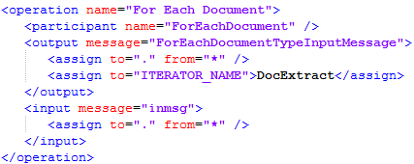

**Choice:**

a Choice will invoke a sequence of steps. In this case, our choice is a simple one: continue or stop. Since we need no steps if the choice is to stop, we need only configure the steps for the instance where we continue.

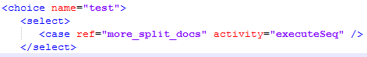

**EBICSEncryptionService:**

Here multiple documents retrieved from database and they have to be decrypt one by one using loop.

document is collect from primary document. after execution of For Each Document service. this service produce decrypted document with name 'Decrypted Output Document'

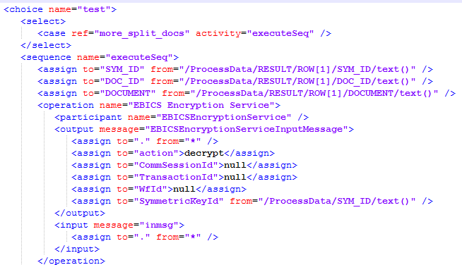

**Get Document Information Service :**

The Get Document Info service provides information about the primary document. You can query the service about many types of information, including DocumentName, DocumentBodyLength, and DocumentID. If 'updateMetaDataOnly' set true then Document name can be changed. In this service document name set with name

which is get from database.

Document name to be set because 'EBICS Encryption Service' give the same name for every decrypted document.

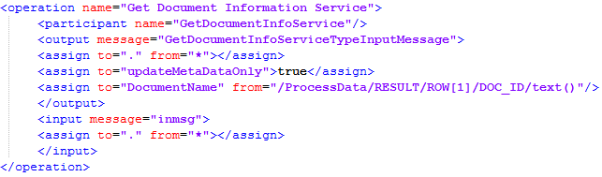

**File System Adapter:**

extracts (exports) files to the file system.

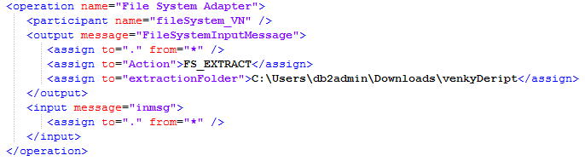

**Release service:**  
Use the Release service to remove elements that are no longer needed by a business process. in loop after extracting

file we have to remove the first row in result and primarydocument containing first document from database.

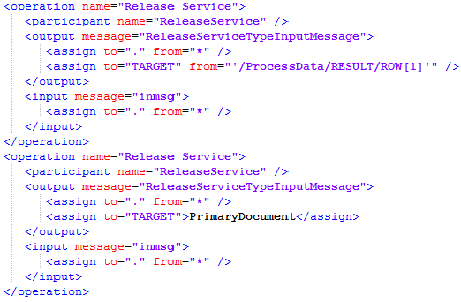

**Sleep Service:**

The Sleep service pauses a business process for the amount of time specified in its configuration.

|  |  |
| --- | --- |
| MSEC_SLEEP_INTERVAL | Duration of sleep time in milliseconds. |
| SLEEP_INTERVAL | Duration of sleep time in seconds. |

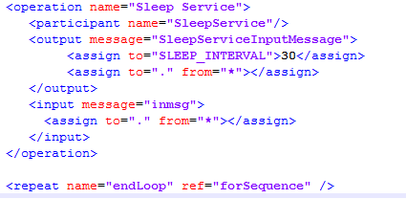



by sequence of execution of above service we can achieve the task. below shown process perform document decryption and store in file system. this task get multiple documents and decrypt. for execution of process click on 'execution manager'

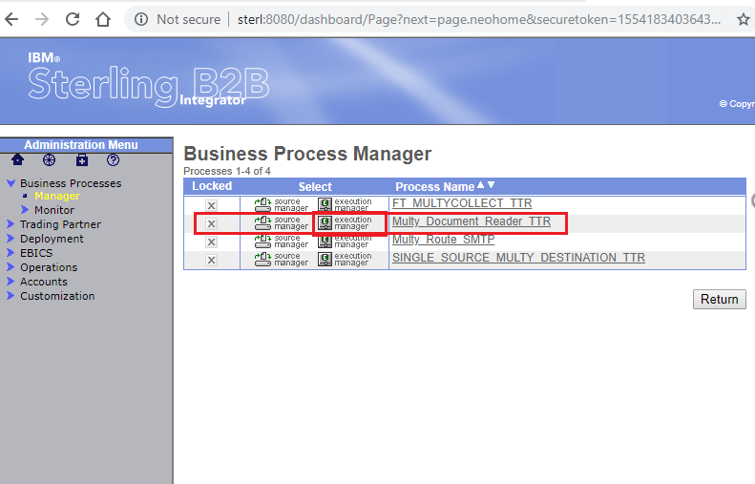

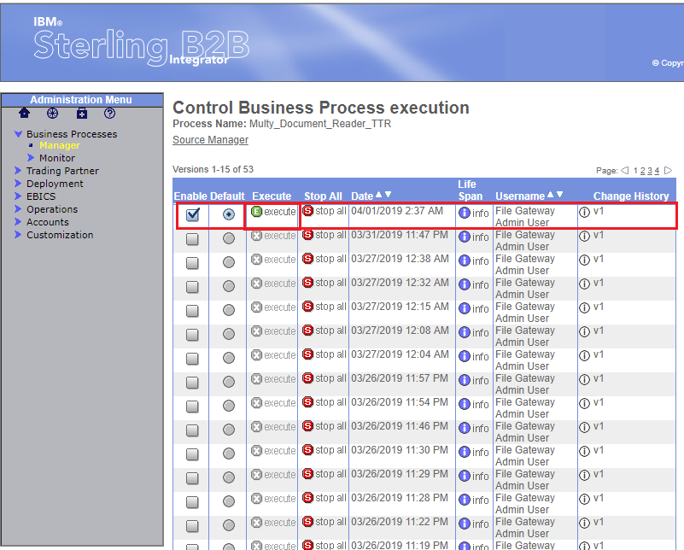

above image we can see different version of process. first one is latest version of process. by seeing date also we can

find latest version. by click on execute we can run the process. After click on execute we will see popup like below and

by click on go process will execute

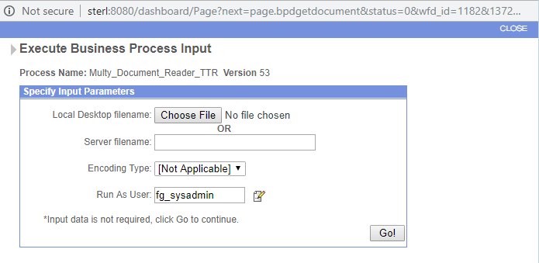

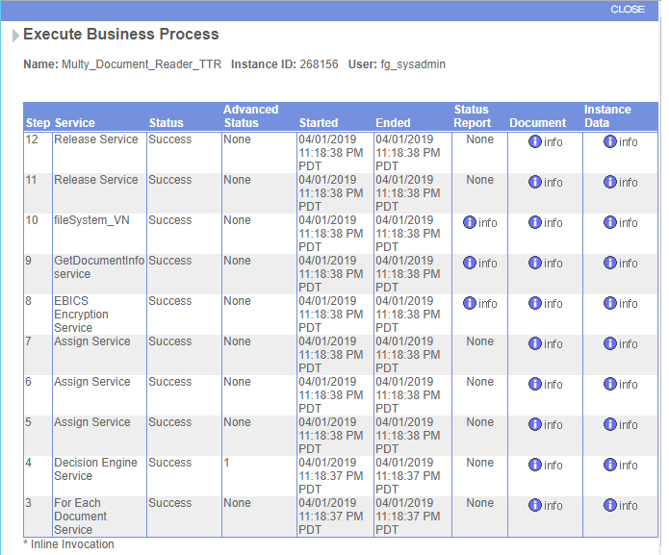

By click on info we can see process data after the service execution

