**File Transfer Between Multiple Platforms**

**Configuring SFTP Client Begin Session Service**

The "SFTP Client Begin Session service" starts an SFTP session with an external trading partner for exchanging business documents.

Create "SFTP Client Begin Session Service" under the deployment in the Administration menu.

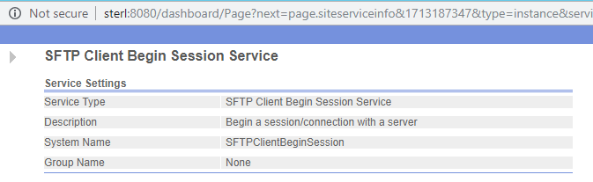

**Configuring SFTP Client CD Service**

The "SFTP Client CD service" changes directories on the trading partner's SFTP server.

Create "SFTP Client CD Service" under deployment in Administration menu.

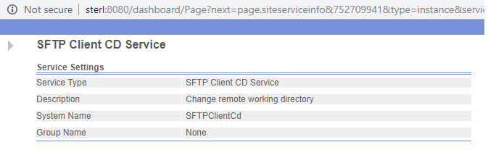

**Configuring SFTP Client GET Service**

The "SFTP Client GET service" retrieves one or more documents from a specified directory on the trading partner's SFTP server.

Create "SFTP Client GET Service" under deployment in Administration menu.

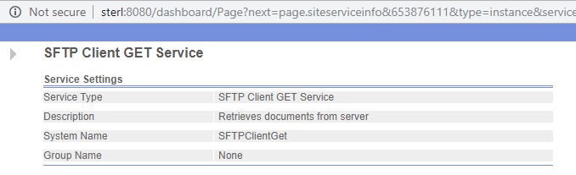

**Configuring For Each Document Service**

The "For Each Document service" incrementally processes a set of documents. Each time the service runs, it makes the next document in the document set the primary document. This enables business processes to contain loops that operate on each document in turn.

Use the For Each Document service when you have multiple documents within the business process that all need to be processed.

Create " For Each Document " Service under deployment in Administration menu.

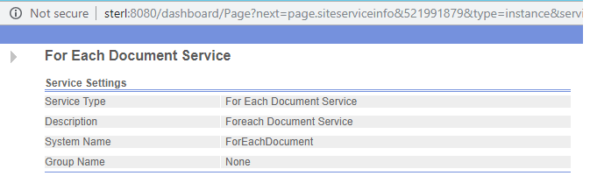

**Configuring SFTP Client PUT Service**

The "SFTP Client PUT service" places a document in a specified directory on the trading partner's SFTP server

Create "SFTP Client PUT Service" under deployment in Administration menu.

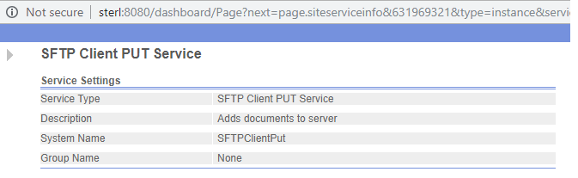

**Configuring File System Adapter**

Create "File System Adapter " Service under deployment in Administrator menu.

Use the "File System adapter" to collect (import) files from a file system into a business process and extract (export) files from a business process to a file system. You can configure the "File System adapter" to start a business process after files are collected from the file system or include the "File System adapter" in a business process flow. In addition, you can schedule the File System adapter to run at specific time intervals.

You can create multiple "File System adapter" configurations, one for each of several collection folders. Alternatively, you can use a single "File System adapter" configuration to point to different directories by specifying the directories for file collection and extraction explicitly in a business process.

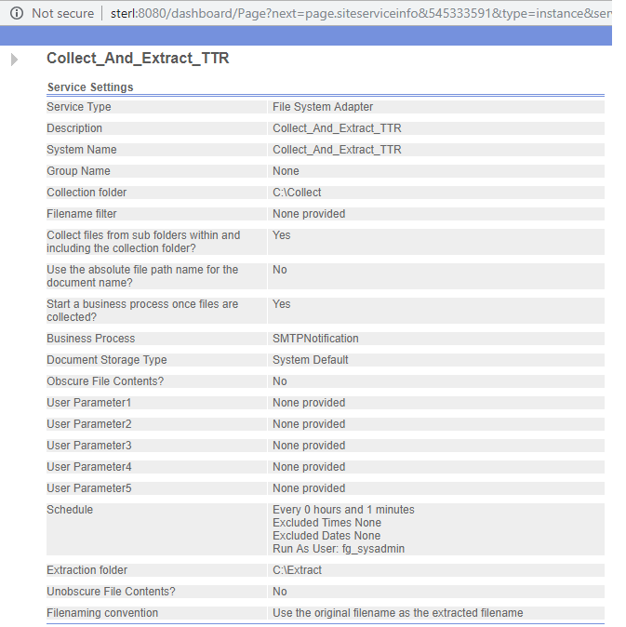

**Configuring SFTP Client End Session Service**

The "SFTP Client End Session" service ends an SFTP session with an external trading partner SFTP server.

Create " SFTP Client End Session Service" under deployment in Administration menu.

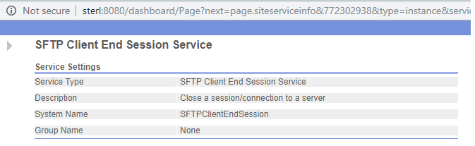

Create the Business Process under the Business Process in Administration menu

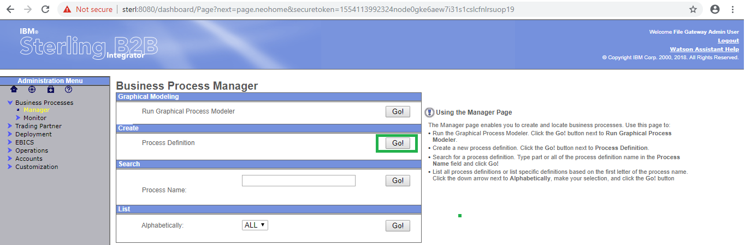

Click on "Go" button as shown above.

Select the Business Process Text Editor and click on next.

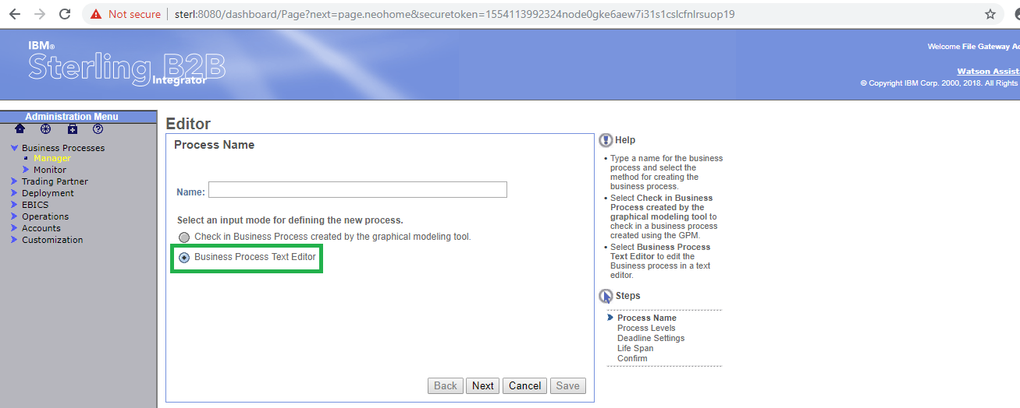

Copy the following xml code in the Business Text Editor as below and click on next.

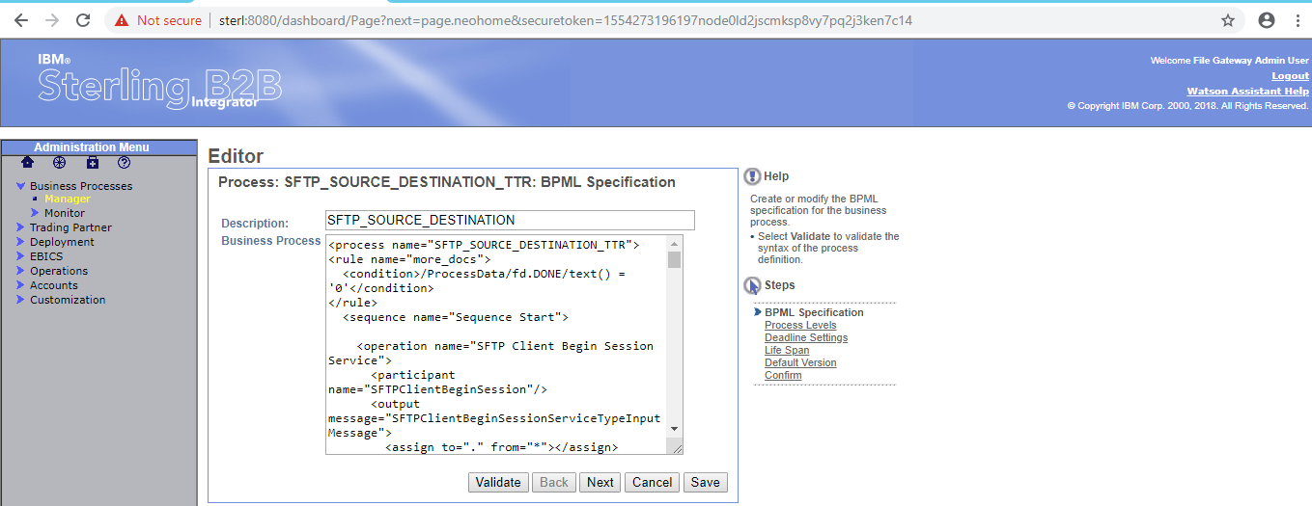

Click on "Validate" button for validating the process.

Business Process shown as below.

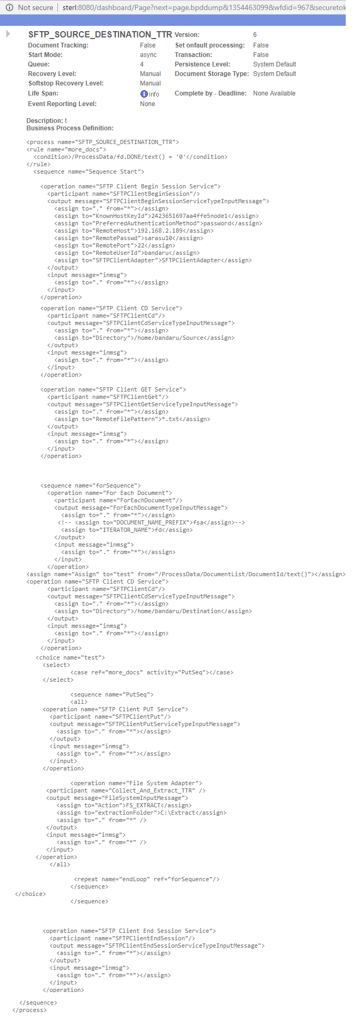

For connecting other platform we need to mention "KnownHostKeyId", "RemoteHost", "RemotePasswd", "RemotePort" and "RemoteUserId" as below.

The below service "SFTP Client Begin Session service" starts an SFTP session with an external trading partner for exchanging business documents.

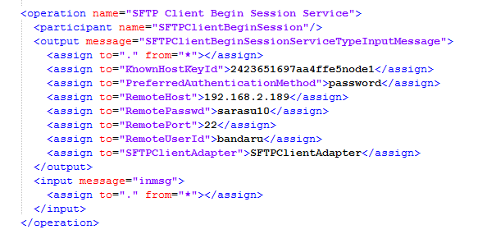

The below "SFTP Client CD service" changes directories on the trading partner's SFTP server.

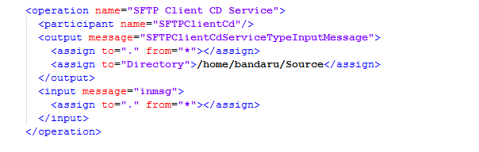

The below "SFTP Client GET service" retrieves one or more documents from a specified directory on the trading partner's SFTP server

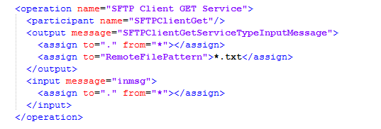

The below "For Each Document service" incrementally processes a set of documents. Each time the service runs, it makes the next document in the document set the primary document. This enables business processes to contain loops that operate on each document in turn.

Use the For Each Document service when you have multiple documents within the business process that all need to be processed.

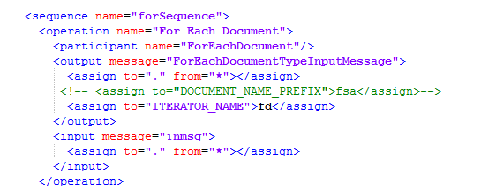

The below "SFTP Client PUT service" places a document in a specified directory on the trading partner's SFTP server

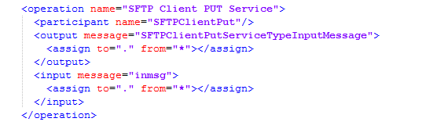

The below "File System adapter" to collect (import) files from a file system into a business process and extract (export) files from a business process to a file system. You can configure the "File System adapter" to start a business process after files are collected from the file system or include the "File System adapter" in a business process flow. In addition, you can schedule the File System adapter to run at specific time intervals.

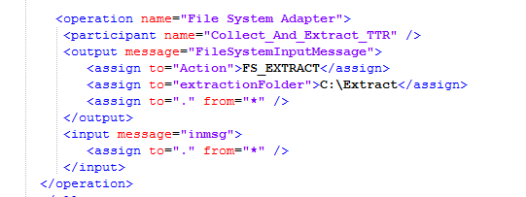

The below "SFTP Client End Session" service ends an SFTP session with an external trading partner SFTP server.

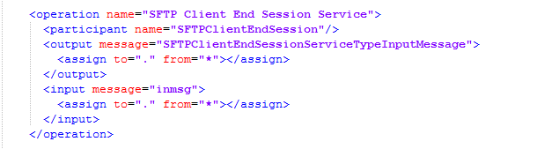

The final XML code as shown below.

Here we are using "**sequence**", "**rule**", "**condition**", "**all**", "**repeat**", "**choice**", "**case**" activities.

A "**sequence**" activity runs a series of child activities in the order in which it lists them. When a process runs, all of the child activities are run. The "**sequence**" activity finishes only after the last child activity is finished.

The "**condition**" element formulates an expression. The condition is met if the expression evaluates to true, or if the expression evaluates to false when the negative attribute is true.

Multiple conditions inside a rule are listed in logical order.

The "**rule**" element defines a rule that is referenced in a choice activity, used in an input element, or dependent on another rule. Dependencies are not affected by the order that rules are listed.

The "**all**" activity contains two or more complex child activities and runs all of them simultaneously. The all activity finishes only after the child activities are finished.

The "**repeat**" activity repeats a complex activity without recursion. It directs Sterling B2B Integrator to return to the beginning of a parent or child state, or to run an activity again.

The "**repeat**" activity can be used only as a child activity of the complex activity that it references.

The "**repeat**" element accepts the ref attribute, which names the complex activity to be repeated. The activity to be repeated must be a complex activity that contains (directly or indirectly) the repeat activity.

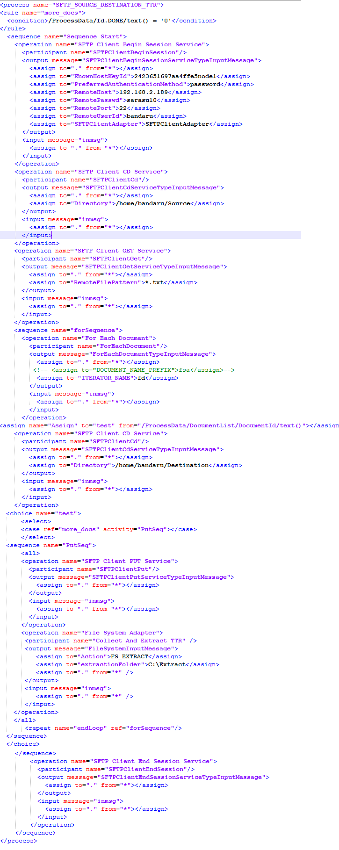

Run the process by click on the "execution manager" .

Modify the process by click on "source manager".

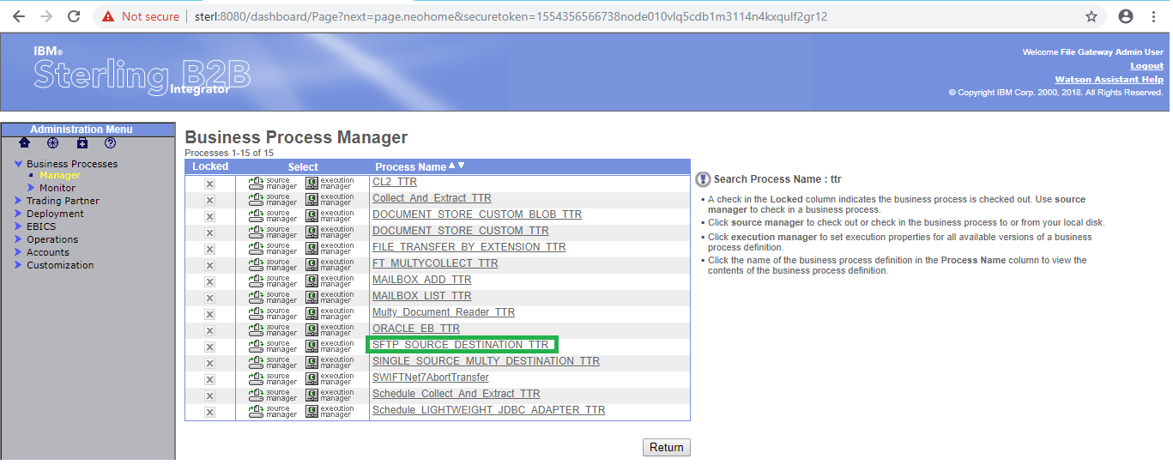

In the below shows the different version of process. first one is latest version of process and which is the last modified version.

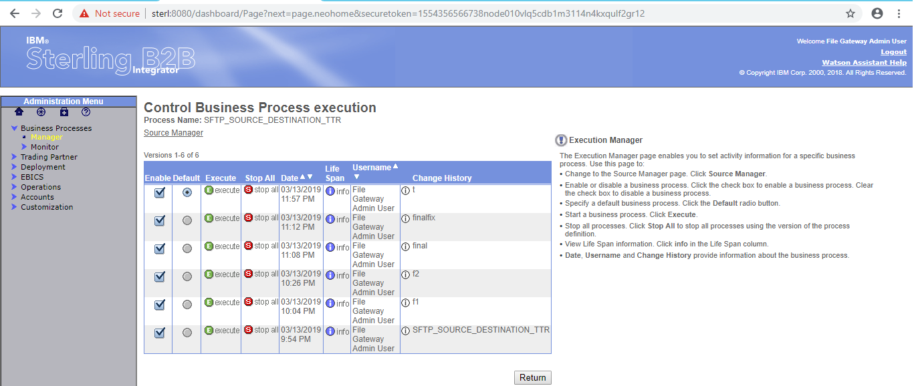

After click on the "execution manager" the following window will open

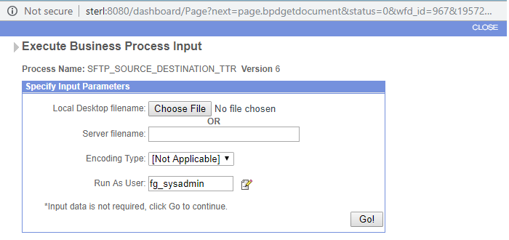

Click on Go button the following window will open